Supplementary Materials
Supplementary Table 1. Hyperparameter ranges and optimal hyperparameters for the nine machine learning models

Model | Hyperparameter | Search_range | Best_value
Decision tree | cost_complexity | [0.000001,0.1] | 0.08
Decision tree | min_n | [5, 10] | 2.00
Decision tree | tree_depth | [3, 7] | 3.00
Elastic Net | mixture (α) | [0, 1] | 0.00
Elastic Net | penalty (λ) | [0.00001,1] | 1.00
Light Gradient Boosting Machine | learn_rate (learning_rate) | [0.001, 0.1] | 0.04
Light Gradient Boosting Machine | loss_reduction (min_gain_to_split) | [0.001, 1] | 0.00
Light Gradient Boosting Machine | min_n (min_data_in_leaf) | [5, 10] | 7.00
Light Gradient Boosting Machine | mtry | [2, 8] | NA
Light Gradient Boosting Machine | tree_depth (max_depth) | [1, 3] | 10.00
Light Gradient Boosting Machine | trees (num_iterations) | [100, 500] | 676.00
Logistic regression | No tunable hyperparameters | NA | NA
Random forest | min_n | [20, 50] | 20.00
Random forest | mtry | [2, 10] | 2.00
Random forest | trees | [200, 500] | 200.00
Support vector machine | cost (C) | [0.00001,100000] | 0.03
Support vector machine | rbf_sigma (σ) | [0.0001,0.1] | 0.00
Multilayer perceptron | epochs (maxit) | [50,150] | 50.00
Multilayer perceptron | hidden_units (size) | [15, 24] | 24.00
Multilayer perceptron | penalty (decay) | [0.001, 1]) | 1.00
Extreme gradient boosting | learn_rate | [0.001, 0.1]) | 0.06
Extreme gradient boosting | loss_reduction | [0.001, 1]) | 0.03
Extreme gradient boosting | min_n | [5, 20] | 5.00
Extreme gradient boosting | mtry | [2, 8] | 1.00
Extreme gradient boosting | sample_size | [0.80, 1.00] | 0.95
Extreme gradient boosting | tree_depth | [1, 3] | 1.00
Extreme gradient boosting | trees | fixed at 1000 (early stopping active) | 26.00
K-nearest neighbors | dist_power (distance) | 2 | 2.00
K-nearest neighbors | neighbors (k) | [3, 11] | 11.00
K-nearest neighbors | weight_func (kernel) | rectangular | rectangular

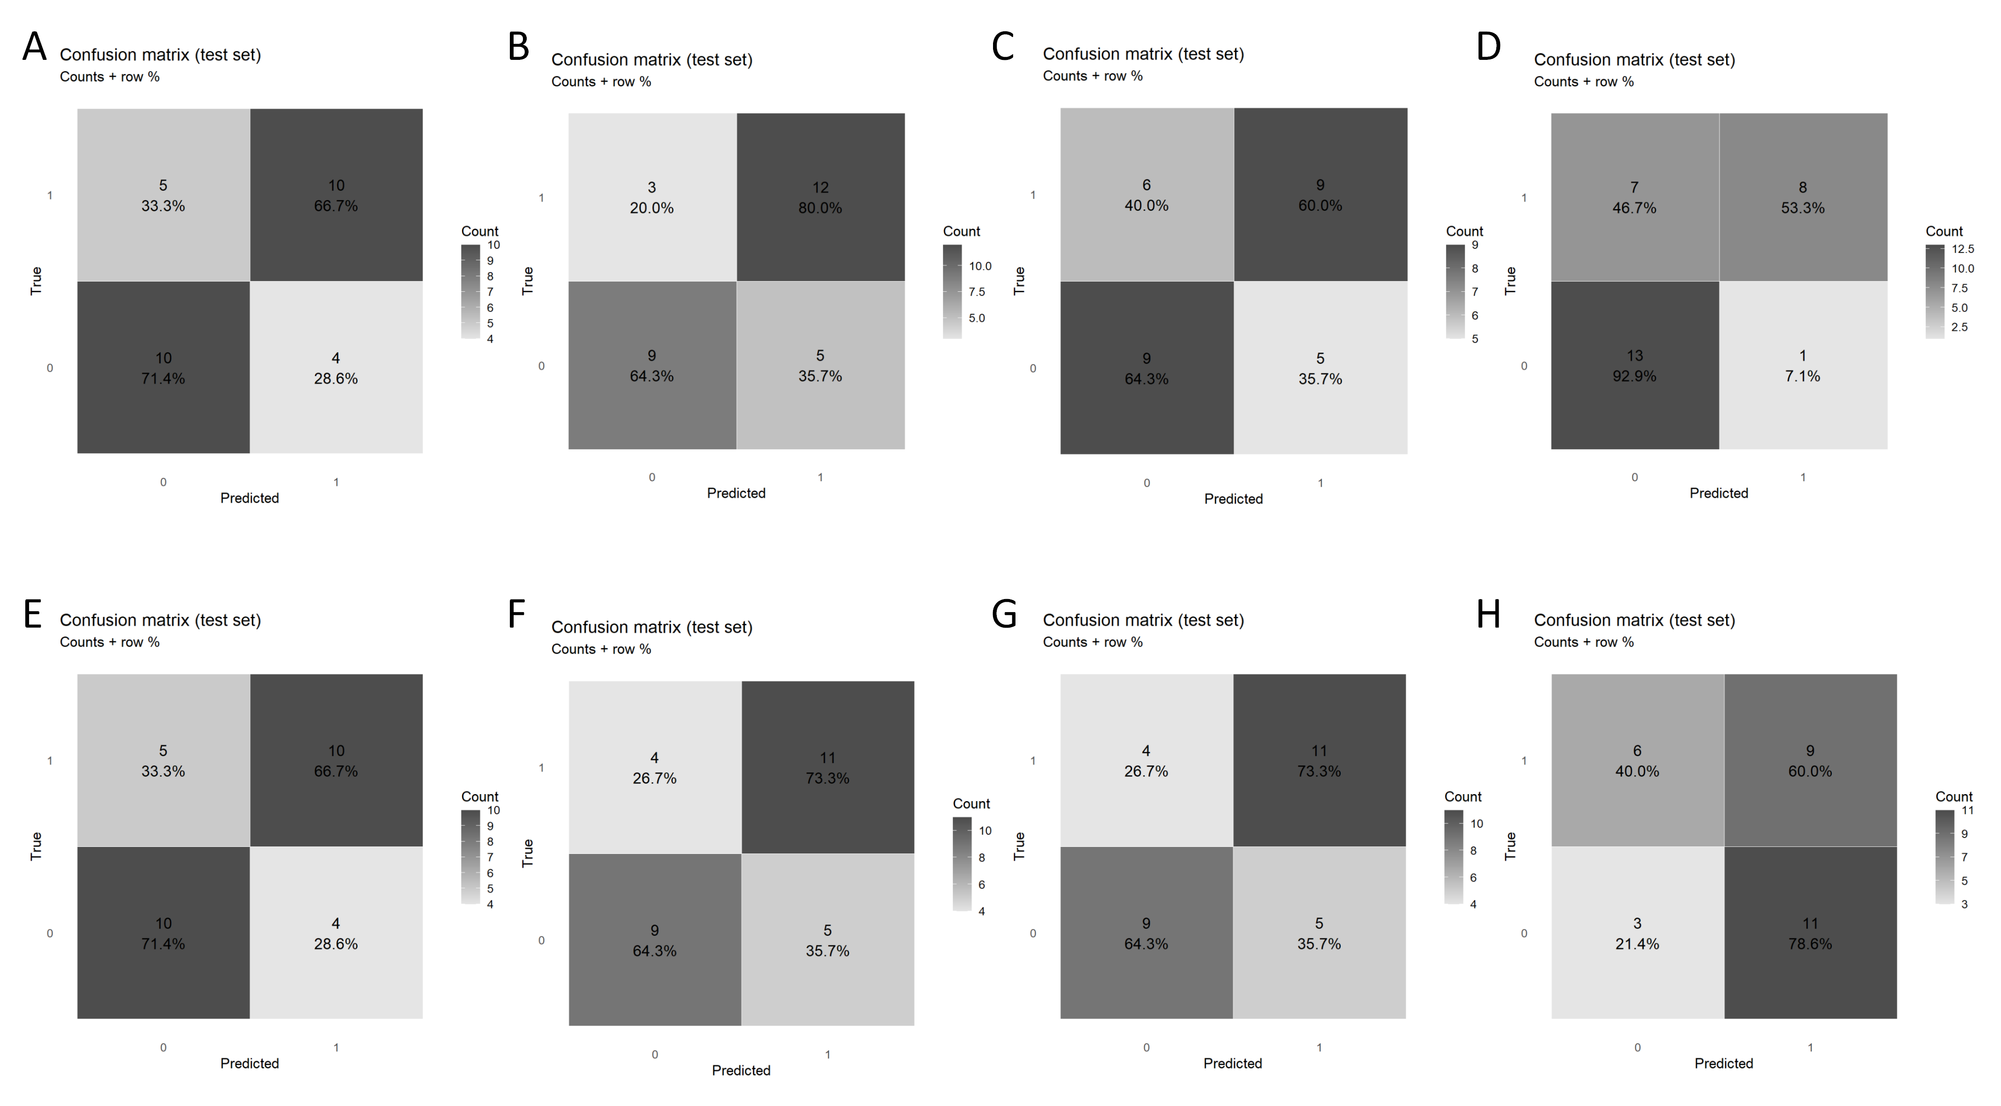
Supplementary Figure 1. Confusion Matrix Set.
A: DT, decision tree;
B: EN, elastic net;
C: KNN, k-nearest neighbors;
D: LightGBM, Light Gradient Boosting Machine;
E: LR, Logistic regression;
F: MLP, multilayer perceptron;
G: SVM, support vector machine;
H: XGB, extreme gradient boosting;

