Supplementary material

- Standardization of data
The extracted features were standardized before dimension reduction, which removed the unit limits of the data of each feature and converted it into a dimensionless pure value. This allowed the indices of different units or orders to be compared and weighted. We used Z-score normalization to make the feature intensities fit a standard normal distribution with μ and σ, wherein μ is the mean value of the features and σ is the standard deviation. The normalized values (also called Z-scores) of the feature intensities (x) were calculated as follows:
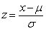

2. Details of Dimension reduction
First, the minimum redundancy maximum relevance (mRMR) algorithm was used to extract robust features from the dataset. The aim of the the minimum redundancy process ensured that the selected features had minimal redundancy among the other features. At the same time, maximum relevance procedure was to select features having the maximum correlation with the actual depression progression，and we selected features with correlation coefficients greater than 0.8 and 0.1 as high correlation and low redundancy features, respectively. Then, the mRMR method was used to obtain an optimal feature set with a high correlation and low redundancy. 20 features were retained by mRMR.
Finally, dimensionality reduction of the selected features was performed using the least absolute shrinkage and selection operator (LASSO) method. LASSO is a powerful algorithm for regression analysis with high dimensional predictors. The LASSO algorithm shrinks some coefficients and reduces others to exactly 0 via an absolute constraint. Thus, LASSO is an outstanding method for feature selection as it retains good features using both a subset selection and ridge regression. In this study, LASSO selected 8 nonzero coefficients, details of LASSO and features can be found in Figure S1 and S2. The formula for the radiomics biomarker constructed using logistic regression based on the 8 selected features is as follows:

alculation formula:
Rad score = -0.944 + 0.072×original_firstorder_Kurtosis_c2
-0.173×wavelet-LHL_glcm_Idn_c2
-0.075×original_shape_MinorAxisLength_c2
0.075×wavelet-LLL_glcm_ClusterTendency_c1
-0.356×log-sigma-4-0-mm-3D_firstorder_Kurtosis_c1
-0.388×wavelet-HHL_glcm_ClusterShade_c1
-0.442×log-sigma-5-0-mm-3D_firstorder_Skewness_c3
-0.25×wavelet-LHL_glcm_Idmn_c3

Notes: c1 represents white matter, c2 represents gray matter, and c3 represents cerebrospinal fluid.

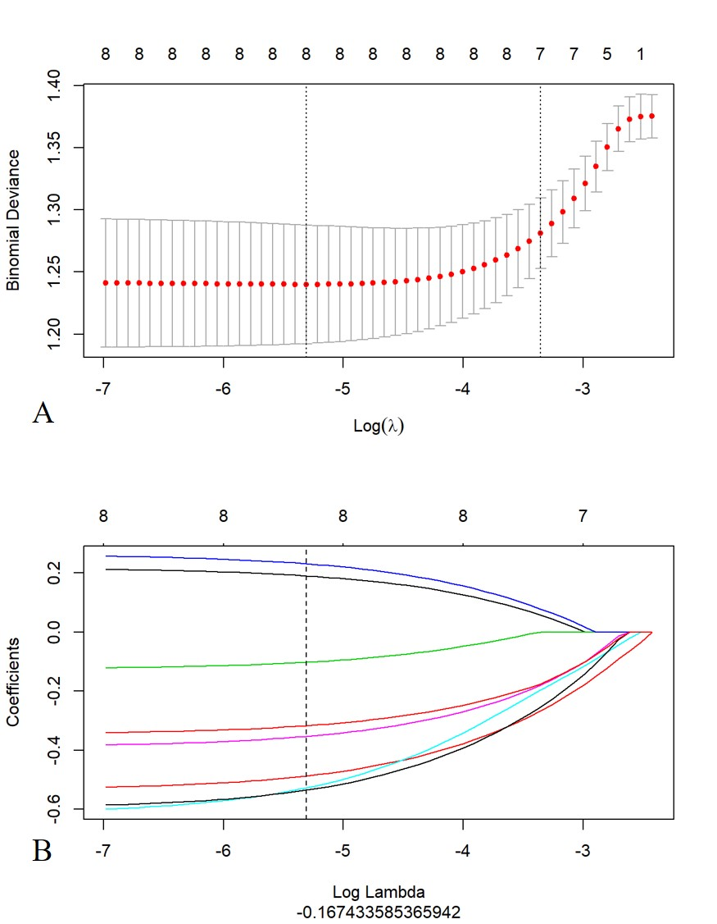
Figure S1. Figure A shows the Feature selection in the dimension reduction process of LASSO. Display the diagnostic bias of models constructed after dimensionality reduction corresponding to different hyperparameters (input values). The vertical dashed line on the left represents the minimum deviation value corresponding to the optimal input value; The dashed line on the right is the optimal input logarithmic function value. Figure B shows the changes of 8 featuress in different LASSO systems as the input values of hyperparameters change. The dashed vertical lines indicate the 8 obtained features with non zero coefficients.

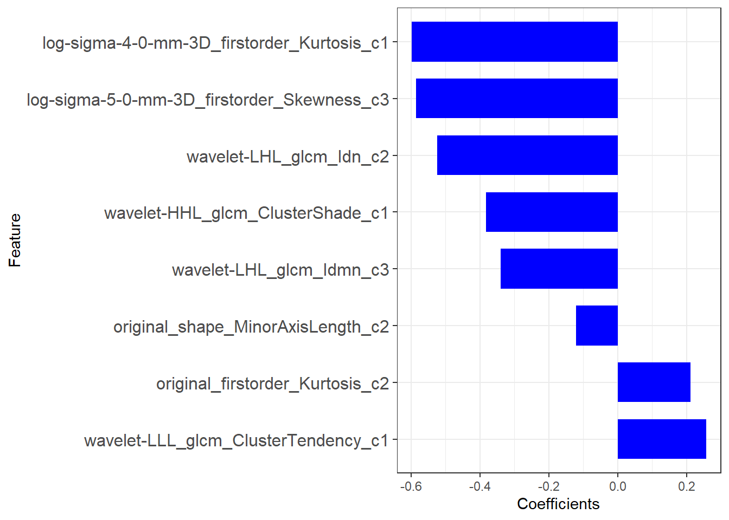
Figure S2. The remaining 8 features after dimensionality reduction are represented by the blue bar graph on the right, where c1 represents white matter, c2 represents gray matter, and c3 represents cerebrospinal fluid.

3.Machine Learning Details
In our study, we used 4 machine-learning classifiers (XGBoot, Decision tree, Random forest and Support vector machines) for identify sports subtype of PD patients. These classifiers were implemented using R package caret [1], which provides a nice interface to access many machine-learning algorithms in R. Furthermore, it also provides a user-friendly framework for training different machine-learning models. We used parameter configurations of machine learning that were previously defined by Fernandez-Delgado et al [2], and we have listed the classification methods along with their parameters and corresponding R packages. At last, we focused on and validated the decision tree model because of its better performance and ease-to-use. The hyperparameter selection and cross validation of decision tree can be seen in Figure S3.

Decision tree (DT)
A C5.0 decision tree based classification method was used in the analysis. C5.0 function of the “C50” package was used for creating classification trees with default parameter tuning under caret interface.
XGBoost (XGB)
R package "xgboost" with caret interface was used for the implementation of extreme gradient boosting classifier. Parameter nrounds was varied with values {50, 100, 150}, max_depth was set to range from 3 to 6, eta (learning rate) was varied with values {0.01, 0.1, 0.3}, and other parameters including gamma, colsample_bytree, and min_child_weight were tuned using default caret grid search.
Random forest (RF)
Random forest provides an improvement to bagging with a modification step of random sampling of predictors. R package “randomForest” with caret interface was used for the implementation. Parameter ntree was set to 500 and mtry was varied with values 2:3:29 (2 to 29 with an increment step of 3).
Support vector machine (SVM)
SVM, with Gaussian kernel function was implemented using a caret interface and R package kernlab. Cost parameter C was varied with values {2⁻² , 2⁻¹ ,1, 2¹ , 2² } and the parameter kernel spread was varied with values in {10⁻² , 10⁻¹ , 1, 10¹ ,10²}.

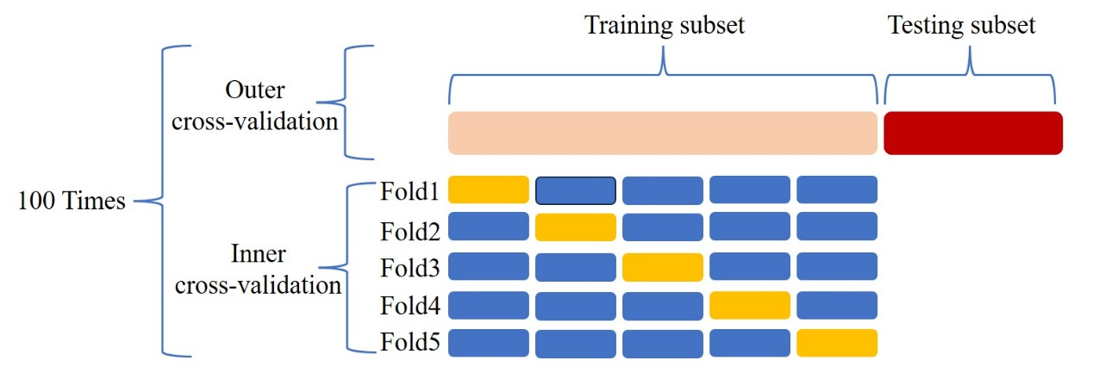
Figure S3. The cross validation process of random forest algorithm based on training queue

Table S1. The information of radiomics features
Feature Groups (N) | Feature names | Feature Groups (N) | Feature names
 | firstorder_10Percentile |  | glszm_GrayLevelNonUniformity
 | firstorder_90Percentile |  | glszm_GrayLevelNonUniformityNormalized
 | firstorder_Energy |  | glszm_GrayLevelVariance
 | firstorder_Entropy |  | glszm_HighGrayLevelZoneEmphasis
 | firstorder_InterquartileRange |  | glszm_LargeAreaEmphasis
 | firstorder_Kurtosis |  | glszm_LargeAreaHighGrayLevelEmphasis
 | firstorder_Maximum |  | glszm_LargeAreaLowGrayLevelEmphasis
First-order features (N = 18) | firstorder_MeanAbsoluteDeviation | GLSZM texture features | glszm_LowGrayLevelZoneEmphasis
 | firstorder_Mean | (N = 16) | glszm_SizeZoneNonUniformity
 | firstorder_Median |  | glszm_SizeZoneNonUniformityNormalized
 | firstorder_Minimum |  | glszm_SmallAreaEmphasis
 | firstorder_Range |  | glszm_SmallAreaHighGrayLevelEmphasis
 | firstorder_RobustMeanAbsoluteDeviation |  | glszm_SmallAreaLowGrayLevelEmphasis
 | firstorder_RootMeanSquared |  | glszm_ZoneEntropy
 | firstorder_Skewness |  | glszm_ZonePercentage
 | firstorder_TotalEnergy |  | glszm_ZoneVariance
 | firstorder_Uniformity
 | glrlm_GrayLevelNonUniformity |  | glcm_Autocorrelation
 | glrlm_GrayLevelNonUniformityNormalized |  | glcm_ClusterProminence
 | glrlm_GrayLevelVariance |  | glcm_ClusterShade
 | glrlm_HighGrayLevelRunEmphasis |  | glcm_ClusterTendency
 | glrlm_LongRunEmphasis |  | glcm_Contrast
GLRLM texture features | glrlm_LongRunHighGrayLevelEmphasis | GLCM texture features | glcm_Correlation
(N = 16) | glrlm_LongRunLowGrayLevelEmphasis | (N = 24) | glcm_DifferenceAverage
 | glrlm_LowGrayLevelRunEmphasis |  | glcm_DifferenceEntropy
 | glrlm_RunEntropy |  | glcm_DifferenceVariance
 | glrlm_RunLengthNonUniformity |  | glcm_Id
 | glrlm_RunLengthNonUniformityNormalized |  | glcm_Idm
 | glrlm_RunPercentage_T2 |  | glcm_Idmn
 | glrlm_RunVariance |  | glcm_Idn
 | glrlm_ShortRunEmphasis |  | glcm_Imc1
 | glrlm_ShortRunHighGrayLevelEmphasis |  | glcm_Imc2
 | glrlm_ShortRunLowGrayLevelEmphasis |  | glcm_InverseVariance
 |  |  | glcm_JointAverage
 |  |  | glcm_JointEnergy
 |  |  | glcm_JointEntropy
 |  |  | glcm_MCC
 |  |  | glcm_MaximumProbability
 |  |  | glcm_SumAverage
 |  |  | glcm_SumEntropy
 |  |  | glcm_SumSquares
 | gldm_DependenceEntropy |  | ngtdm_Busyness
 | gldm_DependenceNonUniformity |  | ngtdm_Coarseness
GLDM texture features | gldm_DependenceNonUniformityNormalized | NGTDM texture features | ngtdm_Complexity
(N = 14) | gldm_DependenceVariance | (N = 5) | ngtdm_Contrast
 | gldm_GrayLevelNonUniformity |  | ngtdm_Strength
 | gldm_GrayLevelVariance
 | gldm_HighGrayLevelEmphasis
 | gldm_LargeDependenceEmphasis
 | gldm_LargeDependenceHighGrayLevelEmphasis
 | gldm_LargeDependenceLowGrayLevelEmphasis
 | gldm_LowGrayLevelEmphasis
 | gldm_SmallDependenceEmphasis
 | gldm_SmallDependenceHighGrayLevelEmphasis
 | gldm_SmallDependenceLowGrayLevelEmphasis
Los features (N = 186) | Log-sigma-1.0，2.0_* (N =186)
Note: GLCM, Gray-level co-occurrence matrices; GLRLM, Gray-level run length matrix; GLSZM, Gray-level size zone matrix; GLDM, Gray-level dependence matrix. *The abbreviated representation of feature types

References
- Kuhn M. Building predictive models in R using the caret package. J Stat Softw. 2008, 28(5):1–26.
- Fernández-Delgado, Cernadas, Barro, et al. Do we need hundreds of classifiers to solve real world classification problems? J. Mach. Learn. Res. 2014, 15:3133–3181.

