Supplementary Table 1: Search strategy-Pubmed

Framework | Search Terms | Search Hits as on  18/02/2026
P-Population | “Myasthenia Gravis” AND "Myasthenia Gravis"[Mesh] | 17,450
I-Intervention | NA
C-Comparator | NA
O-Outcome | EQ-5D OR EQ5D OR (EQ 5-Dimension) OR (EQ 5D) OR Euroqol | 22,306
P AND O | ("Myasthenia Gravis" AND "Myasthenia Gravis"[Mesh]) AND (EQ-5D OR EQ5D OR (EQ 5-Dimension) OR (EQ 5D) OR Euroqol) | 17
Note: The PubMed MeSH term "Myasthenia Gravis"[Mesh] was searched with default explosion. This was intended to capture indexed MG records mapped under relevant MG concepts, including generalized MG, ocular MG, and MuSK-associated MG. Additional broader free-text sensitivity checks using generalized, ocular, MuSK, anti-MuSK, and muscle-specific receptor tyrosine kinase antibody-positive MG variants were performed during revision and did not identify additional eligible included studies.

Supplementary Table 2: Search strategy-Scopus

Framework | Search Terms | Search Hits as on  18/02/2026
P-Population - #1 | “Myasthenia Gravis” | 68,258
I-Intervention | NA
C-Comparator | NA
O-Outcome - #2 | EQ-5D OR EQ5D OR (EQ 5-Dimension) OR (EQ 5D) OR Euroqol | 69,714
P AND O | #1 AND #2 | 158

Supplementary Table 3: Search strategy-Embase
Framework | Search Terms | Search Hits as on  18/02/2026
P-Population #1 | ‘Myasthenia Gravis’ | 36,535
I-Intervention | NA
C-Comparator | NA
O-Outcome #2 | EQ-5D OR EQ5D OR (EQ 5-Dimension) OR (EQ 5D) OR Euroqol | 41,601
P AND O | #1 AND #2 | 70

Supplementary Table 4: Search strategy-Cochrane CENTRAL
Framework | Search Terms | Search Hits as on  18/02/2026
P-Population #1 | “Myasthenia Gravis” | 1178
I-Intervention | NA
C-Comparator | NA
O-Outcome #2 | EQ-5D OR EQ5D OR "EQ 5D" OR "EQ 5-Dimension" OR EuroQol | 18,114
P AND O | #1 AND #2 | 27

Supplementary Table 5: Reason for Exclusion of studies
S.No | Study Label | Study title | Reason for exclusion
1 | Brandsema JF et al. 2024 | Eculizumab in Adolescent Patients With Refractory Generalized Myasthenia Gravis: A Phase 3, Open-Label, Multicenter Study. | Pediatric/adolescent interventional study; no extractable adult baseline EQ-5D utility or EQ-VAS mean/dispersion data suitable for the planned adult synthesis.
2 | Andersen LK et al. 2025 | EQ-5D-5L is a relevant tool for detecting patients with myasthenia gravis needing medical treatment. | Psychometric/validity-focused EQ-5D-5L study; no extractable cohort-level baseline EQ-5D utility or EQ-VAS mean/dispersion data suitable for quantitative synthesis.
3 | Saccà F et al. 2023 | Efgartigimod improved health-related quality of life in generalized myasthenia gravis: results from a randomized, double-blind, placebo-controlled, phase 3 study (ADAPT). | Interventional trial report focused on post-treatment HRQoL change; no extractable baseline EQ-5D utility or EQ-VAS mean/dispersion data independent of treatment effect.
4 | Dewilde S et al. 2023 | People Diagnosed with Myasthenia Gravis have Lower health-related quality of life and Need More Medical and Caregiver Help in Comparison to the General Population: Analysis of Two Observational Studies. | Potentially overlapping MyRealWorld-MG/POPUP dataset; excluded from the relevant synthesis to avoid double-counting because a more complete outcome-specific publication was retained.
5 | Dewilde, S et al. 2026 | Comparing Psychometric Properties of 6 of the 5-Level and 3-Level EQ-5D Bolt-Ons in a Large, Multinational, Longitudinal General Population Sample | Did not report extractable adult MG EQ-5D utility or EQ-VAS mean/dispersion data suitable for the planned synthesis.
6 | Xu, R.H et al. 2025 | Development and Testing of the Psychometric Properties of 20 Bolt-On Items for the EQ-5D-5L Across 31 Rare Diseases | Did not report extractable adult MG EQ-5D utility or EQ-VAS mean/dispersion data suitable for the planned synthesis.
7 | Howard, J.F et al. 2025 | Phase 3 Trial Investigating Impact of Intravenous Efgartigimod in Anti-Acetylcholine Receptor Antibody Negative Generalized Myasthenia Gravis | Conference abstract only; insufficient data
8 | Muppidi, S et al. 2024 | ACHIEVEMENT of MINIMAL SYMPTOM EXPRESSION and EFFECT on DISEASE-SPECIFIC MEASURES in ACETYLCHOLINE RECEPTOR ANTIBODY-POSITIVE PARTICIPANTS with GENERALIZED MYASTHENIA GRAVIS TREATED with EFGARTIGIMOD in ADAPT/ADAPT+ | Conference abstract only; insufficient data
9 | Saccà, F et al. 2024 | Efgartigimod consistently improved health-related quality of life in AChR-Ab+ participants with gMG in IV and SC trials | Conference abstract only; insufficient data
10 | Howard, J et al. 2024 | Long-term Safety, Tolerability, and Efficacy of Subcutaneous Efgartigimod PH20 in Participants with Generalized Myasthenia Gravis: Interim Results of the ADAPT-SC+ Study | Conference abstract only; insufficient data
11 | Howard, J.F et al. 2024 | Achievement of minimal symptom expression in acetylcholine-receptor antibody-positive participants with generalized myasthenia gravis and effect on disease-specific measures in ADAPT/ ADAPT+ studies | Conference abstract only; insufficient data
12 | Saccà, F et al. 2022 | Efgartigimod improved quality-of-life in gMG: a randomised, double-blinded, placebo-controlled, phase 3 trial (ADAPT) | Conference abstract only; insufficient data
13 | Wei, Q.-Q et al. 2021 | Health-related quality of life in amyotrophic lateral sclerosis using EQ-5D-5L | Non-MG population; study focused on amyotrophic lateral sclerosis rather than adults with myasthenia gravis.
14 | Schönfelder, E et al. 2020 | Costs of illness in amyotrophic lateral sclerosis (ALS): A cross-sectional survey in Germany | Non-MG population; study focused on amyotrophic lateral sclerosis rather than adults with myasthenia gravis.
15 | Dewilde, S et al. 2022 | The Association Between QMG Scores and Health-related Quality of Life in Myasthenia Gravis Patients | Conference abstract only; insufficient data
16 | Mahic, M et al. 2021 | PERSPECTIVES ON MYASTHENIA GRAVIS: THE IMPACT ON QUALITY OF LIFE, PRODUCTIVITY AND EMPLOYMENT IN THE UNITED STATES | Conference abstract only; insufficient data
17 | Mahic, M et al. 2021 | PERSPECTIVES ON MYASTHENIA GRAVIS: THE QUALITY OF LIFE AND PRODUCTIVITY OF CAREGIVERS | Conference abstract only; insufficient data
18 | Tapia, C.B. et al. 2017 | Health utilities in myasthenia gravis | Conference abstract only; insufficient data
19 | Barnett, C et al. 2016 | Health utilities in patients with myasthenia gravis | Conference abstract only; insufficient data

Supplementary Table 6. GRADE summary of findings for EQ-5D outcomes in adults with myasthenia gravis
Outcome | Studies / participants | Summary estimate | Heterogeneity / prediction interval | Overall certainty | Interpretation
EQ-5D utility index | 8 studies / 1,514 participants | Descriptive pooled mean 0.74 (95% CI 0.68 to 0.80) | I² = 95.4%; tau² = 0.0075; Q test p < 0.0001; 95% PI 0.52 to 0.96 | Very low | Interpret as a descriptive summary across heterogeneous studies, not as a robust universal health-state utility value for all adults with MG.
EQ-VAS score | 7 studies / 2,760 participants | Descriptive pooled mean 66.49 (95% CI 60.99 to 71.99) | I² = 96.3%; tau² = 51.1096; Q test p < 0.0001; 95% PI 47.70 to 85.28 | Very low | Interpret as a descriptive summary of perceived health status across heterogeneous settings, not as a precise population parameter.
EQ-5D-5L domain-level proportions | 1 study / 610 EQ-5D-5L respondents in MyRealWorld-MG baseline analysis | Most frequent “any problem” domains: pain/discomfort 69.7%, usual activities 68.9%, anxiety/depression 57.4%, mobility 52.3%, self-care 33.6% | Not pooled; single-study descriptive data only | Very low | Use as descriptive evidence of multidimensional burden; do not present as pooled domain prevalence across adults with MG.
Note. Certainty was judged using a GRADE-informed approach adapted for single-arm pooled mean outcomes and descriptive domain-level evidence. Very low certainty indicates that confidence in the estimate is very limited. Certainty was mainly limited by observational study designs, serious inconsistency, wide prediction intervals, incomplete EQ-5D version/tariff reporting, and sparse or single-study evidence for domain-level data.
Abbreviations. CI = confidence interval; EQ-5D = EuroQol 5-Dimension; EQ-5D-5L = EuroQol 5-Dimension 5-Level; EQ-VAS = EuroQol visual analogue scale; GRADE = Grading of Recommendations Assessment, Development and Evaluation; MG = myasthenia gravis; PI = prediction interval.

Author | Q1 | Q2 | Q3 | Q4 | Q5 | Q6 | Q7 | Q8 | Q9 | Q10 | Q11 | Q12 | Q13 | Q14 | Q15 | Q16 | Q17 | Q18 | Q19 | Q20
Andersen et al., 2022 |  |  | 
Barnett et al., 2018
Mendoza et al., 2020 |  |  |  |  |  | 
Dewilde et al., 2024
Winter et al., 2010
Supplementary Figure 1. Risk of Bias assessment of included Cross-sectional studies using the AXIS tool.
Q1. Were the aims/objectives of the study clear?
Q2. Was the study design appropriate for the stated aim(s)?
Q3. Was the sample size justified?
Q4. Was the target/reference population clearly defined? (Is it clear who the research was about?)
Q5. Was the sample frame taken from an appropriate population base so that it closely represented the target/reference population under investigation?
Q6. Was the selection process likely to select subjects/participants that were representative of the target/reference population under investigation?
Q7. Were measures undertaken to address and categorize non-responders?
Q8. Were the risk factor and outcome variables measured appropriate to the aims of the study?
Q9. Were the risk factor and outcome variables measured correctly using instruments/measurements that had been trialed, piloted or published previously?
Q10. Is it clear what was used to determine statistical significance and/or precision estimates (e.g., p-values, confidence intervals)?
Q11. Were the methods (including statistical methods) sufficiently described to enable them to be repeated?
Q12. Were the basic data adequately described?
Q13. Does the response rate raise concerns about non-response bias?
Q14. If appropriate, was information about non-responders described?
Q15. Were the results internally consistent?
Q16. Were the results presented for all the analyses described in the methods?
Q17. Were the authors’ discussions and conclusions justified by the results?
Q18. Were the limitations of the study discussed?
Q19. Were there any funding sources or conflicts of interest that may affect the authors’ interpretation of the results?
Q20. Was ethical approval or consent of participants attained?

Study | Representativeness | Non-  exposed Cohort | Ascertainment of Exposure | Outcome Not Present at Start | Comparabi-lity | Outcome Assessment | Follow-Up Duration | Adequacy of Follow-Up | Total Rating
Dewilde et al., 2023a |  |  |  |  |  |  |  |  | 6 out of 9
Petersson et al., 2025 |  |  |  |  |  |  |  |  | 8 out of 9
de Meel et al., 2020 |  |  |  |  |  |  |  |  | 6 out of 9
Supplementary Figure 2: Risk of Bias assessment of included Cohort study using the Newcastle-Ottawa scale.

Study | Randomization Process | Deviations from Intended Interventions | Missing Outcome Data | Measurement of the Outcome | Selection of the Reported Result | Overall
Dewilde S et al., 2023b
Supplementary Figure 3. Risk of Bias assessment of included RCT using the Cochrane RoB 2.0 tool.

Study | D1 | D2 | D3 | D4 | D5 | D6 | D7 | Overall
Sieb et al., 2010 |  |  |  |  |  |  |  | Serious risk
Supplementary Table 4: Risk of Bias assessment of non-randomized studies using the ROBINS-I tool.

Domains:
D1: Bias due to confounding
D2: Bias in selection of participants into the study
D3: Bias in classification of interventions
D4: Bias due to deviations from intended interventions
D5: Bias due to missing data
D6: Bias in measurement of outcomes
D7: Bias in selection of the reported result

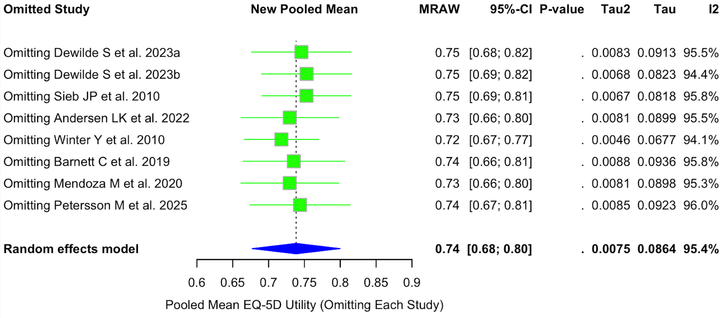
Supplementary Figure 5. Leave-One-Out Sensitivity Analysis of Pooled EQ-5D Utility Scores Among Adults with Myasthenia Gravis

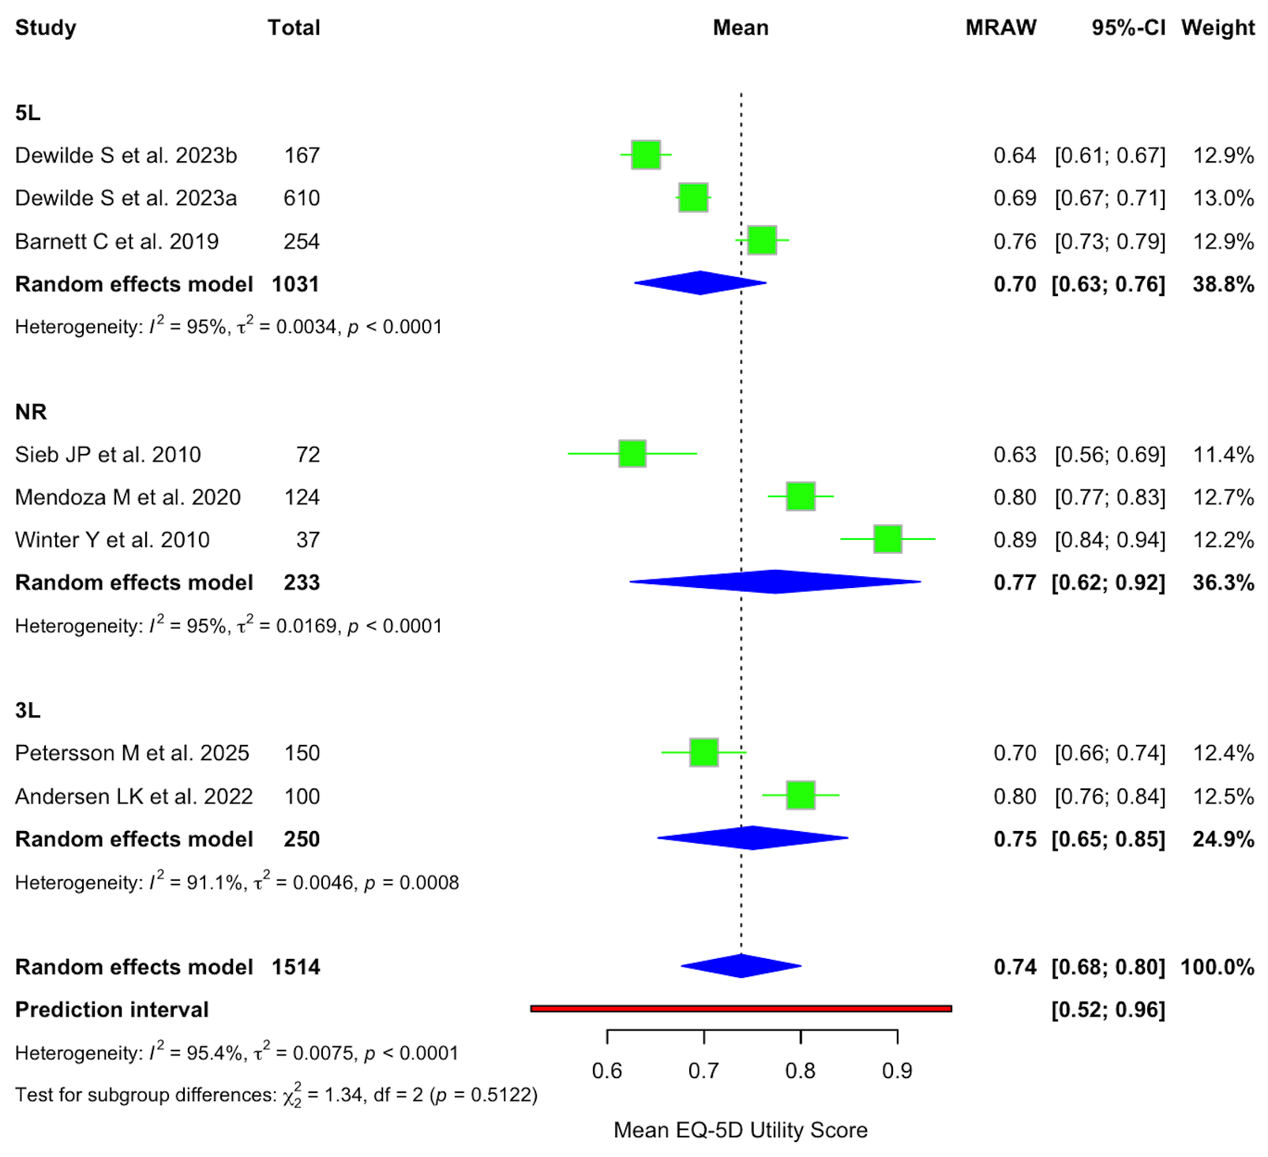
Supplementary Figure 6. Subgroup Analysis of Pooled EQ-5D Utility Scores by Instrument Version Among Adults with Myasthenia Gravis

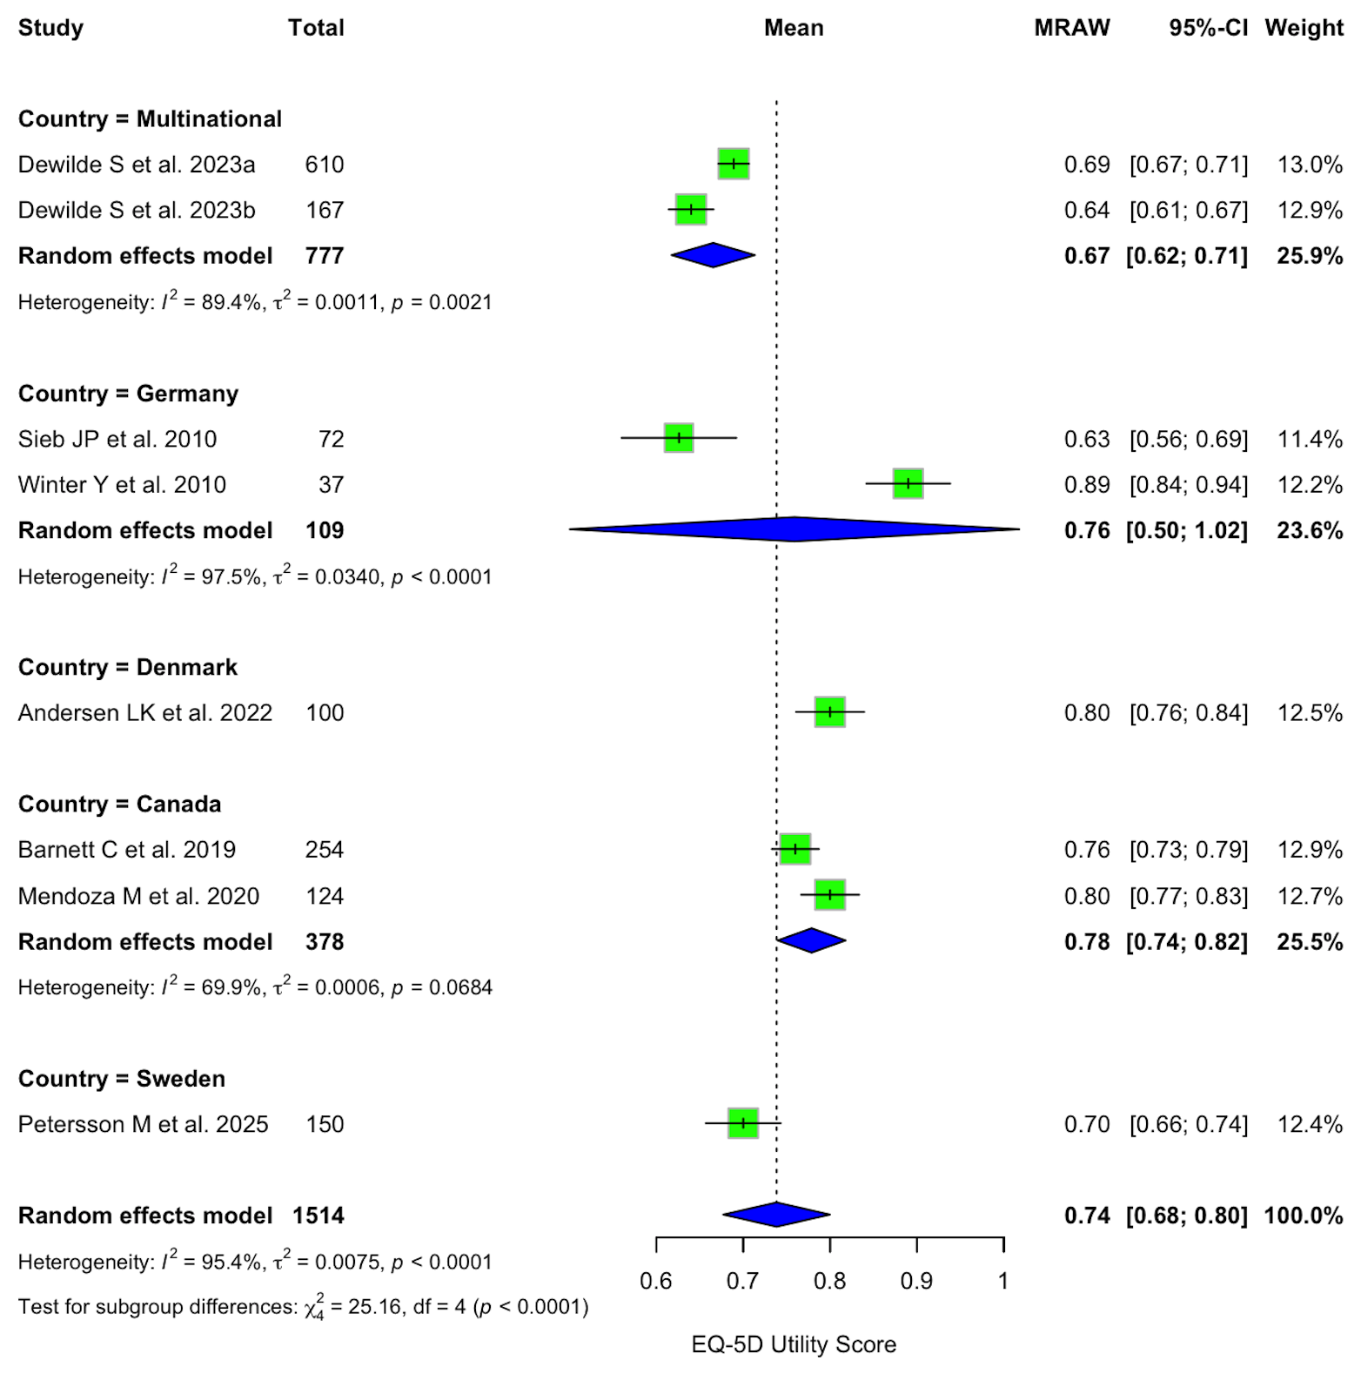
Supplementary Figure 7. Subgroup Analysis of Pooled EQ-5D Utility Scores by Country Among Adults with Myasthenia Gravis

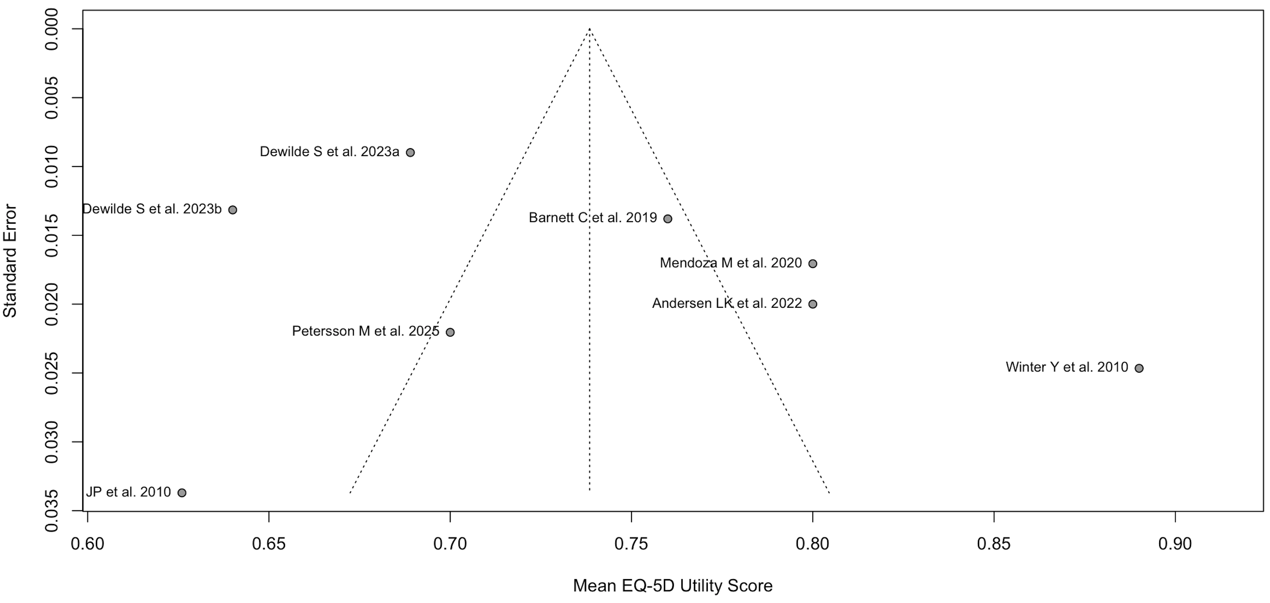
Supplementary Figure 8. Funnel Plot Assessing Publication Bias in Studies Reporting EQ-5D Utility Scores Among Adults with Myasthenia Gravis

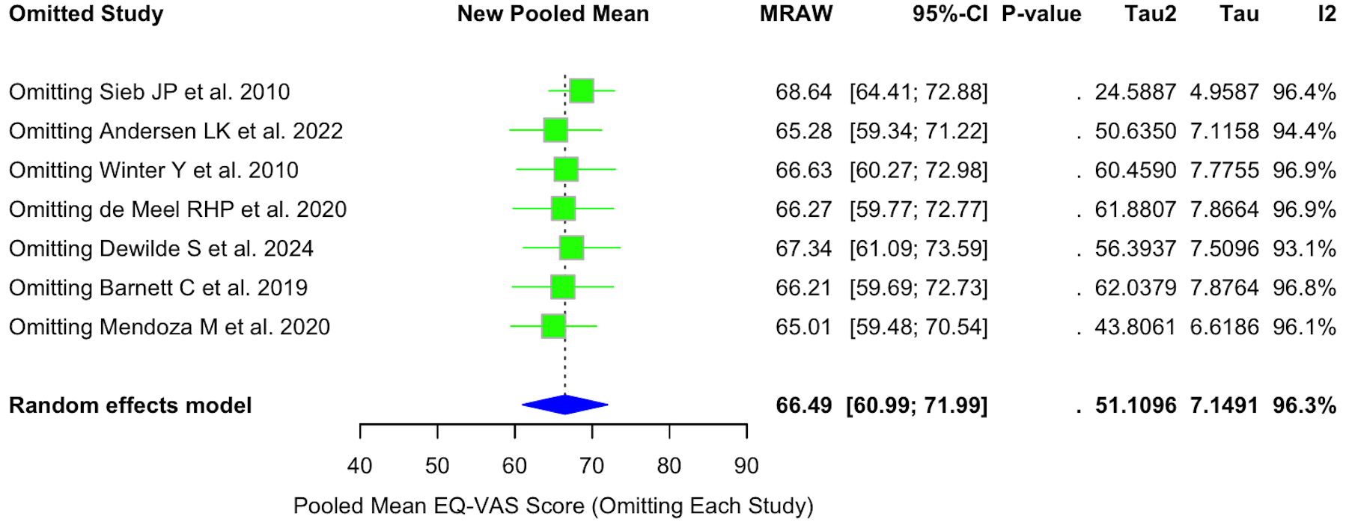
Supplementary Figure 9. Leave-One-Out Sensitivity Analysis of Pooled EQ-VAS Scores Among Adults with Myasthenia Gravis

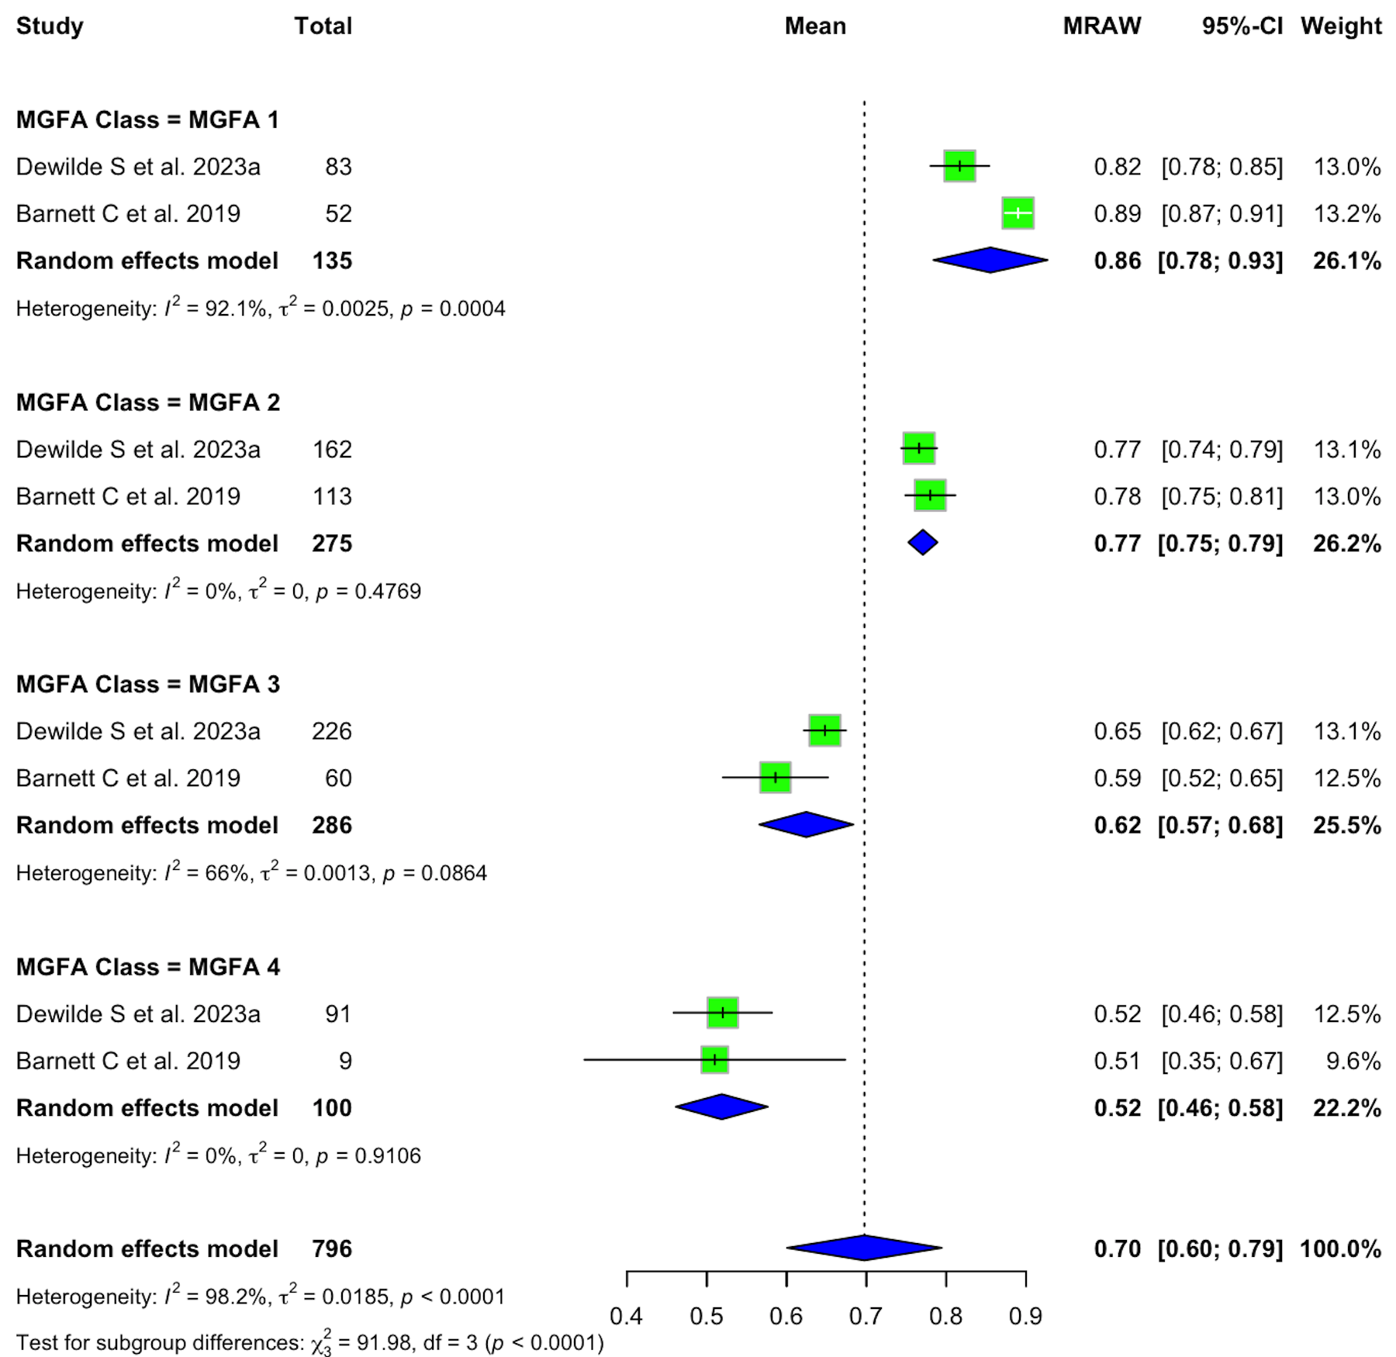
Supplementary Figure 10. Subgroup Analysis of Pooled EQ-5D Utility Scores by MGFA Disease Severity Class Among Adults with Myasthenia Gravis

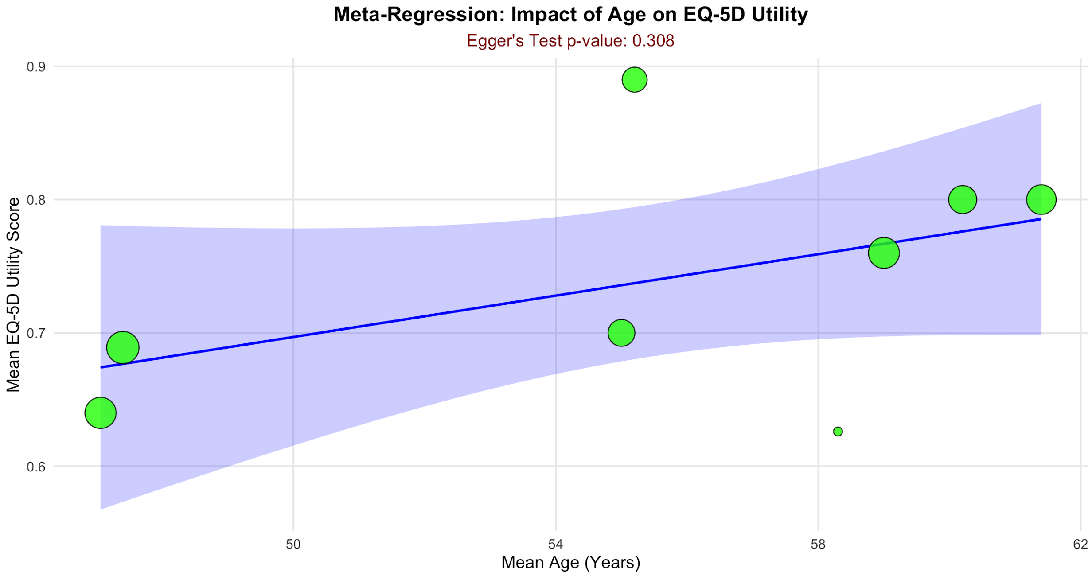
Supplementary Figure 11. Exploratory Meta-Regression Analysis Assessing the Association Between Mean Age and EQ-5D Utility Scores in Adults with Myasthenia Gravis

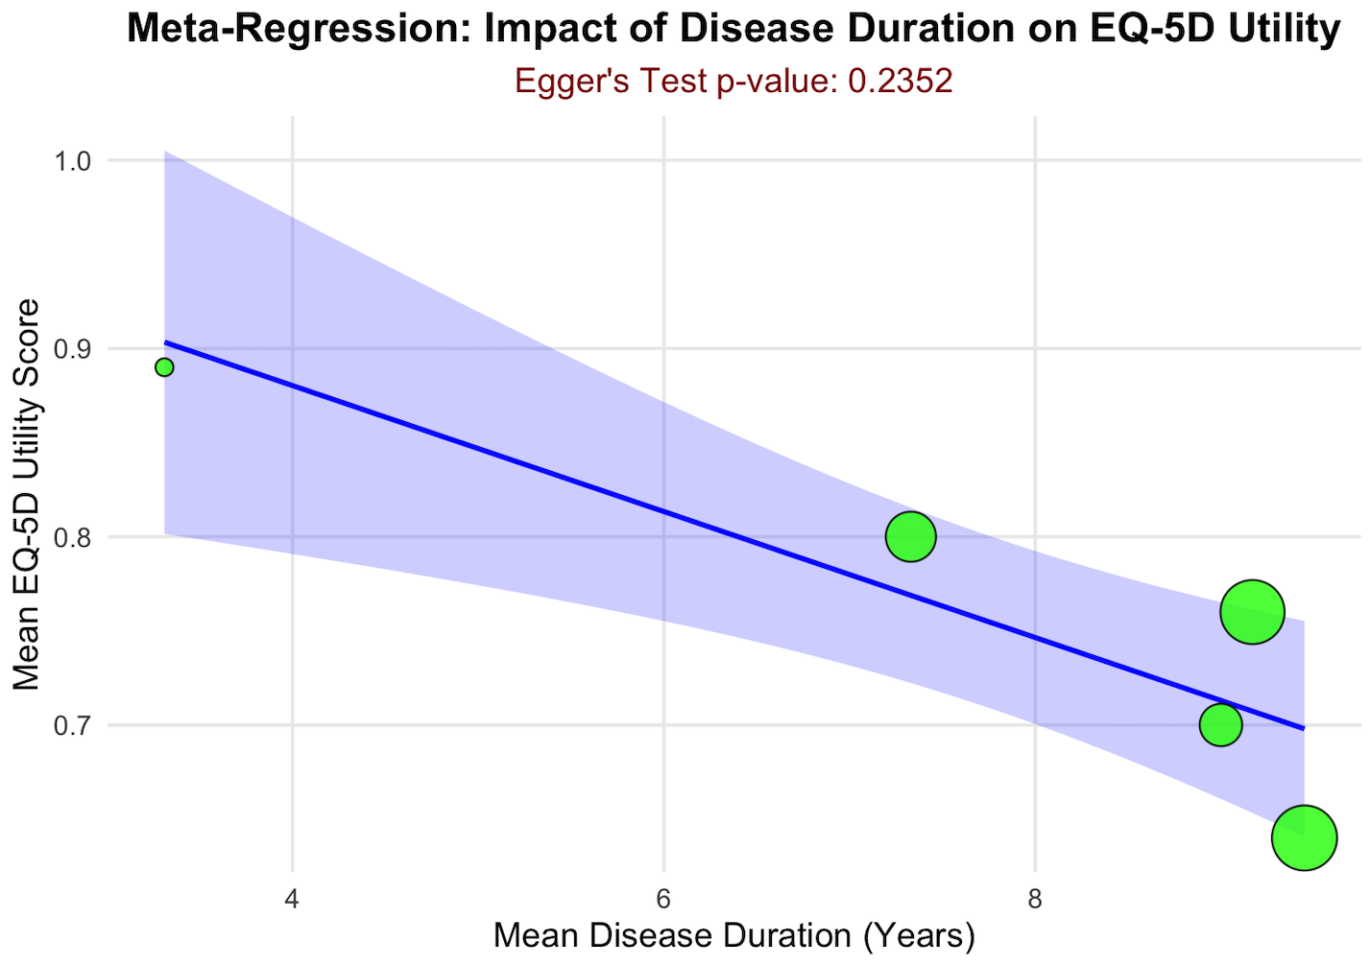
Supplementary Figure 12. Exploratory Meta-Regression Analysis Assessing the Association Between Mean Disease Duration and EQ-5D Utility Scores in Adults with Myasthenia Gravis
Section and Topic | Item # | Checklist item | Location where item is reported
TITLE
Title | 1 | Identify the report as a systematic review. | 1
ABSTRACT
Abstract | 2 | See the PRISMA 2020 for Abstracts checklist. | 2
INTRODUCTION
Rationale | 3 | Describe the rationale for the review in the context of existing knowledge. | 3,4
Objectives | 4 | Provide an explicit statement of the objective(s) or question(s) the review addresses. | 3,4
METHODS
Eligibility criteria | 5 | Specify the inclusion and exclusion criteria for the review and how studies were grouped for the syntheses. | 4
Information sources | 6 | Specify all databases, registers, websites, organisations, reference lists and other sources searched or consulted to identify studies. Specify the date when each source was last searched or consulted. | 4
Search strategy | 7 | Present the full search strategies for all databases, registers and websites, including any filters and limits used. | 4, Supp Table 1-4
Selection process | 8 | Specify the methods used to decide whether a study met the inclusion criteria of the review, including how many reviewers screened each record and each report retrieved, whether they worked independently, and if applicable, details of automation tools used in the process. | 4
Data collection process | 9 | Specify the methods used to collect data from reports, including how many reviewers collected data from each report, whether they worked independently, any processes for obtaining or confirming data from study investigators, and if applicable, details of automation tools used in the process. | 4,5
Data items | 10a | List and define all outcomes for which data were sought. Specify whether all results that were compatible with each outcome domain in each study were sought (e.g. for all measures, time points, analyses), and if not, the methods used to decide which results to collect. | 5
Data items | 10b | List and define all other variables for which data were sought (e.g. participant and intervention characteristics, funding sources). Describe any assumptions made about any missing or unclear information. | 4,5
Study risk of bias assessment | 11 | Specify the methods used to assess risk of bias in the included studies, including details of the tool(s) used, how many reviewers assessed each study and whether they worked independently, and if applicable, details of automation tools used in the process. | 5,6
Effect measures | 12 | Specify for each outcome the effect measure(s) (e.g. risk ratio, mean difference) used in the synthesis or presentation of results. | 6
Synthesis methods | 13a | Describe the processes used to decide which studies were eligible for each synthesis (e.g. tabulating the study intervention characteristics and comparing against the planned groups for each synthesis (item #5)). | 5,6
Synthesis methods | 13b | Describe any methods required to prepare the data for presentation or synthesis, such as handling of missing summary statistics, or data conversions. | 6
Synthesis methods | 13c | Describe any methods used to tabulate or visually display results of individual studies and syntheses. | 6
Synthesis methods | 13d | Describe any methods used to synthesize results and provide a rationale for the choice(s). If meta-analysis was performed, describe the model(s), method(s) to identify the presence and extent of statistical heterogeneity, and software package(s) used. | 6
Synthesis methods | 13e | Describe any methods used to explore possible causes of heterogeneity among study results (e.g. subgroup analysis, meta-regression). | 6
Synthesis methods | 13f | Describe any sensitivity analyses conducted to assess robustness of the synthesized results. | 6
Reporting bias assessment | 14 | Describe any methods used to assess risk of bias due to missing results in a synthesis (arising from reporting biases). | 6
Certainty assessment | 15 | Describe any methods used to assess certainty (or confidence) in the body of evidence for an outcome. | 8
RESULTS
Study selection | 16a | Describe the results of the search and selection process, from the number of records identified in the search to the number of studies included in the review, ideally using a flow diagram. | 7, Figure 1
Study selection | 16b | Cite studies that might appear to meet the inclusion criteria, but which were excluded, and explain why they were excluded. | 7, Supp Table 5
Study characteristics | 17 | Cite each included study and present its characteristics. | 9, Table 1
Risk of bias in studies | 18 | Present assessments of risk of bias for each included study. | 10, Supp Figure 1, 2, 3, 4
Results of individual studies | 19 | For all outcomes, present, for each study: (a) summary statistics for each group (where appropriate) and (b) an effect estimate and its precision (e.g. confidence/credible interval), ideally using structured tables or plots. | 10,11
Results of syntheses | 20a | For each synthesis, briefly summarise the characteristics and risk of bias among contributing studies. | 10
Results of syntheses | 20b | Present results of all statistical syntheses conducted. If meta-analysis was done, present for each the summary estimate and its precision (e.g. confidence/credible interval) and measures of statistical heterogeneity. If comparing groups, describe the direction of the effect. | 10-14, Figure 2 & 3,  Supp Figure 5 - 12
Results of syntheses | 20c | Present results of all investigations of possible causes of heterogeneity among study results. | 12, 13
Results of syntheses | 20d | Present results of all sensitivity analyses conducted to assess the robustness of the synthesized results. | 11,13, Supp. Fig 5,9
Reporting biases | 21 | Present assessments of risk of bias due to missing results (arising from reporting biases) for each synthesis assessed. | 12
Certainty of evidence | 22 | Present assessments of certainty (or confidence) in the body of evidence for each outcome assessed. | 7; Supplementary Table 6
DISCUSSION
Discussion | 23a | Provide a general interpretation of the results in the context of other evidence. | 15
Discussion | 23b | Discuss any limitations of the evidence included in the review. | 17
Discussion | 23c | Discuss any limitations of the review processes used. | 17
Discussion | 23d | Discuss implications of the results for practice, policy, and future research. | 17
OTHER INFORMATION
Registration and protocol | 24a | Provide registration information for the review, including register name and registration number, or state that the review was not registered. | 4
Registration and protocol | 24b | Indicate where the review protocol can be accessed, or state that a protocol was not prepared. | 4
Registration and protocol | 24c | Describe and explain any amendments to information provided at registration or in the protocol. | 4
Support | 25 | Describe sources of financial or non-financial support for the review, and the role of the funders or sponsors in the review. | 17
Competing interests | 26 | Declare any competing interests of review authors. | 18
Availability of data, code and other materials | 27 | Report which of the following are publicly available and where they can be found: template data collection forms; data extracted from included studies; data used for all analyses; analytic code; any other materials used in the review. | 18

Supplementary Appendix 1

