Appendix T.1. Baseline Characteristic table of case-control included studies.

Study | Number of participants cases:controls male | Age (y) | Cases:controls with risk factor | Risk factor exposure | Stroke outcomes | Number of cofounders controlled for in adjusted model
Egido 2012 | 150:300 | 53.8 ± 9.3* | 16:9 | Life events (Holmes & Rahe Questionnaire) | IS, HS | 8
Jood 2017 | 198:396 | 54.5* | NR | Job-control-demand model, the effort-reward imbalance ERI score, and exposure to conflict at work | IS, HS | 13
Reddin 2022 | 13462:13488 | 61.8 * | 2745: 1933 | Psychological stress, stressful life event measured using a standardized questionnaire of self-reported stress at home and work. | NS | 14
Abel 1999 | 655:1087 | 69.8* CASES | NR | Social readjustment | IS | 4
Behymer 2025 | 2964/2964 | 61.85* | NR | Financial stress, Health stress, Emotional well-being stress, Family stress | HS
O’Donnell 2010 | 3000:3000 | 63*CASES | 1:1 | Questionnaire | IS, HS | 11
Sarfo 2022 | 2431:2431 | 61.1* | 1:1 | INTERSTROKE questionnaire for Psychosocial stress and depression | NS | 3
Sarfo 2018 | 2118:2118 | 58.5* | 1:1 | INTERSTROKE questionnaire for Psychosocial stress and depression | NS | 37
Zaitsu 2019 | 128615:999976 | 60 ± 13* | 1:7.7 | Occupational Class | NS | 2
Jood 2009 | 566:593 | 56.3* | 162/46 | Single-item questionnaire for self-perceived psychological stress | IS | 9
Riaz 2016 | 175:171 | NE | NR | Questionnaire on psychosocial stress, diet, smoking, etc. | IS, HS | 8
Khan 2023 | 1582:1582 | 38.52* | NR | Psychosocial stress, hypertension, smoking, alcohol, diet, physical activity, obesity, dyslipidaemia, cardiac causes | IS, HS | 10

*mean
IS: ischemic stroke, HS: hemorrhagic stroke, NS: non-specified stroke

Appendix T.2. Baseline Characteristic table of cohort included studies.
Study Id | Number of participants male(%) | Age at baseline (y) | Risk Factor exposure | Duration of follow-up (y) | Number of stroke events (total) | Stroke outcomes | Number of confounders controlled for in adjusted model
Almas 2015 | 4620 (44.67) | 41.3 | Depression and Anxious Distress | 10 | 228 | IS, HS | 16
Bloostrand 2022 | 146 (10) | 60-82 | Mental Stress | 44 | 337 | IS, HS, NS, FS | 14
Cummings 2016 | 9241 (42) | 64 | Depression, stress | 5.95 | 486 | SI | 6
Fenger-Grøn 2020 | 90832 (32.6) | 40-100 | Partner Bereavement | 5 | 8823 | IS, ICH | 11
Henderson 2013 | 1575 (38.22) | 77.1 | Psychosocial Distress | 6 | 603 | SI, SM | 13
Kuper 2007 | 47942 women | 40.3 | Socioeconomic Status | 11.2 | 200 | IS, HS | 14
Araki 2004 | 124 (32.97) | 75 | Socioeconomic state, behaviors | 3 | 25 | IS,CH | 12
Arbelaez 2007 | 2312 (41.8) | 72.7 | Depression | 11 | 607 | IS | 16
Bos 2008 | 1759 (39.76) | 71.2 | Depression | 15 | 291 | IS, HS, NS | 14
Eurelings 2013 | 729 (40.27) | 74.12 | Apathy, depression | 2 | 55 | IS | 12
Curkendall 2004 | 1495 (49.5) | 49.6 | schizophrenia | 3.3 | NM | ICH, IS, NS, TCI | 7
Ohira 2001 | 311 (35.38) | 40-78 | Depression | 10.3 | 69 | IS, HS, SAH | 9
Surtees 2007 | 8939 (43.33) | 41-80 | Social stress | 7.1 | 452 | FS, NFS | 13
Bergh 2014 | 237879 (100) | 31-58 | Stress resilience | 23 | 3411 | IS, HS, FS | 9
Blomstrand 2014 | 1460 women | 38-60 | Mental stress, socioeconomic state | 32 | 184 | IS, HS, FS, NFS | 9
Everson-Rose 2014 | 3172 (47) | 45-84 | Depression, chronic stress | 8.5 | 195 | IS,HS, NS, TIA | 16
Feller 2013 | 21653 (43) | 35-65 | Life satisfaction | 8 | 440 | SI | 12
Hamano 2014 | 137305 (42.08) | ≥30 | Depression , interpersonal | 3 | 4718 | SI | 9
Lahti 2012 | 6775 (52.36) | > 24 | Schizophrenia | 33 | 619 | SI , SM | 5
Lee 2008 | 2172 (43.77) | 18-44 | Depression | 5 | 98 | SI | 10
Lin 2007 | 9292 (49.68) | >18 | Bipolar disorder | 6 | 315 | SI | 10
Gafarov 2013 | 870 women | 25-64 | Depression | 16 | 35 | SI | NA
Gafarov 2013 | 560 women | 25-64 | Depression | 16 | 35 | SI | 1
Kivimaki 2007 | 3160 (55.45) | 19-65 | Job strain | 11 | 93 | IS | 1 3
kornerup 2010 | 9186 (40.53 ) | 22-99 | psychological | 6-9 | 409 | HS,IS,FS,NFS | 7
Nielsen 2005 | 12,096 (44.41) | 21-98 *56 | Psychological, behavioral | 14-16 | 880 | IS,HS,SAH, ICH | 7
Ohlin 2004 | 13,609 (79.85) | men *46 , women * 42 | psychological | 21 | NA | CVD | 10
Riahi 2023 | 6,779 (47.2) | 45-84 | Psychological, interpersonal | *8.46 | 370 | FS,NFS | 11
Santosa 2021 | 118,706 | 35-70 | psychological | 13 | 2880 | NS | 17
Majed 2012 | 9,601 men | 48 - 64 | psychological | 10 | 136 | IS | 13
mejia-Lancheros 2014 | 7,263 (42.5) | 55- 80 | psychological | 4.8 | NA | NS | 13
Nabi 2010 | 37,012 (62.7) | 20-54 | behavioral | 7 | 105 | FS, NFS,SAH, ICH,CI | 13
Nilsson 2004 | 13,748 | affective disorder patients* 56.7 , osteoarthritis patients *66.6 | psychological | NA | stroke 1.8 % of affective disorder patients , 1.3 % of mania , 1.9 % of depression , 1.9 % osteoarthritis | CVD,CH | 3
salaycik 2006 | 4,120 | 29-100 | psychological | 8 | 228 | HS,IS , TIA ,CVD | 8
shirai 2009 | 88,175 men and women | 40- 69 | psychological | 12 | 3523 | FS,NS | 10
Sumner 2015 | 49,978 | 44-62 | psychological | 20 | 271 | IS | NA
Schiöler 2015 | 75,236 | * 35.3 | Psychosocial, work environment | 15 | 2623 | IS | 5
Tezuka 2019 | 5,936 | 40 - 79 | Anger | 3 | 312 | NM | 8
Williams 2002 | 13,851 | 48-67 | Anger, Hostility | 6.4 | 228 | IS, HS | 12
Xu 2022 | 135,669 | 18-65 | Psychological, occupational | 1 | NA | IS, HS | 8
André-Petersson 2007 | 7,770 | 54.2 (F); 55.5 (M) | Occupational, Interpersonal | 5 | 91 | IS, HS | 7
Everson 2001 | 2,303 | 52.8 | Interpersonal | 1 | 113 | IS, HS | 11
Smoller 2007 | 3,369 | 50-70 | panic | 4 | NA | CVD | 20
Kuan-Yi Tsai 2012 | 322,276 | 56-59 | schizophrenia | 5 | 4491 | IS, HS | 2
Yan 2012 | 4,619 | ≥65 | psychosocial | 11.5 | 548 | IS | 12
Glium 2003 | 5,614 | 45-72 | Education, poverty | 5 | NA | IS, HS | 8
Honjo 2015 | 90,843 | 40-69 | Socioeconomic | 15.4 | NA | IS, HS | 2
Iso 2002 | 73,424 | 40-79 | Psychological | 3 | 657 | IS, NS, CVD | 6
Fujino 2007 | 14,568 | 40–59 | Perceived Noise Exposure | 3 | 35 | ICH | 11
Jackson 2018 | 221,677 | ≥45 | Psychological | 4.7 | 2421 | MI, NS | 5
May 2002 | 2,201 | 49-64 | Psychological | 14 | 130 | NS | 14
Prasad 2020 | 151 | ≥18 | Acute Psychological | 1 | 151 | NS | 5
Surtees 2008 | 20,627 | 76.9 | Psychological | 8.5 | 595 | NS | 14
Truelsen 2003 | 12,689 | 20–98 | Self-Reported Stress | 13 | 929 | NS | 11
Lawrence 1996 | 556 | 60-70 | Occupational | 6 | 44 | NS, CVD | 5
Honjo 2008 | 20,543 | 40 -59 | Socioeconomic | 12 | 902 | NS, ICH | 11
mcFadden 2009 | 22,488 | 39-79 | Socioeconomic | 10 | 683 | NS, CVD | 11
Eng 2003 | 23,522 | 50-85 | Anger Expression | 2 | 57 | NS | 3
Eriksson 2018 | 5,753 (100) | 55 | Noise exposure | NA | 336 | NS | 1
Uchiyama 2005 | 1,615 (56) | 40-75 | Socioeconomic,  Work environment | 5.6 | NA | NS | 5
Tsutsumi 2009 | 6,553 (48) | 18-65 | Occupational | 11 | 147 | CVD,ICH | 9
Harmsen 2006 | 7,457 (100) | 47-55 | Psychological | 28 | 1019 | NS | 7
Gallo 2014 | 5,313 | 18-74 | Psychological | NA | 77 | NS | 5
Glover 2020 | 5,306 (36) | 21-95 | Psychological | 12 | 140 | NS | 5
Harmsen 1990 | 9,998 (100) | 47-55 | Socioeconomic | 11.8 | 230 | NS | 4
Metcalfe 2005 | 5,577 (100) | 34-64 | Social,  Psychological | 25 | 444 | NS | 7
Nagayoshi 2014 | 13,686 (44) | 57 | Socioeconomic | 18.6 | 905 | IS, HS | 14
Engström 2004 | 118,134 (44.8) | 40-89 | Psychological | 10 | 6184 | IS, HS, CVD | 3
Li 2008 | 6,9625 | 40-65 | Socioeconomic | 10 | 275 | IS, HS | 5
Veronesi 2010 | 5,084 | 35-74 | Psychological | 12 | 309 | IS, HS | 9
Ikeda 2008 | 4,4152 | 40-69 | Socioeconomic | 10.7 | 1057 | IS, HS | 7
Ohira 2009 | 1,024 | NA | Socioeconomic | 3 | 429 | IS | 5
*mean
IS: ischemic stroke, HS: hemorrhagic stroke, NS: non-specified stroke, FS: fatal stroke, NFS: non-fatal stroke, ICH: intracerebral hemorrhage, SI: stroke incident, SM: stroke mortality, CH: cerebral hemorrhage, SAH: subarachnoid hemorrhage, TIA: transient ischemic attacks, TCI: transient cerebral ischemia, NM: not mentioned, CVD: cerebrovascular disease, CI: cerebral infarct, MI: myocardial infarction

Appendix T.3. Summary table of ROB assessment using the Newcastle-Ottawa Quality Assessment Scale for Case-Conrol studies.
Study ID |  | Selection |  | Comparability |  | Exposure |  | Quality Score
Abel 1999 | 1 point | 1 point | 1 point | 1 point | 2 points | 1 point | 1 point | 0 point | 8 out of 9
Jood 2017 | 1 point | 1 point | 1 point | 1 point | 2 points | 1 point | 1 point | 0 point | 8 out of 9
Reddin 2022 | 1 point | 1 point | 1 point | 1 point | 2 points | 1 point | 1 point | 1 point | 9 out of 9
Behymer 2025 | 1 point | 1 point | 1 point | 1 point | 2 points | 0 point | 1 point | 0 point | 7 out of 9
Kuan-Yi Tsai 2012 | 1 point | 1 point | 1 point | 1 point | 2 points | 1 point | 1 point | 0 point | 8 out of 9
O’Donnell 2010 | 1 point | 1 point | 1 point | 1 point | 2 points | 1 point | 1 point | 1 point | 9 out of 9
Sarfo 2022 | 1 point | 1 point | 1 point | 1 point | 2 points | 1 point | 1 point | 0 point | 8 out of 9
Sarfo 2018 | 1 point | 1 point | 1 point | 1 point | 2 points | 1 point | 1 point | 0 point | 8 out of 9
Zaitsu 2019 | 1 point | 1 point | 1 point | 1 point | 2 points | 1 point | 1 point | 1 point | 9 out of 9
Egido 2012 | 1 point | 1 point | 1 point | 1 point | 1 point | 1 point | 1 point | 1 point | 9 out of 9
Riaz 2016 | 1 point | 1 point | 0 point | 1 point | 2 point | 1 point | 1 point | 0 point | 7 out of 9
Khan 2023 | 1 point | 1 point | 1 point | 1 point | 2 point | 1 point | 1 point | 0 point | 8 out of 9

Appendix T.4. Summary table of ROB assessment using the Newcastle-Ottawa Quality Assessment Scale for Cohort studies.
Study ID | Selection |  |  |  | Comparability | Outcome |  |  | Quality Score
Albert 2006 | 1 point | 1 point | 1 point | 1 point | 2 points | 1 point | 1 point | 1 point | 9 out of 9
Almas 2015 | 1 point | 1 point | 1 point | 1 point | 2 points | 1 point | 1 point | 1 point | 9 out of 9
Blomstrand 2022 | 1 point | 1 point | 1 point | 1 point | 2 points | 1 point | 1 point | 1 point | 9 out of 9
Cummings 2016 | 1 point | 1 point | 1 point | 1 point | 2 points | 1 point | 1 point | 1 point | 9 out of 9
Fenger-Grøn 2020 | 1 point | 1 point | 1 point | 1 point | 2 points | 1 point | 0 point | 1 point | 8 out of 9
Henderson 2013 | 1 point | 1 point | 1 point | 1 point | 2 points | 1 point | 1 point | 0 point | 8 out of 9
Kuper 2007 | 1 point | 1 point | 0 point | 1 point | 2 points | 1 point | 1 point | 1 point | 9 out of 9
Araki 2004 | 1 point | 1 point | 1 point | 1 point | 2 points | 1 point | 1 point | 1 point | 8 out of 9
Arbelaez 2007 | 1 point | 1 point | 1 point | 1 point | 2 points | 1 point | 1 point | 1 point | 9 out of 9
Bos 2008 | 1 point | 1 point | 1 point | 1 point | 2 points | 1 point | 1 point | 1 point | 8 out of 9
Curkendall 2004 | 1 point | 1 point | 1 point | 1 point | 2 points | 1 point | 1 point | 1 point | 9 out of 9
Eurelings 2013 | 1 point | 1 point | 1 point | 1 point | 2 points | 1 point | 0 point | 1 point | 9 out of 9
Öhlin (2004) | 1 point | 1 point | 1 point | 1 point | 2 points | 1 point | 1 point | 1 point | 9 out of 9
Surtees(2007) | 1 point | 1 point | 1 point | 1 point | 2 points | 1 point | 1 point | 0 point | 8 out of 9
Bergh (2014) | 1 point | 1 point | 1 point | 1 point | 2 points | 1 point | 1 point | 1 point | 8 out of 9
Blomstrand(2014) | 1 point | 1 point | 1 point | 1 point | 2 points | 1 point | 1 point | 1 point | 8 out of 9
Everson-Rose (2014) | 1 point | 1 point | 1 point | 1 point | 2 points | 1 point | 1 point | 1 point | 9 out of 9
Feller 2013 | 1 point | 1 point | 0 point | 1 point | 2 points | 1 point | 1 point | 1 point | 9 out of 9
Hamano 2014 | 1 point | 1 point | 1 point | 1 point | 2 points | 1 point | 1 point | 1 point | 9 out of 9
Lahti 2012 | 1 point | 1 point | 1 point | 1 point | 1 point | 1 point | 1 point | 1 point | 9 out of 9
Lee 2008 | 1 point | 1 point | 1 point | 1 point | 2 points | 1 point | 1 point | 1 point | 8 out of 9
Lin 2007 | 0 point | 1 point | 1 point | 1 point | 2 points | 0 point | 1 point | 1 point | 9 out of 9
Gafarov (2013) | 1 point | 1 point | 1 point | 1 point | 1 point | 1 point | 1 point | 1 point | 8 out of 9
Kivimaki 2007 | 0 point | 1 point | 1 point | 1 point | 2 points | 1 point | 1 point | 1 point | 9 out of 9
kornerup 2010 | 1 point | 1 point | 1 point | 1 point | 2 points | 1 point | 1 point | 1 point | 7out of 9
Kuper 2007 | 1 point | 1 point | 1 point | 1 point | 2 points | 1 point | 1 point | 1 point | 8 out of 9
Nielsen 2005 | 1 point | 1 point | 1 point | 1 point | 2 points | 1 point | 1 point | 1 point | 8 out of 9
Ohlin 2004 | 1 point | 1 point | 1 point | 1 point | 2 points | 1 point | 1 point | 1 point | 9 out of 9
Riahi 2023 | 1 point | 1 point | 1 point | 1 point | 2 points | 1 point | 1 point | 1 point | 9 out of 9
Santosa 2021 | 1 point | 1 point | 0 point | 1 point | 2 points | 1 point | 1 point | 1 point | 9 out of 9
Majed 2012 | 1 point | 1 point | 0 point | 1 point | 2 points | 1 point | 1 point | 1 point | 9 out of 9
mejia-Lancheros 2014 | 1 point | 1 point | 1 point | 1 point | 2 points | 1 point | 1 point | 0 point | 8 out of 9
nabi 2010 | 1 point | 1 point | 1 point | 1 point | 2 points | 1 point | 1 point | 1 point | 8 out of 9
Nilsson 2004 | 0 point | 1 point | 1 point | 1 point | 2 points | 1 point | 1 point | 1 point | 8 out of 9
Salaycik 2006 | 1 point | 1 point | 1 point | 1 point | 2 points | 1 point | 1 point | 1 point | 9 out of 9
shirai 2009 | 1 point | 1 point | 0 point | 1 point | 2 points | 1 point | 1 point | 1 point | 9 out of 9
Schiöler 2015 | 0 point | 0 point | 0 point | 1 point | 1 point | 1 point | 1 point | 1 point | 9 out of 9
Sumner 2015 | 0 point | 0 point | 0 point | 1 point | 1 point | 1 point | 1 point | 1 point | 9 out of 9
Tezuka 2019 | 0 point | 0 point | 0 point | 1 point | 0 point | 1 point | 1 point | 1 point | 8 out of 9
Tsutsumi 2011 | 0 point | 1 point | 0 point | 1 point | 2 points | 1 point | 1 point | 1 point | 5 out of 9
Williams 2002 | 0 point | 0 point | 1 point | 1 point | 1 point | 1 point | 1 point | 1 point | 5 out of 9
Xu 2022 | 1 point | 0 point | 0 point | 1 point | 2 points | 1 point | 1 point | 1 point | 4 out of 9
André-Petersson 2007 | 0 point | 0 point | 0 point | 1 point | 2 point | 1 point | 1 point | 1 point | 7 out of 9
Bergh 2014 | 1 point | 0 point | 1 point | 1 point | 0 point | 1 point | 1 point | 1 point | 6 out of 9
Everson 2001 | 0 point | 0 point | 1 point | 1 point | 1 point | 1 point | 1 piont | 1 point | 7 out of 9
Smoller2007 | 0 point | 0 point | 0 point | 1 point | 2 point | 1 point | 1 point | 1 point | 6 out of 9
YAN1 2012 | 0 point | 0 point | 1 point | 1 point | 2 points | 1 point | 1 point | 0 point | 5 out of 9
gilum2003 | 0 point | 0 point | 0 point | 1 point | 1 point | 1 point | 1 point | 0 point | 5 out of 9
honjo2015 | 1 point | 1 point | 1 point | 1 point | 2 points | 1 point | 1 point | 0 point | 5 out of 9
Fujino 2007 | 0 pont | 1 point | 1 point | 1 point | 2 points | 1 point | 1 point | 0 point | 6 out of 9
Iso 2002 | 1 point | 1 point | 0 point | 1 point | 2 points | 1 point | 1 point | 0 point | 4 out of 9
Jackson 2018 | 1 point | 1 point | 1 point | 1 point | 2 points | 1 point | 1 point | 1 point | 9 out of 9
May 2002 | 0 point | 1 point | 1 point | 0 point | 2 points | 1 point | 1 point | 0 point | 7 out of 9
Surtees 2008 | 0 point | 1 point | 1 point | 1 point | 2 points | 1 point | 1 point | 0 point | 7 out of 9
Truelsen 2003 | 1 point | 1 point | 0 point | 1 point | 2 points | 1 point | 1 point | 1 point | 9 out of 9
Lawrence 1996 | 0 point | 1 point | 1 point | 0 point | 2 points | 1 point | 1 point | 1 point | 7 out of 9
Honjo, 2008 | 0 point | 1 point | 0 point | 1 point | 2 points | 1 point | 1 point | 0 point | 7 out of 9
li2008 | 1 point | 1 point | 1 point | 1 point | 2 points | 1 point | 1 point | 1 point | 8 out of 9
mcfadden2009 | 1 point | 1 point | 1 point | 1 point | 2 points | 1 point | 1 point | 0 point | 6 out of 9
veronesi2010 | 1 point | 1 point | 1 point | 1 point | 2 points | 1 point | 1 point | 1 point | 7 out of 9
Ohira 2009 | 1 point | 0 points | 1 point | 1 point | 1 point | 1 point | 0 points | 1 point | 9 out of 9
Eriksson 2018 | 1 point | 1 point | 1 point | 1 point | 2 points | 1 point | 1 point | 1 point | 9 out of 9
Uchiyama 2005 | 1 point | 0 point | 1 point | 1 point | 2 point | 1 point | 1 point | 1 point | 9 out of 9
Tsutsumi 2009 | 1 point | 1 point | 1 point | 1 point | 2 point | 1 point | 1 point | 0 points | 5 out of 9
Harmsen 2006 | 1 point | 1 point | 1 point | 1 point | 2 point | 1 point | 1 point | 1 point | 9 out of 9
Gallo 2014 | 1 point | 1 point | 1 point | 1 point | 2 point | 1 point | 0 point | 0 point | 7 out of 9
Glover 2020 | 1 point | 1 point | 1 point | 1 point | 2 point | 1 point | 1 point | 1 point | 9 out of 9
Harmsen 1990 | 1 point | 1 point | 1 point | 1 point | 2 point | 1 point | 1 point | 1 point | 9 out of 9
Metcalfe 2005 | 1 point | 1 point | 1 point | 1 point | 2 point | 1 point | 1 point | 0 point | 6 out of 9
Ikeda 2008 | 1 point | 1 point | 1 point | 1 point | 2 point | 1 point | 1 point | 1 point | 9 out of 9
Nagayoshi 2014 | 1 point | 1 point | 1 point | 1 point | 2 points | 1 point | 1 point | 1 point | 9 out of 9
Engström 2004 | 1 point | 1 point | 1 point | 1 point | 2 points | 1 point | 1 point | 1 point | 9 out of 9
Ohira (2001) | 1 point | 1 point | 1 point | 1 point | 2 points | 1 point | 1 point | 1 point | 9 out of 9

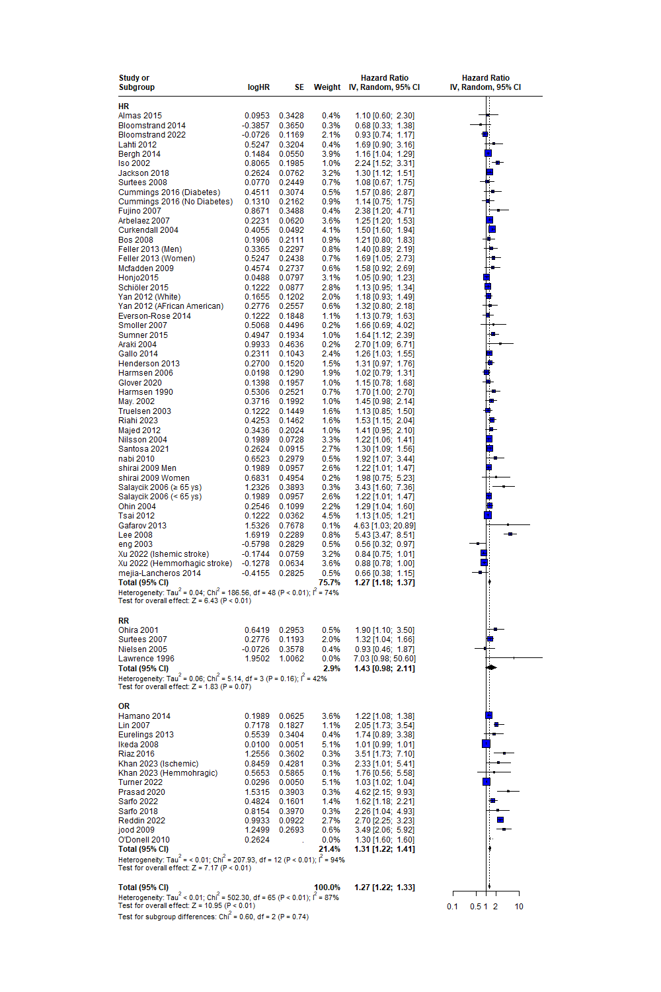
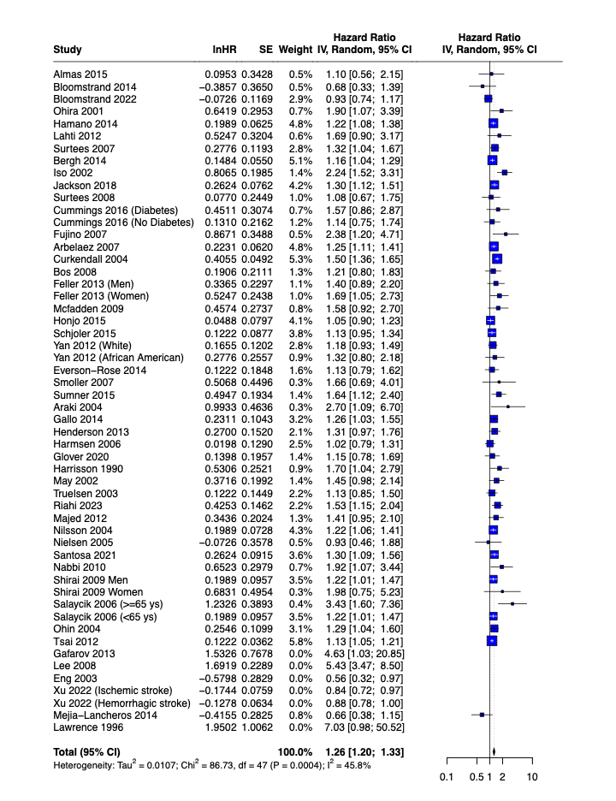
Appendix Fig.1. Psychological Factors Forest Plot after removing outliers
Appendix Fig.2. Subgroup Analysis forest Plot by Effect Measure Used
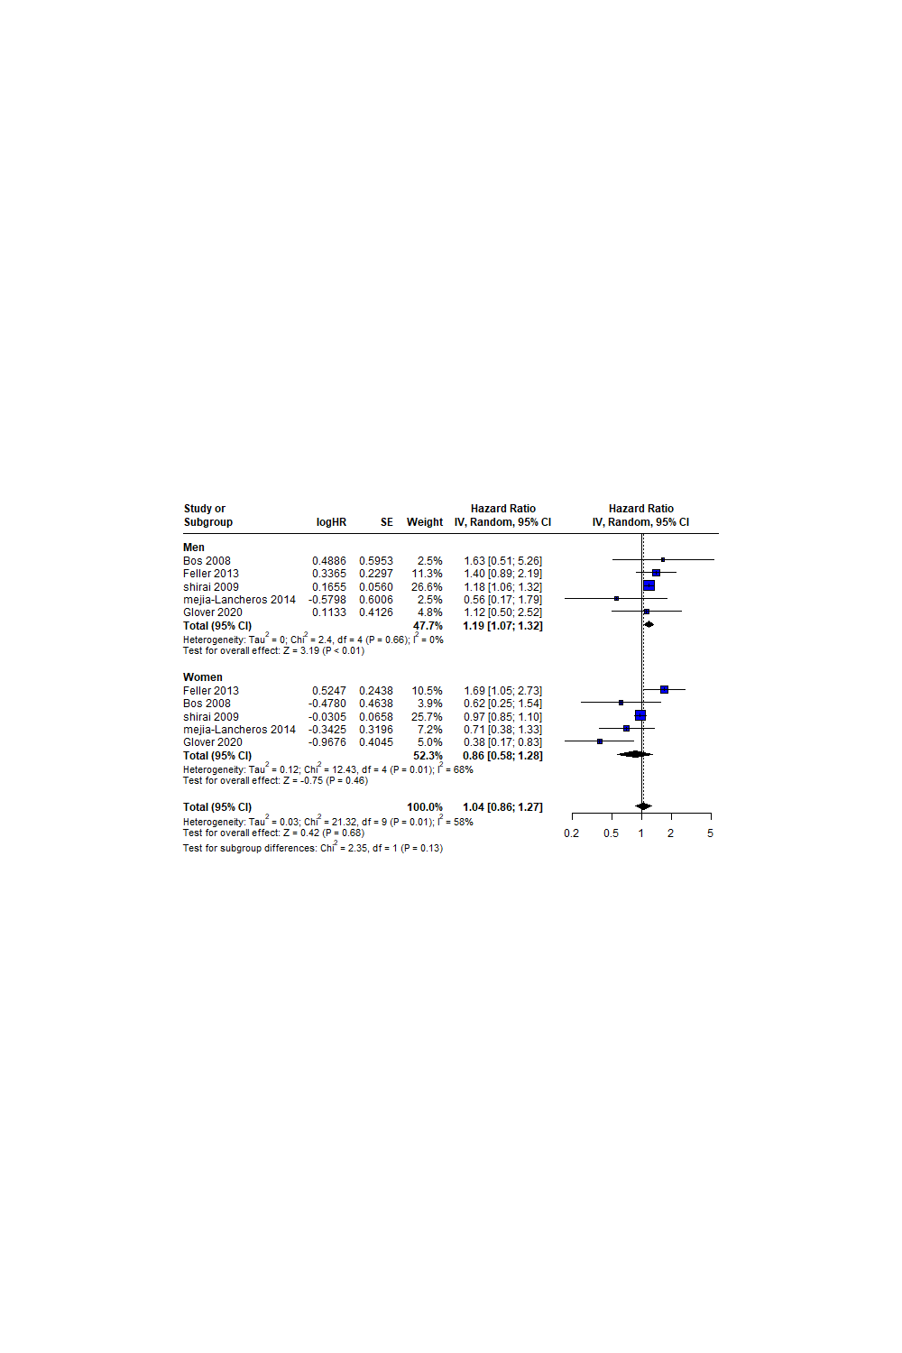
Appendix Fig.3. Gender Subgroup Analysis Forest Plot.

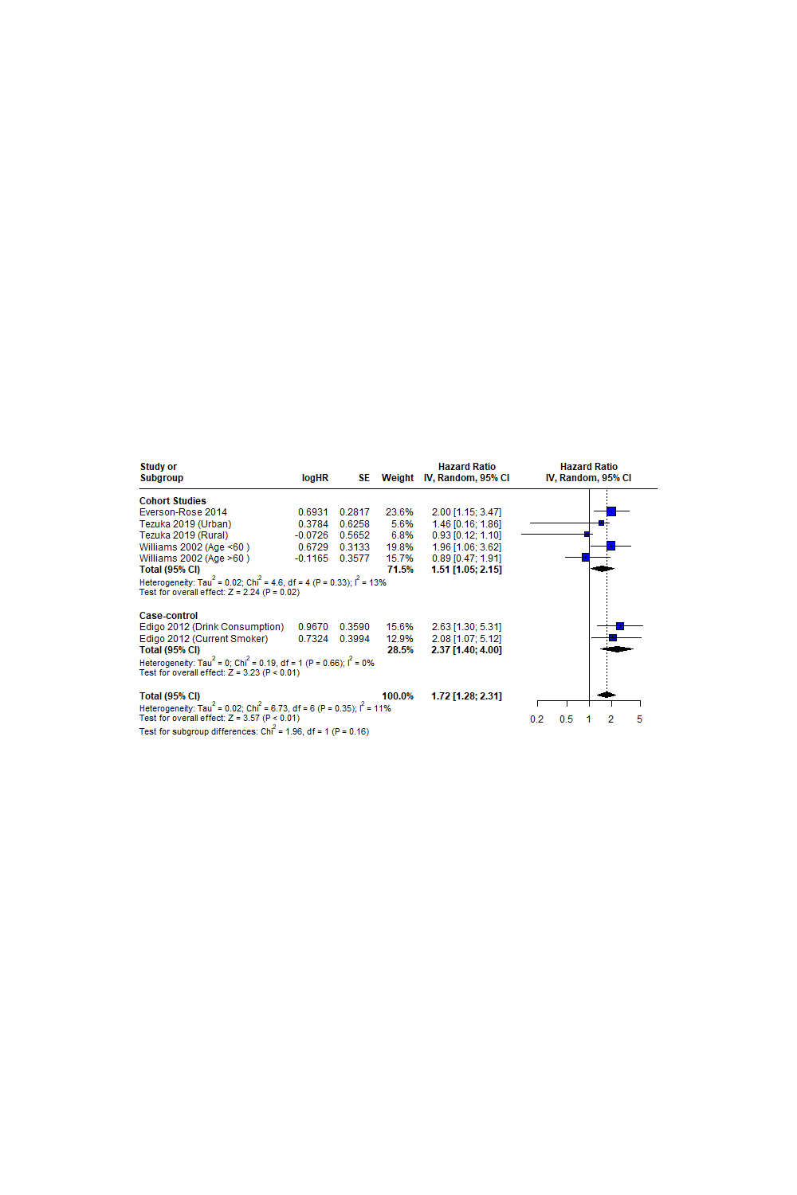
Appendix Fig.4. Behavioral Risk Factors Forest Plot

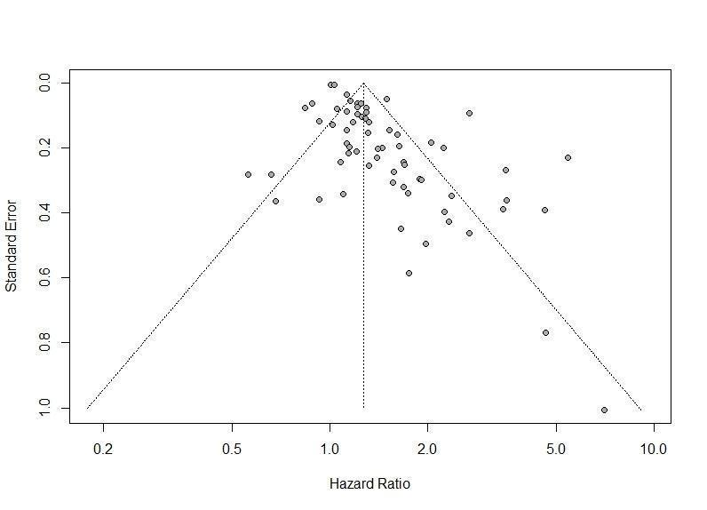
Appendix. Fig.5 Psychological Risk Factors Funnel plot

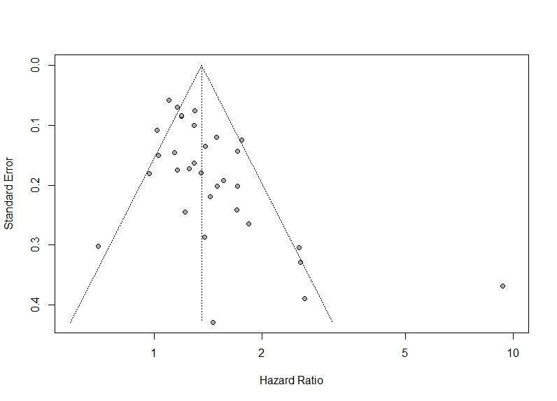Appendix Fig.6. Vocational Risk Factors Funnel Plot

