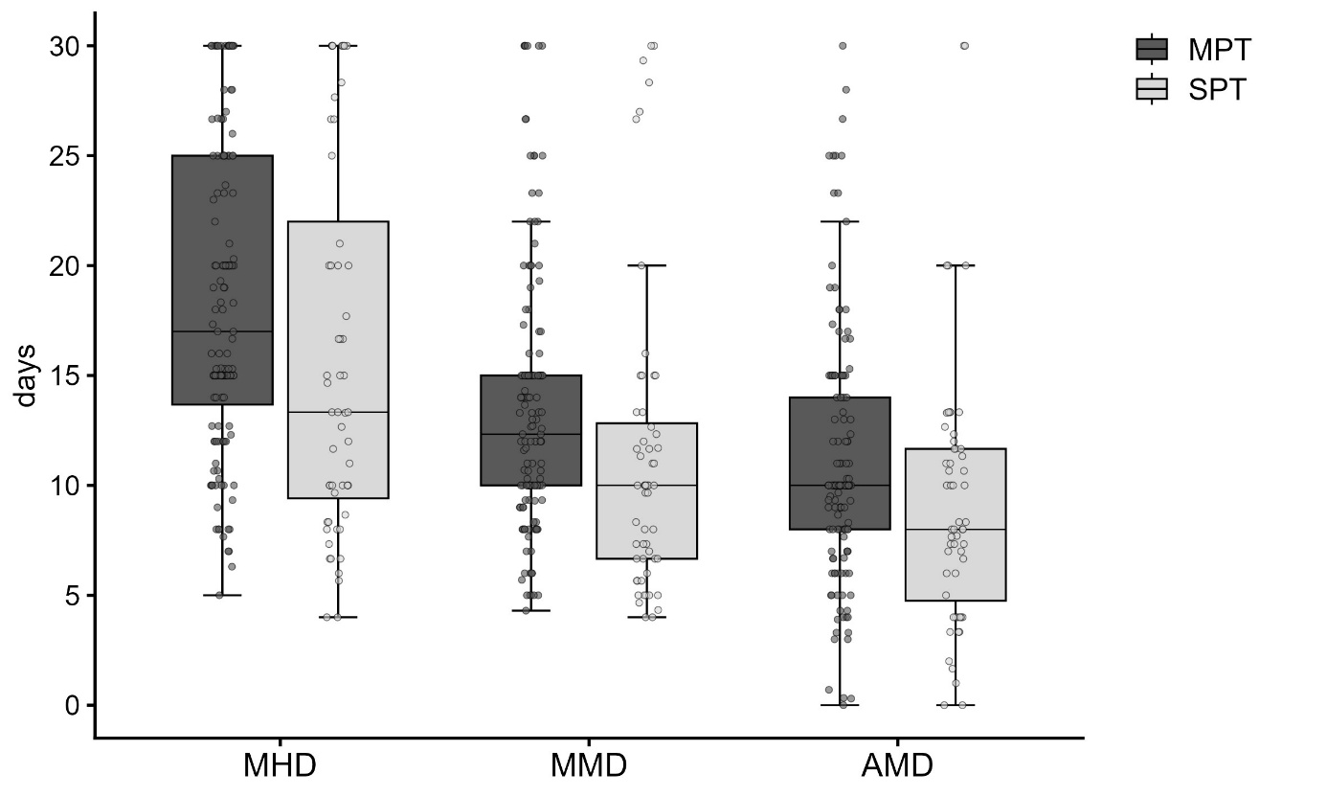
Figure S1: Baseline MHD, MMD and AMD of SPT and MPT group. (Abbreviations: AMD: Acute medication days, SPT: Single prior preventive therapy, MPT: Multiple prior preventive therapies, MHD: monthly headache days, MMD: monthly migraine days).

