Supplementary Materials

Method S1: Radiomic feature extraction
In this study, the original and derived MR images (images processed by laplacian of gaussian or wavelet filter) were used to extract radiomic features by using the open-source Pyradiomics package^{[1]}. The extraction parameters were as below:
Image types: ‘Original’, ‘LoG’, and ‘Wavelet’. LoG filter was used for image filtration with sigma of 2 mm, 4 mm, and 6 mm, respectively. Wavelet filter was applied to focus features on the different decomposition and approximation level of the original contoured volumes, and the bin width of which was set as 10.
Hyperparameter setting: ‘geometryTolerance’, ‘binWidth’, ‘interpolator’, and ‘resampledPixelSpacing’. The geometry tolerance was set as 1.00000e-4. Voxels in each volume were resampled to a unified voxel size of 1×1×1 mm³ using ‘sitkBSpline’ while the bin width was set as 25.
Feature groups: ‘shape-based features’, ‘first-order features’, ‘gray-level co-occurrence matrix (GLCM)’, ‘gray-level run length matrix (GLRLM)’, ‘gray-level size zone matrix (GLSZM)’, ‘gray-level dependence matrix (GLDM)’, and ‘neighbourhood gray-tone difference matrix (NGTDM)’. The radiomic feature group and their name are listed in Table S2. See https://pyradiomics.readthedocs.io for detailed feature descriptions and mathematical formulas.

References
1. van Griethuysen JJM, Fedorov A, Parmar C, et al. Computational Radiomics System to Decode the Radiographic Phenotype. Cancer Res. 2017;77(21):e104-e107.

Table S1 MR Imaging Acquisition
Parameters | Center 1 |  | Center 2 |  | Center 3 |  | Center 4
Parameters | DWI | ASL | DWI | ASL | DWI | ASL | DWI | ASL
TR (ms) | 2500 | 4560 | 2890 | 4142 | 3492 | 5000 | 4321 | 4642
TE (ms) | 65.5 | 10.5 | 96.7 | 11.6 | 80.9 | 13.8 | 77.9 | 10.7
Thickness (mm) | 5.0 | 4.0 | 5.5 | 6.0 | 5.0 | 4.0 | 5.0 | 4.0
FOV (cm×cm) | 24×24 | 24×24 | 23×23 | 24×24 | 23×23 | 22.4×22.4 | 24×24 | 24×24
Matrix | 256×256 | 128×128 | 152×122 | 128×128 | 144×100 | 100×64 | 256×256 | 128×128
PLD (ms) |  | 1525 |  | 2000 |  | 1800 |  | 1500
Note: Center 1, Discovery 750, GE Healthcare; Center 2, Ingenia, Philips Healthcare; Center 3, uMR790, United Imaging Healthcare; Center 4, Signa Architect, GE Healthcare.
Abbreviations: TR, repetition time; TE, echo time; FOV, field of view; PLD, post label delay.

Table S2 Types of the extracted radiomic features
Feature group | Number | Feature name | Feature name
Shape | 13 | Flatness | Mesh volume
Shape | 13 | Least axis length | Minor axis length
Shape | 13 | Major axis length | Sphericity
Shape | 13 | Maximum 2D diameter (Column) | Surface area
Shape | 13 | Maximum 2D diameter (Row) | Surface area to volume ratio
Shape | 13 | Maximum 2D diameter (Slice) | Voxel volume
Shape | 13 | Maximum 3D Diameter
First-order | 18 | 10th percentile | Median
First-order | 18 | 90th percentile | Minimum
First-order | 18 | Energy | Range
First-order | 18 | Entropy | Robust mean absolute deviation
First-order | 18 | Interquartile range | Root mean squared
First-order | 18 | Kurtosis | Skewness
First-order | 18 | Maximum | Total Energy
First-order | 18 | Mean absolute deviation | Uniformity
First-order | 18 | Mean | Variance
GLCM | 24 | Auto correlation | Inverse difference normalized
GLCM | 24 | Cluster prominence | Informational measure of correlation1
GLCM | 24 | Cluster shade | Informational measure of correlation2
GLCM | 24 | Cluster tendency | Inverse variance
GLCM | 24 | Contrast | Joint average
GLCM | 24 | Correlation | Joint energy
GLCM | 24 | Difference average | Joint entropy
GLCM | 24 | Difference entropy | Maximal correlation coefficient
GLCM | 24 | Difference variance | Maximum probability
GLCM | 24 | Inverse difference | Sum average
GLCM | 24 | Inverse difference moment | Sum entropy
GLCM | 24 | Inverse difference moment Normalized | Sum squares
GLRLM | 16 | Gray level non-uniformity | Run entropy
GLRLM | 16 | Gray level non-uniformity Normalized | Run length non-uniformity
GLRLM | 16 | Gray level variance | Run length non-uniformity Normalized
GLRLM | 16 | High gray level run emphasis | Run percentage
GLRLM | 16 | Long run emphasis | Run variance
GLRLM | 16 | Long run high gray level Emphasis | Short run emphasis
GLRLM | 16 | Long run low gray level Emphasis | Short run high gray level Emphasis
GLRLM | 16 | Low gray level run emphasis | Short run low gray level Emphasis
GLSZM | 16 | Gray level non-uniformity | Size-zone non-uniformity
GLSZM | 16 | Gray level non-uniformity Normalized | Size-zone non-uniformity Normalized
GLSZM | 16 | Gray level variance | Small area emphasis
GLSZM | 16 | High gray level zone emphasis | Small area high gray level Emphasis
GLSZM | 16 | Large area emphasis | Small area low gray level Emphasis
GLSZM | 16 | Large area high gray level Emphasis | Zone entropy
GLSZM | 16 | Large area low gray level Emphasis | Zone percentage
GLSZM | 16 | Low gray level zone emphasis | Zone variance
GLDM | 14 | Dependence entropy | Gray level non-uniformity
GLDM | 14 | Dependence non-uniformity | Gray level variance
GLDM | 14 | Dependence non-uniformity Normalized | High gray level Emphasis
GLDM | 14 | Dependence variance | Large dependence Emphasis
GLDM | 14 | Large dependence high gray level Emphasis | Large dependence low gray level Emphasis
GLDM | 14 | Low gray level Emphasis | Small dependence Emphasis
GLDM | 14 | Small dependence high gray level Emphasis | Small dependence low gray level Emphasis
NGTDM | 5 | Busyness | Contrast
NGTDM | 5 | Coarseness | Strength
NGTDM | 5 | Complexity
Abbreviations: GLCM, gray level co-occurrence matrix; GLRLM, gray level run length matrix; GLSZM, gray level size zone matrix; NGTDM, neighboring gray tone difference matrix.

Table S3 Representative radiomic features of the optimal radiomic models for each MRI sequence
MRI sequence | Radiomic features
 | original_glrlm_LongRunLowGrayLevelEmphasis
 | original_glszm_LargeAreaLowGrayLevelEmphasis
 | original_ngtdm_Busyness
 | log-sigma-5-0-mm-3D_glszm_GrayLevelNonUniformity
 | wavelet-LLH_firstorder_Maximum
 | wavelet-LLH_firstorder_RootMeanSquared
 | wavelet-LLH_glszm_ZonePercentage
 | wavelet-LLH_ngtdm_Contrast
 | wavelet-LHH_gldm_SmallDependenceLowGrayLevelEmphasis
 | wavelet-HLL_glszm_SizeZoneNonUniformity
 | wavelet-HLL_ngtdm_Busyness
 | wavelet-HLH_firstorder_InterquartileRange
 | wavelet-HLH_glrlm_LongRunLowGrayLevelEmphasis
 | wavelet-HLH_ngtdm_Coarseness
 | wavelet-LLL_glrlm_LongRunLowGrayLevelEmphasis
 | wavelet-LLL_glszm_LargeAreaLowGrayLevelEmphasis
ADC | log-sigma-3-0-mm-3D_glcm_Correlation
ADC | log-sigma-3-0-mm-3D_glszm_HighGrayLevelZoneEmphasis
ADC | log-sigma-5-0-mm-3D_firstorder_Skewness
ADC | wavelet-HLL_firstorder_Skewness
ADC | wavelet-HLL_glcm_DifferenceEntropy
ADC | wavelet-HLH_glcm_Imc2
ADC | wavelet-HHL_firstorder_Skewness
ADC | wavelet-LLL_gldm_SmallDependenceHighGrayLevelEmphasis
CBF | log-sigma-3-0-mm-3D_glrlm_ShortRunHighGrayLevelEmphasis
CBF | wavelet-LHH_firstorder_Maximum
CBF | wavelet-HLL_firstorder_Skewness

Table S4 Comparison of differences between AUCs of the prediction models
 | Model | Clinical model | DWI | ADC | CBF | Fusion radiomics model | Clinical-radiomics nomogram
Training cohort | Clinical model | - | - | - | - | - | -
Training cohort | DWI | 0.002 | - | - | - | - | -
Training cohort | ADC | <0.001 | 0.036 | - | - | - | -
Training cohort | CBF | 0.014 | 0.474 | 0.002 | - | - | -
Training cohort | Fusion radiomics model | <0.001 | <0.001 | <0.001 | <0.001 | - | -
Training cohort | Clinical-radiomics nomogram | <0.001 | <0.001 | <0.001 | <0.001 | 0.088 | -
Validation cohort | Clinical model | - | - | - | - | - | -
Validation cohort | DWI | <0.001 | - | - | - | - | -
Validation cohort | ADC | <0.001 | 0.665 | - | - | - | -
Validation cohort | CBF | <0.001 | 0.416 | 0.778 | - | - | -
Validation cohort | Fusion radiomics model | <0.001 | <0.001 | <0.001 | <0.001 | - | -
Validation cohort | Clinical-radiomics nomogram | <0.001 | <0.001 | <0.001 | <0.001 | 0.002 | -

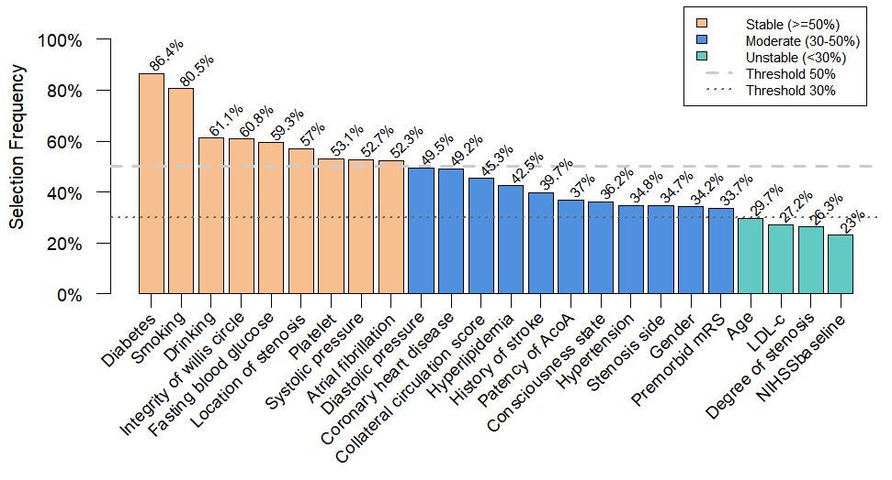
Fig. S1 Results of feature selection using LASSO regression combined with bootstrap resampling (1,000 iterations).
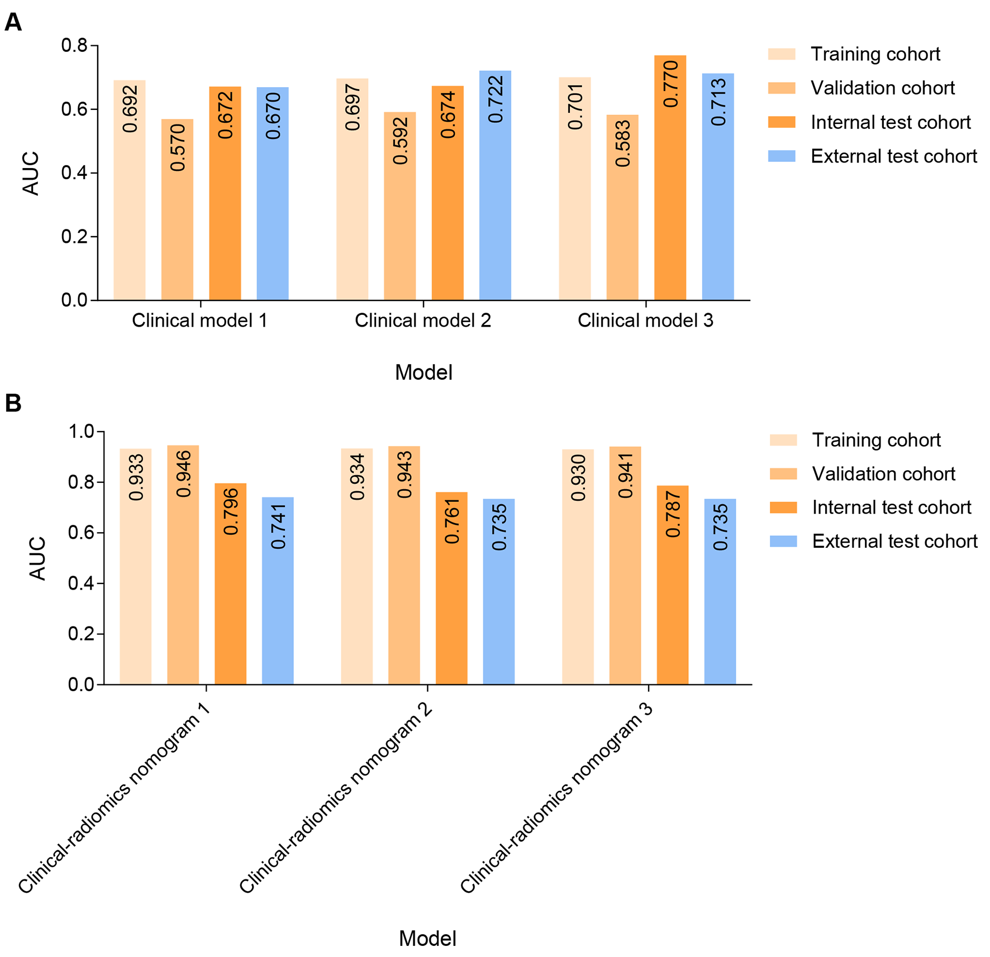
Fig. S2 Comparison of model predictive performance across different feature combinations. Clinical model 1. Clinical model 1 was constructed using diabetes and location of stenosis identified through logistic regression. Clinical model 2 incorporated NIHSS_{baseline} in addition to the features in Clinical model 1. Clinical model 3 further included age based on Clinical model 2. Clinical-radiomics nomogram 1, the optimal combined model in our manuscript, was constructed using diabetes, DWI-radscore, ADC-radscore, and CBF-radscore. Clinical-radiomics nomogram 2 added NIHSS_{baseline} to the features in Nomogram 1. Clinical-radiomics nomogram 3 further incorporated age based on Nomogram 2.

