Figure S1. Flow of the analytic sample. 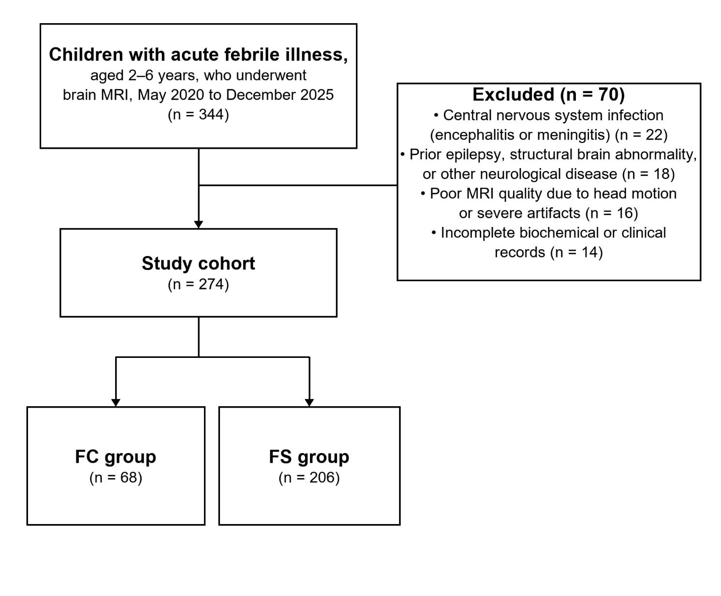
Figure S2. Age distribution of the analytic sample by integer year. (A) FC versus FS. (B) FC, simple FS, and complex FS.

Table S1. Full univariate results from age- and sex-adjusted general linear models.
Domain | Marker | FC | FS | Simple | Complex | q FS vs FC | q 3-group | q complex vs simple
Inflammation | CRP, mg/L | 7.98 ± 5.39 | 3.11 ± 1.77 | 3.41 ± 1.81 | 1.92 ± 0.94 | < 0.001 | < 0.001 | 0.029
Inflammation | ESR, mm/h | 18.81 ± 19.57 | 11.75 ± 6.87 | 12.25 ± 7.49 | 9.77 ± 2.58 | < 0.001 | < 0.001 | 0.19
Inflammation | IL-6, ng/L | 41.83 ± 49.70 | 51.27 ± 47.70 | 50.75 ± 49.32 | 53.36 ± 41.03 | 0.303 | 0.468 | 0.497
Coagulation | INR | 1.08 ± 0.11 | 1.10 ± 0.12 | 1.10 ± 0.12 | 1.11 ± 0.12 | 0.262 | 0.406 | 0.92
Coagulation | APTT, s | 37.96 ± 8.57 | 38.07 ± 6.66 | 38.42 ± 6.74 | 36.66 ± 6.20 | 0.863 | 0.572 | 0.692
Coagulation | Thrombin time, s | 15.70 ± 1.49 | 15.36 ± 1.49 | 15.39 ± 1.52 | 15.21 ± 1.39 | 0.262 | 0.406 | 0.692
Coagulation | Prothrombin activity, % | 93.69 ± 14.98 | 90.22 ± 13.89 | 90.01 ± 13.56 | 91.07 ± 15.30 | 0.251 | 0.406 | 0.995
Coagulation | PT, s | 12.88 ± 1.61 | 13.31 ± 1.59 | 13.31 ± 1.55 | 13.32 ± 1.76 | 0.251 | 0.406 | 0.995
Coagulation | Fibrinogen, g/L | 3.32 ± 0.89 | 3.28 ± 0.72 | 3.32 ± 0.73 | 3.12 ± 0.63 | 0.863 | 0.406 | 0.692
Coagulation | D-dimer, μg/mL (FEU) | 0.80 ± 1.55 | 1.02 ± 3.54 | 1.06 ± 3.76 | 0.86 ± 2.49 | 0.863 | 0.958 | 0.995
Immunity | C3, g/L | 0.96 ± 0.23 | 0.93 ± 0.19 | 0.94 ± 0.19 | 0.91 ± 0.20 | 0.621 | 0.645 | 0.439
Immunity | C4, g/L | 0.24 ± 0.09 | 0.24 ± 0.07 | 0.23 ± 0.06 | 0.25 ± 0.10 | 0.85 | 0.664 | 0.439
Immunity | IgA, g/L | 1.26 ± 0.76 | 0.85 ± 0.55 | 0.84 ± 0.57 | 0.88 ± 0.47 | < 0.001 | 0.002 | 0.439
Immunity | IgG, g/L | 9.40 ± 2.49 | 8.05 ± 2.18 | 7.83 ± 2.19 | 8.93 ± 1.92 | 0.003 | 0.002 | 0.25
Immunity | IgM, g/L | 1.34 ± 0.52 | 1.13 ± 0.43 | 1.14 ± 0.43 | 1.10 ± 0.43 | 0.024 | 0.054 | 0.439
Metabolic/hepatorenal | ALT, U/L | 18.04 ± 17.39 | 17.63 ± 20.69 | 17.39 ± 21.77 | 18.59 ± 15.83 | 0.999 | 0.989 | 0.79
Metabolic/hepatorenal | AST, U/L | 33.10 ± 11.07 | 39.03 ± 29.91 | 40.14 ± 32.41 | 34.59 ± 15.89 | 0.401 | 0.583 | 0.79
Metabolic/hepatorenal | Total bilirubin, μmol/L | 5.26 ± 3.17 | 5.07 ± 2.64 | 5.10 ± 2.61 | 4.97 ± 2.78 | 0.999 | 0.989 | 0.79
Metabolic/hepatorenal | Albumin, g/L | 42.15 ± 3.69 | 43.34 ± 3.38 | 43.14 ± 3.24 | 44.12 ± 3.85 | 0.16 | 0.063 | 0.205
Metabolic/hepatorenal | Creatinine, μmol/L | 33.38 ± 8.29 | 31.56 ± 6.99 | 31.02 ± 6.29 | 33.71 ± 9.07 | 0.999 | 0.989 | 0.943
Metabolic/hepatorenal | ALP, U/L | 177.63 ± 50.86 | 221.91 ± 198.75 | 207.60 ± 91.10 | 279.49 ± 405.19 | 0.397 | 0.063 | 0.169
Metabolic/hepatorenal | BUN, mmol/L | 3.93 ± 1.37 | 3.97 ± 1.16 | 3.92 ± 1.03 | 4.18 ± 1.58 | 0.999 | 0.583 | 0.509
Metabolic/hepatorenal | Uric acid, μmol/L | 237.84 ± 73.43 | 279.25 ± 97.78 | 280.29 ± 98.18 | 275.03 ± 97.27 | 0.039 | 0.063 | 0.943
Metabolic/hepatorenal | LDH, U/L | 284.37 ± 79.18 | 297.24 ± 91.70 | 301.73 ± 89.21 | 279.20 ± 100.25 | 0.999 | 0.989 | 0.849
Metabolic/hepatorenal | Sodium, mmol/L | 137.05 ± 2.53 | 136.59 ± 2.52 | 136.46 ± 2.50 | 137.13 ± 2.55 | 0.827 | 0.583 | 0.509
Metabolic/hepatorenal | Corrected calcium, mmol/L | 2.29 ± 0.10 | 2.32 ± 0.10 | 2.31 ± 0.09 | 2.32 ± 0.13 | 0.397 | 0.583 | 0.79
Metabolic/hepatorenal | Potassium, mmol/L | 4.30 ± 0.43 | 4.43 ± 0.45 | 4.43 ± 0.44 | 4.42 ± 0.48 | 0.401 | 0.583 | 0.79
Blood cells | White-cell count, ×10⁹/L | 8.85 ± 5.70 | 9.16 ± 5.26 | 9.49 ± 5.55 | 7.83 ± 3.63 | 0.794 | 0.162 | 0.45
Blood cells | Red-cell count, ×10¹²/L | 4.21 ± 0.41 | 4.39 ± 0.40 | 4.39 ± 0.39 | 4.38 ± 0.44 | 0.023 | 0.086 | 0.974
Blood cells | Monocytes, ×10⁹/L | 0.71 ± 0.43 | 0.72 ± 0.46 | 0.74 ± 0.47 | 0.66 ± 0.40 | 0.961 | 0.655 | 0.807
Blood cells | Lymphocytes, ×10⁹/L | 2.66 ± 1.78 | 2.01 ± 1.41 | 2.02 ± 1.48 | 1.95 ± 1.09 | 0.001 | 0.006 | 0.974
Blood cells | Basophils, ×10⁹/L | 0.02 ± 0.02 | 0.02 ± 0.02 | 0.02 ± 0.02 | 0.01 ± 0.01 | 0.113 | 0.162 | 0.639
Blood cells | Eosinophils, ×10⁹/L | 0.10 ± 0.14 | 0.04 ± 0.08 | 0.03 ± 0.08 | 0.06 ± 0.09 | < 0.001 | 0.002 | 0.639
Blood cells | Neutrophils, ×10⁹/L | 5.36 ± 5.04 | 6.76 ± 6.42 | 6.71 ± 5.30 | 6.98 ± 9.79 | 0.075 | 0.162 | 0.974
Blood cells | Hemoglobin, g/L | 116.22 ± 11.55 | 119.07 ± 9.29 | 119.01 ± 9.34 | 119.29 ± 9.17 | 0.075 | 0.162 | 0.974
Blood cells | Platelets, ×10⁹/L | 291.32 ± 100.45 | 264.33 ± 82.35 | 262.74 ± 81.69 | 270.76 ± 85.67 | 0.069 | 0.162 | 0.974
Hippocampal AI | Head AI | −0.06 ± 0.13 | −0.07 ± 0.18 | −0.07 ± 0.19 | −0.05 ± 0.11 | 0.966 | 0.813 | 0.531
Hippocampal AI | Body AI | 0.02 ± 0.16 | −0.01 ± 0.23 | −0.02 ± 0.25 | 0.02 ± 0.12 | 0.966 | 0.813 | 0.531
Hippocampal AI | Tail AI | −0.12 ± 0.23 | −0.14 ± 0.23 | −0.14 ± 0.24 | −0.11 ± 0.17 | 0.966 | 0.813 | 0.531
Note: q values are Benjamini–Hochberg FDR within domain. q values below 0.001 are reported as < 0.001. Means are mean ± SD.
Table S2. Domain PC1 eigenvalues on the pooled 2–6-year sample (correlation-matrix PCA).
Domain | n markers | PC1 eigenvalue | PC1 % variance
Inflammation | 3 | 1.243 | 41.4
Coagulation | 7 | 2.657 | 38.0
Immunity | 5 | 1.843 | 36.9
Metabolic/hepatorenal | 12 | 2.251 | 18.8
Blood cells | 9 | 2.828 | 31.4

Table S3. Marker loadings on domain PC1.
Domain | Marker | PC1 loading
Inflammation | CRP, mg/L | 0.545
Inflammation | ESR, mm/h | 0.748
Inflammation | IL-6, ng/L | −0.622
Coagulation | INR | −0.889
Coagulation | APTT, s | −0.326
Coagulation | Thrombin time, s | −0.161
Coagulation | Prothrombin activity, % | 0.936
Coagulation | PT, s | −0.903
Coagulation | Fibrinogen, g/L | −0.162
Coagulation | D-dimer, μg/mL (FEU) | −0.134
Immunity | C3, g/L | 0.680
Immunity | C4, g/L | 0.600
Immunity | IgA, g/L | 0.717
Immunity | IgG, g/L | 0.655
Immunity | IgM, g/L | 0.277
Metabolic/hepatorenal | ALT, U/L | 0.803
Metabolic/hepatorenal | AST, U/L | 0.914
Metabolic/hepatorenal | Total bilirubin, μmol/L | 0.132
Metabolic/hepatorenal | Albumin, g/L | −0.071
Metabolic/hepatorenal | Creatinine, μmol/L | −0.114
Metabolic/hepatorenal | ALP, U/L | −0.087
Metabolic/hepatorenal | BUN, mmol/L | 0.120
Metabolic/hepatorenal | Uric acid, μmol/L | 0.068
Metabolic/hepatorenal | LDH, U/L | 0.767
Metabolic/hepatorenal | Sodium, mmol/L | −0.242
Metabolic/hepatorenal | Corrected calcium, mmol/L | −0.106
Metabolic/hepatorenal | Potassium, mmol/L | 0.225
Blood cells | White-cell count, ×10⁹/L | 0.867
Blood cells | Red-cell count, ×10¹²/L | 0.211
Blood cells | Monocytes, ×10⁹/L | 0.769
Blood cells | Lymphocytes, ×10⁹/L | 0.390
Blood cells | Basophils, ×10⁹/L | 0.657
Blood cells | Eosinophils, ×10⁹/L | 0.241
Blood cells | Neutrophils, ×10⁹/L | 0.656
Blood cells | Hemoglobin, g/L | 0.099
Blood cells | Platelets, ×10⁹/L | 0.598
Note: The largest absolute loading in each domain is positive.

