Additional file 1: Supplementary figures and tables
Peak time of venous outflow: a reproducible CT perfusion marker independently associated with 90-day functional outcome after thrombectomy for anterior-circulation large-vessel occlusion in a retrospective cohort study
Supplementary Methods S1. Detailed CTP acquisition and PTV/ATV measurement protocol
CTP was acquired on a Siemens SOMATOM Force scanner (Siemens Healthineers, Forchheim, Germany) using the institutional stroke imaging protocol. The examination generally covered 30–40 dynamic phases at 1.5-second intervals. Acquisition parameters were rotation time 0.32 s, tube voltage 80–120 kV, tube current 80–150 mAs, 5.0-mm slice thickness, 3.0-mm reconstruction interval, 176-mm field of view, and an Hr36 convolution kernel. Iomeprol (Iomeron 370/400), 40–50 mL, was injected intravenously at 4.8–6.0 mL/s, followed by a 20–30 mL saline flush at the same rate; acquisition began after a 5-second delay. Images were postprocessed using Siemens perfusion software; the exact software version could not be retrieved retrospectively.
For PTV measurement, the superior sagittal sinus was assessed on axial CTP source images at the level where the lumen was continuously opacified and least affected by adjacent bone, partial-volume artifact, or venous confluence overlap. The ROI was placed centrally within the sinus lumen, avoiding the sinus wall and adjacent structures; its size was adjusted to remain fully intraluminal when the sinus caliber varied. PTV was defined as the interval from contrast injection to maximal venous contrast concentration. Two experienced radiologists independently and blindly measured PTV, and the arithmetic mean of their measurements was used for quartile grouping and regression analyses. For arterial normalization, the arterial ROI was placed at the terminal internal carotid artery and the venous ROI in the superior sagittal sinus; arterial and venous peak times were read directly from the software-generated time-density curves. The CTP post-processing output labelled CBF30 was defined as the volume of tissue with rCBF below 30% of the contralateral normal reference tissue and reported in mL; it was treated as an imaging-based estimate of ischemic-core volume rather than a histopathological measurement. The representative ROIs and curves are shown in Supplementary Fig. S2.
Quality control and missingness: during the initial quality screen, poor-quality CTP was defined operationally as motion artifact and/or incomplete bolus coverage that prevented reliable assessment of the time-density curve. When the venous curve or peak was uncertain, the reader repeated the ROI placement and curve review before accepting the measurement. A venous peak was accepted only when it occurred before the final acquisition phase and was followed by a descending limb on the time-density curve; five examinations with a truncated curve that did not capture the venous peak were excluded during cohort assembly. Arterial peak time was unavailable in 26 of 408 patients. The patient-level technical reason was not recorded in the retrospective source database and cannot be reconstructed. Among 382 technically measurable normalized values, the range was -2.330 to 22.900 s; after the pragmatic post hoc exclusion of 9 values <1 s, the primary normalized analysis included 373 patients with a range of 1.005 to 22.900 s. The 1-s rule was a pragmatic, post hoc technical-plausibility convention for flagging very small or negative arterial-to-venous peak-time differences in data acquired at 1.5s intervals. The acquisition interval provides context for timing uncertainty but does not uniquely justify a 1-s cutoff; the threshold was not prospectively specified or physiologically validated. The distribution of patients with unavailable ATV by occlusion site, eTICI status, and inclusion in the normalized analysis is summarized in Supplementary Table S11.
Supplementary Methods S2. eTICI coding and sensitivity analysis
In the primary multivariable logistic models, eTICI grades 0, 1, 2a, 2b, 2c, and 3 were coded 0–5 and entered as one numeric term. This specification assumes the same change in log odds between adjacent coded grades. For sensitivity analysis, the numeric term was replaced with an indicator for eTICI <2c versus ≥2c (near-complete or complete reperfusion), while all other covariates, outcome definitions, and 408 observations were retained. The numbers of patients/favorable outcomes for grades 0, 1, 2a, 2b, 2c, and 3 were 17/0, 3/1, 10/0, 68/24, 29/16, and 281/151, respectively. A fully categorical six-grade model was not used for inference because the eTICI 0 and 2a groups contained no favorable outcomes (90-day mRS 0–2), making separate coefficients unreliable.

Supplementary Figure S1. The Flowchart
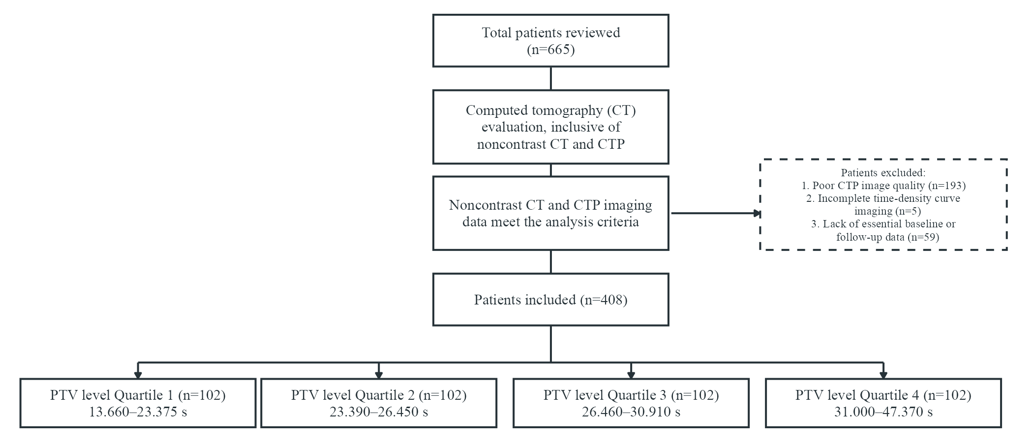

Supplementary Figure S2. Methodology for quantifying PTV using CT perfusion time-density curve analysis. (a) genu of corpus callosum level; (b) lateral ventricle body level with superior sagittal sinus ROI (arrow); (c) arterial and venous time-density curves, peak time read directly from the CT perfusion software.
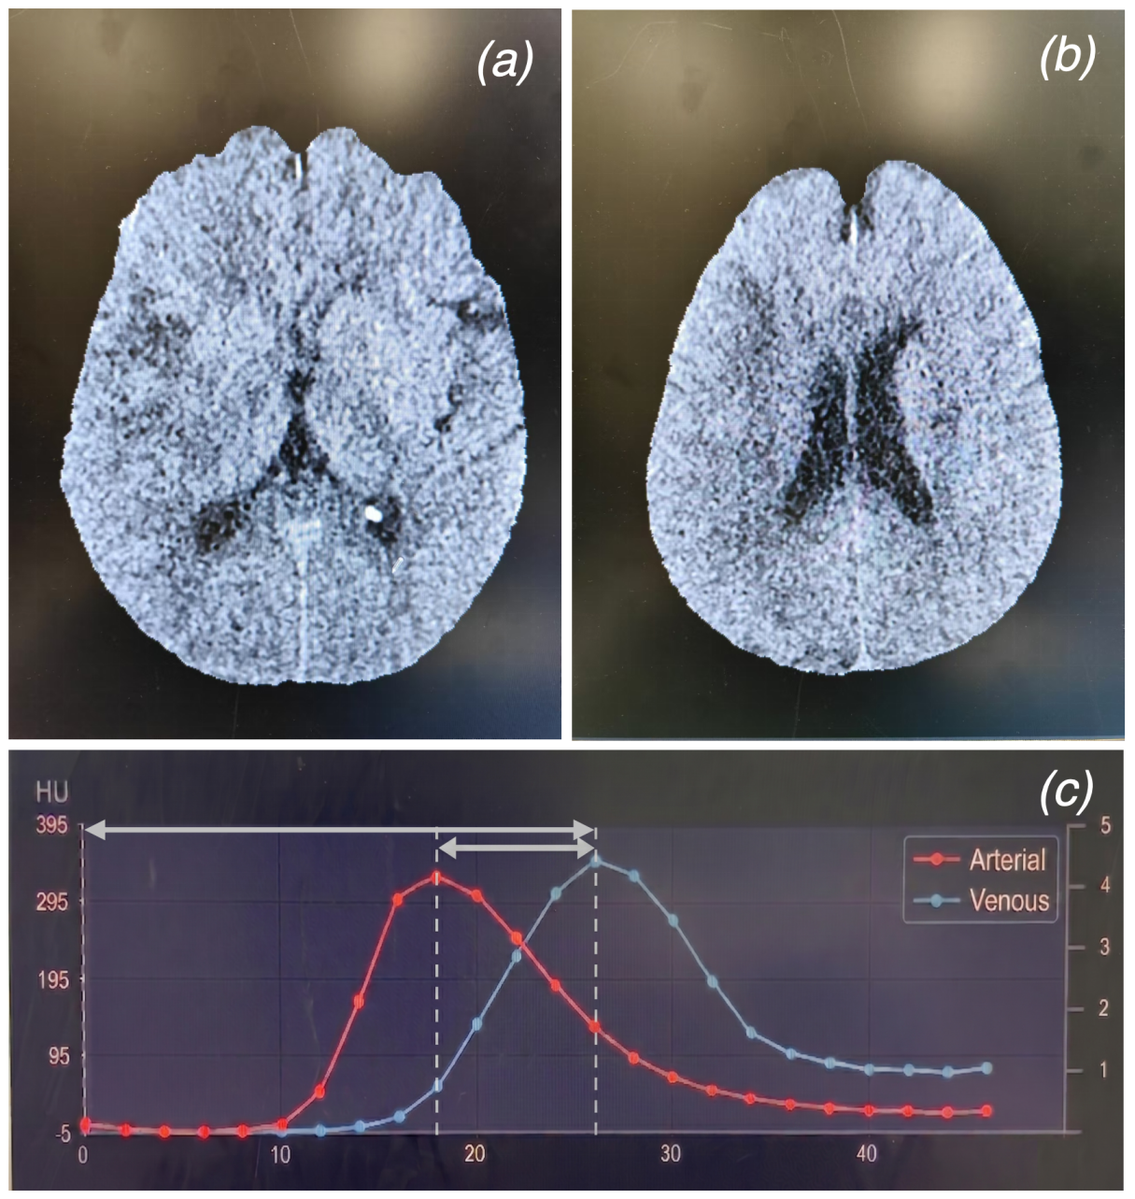

Supplementary Table S1. Univariate and Multivariate Logistic Regression Analysis of 90-Day Modified Rankin Scale (mRS) 0-2 Outcomes - Basic Adjusted Model
Variable | Unadjusted OR  (95% CI) | P value | Adjusted OR  (95% CI) | P value
PTV Continuous | 0.94 (0.904-0.970) | <0.001 | 0.95 (0.902-0.992) | 0.022
PTV Quartile 1 | Reference | Reference | Reference | Reference
Quartile 2 | 0.60 (0.344-1.041) | 0.069 | 0.66 (0.338-1.301) | 0.232
Quartile 3 | 0.65 (0.372-1.126) | 0.123 | 0.85 (0.430-1.674) | 0.636
Quartile 4 | 0.38 (0.217-0.672) | <0.001 | 0.45 (0.208-0.967) | 0.041
Sex | 1.22 (0.819-1.822) | 0.327
Age | 0.96 (0.947-0.980) | <0.001 | 0.96 (0.942-0.984) | <0.001
Hypertension | 0.78 (0.528-1.161) | 0.224
Diabetes | 0.46 (0.273-0.776) | 0.004 | 0.36 (0.192-0.675) | 0.001
Hyperlipemia | 1.26 (0.687-2.296) | 0.458
Atrial Fibrillation | 0.67 (0.442-1.007) | 0.054 | 0.89 (0.421-1.869) | 0.753
History of Stroke | 1.06 (0.620-1.829) | 0.820
Baseline SBP | 0.99 (0.981-0.997) | 0.007
Baseline DBP | 0.99 (0.983-1.006) | 0.339
Baseline NIHSS | 0.91 (0.877-0.940) | <0.001 | 0.93 (0.895-0.975) | 0.002
Baseline ASPECTS | 1.32 (1.203-1.459) | <0.001 | 1.38 (1.226-1.550) | <0.001
NIHSS from baseline 24 at hours | 0.80 (0.768-0.842) | <0.001
NIHSS at 5-7 days or early discharge
TOAST LAA | Reference | Reference | Reference | Reference
CE | 1.02 (0.668-1.564) | 0.919 | 1.91 (0.893-4.081) | 0.095
Other or unknown | 1.62 (0.856-3.054) | 0.138 | 1.71 (0.772-3.782) | 0.186
Intravenous Thrombolysis | 0.83 (0.549-1.246) | 0.364
Occlusion site ICA | Reference | Reference | Reference | Reference
MCA-M1 | 1.29 (0.811-2.061) | 0.280 | 0.91 (0.517-1.592) | 0.734
MCA-M2 | 2.18 (1.151-4.148) | 0.017 | 1.74 (0.802-3.755) | 0.161
Tan ≥ 50% | 3.66 (2.427-5.513) | <0.001
HIR ≤ 0.4 | 2.05 (1.348-3.114) | <0.001
eTICI | 1.69 (1.378-2.075) | <0.001 | 1.77 (1.387-2.248) | <0.001
Onset to Puncture time | 1.00 (1.000-1.001) | 0.154
Treatment workflow time | 1.00 (0.999-1.001) | 0.853 | 1.00 (0.999-1.001) | 0.860
Puncture to procedure-end workflow time | 1.00 (0.998-1.001) | 0.500
Adjusted for age, atrial fibrillation, diabetes, TOAST, occlusion site, baseline ASPECTS, baseline NIHSS, treatment workflow time (TWT) and eTICI score
Abbreviations: PTV = peak time of venous outflow; NIHSS = National Institutes of Health Stroke Scale; ASPECTS = Alberta Stroke Program Early CT Score; TOAST = Trial of ORG 10172 in Acute Stroke Treatment; LAA = large-artery atherosclerosis; CE = cardioembolism; eTICI = expanded Treatment in Cerebral Infarction; SBP = systolic blood pressure; DBP = diastolic blood pressure; ICA = internal carotid artery; MCA = middle cerebral artery.

Supplementary Table S2. Univariate and Multivariate Logistic Regression Analysis of 90-Day Modified Rankin Scale(mRS) 0-2 Outcomes-Extended Model Including Collateral Variables
Variable | Unadjusted OR (95% CI) | P value | Adjusted OR (95% CI) | P value
PTV Continuous | 0.94 (0.904-0.970) | <0.001 | 0.94 (0.895-0.990) | 0.019
PTV Quartile 1 | Reference | Reference | Reference | Reference
Quartile 2 | 0.60 (0.344-1.041) | 0.069 | 0.61 (0.304-1.238) | 0.173
Quartile 3 | 0.65 (0.372-1.126) | 0.123 | 0.66 (0.321-1.338) | 0.246
Quartile 4 | 0.38 (0.217-0.672) | <0.001 | 0.41 (0.183-0.911) | 0.029
Sex | 1.22 (0.819-1.822) | 0.327
Age | 0.96 (0.947-0.980) | <0.001 | 0.96 (0.937-0.982) | <0.001
Hypertension | 0.78 (0.528-1.161) | 0.224
Diabetes | 0.46 (0.273-0.776) | 0.004 | 0.37 (0.190-0.716) | 0.003
Hyperlipemia | 1.26 (0.687-2.296) | 0.458
Atrial Fibrillation | 0.67 (0.442-1.007) | 0.054 | 0.94 (0.414-2.114) | 0.873
History of Stroke | 1.06 (0.620-1.829) | 0.820
Baseline SBP | 0.99 (0.981-0.997) | 0.007
Baseline DBP | 0.99 (0.983-1.006) | 0.339
Baseline NIHSS | 0.91 (0.877-0.940) | <0.001 | 0.94 (0.901-0.985) | 0.009
Baseline ASPECTS | 1.32 (1.203-1.459) | <0.001 | 1.31 (1.152-1.484) | <0.001
NIHSS from baseline 24 at hours | 0.80 (0.768-0.842) | <0.001
NIHSS at 5-7 days or early discharge
TOAST LAA | Reference | Reference | Reference | Reference
CE | 1.02 (0.668-1.564) | 0.919 | 1.52 (0.674–3.413) | 0.314
Other or unknown | 1.62 (0.856-3.054) | 0.138 | 1.60 (0.691–3.714) | 0.272
Intravenous Thrombolysis | 0.83 (0.549-1.246) | 0.364
Occlusion site ICA | Reference | Reference | Reference | Reference
MCA-M1 | 1.29 (0.811-2.061) | 0.28 | 0.96 (0.534–1.713) | 0.880
MCA-M2 | 2.18 (1.151-4.148) | 0.017 | 1.59 (0.712–3.559) | 0.257
Tan ≥ 50% | 3.66 (2.427-5.513) | <0.001 | 2.82 (1.641–4.859) | <0.001
HIR ≤ 0.4 | 2.05 (1.348-3.114) | <0.001 | 0.82 (0.465–1.441) | 0.488
eTICI | 1.69 (1.378-2.075) | <0.001 | 1.71 (1.325–2.205) | <0.001
Onset to Puncture time | 1.00 (1.000-1.001) | 0.154
Treatment workflow time | 1.00 (0.999-1.001) | 0.853 | 1.00 (0.999-1.000) | 0.389
Puncture to procedure-end workflow time | 1.00 (0.998-1.001) | 0.500
Adjusted for age, atrial fibrillation, diabetes, TOAST, occlusion site, baseline ASPECTS, baseline NIHSS, treatment workflow time (TWT) and eTICI score, Tan ≥ 50%, HIR ≤ 0.4
Abbreviations: PTV = peak time of venous outflow; NIHSS = National Institutes of Health Stroke Scale; ASPECTS = Alberta Stroke Program Early CT Score; TOAST = Trial of ORG 10172 in Acute Stroke Treatment; LAA = large-artery atherosclerosis; CE = cardioembolism; eTICI = expanded Treatment in Cerebral Infarction; SBP = systolic blood pressure; DBP = diastolic blood pressure; ICA = internal carotid artery; MCA = middle cerebral artery

Supplementary Figure S3. Restricted cubic spline (RCS) curve of the peak time of venous outflow (PTV) and the odds ratio of mRS 0-2 at 90 days.
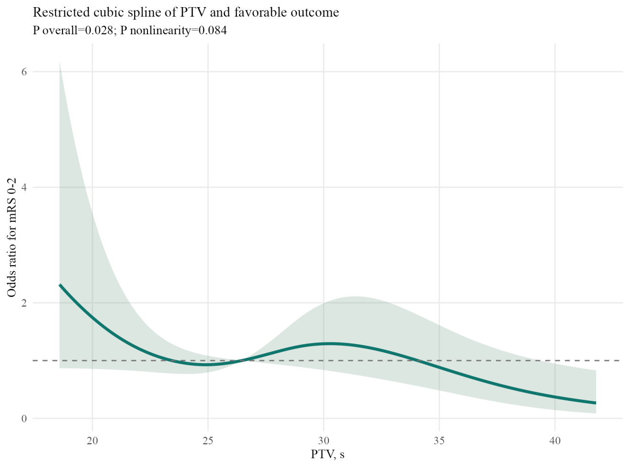
Adjusted for age, atrial fibrillation, diabetes, TOAST, occlusion site, baseline ASPECTS, baseline NIHSS, treatment workflow time (TWT) and eTICI score.

Supplementary Figure S4. Exploratory interaction plots for the peak time of venous outflow (PTV) with hypoperfusion intensity ratio (HIR) and modified Tan collateral status.

Supplementary Table S3. Continuous mean PTV associations and sensitivity analyses
Outcome | Model | N | OR per 1-s PTV increase (95% CI) | P value
Favorable outcome (mRS 0-2) | Unadjusted | 408 | 0.94 (0.904-0.970) | <0.001
Favorable outcome (mRS 0-2) | Adjusted | 408 | 0.95 (0.902-0.992) | 0.022
Favorable outcome (mRS 0-2) | Extended | 384 | 0.94 (0.895-0.990) | 0.019
Excellent outcome (mRS 0-1) | Unadjusted | 408 | 0.96 (0.927-0.999) | 0.044
Excellent outcome (mRS 0-1) | Adjusted | 408 | 0.98 (0.936-1.032) | 0.489
Excellent outcome (mRS 0-1) | Extended | 384 | 0.98 (0.934-1.034) | 0.505
Functional independence/better  (mRS 0-3) | Unadjusted | 408 | 0.95 (0.919-0.984) | 0.004
Functional independence/better  (mRS 0-3) | Adjusted | 408 | 0.97 (0.931-1.022) | 0.298
Functional independence/better  (mRS 0-3) | Extended | 384 | 0.98 (0.934-1.031) | 0.448
90-day mortality | Unadjusted | 408 | 1.06 (1.017-1.100) | 0.005
90-day mortality | Adjusted | 408 | 1.04 (0.989-1.101) | 0.120
90-day mortality | Extended | 384 | 1.04 (0.983-1.096) | 0.181
Symptomatic intracranial hemorrhage | Unadjusted | 408 | 1.06 (1.010-1.117) | 0.019
Symptomatic intracranial hemorrhage | Adjusted | - | - | -
Symptomatic intracranial hemorrhage | Extended | - | - | -
Any intracranial hemorrhage | Unadjusted | 408 | 1.07 (1.035-1.112) | <0.001
Any intracranial hemorrhage | Adjusted | 408 | 1.06 (1.012-1.106) | 0.012
Any intracranial hemorrhage | Extended | 384 | 1.05 (1.003-1.098) | 0.036
Malignant cerebral edema | Unadjusted | 399 | 1.04 (0.996-1.080) | 0.076
Malignant cerebral edema | Adjusted | - | - | -
Malignant cerebral edema | Extended | - | - | -
The adjusted model included age, atrial fibrillation, diabetes, TOAST, occlusion site, baseline ASPECTS, baseline NIHSS, treatment workflow time (TWT), and eTICI score. The extended model additionally included modified Tan collateral status and hypoperfusion intensity ratio (HIR). The unadjusted model included PTV alone. PTV was calculated as the arithmetic mean of two independent blinded reader measurements. Conventional adjusted and extended logistic regression models were not fitted for sICH and MCE because the numbers of events were limited relative to the number of model parameters. Firth-penalized sensitivity analyses are reported in Supplementary Table S14.

Supplementary Table S4. Ordinal mRS shift analysis
Term | Common OR for worse mRS (95% CI) | P value
Unadjusted model
Q1 | Reference | Reference
Q2 | 1.13 (0.70-1.84) | 0.608
Q3 | 1.24 (0.77-2.00) | 0.383
Q4 | 2.02 (1.24-3.31) | 0.005
Per 1-s increase in PTV | 1.05 (1.02-1.09) | <0.001
Adjusted model
Q1 | Reference | Reference
Q2 | 0.87 (0.53-1.45) | 0.599
Q3 | 0.81 (0.48-1.36) | 0.417
Q4 | 1.31 (0.73-2.36) | 0.367
Per 1-s increase in PTV | 1.03 (1.00-1.07) | 0.091
Common odds ratios are from proportional-odds ordinal logistic regression across the full 90-day mRS 0-6 range (n = 408; 102 per quartile). An odds ratio greater than 1 denotes a shift toward a worse (higher) mRS score. Adjusted models included age, atrial fibrillation, diabetes, TOAST subtype, occlusion site, baseline ASPECTS, baseline NIHSS, treatment workflow time (TWT) and eTICI score. The proportional-odds assumption was not violated (likelihood-ratio test against an unconstrained multinomial model: quartile model P = 0.24; continuous model P = 0.39).

Supplementary Table S5. Collateral-pattern stratified analyses
 | Tan+HIR+ | (n=152) | Tan&HIRmixed | (n=120) | Tan-HIR- | (n=112)
 | aOR(95% CI)* | P value | aOR* | P value | aOR* | P value
Primary Outcome
mRS 0-2 | 0.90 (0.831-0.982) | 0.017 | 0.96 (0.870-1.055) | 0.382 | 0.89 (0.784-1.017) | 0.087
Secondary outcomes
90 days mRS | 1.06 (0.999-1.129) | 0.050 | 1.05 (0.970-1.131) | 0.24 | 1.05 (0.983-1.128) | 0.140
mRS 0-1 | 0.96 (0.890-1.043) | 0.357 | 1.00 (0.903-1.103) | 0.967 | 0.96 (0.845-1.097) | 0.570
mRS 0-3 | 0.93 (0.848-1.026) | 0.150 | 1.02 (0.918-1.129) | 0.74 | 0.93 (0.851-1.026) | 0.153
Safety outcomes
Mortality | 1.11 (0.971-1.264) | 0.129 | 1.19 (1.037-1.361) | 0.013 | 1.05 (0.960-1.150) | 0.281
sICH (model not fitted) | - | - | - | - | - | -
anyICH | 1.07 (0.974-1.174) | 0.161 | 1.03 (0.931-1.141) | 0.559 | 1.01 (0.938-1.093) | 0.751
*Adjusted for age, atrial fibrillation, diabetes, TOAST, occlusion site, baseline ASPECTS, baseline NIHSS, treatment workflow time, and eTICI score. The sICH model was not fitted within the collateral-pattern strata because of sparse events; this endpoint is exploratory.
Abbreviations: OR, odds ratio.

Supplementary Table S6. Mean PTV and COVES interobserver agreement
Measure | Value | N
Mean PTV interobserver ICC (absolute agreement, single measures) | 0.956 | 408.0
Mean difference reader2-reader1 (s) | -0.17
Mean absolute difference (s) | 0.91
Pearson correlation | 0.957
COVES interobserver agreement | quadratic-weighted kappa=0.95; ICC 0.95 | 387

Supplementary Table S7. Sensitivity analysis using arterially normalized mean PTV (mean venous peak time minus arterial peak time; 382 technically measurable values ranged from -2.330 to 22.900 s; the primary analysis excluded 9 values <1 s and included 373 patients with a range of 1.005 to 22.900 s)
Model | N | OR (95% CI) | P value
Unadjusted | 373 | 0.93 (0.875-0.978) | 0.006
Main adjusted | 373 | 0.91 (0.848-0.982) | 0.015
Extended model (additionally adjusted for Tan and HIR) | 360 | 0.91 (0.843-0.984) | 0.017
Adjusted Q4 vs Q1 | 373 | 0.36 (0.167-0.786) | 0.010
Adjusted models included age, atrial fibrillation, diabetes, TOAST subtype, occlusion site, baseline ASPECTS, baseline NIHSS, treatment workflow time (TWT), and eTICI score.

Supplementary Table S8. Progressive adjustment analyses for the primary outcome (mRS 0-2 at 90 days) using arithmetic-mean PTV
Outcomes | PTV levels | Unadjusted OR (95% CI) | P | Model 1 OR (95% CI)ª | P | Model 2 OR (95% CI)^{b} | P | Model 3 OR (95% CI)^{c} | P | Model 4 OR (95% CI)^{d} | P
mRS 0-2 | Continuous | 0.94 (0.904-0.970) | <0.001 | 0.95 (0.911-0.989) | 0.013 | 0.95 (0.909-0.996) | 0.035 | 0.95 (0.902-0.992) | 0.022 | 0.94 (0.895-0.990) | 0.019
 | Quartile 1 | Reference |  | Reference |  | Reference |  | Reference |  | Reference
 | Quartile 2 | 0.60 (0.344-1.041) | 0.069 | 0.67 (0.379-1.200) | 0.180 | 0.64 (0.333-1.213) | 0.169 | 0.66 (0.338-1.301) | 0.232 | 0.61 (0.304-1.238) | 0.173
 | Quartile 3 | 0.65 (0.372-1.126) | 0.123 | 0.75 (0.415-1.350) | 0.336 | 0.91 (0.473-1.742) | 0.771 | 0.85 (0.430-1.674) | 0.636 | 0.66 (0.321-1.338) | 0.246
 | Quartile 4 | 0.38 (0.217-0.672) | <0.001 | 0.50 (0.258-0.966) | 0.039 | 0.49 (0.232-1.019) | 0.056 | 0.45 (0.208-0.967) | 0.041 | 0.41 (0.183-0.911) | 0.029
ª Adjusted for age, atrial fibrillation, diabetes
^{b} Adjusted for age, atrial fibrillation, diabetes, TOAST, occlusion, ASPECTS, NIHSS
^{c} Adjusted for age, atrial fibrillation, diabetes, TOAST, occlusion, ASPECTS, NIHSS, TWT, eTICI
^{d} Adjusted for age, atrial fibrillation, diabetes, TOAST, occlusion, ASPECTS, NIHSS, TWT, eTICI, Tan ≥ 50%, HIR ≤ 0.4
Abbreviations: OR, odds ratio; PTV = peak time of venous outflow; NIHSS = National Institutes of Health Stroke Scale; ASPECTS = Alberta Stroke Program Early CT Score; TOAST = Trial of ORG 10172 in Acute Stroke Treatment; eTICI = expanded Treatment in Cerebral Infarction. In the full cohort, treatment workflow time (TWT) was measured from symptom onset to the first angiographic demonstration of successful reperfusion for patients with eTICI ≥2b (n=378), or to the final angiographic run, used as the procedure-completion time, for patients with final eTICI <2b (n=30). The latter values do not represent successful reperfusion times.

Supplementary Figure S5. Subgroup analyses of the association between the peak time of venous outflow and mRS 0-2 at 90 days.
Adjusted for age, atrial fibrillation, diabetes, TOAST, occlusion, ASPECTS, NIHSS, TWT, eTICI
Forest plot showing adjusted odds ratios (ORs) with 95% confidence intervals (CIs) for the association between PTV (analyzed as a continuous variable) and favorable functional outcome (90-day mRS 0-2) across different subgroups.
Abbreviations: NIHSS = National Institutes of Health Stroke Scale; ASPECTS = Alberta Stroke Program Early CT Score; TOAST = Trial of ORG 10172 in Acute Stroke Treatment; LAA = large-artery atherosclerosis; CE = cardioembolism; ICA = internal carotid artery; MCA = middle cerebral artery; TWT = treatment workflow time.

14.Supplementary Table S9. Full distribution of the 90-day modified Rankin Scale (mRS 0-6) by mean PTV quartile
PTV quartile | mRS 0 | mRS 1 | mRS 2 | mRS 3 | mRS 4 | mRS 5 | mRS 6 | Total
Q1 | 15 (14.7) | 21 (20.6) | 24 (23.5) | 7 (6.9) | 13 (12.7) | 4 (3.9) | 18 (17.6) | 102
Q2 | 16 (15.7) | 19 (18.6) | 12 (11.8) | 21 (20.6) | 9 (8.8) | 8 (7.8) | 17 (16.7) | 102
Q3 | 12 (11.8) | 18 (17.6) | 19 (18.6) | 20 (19.6) | 8 (7.8) | 5 (4.9) | 20 (19.6) | 102
Q4 | 10 (9.8) | 16 (15.7) | 10 (9.8) | 16 (15.7) | 12 (11.8) | 7 (6.9) | 31 (30.4) | 102
Data are n (%) within each quartile; percentages are row-wise and may not sum to 100.0 because of rounding. Quartiles were defined on the two-reader arithmetic-mean PTV using dplyr::ntile(PTV_mean, 4) after ranking values in ascending order. Tied values, if any, were resolved sequentially by ascending original source-file number (the locked CSV row order). Q1 comprised ranks 1–102, Q2 ranks 103–204, Q3 ranks 205–306, and Q4 ranks 307–408. No tied value occurred at an observed transition; the observed group-transition pairs were 23.375/23.390, 26.450/26.460, and 30.910/31.000 s. The interpolated sample quartile positions were 23.38625, 26.45500, and 30.93250 s; these were descriptive only and were not used as overlapping cut points. Higher mRS scores denote worse outcome. No 90-day mRS values were missing. This table accompanies the ordinal shift analysis in Supplementary Table S4.
Abbreviations: PTV = peak time of venous outflow; mRS = modified Rankin Scale.

15.Supplementary Table S10. Collinearity diagnostics for the main adjusted model
Covariate | GVIF | df | GVIF^(1/(2·df))
Mean PTV | 1.376 | 1 | 1.173
Age | 1.237 | 1 | 1.112
Atrial fibrillation | 2.401 | 1 | 1.550
Diabetes | 1.068 | 1 | 1.034
TOAST subtype | 2.627 | 2 | 1.273
Occlusion site | 1.086 | 2 | 1.021
Baseline ASPECTS | 1.164 | 1 | 1.079
Baseline NIHSS | 1.159 | 1 | 1.076
TWT | 1.185 | 1 | 1.089
eTICI | 1.034 | 1 | 1.017
Generalised variance inflation factors (GVIF) for the main adjusted model of favorable outcome (mRS 0-2 at 90 days; n = 408, 192 events). For multi-category variables the adjusted measure GVIF^(1/(2·df)) is comparable to the square root of a conventional VIF, so a value of 1.00 indicates no inflation. All adjusted values were below 1.60, including the atrial fibrillation and TOAST subtype terms queried during review (1.550 and 1.273, respectively). No evidence of problematic collinearity was found.
Abbreviations: PTV = peak time of venous outflow; ASPECTS = Alberta Stroke Program Early CT Score; NIHSS = National Institutes of Health Stroke Scale; TWT = treatment workflow time; eTICI = expanded Treatment in Cerebral Infarction; GVIF = generalised variance inflation factor; df = degrees of freedom.

16.Supplementary Table S11. Baseline, treatment, and outcome comparison of patients included in versus excluded from the arterially normalized mean PTV analysis
Variable | Included (n=373) | Excluded (n=35) | P value
Age, years, median (IQR) | 68.0 (58.0, 76.0) | 66.0 (58.5, 74.0) | 0.478
Baseline SBP, mmHg, median (IQR) | 141.0 (127.0, 160.0) | 142.0 (131.5, 160.0) | 0.738
Baseline DBP, mmHg, median (IQR) | 84.0 (74.0, 95.0) | 81.0 (80.0, 97.5) | 0.509
Baseline NIHSS, median (IQR) | 14.0 (10.0, 19.0) | 15.0 (9.5, 17.0) | 0.761
Baseline ASPECTS, median (IQR) | 7.0 (6.0, 8.0) | 7.0 (6.0, 9.0) | 0.921
Onset to puncture time, min, median (IQR) | 375.0 (227.0, 580.0) | 530.0 (296.0, 740.0) | 0.015
Treatment workflow time, min, median (IQR) | 496.0 (345.0, 722.0) | 605.0 (414.0, 808.5) | 0.104
Mean PTV, s, median (IQR) | 26.6 (23.5, 31.0) | 25.7 (21.9, 30.2) | 0.152
Male sex, n (%) | 228/373 (61.1) | 21/35 (60.0) | 0.896
Hypertension, n (%) | 210/373 (56.3) | 26/35 (74.3) | 0.039
Diabetes, n (%) | 68/373 (18.2) | 10/35 (28.6) | 0.137
Atrial fibrillation, n (%) | 133/373 (35.7) | 10/35 (28.6) | 0.401
Previous ischemic stroke, n (%) | 59/373 (15.8) | 3/35 (8.6) | 0.254
Intravenous thrombolysis, n (%) | 132/373 (35.4) | 9/35 (25.7) | 0.250
eTICI ≥2b, n (%) | 346/373 (92.8) | 32/35 (91.4) | 0.773
Favorable outcome (mRS 0-2), n (%) | 177/373 (47.5) | 15/35 (42.9) | 0.602
Any intracranial hemorrhage, n (%) | 122/373 (32.7) | 9/35 (25.7) | 0.397
90-day death, n (%) | 79/373 (21.2) | 7/35 (20.0) | 0.870
Occlusion site, n (%) |  |  | 0.286
ICA | 97/373 (26.0) | 7/35 (20.0)
MCA-M1 | 217/373 (58.2) | 25/35 (71.4)
MCA-M2 | 59/373 (15.8) | 3/35 (8.6)
Of 408 patients, arterial peak time (ATV) was unavailable in 26 and a further 9 had an arterially normalized value below the 1-second technical plausibility threshold, leaving 373 patients in the primary normalized analysis and 35 excluded. The 382 technically measurable normalized values ranged from -2.330 to 22.900 s; the 373-value primary analysis ranged from 1.005 to 22.900 s (median 7.700 s; IQR 5.045-9.995 s). The 1-s rule was a pragmatic, post hoc technical-plausibility convention for flagging very small or negative arterial-to-venous peak-time differences in data acquired at 1.5-s intervals. The acquisition interval provides context for timing uncertainty but does not uniquely justify a 1-s cutoff; the threshold was not prospectively specified or physiologically validated. Among the 26 patients without a recorded ATV, 24 achieved eTICI ≥2b reperfusion and the occlusion sites were 5 internal carotid artery, 20 MCA-M1, and 1 MCA-M2, so the missingness was not confined to proximal occlusion or to unsuccessful reperfusion. Continuous variables were compared with the Mann-Whitney U test and categorical variables with the Pearson chi-square test; no correction for multiple comparisons was applied and these comparisons are descriptive.
The two groups were similar for demographic, clinical-severity, imaging, reperfusion, and 90-day outcome variables. Two differences reached nominal significance: excluded patients had a longer onset-to-puncture time (median 530.0 vs 375.0 minutes; P=0.015) and a higher prevalence of hypertension (74.3% vs 56.3%; P=0.039). Because ATV availability reflects whether the arterial time-density-curve output was preserved and exported rather than any clinical criterion, and because the missingness mechanism cannot be reconstructed retrospectively, residual selection bias in the normalized analysis cannot be excluded.
Abbreviations: ASPECTS = Alberta Stroke Program Early CT Score; ATV = arterial peak time; DBP = diastolic blood pressure; eTICI = expanded Treatment in Cerebral Infarction; ICA = internal carotid artery; IQR = interquartile range; MCA = middle cerebral artery; mRS = modified Rankin Scale; NIHSS = National Institutes of Health Stroke Scale; PTV = peak time of venous outflow; SBP = systolic blood pressure.
Endpoint assessment and adjudication: eTICI was taken from the routine angiographic grade documented by the treating neurointerventional team in the source DSA procedural record and was abstracted by study investigators; no independent central re-adjudication was performed. Any ICH and sICH were determined from routine post-treatment imaging and clinical documentation according to the modified Heidelberg classification, and MCE was determined from routine follow-up imaging using the study criteria; these endpoints were abstracted by investigators. The PTV readers were blinded to clinical outcomes and did not participate in 90-day outcome assessment. Modified Tan collateral status was independently assessed by Chen Gong and Liping Huang on admission CTA/CTP source images, with both assessors blinded to 90-day clinical outcomes and PTV measurements. Routine clinical graders were separate from the imaging assessors.

17.Supplementary Table S12. Bootstrap internal validation and calibration of incremental models for favorable outcome (mRS 0–2 at 90 days)
Model | Measure | Estimate
Clinical-imaging model (without PTV) | Apparent AUC | 0.800
Clinical-imaging model (without PTV) | Optimism-corrected AUC; bootstrap test-performance distribution (2.5th–97.5th percentile) | 0.777; 0.779–0.798
Clinical-imaging model (without PTV) | Apparent / optimism-corrected Brier score | 0.181 / 0.193
Clinical-imaging model (without PTV) | Optimism-corrected calibration intercept / slope | 0.005 / 0.880
Clinical-imaging + mean PTV | Apparent AUC | 0.807
Clinical-imaging + mean PTV | Optimism-corrected AUC; bootstrap test-performance distribution (2.5th–97.5th percentile) | 0.784; 0.784–0.804
Clinical-imaging + mean PTV | Apparent / optimism-corrected Brier score | 0.179 / 0.191
Clinical-imaging + mean PTV | Optimism-corrected calibration intercept / slope | 0.004 / 0.874
Abbreviations: AUC = area under the receiver-operating-characteristic curve; Brier score = mean squared probabilistic prediction error; PTV = peak time of venous outflow. Values are based on 2,000 bootstrap resamples with replacement from the complete 408-patient cohort. Each model was refitted in each resample. Optimism-corrected estimates equal the original apparent estimate minus mean bootstrap optimism; for Brier score, this increases the score because bootstrap apparent error is lower than test error. The listed AUC ranges are the 2.5th–97.5th percentiles of bootstrap-refitted model test performance and are not confidence intervals for the optimism-corrected point estimates. Calibration intercept and slope were evaluated using the same bootstrap optimism-correction procedure. Supplementary Fig. S6 is an apparent decile-based calibration plot from the original fitted models.
18.Supplementary Figure S6. Apparent decile-based calibration plot for the clinical-imaging model with and without arithmetic-mean PTV.
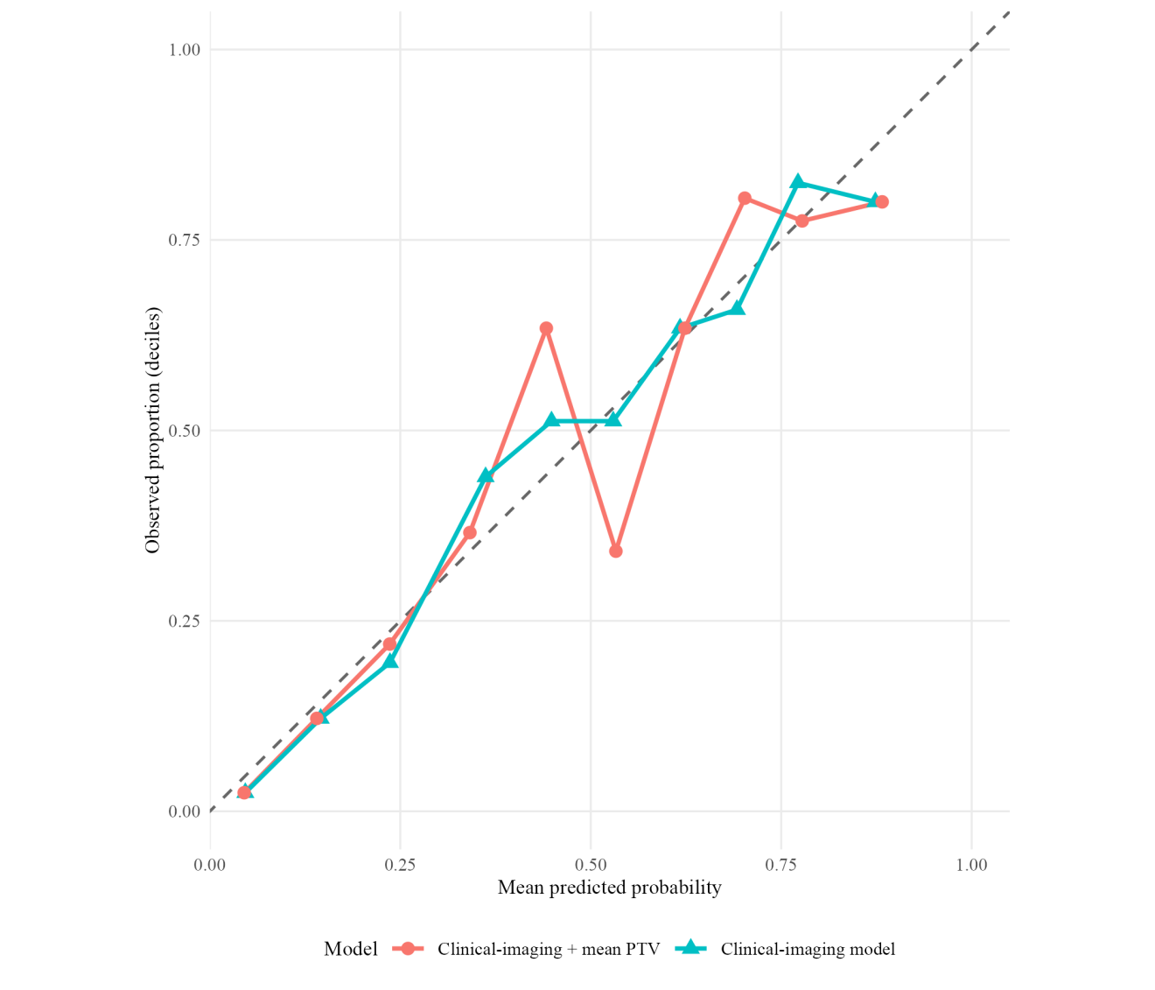
The dashed line denotes perfect calibration. Points show observed proportions within deciles of model-predicted risk; numerical optimism-corrected calibration intercepts and slopes are reported in Supplementary Table S12.
19.Supplementary Table S13. Multiple-imputation model specification and diagnostics
Item | Specification | Result
Incomplete variables | Modified Tan collateral status; HIR | 1 and 23 missing values, respectively
Imputation method | Logistic regression for each binary variable | 20 imputations; 20 iterations
Variables not imputed | Outcome, PTV, age, atrial fibrillation, diabetes, TOAST, occlusion, ASPECTS, NIHSS, TWT, eTICI | Retained as observed and used as predictors
Pooling | Rubin’s rules | PTV OR 0.947 (95% CI 0.902–0.994), P=0.028
Diagnostics | Chain trace plots and mice convergence diagnostics | No material drift or convergence concern identified
The imputation model included the outcome and all analysis covariates as predictors; the outcome was not imputed. The trace plot and convergence output are archived in the reproducibility folder.

20.Supplementary Table S14. Firth-penalized sensitivity analyses for sparse safety endpoints (sICH and MCE)
Model | PTV level | N | OR (95% CI) | P value
Firth adjusted | Continuous PTV (per 1 s) | 408 | 1.04 (0.976–1.108) | 0.217
Firth adjusted | Q2 vs Q1 | 408 | 0.60 (0.201–1.722) | 0.344
Firth adjusted | Q3 vs Q1 | 408 | 0.87 (0.316–2.423) | 0.795
Firth adjusted | Q4 vs Q1 | 408 | 1.19 (0.414–3.513) | 0.748
Firth adjusted | MCE: Continuous PTV (per 1 s) | 399 | 1.04 (0.988–1.103) | 0.125
Firth adjusted | MCE: Q2 vs Q1 | 399 | 0.86 (0.356–2.091) | 0.746
Firth adjusted | MCE: Q3 vs Q1 | 399 | 1.00 (0.410–2.421) | 0.991
Firth adjusted | MCE: Q4 vs Q1 | 399 | 2.09 (0.823–5.437) | 0.121
Profile-likelihood confidence intervals and penalized-likelihood P values are shown. The sICH model included PTV_mean and the main covariate set in 408 patients (42 events); the MCE model used the same covariate set in 399 patients with classified MCE status (80 events). PTV_mean was the arithmetic mean of two blinded reader measurements. These analyses were exploratory and did not redefine the primary outcome model.
21.Supplementary Table S15. Sensitivity of the adjusted PTV associations to eTICI coding
PTV contrast | N | Original numeric eTICI (0–5) |  | Collapsed eTICI (<2c vs ≥2c)
 |  | Adjusted OR (95% CI) | P value | Adjusted OR (95% CI) | P value
Continuous PTV (per 1 s) | 408 | 0.946 (0.902–0.992) | 0.022 | 0.947 (0.903–0.993) | 0.024
Q2 vs Q1 | 408 | 0.663 (0.338–1.301) | 0.232 | 0.712 (0.366–1.385) | 0.317
Q3 vs Q1 | 408 | 0.849 (0.430–1.674) | 0.636 | 0.884 (0.452–1.727) | 0.717
Q4 vs Q1 | 408 | 0.448 (0.208–0.967) | 0.041 | 0.471 (0.220–1.010) | 0.053
Values are adjusted odds ratios for favorable 90-day outcome (mRS 0–2), with Wald 95% confidence intervals and two-sided Wald P values. Both models included age, atrial fibrillation, diabetes, TOAST subtype, occlusion site, baseline ASPECTS, baseline NIHSS, treatment workflow time (TWT), and eTICI; only eTICI coding differed. Original eTICI codes 0–5 represented grades 0, 1, 2a, 2b, 2c, and 3, respectively. Collapsed groups: <2c, n=98 (25 favorable outcomes); ≥2c, n=310 (167 favorable outcomes). All four PTV quartiles contained 102 patients. Abbreviations: eTICI, expanded Treatment in Cerebral Infarction; PTV, peak time of venous outflow; OR, odds ratio; CI, confidence interval; mRS, modified Rankin Scale; ASPECTS, Alberta Stroke Program Early CT Score; NIHSS, National Institutes of Health Stroke Scale; TOAST, Trial of ORG 10172 in Acute Stroke Treatment.

