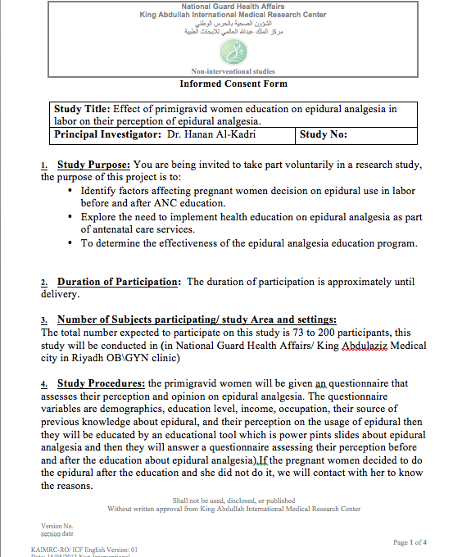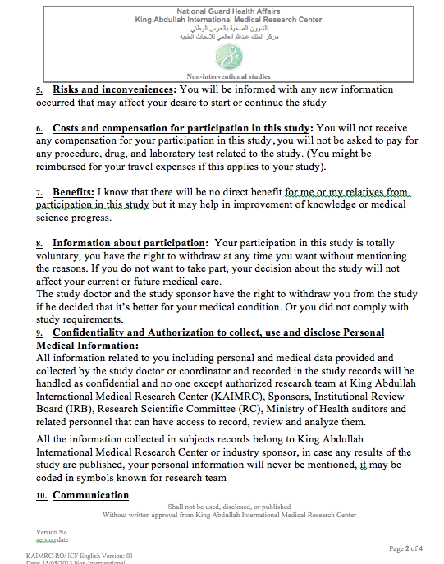

Study date:
Study code:
Study number:
Serial number:
Age: ________yrs.

General information:

- How much schooling have you completed?
- Primary school
- Middle School
- High School
- College
- Postgraduate
- Illiterate
- What is your employment status ?
  - Employed
  - Not employed
- Can you give a rough estimate of the family income per month?
- Less than 5,000 SR
- 5,000 to ≥10, 000 SR
- 10,000 to ≥15, 000 SR
- More than 15,000 SR
- Where is your residency?
  - Urban
  - Rural

Question related to the research:
- What do you think is the most effective means of pain control in labour?
- No effective method
- Pain relief with intramuscular analgesia
- Pain relief with intravenous analgesia
- Pain relief by using gas inhalation
- Epidural analgesia
- Others……
- Don’t know
- Before coming to the hospital, what was the number one reason why you might have wanted an epidural for labour? (Check only one item)
- Pain control
- Relief of fatigue/stress
- Encouraged to obtain epidural by friend/family member
- Encouraged to obtain epidural by OB, midwife, labour educator.
- Other, please list___________.

- Before coming to the hospital, what was the number one concern you had regarding epidurals, which may have led you towards avoiding an epidural for labour? (Check only one item)
- Concern over possible risks to me (back pain, headache, etc.)
- Concern over possible risks to baby
- Pain from needle/procedure
- Afraid of delaying labour or increasing the risk of C-section
- Cost
- Desire for natural childbirth
- Discouraged by OB, midwife, doula, labour educator
- Other, please list_____________ .
- What was your main source of information on epidurals prior to your labour? (Check only one item)
- Physician
- Midwife
- Family member/friend
- Book/video/TV program
- Childbirth class
- Internet
- Other, please list______________.
- Did your partner prefer you receive an epidural for labour?
- Yes
- No
- Neutral (He thinks this is your own decision to make)

- In the future, will you request an epidural when in labour?
  - Yes
  - No
  - Not decided
Answer the following question after receiving education about epidural:

- After receiving the education about epidural, will you request an epidural when in labour?
  - Yes
  - No
  - Not decided

- If you plan to request epidural analgesia when in labour, would you want the issue to be introduced to you formally during your antenatal visits?
- Yes
  - If Yes:
    - By means of a pamphlet that I can read
    - By means of a video that I can watch
    - During antenatal talks by the health educator
    - During the doctors’ consultation
    - In a special session by the anesthetist
- No introduction needed – I understand already

