Figure S2: Coagulation parameters according to clear fluid administration (0-2L, 2L-3.5L, >3.5L) and increasing volume of blood loss (0-1.0, 1.0-1.5, 1.5-2.0 L, 2.0-2.5L, 2.5-3.0L, 3.0-3.5L, 3.5-4.0L and >4L).
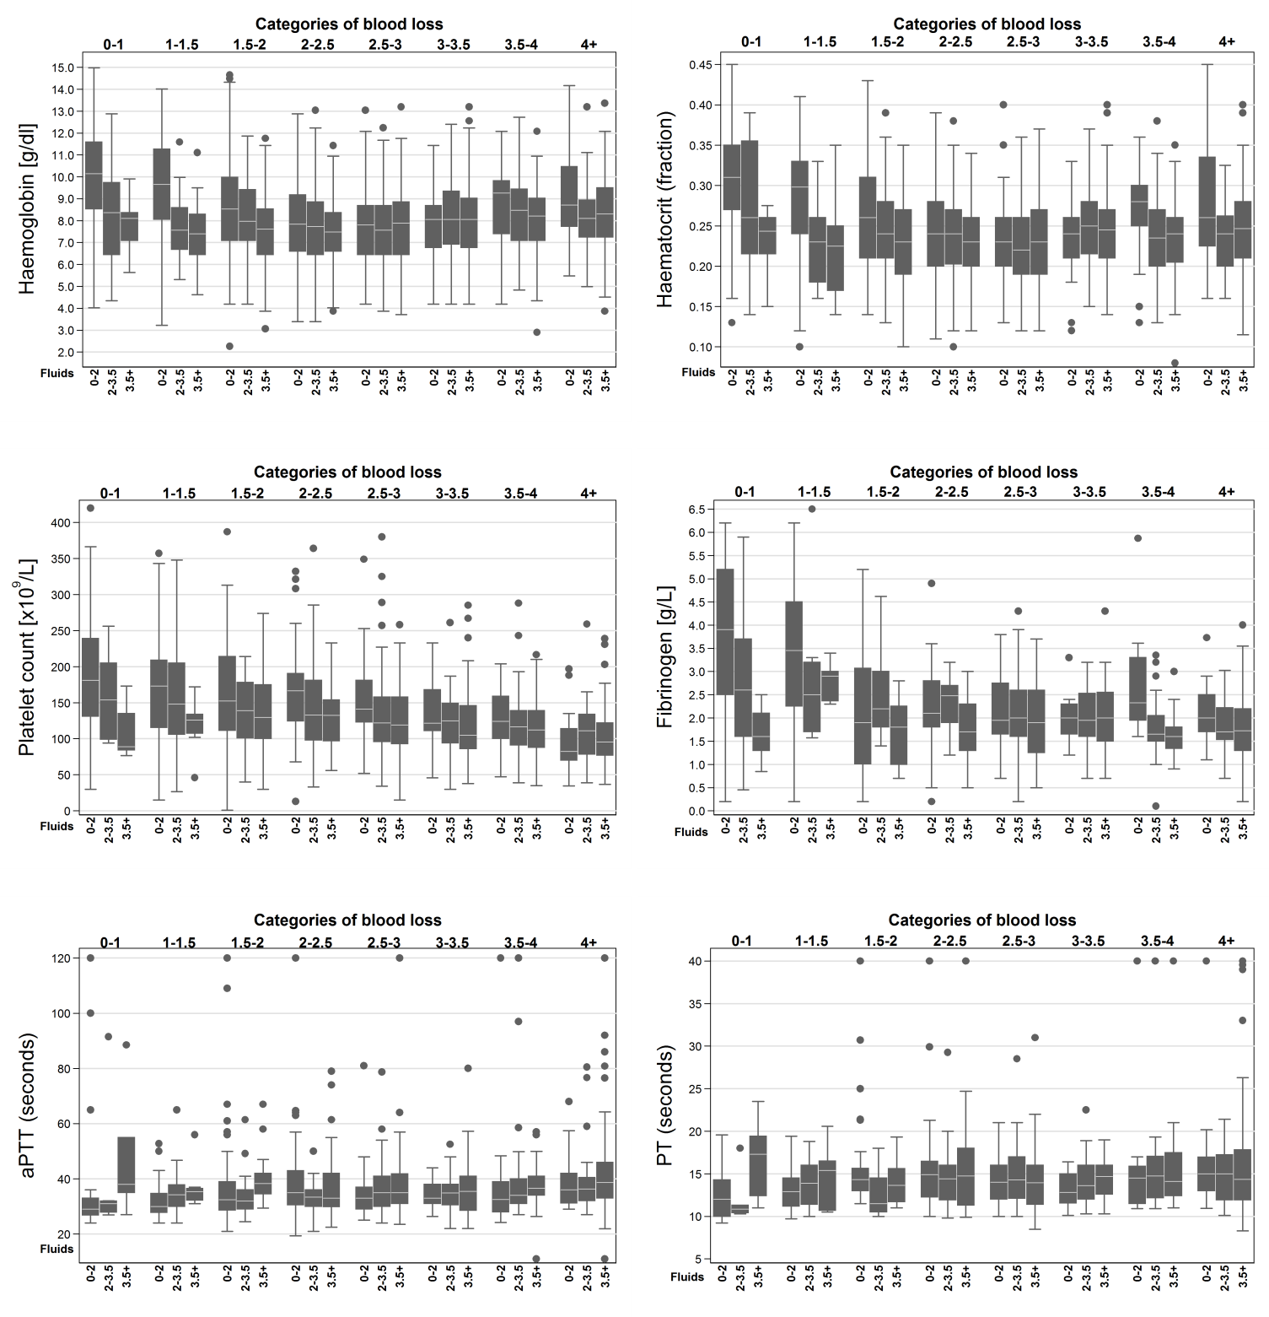
Laboratory parameters are presented in box plots. Circles are outliers. The box represents the 25th and 75th percentiles and the whiskers are the upper and lower adjacent values.

