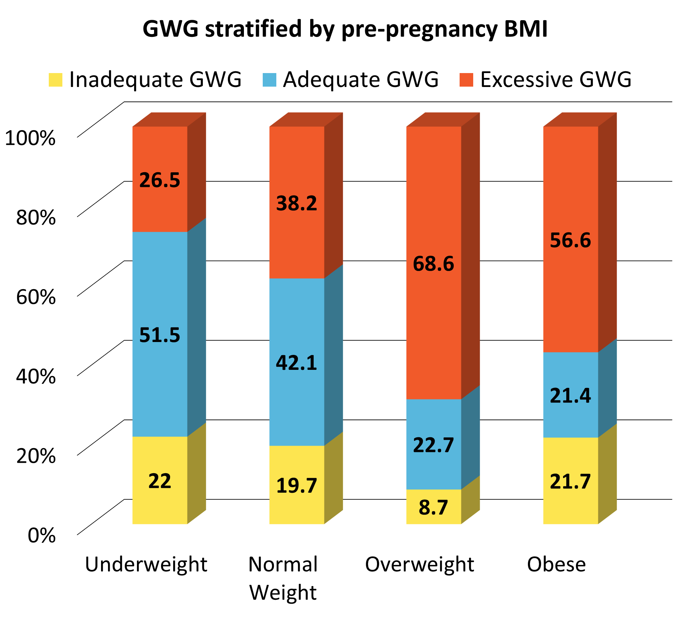
Additional file 1: Figure S1. Distribution of GWG stratified by pre-pregnancy BMI
(the numbers on columns represent percentages; percentages add to 100 per column)

