Additional file 4 Figure S1. Inter-pregnancy differences in the BW/GA percentile
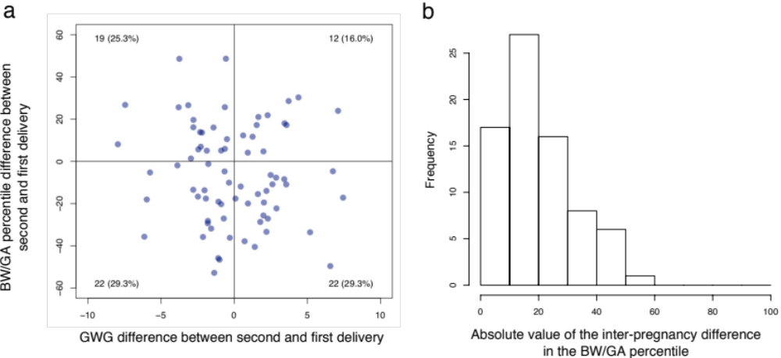

- Relationship between inter-pregnancy differences in the GWG and BW/GA percentile. X-axis denotes the differences between the second GWG and the first GWG. Y-axis denotes the differences between the second BW/GA percentile and the first BW/GA percentile.
- Histogram of the absolute value of the inter-pregnancy differences in the BW/GW percentile.
GWG, gestational weight gain; BW/GA, birth weight for gestational age.

