Additional file 5 Figure S2. Relationship between GWG and BW/GA percentile in the subgroups by pre-pregnancy BMI and BW/GA
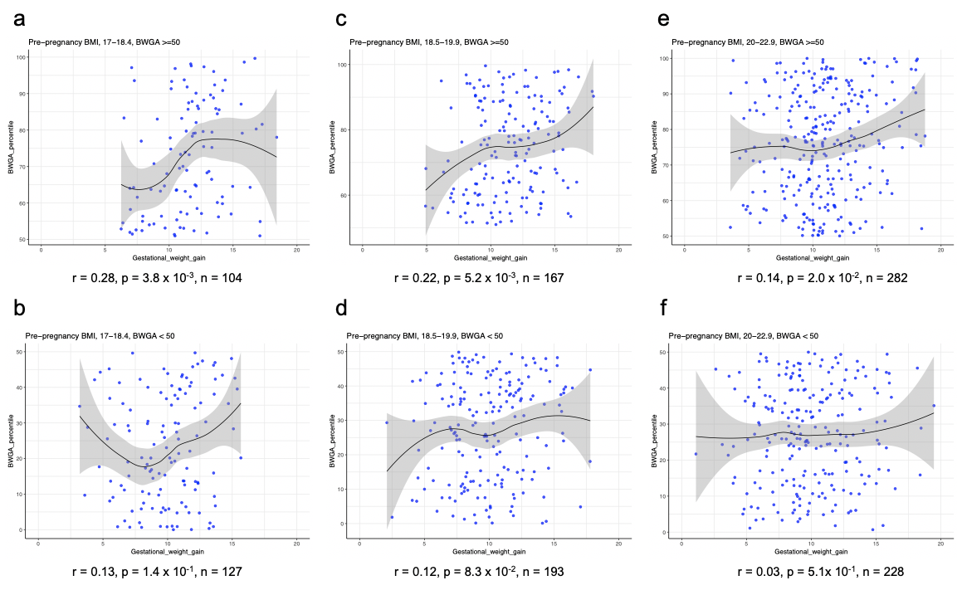
Scatter plots showing the relationship between GWG and the BW/GA percentile for distinct groups stratified by pre-pregnancy BMI and neonatal size. (a, b) 17 ≦ pre-pregnancy BMI < 18.5; (c,d) 18.5 ≦ pre-pregnancy BMI < 20; (e,f) 20 ≦ pre-pregnancy BMI < 23; (a,c,e) 50 ≦ BW/GA percentile; (b,d,f) BW/GA percentile < 50. Women with extremely high and low GWG (outside the first quartile -1.5 x interquartile range and the third quartile + 1.5 x interquartile range) were excluded. Correlation coefficient between GWG and BW/GA (r), p-value, and sample size (n) are indicated. Black line with gray band indicates the local polynomial regression line with standard error. BW/GA, birth weight for gestational age.

