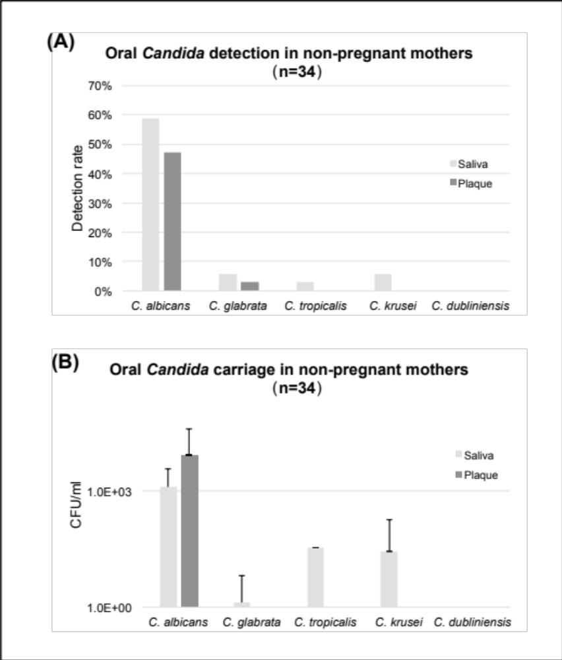
Additional file 2: Figure S1. Oral Candida status in non-pregnant mothers
(A) Oral (saliva and plaque) Candida species detection in non-pregnant women. (B). Candida species carriage in the saliva and plaque of non-pregnant women.

