Supplementary Material
The provision of epidural analgesia according to maternal birthplace: a Norwegian register study
Waldum ÅH et al.

Supplementary Flowchart. Inclusion and exclusion process
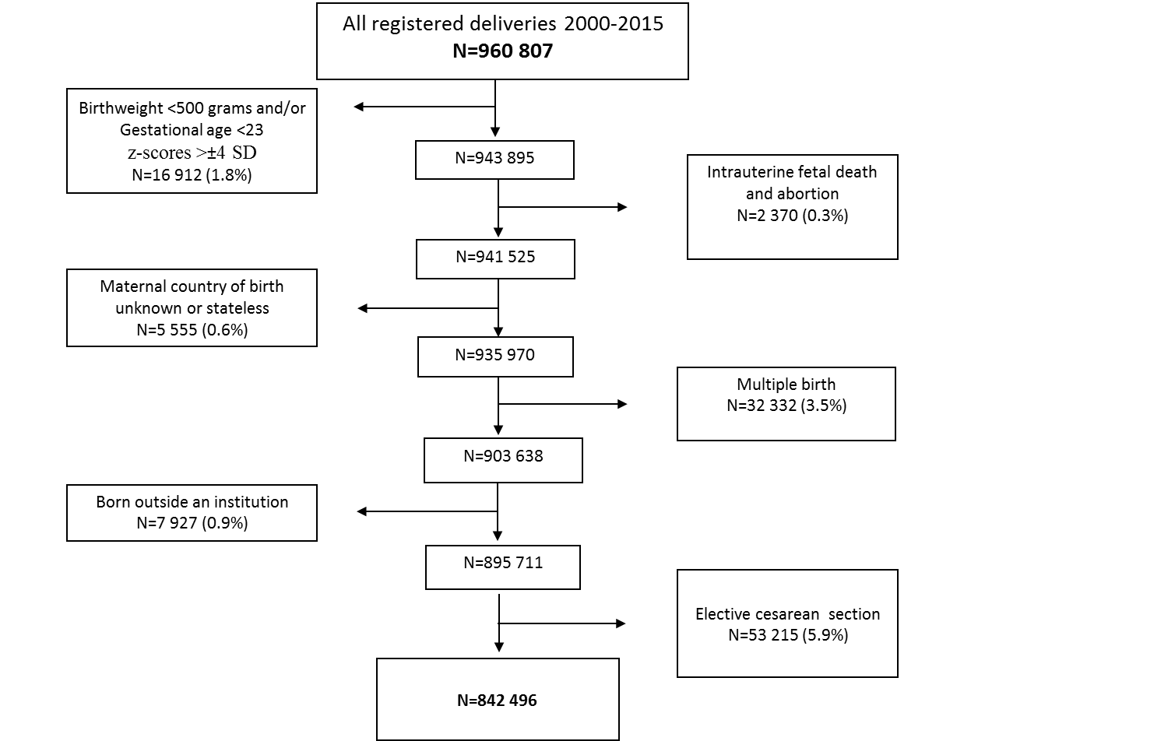

Supplementary Table 1. Top 3 countries of maternal birthplace within immigrant group, N=175038
Maternal region of birth | n (%)
High-income countries, n (% of immigrants)  Sweden, %*  Germany, %*  Denmark, %* | 41450 (23.7)  29.0  11.7  9.3
Europe/Central Asia, n (%)  Poland, %*  Russia, %*  Lithuania, % | 41185 (23.5)  27.6  13.5  12.4
Sub-Saharan Africa, n (%)  Somalia, %*  Eritrea, %*  Ethiopia, %* | 23499 (13.4)  51.2  11.9  10.1
North Africa/Middle East, n (%)  Iraq, %*  Turkey, %*  Afghanistan, %* | 26735 (15.3)  33.5  15.1  12.1
South Asia, n (%)  Pakistan, %*  India, %*  Bangladesh, %* | 11585 (6.6)  72.0  22.7  3.1
East Asia/Pacific, n (%)  Philippines, %*  Thailand, %*  Vietnam, %* | 25107 (14.3)  25.3  22.7  20.8
Latin America/Caribbean, n (%)  Brazil, %*  Colombia, %*  Peru, %* | 5477 (3.1)  32.4  20.5  9.8
* percentage within each immigrant group

Supplementary Table 2. Associations between residence time and epidural analgesia in primiparous immigrant women with instrumental vaginal delivery, N= 14181
 | Crude OR | 95% CI |  | P-value | Adjusted OR* | 95% CI |  | P-value
Global Burden of Disease
High income | Ref. |  |  |  | Ref.
Europe/Central Asia | 1.02 | 0.93 | 1.12 | 0.675 | 1.08 | 0.97 | 1.19 | 0.144
Sub-Saharan Africa | 0.74 | 0.65 | 0.84 | <0.001 | 0.77 | 0.68 | 0.88 | <0.001
North Africa/ Middle East | 1.08 | 0.96 | 1.22 | 0.196 | 1.14 | 1.00 | 1.29 | 0.043
South Asia | 1.04 | 0.89 | 1.21 | 0.648 | 1.07 | 0.91 | 1.25 | 0.429
East Asia/Pacific | 0.71 | 0.64 | 0.79 | <0.001 | 0.74 | 0.66 | 0.82 | <0.001
Latin America/ Caribbean | 1.96 | 1.55 | 2.48 | <0.001 | 2.03 | 1.61 | 2.56 | <0.001
Residence time
<2 years | Ref. |  |  |  | Ref.
2-10 years | 1.16 | 1.08 | 1.26 | <0.001 | 1.17 | 1.08 | 1.27 | <0.001
>10 years | 1.43 | 1.28 | 1.61 | <0.001 | 1.46 | 1.30 | 1.64 | <0.001
Missing | 1.36 | 1.18 | 1.56 | <0.001 | 1.29 | 1.11 | 1.51 | 0.001
*Adjusted for age at delivery (<20, 20-34, ≥35 years), marital status (married/cohabiting y/n), maternal education (lower, middle, higher, missing), birth weight, year of childbirth and size of obstetric department. GBD: Global Burden of Disease; OR: Odds ratio; CI: Confidence interval.

Supplementary Table 3. Rate of maternal disease
 | Preeclampsia/Eclampsia  % | Diabetes type 1  %
2000-2003 | 3.9 | 0.4
2004-2007 | 3.6 | 0.4
2008-2011 | 3.2 | 0.4
2012-2015 | 2.0 | 0.4

Supplementary table 4. Pudendal block provision by maternal birthplace, stratified by parity
Spontaneous vaginal delivery | Primiparous women, N 248661 |  |  |  |  |  |  |  |  |  |  |  |  | Multiparous women, N 427035
Global Burden of Disease | CrudeOR | 95% CI |  |  |  |  | Adj OR* |  |  |  | 95% CI |  |  |  |  |  | CrudeOR | 95% CI |  |  |  |  |  | Adj OR** |  |  |  | 95% CI
Norway | Ref. |  |  |  |  |  | Ref. |  |  |  |  |  |  |  |  |  | Ref. |  |  |  |  |  |  | Ref.
High-income | 1.54 | 1.04 |  |  |  | 1.28 | 1.10 |  |  |  | 0.99 | 1.22 |  |  |  |  | 1.21 | 1.09 |  |  |  |  | 1.34 | 1.14 |  |  |  | 1.03 |  | 1.27
Europe/Central Asia | 0.83 | 0.75 |  |  |  | 0.94 | 0.91 |  |  |  | 0.81 | 1.03 |  |  |  |  | 0.73 | 0.64 |  |  |  |  | 0.83 | 0.80 |  |  |  | 0.70 |  | 0.92
Sub-Saharan Africa | 1.05 | 0.87 |  |  |  | 1.26 | 1.14 |  |  |  | 0.94 | 1.37 |  |  |  |  | 0.68 | 0.58 |  |  |  |  | 0.79 | 0.76 |  |  |  | 0.64 |  | 0.90
North Africa/Middle East | 0.88 | 0.75 |  |  |  | 1.04 | 0.90 |  |  |  | 0.76 | 1.06 |  |  |  |  | 0.75 | 0.65 |  |  |  |  | 0.87 | 0.78 |  |  |  | 0.67 |  | 0.91
South Asia | 0.89 | 0.70 |  |  |  | 1.14 | 0.85 |  |  |  | 0.66 | 1.09 |  |  |  |  | 0.91 | 0.74 |  |  |  |  | 1.11 | 0.85 |  |  |  | 0.69 |  | 1.04
East Asia/Pacific | 0.88 | 0.75 |  |  |  | 1.03 | 0.91 |  |  |  | 0.77 | 1.07 |  |  |  |  | 0.80 | 0.68 |  |  |  |  | 0.93 | 0.81 |  |  |  | 0.69 |  | 0.96
Latin America/Caribbean | 0.88 | 0.65 |  |  |  | 1.21 | 0.89 |  |  |  | 0.65 | 1.22 |  |  |  |  | 1.28 | 0.96 |  |  |  |  | 1.70 | 1.28 |  |  |  | 0.96 |  | 1.70
Instrumental vaginal delivery | Primiparous women, N 62565 |  |  |  |  |  |  |  |  |  |  |  |  |  | Multiparous women, N 19249
Global Burden of Disease | CrudeOR | 95% CI |  |  |  |  |  | Adj OR* |  |  | 95% CI |  |  |  | CrudeOR |  |  | 95% CI |  |  |  |  |  |  | Adj OR** |  |  | 95% CI
Norway | Ref. |  |  |  |  |  |  | Ref. |  |  |  |  |  |  | Ref. |  |  |  |  |  |  |  |  |  | Ref.
High-income | 0.99 |  | 0.87 |  | 1.13 |  |  | 0.94 |  |  | 0.82 |  | 1.07 |  |  | 0.99 |  |  |  | 0.77 |  | 1.25 |  |  | 0.99 |  | 0.77 |  |  |  | 1.26
Europe/Central Asia | 0.96 |  | 0.84 |  | 1.09 |  |  | 0.92 |  |  | 0.81 |  | 1.06 |  |  | 0.88 |  |  |  | 0.68 |  | 1.15 |  |  | 0.95 |  | 0.73 |  |  |  | 1.24
Sub-Saharan Africa | 0.71 |  | 0.56 |  | 0.91 |  |  | 0.71 |  |  | 0.55 |  | 0.92 |  |  | 0.41 |  |  |  | 0.27 |  | 0.62 |  |  | 0.48 |  | 0.32 |  |  |  | 0.74
North Africa/Middle East | 0.75 |  | 0.61 |  | 0.91 |  |  | 0.72 |  |  | 0.59 |  | 0.89 |  |  | 0.53 |  |  |  | 0.37 |  | 0.76 |  |  | 0.59 |  | 0.40 |  |  |  | 0.86
South Asia | 0.86 |  | 0.65 |  | 1.14 |  |  | 0.82 |  |  | 0.62 |  | 1.09 |  |  | 0.54 |  |  |  | 0.32 |  | 0.91 |  |  | 0.58 |  | 0.34 |  |  |  | 0.99
East Asia/Pacific | 0.93 |  | 0.78 |  | 1.09 |  |  | 0.91 |  |  | 0.77 |  | 1.08 |  |  | 1.12 |  |  |  | 0.87 |  | 1.45 |  |  | 1.19 |  | 0.91 |  |  |  | 1.56
Latin America/Caribbean | 1.15 |  | 0.83 |  | 1.61 |  |  | 1.11 |  |  | 0.79 |  | 1.55 |  |  | 1.49 |  |  |  | 0.85 |  | 2.60 |  |  | 1.57 |  | 0.89 |  |  |  | 2.76
Emergency cesarean delivery | Primiparous women, N 50424 |  |  |  |  |  |  |  |  |  |  |  |  |  |  | Multiparous women, N 34562
Global Burden of Disease | CrudeOR | 95% CI |  |  |  |  |  | Adj OR* |  | 95% CI |  |  |  |  | CrudeOR |  |  | 95% CI |  |  |  |  |  |  |  | Adj OR** |  |  | 95% CI
Norway | Ref. |  |  |  |  |  |  | Ref. |  |  |  |  |  |  | Ref. |  |  |  |  |  |  |  |  |  |  | Ref.
High-income | 1.09 |  |  | 0.73 | 1.63 |  |  | 1.06 | 0.71 |  |  |  | 1.61 |  |  | 1.08 |  |  | 0.55 |  | 2.13 |  |  |  |  | 1.01 |  |  | 0.51 |  | 2.01
Europe/Central Asia | 0.88 |  |  | 0.55 | 1.40 |  |  | 0.84 | 0.51 |  |  |  | 1.36 |  |  | 0.96 |  |  | 0.45 |  | 2.05 |  |  |  |  | 0.98 |  |  | 0.45 |  | 2.15
Sub-Saharan Africa | 0.75 |  |  | 0.42 | 1.35 |  |  | 0.80 | 0.44 |  |  |  | 1.47 |  |  | 0.37 |  |  | 0.14 |  | 0.99 |  |  |  |  | 0.45 |  |  | 0.16 |  | 1.27
North Africa/Middle East | 0.77 |  |  | 0.40 | 1.49 |  |  | 0.85 | 0.43 |  |  |  | 1.68 |  |  | 0.81 |  |  | 0.36 |  | 1.83 |  |  |  |  | 0.91 |  |  | 0.38 |  | 2.16
South Asia | 1.09 |  |  | 0.49 | 2.46 |  |  | 1.27 | 0.55 |  |  |  | 2.89 |  |  | 0.28 |  |  | 0.04 |  | 2.01 |  |  |  |  | 0.34 |  |  | 0.05 |  | 2.45
East Asia/Pacific | 0.61 |  |  | 0.34 | 1.12 |  |  | 0.66 | 0.36 |  |  |  | 1.22 |  |  | 1.45 |  |  | 0.80 |  | 2.63 |  |  |  |  | 1.51 |  |  | 0.81 |  | 2.83
Latin America/Caribbean | 0.39 |  |  | 0.10 | 1.58 |  |  | 0.40 | 0.10 |  |  |  | 1.64 |  |  | - |  |  | - |  | - |  |  |  |  | - |  |  | - |  | -

*Adjusted for: age at delivery (<20, 20-34, ≥35 years), marital status (married/cohabiting y/n), maternal education (lower, middle, higher, missing), birth weight, year of childbirth and size of obstetric department. **In multiparous women, also adjusted for parity (1, 2, 3, 4+ births) and previous caesarean delivery (y/n).
OR: Odds ratio; CI: Confidence interval.

Supplementary table 5. Spinal analgesia provision by maternal birthplace, stratified by parity
Spontaneous vaginal delivery | Primiparous women, N 248661 |  |  |  |  |  |  |  |  | Multiparous women, N 427035
Global Burden of Disease | Crude OR | 95% CI |  |  | Adj OR* |  | 95% CI |  |  | Crude OR | 95% CI |  | Adj OR** | 95% CI
Norway | Ref. |  |  |  | Ref. |  |  |  |  | Ref. |  |  | Ref.
High-income | 0.98 | 0.84 |  | 1.15 | 0.93 |  | 0.79 |  | 1.09 | 1.17 | 1.03 | 1.32 | 1.13 | 0.99 | 1.28
Europe/Central Asia | 0.83 | 0.70 |  | 0.97 | 0.75 |  | 0.63 |  | 0.89 | 0.96 | 0.84 | 1.11 | 0.91 | 0.79 | 1.05
Sub-Saharan Africa | 1.20 | 0.93 |  | 1.53 | 1.18 |  | 0.91 |  | 1.52 | 0.64 | 0.53 | 0.79 | 0.66 | 0.53 | 0.81
North Africa/Middle East | 0.81 | 0.64 |  | 1.03 | 0.82 |  | 0.64 |  | 1.04 | 0.67 | 0.56 | 0.81 | 0.71 | 0.58 | 0.86
South Asia | 0.89 | 0.63 |  | 1.28 | 0.92 |  | 0.64 |  | 1.33 | 0.81 | 0.63 | 1.04 | 0.85 | 0.66 | 1.11
East Asia/Pacific | 1.29 | 1.07 |  | 1.56 | 1.29 |  | 1.06 |  | 1.56 | 0.88 | 0.73 | 1.06 | 0.90 | 0.75 | 1.09
Latin America/Caribbean | 1.12 | 0.75 |  | 1.66 | 1.08 |  | 0.72 |  | 1.61 | 1.20 | 0.84 | 1.71 | 1.08 | 0.75 | 1.54
Instrumental vaginal delivery | Primiparous women, N 62565 |  |  |  |  |  |  |  |  | Multiparous women, N 19249
Global Burden of Disease | Crude OR | 95% CI |  |  | Adj OR* |  | 95% CI |  |  | Crude OR | 95% CI |  | Adj OR** | 95% CI
Norway | Ref. |  |  |  | Ref. |  |  |  |  | Ref. |  |  | Ref.
High-income | 0.90 | 0.72 |  | 1.13 | 0.90 |  | 0.71 |  | 1.13 | 1.24 | 0.93 | 1.65 | 1.21 | 0.90 | 1.62
Europe/Central Asia | 0.75 | 0.59 |  | 0.96 | 0.70 |  | 0.54 |  | 0.91 | 0.63 | 0.43 | 0.94 | 0.58 | 0.39 | 0.88
Sub-Saharan Africa | 0.67 | 0.43 |  | 1.04 | 0.67 |  | 0.43 |  | 1.04 | 0.73 | 0.48 | 1.11 | 0.71 | 0.45 | 1.12
North Africa/Middle East | 0.80 | 0.57 |  | 1.11 | 0.82 |  | 0.58 |  | 1.15 | 0.74 | 0.49 | 1.12 | 0.73 | 0.47 | 1.13
South Asia | 0.72 | 0.43 |  | 1.21 | 0.76 |  | 0.45 |  | 1.28 | 0.59 | 0.30 | 1.14 | 0.63 | 0.32 | 1.23
East Asia/Pacific | 0.80 | 0.59 |  | 1.09 | 0.82 |  | 0.60 |  | 1.12 | 0.79 | 0.53 | 1.17 | 0.78 | 0.52 | 1.17
Latin America/Caribbean | 0.99 | 0.54 |  | 1.81 | 0.98 |  | 0.53 |  | 1.79 | - | - | - | - | - | -
Emergency cesarean delivery | Primiparous women, N 50424 |  |  |  |  |  |  |  |  | Multiparous women, N 34562
Global Burden of Disease | Crude OR |  | 95% CI |  |  | Adj OR* |  | 95% CI |  | Crude OR | 95% CI |  | Adj OR** | 95% CI
Norway | Ref. |  |  |  | Ref. |  |  |  |  | Ref. |  |  | Ref.
High-income | 0.87 | 0.80 |  | 0.94 | 0.92 |  | 0.85 |  | 0.99 | 0.94 | 0.85 | 1.05 | 0.98 | 0.88 | 1.08
Europe/Central Asia | 0.91 | 0.84 |  | 0.98 | 0.92 |  | 0.85 |  | 1.00 | 0.87 | 0.79 | 0.97 | 0.89 | 0.80 | 1.00
Sub-Saharan Africa | 0.96 | 0.88 |  | 1.05 | 0.96 |  | 0.87 |  | 1.06 | 0.87 | 0.80 | 0.95 | 0.96 | 0.87 | 1.06
North Africa/Middle East | 0.99 | 0.89 |  | 1.10 | 1.01 |  | 0.91 |  | 1.20 | 0.91 | 0.82 | 1.02 | 0.99 | 0.88 | 1.10
South Asia | 1.01 | 0.87 |  | 1.17 | 1.04 |  | 0.89 |  | 1.22 | 0.92 | 0.79 | 1.08 | 1.00 | 0.86 | 1.17
East Asia/Pacific | 0.89 | 0.81 |  | 0.97 | 0.90 |  | 0.82 |  | 0.99 | 0.92 | 0.83 | 1.02 | 0.98 | 0.88 | 1.09
Latin America/Caribbean | 0.77 | 0.65 |  | 0.90 | 0.79 |  | 0.67 |  | 0.93 | 0.97 | 0.78 | 1.21 | 1.01 | 0.81 | 1.27
*Adjusted for: age at delivery (<20, 20-34, ≥35 years), marital status (married/cohabiting y/n), maternal education (lower, middle, higher, missing), birth weight, year of childbirth and size of obstetric department. **In multiparous women, also for parity (1, 2, 3, 4+ births) and previous caesarean delivery (y/n). OR: Odds ratio; CI: Confidence interval.

