Sensitivity analysis

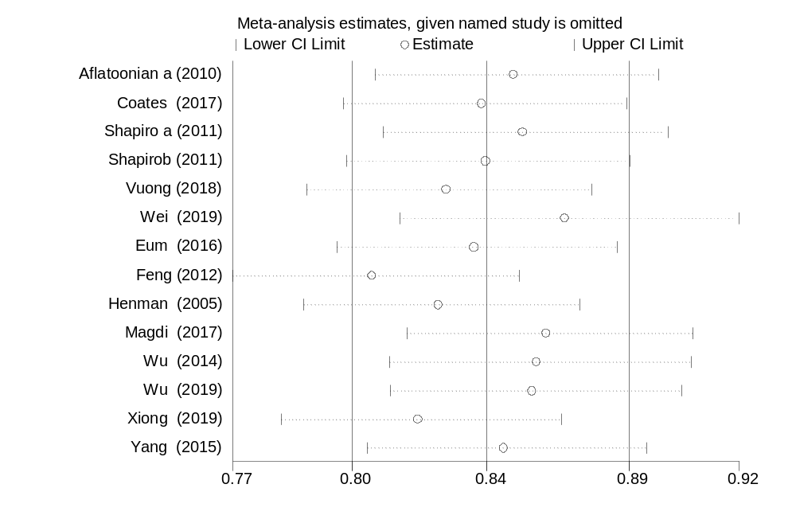
Appendix 37: The sensitivity analysis of implantation rate showed the pooled proportion when the studies omitted step by step

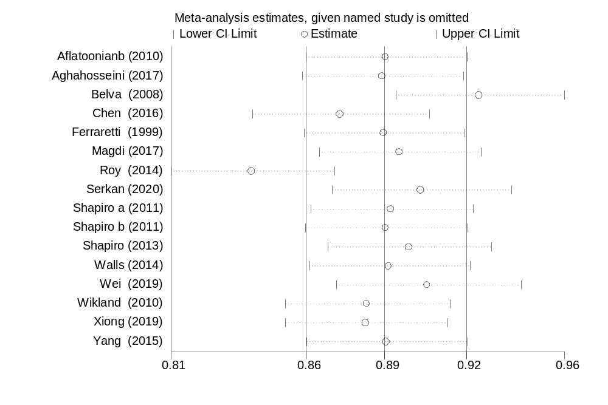
Appendix 38: The sensitivity analysis of pregnancy rate showed the pooled proportion when the studies omitted step by step

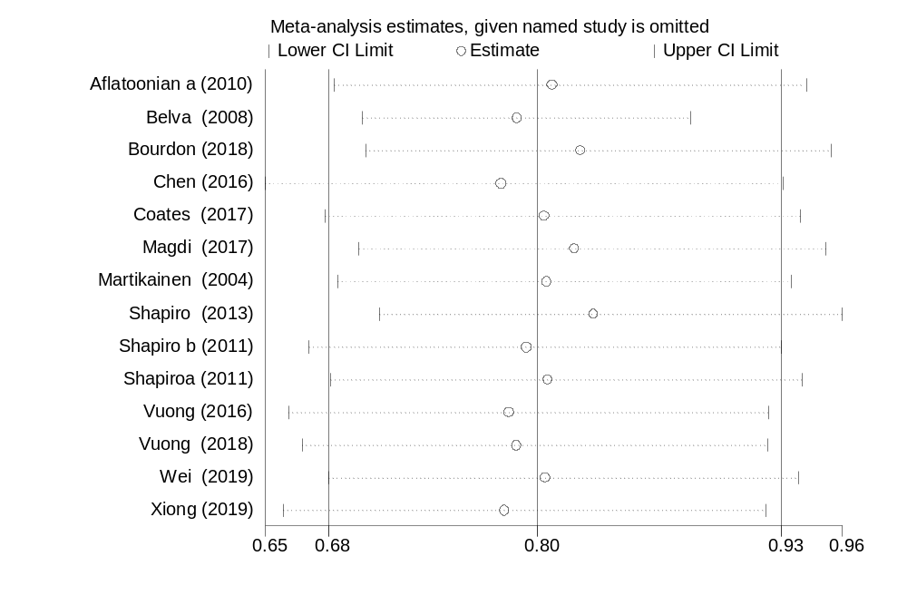
Appendix 39: The sensitivity analysis of ongoing pregnancy rate showed the pooled proportion when the studies omitted step by step

Appendix 40: The sensitivity analysis of ongoing pregnancy rate showed the pooled proportion when the studies omitted step by step
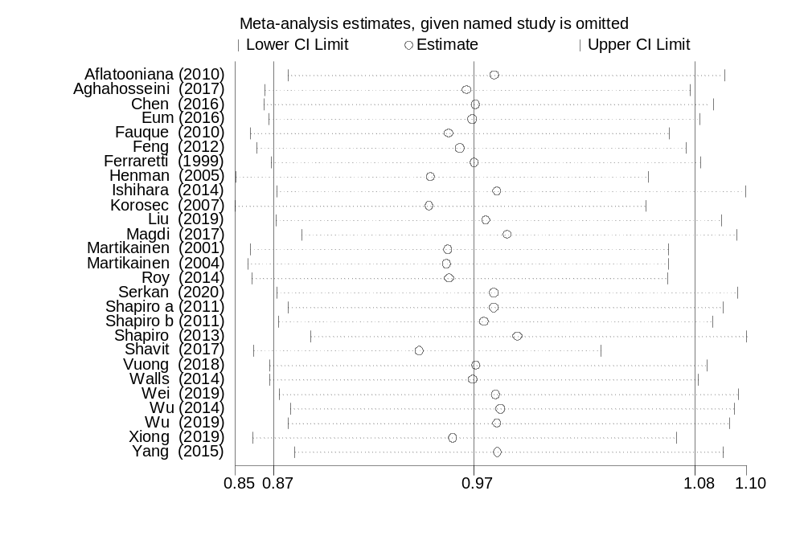
Appendix 41: The sensitivity analysis of clinical pregnancy rate showed the pooled proportion when the studies omitted step by step

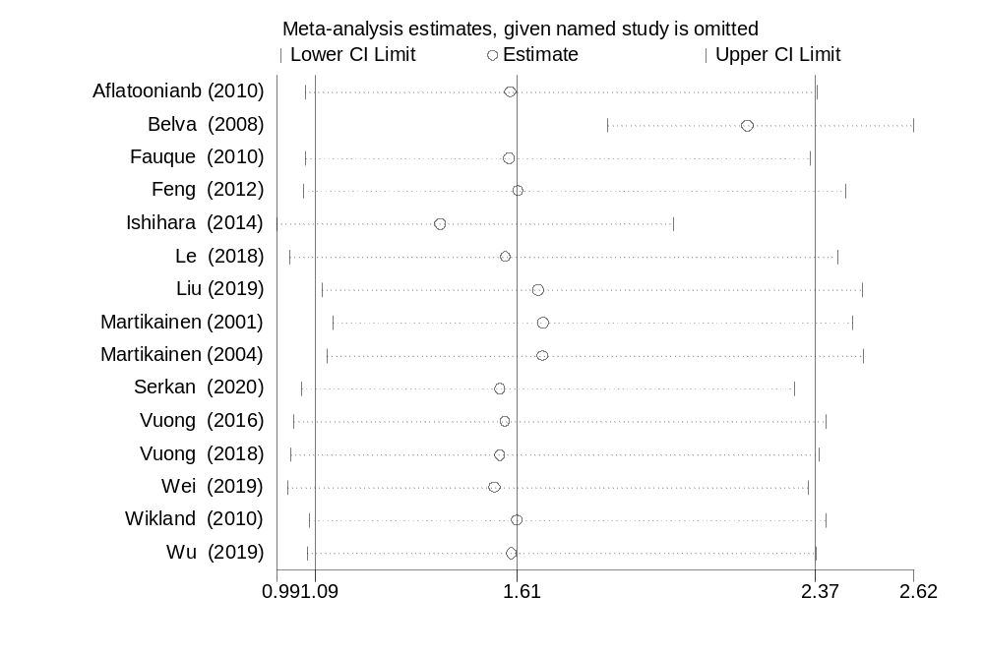
Appendix 42: The sensitivity analysis of ectopic pregnancy rate showed the pooled proportion when the studies omitted step by step

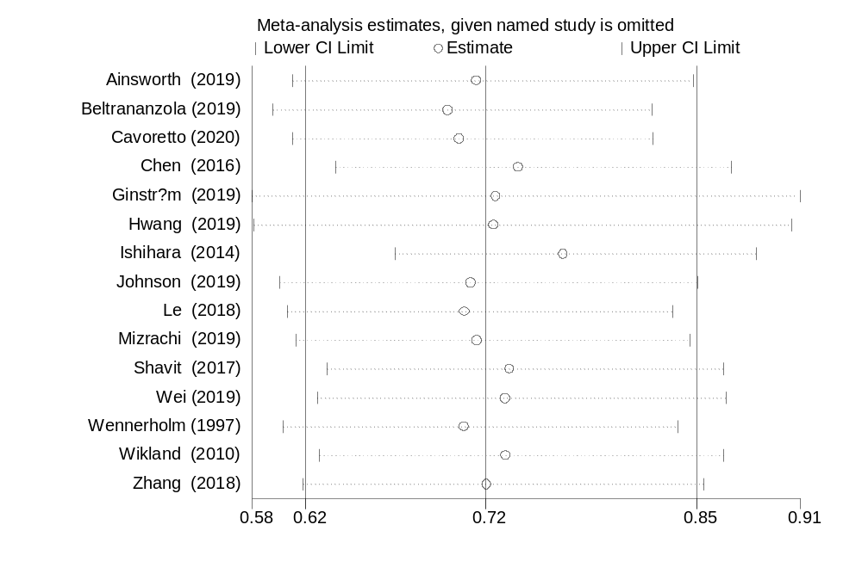
Appendix 43: The sensitivity analysis of PIH and pre-eclampsia showed the pooled proportion when the studies omitted step by step

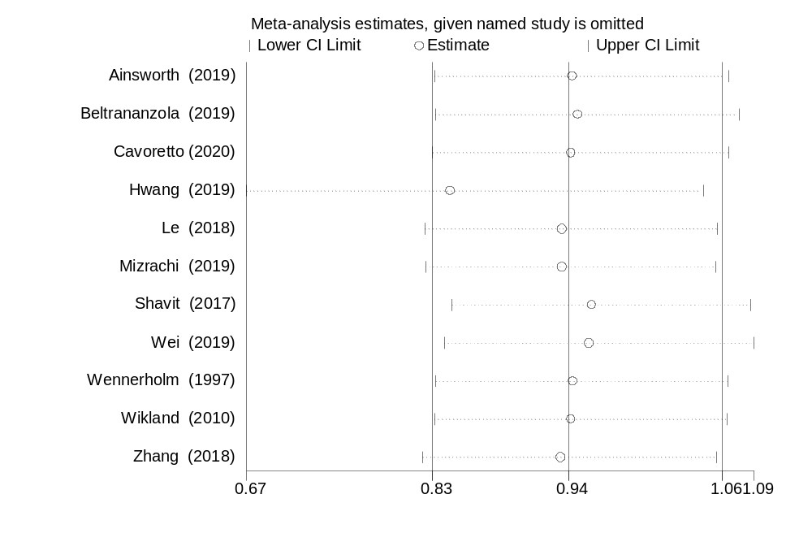
Appendix 44: The sensitivity analysis of GDM showed the pooled proportion when the studies omitted step by step

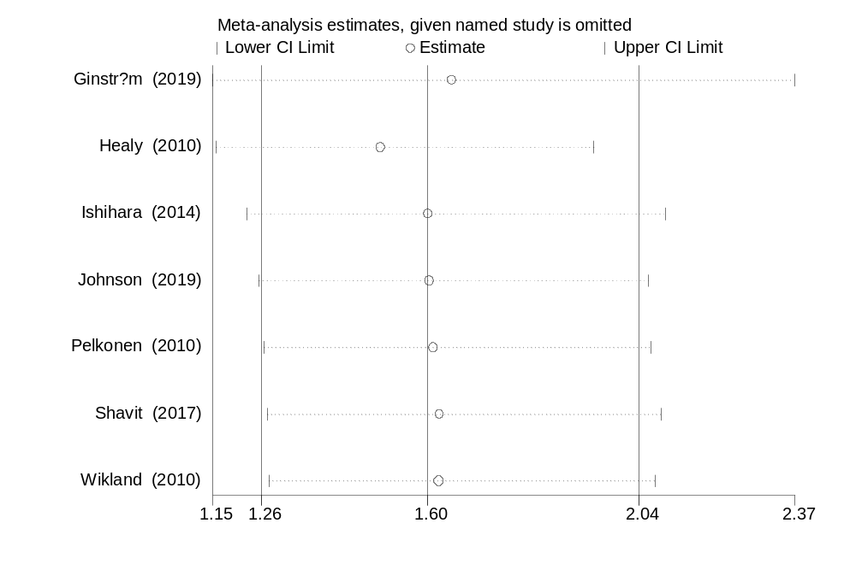
Appendix 45: The sensitivity analysis of placental abruption showed the pooled proportion when the studies omitted step by step

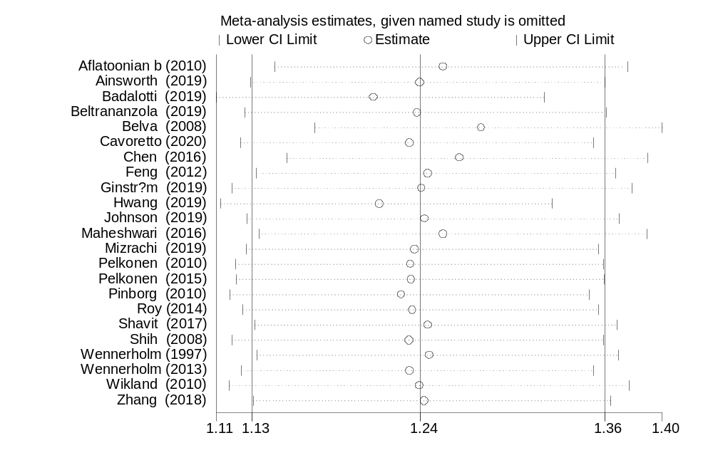
Appendix 46: The sensitivity analysis of PTD showed the pooled proportion when the studies omitted step by step

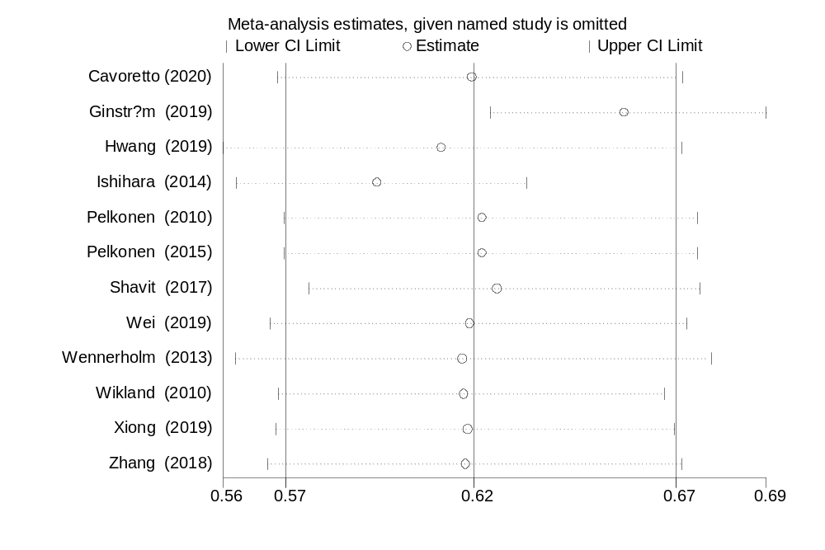
Appendix 47: The sensitivity analysis of LGA showed the pooled proportion when the studies omitted step by step

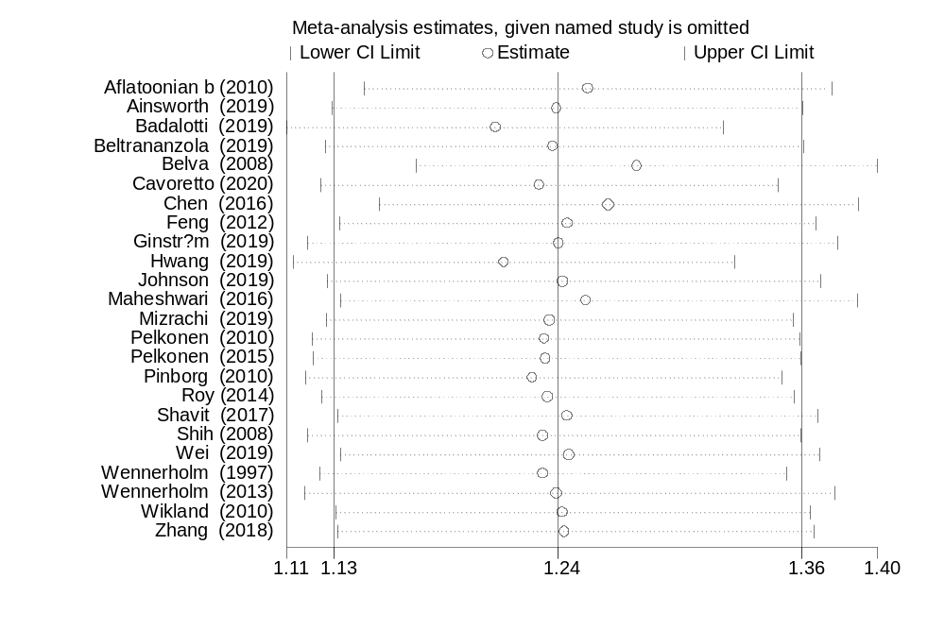
Appendix 48: The sensitivity analysis of SGA showed the pooled proportion when the studies omitted step by step

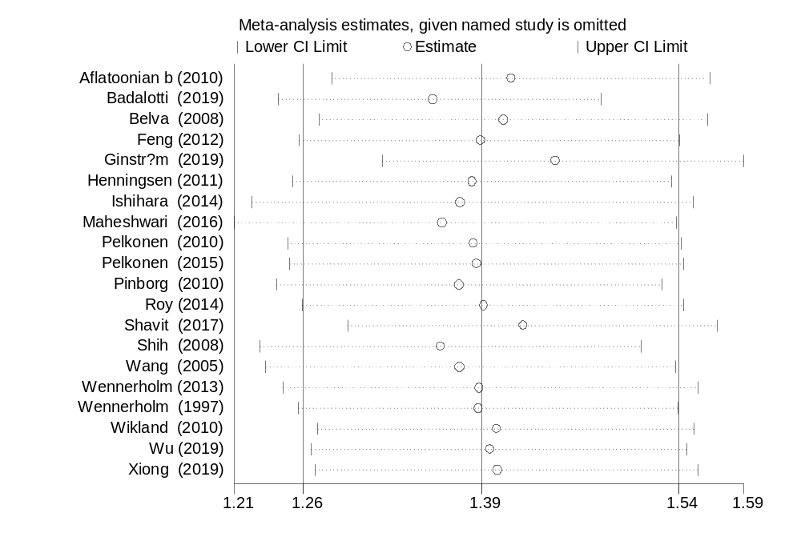
Appendix 49: The sensitivity analysis of LBW showed the pooled proportion when the studies omitted step by step

