Additional File 3: Results from Interviews

1) Stockout times of oxytocin and misoprostol at health facilities in the last 6 months
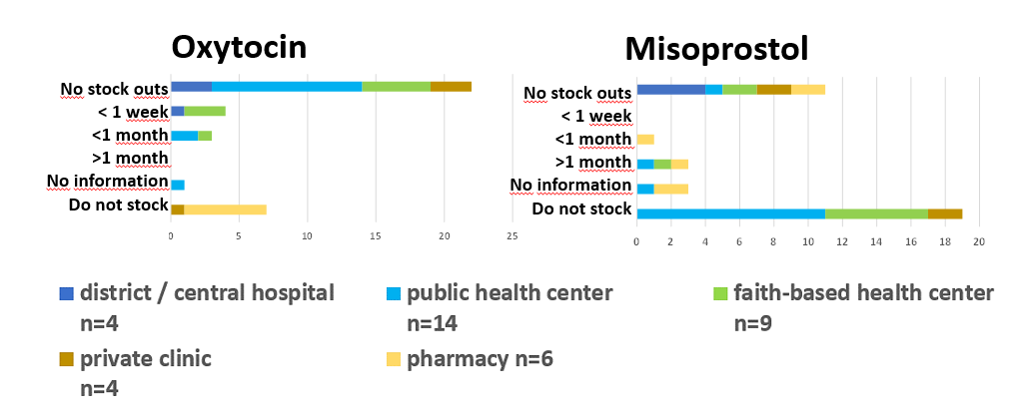
In case of public and faith-based health facilities and private clinics, this information was verified by inspecting the stock cards for the respective medicines. n= number of facilities.

2) Availability of Standard Operating Procedures (SOPs) for (oxytocic) storage
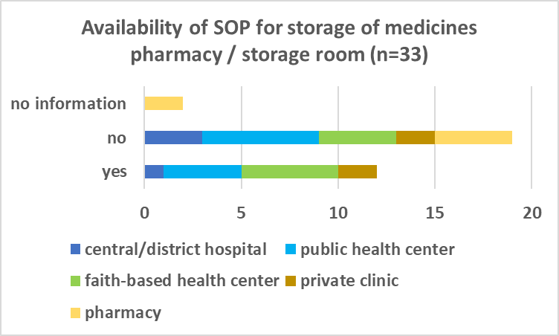
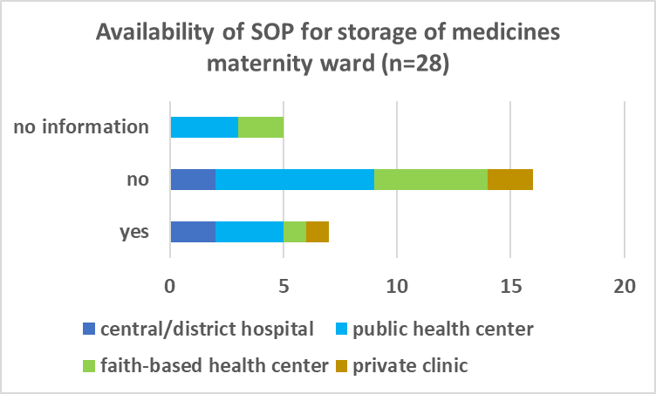
Specific SOPs just for the storage of oxytocin or misoprostol were not available at any health facility /pharmacy.

3) Profession / training level of person responsible for oxytocics / who administers oxytocics
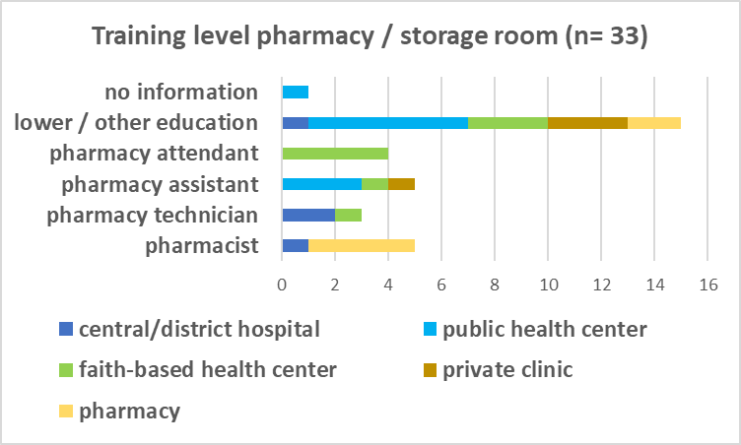
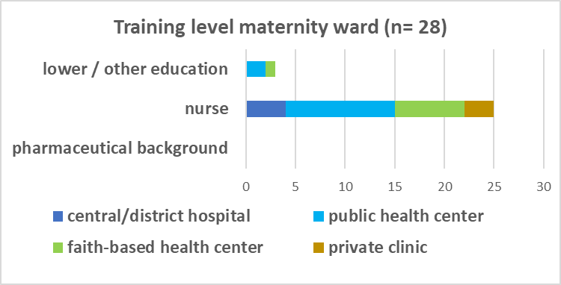

4) Work experience of person responsible for oxytocics / who administers oxytocics
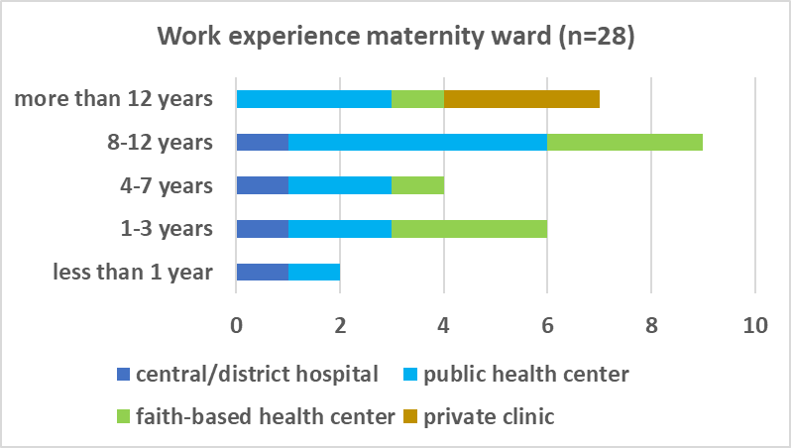
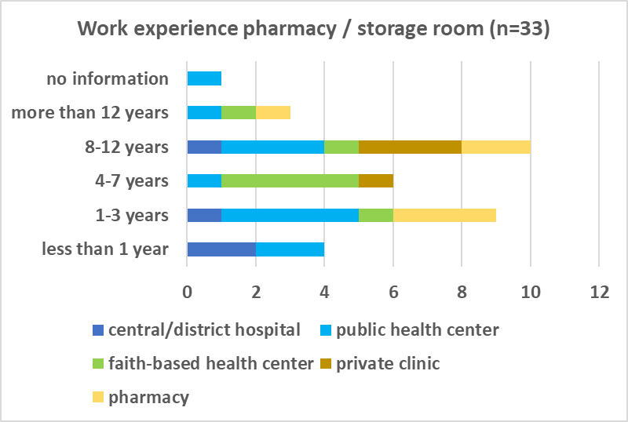

5) Storage of misoprostol
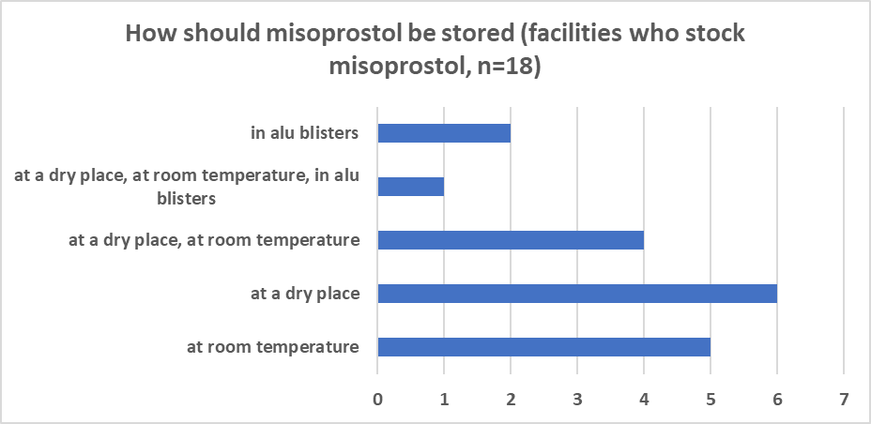
Question as multiple choice. The importance of aluminium /aluminium blisters as primary packaging is not well known (only 3 out of 18 ticked “in aluminium / aluminium blisters”); n= 18 (12 health facilites + 6 pharmacies)

6) At what time do you switch off the fridge in the facility?
One health worker from a public health center ticked “in the evening” on the question “at what time do you switch of the fridge in the facility?”. One health worker from a faith-based health center ticked “over the weekend” when asked this question. All other health worker ticked “never switched off”.

7) When do you give misoprostol do prevent / treat PPH? Multiple answers possible
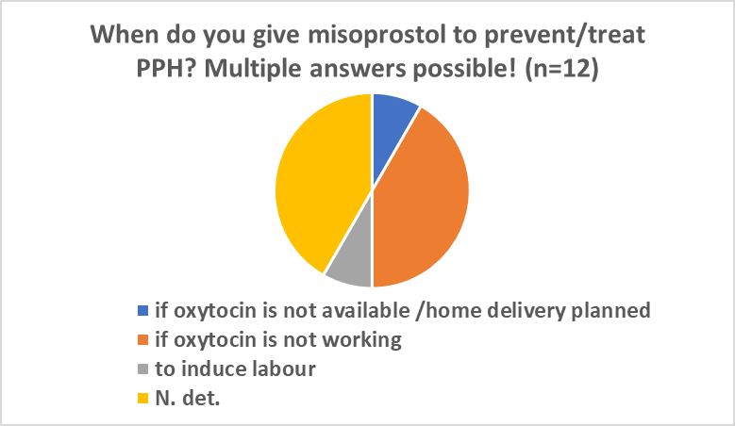
Answers of all 12 health facilities, who stock misoprostol. N.det.: not determined.
8) Numbers of deliveries at health facilities, and PPH rates
Type of facility | Facility number | number of deliveries in the last 6 months | % reported PPH/deliveries last 6 months | have N° of deliveries increased /decreased?
central hospital | 1 | 6768 | N.det. | decreased
district hospital | 2 | 2130 | 3.38 | NA (person new at facility)
district hospital | 3 | 780 | 1.58 | increased
district hospital | 4 | 3847 | 0.94 | increased
public health center | 5 | 260 | 0.38 | N.det.
public health center | 6 | N.det. | N.det. | N.det.
public health center | 7 | 1455 | 1.24 | increased
public health center | 8 | 1680 | 0.36 | increased
public health center | 9 | 520 | N.det. | increased
public health center | 10 | 203 | 0.99 | increased
public health center | 11 | 30 | 33.3 | varies with months
public health center | 12 | 318 | 3.1 | increased
public health center | 13 | 141 | 0 | N.det.
public health center | 14 | 620 | N.det. | increased
public health center | 15 | 330 | 3.3 | increased
public health center | 16 | 540 | 1.1 | N.det.
public health center | 17 | 59 | 3.39 | varies with months
public health center | 18 | N.det. | N.det. | N.det.
faith-based health center | 19 | N.det. | N.det. | N.det.
faith-based health center | 20 | 1293 | 1.47 | increased
faith-based health center | 21 | 1800 | 1.3 | increased
faith-based health center | 22 | 78 | 3.85 | decreased
faith-based health center | 23 | 220 | 0.9 | decreased
faith-based health center | 24 | 290 | 6.21 | decreased
faith-based health center | 25 | 23 | 0 | increased
faith-based health center | 26 | 32 | 6.25 | increased
faith-based health center | 27 | 241 | 0.83 | increased
private clinic | 28 | 15 | 0 | neither
private clinic | 29 | 7 | 0 | decreased
private clinic | 30 | 92 | 0 | N.det.
private clinic | 31 | no delivery services
N.det: not determined. PPH: Post-partum haemorrhage

As reasons for increased numbers of deliveries were mentioned:
- Lack of familiy planning (n=8)
- Increased teenage pregnancies (n=2)
- People prefer delivering in health center rather than at home (n=3)
- Closing of nearby health center (n=1)
As reasons for decreased numbers of deliveries were mentioned:
- Successful family planning campaign (n=2)
- Women are referred to district hospitals due to birth complications (n=1)
- Expensive, people prefer public health center (n=1, private clinic)
- NA (n=1)

