Supplemental Materials
Association between maternal outdoor physical exercise and the risk of preterm birth: a case-control study in Wuhan, China

Miao Cai¹, Bin Zhang², Rong Yang², Tongzhang Zheng³, Guanghui Dong⁴, Hualiang Lin¹, Steven E. Rigdon⁵, Hong Xian⁵, Leslie Hinyard⁶, Pamela K. Xaverius⁵, Echu Liu⁷, Thomas E. Burroughs⁶, Daire R. Jansson⁵, Morgan H. LeBaige⁵, Shaoping Yang^{2*}, Zhengmin Qian^{5*}

- Department of Epidemiology, School of Public Health, Sun Yat-sen University, Guangzhou, Guangdong, 510080, China
- Wuhan Children’s Hospital (Wuhan Maternal and Child Healthcare Hospital), Tongji Medical College, Huazhong University of Science & Technology, Wuhan, Hubei, 430015, China
- Department of Epidemiology Brown School of Public Health, RI 02903, USA
- Department of Toxicology, School of Public Health, Sun Yat-sen University, Guangzhou, Guangdong, 510080 China
- Department of Epidemiology and Biostatistics, College for Public Health & Social Justice, Saint Louis University, Saint Louis, MO 63104 USA
- Center for Health Outcomes Research, Saint Louis University, 3545 Lafayette Avenue, Saint Louis, MO 63104 USA
- Department of Health Management and Policy, College for Public Health and Social Justice, Saint Louis University, Saint Louis MO 63104 USA

Emails for correspondence:
Shaoping Yang, MD, email: 1464502946@qq.com
Zhengmin Qian, MD, PhD,email: zhengmin.qian@slu.edu

Table of Contents | Page
Supplemental Figure 1A: Trace plots of parameters for the five-category physical exercise variable in the Bayesian hierarchical logistic regression | 1
Supplemental Figure 1B: Trace plots of parameters for the splines in the Bayesian generalized additive mixed model | 1
Supplemental Figure 2: Sensitivity analysis on partial effect estimates of maternal physical exercise per day (in minutes) on the probability of preterm birth using different knots. | 2

Supplemental Figure 1A: Trace plots of parameters for the five-category physical exercise variable in the Bayesian hierarchical logistic regression
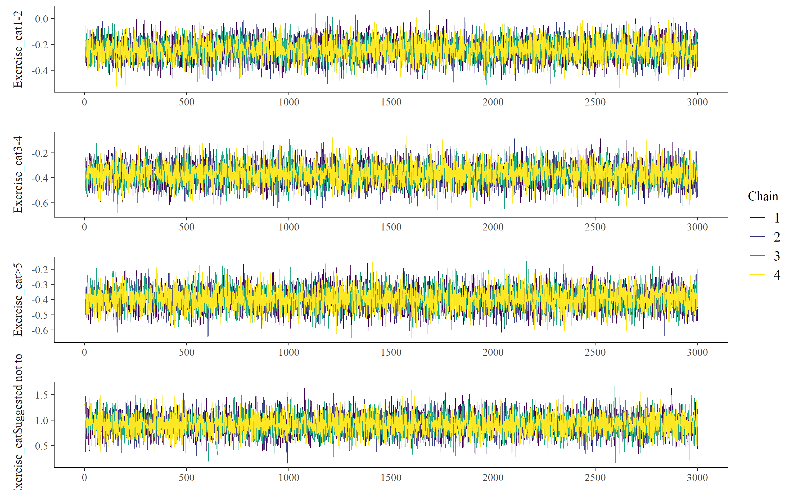
Supplemental Figure 1B: Trace plots of parameters for the splines in the Bayesian generalized additive mixed model
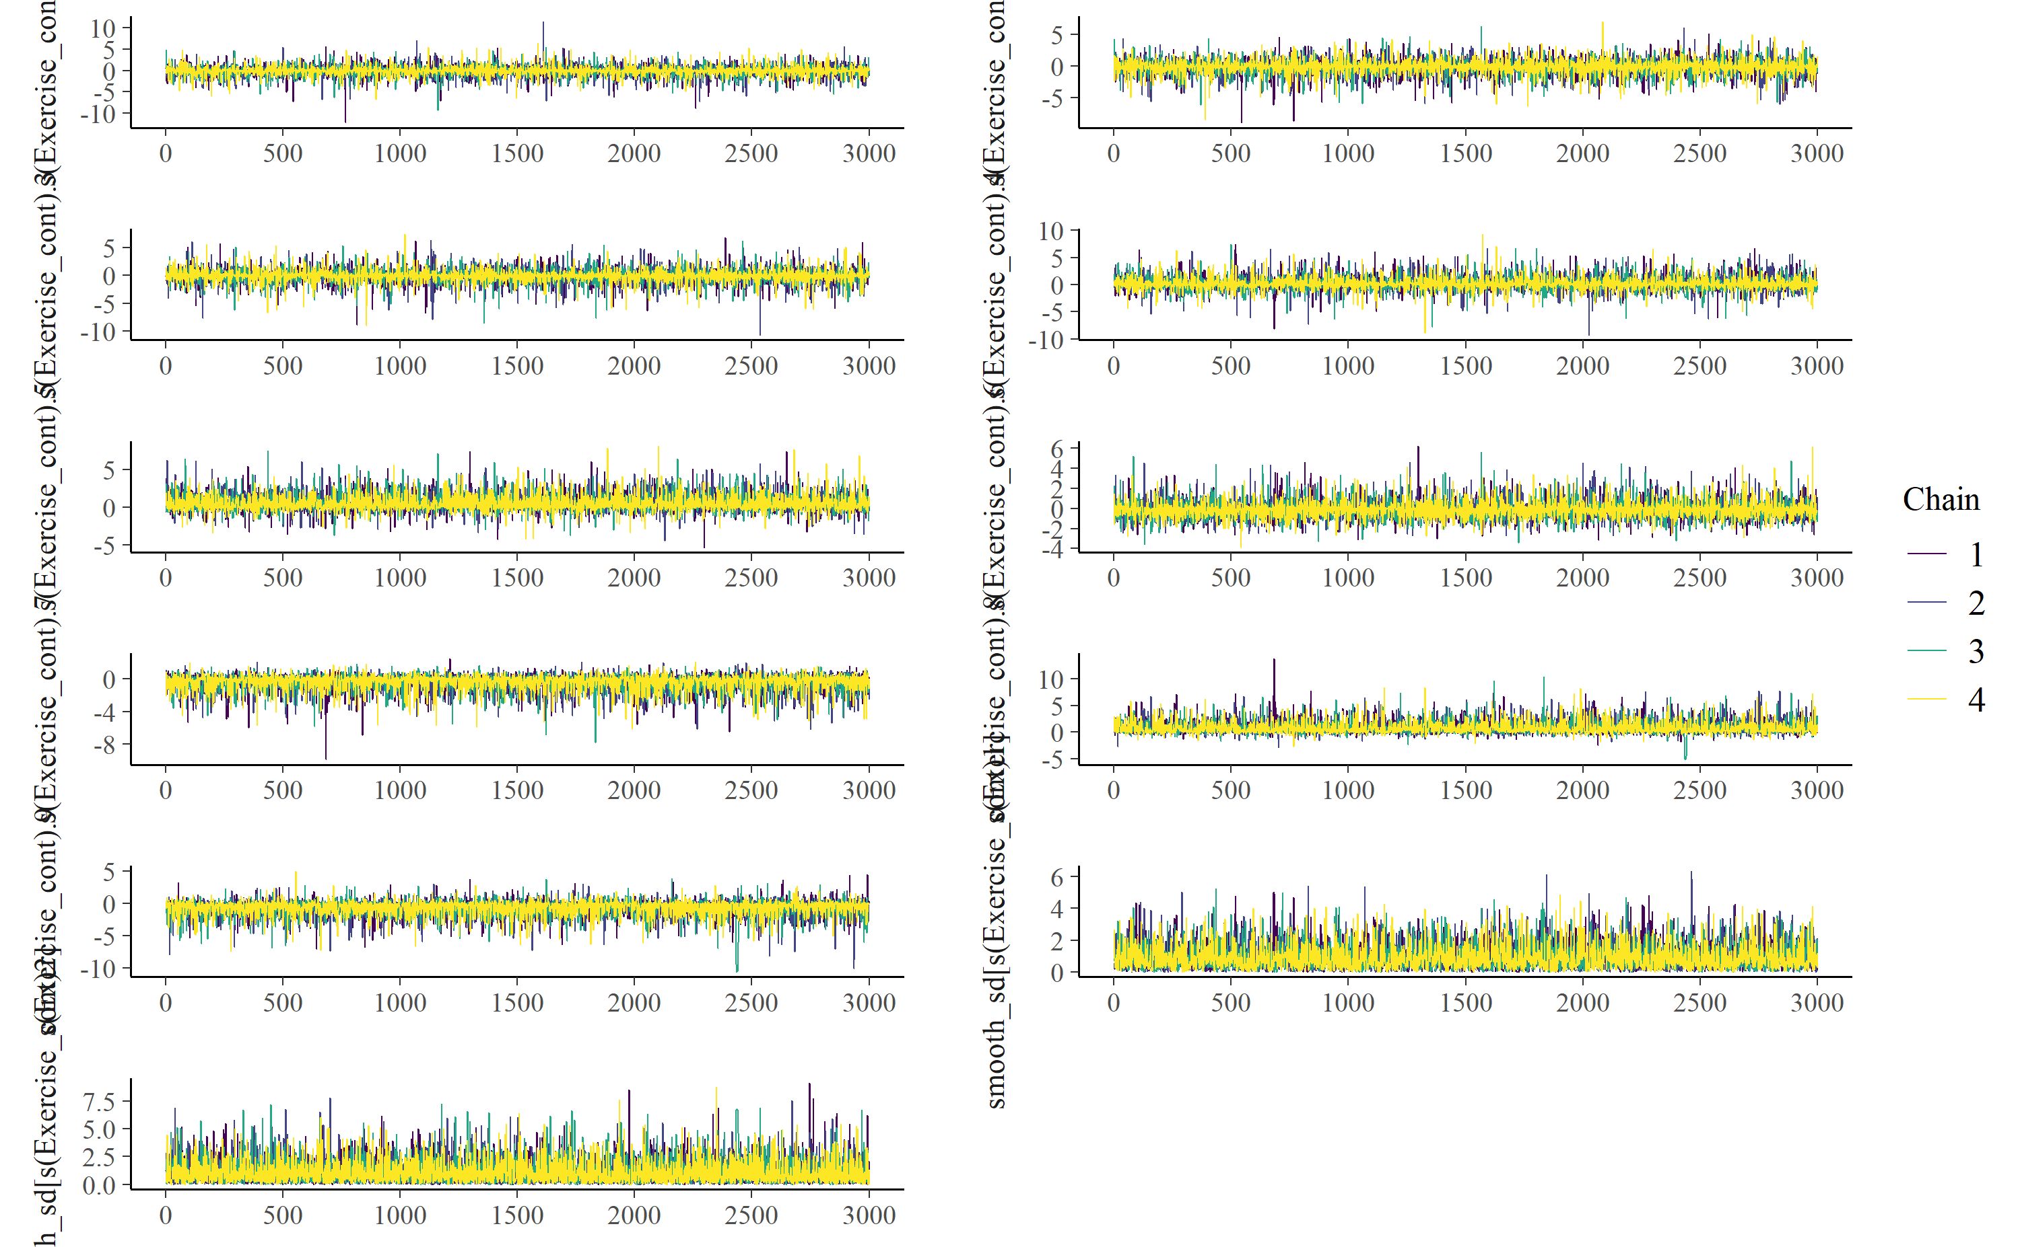
Supplemental Figure 2: Sensitivity analysis on partial effect estimates of maternal physical exercise per day (in minutes) on the probability of preterm birth using different knots.
