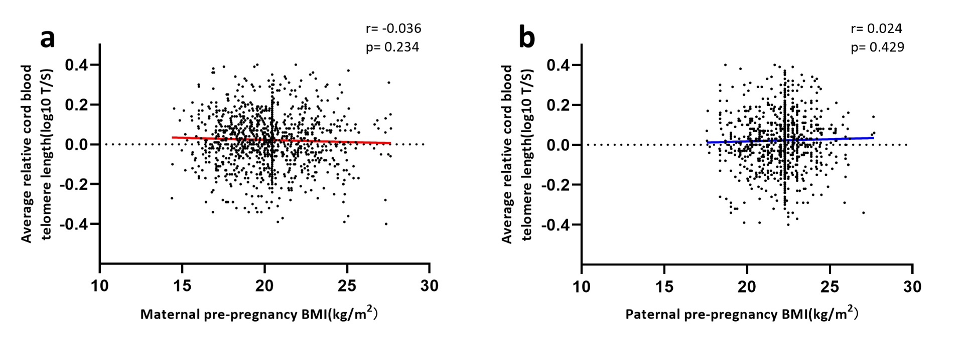
Figure S2. Pearson correlation between parental pre-pregnancy BMI and newborn telomere length. (Relative average telomere lengths were expressed as the ratio of telomere copy number to single-copy gene number (T/S ratio). a Maternal BMI. b Paternal BMI).

