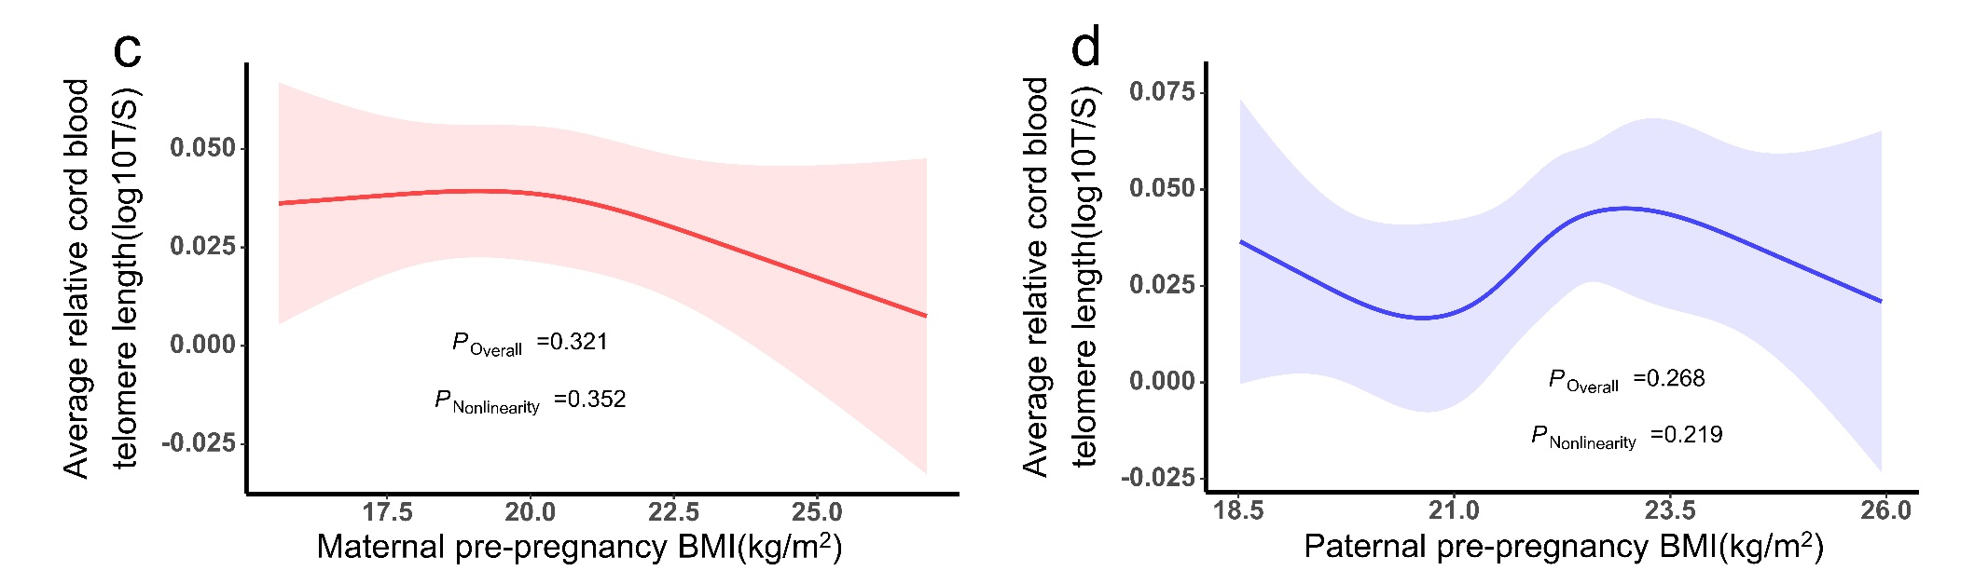
Figure S3. Restricted cubic spline analysis of the correlation between parental BMI and newborn telomere length. (Relative average telomere lengths were expressed as the ratio of telomere copy number to single-copy gene number (T/S ratio). c. Maternal BMI (knots=3). d. Paternal BMI (knots=6).
The number of knots was chosen based on the Akaike information criterion (AIC).
Models adjusted for parental age, newborn factors (sex, gestational age and birth weight). maternal factors (residential place, gravidity, parity, drinking before pregnancy, passive smoking during pregnancy, pregnancy comorbidities or complications, and cesarean section).

