Supplementary Files

Manuscript Title: An Unconditional Prenatal Income Supplement is Associated with Improved Birth and Early Childhood Outcomes among First Nations Children in Manitoba, Canada: A Population-Based Cohort Study
Authors: Jennifer E. Enns, Nathan Nickel, Mariette Chartier, Dan Chateau, Rhonda Campbell, Wanda Phillips-Beck, Joykrishna Sarkar, Elaine Burland, Alan Katz, Rob Santos, Marni Brownell

Supplementary File 1.
List of Datasets from the Manitoba Population Research Data Repository p. 2
Supplementary File 2.
Families First Screening Form p. 3
Supplementary File 3.
List of Study Outcomes p. 5

Supplementary File 1. List of Datasets from the Manitoba Population Research Data Repository
Dataset | Description
Datasets used to identify and describe individuals in the study cohort
Manitoba Health Insurance Registry | Demographic information on Manitoba residents registered for universal healthcare
Canada Census | Small geographical area-level data from the Canada Census, used to create the Socioeconomic Factor Index 2 (SEFI 2), an index of socioeconomic status*
Manitoba First Nations Research File | An official record of persons registered as First Nations individuals under the Indian Act.
Families First Universal Newborn Screen Data | Information on biological, social and demographic factors of Manitoba families, including parents’ ethnic identity, history of alcohol and drug use, mental health disorders, and education.
Healthy Baby Prenatal Benefit Data | Information on biological, social and demographic factors of Manitoba families, including income, marital status, and benefits received.
Early Development Instrument | The Early Development Instrument assesses children’s developmental vulnerability across five domains through a kindergarten teacher-administered questionnaire.
Employment and Income Assistance Data | Demographic information on Manitoba residents who receive financial assistance.
Hospital Discharge Abstracts | Demographic and clinical information on hospitalized patients, including information on births and birth outcomes.
Datasets used to examine birth and early childhood outcomes
Hospital Discharge Abstracts | Demographic and clinical information on hospitalized patients, including information on births and birth outcomes.
Manitoba Immunization Monitoring System | An electronic registry that captures pediatric and adult immunizations.
Early Development Instrument | The Early Development Instrument assesses children’s developmental vulnerability across five domains through a kindergarten teacher-administered questionnaire.
*Chateau D, Metge C, Prior H, Soodeen RA. 2012. Learning from the census: The Socioeconomic Factor Index (SEFI) and health outcomes in Manitoba. Can J Public Health 103(8 Suppl 2): S23-7.

Supplementary File 2. Families First Screening Form
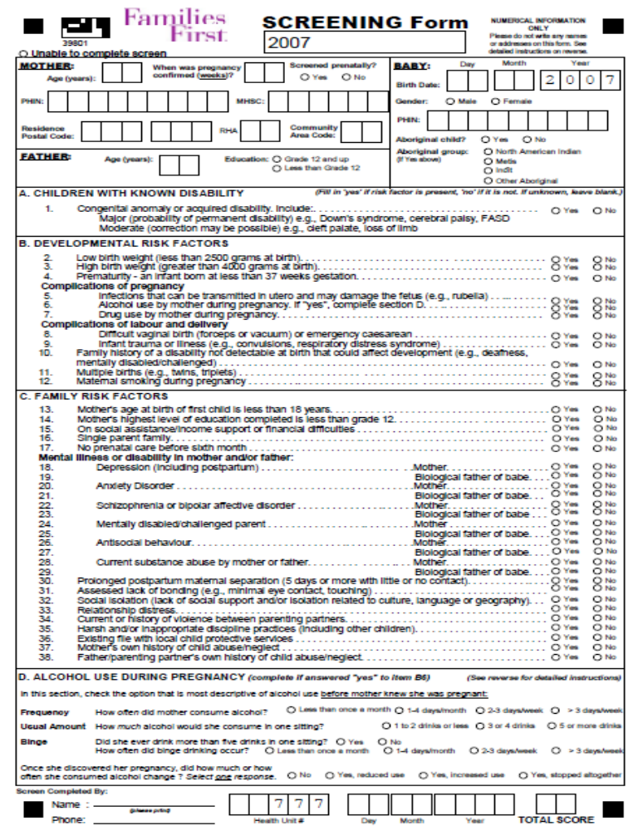
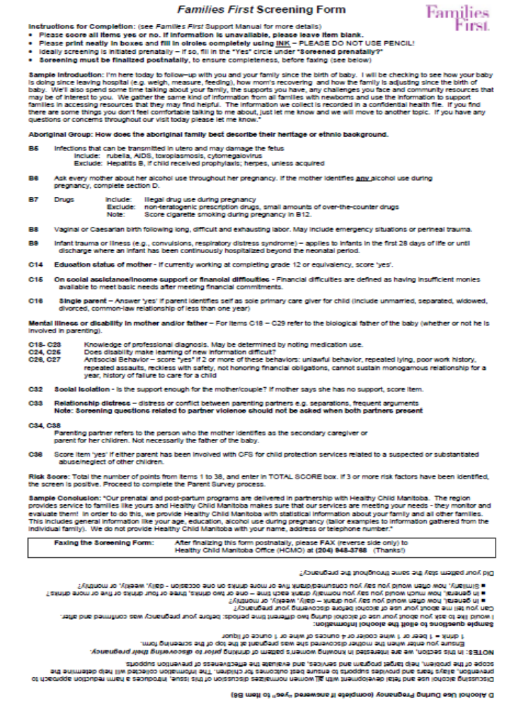
Supplementary File 3. List of Study Outcomes
Outcome | Definition
Low birth weight | <2500 g at birth
Preterm birth | <37 week gestational age
Small for gestational age | <10th percentile for gestational age and gender using Canadian standardª
Large for gestational age | >90th percentile for gestational age and gender using Canadian standardª
5-min Apgar score | Apgar score dichotomized into ≤7 and ≥8
Breastfeeding initiation | Exclusive or partial breastfeeding at hospital discharge
Hospital readmission | Readmission to any Manitoba hospital within 28 days or 2 years of birth
Length of stay of birth hospitalization | Length of hospital stay at birth (continuous measure calculated separately for infants delivered vaginally and by caesarean delivery due to different stays expected for these groups)
Complete childhood immunization | Received complete series of recommended vaccinations from birth to age 1 and 2 using the Manitoba immunization schedule^{b}
Developmental vulnerability at kindergarten | Readiness in five developmental domains in Kindergarten, as measured by the Early Development Instrument: 1) physical health and well-being, 2) social competence, 3) emotional maturity, 4) language and cognitive development, and 5) communication skills and general knowledge
ª Kramer et al. (2001).
^{b} https://www.gov.mb.ca/health/publichealth/cdc/div/schedules.html#child

