Title Page for Table S1

Antenatal management and maternal/fetal outcomes associated with hyperglycaemia in pregnancy (HIP) in Uganda; a prospective cohort study

Jack Milln (MBBS)^{1,2}* and Betty Nakabuye (MMED)^{3,4}, Barnabas Kahiira Natamba (PhD)¹, Isaac Sekitoleko (MSc)¹, Michael Mubiru (BSc)¹, Arthur Araali Namara (MSc)¹, Samuel Tumwesigire (MBchB)¹, Salome Tino (MPH)¹, Mandy Mirembe (MSc)¹, Ayoub Kakande (MSc)¹, Brian Agaba (MMED)³, Faridah Nansubuga (MMED)⁵, Daniel Zaake (MMED)⁵, Ben Ayiko (MMED)⁶, Herbert Kalema (MMED)⁷, Sarah Nakubulwa (PhD)^{8,9}, Musa Sekikubo (PhD)^{8,9}, Annettee Nakimuli (PhD)^{8,9}, Emily L Webb (PhD)¹⁰, Moffat J Nyirenda (PhD)^{1,10}

¹ Non-Communicable Diseases Theme, Medical Research Council/Uganda Virus Research Institute and London School of Hygiene and Tropical Medicine (MRC/UVRI & LSHTM) Uganda Research Unit, Plot 51-59, Nakiwogo Road, P. O. BOX 49, Entebbe, Uganda.
² Department of Endocrinology and Diabetes, Queen Mary University of London, Mile End Road, London, UK.
³ Rubaga Uganda Martyrs Hospital, Kampala, Uganda.
⁴ School of Public Health, Makerere University College of Health Sciences, Kampala, Uganda
⁵ St. Francis Hospital, Nsambya, Kampala, Uganda
⁶ Entebbe Regional Referral Hospital, Entebbe, Uganda
⁷ Masaka Regional Referral Hospital, Masaka, Uganda
⁸ Department of Obstetrics and Gynaecology, School of Medicine, Makerere University College of Health Sciences, Kampala, Uganda

⁹ Kawempe National Referral Hospital, Kampala, Uganda
¹⁰ London School of Hygiene and Tropical Medicine (LSHTM), London, UK
* Corresponding author

Corresponding author:

Dr Jack Milln
MRC/UVRI & LSHTM Uganda Research Unit, Plot 51-59, Nakiwogo Road, P. O. BOX 49, Entebbe, Uganda.
Tel.: +256 793 392872. No fax available
jackmilln@doctors.org.uk

Table S1:
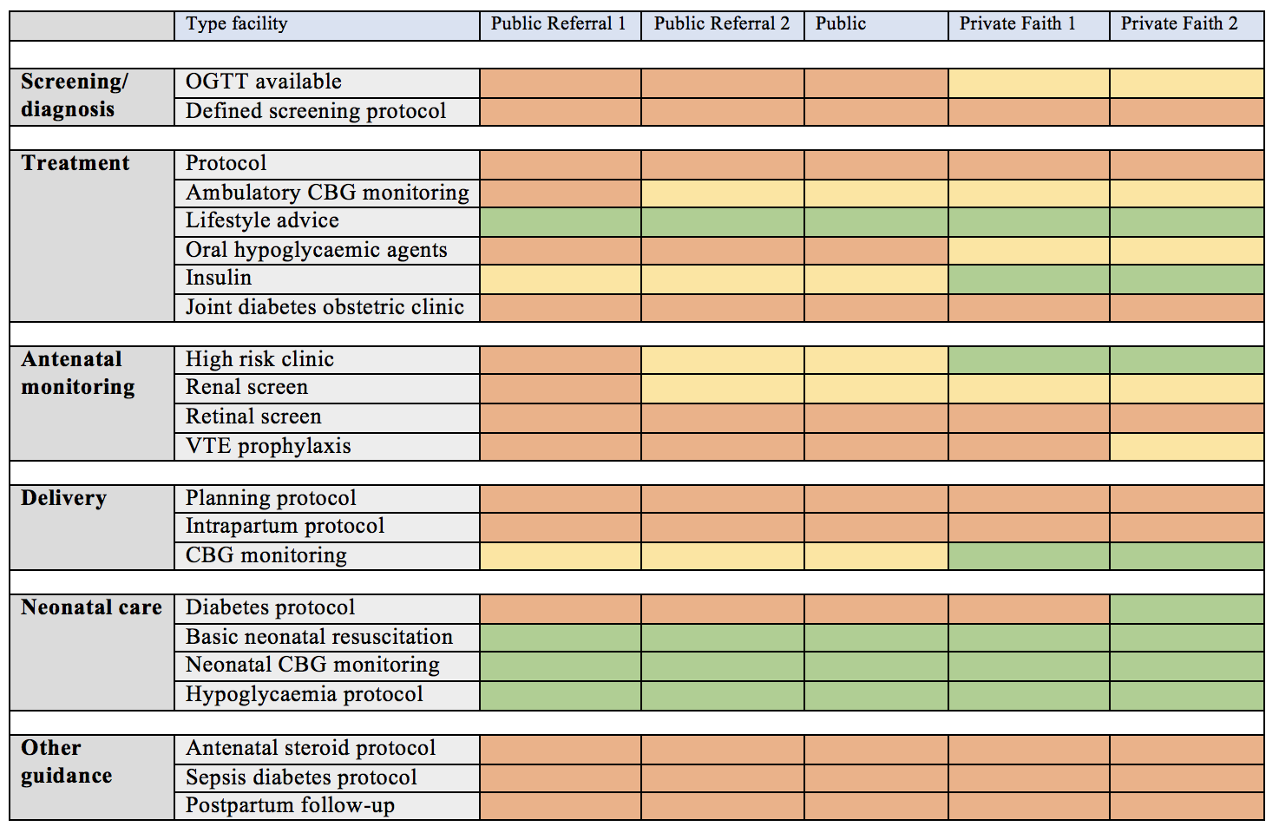

Table S1: Summary of diabetes antenatal management at five study sites prior to commencement of the study. Red, absent at the facility; yellow, occasionally done but without documentation of guidelines; green, regularly done and documentation of guidelines present. CBG, capillary blood glucose.

