Supplementary file 2

Inter-hospital and inter-disciplinary variation in planned birth practices and readiness for change: a survey study

Coates, Dominiek^{1, 2} (Corresponding author) Correspondence to Dominiek.Coates@uts.edu.au
Donnolley, Natasha⁴
Foureur, Maralyn^{8, 5}
Henry, Amanda^{3, 6, 7}

¹University of Technology Sydney, Faculty of Health, Centre for Midwifery and Child and Family Health

²Maridulu Budyari Gumal, the Sydney Partnership for Health, Education, Research and Enterprise (SPHERE)

³ School of Women's and Children's Health, UNSW Medicine, UNSW, Sydney, Australia

⁴ National Perinatal Epidemiology and Statistics Unit, Centre for Big Data Research in Health, UNSW, Sydney, Australia

⁵University of Newcastle, Faculty of Health and Medicine, Australia

⁶ Department of Women's and Children's Health, St George Hospital, Sydney, Australia

⁷ The George Institute for Global Health, UNSW Medicine, Australia

⁸Hunter New England Nursing and Midwifery Research Centre, Australia

Supplementary figures to Table 3

Survey respondents’ perceptions of practices in relation to the timing of IOL – average and range of responses between units

Respondents were asked to choose the single most correct option, assuming for each indication that it is the only reason for IOL, and that the woman does not have a contraindication to vaginal birth. Please note, the “not a reason for IOL” option does not mean women in your unit are never induced for this reason: it indicates that it is not standard practice to induce for this reason/IOL for this reason would only be on a case by case basis.

Suspected macrosomia
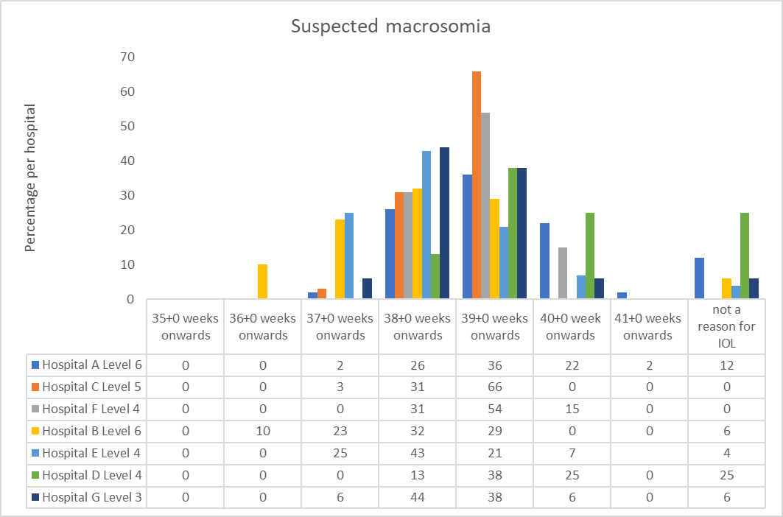

Request for IOL without medical indications
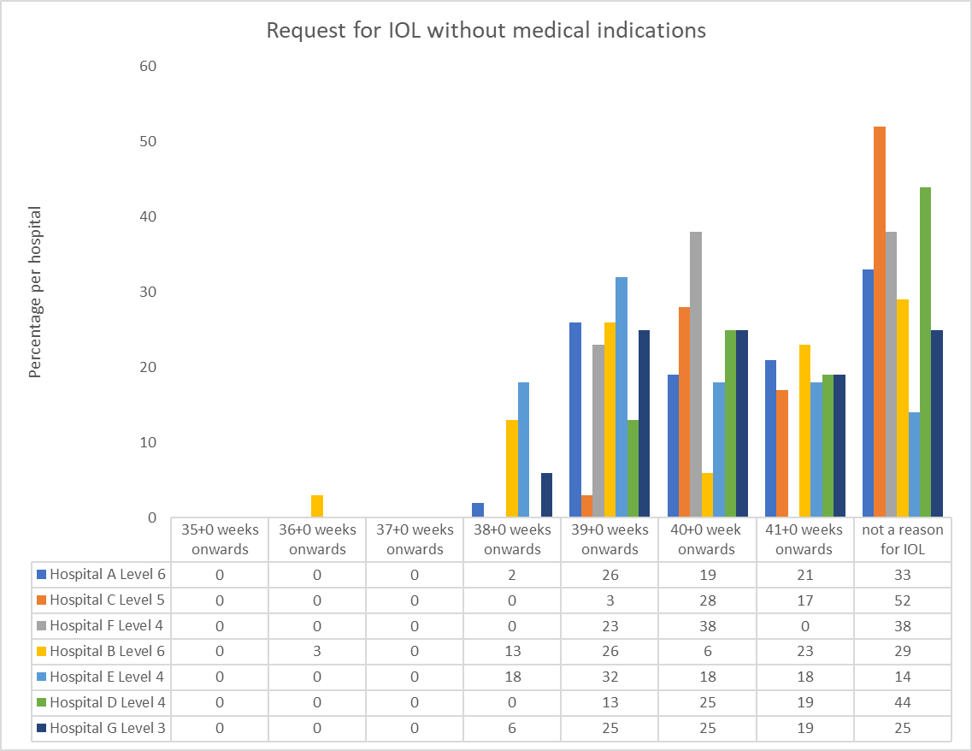

Gestational diabetes that is diet controlled
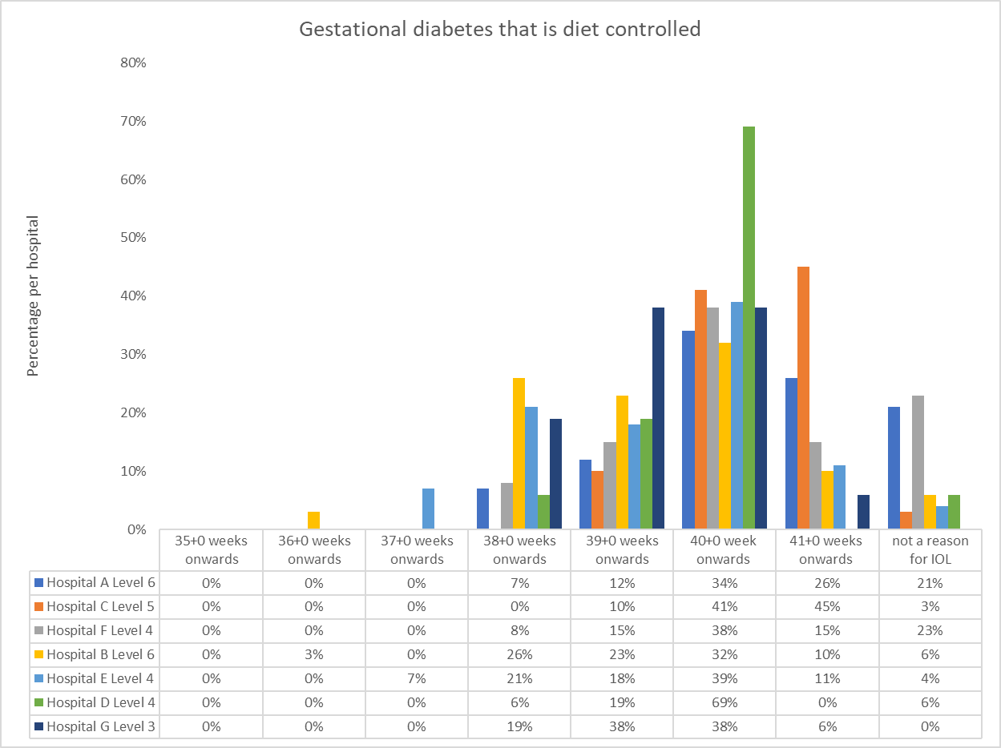

Gestational diabetes managed with oral hypoglycaemics (e.g. metformin)

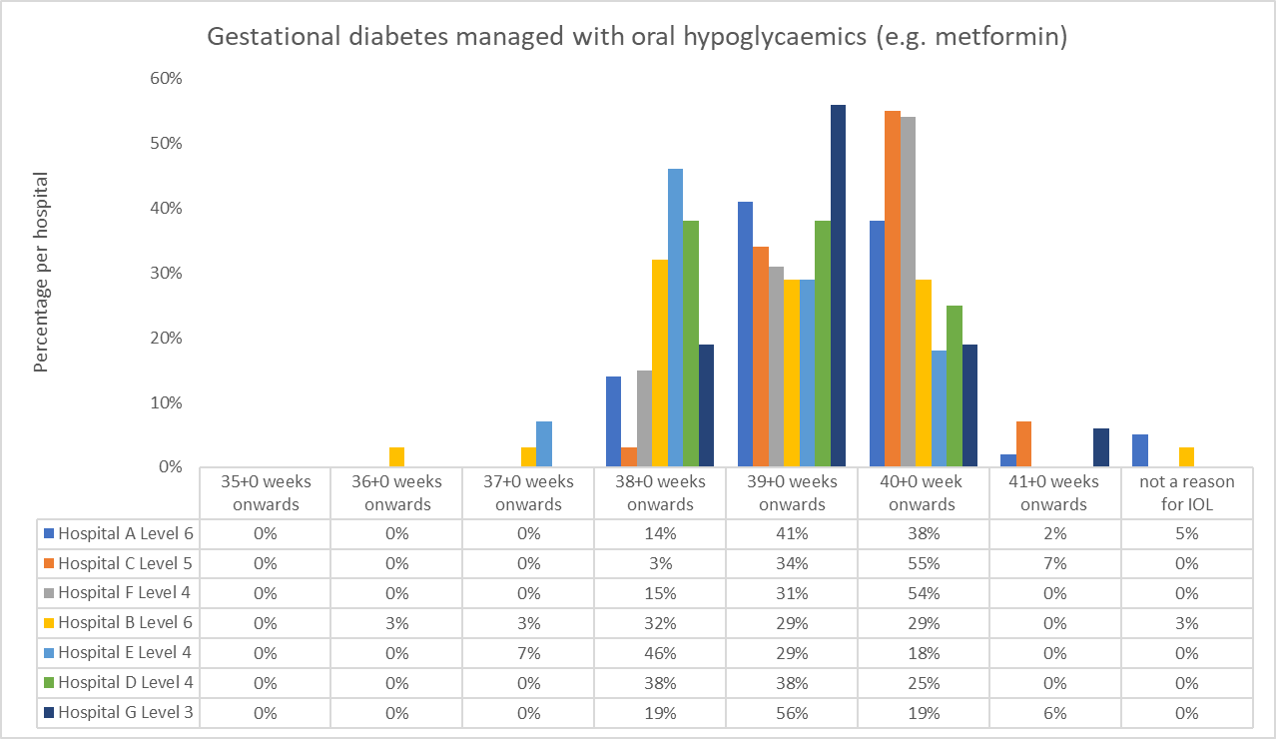

Insulin-dependent gestational diabetes (not pre-pregnancy Type I or II)

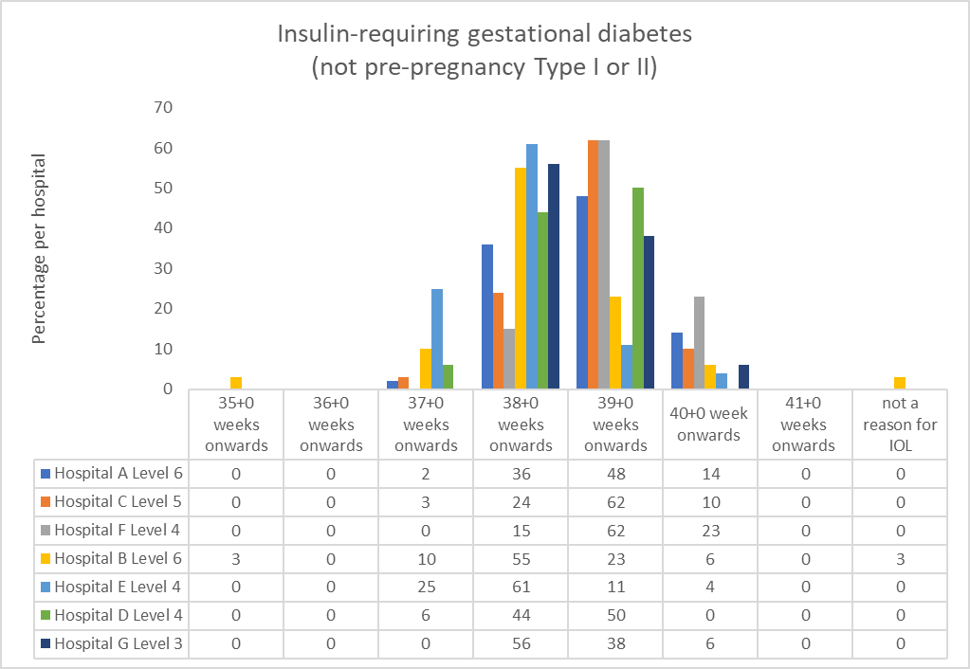

Pre-pregnancy diabetes, Type I
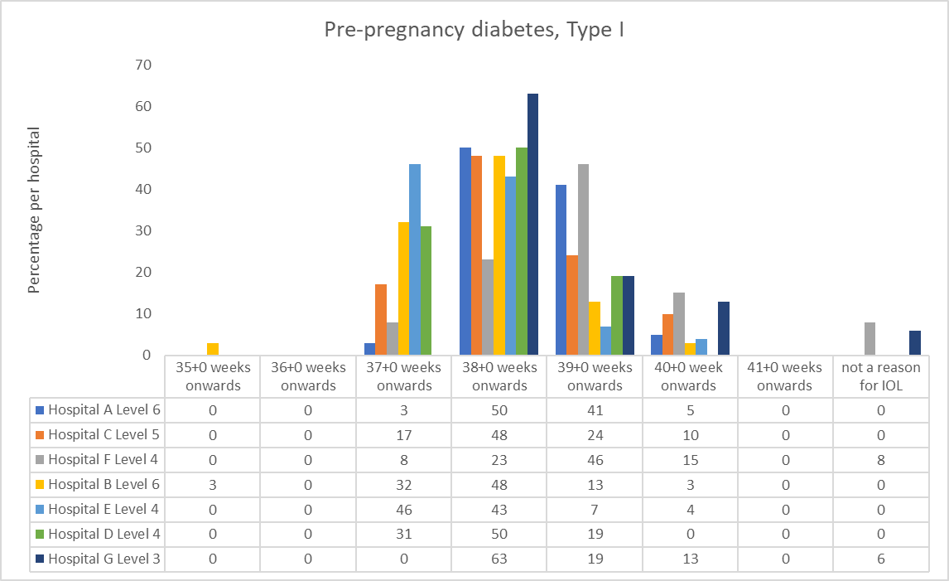

Pre-pregnancy diabetes, Type II
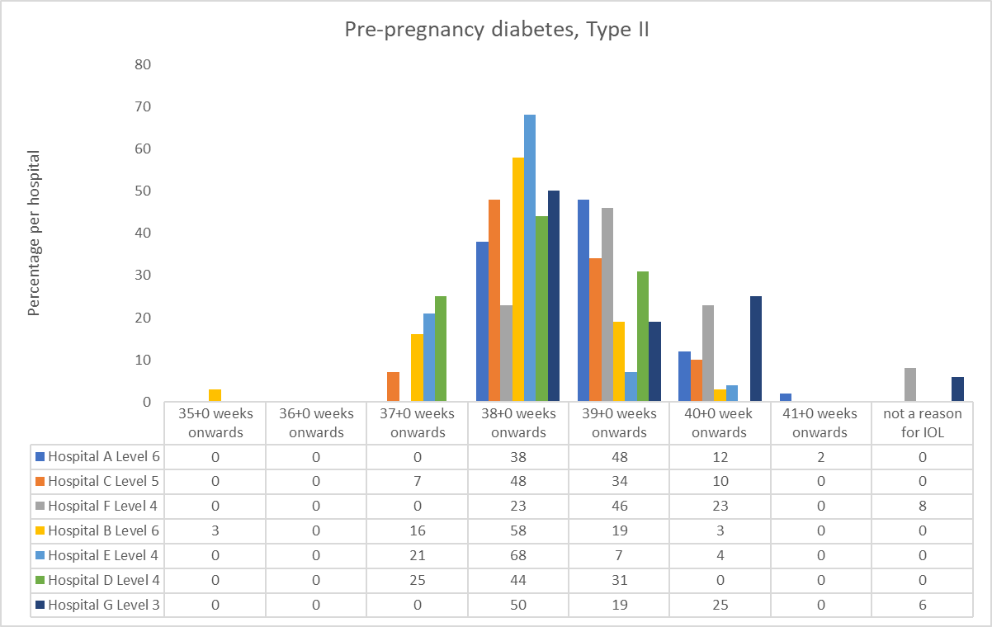

Gestational hypertension (new-onset high blood pressure after 20 weeks, no preeclampsia)
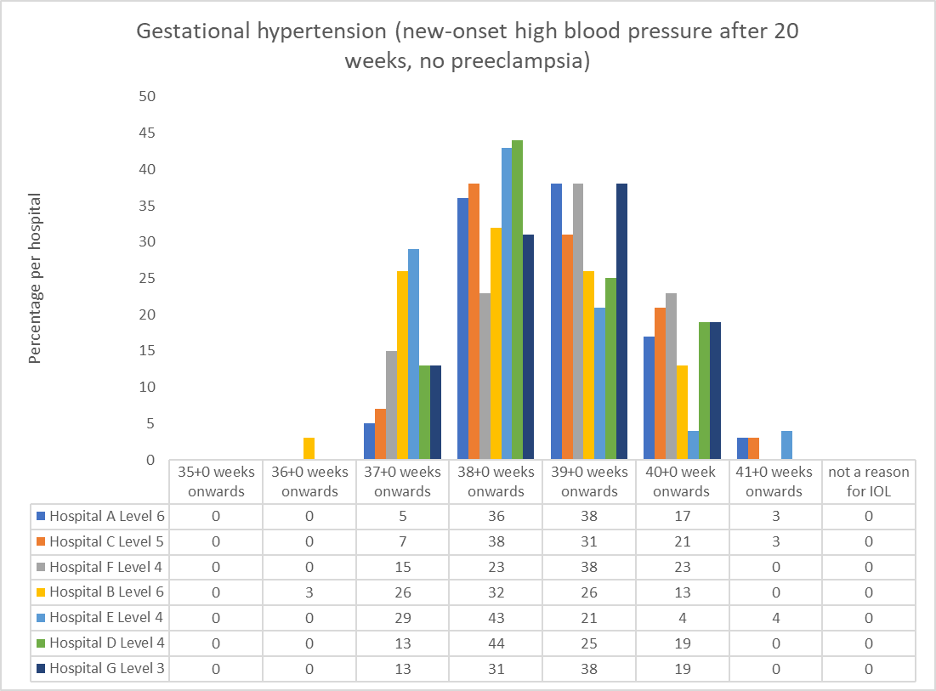

Chronic/essential hypertension
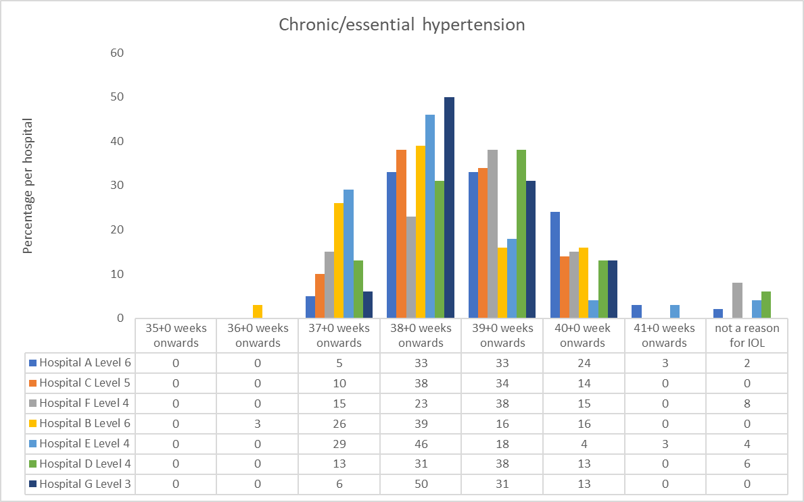

Preeclampsia (assume no urgent indication for birth)
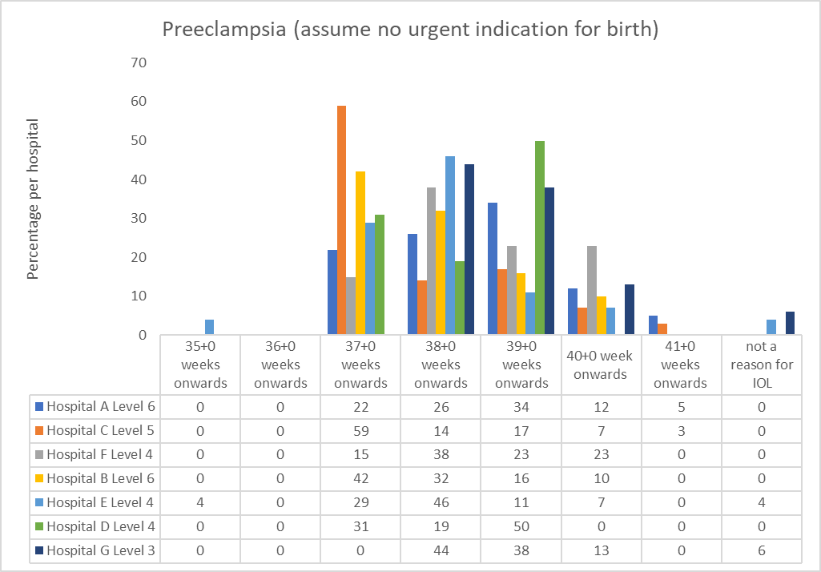

Uncomplicated monochorionic diamniotic (MCDA) twin pregnancies (if vaginal birth is planned)
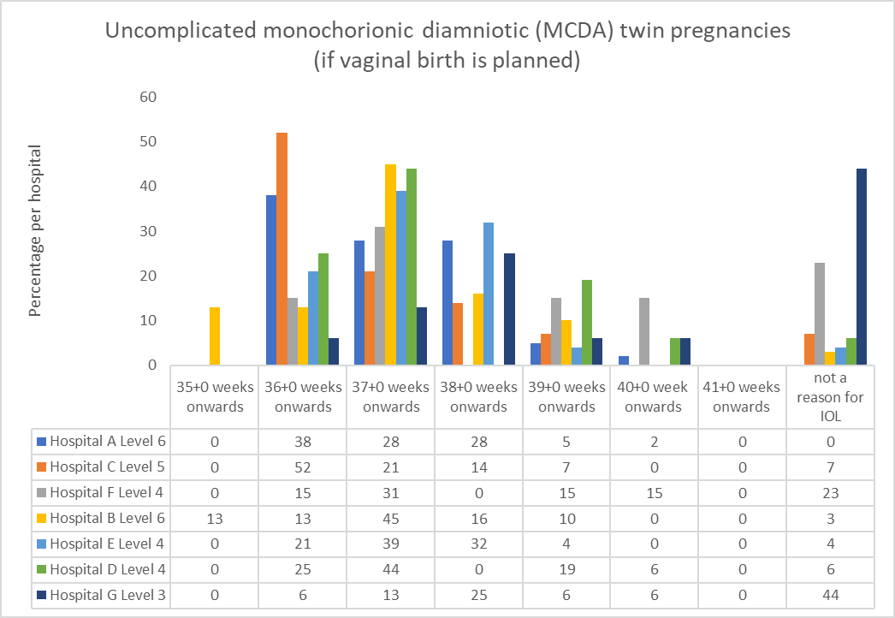

Uncomplicated dichorionic diamniotic (DCDA) twin pregnancies (if vaginal birth is planned)
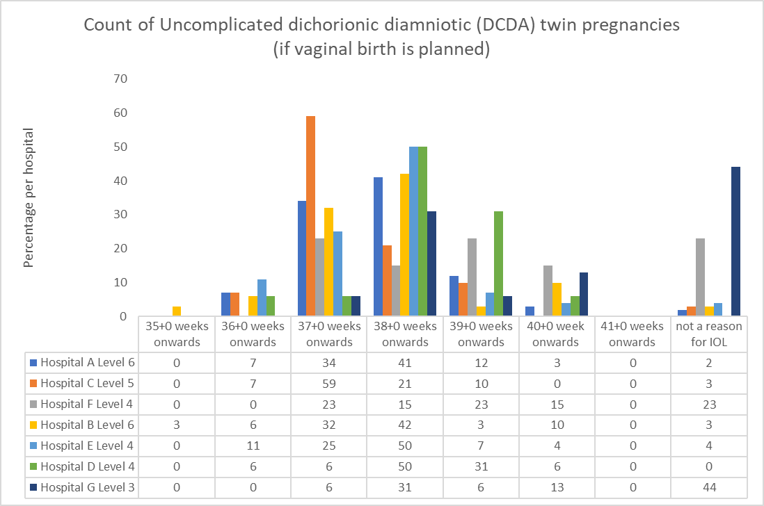

Cholestasis of pregnancy
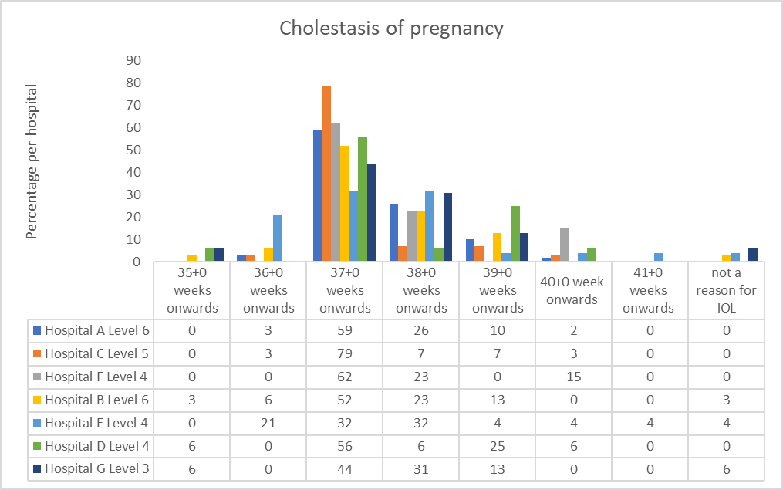

Maternal age of 40 and over
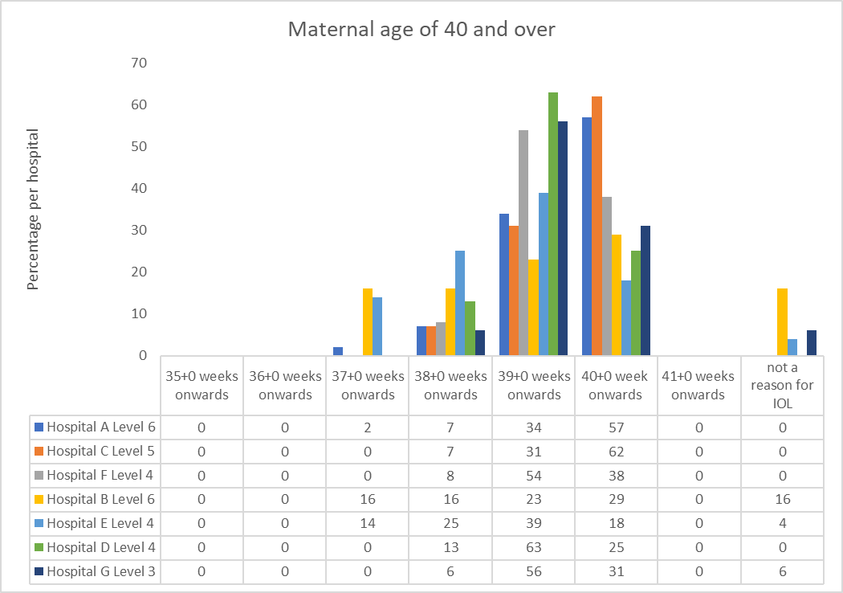

Substantially elevated BMI (> 40 kg/m2)
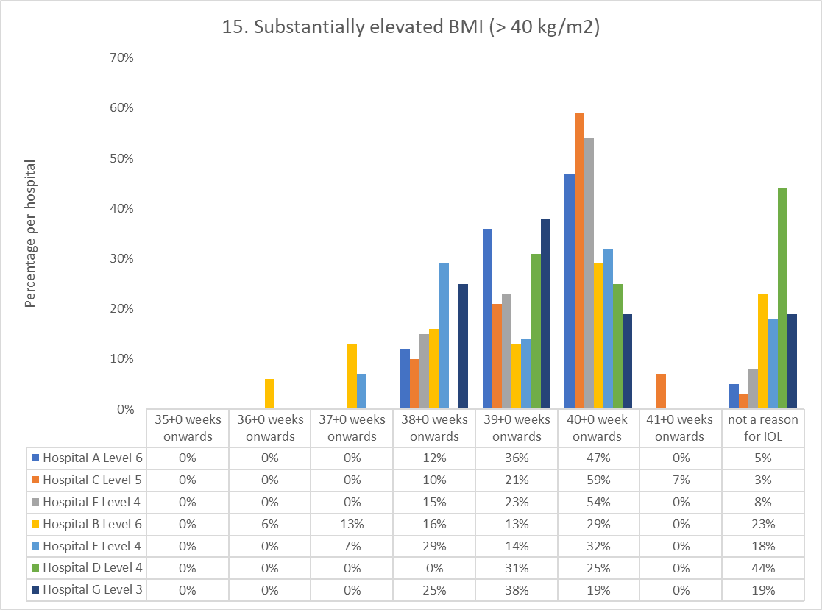

Supplementary figures to Table 4

Survey respondents’ perceptions of practices in their unit in relation to the timing of IOL for prelabour rupture of membranes (PROM) women with no other complications or signs of chorioamnionitis

At term (37+0) who are Group B streptococcus positive

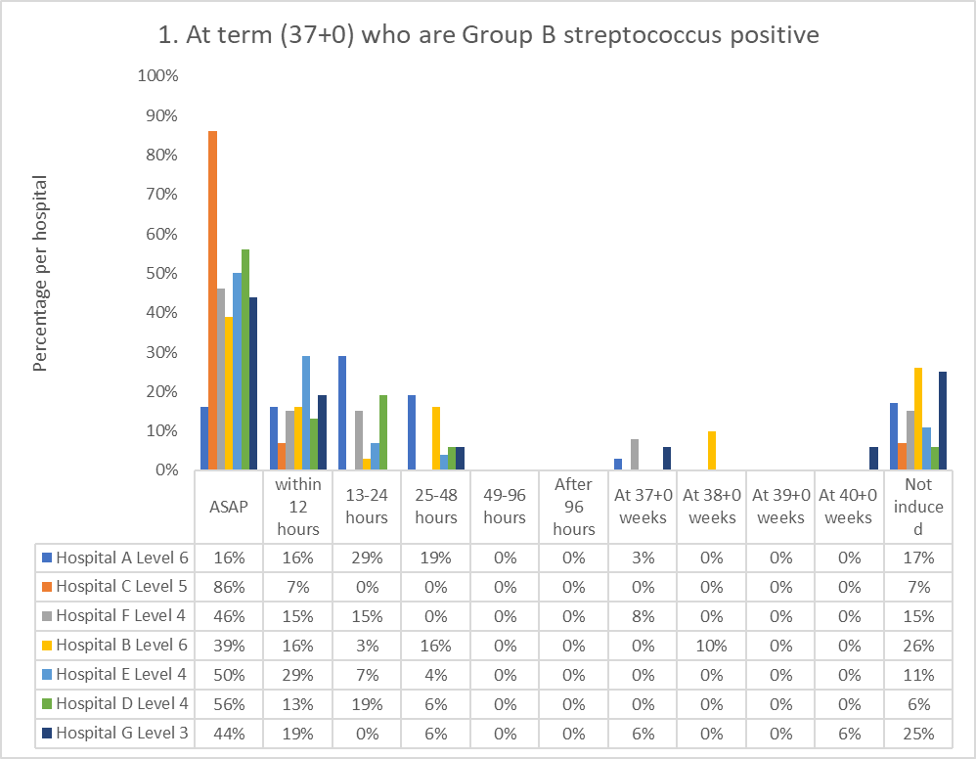

At term (>37+0) who are Group B streptococcus negative
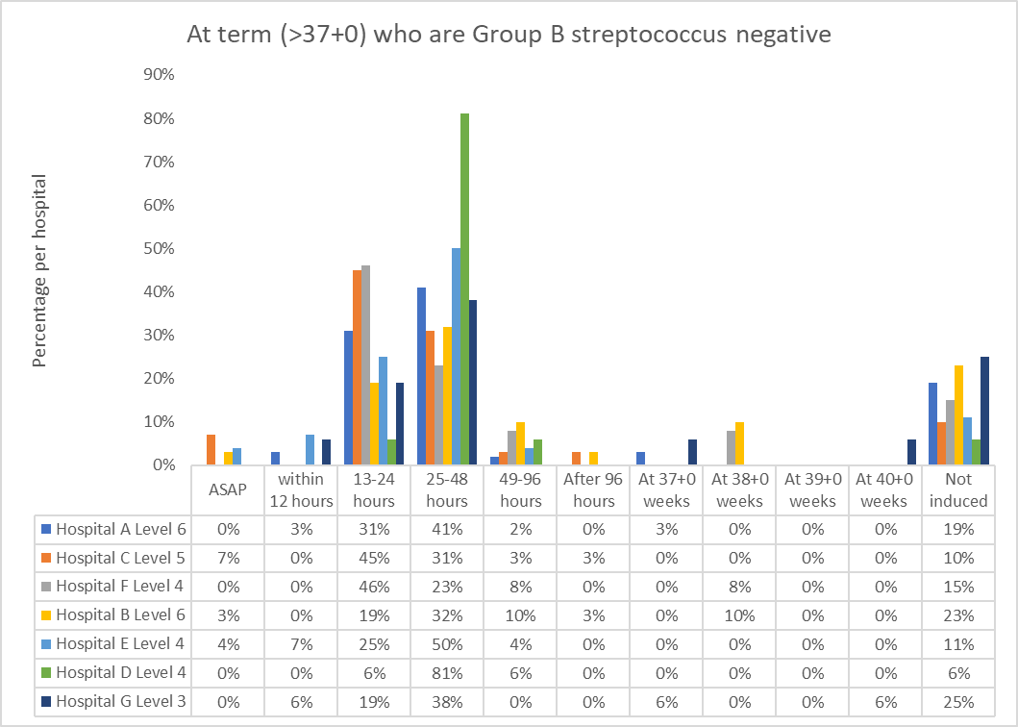

Late preterm (34+0 - 36+6 weeks) who are Group B streptococcus positive
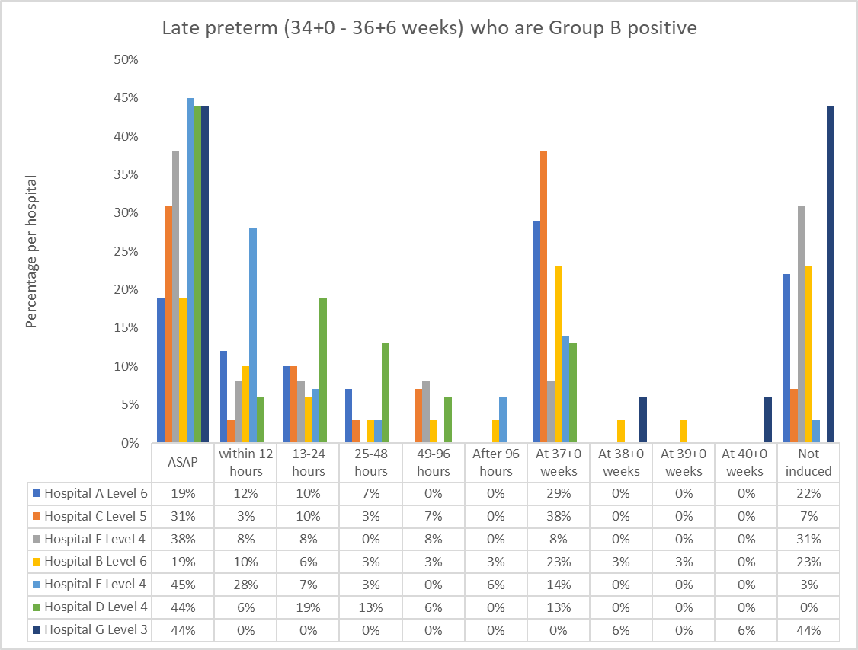

Late preterm (34+0-36+6 weeks) who are Group B streptococcus negative
