 | Pregnant/Postpartum women | OBGYN doctors’ clinics/hospitals
Metropolitan cities | N (%) | N (%)
Seoul | 236 (45.2%) | 141(37.8%)
Gyeonggi | 124 (23.8%) | 83(22.3%)
Other cities (Incheon, Daejeon,  Gwangju, Busan, Ulsan, Daegu) | 62 (11.9%) | 78(20.9%)
Non-metropolitan cities
Chungcheong | 9 (1.7%) | 24(6.4%)
Gyeongsang | 10 (1.9%) | 28(7.5%)
Jeolla | 19 (3.6%) | 8(2.1%)
Gangwon | 23 (4.4%) | 4(1.1%)
Jeju | 39 (7.5%) | 7(1.9%)

S5. Geographical distributions of respondents

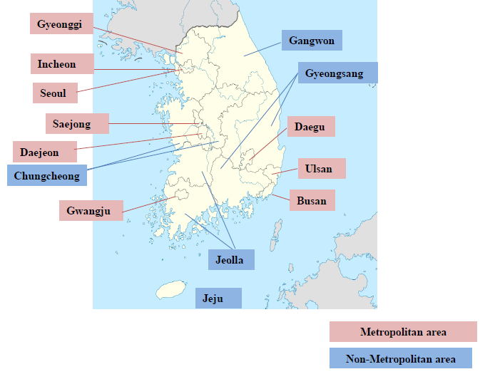
This map is edited from the map in Wikimedia Commons.

