Supplementary Files
ST1: Women of childbearing age of RCGP RSC cohort registered each year.

Year | Denominator
2004 | 502,783
2005 | 535,266
2006 | 555,876
2007 | 574,413
2008 | 589,540
2009 | 598,973
2010 | 609,125
2011 | 623,279
2012 | 638,295
2013 | 654,442
2014 | 674,969
2015 | 693,886
2016 | 702,854
2017 | 574,413
2018 | 589,540

SF1: Prescription of valproate to women of childbearing age in the general population divided in four age groups.
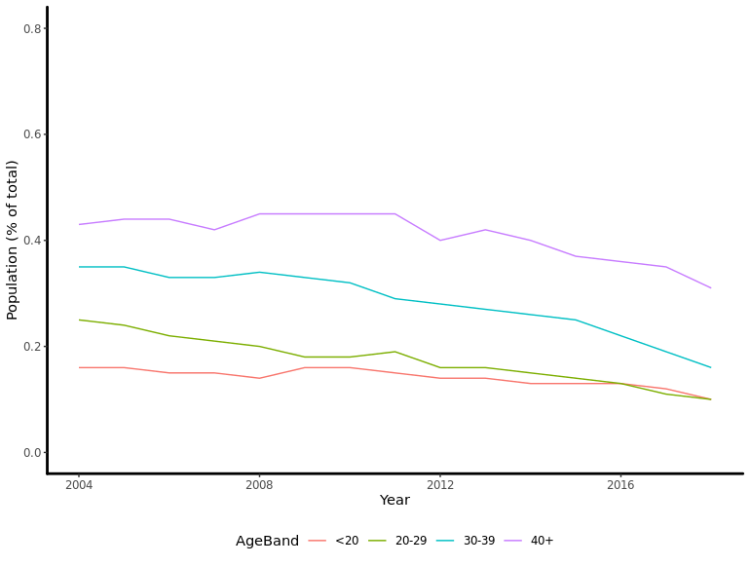

SF2: Trends over time of contraception prescription to women of childbearing age using valproate.
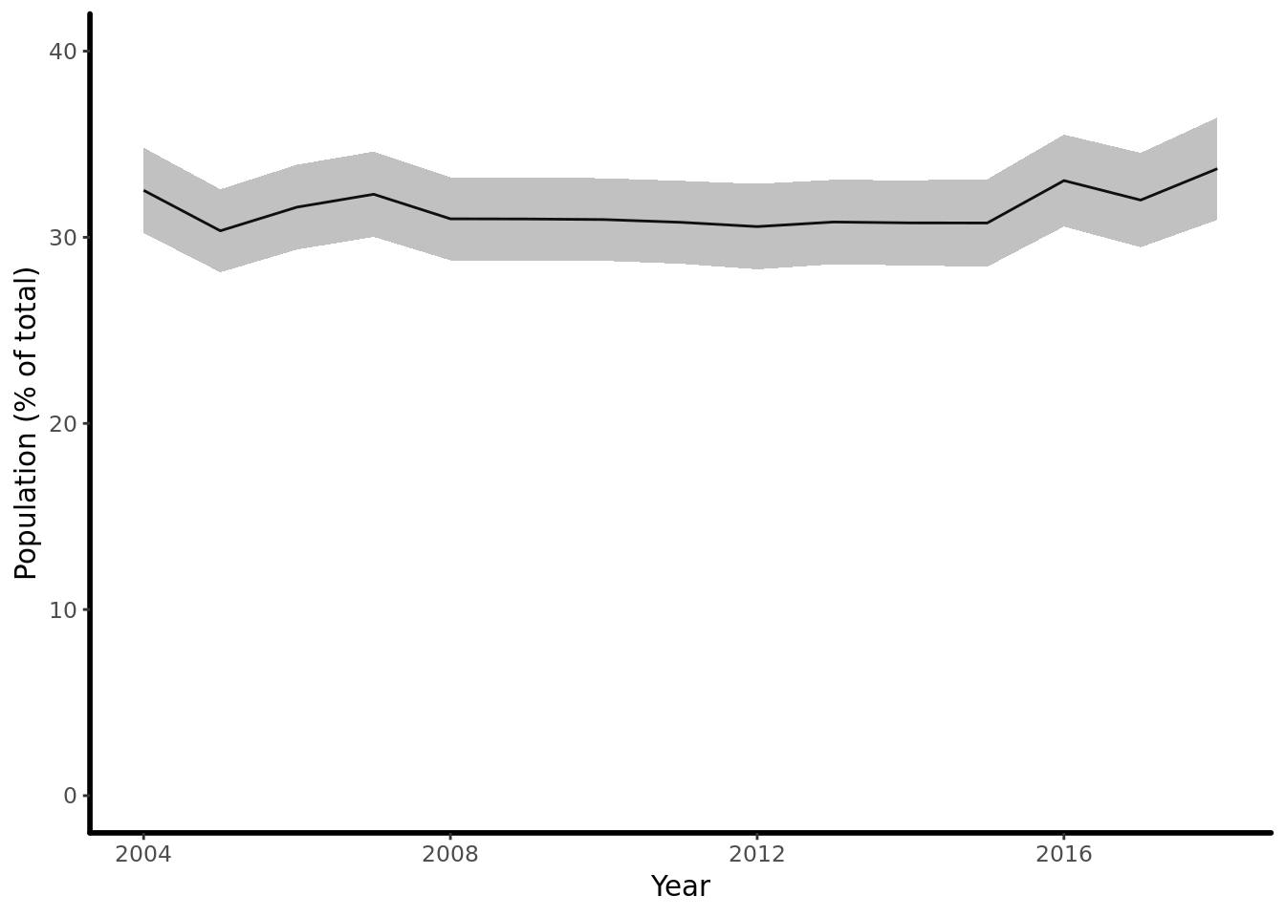

ST2: Adjusted odds ratios of contraception patterns among pathologies and valproate prescription. Covariates adjusted for: age; deprivation quintile; smoking status; epilepsy; bipolar disease; migraine.
Association with contraception | Odds Ratio | 95%CI | P value
Women prescribed valproate | 1.41 | (1.23-1.61) | <0.001

