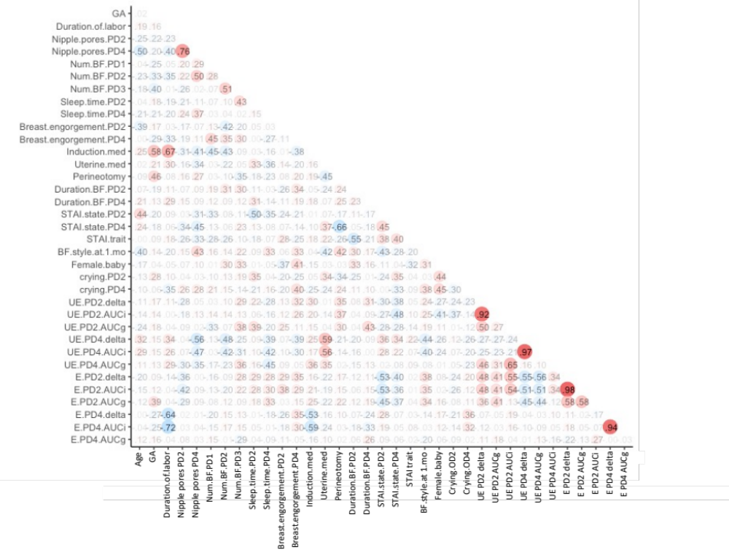
Supplementary Figure S1. Pearson’s correlation coefficients matrix. The size and color of the circles reflect correlation coefficients for each combination of the correlation analysis.

