Supplementary Material

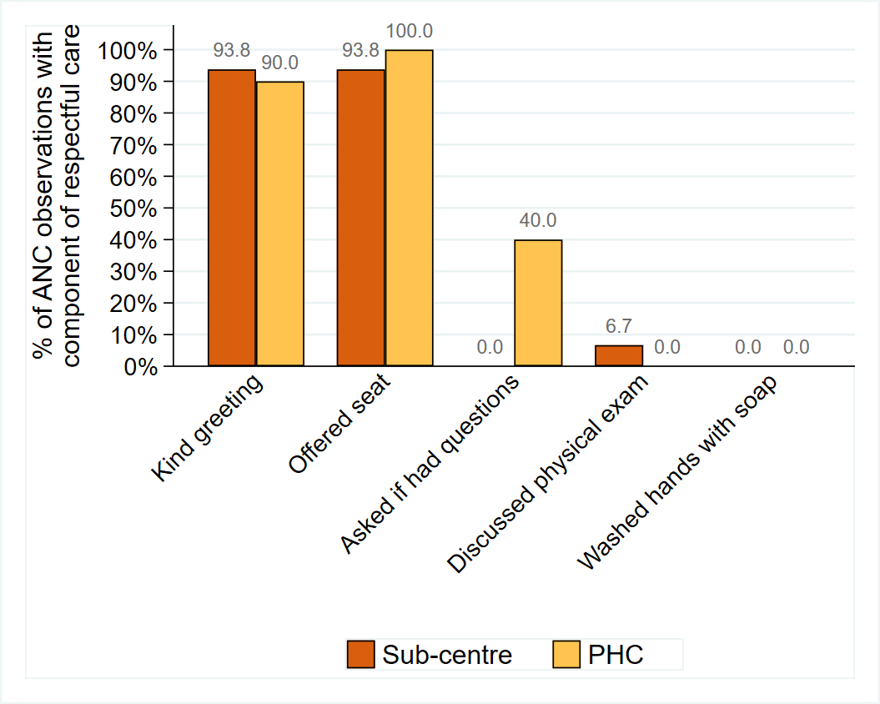
Supplementary Figure S1: Percentage of ANC observations with components of respectful care, stratified by facility type

Supplementary Table S1: Percentage of ANC consultations in which each component of measuring blood pressure correctly was observed (N=35, with one ANC observation excluded as there was no physical exam)
Blood pressure component | Percentage with component of blood pressure measured correctly
Blood pressure component | Sub-centre (n=16) | PHC  (n=19)
Asked if the patient had tea or coffee | 31.3 | 52.6
Back supported during BP measurement | 12.5 | 15.8
Feet rested | 87.5 | 94.7
Measurement taken on the left arm | 81.3 | 52.6
Arm rested on the table | 56.3 | 79.0
Asked to roll-up sleeve | 81.3 | 73.7
Lower band of cuff positioned 1-2cm above the elbow | 87.5 | 84.2
Cuff at heart level | 87.5 | 94.7
Deflation rate of not more than 2 to 3 mm Hg/s | 100 | 89.5

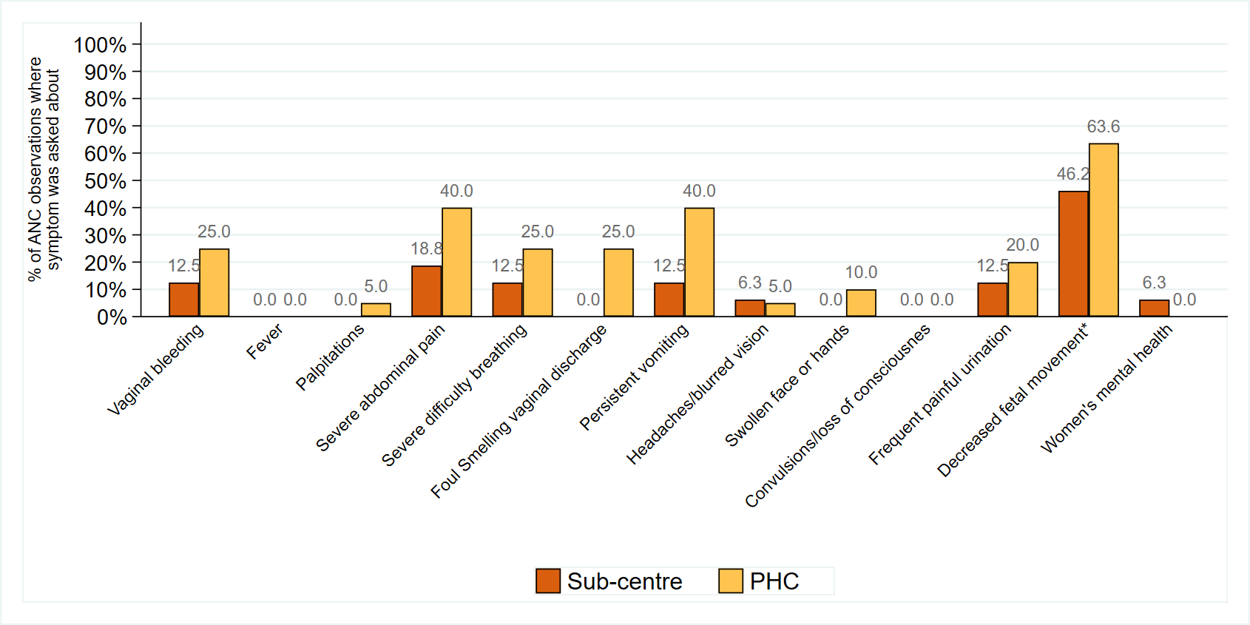
Supplementary Figure S2: Percentage of ANC observations with in which specific symptoms were asked about in the ANC consultation, stratified by facility type
*Only includes ANC observations at 22 weeks gestation onwards (N=22)

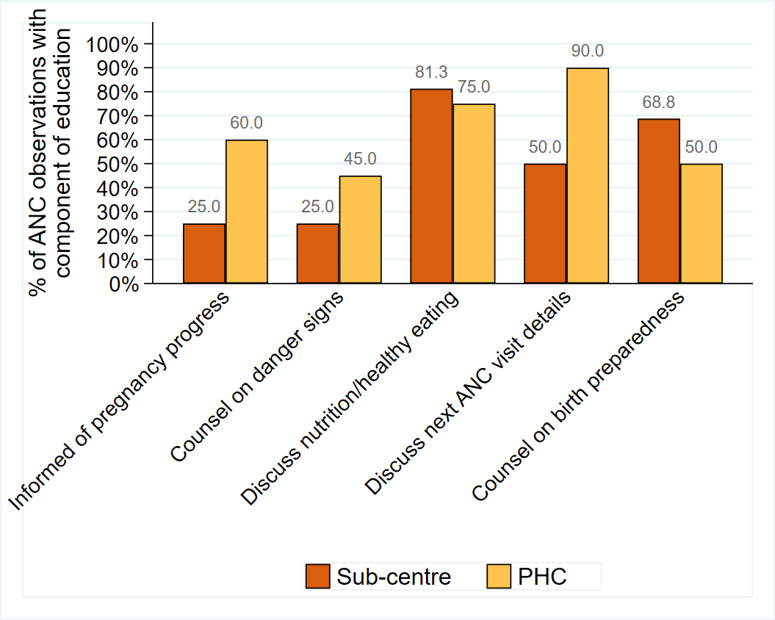
Supplementary Figure S3: Percentage of ANC observations with components of education, stratified by facility type

