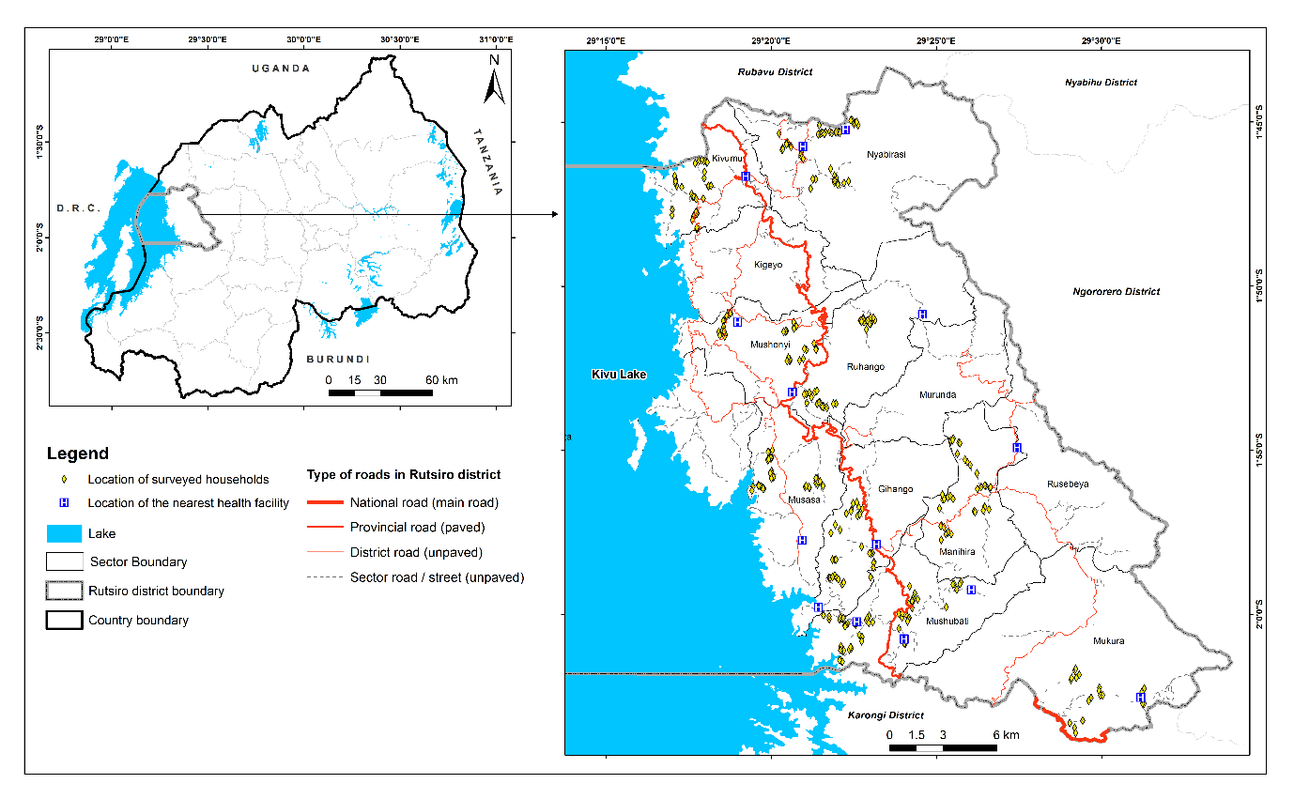
Supplementary file 1: The study area map illustrating the location of the surveyed households as well the corresponding nearest health facilities in Rutsiro district in Rwanda

