Additional file 2. Forest plot of premature rates by last menstrual period and USG before 24 weeks without duplicated rates.
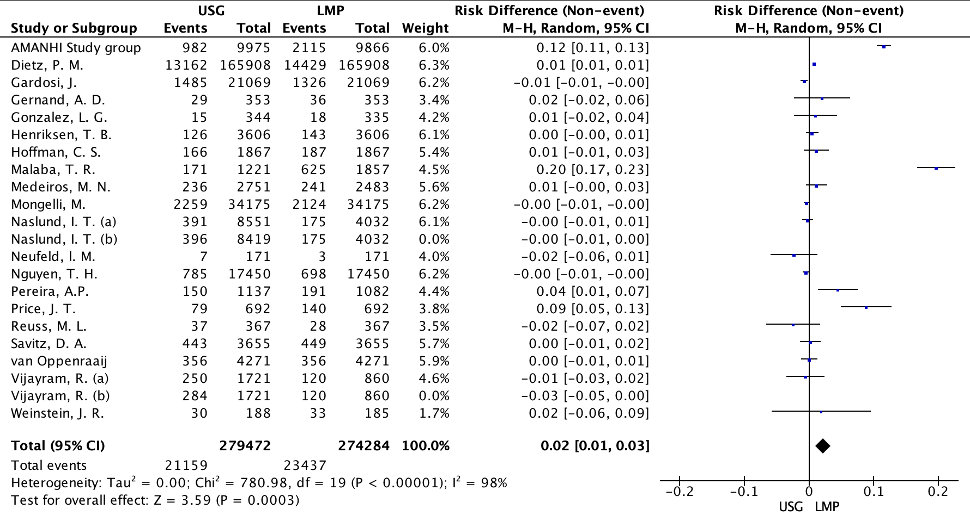

Legends: LMP: last menstrual period; USG: ultrasonography. Naslund (a): CRL measurement; Naslund (b): BPD measurement in the first trimester. Vijayram (a): USG Hadlock; Vijayram (b): USG Robinson-Fleming formula.

