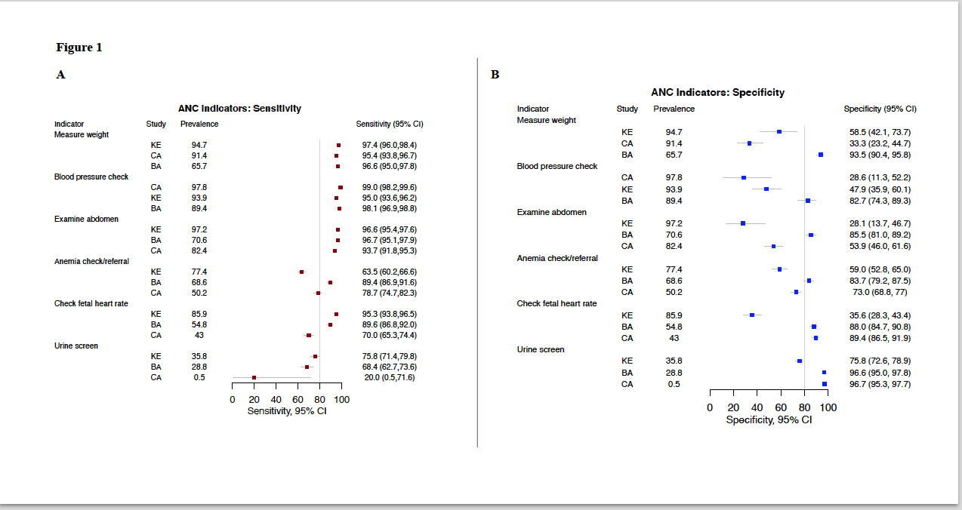
Additional File 3. Antenatal Care Indicator Sensitivity (Panel A) and Specificity (Panel B) by Country of Study, Sorted by Indicator Prevalence. Bangladesh (BA), Cambodia (CA) and Kenya (KE). Grey horizontal lines represent 95% confidence intervals about the estimates, overlapping confidence intervals implies no statistical difference in level of the predictor. As a benchmark for indicator quality, 80% sensitivity and specificity is shown as a vertical grey line

