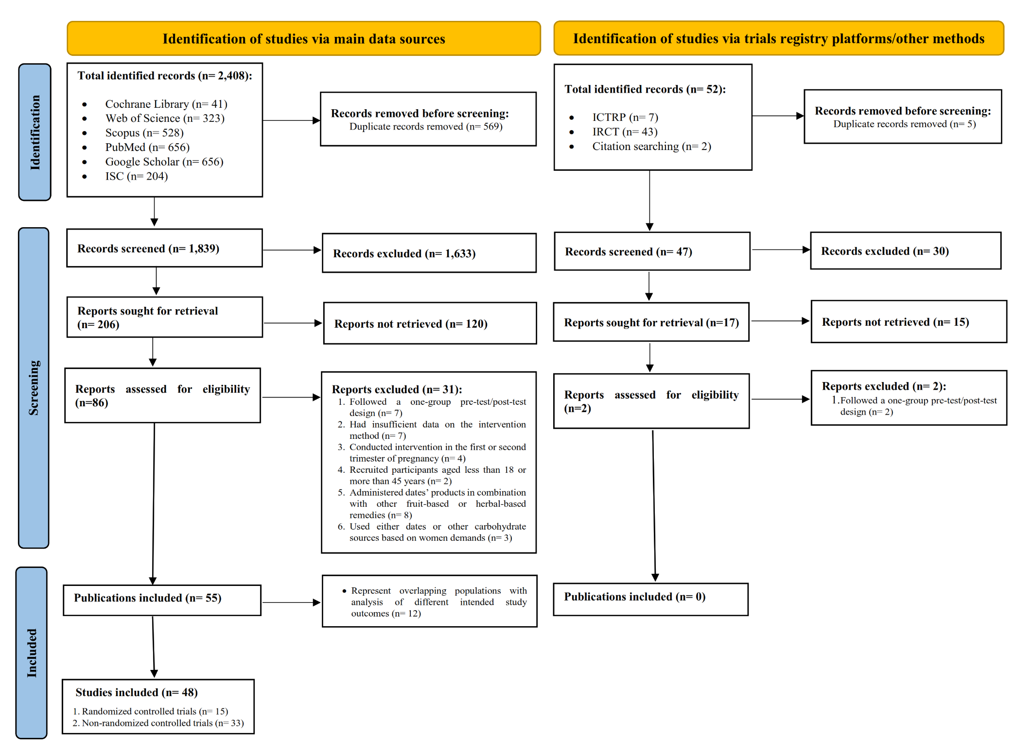
Supplementary Fig. 1: PRISMA 2020 flow diagram for the process of studies screening and selection

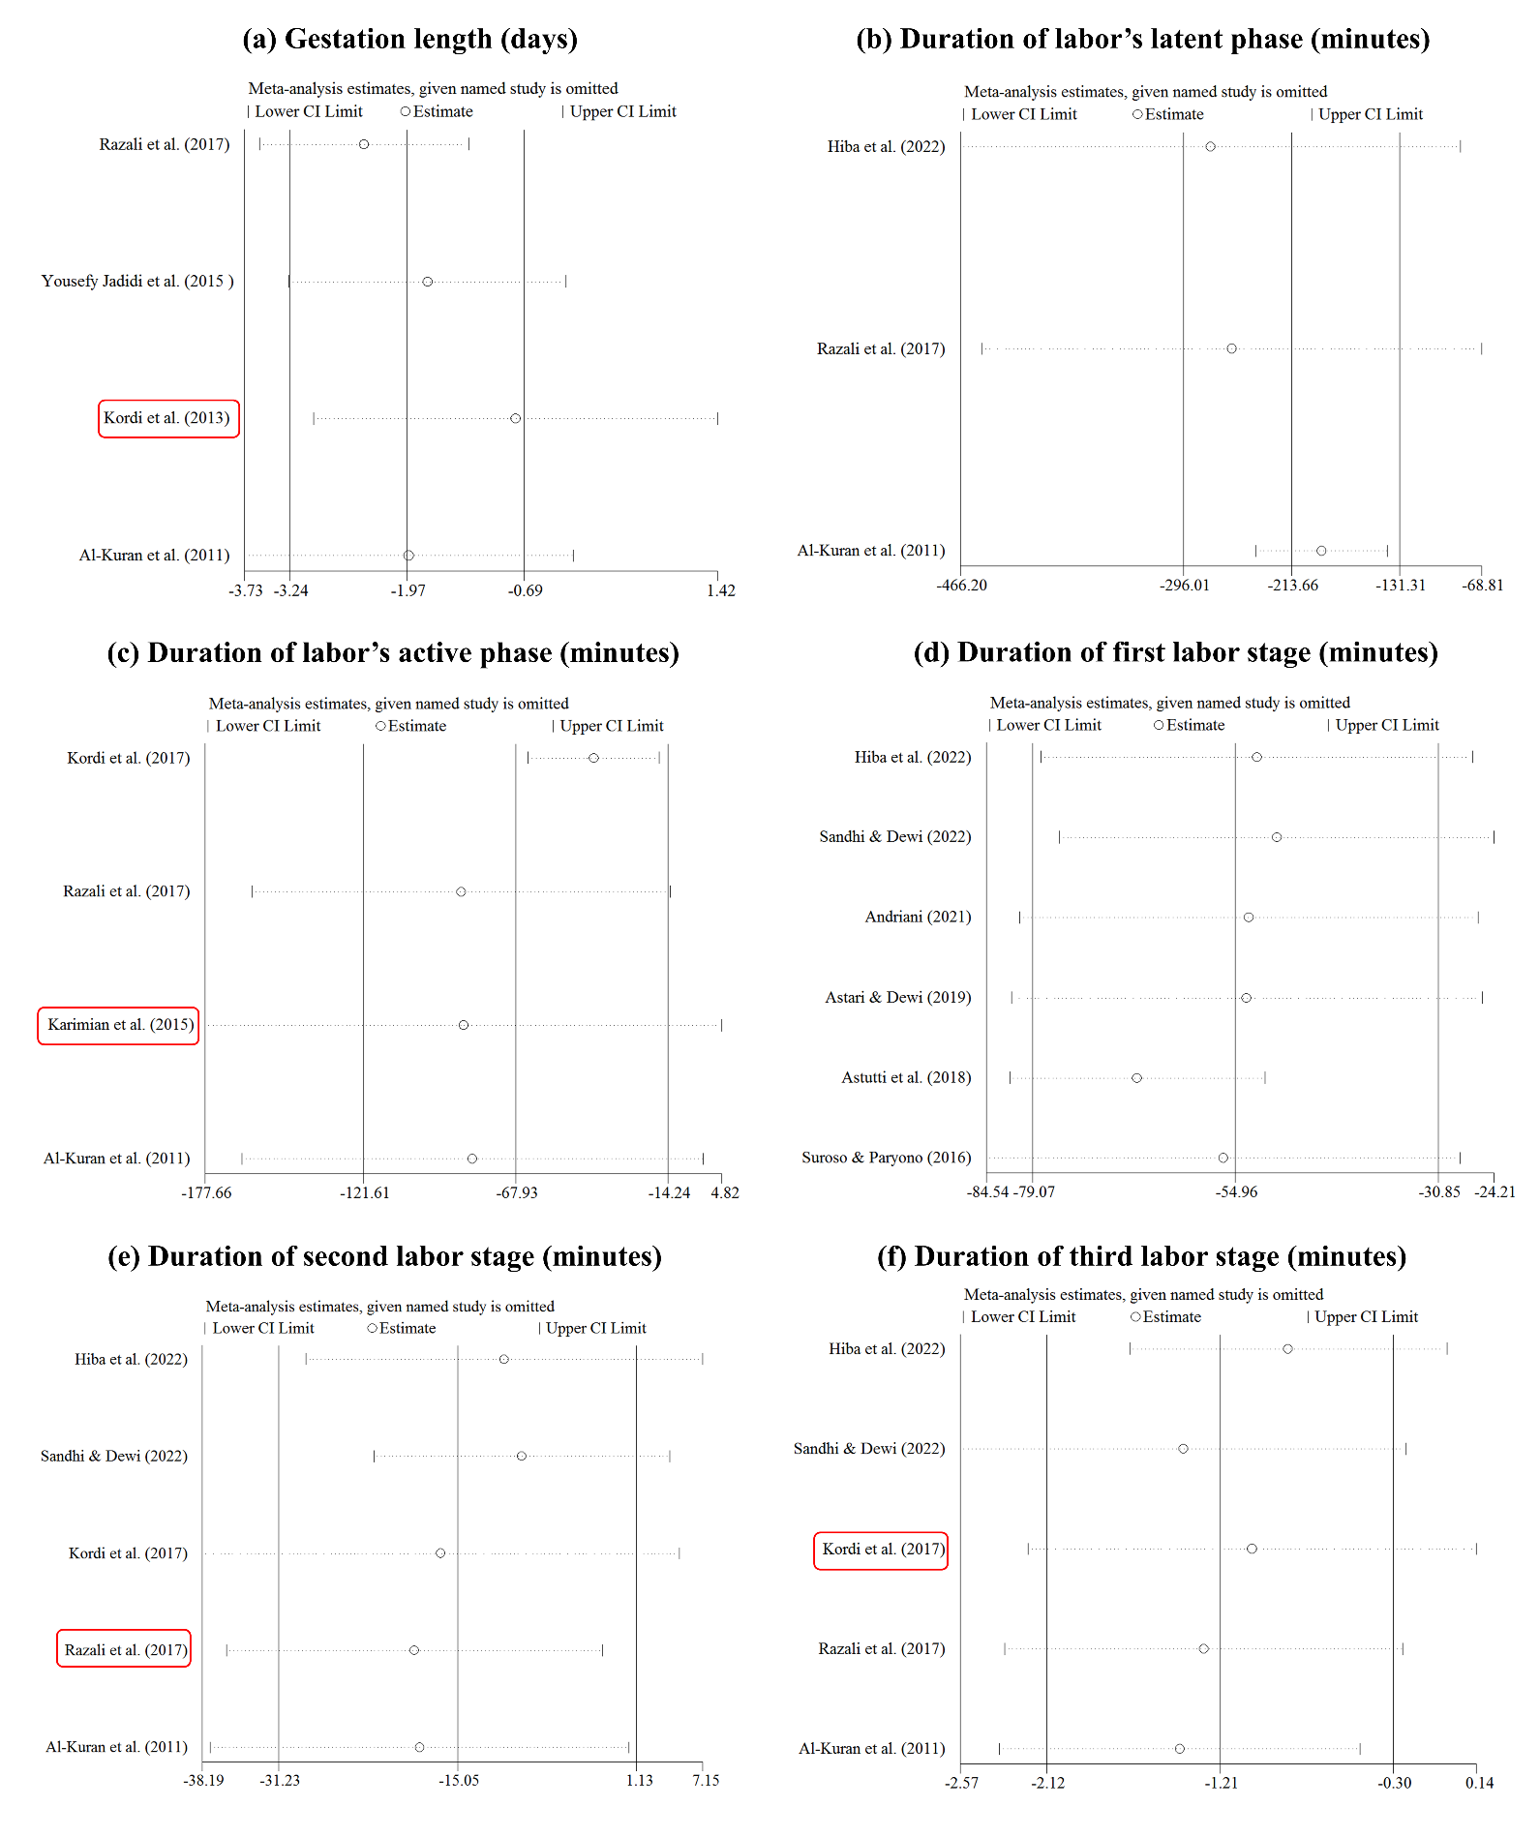
Supplementary Fig. 2: Sensitivity analysis for the effects of oral consumption of dates in late pregnancy on the duration of gestation (a), labor’s latent phase (b), labor’s active phase (c), the first labor stage (d), the second labor stage (e), and the third labor stage (f)

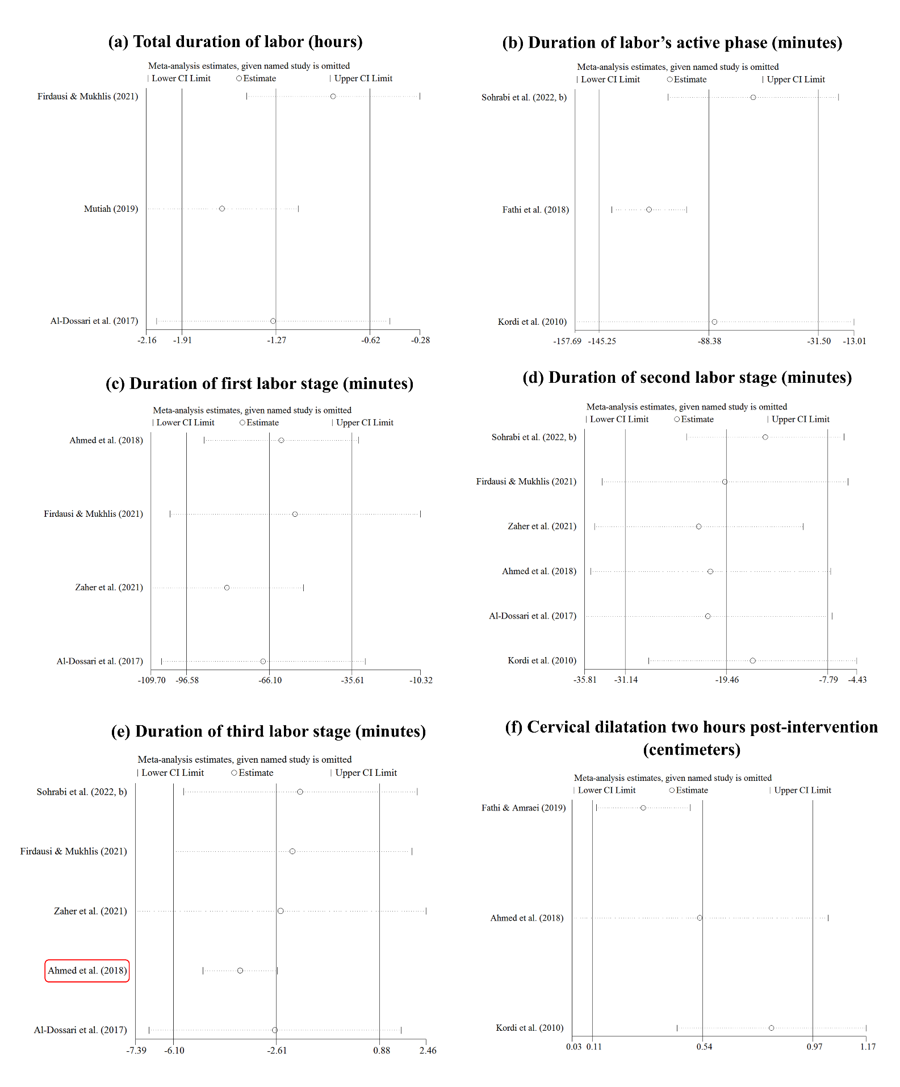
Supplementary Fig. 3: Sensitivity analysis for the effects of oral consumption of dates in labor on the duration of total labor (a), labor’s active phase (b), the first labor stage (c), the second labor stage (d), and the third labor stage (e); and cervical dilatation approximately two hours after the beginning of intervention (f)

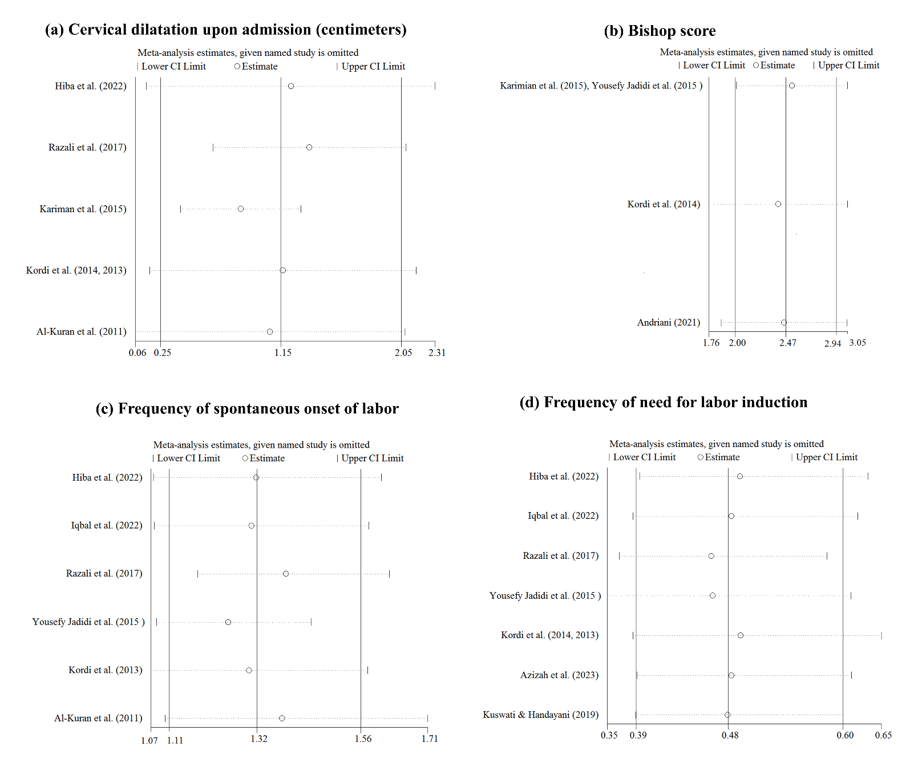
Supplementary Fig. 4: Sensitivity analysis for the effects of oral consumption of dates in late pregnancy on cervical dilatation upon admission (a); Bishop score (b); frequency of spontaneous onset of labor (c); and frequency of need for labor induction (d)
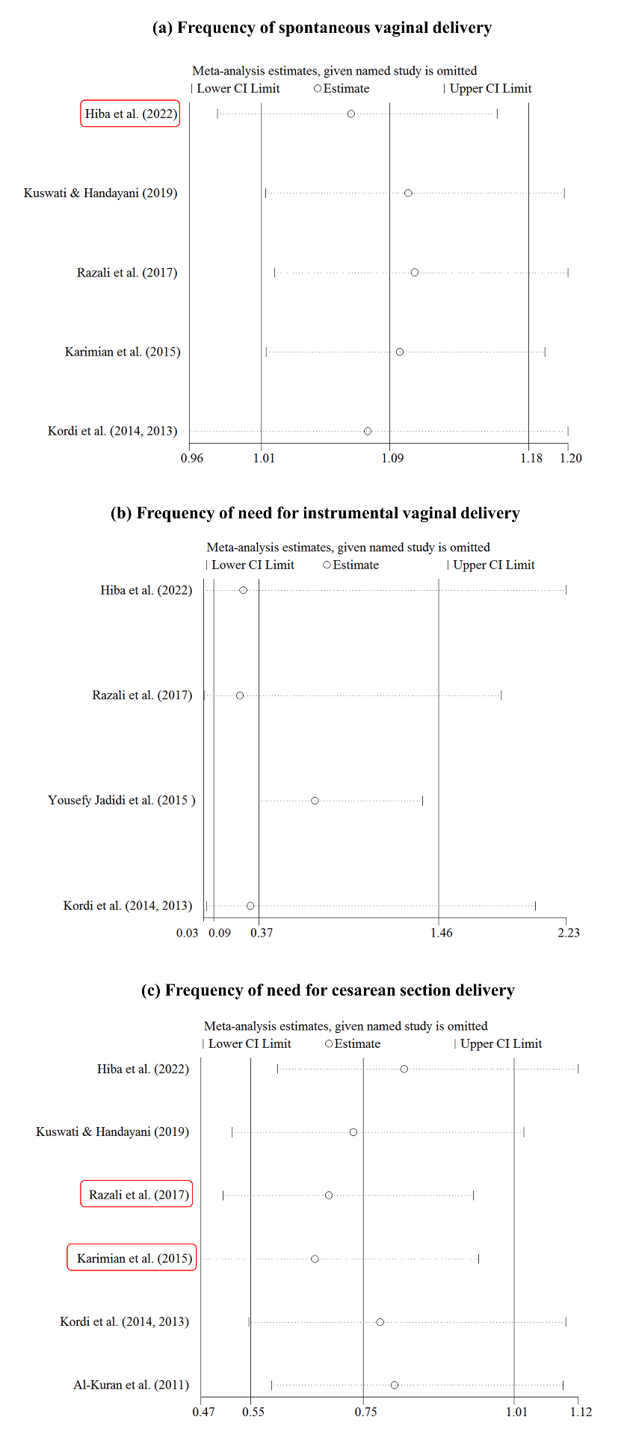

Supplementary Fig. 5: Sensitivity analysis for the effects of oral consumption of dates in late pregnancy on the frequency of spontaneous vaginal delivery (a), need for instrumental vaginal delivery (b), and need for cesarean section delivery (c)
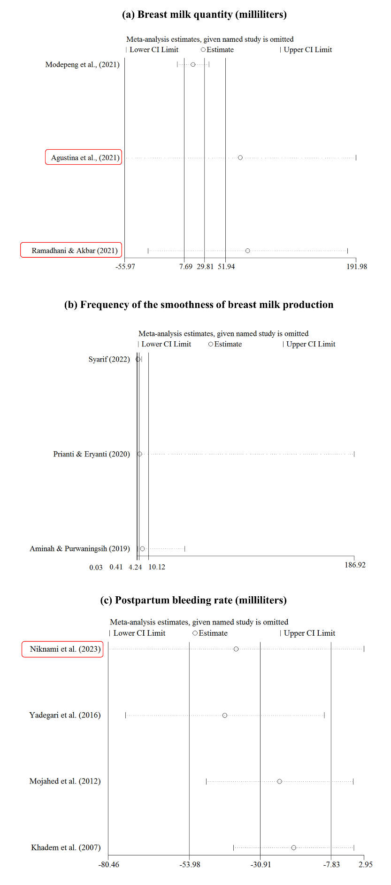

Supplementary Fig. 6: Sensitivity analysis for the effects of oral consumption of dates in postpartum on changes in breast milk quantity from baseline to post-intervention (a); the frequency of smoothness of breast milk production (b); and first-day postpartum bleeding rate (c)
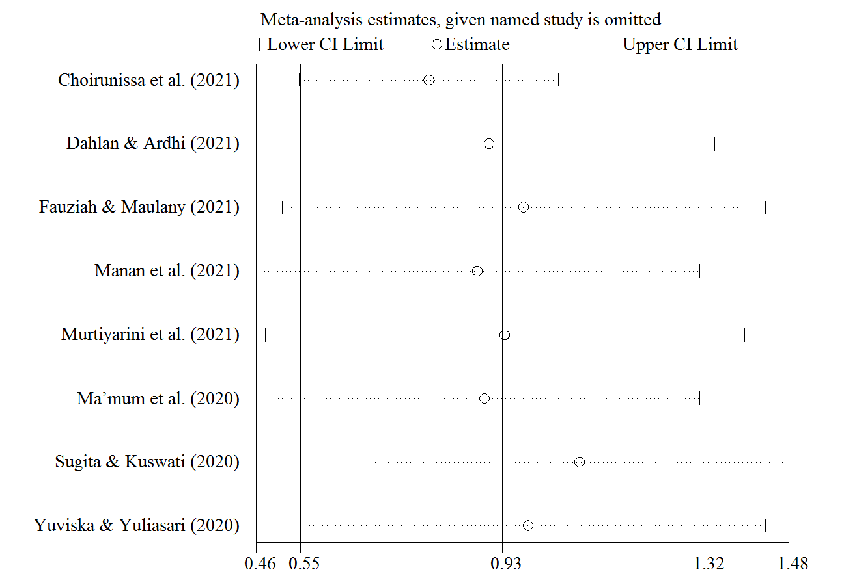Supplementary Fig. 7: Sensitivity analysis for the effect of oral consumption of dates in the third trimester of pregnancy on changes in maternal hemoglobin levels (gr/dl) from baseline to post-intervention
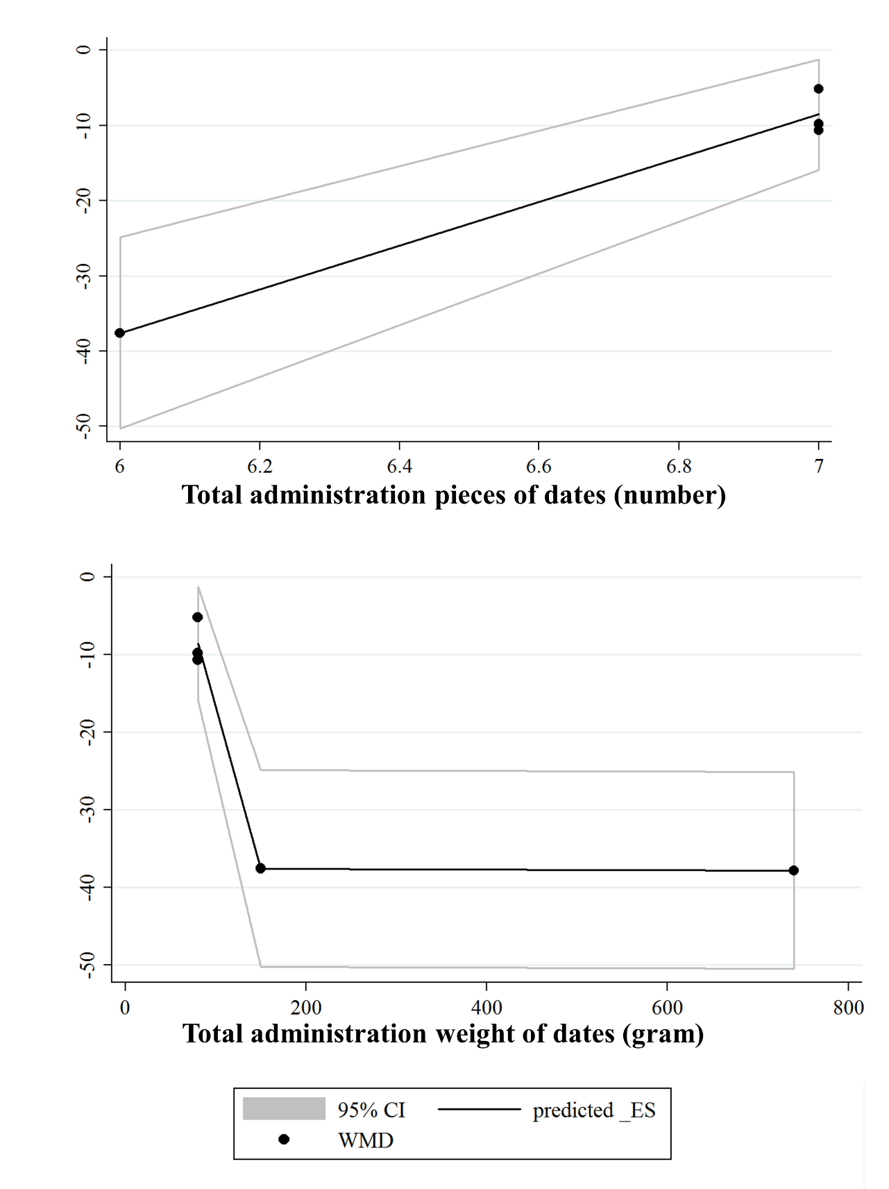 Supplementary Fig. 8: Dose-response analysis for the association between the total administration dosage of dates and changes in the duration of the second labor stage (minute, intervention time: labor)
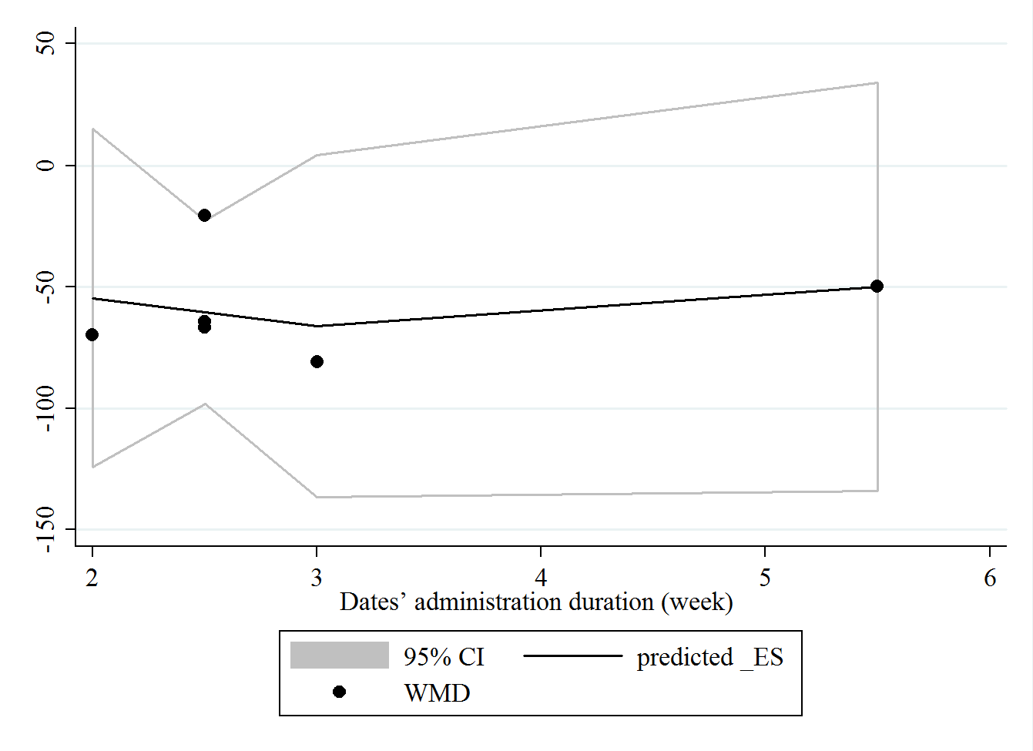Supplementary Fig. 9: Dose-response analysis for the association between the administration duration of dates and changes in the length of the first labor stage (minute, intervention time: late pregnancy)
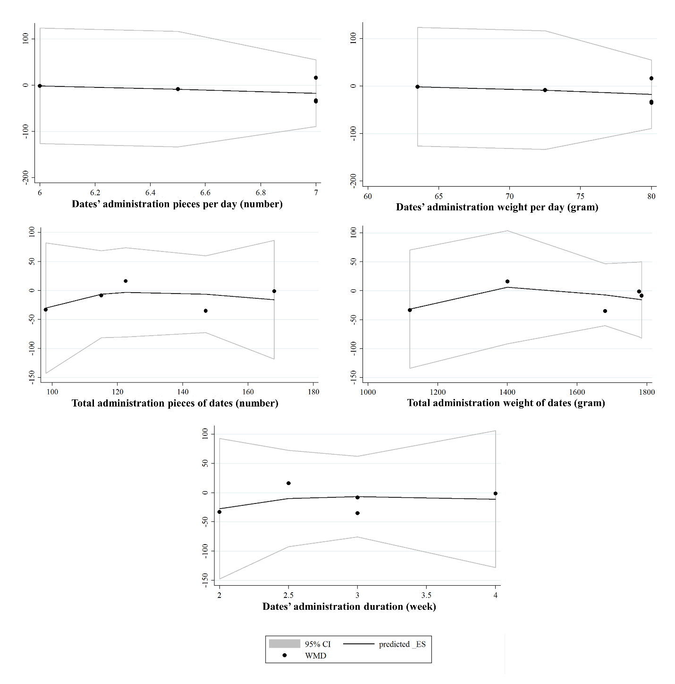Supplementary Fig. 10: Dose-response analysis for the association between the administration dosage and duration of dates and changes in the length of the second labor stage (minute, intervention time: late pregnancy)
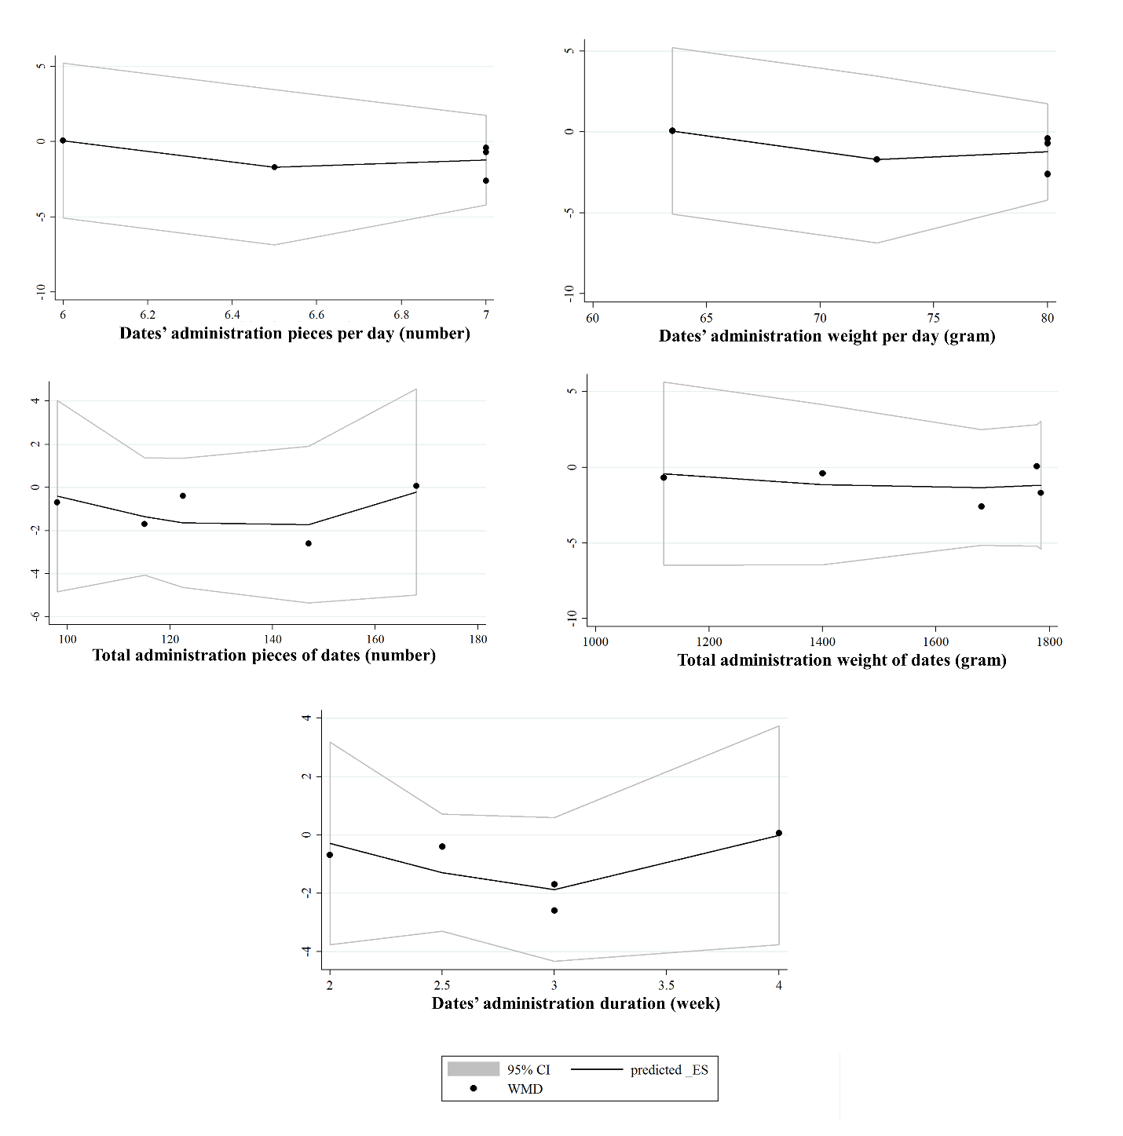Supplementary Fig. 11: Dose-response analysis for the association between the administration dosage and duration of dates and changes in the length of the third labor stage (minute, intervention time: late pregnancy)
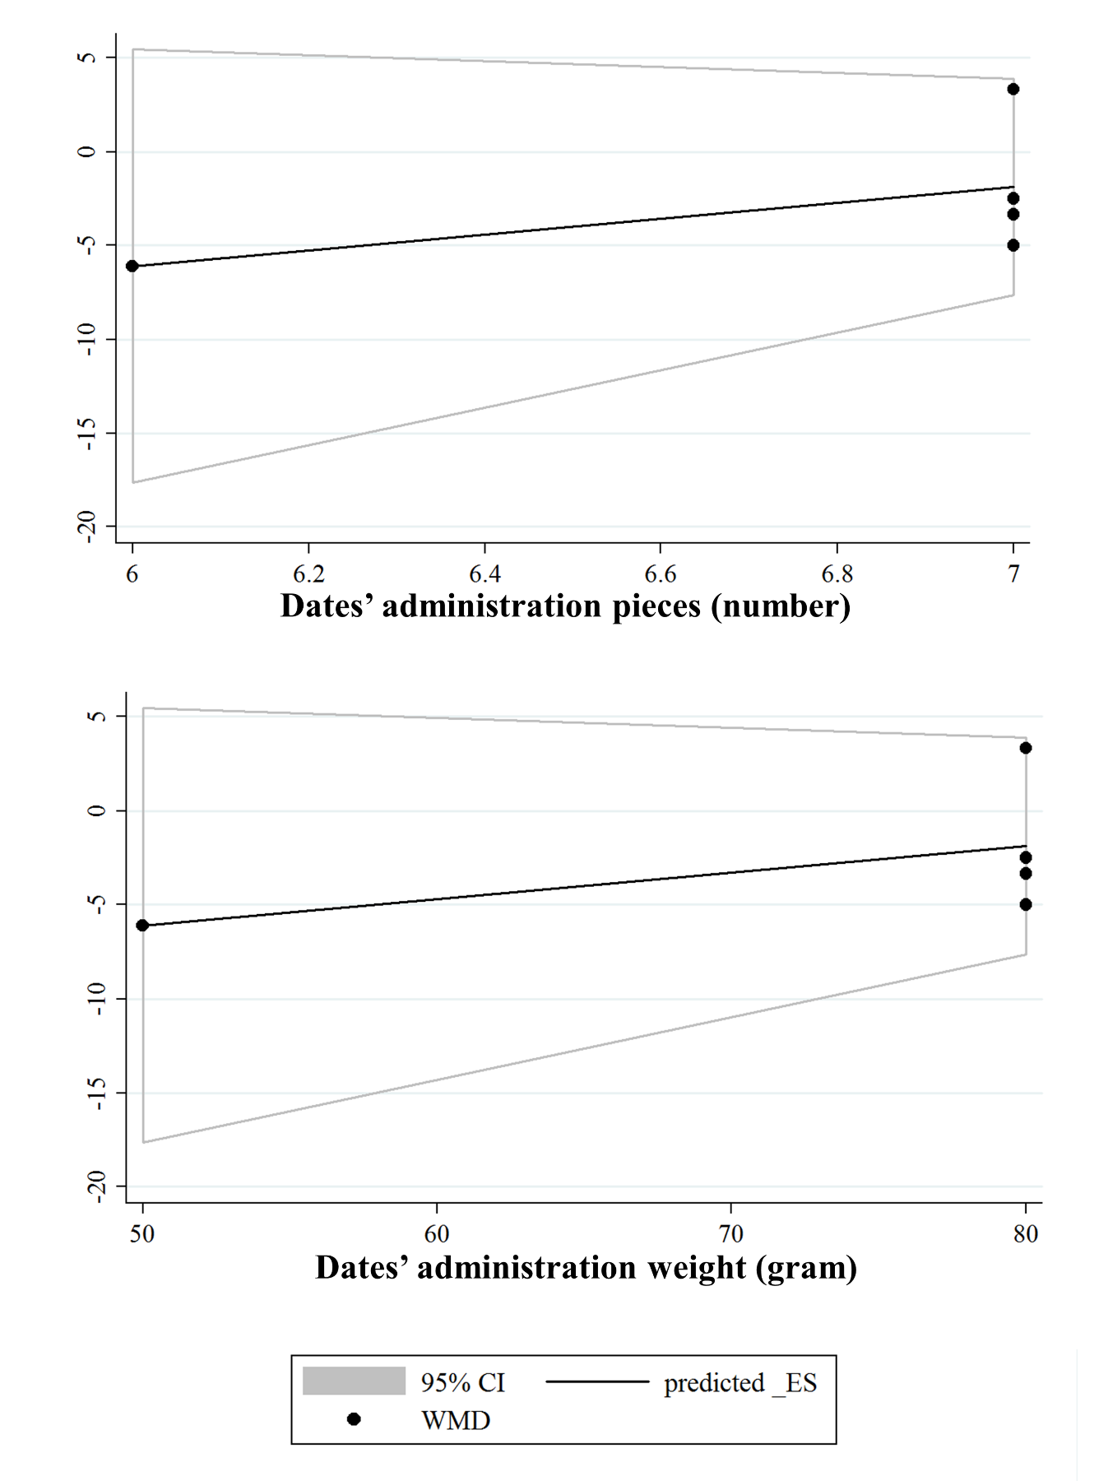Supplementary Fig. 12: Dose-response analysis for the association between the administration dosage of dates and changes in the length of the third labor stage (minute, intervention time: labor)
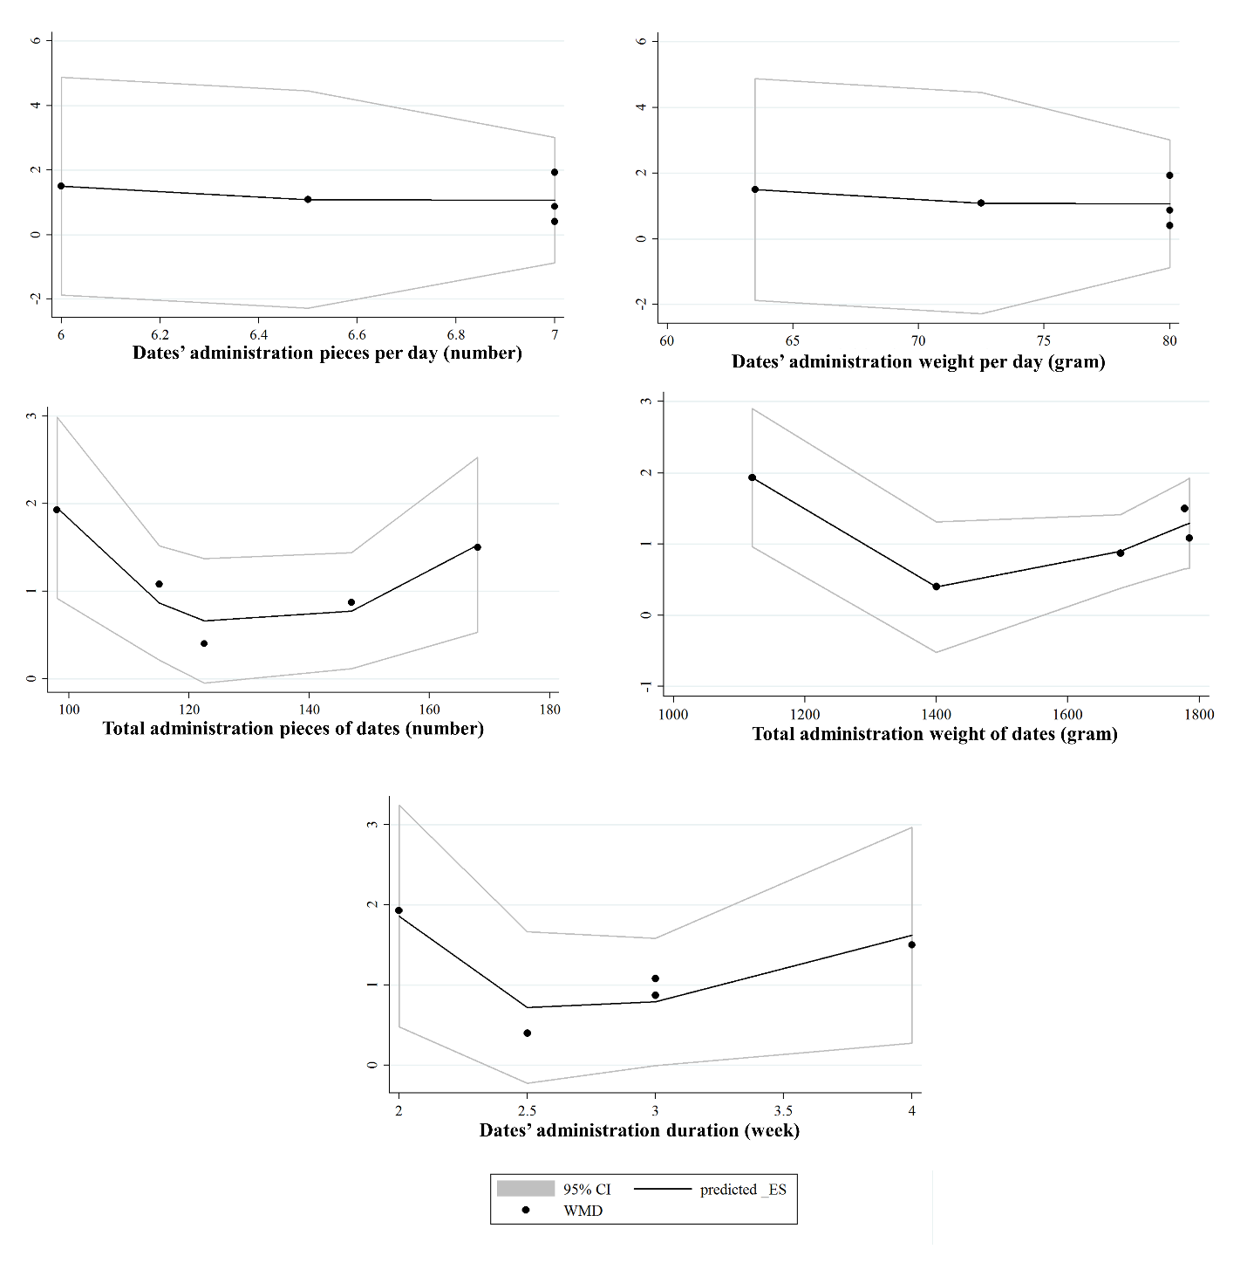 Supplementary Fig. 13: Dose-response analysis for the association between the administration dosage and duration of dates and changes in the cervical dilation upon admission (centimeters, intervention time: late pregnancy)
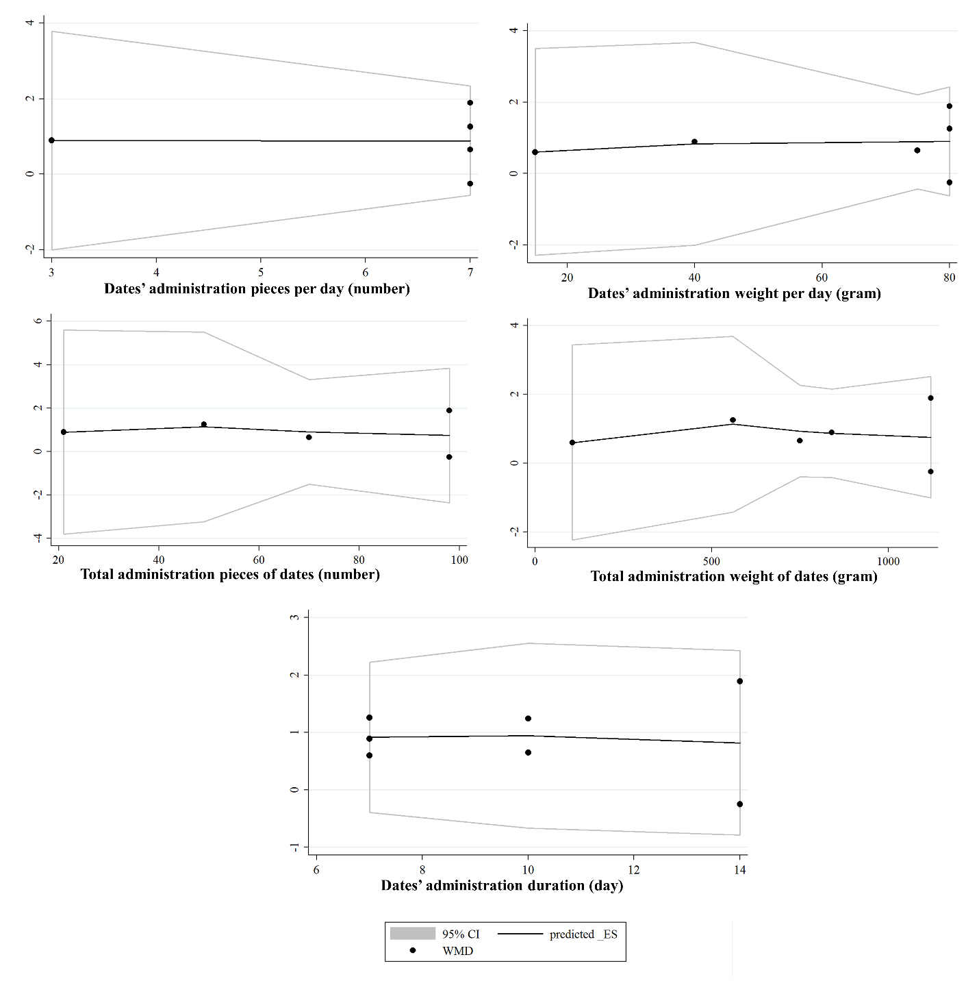Supplementary Fig. 14: Dose-response analysis for the association between the administration dosage and duration of dates and changes in the maternal hemoglobin levels (gr/dl, intervention time: the third trimester of pregnancy)

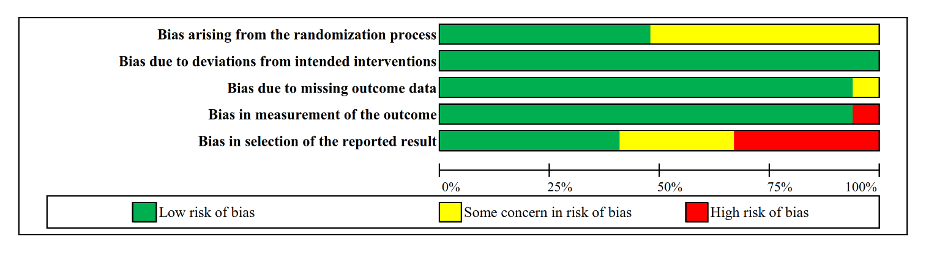 Supplementary Fig. 15: Summary of the authors’ judgments about the risk of bias domains across the 15 included randomized controlled trials (RCTs)

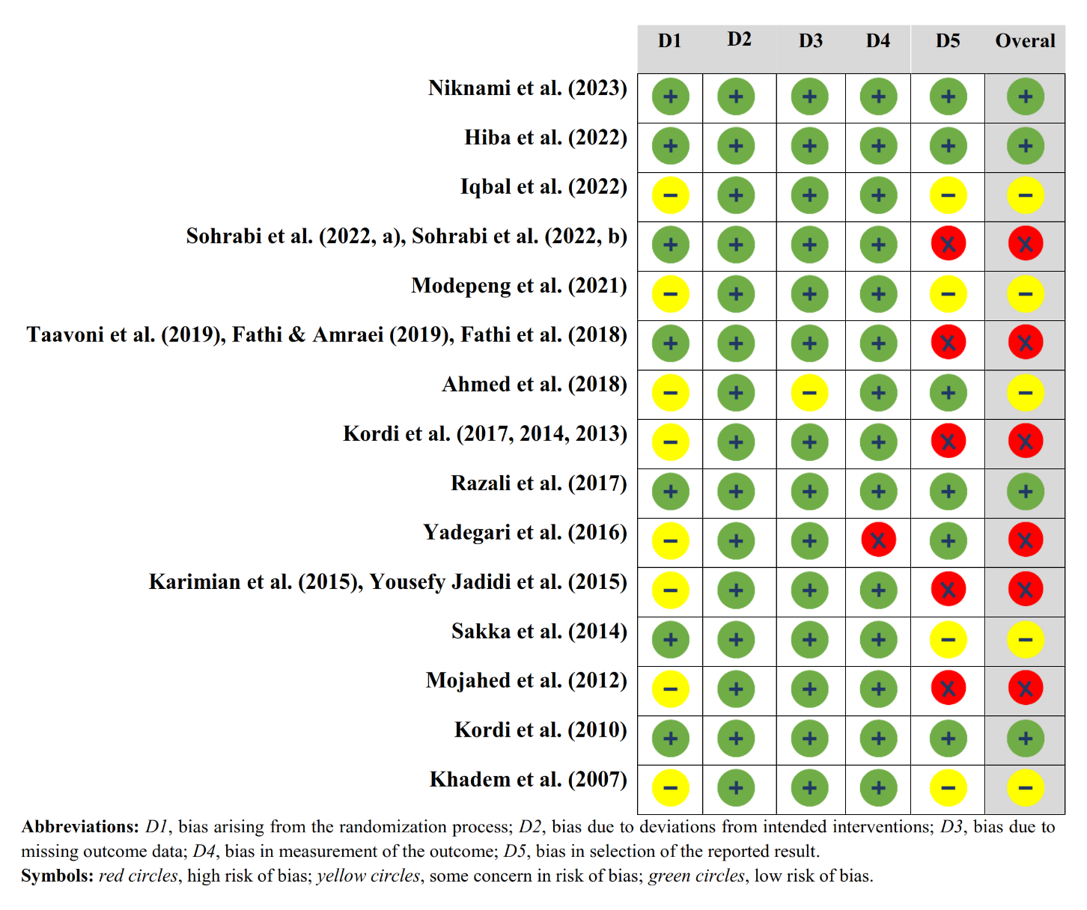Supplementary Fig. 16: Summary of the authors’ judgments about the risk of bias domains within the 15 included randomized controlled trials (RCTs)

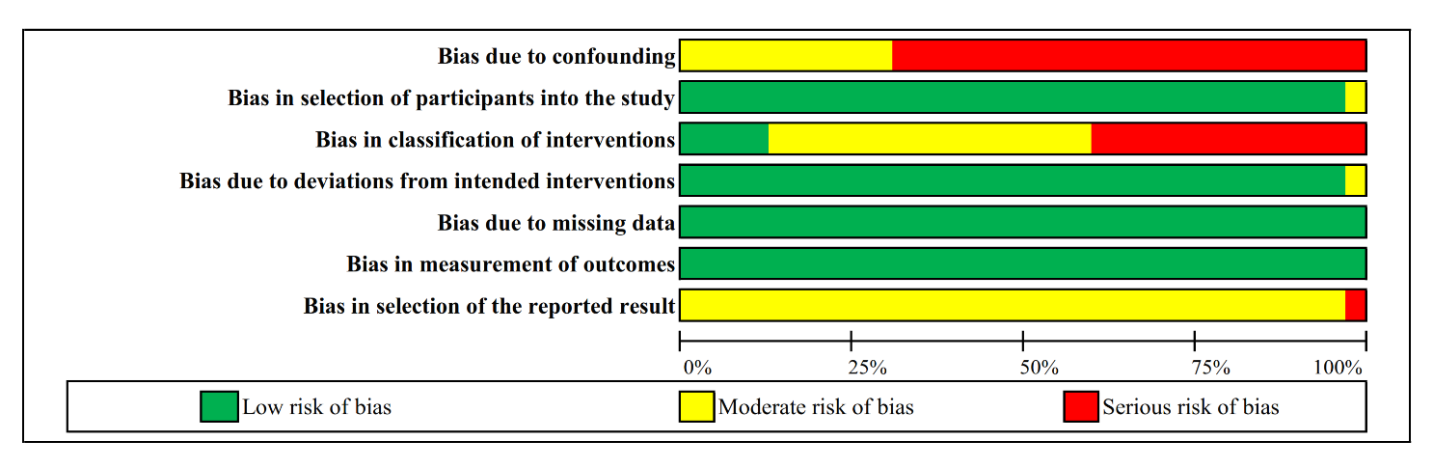 Supplementary Fig. 17: Summary of the authors’ judgments about the risk of bias domains across the 33 included non-randomized controlled trials (non-RCTs)

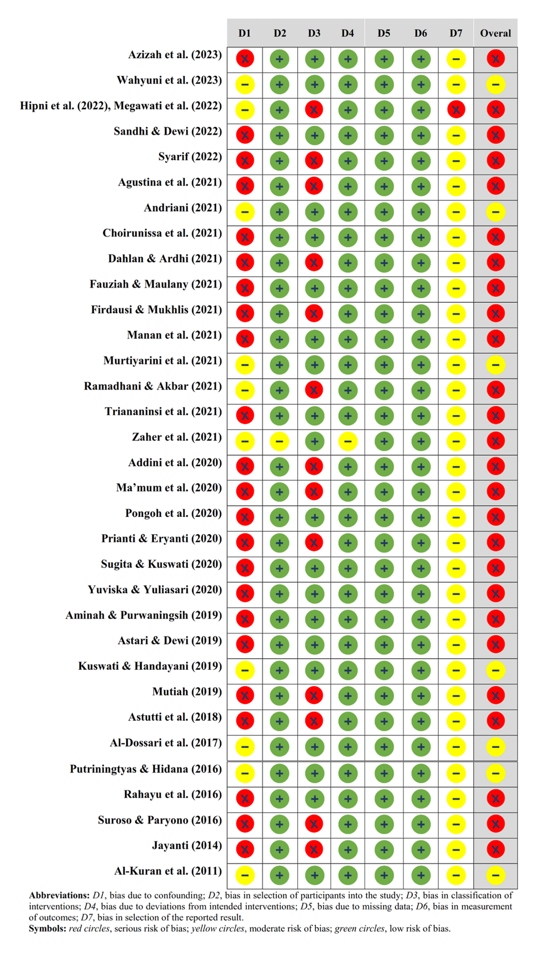
Supplementary Fig. 18: Summary of the authors’ judgments about the risk of bias domains within the 33 included non-randomized controlled trials (non-RCTs)

Supplementary Table 1. PRISMA 2020 checklist for reporting systematic reviews and meta-analyses
Section and Topic | Item # | Checklist item | Location where item is reported
TITLE
Title | 1 | Identify the report as a systematic review. | p 1 (line 3)
ABSTRACT
Abstract | 2 | See the PRISMA 2020 for Abstracts checklist. | p 3-4
INTRODUCTION
Rationale | 3 | Describe the rationale for the review in the context of existing knowledge. | p 6-7
Objectives | 4 | Provide an explicit statement of the objective(s) or question(s) the review addresses. | p 7
METHODS
Eligibility criteria | 5 | Specify the inclusion and exclusion criteria for the review and how studies were grouped for the syntheses. | p 8, table 1
Information sources | 6 | Specify all databases, registers, websites, organisations, reference lists and other sources searched or consulted to identify studies. Specify the date when each source was last searched or consulted. | p 8
Search strategy | 7 | Present the full search strategies for all databases, registers and websites, including any filters and limits used. | p 9, Supplementary Table 2
Selection process | 8 | Specify the methods used to decide whether a study met the inclusion criteria of the review, including how many reviewers screened each record and each report retrieved, whether they worked independently, and if applicable, details of automation tools used in the process. | p 9-10
Data collection process | 9 | Specify the methods used to collect data from reports, including how many reviewers collected data from each report, whether they worked independently, any processes for obtaining or confirming data from study investigators, and if applicable, details of automation tools used in the process. | p 9-10
Data items | 10a | List and define all outcomes for which data were sought. Specify whether all results that were compatible with each outcome domain in each study were sought (e.g. for all measures, time points, analyses), and if not, the methods used to decide which results to collect. | Table 1
Data items | 10b | List and define all other variables for which data were sought (e.g. participant and intervention characteristics, funding sources). Describe any assumptions made about any missing or unclear information. | Table 1, p 9
Study risk of bias assessment | 11 | Specify the methods used to assess risk of bias in the included studies, including details of the tool(s) used, how many reviewers assessed each study and whether they worked independently, and if applicable, details of automation tools used in the process. | p 10
Effect measures | 12 | Specify for each outcome the effect measure(s) (e.g. risk ratio, mean difference) used in the synthesis or presentation of results. | p 10
Synthesis methods | 13a | Describe the processes used to decide which studies were eligible for each synthesis (e.g. tabulating the study intervention characteristics and comparing against the planned groups for each synthesis (item #5)). | p 10
Synthesis methods | 13b | Describe any methods required to prepare the data for presentation or synthesis, such as handling of missing summary statistics, or data conversions. | p 9-10
Synthesis methods | 13c | Describe any methods used to tabulate or visually display results of individual studies and syntheses. | p 10
Synthesis methods | 13d | Describe any methods used to synthesize results and provide a rationale for the choice(s). If meta-analysis was performed, describe the model(s), method(s) to identify the presence and extent of statistical heterogeneity, and software package(s) used. | p 10
Synthesis methods | 13e | Describe any methods used to explore possible causes of heterogeneity among study results (e.g. subgroup analysis, meta-regression). | p 10
Synthesis methods | 13f | Describe any sensitivity analyses conducted to assess robustness of the synthesized results. | p 10
Reporting bias assessment | 14 | Describe any methods used to assess risk of bias due to missing results in a synthesis (arising from reporting biases). | p 10
Certainty assessment | 15 | Describe any methods used to assess certainty (or confidence) in the body of evidence for an outcome. | p 10
RESULTS
Study selection | 16a | Describe the results of the search and selection process, from the number of records identified in the search to the number of studies included in the review, ideally using a flow diagram. | p 11, Supplementary Figure 1
Study selection | 16b | Cite studies that might appear to meet the inclusion criteria, but which were excluded, and explain why they were excluded. | p 11, Supplementary Table 3
Study characteristics | 17 | Cite each included study and present its characteristics. | p 11-12 (Table 2)
Risk of bias in studies | 18 | Present assessments of risk of bias for each included study. | Supplementary Figures 16, 18
Results of individual studies | 19 | For all outcomes, present, for each study: (a) summary statistics for each group (where appropriate) and (b) an effect estimate and its precision (e.g. confidence/credible interval), ideally using structured tables or plots. | Table 2
Results of syntheses | 20a | For each synthesis, briefly summarise the characteristics and risk of bias among contributing studies. | Supplementary Figures 15, 17
Results of syntheses | 20b | Present results of all statistical syntheses conducted. If meta-analysis was done, present for each the summary estimate and its precision (e.g. confidence/credible interval) and measures of statistical heterogeneity. If comparing groups, describe the direction of the effect. | P 12-20, Figures 1-6
Results of syntheses | 20c | Present results of all investigations of possible causes of heterogeneity among study results. | p 20-21
Results of syntheses | 20d | Present results of all sensitivity analyses conducted to assess the robustness of the synthesized results. | Suppl Figures 2-7
Reporting biases | 21 | Present assessments of risk of bias due to missing results (arising from reporting biases) for each synthesis assessed. | p 22
Certainty of evidence | 22 | Present assessments of certainty (or confidence) in the body of evidence for each outcome assessed. | p 22
DISCUSSION
Discussion | 23a | Provide a general interpretation of the results in the context of other evidence. | p 23-27
Discussion | 23b | Discuss any limitations of the evidence included in the review. | p 32
Discussion | 23c | Discuss any limitations of the review processes used. | p 32
Discussion | 23d | Discuss implications of the results for practice, policy, and future research. | p 27-31
OTHER INFORMATION
Registration and protocol | 24a | Provide registration information for the review, including register name and registration number, or state that the review was not registered. | p 7
Registration and protocol | 24b | Indicate where the review protocol can be accessed, or state that a protocol was not prepared. | p 7
Registration and protocol | 24c | Describe and explain any amendments to information provided at registration or in the protocol. | N/A
Support | 25 | Describe sources of financial or non-financial support for the review, and the role of the funders or sponsors in the review. | p 34
Competing interests | 26 | Declare any competing interests of review authors. | p 33

Supplementary Table 2. Search characteristics in selected data-sources for the effects of oral consumption of dates in the peripartum period on childbirth and perinatal outcomes
Data sources | Search strategy | Search results
WOS (Core Collection) | (AB=(Phoeniceae) OR AB=("Phoenix dactylifera") OR AB=(Nakhl) OR AB=("Date palm") OR AB=("Palm date") OR AB=("Date fruit*") OR TI=(Dates) OR AB=(Khorma) OR AB=(Kurma) OR AB=(Rutab) OR AB=(Ruthab)) AND (AB=(Labor) OR AB=(Labour) OR AB=(Obstetric) OR AB=(Deliver*) OR AB=(Parturition) OR AB=(Parturient*) OR AB=(Childbirth) OR AB=(Birth) OR AB=(Pregnan*) OR AB=(Conception) OR AB=(Gestation) OR AB=(Postpartum) OR AB=(Post-partum) OR AB=(Infant*) OR AB=(Neonate*)) AND (AB=(Intervention*) OR TS=("Clinical trial") OR AB=(Trial) OR AB=(Experiment*) OR AB=(Quasi-experiment*) OR AB=(Quasiexperiment*) OR AB=(Random*) OR AB=(Assign*)) | 323
Scopus | (TITLE-ABS-KEY (Phoeniceae) OR TITLE-ABS-KEY ("Phoenix dactylifera") OR TITLE-ABS-KEY (Nakhl) OR TITLE-ABS-KEY ("Date palm") OR TITLE-ABS-KEY ("Palm date") OR TITLE-ABS-KEY ("Date fruit*") OR TITLE (Dates) OR TITLE-ABS-KEY (Khorma) OR TITLE-ABS-KEY (Kurma) OR TITLE-ABS-KEY (Rutab) OR TITLE-ABS-KEY (Ruthab)) AND (TITLE-ABS-KEY (Labor) OR TITLE-ABS-KEY (Labour) OR TITLE-ABS-KEY (Obstetric) OR TITLE-ABS-KEY (Deliver*) OR TITLE-ABS-KEY (Parturition) OR TITLE-ABS-KEY (Parturient*) OR TITLE-ABS-KEY (Childbirth) OR TITLE-ABS-KEY (Birth) OR TITLE-ABS-KEY (Pregnan*) OR TITLE-ABS-KEY (Conception) OR TITLE-ABS-KEY (Gestation) OR TITLE-ABS-KEY (Post-partum) OR TITLE-ABS-KEY (Postpartum) OR TITLE-ABS-KEY (Infant*) OR TITLE-ABS-KEY (Neonate*)) AND (TITLE-ABS-KEY (Intervention*) OR TITLE-ABS-KEY (Trial) OR TITLE-ABS-KEY (Experiment*) OR TITLE-ABS-KEY (Quasi-experiment*) OR TITLE-ABS-KEY (Quasiexperiment*) OR TITLE-ABS-KEY (Random) OR TITLE-ABS-KEY (Assign*)) | 528
Cochrane Library | (Phoeniceae OR "Phoenix dactylifera" OR Nakhl OR "Date palm" OR "Palm date" OR "Date fruit*" OR Khorma OR Kurma OR Rutab OR Ruthab) in Title Abstract Keyword AND (Labor OR Labour OR Obstetric OR Deliver* OR Parturition OR Parturient* OR Childbirth OR Birth OR Pregnan* OR Conception OR Gestation OR Post-partum OR Postpartum OR Infant* OR Neonate*) in Title Abstract Keyword - (Word variations have been searched) | 41
PubMed | ((Phoeniceae[Mesh] OR Phoeniceae[Tiab] OR "Phoenix dactylifera"[All] OR Phoenix[Tiab] OR Nakhl[Tiab] OR "Date palm"[Tiab] OR "Palm date"[Tiab] OR "Date fruit*"[Tiab] OR "Dates fruit*"[Tiab] OR Dates[Ti] OR Khorma[Tiab] OR Kurma[Tiab] OR Rutab[Tiab] OR Ruthab[Tiab]) AND ("Labor, Obstetric"[Mesh] OR Labor[Tiab] OR Labour[Tiab] OR "Delivery, Obstetric"[Mesh] OR Deliver*[Tiab] OR Parturition[Mesh] OR Parturition[Tiab] OR Parturient*[Tiab] OR Childbirth[Tiab] OR Birth[Tiab] OR Pregnancy[Mesh] OR Pregnan*[Tiab] OR Conception[Tiab] OR Gestation[Tiab] OR Post-partum[Tiab] OR Postpartum[Tiab] OR Infant[Mesh] OR Infant*[Tiab] OR Neonate*[Tiab] OR Newborn*[Tiab])) | 656
Google Scholar | intitle:(Phoeniceae|"Phoenix dactylifera*"|"Date palm"|"Date fruit*"|Khorma|Kurma|Rutab) AND (Labor|Delivery|Obstetric|Parturition|Pregnan*|Childbirth|Gestation|Post-partum|Postpartum) AND (Trial|Intervention*|Experiment*) | 656
ISC | The search was done in Persian and English:  - Persian: Allfields=خرما و زايمان&Language=.Persian.English.Arabic4050  - English: Allfields= ((Date OR Phoenix dactylifera OR Khorma OR Kurma) AND (Pregnancy OR Labor OR Childbirth))&Language=.Persian.English.Arabic4050 | 204
ICTRP | (Phoeniceae OR Phoenix dactylifera* OR Date palm OR Date fruit* OR Khorma OR Kurma OR Rutab) AND (Labor OR Delivery OR Obstetric OR Parturition OR Pregnan* OR Childbirth OR Gestation OR Post-partum OR Postpartum) | 7
IRCT | The search was done in Persian and English:  - Persian: summary_fa:خرما و زايمان  - English: ((@summary:Labor) OR (@summary:Delivery) OR (@summary:Obstetric) OR (@summary:Parturition) OR (@summary:Childbirth) OR (@summary:Gestation) OR (@summary:Post-partum) OR (@summary:Postpartum)) AND ((@summary:Date) OR (@summary:Phoeniceae) OR (@summary:"Phoenix dactylifera") OR (@summary:"Date palm") OR (@summary:"Date fruit*")) | 43
Abbreviations: ICTRP, International Clinical Trials Registry Platform; IRCT, Iranian Registry of Clinical Trials; ISC, Scientific Content Database of Islamic World Science Citation Center; WOS, Web of Science.

Supplementary Table 3. Studies excluded after assessing their eligibility by full-text review (n= 33)
Criteria | References
Followed a one-group pre-test/post-test design (n= 9) | - Dewi RK, Afifi DN, Awatiszahro A, Yulianti D. The effect of dates (Phoenix dactylifera) on breast milk production in post-partum mother day 3-9. J Global Res Public Health. 2021;6(1):52-5. https://doi.org/10.30994/jgrph.v6i1.314.  - Dewi RK, Puspita NLM, Rohmawati H, Khotimah S, Salsabila G. The effect of dates administration on hemoglobin levels in pregnant women trimester III. J Global Res Public Health. 2021;6(2):124-8. https://doi.org/10.30994/jgrph.v6i2.353.  - Ginting WM, Br. Girsang DM, Ginting KA, Br. Karo DM, Sirait RA. [The effect of giving dates on increasing haemoglobin levels in pregnant women with anemia (Indonesian)]. Jurnal Penelitian Kebidanan & Kespro. 2021;3(2):45-50. https://doi.org/10.36656/jpk2r.v3i2.651.  - Irmawati S, Rosdiana R. [Effect of dates extract on increasing Hb levels in pregnant women (Indonesian)]. Jurnal Ilmiah Kesehatan Sandi Husada. 2020;9(2):1063-9. https://doi.org/10.35816/jiskh.v12i2.463.  - Maulidanita R, Mardiah A. The effect of giving date juice on hemoglobin levels of pregnant women in the third trimester anemia at Pratama Clinic Hanum Medan 2020. Jurnal Kesehatan LLDikti Wilayah 1 (JUKES). 2021;1(1):22-7. https://doi.org/10.54076/jukes.v1i1.129.  - Rahma Kusuma D, Nara Lintan Mega P, Huda R, Siti K, Gina S. The effect of dates administration on hemoglobin levels in pregnant women trimester III. J Global Res Public Health. 2021;6(2):124-8. https://doi.org/10.30994/jgrph.v6i2.353.  - Setiowati W. [The influence of palm extract (Phoenix Dactylifera) to increase of hemoglobin level to trimester III pragnant woman (Indonesian)]. J Kesehat STIKES Darul Azhar Batulicin. 2018;6(1):85-95.  - Widowati R, Kundaryanti R, Lestari PP. [The effect of giving dates extract on increasing hemoglobin levels in pregnant women (Indonesian)]. Jurnal Al-Azhar Indonesia Seri Sains dan Teknologi. 2019;5(2):60-5. https://doi.org/10.36722/sst.v5i2.351.  - Wulandari W, Siregar Y, Irianti E, Hasibuan Y. [Effectiveness of date palm extract on improving hemoglobin levels of third trimester pregnant women in Sumiariani Clinic and Pratama Sari Clinic in 2019 (Indonesian)]. Medical Journal. 2019;7(2):356-60.
Had insufficient data on the intervention method (n= 7) | - Gunawan W, Ode Hajrah W. The effect of date palm juice consumption on the active phase of labor among primigravida. SEAJOM: The Southeast Asia Journal of Midwifery. 2020;6(1):16-21.  - Maryani D, Himalaya D, Ningsih DA. Effect of date syrup (Phoenix Dactylifera) on hemoglobin of postpartum mothers in midwifery independent practices, Bengkulu City. Open Access Maced J Med Sci. 2022;10(G):413-6. https://doi.org/10.3889/oamjms.2022.8672.  - Prihartini SD. [The effect of dates juice on the smoothness of the 1st stage of labor (Indonesian)]. Jurnal Program studi Kebidanan Fakultas Ilmu Kesehatan. 2014;1(2):14.  - Rahayu R. [The effectiveness of adding dates extract in fulfilling the nutrition of anemia pregnant women at the Wedi Health Center, Klaten Regency (Indonesian)]. Jurnal Kebidanan dan Kesehatan Tradisional (J Kebidanan Kesehatan Tradisional). 2017;2(2):97-108. https://doi.org/10.37341/jkkt.v2i2.45.  - Rosyidah NN, Kiftiyah B. [The effectiveness of giving young dates extract on the acceleration of the first stage of labor (Indonesian)]. Jurnal Keperawatan Dan Kebidanan. 2017;9(1):http://jurnalonline.lppmdianhusada.ac.id.  - Winancy W, Aticeh A, Hajrah WO. The effect of date palm juice consumption on the active phase of labor among primigravida. SEAJOM: The Southeast Asia Journal of Midwifery. 2020;6(1):16-21.  - Yulinda D, Azizah I. [The effect of date juice on prolactin and expulsion of breast milk in postpartum mothers at Bpm Pipin Heryanti Yogyakarta in 2017 (Indonesian)]. Media Ilmu Kesehat. 2017;6(3):195-8. https://doi.org/10.30989/mik.v6i3.196.
Conducted intervention in the first or second trimester of pregnancy (n= 4) | - Jannah M, Puspaningtyas M. [Increasing Hb levels of pregnant women with dates palm juice and green bean juice in Pekalongan (Indonesian)]. PLACENTUM: Jurnal Ilmiah Kesehatan Dan Aplikasinya. 2018;6(2):1-6. https://doi.org/10.13057/placentum.v%vi%i.22518.  - Megasari M, Husanah E. The effectiveness of consumption of dates on increased hemoglobin levels in pregnant women with mild anemia at the Arrabih Primary Clinic. Science Midwifery. 2021;9(2):463-5.  - Sendra E, Pratamaningtyas S, Panggayuh A. [The effect of consumption of dates (Phoenix Dactylifera) on increased hemoglobin levels in trimester II pregnant women at the Kediri Health Center (Indonesian)]. Jurnal Ilmu Kesehatan. 2016;5(1):96-104. https://doi.org/10.32831/jik.v5i1.119.  - Sumarni T, Yuliwati N. The effectiveness of dates and beets on hemoglobin levels in trimester II pregnant women at BPM Titin Sumarni. Int J Med Health. 2023;2(1):53-9. https://doi.org/10.55606/ijmh.v2i1.991.
Recruited participants aged less than 18 or more than 45 years (n= 2) | - Purnama A, Melawati M. The benefits of dates ruthab on blood volume on labor stage 4th. J Nurs Pract. 2019;3(1):72-8. https://doi.org/10.30994/jnp.v3i1.67.  - Saidah H, Sari DK. [Differences in the effectiveness of giving dates and oxytocin massage on breast milk production for breastfeeding mothers 0-6 months (Indonesian)]. Judika (Jurnal Nusantara Medika). 2021;5(2):71-84. https://doi.org/10.29407/judika.v5i2.17439.
Administered dates in combination with other fruits or herbal agents (n= 8) | - Anggiani N, Farlikhatun L. Comparison of date milk and oxytocin massage on increasing breast milk production in breastfeeding mothers in the Jiput Health Center Working Area, Pandeglang Regency, 2022. Jurnal Eduhealth. 2023;14(01):107-14.  - Astuti Y, Susiloningtyas I. The effect of mixed juice of young green coconut and date fruits on the duration of active phase of labor. Jurnal Kebidanan dan Kesehatan Tradisional. 2021:7-15. https://doi.org/10.37341/jkkt.v0i0.229.  - Baska DY, Wahyuni EE, Yulyana N. Intervention of Kusuma milk-shake drink on cervical dilatation and duration of labor: Experience from Bengkulu, Indonesia. Althea Med J. 2023;10(1):21-6. https://doi.org/10.15850/amj.v10n1.2824.  - Martasari BL, Cahyadi W, Nugraha GI, Husin F, Susiarno H, Hidayat YM, et al. The effect of mixed-fruit juice on uterine contractions and cervical dilatation during the first stage of delivery. Glob Med Health Commun. 2019;7(1):7-14.  - Mohammadierad R, Mohammad-Alizadeh-Charandabi S, Mirghafourvand M, Fazil F. Effect of saffron with or without date sugar on intensity of pain and anxiety during labor in primiparous females: A randomized, controlled trial. Iran Red Crescent Med J. 2018;20(1):1-8. https://doi.org/10.5812/ircmj.61289.  - Rahayu S, Wahyuni S. The effect of mixture of citrus dates juice extract (Phoenix Dactylifera L) on blood profile changes for post-partum mother. Indian J Public Health Res Dev. 2019;10(8):1097‐102.  - Suryati Y, Murtiningsih M, Fitriani H, Mulyani S, Pragholapati A. The effect of spinach combined with date juice on hemoglobin concentration among pregnant women in Indonesia: A queasy experimental design. Mal J Med Health Sci. 2022;18(Supp 17):291-5.  - Tanasinpiboon C, Pavadhgul P, Bumrungpert A. Consumption of palm date herbal beverage: Effect on maternal and infant nutritional status. Thai J Public Health. 2021;51(3):234-42.
Used either dates or other carbohydrate sources based on women demands (n= 3) | - Rahmani R, Khakbazan Z, Yavari P, Granmayeh M, Yavari L. Effect of oral carbohydrate intake on labor progress: Randomized controlled trial. Iran J Public Health. 2012;41(11):59-66.  - Rahmani Bilandi R, Moslem A, Rahmani B M, Askari F. [The effect of food intake during labor on maternal outcomes: A randomized controlled trial (Persian)]. Intern Med Today. 2009;15(2):17-23.  - Rahmani Bilandi R, Khakbazan Z, Bahri N, Baloochi T, Khargani R. [The effect of food intake during labor on pain and anxiety in pregnant women (Persian)]. Zahedan J Res Med Sci. 2012;13(8):e93776.

Supplementary Table 4. Subgroup analyses for the effects of oral consumption of dates in the peripartum period on childbirth and perinatal outcomes
Variables |  | ESs (n) | I² | Cochran’s Q test | WMD/RR*  (95% CI) | P-within
Gestation length (days, intervention time: late pregnancy, I² overal: 9.6%)^{1, 2}
Women’s gestational age at recruitment (week) | 36 | 2 | 0.0% | 0.589 | ˗0.33 (˗2.64, 1.99) | 0.782
Women’s gestational age at recruitment (week) | ≥37 | 2 | 0.0% | 0.484 | ˗2.54 (˗3.71, ˗1.37) | < 0.001
Study’s country of origin | Iran | 2 | 0.0% | 0.484 | ˗2.54 (˗3.71, ˗1.37) | < 0.001
Study’s country of origin | Others (i.e., Malaysia, Jordan) | 2 | 0.0% | 0.859 | ˗0.33 (˗2.64, 1.99) | 0.782
Study’s publication language | English | 2 | 0.0% | 0.859 | ˗0.33 (˗2.64, 1.99) | 0.782
Study’s publication language | Persian | 2 | 0.0% | 0.484 | ˗2.54 (˗3.71, ˗1.37) | < 0.001
Study’s methodological quality** | Low | 2 | 0.0% | 0.484 | ˗2.54 (˗3.71, ˗1.37) | < 0.001
Study’s methodological quality** | Moderate | 1 | - | - | ˗0.70 (˗5.43, 4.03) | 0.772
Study’s methodological quality** | High | 1 | - | - | ˗0.21 (˗2.86, 2.44) | 0.877
Dates’ administration ripening stage | Tamer | 3 | 24.2% | 0.268 | ˗1.74 (˗3.25, ˗0.23) | 0.024
Dates’ administration ripening stage | Rutab | 1 | - | - | ˗5.04 (˗12.13, 2.05) | 0.164
Dates’ administration variety | Bam Mazafati/Iran | 2 | 0.0% | 0.484 | ˗2.54 (˗3.71, ˗1.37) | < 0.001
Dates’ administration variety | Not reported | 2 | 0.0% | 0.859 | ˗0.33 (˗2.64, 1.99) | 0.782
Duration of labor’s latent phase (minutes, intervention time: late pregnancy, I² overal: 27.5%)^{2,3}
Women’s gestational age at recruitment (week) | 36 | 2 | 47.1% | 0.169 | ˗275.56 (˗466.20, ˗ 84.91) | 0.005
Women’s gestational age at recruitment (week) | >35 | 1 | - | - | ˗190.20 (˗243.03, ˗137.37) | < 0.001
Study’s country of origin | Malaysia | 1 | - | - | ˗197.00 (˗325.60, ˗41.40) | 0.013
Study’s country of origin | Jordan | 1 | - | - | ˗396.00 (˗633.13, ˗158.87) | 0.001
Study’s country of origin | Pakistan | 1 | - | - | ˗190.20 (˗243.03, ˗137.37) | < 0.001
Study’s methodological quality** | Moderate | 1 | - | - | ˗396.00 (˗633.13, ˗158.87) | 0.001
Study’s methodological quality** | High | 2 | 0.0% | 0.935 | ˗190.90 (˗240.93, ˗140.87) | < 0.001
Dates’ administration ripening stage | Tamer | 2 | 47.1% | 0.169 | ˗275.56 (˗466.20, ˗ 84.91) | 0.005
Dates’ administration ripening stage | Not reported | 1 | - | - | ˗190.20 (˗243.03, ˗137.37) | < 0.001
Duration of labor’s active phase (minutes, intervention time: late pregnancy, I² overal: 77.0%)^{1,2}
Women’s gestational age at recruitment (week) | 36 | 2 | 0.0% | 0.611 | ˗35.61 (˗71.93, 0.71) | 0.055
Women’s gestational age at recruitment (week) | ≥37 | 2 | 91.5% | 0.001 | ˗125.14 (˗296.33, 46.06) | 0.152
Study’s country of origin | Iran | 2 | 91.5% | 0.001 | ˗125.14 (˗296.33, 46.06) | 0.152
Study’s country of origin | Others (Malaysia, Jordan) | 2 | 0.0% | 0.611 | ˗35.61 (˗71.93, 0.71) | 0.055
Study’s publication language | English | 3 | 84.2% | 0.002 | ˗86.42 (˗177.66, 4.82) | 0.063
Study’s publication language | Persian | 1 | - | - | ˗43.68 (˗73.59, ˗13.77) | 0.004
Study’s methodological quality** | Low | 2 | 91.5% | 0.001 | ˗125.14 (˗296.33, 46.06) | 0.152
Study’s methodological quality** | Moderate | 1 | - | - | ˗44.00 (˗92.61, 4.61) | 0.076
Study’s methodological quality** | High | 1 | - | - | ˗0.25 (˗76.65, 29.65) | 0.370
Dates’ administration ripening stage | Tamer | 3 | 84.2% | 0.002 | ˗86.42 (˗177.66, 4.82) | 0.063
Dates’ administration ripening stage | Rutab | 1 | - | - | ˗43.68 (˗73.59, ˗13.77) | 0.004
Dates’ administration variety | Bam Mazafati/Iran | 2 | 91.5% | 0.001 | ˗125.14 (˗296.33, 46.06) | 0.152
Dates’ administration variety | Not reported | 2 | 0.0% | 0.611 | ˗35.61 (˗71.93, 0.71) | 0.055
Duration of first labor stage (minutes, intervention time: late pregnancy, I² overall: 70.8%)^{2,4}
Women’s gestational age at recruitment (week) | 34 | 1 | - | - | ˗49.80 (˗92.34, ˗7.26) | 0.022
Women’s gestational age at recruitment (week) | ≥35 | 5 | 76.6% | 0.002 | ˗56.40 (˗84.54, ˗28.26) | < 0.001
Women’s parity | 0 | 1 | - | - | ˗81.00 (˗144.93, ˗17.07) | 0.013
Women’s parity | ≥1 | 3 | 0.0% | 0.836 | ˗60.47 (˗84.13, ˗36.82) | < 0.001
Women’s parity | Not reported | 2 | 94.2% | <0.001 | ˗44.80 (˗92.95, 3.35) | 0.068
Study’s country of origin | Indonesia | 5 | 74.8% | 0.003 | ˗52.36 (˗78.04, ˗26.68) | < 0.001
Study’s country of origin | Pakistan | 1 | - | - | ˗81.00 (˗144.93, ˗17.07) | 0.013
Study’s publication language | English | 1 | - | - | ˗81.00 (˗144.93, ˗17.07) | 0.013
Study’s publication language | Indonesian | 5 | 74.8% | 0.003 | ˗52.36 (˗78.04, ˗26.68) | < 0.001
Study’s methodological quality** | Low | 4 | 79.7% | 0.002 | ˗49.84 (˗79.23, ˗20.44) | 0.001
Study’s methodological quality** | Moderate | 1 | - | - | ˗66.70 (˗110.59, ˗22.81) | 0.003
Study’s methodological quality** | High | 1 | - | - | ˗81.00 (˗144.93, ˗17.07) | 0.013
Dates’ administration form | Pure | 4 | 0.0% | 0.975 | ˗69.05 (˗85.30, ˗52.79) | < 0.001
Dates’ administration form | Juice | 2 | 36.2% | 0.210 | ˗28.35 (˗53.51, ˗3.19) | 0.027
Dates’ administration variety | Ajwa | 1 | - | - | ˗69.81 (˗90.64, ˗48.96) | < 0.001
Dates’ administration variety | Tunisian | 1 | - | - | ˗66.70 (˗110.59, ˗22.81) | 0.003
Dates’ administration variety | Sukkari | 1 | - | - | ˗64.20 (˗101.58, ˗26.82) | 0.001
Dates’ administration variety | Not reported | 3 | 54.7% | 0.110 | ˗40.23 (˗72.76, ˗7.71) | 0.015
Duration of second labor stage (minutes, intervention time: late pregnancy, I² overall: 90.6%)^{1,2}
Women’s gestational age at recruitment (week) | >35 | 1 | - | - | ˗35.04 (˗57.76, ˗12.32) | 0.003
Women’s gestational age at recruitment (week) | 36 | 2 | 0.0% | 0.394 | 1.50 (˗13.41, 16.41) | 0.844
Women’s gestational age at recruitment (week) | ≥37 | 2 | 97.1% | <0.001 | ˗20.70 (˗44.89, 3.50) | 0.094
Study’s country of origin | Iran | 1 | - | - | ˗8.50 (˗13.00, ˗4.00) | < 0.001
Study’s country of origin | Indonesia | 1 | - | - | ˗33.19 (˗40.17, ˗26.21) | < 0.001
Study’s country of origin | Malaysia | 1 | - | - | 16.00 (˗20.54, 52.54) | 0.391
Study’s country of origin | Jordan | 1 | - | - | ˗1.40 (˗17.73, 14.93) | 0.867
Study’s country of origin | Pakistan | 1 | - | - | ˗35.04 (˗57.76, ˗12.32) | 0.003
Study’s publication language | English | 4 | 61.0% | 0.053 | ˗9.26 (˗22.66, 4.14) | 0.176
Study’s publication language | Indonesian | 1 | - | - | ˗33.19 (˗40.17, ˗26.21) | < 0.001
Study’s methodological quality** | Low | 2 | 97.1% | <0.001 | ˗20.70 (˗44.89, 3.50) | 0.094
Study’s methodological quality** | Moderate | 1 | - | - | ˗1.40 (˗17.73, 14.93) | 0.867
Study’s methodological quality** | High | 2 | 81.5% | 0.020 | ˗11.61 (˗61.46, 38.24) | 0.648
Dates’ administration ripening stage | Tamer | 3 | 13.4% | 0.315 | ˗6.58 (˗13.40, 0.24) | 0.059
Dates’ administration ripening stage | Not reported | 2 | 0.0% | 0.879 | ˗33.35 (˗40.02, ˗26.68) | < 0.001
Dates’ administration variety | Bam Mazafati/Iran | 1 | - | - | ˗8.50 (˗13.00, ˗4.00) | < 0.001
Dates’ administration variety | Ajwa | 1 | - | - | ˗33.19 (˗40.17, ˗26.21) | < 0.001
Dates’ administration variety | Not reported | 3 | 73.9% | 0.022 | ˗8.80 (˗35.92, 18.32) | 0.525
Duration of third labor stage (minutes, intervention time: late pregnancy, I² overall: 28.8%)^{1,2}
Women’s gestational age at recruitment (week) | >35 | 1 | - | - | ˗2.60 (˗4.22, ˗0.98) | 0.002
Women’s gestational age at recruitment (week) | 36 | 2 | 0.0% | 0.793 | ˗0.12 (˗1.79, 1.55) | 0.891
Women’s gestational age at recruitment (week) | ≥37 | 2 | 1.1% | 0.315 | ˗1.09 (˗2.06, ˗12.00) | 0.009
Study’s country of origin | Iran | 1 | - | - | ˗1.70 (˗3.23, ˗0.17) | 0.029
Study’s country of origin | Indonesia | 1 | - | - | ˗0.69 (˗1.93, 0.55) | 0.276
Study’s country of origin | Malaysia | 1 | - | - | ˗0.40 (˗3.09, 2.29) | 0.771
Study’s country of origin | Jordan | 1 | - | - | 0.06 (˗2.07, 2.19) | 0.956
Study’s country of origin | Pakistan | 1 | - | - | ˗2.60 (˗4.22, ˗0.98) | 0.002
Study’s publication language | English | 4 | 34.0% | 0.208 | ˗1.40 (˗2.57, ˗0.23) | 0.019
Study’s publication language | Indonesian | 1 | - | - | ˗0.69 (˗1.93, 0.55) | 0.276
Study’s methodological quality** | Low | 2 | 1.1% | 0.315 | ˗1.09 (˗2.06, ˗12.00) | 0.009
Study’s methodological quality** | Moderate | 1 | - | - | 0.06 (˗2.07, 2.19) | 0.956
Study’s methodological quality** | High | 2 | 47.0% | 0.020 | ˗1.77 (˗3.86, 0.32) | 0.096
Dates’ administration ripening stage | Tamer | 3 | 0.0% | 0.377 | ˗0.98 (˗2.10, 0.15) | 0.089
Dates’ administration ripening stage | Not reported | 2 | 70.3% | 0.067 | ˗1.57 (˗3.44, 0.29) | 0.099
Dates’ administration variety | Bam Mazafati/Iran | 1 | - | - | ˗1.70 (˗3.23, ˗0.17) | 0.029
Dates’ administration variety | Ajwa | 1 | - | - | ˗0.69 (˗1.93, 0.55) | 0.276
Dates’ administration variety | Not reported | 3 | 55.1% | 0.108 | ˗1.15 (˗2.96, 0.67) | 0.215
Total duration of labor (hours, intervention time: labor, I² overall: 48.7%)^{2,4}
Women’s gestational age at recruitment (week) | >37 | 1 | - | - | ˗1.00 (˗3.09, 1.09) | 0.379
Women’s gestational age at recruitment (week) | Not reported | 2 | 73.8% | 0.051 | ˗1.29 (˗2.09, ˗0.48) | 0.002
Women’s parity | 0 | 1 | - | - | ˗1.00 (˗3.09, 1.09) | 0.379
Women’s parity | ≥1 | 2 | 73.8% | 0.051 | ˗1.29 (˗2.09, ˗0.48) | 0.002
Study’s country of origin | Indonesia | 2 | 73.8% | 0.051 | ˗1.29 (˗2.09, ˗0.48) | 0.002
Study’s country of origin | Saudi Arabia | 1 | - | - | ˗1.00 (˗3.09, 1.09) | 0.379
Study’s publication language | English | 1 | - | - | ˗1.00 (˗3.09, 1.09) | 0.379
Study’s publication language | Indonesian | 2 | 73.8% | 0.051 | ˗1.29 (˗2.09, ˗0.48) | 0.002
Study’s methodological quality** | Low | 2 | 73.8% | 0.051 | ˗1.29 (˗2.09, ˗0.48) | 0.002
Study’s methodological quality** | Moderate | 1 | - | - | ˗1.00 (˗3.09, 1.09) | 0.379
Dates’ administration form | Pure | 2 | 0.0% | 0.537 | ˗1.64 (˗2.16, ˗1.11) | <0.001
Dates’ administration form | Juice | 1 | - | - | ˗0.86 (˗1.48, ˗0.24) | 0.007
Dates’ administration variety | Sukkari | 1 | - | - | ˗1.68 (˗2.22, ˗1.14) | <0.001
Dates’ administration variety | Not reported | 2 | 0.0% | 0.900 | ˗0.87 (˗1.47, ˗0.28) | 0.004
Duration of labor’s active phase (minutes, intervention time: labor, I² overall: 94.2%)⁵
Women’s gestational age at recruitment (week) | 37-42 | 2 | 0.0% | 0.370 | ˗119.27 (˗138.56, ˗99.98) | <0.001
Women’s gestational age at recruitment (week) | 38-42 | 1 | - | - | ˗48.85 (˗145.25, ˗31.50) | <0.001
Control condition | Placebo + standard care | 2 | 0.0% | 0.370 | ˗119.27 (˗138.56, ˗99.98) | <0.001
Control condition | Drinking non-sweet liquids + standard care | 1 | - | - | ˗48.85 (˗145.25, ˗31.50) | <0.001
Study’s publication language | English | 1 | - | - | ˗122.67 (˗143.34, ˗102.00) | <0.001
Study’s publication language | Persian | 2 | 64.4% | 0.094 | ˗65.22 (˗109.45, ˗20.99) | 0.004
Study’s methodological quality** | Low | 2 | 97.0% | <0.001 | ˗85.35 (˗157.69, ˗13.01) | <0.001
Study’s methodological quality** | High | 1 | - | - | ˗96.33 (˗150.04, ˗42.62) | 0.021
Dates’ administration ripening stage | Tamer | 2 | 97.0% | <0.001 | ˗85.35 (˗157.69, ˗13.01) | <0.001
Dates’ administration ripening stage | Not reported | 1 | - | - | ˗96.33 (˗150.04, ˗42.62) | 0.021
Dates’ administration variety | Bam Mazafati/Iran | 1 | - | - | ˗122.67 (˗143.34, ˗102.00) | <0.001
Dates’ administration variety | Not reported | 2 | 64.4% | 0.094 | ˗65.22 (˗109.45, ˗20.99) | 0.004
Duration of first labor stage (minutes, intervention time: labor, I² overall: 30.2%)²
Women’s gestational age at recruitment (week) | >37 | 2 | 0.0% | 0.846 | ˗42.34 (˗75.13, ˗9.56) | 0.011
Women’s gestational age at recruitment (week) | Not reported | 2 | 0.0% | 0.340 | ˗83.15 (˗112.03, ˗54.27) | <0.001
Women’s parity | 0 | 2 | 0.0% | 0.846 | ˗42.34 (˗75.13, ˗9.56) | 0.011
Women’s parity | ≥1 | 2 | 0.0% | 0.340 | ˗83.15 (˗112.03, ˗54.27) | <0.001
Study’s country of origin | Saudi Arabia | 2 | 0.0% | 0.328 | ˗97.93 (˗182.08, ˗13.79) | 0.023
Study’s country of origin | Others (Indonesia, Egypt) | 2 | 63.3% | 0.099 | ˗61.41 (˗98.73, ˗24.10) | 0.001
Study’s publication language | English | 3 | 18.2% | 0.295 | ˗56.52 (˗102.73, ˗10.32) | 0.016
Study’s publication language | Indonesian | 1 | - | - | ˗79.55 (˗109.36, ˗49.47) | <0.001
Study’s methodological quality** | Low | 2 | 63.3% | 0.099 | ˗61.41 (˗98.73, ˗24.10) | 0.001
Study’s methodological quality** | Moderate | 2 | 0.0% | 0.328 | ˗97.93 (˗182.08, ˗13.79) | 0.023
Study arms | Two | 3 | 27.2% | 0.253 | ˗61.57 (˗90.02, ˗33.12) | <0.001
Study arms | Three | 1 | - | - | ˗138.03 (˗254.40, ˗21.66) | 0.020
Dates’ administration form | Pure | 2 | 63.3% | 0.099 | ˗61.41 (˗98.73, ˗24.10) | 0.001
Dates’ administration form | Pure followed by drinking water | 2 | 0.0% | 0.328 | ˗97.93 (˗182.08, ˗13.79) | 0.023
Dates’ administration ripening stage | Rutab | 1 | - | - | ˗138.03 (˗254.40, ˗21.66) | 0.020
Dates’ administration ripening stage | Not reported | 3 | 27.2% | 0.253 | ˗61.57 (˗90.02, ˗33.12) | <0.001
Dates’ administration variety | Sukkari | 1 | - | - | ˗79.55 (˗109.36, ˗49.47) | <0.001
Dates’ administration variety | Rutana | 1 | - | - | ˗138.03 (˗254.40, ˗21.66) | 0.020
Dates’ administration variety | Not reported | 2 | 0.0% | 0.846 | ˗42.34 (˗75.13, ˗9.56) | 0.011
Duration of second labor stage (minutes, intervention time: labor, I² overall: 91.3%)
Women’s gestational age at recruitment (week) | >37 | 4 | 94.6% | <0.001 | ˗21.96 (˗39.63, ˗4.28) | 0.015
Women’s gestational age at recruitment (week) | Not reported | 2 | 33.4% | 0.221 | ˗15.58 (˗24.02, ˗7.13) | <0.001
Women’s parity | 0 | 4 | 94.6% | <0.001 | ˗21.96 (˗39.63, ˗4.28) | 0.015
Women’s parity | ≥1 | 2 | 33.4% | 0.221 | ˗15.58 (˗24.02, ˗7.13) | <0.001
Control condition | Standard care | 4 | 64.1% | 0.039 | ˗10.61 (˗17.17, ˗4.04) | 0.002
Control condition | Placebo + Standard care | 2 | 0.0% | 0.978 | ˗37.65 (˗45.09, ˗30.21) | <0.001
Study’s country of origin | Iran | 2 | 0.0% | 0.978 | ˗37.65 (˗45.09, ˗30.21) | <0.001
Study’s country of origin | Saudi Arabia | 2 | 0.0% | 0.903 | ˗10.61 (˗17.08, ˗3.25) | 0.004
Study’s country of origin | Others (Indonesia, Egypt) | 2 | 87.5% | 0.005 | ˗11.72 (˗25.58, 2.15) | 0.098
Study’s publication language | English | 4 | 93.3% | 0.295 | ˗15.71 (˗30.58, ˗0.84) | 0.038
Study’s publication language | Others (Indonesian, Persian) | 2 | 75.9% | 0.042 | ˗27.47 (˗45.45, ˗9.50) | 0.003
Study’s methodological quality** | Low | 3 | 95.3% | <0.001 | ˗20.47 (˗40.26, ˗0.68) | 0.043
Study’s methodological quality** | Moderate | 2 | 0.0% | 0.903 | ˗10.16 (˗17.08, ˗3.25) | 0.004
Study’s methodological quality** | High | 1 | - | - | ˗37.84 (˗53.27, ˗22.41) | <0.001
Study arms | Two | 3 | 75.5% | 0.017 | ˗10.83 (˗19.32, ˗2.33) | 0.013
Study arms | Three | 3 | 87.8% | <0.001 | ˗28.50 (˗47.05, ˗9.95) | 0.003
Dates’ administration form | Pure | 3 | 75.5% | 0.017 | ˗10.83 (˗19.32, ˗2.33) | 0.013
Dates’ administration form | Pure followed by drinking water | 1 | - | - | ˗10.67 (˗21.41, 0.07) | 0.052
Dates’ administration form | Syrup | 2 | 0.0% | 0.978 | ˗37.65 (˗45.09, ˗30.21) | <0.001
Dates’ administration ripening stage | Tamer | 1 | - | - | ˗37.59 (˗46.08, ˗29.10) | <0.001
Dates’ administration ripening stage | Rutab | 1 | - | - | ˗10.67 (˗21.41, 0.07) | 0.052
Dates’ administration ripening stage | Not reported | 3 | 86.1% | <0.001 | ˗16.37 (˗27.70, ˗5.04) | 0.005
Dates’ administration variety | Bam Mazafati/Iran | 1 | - | - | ˗37.59 (˗46.08, ˗29.10) | <0.001
Dates’ administration variety | Sukkari | 1 | - | - | ˗19.36 (˗28.19, ˗10.53) | <0.001
Dates’ administration variety | Rutana | 1 | - | - | ˗10.67 (˗21.41, 0.07) | 0.052
Dates’ administration variety | Not reported | 3 | 87.6% | <0.001 | ˗15.70 (˗30.21, ˗1.19) | 0.034
Duration of third labor stage (minutes, intervention time: labor, I² overall: 96.3%)
Women’s gestational age at recruitment (week) | >37 | 3 | 52.5% | 0.122 | ˗3.66 (˗5.15, ˗2.18) | <0.001
Women’s gestational age at recruitment (week) | Not reported | 2 | 96.5% | <0.001 | ˗0.74 (˗8.90, 7.43) | 0.860
Women’s parity | 0 | 3 | 52.5% | 0.122 | ˗3.66 (˗5.15, ˗2.18) | <0.001
Women’s parity | ≥1 | 2 | 96.5% | <0.001 | ˗0.74 (˗8.90, 7.43) | 0.860
Control condition | Standard care | 4 | 97.0% | <0.001 | ˗1.80 (˗5.77, 2.16) | 0.372
Control condition | Placebo + standard care | 1 | - | - | ˗6.09 (˗8.88, ˗3.30) | <0.001
Study’s country of origin | Saudi Arabia | 2 | 95.2% | <0.001 | 0.49 (˗5.22, 6.20) | 0.866
Study’s country of origin | Others (Iran, Indonesia, Egypt) | 3 | 56.3% | 0.101 | ˗4.38 (˗6.13, ˗2.62) | <0.001
Study’s publication language | English | 4 | 97.1% | <0.001 | ˗2.06 (˗6.10, 1.97) | 0.316
Study’s publication language | Indonesian | 1 | - | - | ˗5.00 (˗7.79, ˗2.21) | <0.001
Study’s methodological quality** | Low | 3 | 56.3% | 0.101 | ˗4.38 (˗6.13, ˗2.62) | <0.001
Study’s methodological quality** | Moderate | 2 | 95.2% | <0.001 | 0.49 (˗5.22, 6.20) | 0.866
Study arms | Two | 3 | 0.0% | 0.386 | ˗3.37 (˗3.95, ˗2.79) | <0.001
Study arms | Three | 2 | 97.3% | <0.001 | ˗1.29 (˗10.52, 7.94) | 0.784
Dates’ administration form | Pure | 3 | 0.0% | 0.386 | ˗3.37 (˗3.95, ˗2.79) | <0.001
Dates’ administration form | Pure followed by drinking water | 1 | - | - | 3.33 (2.13, 4.53) | <0.001
Dates’ administration form | Syrup | 1 | - | - | ˗6.09 (˗8.88, ˗3.30) | <0.001
Dates’ administration ripening stage | Tamer | 1 | - | - | ˗6.09 (˗8.88, ˗3.30) | <0.001
Dates’ administration ripening stage | Rutab | 1 | - | - | 3.33 (2.13, 4.53) | <0.001
Dates’ administration ripening stage | Not reported | 3 | 0.0% | 0.386 | ˗3.37 (˗3.95, ˗2.79) | <0.001
Dates’ administration variety | Bam Mazafati/Iran | 1 | - | - | ˗6.09 (˗8.88, ˗3.30) | <0.001
Dates’ administration variety | Sukkari | 1 | - | - | ˗5.00 (˗7.79, ˗2.21) | <0.001
Dates’ administration variety | Rutana | 1 | - | - | 3.33 (2.13, 4.53) | <0.001
Dates’ administration variety | Not reported | 2 | 0.0% | 0.463 | ˗3.30 (˗3.89, ˗2.71) | <0.001
Cervical dilatation two hours post-intervention (centimeters, intervention time: labor, I² overall: 65.6%)⁶
Women’s gestational age at recruitment (week) | >37 | 2 | 82.2% | 0.018 | 0.53 (0.03, 1.02) | 0.038
Women’s gestational age at recruitment (week) | Not reported | 1 | - | - | 0.73 (˗0.69, 2.15) | 0.313
Women’s parity | 0 | 2 | 82.2% | 0.018 | 0.53 (0.03, 1.02) | 0.038
Women’s parity | ≥1 | 1 | - | - | 0.73 (˗0.69, 2.15) | 0.313
Control condition | Standard care | 1 | - | - | 0.73 (˗0.69, 2.15) | 0.313
Control condition | Standard care + Placebo/non-sweet liquids | 2 | 82.2% | 0.018 | 0.53 (0.03, 1.02) | 0.038
Study’s country of origin | Iran | 2 | 82.2% | 0.018 | 0.53 (0.03, 1.02) | 0.038
Study’s country of origin | Saudi Arabia | 1 | - | - | 0.73 (˗0.69, 2.15) | 0.313
Study’s publication language | English | 1 | - | - | ˗5.00 (˗7.79, ˗2.21) | <0.001
Study’s publication language | Persian | 2 | 82.2% | 0.018 | 0.53 (0.03, 1.02) | 0.038
Study’s methodological quality** | Low | 1 | - | - | 0.81 (0.43, 1.19) | <0.001
Study’s methodological quality** | Moderate | 1 | - | - | 0.73 (˗0.69, 2.15) | 0.313
Study’s methodological quality** | High | 1 | - | - | 0.30 (0.12, 0.48) | 0.001
Dates’ administration form | Pure followed by drinking water | 1 | - | - | ˗5.00 (˗7.79, ˗2.21) | <0.001
Dates’ administration form | Syrup | 2 | 82.2% | 0.018 | 0.53 (0.03, 1.02) | 0.038
Dates’ administration ripening stage | Tamer | 1 | - | - | 0.81 (0.43, 1.19) | <0.001
Dates’ administration ripening stage | Rutab | 1 | - | - | 0.73 (˗0.69, 2.15) | 0.313
Dates’ administration ripening stage | Not reported | 1 | - | - | 0.30 (0.12, 0.48) | 0.001
Dates’ administration variety | Rutana | 1 | - | - | ˗5.00 (˗7.79, ˗2.21) | <0.001
Dates’ administration variety | Not reported | 2 | 82.2% | 0.018 | 0.53 (0.03, 1.02) | 0.038
Cervical dilatation upon admission (centimeters, intervention time: late pregnancy, I² overall: 99.3%)^{1,2}
Women’s gestational age at recruitment (week) | >35 | 1 | - | - | 0.87 (0.60, 1.14) | <0.001
Women’s gestational age at recruitment (week) | 36 | 2 | 88.6% | 0.003 | 0.89 (˗0.18, 1.96) | 0.104
Women’s gestational age at recruitment (week) | 37 or 38 | 2 | 67.9% | 0.077 | 1.64 (0.85, 2.43) | <0.001
Study’s country of origin | Iran | 2 | 67.9% | 0.077 | 1.64 (0.85, 2.43) | <0.001
Study’s country of origin | Others (Malaysia, Jordan, Pakistan) | 3 | 89.6% | <0.001 | 0.81 (0.32, 1.31) | 0.001
Study’s publication language | English | 3 | 89.6% | <0.001 | 0.81 (0.32, 1.31) | 0.001
Study’s publication language | Persian | 2 | 67.9% | 0.077 | 1.64 (0.85, 2.43) | <0.001
Study’s methodological quality** | Low | 2 | 67.9% | 0.077 | 1.64 (0.85, 2.43) | <0.001
Study’s methodological quality** | Moderate | 1 | - | - | 1.50 (0.78, 2.22) | <0.001
Study’s methodological quality** | High | 2 | 90.9% | 0.001 | 0.62 (0.16, 1.08) | 0.008
Dates’ administration ripening stage | Tamer | 3 | 81.3% | 0.005 | 0.92 (0.14, 1.71) | 0.021
Dates’ administration ripening stage | Rutab | 1 | - | - | 1.93 (1.84, 2.02) | <0.001
Dates’ administration ripening stage | Not reported | 1 | - | - | 0.87 (0.60, 1.14) | <0.001
Dates’ administration variety | Bam Mazafati/Iran | 2 | 67.9% | 0.077 | 1.64 (0.85, 2.43) | <0.001
Dates’ administration variety | Not reported | 3 | 89.6% | <0.001 | 0.81 (0.32, 1.31) | 0.001
Bishop score (intervention time: late pregnancy, I² overall: 0.0%)^{2,7}
Women’s gestational age at recruitment (week) | ≥36 | 1 | - | - | 2.50 (1.72, 3.28) | <0.001
Women’s gestational age at recruitment (week) | 37 or 38 | 2 | 0.0% | 0.603 | 2.46 (1.87, 3.04) | <0.001
Women’s parity | 0 | 2 | 0.0% | 0.603 | 2.46 (1.87, 3.04) | <0.001
Women’s parity | ≥1 | 1 | - | - | 2.50 (1.72, 3.28) | <0.001
Study’s country of origin | Iran | 2 | 0.0% | 0.603 | 2.46 (1.87, 3.04) | <0.001
Study’s country of origin | Indonesia | 1 | - | - | 2.50 (1.72, 3.28) | <0.001
Study’s publication language | English | 1 | - | - | 2.55 (1.86, 3.24) | <0.001
Study’s publication language | Others (Persian, Indonesian) | 2 | 0.0% | 0.668 | 2.40 (1.76, 3.05) | <0.001
Study’s methodological quality** | Low | 2 | 0.0% | 0.603 | 2.46 (1.87, 3.04) | <0.001
Study’s methodological quality** | Moderate | 1 | - | - | 2.50 (1.72, 3.28) | <0.001
Dates’ administration ripening stage | Tamer | 1 | - | - | 2.55 (1.86, 3.24) | <0.001
Dates’ administration ripening stage | Rutab | 1 | - | - | 2.20 (1.07, 3.33) | <0.001
Dates’ administration ripening stage | Not reported | 1 | - | - | 2.50 (1.72, 3.28) | <0.001
Dates’ administration variety | Bam Mazafati/Iran | 2 | 0.0% | 0.603 | 2.46 (1.87, 3.04) | <0.001
Dates’ administration variety | Tunisian | 1 | - | - | 2.50 (1.72, 3.28) | <0.001
Frequency of spontaneous onset of labor (intervention time: late pregnancy, I² overall: 76.4%)^{1,2}
Women’s gestational age at recruitment (week) | ≥35 | 1 | - | - | 1.37 (1.11, 1.70) | 0.003
Women’s gestational age at recruitment (week) | 36 | 2 | 15.0% | 0.278 | 1.10 (0.90, 1.22) | 0.081
Women’s gestational age at recruitment (week) | 37-38 | 3 | 30.6% | 0.237 | 1.51 (1.25, 1.83) | <0.001
Study’s country of origin | Iran | 2 | 63.7% | 0.097 | 1.66 (1.11, 2.48) | 0.013
Study’s country of origin | Pakistan | 2 | 0.0% | 0.845 | 1.39 (1.18, 1.64) | <0.001
Study’s country of origin | Others (Malaysia, Jordan,) | 2 | 15.0% | 0.278 | 1.10 (0.99, 1.22) | 0.081
Study’s publication language | English | 4 | 63.9% | 0.040 | 1.21 (1.04, 1.40) | 0.012
Study’s publication language | Persian | 2 | 63.7% | 0.097 | 1.66 (1.11, 2.48) | 0.013
Study’s methodological quality** | Low | 2 | 63.7% | 0.097 | 1.66 (1.11, 2.48) | 0.013
Study’s methodological quality** | Moderate | 2 | 51.0% | 0.153 | 1.25 (1.01, 1.54) | 0.036
Study’s methodological quality** | High | 2 | 81.4% | 0.021 | 1.18 (0.89, 1.57) | 0.244
Dates’ administration ripening stage | Tamer | 3 | 75.3% | 0.017 | 1.19 (0.99, 1.42) | 0.058
Dates’ administration ripening stage | Rutab | 1 | - | - | 2.14 (1.35, 3.39) | 0.001
Dates’ administration ripening stage | Not reported | 2 | 0.0% | 0.845 | 1.39 (1.18, 1.64) | <0.001
Dates’ administration variety | Bam Mazafati/Iran | 2 | 63.7% | 0.097 | 1.66 (1.11, 2.48) | 0.013
Dates’ administration variety | Not reported | 4 | 63.9% | 0.040 | 1.21 (1.04, 1.40) | 0.012
Frequency of need for labor induction (intervention time: late pregnancy, I² overall: 0.0%)^{2,7}
Women’s gestational age at recruitment (week) | ≥35 | 1 | - | - | 0.41 (0.22, 0.76) | 0.004
Women’s gestational age at recruitment (week) | 36-38 | 5 | 0.0% | 0.832 | 0.50 (0.39, 0.63) | <0.001
Women’s parity | 0 | 4 | 0.0% | 0.643 | 0.49 (0.38, 0.63) | <0.001
Women’s parity | ≥1 | 1 | - | - | 0.50 (0.05, 5.22) | 0.563
Study’s country of origin | Iran | 2 | 0.0% | 0.613 | 0.49 (0.36, 0.65) | <0.001
Study’s country of origin | Pakistan | 2 | 0.0% | 0.790 | 0.43 (0.28, 0.67) | <0.001
Study’s country of origin | Indonesia | 2 | 0.0% | 0.899 | 0.43 (0.18, 1.04) | 0.062
Study’s country of origin | Malaysia | 1 | - | - | 0.75 (0.34, 1.68) | 0.483
Study’s publication language | English | 4 | 0.0% | 0.690 | 0.49 (0.34, 0.71) | <0.001
Study’s publication language | Persian | 2 | 0.0% | 0.613 | 0.49 (0.36, 0.65) | <0.001
Study’s publication language | Indonesian | 1 | - | - | 0.42 (0.16, 1.09) | 0.075
Study’s methodological quality** | Low | 3 | 0.0% | 0.844 | 0.48 (0.36, 0.63) | 0.030
Study’s methodological quality** | Moderate | 1 | 0.0% | 0.944 | 0.46 (0.26, 0.83) | 0.010
Study’s methodological quality** | High | 2 | 28.1% | 0.238 | 0.52 (0.29, 0.94) | <0.001
Dates’ administration ripening stage | Tamer | 2 | 18.8% | 0.267 | 0.52 (0.33, 0.81) | 0.005
Dates’ administration ripening stage | Rutab | 1 | - | - | 0.52 (0.35, 0.77) | 0.001
Dates’ administration ripening stage | Not reported | 4 | 0.0% | 0.993 | 0.43 (0.29, 0.64) | <0.001
Dates’ administration variety | Bam Mazafati/Iran | 2 | 0.0% | 0.613 | 0.49 (0.36, 0.65) | <0.001
Dates’ administration variety | Ajwa | 1 | - | - | 0.42 (0.16, 1.09) | 0.075
Dates’ administration variety | Not reported | 4 | 0.0% | 0.690 | 0.49 (0.34, 0.71) | <0.001
Frequency of spontaneous vaginal delivery (intervention time: late pregnancy, I² overall: 0.0%)^{2,7}
Women’s gestational age at recruitment (week) | ≥35 | 1 | - | - | 1.28 (1.02, 1.60) | 0.030
Women’s gestational age at recruitment (week) | 36, 37, or 38 | 3 | 0.0% | 0.587 | 1.07 (0.98, 1.18) | 0.147
Women’s parity | 0 | 4 | 0.0% | 0.398 | 1.10 (1.01, 1.20) | 0.029
Women’s parity | 0-2 | 1 | - | - | 1.04 (0.86, 1.25) | 0.688
Study’s country of origin | Iran | 2 | 0.0% | 0.514 | 1.09 (0.98, 1.22) | 0.102
Study’s country of origin | Others (Pakistan, Malaysia, Indonesia) | 3 | 33.5% | 0.222 | 1.09 (0.94, 1.26) | 0.237
Study’s publication language | English | 3 | 33.5% | 0.222 | 1.09 (0.94, 1.26) | 0.237
Study’s publication language | Persian | 2 | 0.0% | 0.514 | 1.09 (0.98, 1.22) | 0.102
Study’s methodological quality** | Low | 2 | 0.0% | 0.514 | 1.09 (0.98, 1.22) | 0.102
Study’s methodological quality** | Moderate | 1 | - | - | 1.04 (0.86, 1.25) | 0.688
Study’s methodological quality** | High | 2 | 60.5% | 0.111 | 1.13 (0.89, 1.43) | 0.332
Dates’ administration ripening stage | Tamer | 2 | 0.0% | 0.376 | 1.08 (0.98, 1.19) | 0.128
Dates’ administration ripening stage | Rutab | 1 | - | - | 1.00 (0.73, 1.37) | <0.001
Dates’ administration ripening stage | Not reported | 2 | 59.7% | 0.115 | 1.14 (0.91, 1.43) | 0.246
Dates’ administration variety | Bam Mazafati/Iran | 2 | 0.0% | 0.514 | 1.09 (0.98, 1.22) | 0.102
Dates’ administration variety | Not reported | 3 | 33.5% | 0.222 | 1.09 (0.94, 1.26) | 0.237
Frequency of need for instrumental vaginal delivery (intervention time: late pregnancy, I² overall: 75.8%)^{1,2}
Women’s gestational age at recruitment (week) | ≥35 | 1 | - | - | 0.67 (0.20, 2.26) | 0.515
Women’s gestational age at recruitment (week) | 36, 37, or 38 | 3 | 83.6% | 0.002 | 0.27 (0.03, 2.23) | 0.226
Study’s country of origin | Iran | 2 | 80.3% | 0.024 | 0.14 (0.01, 2.55) | 0.185
Study’s country of origin | Others (Pakistan, Malaysia) | 2 | 0.0% | 0.812 | 0.75 (0.37, 1.53) | 0.432
Study’s publication language | English | 2 | 0.0% | 0.812 | 0.75 (0.37, 1.53) | 0.432
Study’s publication language | Persian | 2 | 80.3% | 0.024 | 0.14 (0.01, 2.55) | 0.185
Study’s methodological quality** | Low | 2 | 80.3% | 0.024 | 0.14 (0.01, 2.55) | 0.185
Study’s methodological quality** | High | 2 | 0.0% | 0.812 | 0.75 (0.37, 1.53) | 0.432
Dates’ administration ripening stage | Tamer | 2 | 0.0% | 0.625 | 0.72 (0.33, 1.57) | 0.413
Dates’ administration ripening stage | Rutab | 1 | - | - | 0.04 (0.01, 0.26) | 0.001
Dates’ administration ripening stage | Not reported | 1 | - | - | 0.67 (0.20, 2.26) | 0.515
Dates’ administration variety | Bam Mazafati/Iran | 2 | 80.3% | 0.024 | 0.14 (0.01, 2.55) | 0.185
Dates’ administration variety | Not reported | 2 | 0.0% | 0.812 | 0.75 (0.37, 1.53) | 0.432
Frequency of need for cesarean section delivery (intervention time: late pregnancy, I² overall: 8.8%)^{2,7}
Women’s gestational age at recruitment (week) | ≥35 | 1 | - | - | 0.52 (0.27, 1.00) | 0.051
Women’s gestational age at recruitment (week) | 36 | 2 | 62.6% | 0.102 | 0.77 (0.33, 1.78) | 0.540
Women’s gestational age at recruitment (week) | 37 or 38 | 2 | 24.1% | 0.251 | 0.80 (0.49, 1.30) | 0.361
Women’s parity | 0 | 5 | 25.9% | 0.249 | 0.73 (0.52, 1.02) | 0.067
Women’s parity | 0-2 | 1 | - | - | 1.00 (0.15, 6.64) | <0.001
Study’s country of origin | Iran | 2 | 24.1% | 0.251 | 0.80 (0.49, 1.30) | 0.361
Study’s country of origin | Others (Pakistan, Malaysia, Indonesia, Jordan) | 4 | 21.8% | 0.280 | 0.69 (0.44, 1.10) | 0.117
Study’s publication language | English | 4 | 21.8% | 0.280 | 0.69 (0.44, 1.10) | 0.117
Study’s publication language | Persian | 2 | 24.1% | 0.251 | 0.80 (0.49, 1.30) | 0.361
Study’s methodological quality** | Low | 2 | 24.1% | 0.251 | 0.80 (0.49, 1.30) | 0.361
Study’s methodological quality** | Moderate | 2 | 0.0% | 0.493 | 0.54 (0.26, 1.11) | 0.096
Study’s methodological quality** | High | 2 | 63.5% | 0.098 | 0.77 (0.36, 1.68) | 0.516
Dates’ administration ripening stage | Tamer | 3 | 38.1% | 0.199 | 0.70 (0.41, 1.21) | 0.204
Dates’ administration ripening stage | Rutab | 1 | - | - | 0.94 (0.59, 1.51) | 0.811
Dates’ administration ripening stage | Not reported | 2 | 0.0% | 0.526 | 0.56 (0.30, 1.04) | 0.065
Dates’ administration variety | Bam Mazafati/Iran | 2 | 24.1% | 0.251 | 0.80 (0.49, 1.30) | 0.361
Dates’ administration variety | Not reported | 4 | 21.8% | 0.280 | 0.69 (0.44, 1.10) | 0.117
Breast milk quantity (milliliters, intervention time: postpartum, I² overall: 92.4%)²
Study’s country of origin | Indonesia | 2 | 92.2% | <0.001 | 17.37 (0.52, 34.22) | 0.043
Study’s country of origin | Thailand | 1 | - | - | 134.83 (75.94, 193.72) | <0.001
Study’s publication language | English | 1 | - | - | 134.83 (75.94, 193.72) | <0.001
Study’s publication language | Indonesian | 2 | 92.2% | <0.001 | 17.37 (0.52, 34.22) | 0.043
Study’s methodological quality** | Low | 2 | 92.2% | <0.001 | 17.37 (0.52, 34.22) | 0.043
Study’s methodological quality** | Moderate | 1 | - | - | 134.83 (75.94, 193.72) | <0.001
Dates’ administration form | Pure | 1 | - | - | 134.83 (75.94, 193.72) | <0.001
Dates’ administration form | Juice | 1 | - | - | 8.13 (˗1.12, 17.38) | 0.085
Dates’ administration form | Not reported | 1 | - | - | 25.37 (23.46, 27.28) | <0.001
Dates’ administration ripening stage | Tamer | 1 | - | - | 134.83 (75.94, 193.72) | <0.001
Dates’ administration ripening stage | Not reported | 2 | 92.2% | <0.001 | 17.37 (0.52, 34.22) | 0.043
Dates’ administration variety | Deglet Nour/Tunisia | 1 | - | - | 134.83 (75.94, 193.72) | <0.001
Dates’ administration variety | Not reported | 2 | 92.2% | <0.001 | 17.37 (0.52, 34.22) | 0.043
Frequency of smoothness of breast milk production (intervention time: postpartum, I² overall: 91.6%)⁸
Control condition | Standard care | 2 | 79.1% | 0.029 | 4.72 (0.54, 41.18) | 0.160
Control condition | Standard care + drinking Katuk leaves extract | 1 | - | - | 0.53 (0.32, 0.88) | 0.015
Dates’ administration forms | Pure | 1 | - | - | 0.53 (0.32, 0.88) | 0.015
Dates’ administration forms | Juice | 2 | 79.1% | 0.029 | 4.72 (0.54, 41.18) | 0.160
First-day postpartum bleeding rate (milliliters, intervention time: postpartum, I² overall: 85.9%)^{2,9}
Women’s gestational age at recruitment (week) | 37-42 | 3 | 76.9% | 0.013 | ˗19.96 (˗39.58, ˗0.34) | 0.046
Women’s gestational age at recruitment (week) | 38-42 | 1 | - | - | ˗58.20 (˗81.02, ˗35.38) | <0.001
Women’s parity | 0 | 1 | - | - | ˗4.42 (˗17.27, 8.43) | 0.500
Women’s parity | ≥1 | 2 | 90.1% | 0.001 | ˗36.42 (˗76.52, 3.68) | 0.075
Women’s parity | Not reported | 1 | - | - | ˗58.61 (˗93.69, ˗23.53) | 0.001
Control condition | Standard care | 2 | 55.0% | 0.136 | ˗11.30 (˗23.79, 1.19) | 0.076
Control condition | Intramascular oxytocin | 2 | 0.0% | 0.985 | ˗58.32 (˗77.45, ˗39.19) | <0.001
Study’s publication language | English | 2 | 90.1% | 0.001 | ˗36.42 (˗76.52, 3.68) | 0.075
Study’s publication language | Persian | 2 | 87.6% | 0.004 | ˗28.96 (˗81.82, 23.91) | 0.283
Study’s methodological quality** | Low | 2 | 87.6% | 0.004 | ˗28.96 (˗81.82, 23.91) | 0.283
Study’s methodological quality** | Moderate | 1 | - | - | ˗58.20 (˗81.02, ˗35.38) | <0.001
Study’s methodological quality** | High | 1 | - | - | ˗17.20 (˗28.02, ˗6.38) | 0.002
Dates’ administration form | Pure | 3 | 87.7% | <0.001 | ˗24.53 (˗48.48, ˗0.58) | 0.045
Dates’ administration form | Pure followed by drinking water | 1 | - | - | ˗58.61 (˗93.69, ˗23.53) | 0.001
Dates’ administration ripening stage | Tamer | 2 | 90.1% | 0.001 | ˗36.42 (˗76.52, 3.68) | 0.075
Dates’ administration ripening stage | Rutab | 2 | 87.6% | 0.004 | ˗28.96 (˗81.82, 23.91) | 0.283
Dates’ administration variety | Bam Mazafati/Iran | 3 | 76.9% | 0.013 | ˗19.96 (˗39.58, ˗0.34) | 0.046
Dates’ administration variety | Deglet Nour | 1 | - | - | ˗58.20 (˗81.02, ˗35.38) | <0.001
Maternal hemoglobin levels (gr/dl, intervention time: the third trimester of pregnancy, I² overall: 96.3%)^{2,10}
Study’s publication language | English | 4 | 94.3% | <0.001 | 1.29 (0.79, 1.78) | <0.001
Study’s publication language | Indonesian | 4 | 80.3% | 0.002 | 0.55 (0.27, 0.84) | <0.001
Study’s methodological quality** | Low | 7 | 96.8% | <0.001 | 0.94 (0.48, 1.39) | <0.001
Study’s methodological quality** | Moderate | 1 | - | - | 0.89 (0.68, 1.10) | <0.001
Dates’ administration forms | Pure | 6 | 95.8% | <0.001 | 0.95 (0.45, 1.44) | <0.001
Dates’ administration forms | Juice | 2 | 74.7% | 0.047 | 0.84 (0.23, 1.45) | 0.007
Dates’ administration variety | Ajwa/Sukari | 2 | 75.5% | 0.043 | 1.06 (0.70, 1.42) | <0.001
Dates’ administration variety | Tunisian/Egyptian | 2 | 84.3% | 0.012 | 0.86 (0.42, 1.30) | <0.001
Dates’ administration variety | Not reported | 4 | 98.2% | <0.001 | 0.88 (0.01, 1.74) | 0.046
Abbreviations: CI, confidence interval; ESs, effect sizes; I², I-squared statistic; n, number; RR, risk ratio; WMD, weighted mean difference.
¹ All women were nulliparous and all used dates in pure form; all studies used a two-arm design.
² All studies used standard care for the comparison group.
³ All women were nulliparous and all used dates in pure form; all studies were published in English, did not report the dates’ administration variety, and used a two-arm design.
⁴ None of the studies reported the dates’ administration ripening stage, all used a two-arm design.
⁵ All women were nulliparous and all used dates in syrup form; all studies were conducted in Iran and had a three-arm design.
⁶ All studies followed a three-arm design.
⁷ All studies used dates in pure form and followed a two-arm design.
⁸ All studies were conducted in Indonesia, were published in Indonesian, followed a two-arm design, and had low methodological quality.
⁹ All studies were conducted in Iran and followed a two-arm design.
¹⁰ All studies were conducted in Indonesia, followed a two-arm design, and used dates in Tamer ripening stage.
* RR is reported for frequency of spontaneous onset of labor, need for labor induction, spontaneous vaginal delivery, need for instrumental vaginal delivery, need for cesarean section delivery, and smoothness of breast milk production; while WMD is used for other study outcomes.
** Cochrane’s Risk of Bias (RoB) Assessment Tools: Cochrane’s RoB in Non-randomized Studies-of Interventions (ROBINS-I) and the RoB2 tools were used for non-randomized and randomized studies, respectively.

Supplementary Table 5. Meta-regression for the effects of oral consumption of dates in the peripartum period on childbirth and perinatal outcomes
Variables | ESs (n) | β (95% CI) | I² residual | P-value
Gestation length (days, intervention time: late pregnancy)
Study’s publication date | 4 | 0.36 (˗1.15, 1.88) | 6.86% | 0.406
Total sample size | 4 | ˗0.01 (˗0.10, 0.07) | 14.05% | 0.550
Dates’ administration duration (week) | 4 | 0.48 (˗7.68, 8.65) | 39.60% | 0.823
Dates’ administration pieces per day | 4 | 0.61 (˗11.68, 12.91) | 30.80% | 0.850
Dates’ administration dosage per day (gram) | 4 | 0.02 (˗0.74, 0.79) | 33.26% | 0.898
Total dates’ administration pieces | 4 | 0.04 (˗0.15, 0.24) | 6.48% | 0.435
Total dates’ administration dosage (gram) | 4 | ˗0.0007 (˗0.01, 0.01) | 25.38% | 0.879
Duration of labor’s latent phase (minutes, intervention time: late pregnancy)
Study’s publication date | 3 | 13.53 (˗109.04, 136.12) | 0.0% | 0.394
Total sample size | 3 | 4.68 (˗42.06, 51.43) | 11.32% | 0.424
Dates’ administration duration (week) | 3 | ˗126.87 (˗1357.76, 1104.02) | 3.63% | 0.415
Dates’ administration pieces per day | 3 | 205.09 (˗1366.04, 1776.24) | 0.0% | 0.345
Dates’ administration dosage per day (gram) | 3 | 12.43 (˗82.79, 107.65) | 0.0% | 0.345
Total dates’ administration pieces | 3 | ˗3.34 (˗49.77, 43.08) | 51.38% | 0.528
Total dates’ administration dosage (gram) | 3 | ˗0.29 (˗6.23, 5.65) | 61.39% | 0.643
Duration of labor’s active phase (minutes, intervention time: late pregnancy)
Study’s publication date | 4 | ˗11.43 (˗97.51, 74.63) | 84.14% | 0.625
Total sample size | 4 | ˗1.69 (˗6.94, 3.55) | 79.00% | 0.299
Dates’ administration duration (week) | 4 | ˗12.43 (˗313.83, 288.97) | 84.38% | 0.875
Dates’ administration pieces per day | 4 | 38.36 (˗491.73, 568.99) | 84.07% | 0.784
Dates’ administration dosage per day (gram) | 4 | 1.88 (˗30.78, 34.56) | 84.21% | 0.827
Total dates’ administration pieces | 4 | 0.57 (˗7.93, 9.09) | 84.66% | 0.797
Total dates’ administration dosage (gram) | 4 | ˗0.13 (˗0.81, 0.54) | 82.49% | 0.478
Duration of first labor stage (minutes, intervention time: late pregnancy)
Study’s publication date | 6 | ˗7.30 (˗19.32, 4.71) | 36.62% | 0.167
Total sample size | 6 | ˗0.32 (˗1.31, 0.66) | 72.83% | 0.416
Dates’ administration duration (week) | 6 | 2.12 (˗27.21, 31.46) | 76.37% | 0.850
Dates’ administration pieces per day | 4 | ˗1.40 (˗20.43, 17.62) | 0.00% | 0.780
Dates’ administration dosage per day (gram) | 4 | ˗0.06 (˗2.66, 2.52) | 0.00% | 0.921
Total dates’ administration pieces | 4 | ˗0.13 (˗1.48, 1.21) | 0.00% | 0.708
Total dates’ administration dosage (gram) | 4 | ˗0.01 (˗0.15, 0.12) | 0.00% | 0.702
Duration of second labor stage (minutes, intervention time: late pregnancy)
Study’s publication date | 5 | ˗3.39 (˗7.10, 0.31) | 55.21% | 0.062
Total sample size | 5 | 0.17 (˗0.30, 0.64) | 69.89% | 0.339
Dates’ administration duration (week) | 5 | 12.32 (˗27.57, 52.23) | 73.54% | 0.398
Dates’ administration pieces per day | 5 | ˗27.80 (˗85.95, 30.33) | 67.98% | 0.225
Dates’ administration dosage per day (gram) | 5 | ˗1.60 (˗5.38, 2.17) | 71.97% | 0.269
Total dates’ administration pieces | 5 | 0.20 (˗1.02, 1.42) | 89.75% | 0.635
Total dates’ administration dosage (gram) | 5 | 0.02 (˗0.07, 0.13) | 66.31% | 0.486
Duration of third labor stage (minutes, intervention time: late pregnancy)
Study’s publication date | 5 | ˗0.12 (˗0.53, 0.28) | 34.53% | 0.398
Total sample size | 5 | ˗0.007 (˗0.03, 0.01) | 27.31% | 0.437
Dates’ administration duration (week) | 5 | 0.04 (˗2.63, 2.73) | 45.95% | 0.959
Dates’ administration pieces per day | 5 | ˗0.97 (˗5.37, 3.42) | 40.85% | 0.532
Dates’ administration dosage per day (gram) | 5 | ˗0.06 (˗0.33, 0.20) | 39.83% | 0.509
Total dates’ administration pieces | 5 | ˗0.001 (˗0.07, 0.06) | 44.96% | 0.954
Total dates’ administration dosage (gram) | 5 | ˗0.001 (˗0.006, 0.004) | 33.11% | 0.537
Total duration of labor (hours, intervention time: labor)
Study’s publication date | 3 | ˗0.32 (˗2.60, 1.95) | 0.00% | 0.319
Total sample size | 3 | 0.04 (˗2.59, 2.68) | 73.76% | 0.857
Duration of labor’s active phase (minutes, intervention time: labor)
Study’s publication date | 3 | ˗1.30 (˗82.99, 80.37) | 95.65% | 0.872
Total sample size | 3 | ˗0.75 (˗14.25, 12.75) | 87.45% | 0.608
Dates’ administration duration (minute) | 3 | ˗0.73 (˗8.11, 6.65) | 73.13% | 0.427
Total dates’ administration dosage (milliliter) | 3 | ˗0.01 (˗1.50, 1.46) | 97.02% | 0.900
Duration of first labor stage (minutes, intervention time: labor)
Study’s publication date | 4 | 8.20 (˗52.80, 69.20) | 48.70% | 0.621
Total sample size | 4 | 0.59 (˗0.99, 2.18) | 0.00% | 0.251
Dates’ administration pieces | 4 | ˗66.39 (˗118.68, ˗14.10) | 30.24% | 0.027
Dates’ administration dosage (gram) | 4 | ˗66.39 (˗118.68, ˗14.10) | 30.24% | 0.027
Duration of second labor stage (minutes, intervention time: labor)
Study’s publication date | 6 | 0.99 (˗3.46, 05.44) | 92.83% | 0.570
Total sample size | 6 | ˗0.12 (˗0.68, 0.43) | 93.00% | 0.563
Dates’ administration pieces | 5 | 27.03 (3.51, 50.54) | 64.10% | 0.035
Dates’ administration dosage (gram) | 6 | ˗0.08 (˗0.85, 0.68) | 92.57% | 0.777
Duration of third labor stage (minutes, intervention time: labor)
Study’s publication date | 5 | ˗1.21 (˗3.50, 1.07) | 91.57% | 0.191
Total sample size | 5 | ˗0.02 (˗0.20, 0.15) | 95.97% | 0.674
Dates’ administration pieces | 5 | 4.30 (˗9.19, 17.80) | 96.99% | 0.385
Dates’ administration dosage (gram) | 5 | 0.14 (˗0.30, 0.59) | 96.99% | 0.385
Cervical dilatation two hours post-intervention (centimeters, intervention time: labor)
Study’s publication date | 3 | 0.05 (˗0.24, 0.35) | 0.00% | 0.250
Total sample size | 3 | 0.12 (˗0.54, 0.80) | 0.00% | 0.250
Dates’ administration dosage (gram) | 3 | ˗0.006 (˗0.03, 0.02) | 0.00% | 0.251
Cervical dilatation upon admission (centimeters, intervention time: late pregnancy)
Study’s publication date | 5 | ˗0.07 (˗0.33, 0.18) | 99.18% | 0.425
Total sample size | 5 | ˗0.01 (˗0.03, 0.01) | 88.25% | 0.297
Dates’ administration duration (week) | 5 | ˗0.06 (˗1.67, 1.54) | 98.86% | 0.901
Dates’ administration pieces per day | 5 | ˗0.38 (˗3.03, 2.27) | 99.51% | 0.680
Dates’ administration dosage per day (gram) | 5 | ˗0.02 (˗0.18, 0.13) | 99.51% | 0.674
Total dates’ administration pieces | 5 | ˗0.004 (˗0.04, 0.03) | 98.55% | 0.737
Total dates’ administration dosage (gram) | 5 | ˗0.0007 (˗0.004, 0.003) | 98.52% | 0.606
Bishop score (intervention time: late pregnancy)
Study’s publication date | 3 | 0.002 (˗0.93, 0.94) | 0.00% | 0.980
Total sample size | 3 | 0.0007 (˗0.04, 0.04) | 0.00% | 0.873
Dates’ administration duration (week) | 3 | 0.30 (˗7.86, 8.46) | 0.00% | 0.720
Dates’ administration pieces per day | 3 | ˗0.01 (˗1.75, 1.71) | 0.00% | 0.910
Dates’ administration dosage per day (gram) | 3 | ˗0.002 (˗0.18, 0.17) | 0.00% | 0.892
Total dates’ administration pieces | 3 | 0.0001 (˗0.10, 0.10) | 0.00% | 0.985
Total dates’ administration dosage (gram) | 3 | 0.00008 (˗0.006, 0.006) | 0.00% | 0.892
Frequency of spontaneous onset of labor (intervention time: late pregnancy)
Study’s publication date | 6 | 0.001 (˗0.10, 0.10) | 87.13% | 0.961
Total sample size | 6 | ˗0.002 (˗0.01, 0.009) | 87.32% | 0.643
Dates’ administration duration (week) | 6 | ˗0.25 (˗0.86, 0.35) | 87.34% | 0.315
Dates’ administration pieces per day | 6 | 0.16 (˗0.80, 1.13) | 87.20% | 0.660
Dates’ administration dosage per day (gram) | 6 | 0.01 (˗0.05, 0.08) | 87.33% | 0.584
Total dates’ administration pieces | 6 | ˗0.007 (˗0.02, 0.008) | 86.89% | 0.251
Total dates’ administration dosage (gram) | 6 | ˗0.0007 (˗0.002, 0.0009) | 86.99% | 0.290
Frequency of need for labor induction (intervention time: late pregnancy)
Study’s publication date | 7 | ˗0.006 (˗0.09, 0.07) | 0.00% | 0.843
Total sample size | 7 | ˗0.0001 (˗0.006, 0.005) | 0.00% | 0.962
Dates’ administration duration (week) | 7 | ˗0.06 (˗0.62, 0.48) | 0.00% | 0.758
Dates’ administration pieces per day | 7 | 0.06 (˗0.70, 0.84) | 0.00% | 0.829
Dates’ administration dosage per day (gram) | 7 | 0.005 (˗0.05, 0.06) | 0.00% | 0.822
Total dates’ administration pieces | 7 | ˗0.001 (˗0.01, 0.01) | 0.00% | 0.830
Total dates’ administration dosage (gram) | 7 | ˗0.0001 (˗0.001, 0.0008) | 0.00% | 0.746
Frequency of spontaneous vaginal delivery (intervention time: late pregnancy)
Study’s publication date | 5 | 0.01 (˗0.04, 0.07) | 16.20% | 0.458
Total sample size | 5 | 0.0004 (˗0.002, 0.003) | 23.22% | 0.682
Dates’ administration duration (week) | 5 | 0.15 (˗0.29, 0.60) | 0.00% | 0.349
Dates’ administration pieces per day | 5 | ˗0.04 (˗0.33, 0.24) | 22.00% | 0.653
Dates’ administration dosage per day (gram) | 5 | ˗0.002 (˗0.01, 0.01) | 21.56% | 0.640
Total dates’ administration pieces | 5 | 0.0002 (˗0.005, 0.006) | 28.46% | 0.890
Total dates’ administration dosage (gram) | 5 | 0.00005 (˗0.0005, 0.0006) | 26.47%
Frequency of need for instrumental vaginal delivery (intervention time: late pregnancy) |  |  |  | 0.785
Study’s publication date | 4 | 0.02 (˗0.46, 0.52) | 0.00% | 0.833
Total sample size | 4 | 0.002 (˗0.04, 0.05) | 0.00% | 0.854
Dates’ administration duration (week) | 4 | 0.22 (˗4.02, 4.48) | 0.00% | 0.840
Dates’ administration pieces per day | 4 | 0.34 (˗7.57, 8.26) | 0.00% | 0.870
Dates’ administration dosage per day (gram) | 4 | 0.02 (˗0.50, 0.55) | 0.00% | 0.870
Total dates’ administration pieces | 4 | 0.008 (˗0.08, 0.10) | 0.00% | 0.738
Total dates’ administration dosage (gram) | 4 | 0.0002 (˗0.006, 0.007) | 0.00% | 0.878
Frequency of need for cesarean section delivery (intervention time: late pregnancy)
Study’s publication date | 6 | ˗0.001 (˗0.12, 0.11) | 0.00% | 0.969
Total sample size | 6 | ˗0.001 (˗0.01, 0.009) | 0.00% | 0.663
Dates’ administration duration (week) | 6 | ˗0.28 (˗0.89, 0.31) | 0.00% | 0.257
Dates’ administration pieces per day | 6 | 0.38 (˗0.1462, 1.39) | 0.00% | 0.324
Dates’ administration dosage per day (gram) | 6 | 0.02 (˗0.03, 0.08) | 0.00% | 0.365
Total dates’ administration pieces | 6 | ˗0.005 (˗0.02, 0.009) | 0.00% | 0.360
Total dates’ administration dosage (gram) | 6 | ˗0.0006 (˗0.001, 0.0007) | 0.00% | 0.280
Breast milk quantity (milliliters, intervention time: postpartum)
Study’s publication date | 3 | 50.81 (˗113.38, 215.00) | 92.37% | 0.315
Total sample size | 3 | 6.90 (˗18.03, 31.85) | 92.19% | 0.176
Frequency of smoothness of breast milk production (intervention time: postpartum)
Study’s publication date | 3 | 4.65 (˗9.34, 18.65) | 97.01% | 0.148
Total sample size | 3 | ˗3.75 (˗68.72, 61.20) | 99.25% | 0.597
First-day postpartum bleeding rate (milliliters, intervention time: postpartum)
Study’s publication date | 4 | 2.97 (˗5.47, 11.42) | 86.41% | 0.269
Total sample size | 4 | 0.95 (˗3.77, 5.68) | 82.77% | 0.477
Dates’ administration duration (minute) | 3 | 0.43 (˗1.89, 2.75) | 55.03% | 0.256
Dates’ administration pieces | 4 | 7.13 (˗19.18, 33.45) | 76.94% | 0.364
Dates’ administration dosage (gram) | 4 | 0.71 (˗1.91, 3.34) | 76.94% | 0.364
Maternal hemoglobin levels (gr/dl, intervention time: the third trimester of pregnancy)
Study’s publication date | 8 | 0.05 (˗1.28, 1.40) | 95.07% | 0.917
Total sample size | 8 | ˗0.004 (˗0.05, 0.04) | 96.64% | 0.813
Dates’ administration duration (day) | 7 | ˗0.004 (˗0.24, 0.23) | 95.00% | 0.962
Dates’ administration pieces per day | 5 | 0.003 (˗0.79, 0.80) | 97.31% | 0.990
Dates’ administration dosage per day (gram) | 6 | 0.004 (˗0.03, 0.03) | 96.25% | 0.750
Total dates’ administration pieces | 5 | ˗0.002 (˗0.04, 0.04) | 96.92% | 0.885
Total dates’ administration dosage (gram) | 6 | 0.0001 (˗0.002, 0.002) | 95.90% | 0.883
Abbreviation: CI, confidence interval; ESs, effect sizes; I², I-squared statistic; n, number.

Supplementary Table 6. Publication bias for the effects of oral consumption of dates in the peripartum period on childbirth and perinatal outcomes
Outcomes (intervention time) | ESs  (number) | P-values
Outcomes (intervention time) | ESs  (number) | Begg’s test | Egger’s test
Gestation length (late pregnancy) | 4 | 1.000 | 0.751
Duration of labor’s latent phase (late pregnancy) | 3 | 0.296 | 0.426
Duration of labor’s active phase (late pregnancy) | 4 | 0.734 | 0.302
Duration of first labor stage (late pregnancy) | 6 | 0.707 | 0.227
Duration of second labor stage (late pregnancy) | 5 | 0.806 | 0.928
Duration of third labor stage (late pregnancy) | 5 | 1.000 | 0.710
Total duration of labor (labor) | 3 | 1.000 | 0.814
Duration of labor’s active phase (labor) | 3 | 1.000 | 0.669
Duration of first labor stage (labor) | 4 | 0.734 | 0.712
Duration of second labor stage (labor) | 6 | 0.707 | 0.141
Duration of third labor stage (labor) | 5 | 1.000 | 0.935
Cervical dilatation two hours post-intervention (labor) | 3 | 1.000 | 0.557
Cervical dilatation upon admission (late pregnancy) | 5 | 0.806 | 0.841
Bishop score (late pregnancy) | 3 | 0.296 | 0.069
Spontaneous onset of labor (late pregnancy) | 6 | 0.060 | 0.003
Need for labor induction (late pregnancy) | 7 | 1.000 | 0.785
Spontaneous vaginal delivery (late pregnancy) | 5 | 1.000 | 0.840
Need for instrumental vaginal delivery (late pregnancy) | 4 | 0.089 | 0.061
Need for cesarean section delivery (late pregnancy) | 6 | 1.000 | 0.703
Breast milk quantity (postpartum) | 3 | 1.000 | 0.925
Smoothness of breast milk production (postpartum) | 3 | 0.296 | 0.026
First-day postpartum bleeding rate (postpartum) | 4 | 0.734 | 0.185
Maternal hemoglobin levels (the third trimester of pregnancy) | 8 | 0.902 | 0.362
Abbreviation: ESs, effect sizes.

Supplementary Table 7. Assessment of the risk of bias of the 15 included randomized controlled trials (RCTs) regarding the effects of oral consumption of dates in the peripartum period on childbirth and perinatal outcomes
Authors | Domains | Judgment | Support for judgment
Niknami et al., 2023 | Bias arising from the randomization process | Low | - Quote: “The subjects were selected using the available sampling method and the eligible subjects were divided into the date and control groups using the block randomization method with block sizes of four and six. The Sealed Envelope Simple Randomization Service (2019) was used to generate the randomization list and sequentially numbered; opaque sealed envelopes (SNOSE) were used to hide the allocation of participants.”  - Comment: Allocation was adequately concealed, and an adequate method was used to generate the allocation sequence. Also, baseline balances across intervention groups suggest no problem with randomization.
Niknami et al., 2023 | Bias due to deviations from intended interventions | Low | - Comment: Participants, carers, or personnel were probably not blinded, but co-interventions were assumed to be balanced across intervention groups, and there was no evidence of deviations from the intended interventions that were likely to impact the outcome.
Niknami et al., 2023 | Bias due to missing outcome data | Low | - Quote: “A total of 202 mothers were screened and 98 mothers were eligible to enter the study. Follow-up data were available for 93 mothers (48 cases in the date group and 45 cases in the control group) to be included in the intention-to-treat (ITT) analysis.”  - Comment: There were missing data, but an adequate statistical method was used for handling missing data.
Niknami et al., 2023 | Bias in measurement of the outcome | Low | - Comment: The outcome assessor was probably not blinded, but the outcome assessment was unlikely to be influenced by knowledge of the intervention received.
Niknami et al., 2023 | Bias in selection of the reported result | Low | - Comment: All the study’s pre-specified outcomes have been reported in a pre-specified way (registered protocol No. IRCT20210607051505N2).
Hiba et al., 2022 | Bias arising from the randomization process | Low | - Quote: “One hundred forty eligible women were randomized into equal-strength Experimental and Control Groups (70 in each Group) using the lottery technique after obtaining informed written consent”; “The randomization arrangement was performed by means of sealed envelopes numbered from 1 to 10, equally allocated by randomization to the date consumers and the group of control.”  - Comment: Allocation was adequately concealed, and an adequate method was used to generate the allocation sequence. Additionally, no information was provided about baseline imbalances across intervention groups to decide on the randomization problem.
Hiba et al., 2022 | Bias due to deviations from intended interventions | Low | - Comment: No information was provided on the blindness of participants, carers, or personnel, but co-interventions were assumed to be balanced across intervention groups and there was no evidence of deviations from the intended interventions that were likely to impact on the outcome.
Hiba et al., 2022 | Bias due to missing outcome data | Low | - Comment: No missing outcome data.
Hiba et al., 2022 | Bias in measurement of the outcome | Low | - Comment: There was no information on the blindness of outcome assessors, but the outcome assessment was unlikely to be influenced by knowledge of the intervention received.
Hiba et al., 2022 | Bias in selection of the reported result | Low | - Comment: The registered protocol is unavailable, but the review authors believed that reported outcome data were unlikely to have been selected from multiple outcome measurements or multiple analyses of the data.
Iqbal et al., 2022 | Bias arising from the randomization process | Some concern | - Quote: “Random division of the patients in two groups by lottery method was carried out at recruitment.”  - Comment: No information was provided about the concealment of allocation, but an acceptable method was used to generate the allocation sequence. Additionally, no information was provided about baseline imbalances across intervention groups to decide on the randomization problem.
Iqbal et al., 2022 | Bias due to deviations from intended interventions | Low | - Comment: No information was provided on the blindness of participants, carers, or personnel, but co-interventions were assumed to be balanced across intervention groups, and there was no evidence of deviations from the intended interventions that were likely to impact the outcome.
Iqbal et al., 2022 | Bias due to missing outcome data | Low | - Comment: No missing outcome data.
Iqbal et al., 2022 | Bias in measurement of the outcome | Low | - Comment: There was no information on the blindness of outcome assessors, but the outcome assessment was unlikely to be influenced by knowledge of the intervention received.
Iqbal et al., 2022 | Bias in selection of the reported result | Some concern | - Comment: The registered protocol is unavailable, and there is insufficient information to exclude the possibility that reported outcome data were selected from multiple outcome measurements or analyses of the data.
Sohrabi et al., 2022, a; Sohrabi et al., 2022, b | Bias arising from the randomization process | Low | - Quote: “For sampling, at first, participants were selected by the available or easy method and the randomization method was in the form of triple block (ABC) in which each method was placed in sealed envelopes and participants were randomly divided into three groups, including a group receiving saffron–honey syrup, a group receiving date syrup, and a control group”; “… the randomization method was in the form of triple block (ABC) in which each method was placed in sealed envelopes ...”  - Allocation was adequately concealed, and an adequate method was used to generate the allocation sequence. Also, baseline balances across intervention groups suggest no problem with randomization.
Sohrabi et al., 2022, a; Sohrabi et al., 2022, b | Bias due to deviations from intended interventions | Low | - Quotes: “It was not possible to prepare date syrup and honey–saffron syrup with the same shape, color, and taste, so it was not possible to blind the participants completely”; “The syrups were provided in opaque glasses and coded. The codes were delivered by researcher. The assistant researcher Fateme Mohamadi (FM) was unaware of the codes”; “The researcher gave the syrups to the participants and knew the type of intervention but the assistant researcher did not know the type of intervention in the three groups. Thus, the blindness of the study was maintained”; “Each participant was placed in an individual room during her labor. They were not in contact with each other and did not know the type of intervention in each other”; “… also the assistant researcher recorded the results of vaginal examinations.”  - Comment: Participants and personnel were unaware of intervention groups, and there was no evidence of deviations from the intended interventions likely to impact the outcome.
Sohrabi et al., 2022, a; Sohrabi et al., 2022, b | Bias due to missing outcome data | Low | - Quote: “… 63 pregnant women were chosen for participation in each group and the total sample size was 189 people”; “This study was performed on 180 nulliparous women in three 60‑people groups.”  - Comment: Three out of 63 women were excluded from each group. Assuming a similar proportion of and similar reasons for missing data in compared groups, the review authors believed the missing data could not clinically influence the observed effect size.
Sohrabi et al., 2022, a; Sohrabi et al., 2022, b | Bias in measurement of the outcome | Low | - Quotes: “The syrups were provided in opaque glasses and coded. The codes were delivered by researcher. The assistant researcher Fateme Mohamadi (FM) was unaware of the codes”; “The researcher gave the syrups to the participants and knew the type of intervention but the assistant researcher did not know the type of intervention in the three groups”; “… also the assistant researcher recorded the results of vaginal examinations.”  - Comment: The outcome assessor was unaware of the intervention received by study participants.
Sohrabi et al., 2022, a; Sohrabi et al., 2022, b | Bias in selection of the reported result | High | - Comment: Evaluation of pain severity was not documented in the registered protocol (No. IRCT20190924044873N1). Also, two articles were published with, to some extent, similar data. Hence, reported outcome data were likely selected from multiple outcome measurements.
Modepeng et al., 2021 | Bias arising from the randomization process | Some concern | - Quote: “The participants in this study were asked to separate into two groups: an intervention group and a control group”; “The 25 participants in the intervention group were breastfeeding mothers who received health care services at a breastfeeding clinic from one local hospital (district A). The other 25 participants in the control group were breastfeeding mothers who received health care services at a breastfeeding clinic from another hospital (district B).”  - Comment: No information was provided about the concealment of allocation, and there was a problem with the sequence generation method.
Modepeng et al., 2021 | Bias due to deviations from intended interventions | Low | - Comment: No information was provided on the blindness of participants, carers, or personnel, but co-interventions were assumed to be balanced across intervention groups, and there was no evidence of deviations from the intended interventions that were likely to impact the outcome.
Modepeng et al., 2021 | Bias due to missing outcome data | Low | - Quote: “At the beginning of the study, there were 25 participants in each group. However, at the end of the study, there were 23 participants in the control group.”  - Comment: The review authors believed the missing data could not clinically influence the observed effect size.
Modepeng et al., 2021 | Bias in measurement of the outcome | Low | - Quote: “Participants pumped their breast milk, using an advanced electric breast pump (XILING) for 24 hours, and recorded breastmilk quantity (mL) at week 0, 2, and 4 on the breast milk quantity record form”; “Moreover, the researcher visited the intervention group and the control group in week 2 and 4 to keep a record of the breast milk quantity, dietary, and water intake.”  - Comment: The outcome assessor was probably not blinded, but the outcome assessment was unlikely to be influenced by knowledge of the intervention received.
Modepeng et al., 2021 | Bias in selection of the reported result | Some concern | - Comment: The registered protocol is unavailable, and there is insufficient information to exclude the possibility that reported outcome data were selected from multiple outcome measurements or analyses of the data.

Taavoni et al., 2019; Fathi & Amraei, 2019; Fathi et al., 2018 | Bias arising from the randomization process | Low | - Quote: “In this study, samples were randomly assigned to the palm syrup group (card No. 1) or placebo group (card No. 2). The first person who chose a card was randomly selected, and then placed in each of the two groups and the next person was placed in the other group. For example, if the first person chose the number two, she would be placed in the control group, and as a result, the next person would be in the palm syrup group, and again for the third one, both cards were submitted for selection”; “Also, none of the samples were aware of the nature of the numbers 1 and 2 cards, and after the selection of the card, the process of doing research was explained to them.”  - Comment: Allocation was adequately concealed, and an adequate method was used to generate the allocation sequence. Also, baseline balances across intervention groups suggest no problem with randomization.
 | Bias due to deviations from intended interventions | Low | - Quote: “The random allocation of samples was done by the researcher, but in order to prevent bias in the research, the researcher’s colleague (who was not aware of the nature of each person in each of the two groups) was used to record the severity of pain”; “Also, in order to blindness and preventing bias, the research team was used the fellow researchers to record the pain intensity. In fact, the fellow researchers, without any knowledge of the nature of the subjects studied in which of the two groups, recorded the severity of pain…”  - Comment: Participants and personnel were unaware of intervention groups, and there was no evidence of deviations from the intended interventions that were likely to impact the outcome.
 | Bias due to missing outcome data | Low | - Comment: No missing outcome data.
 | Bias in measurement of the outcome | Low | - Quote: “Also, in order to blindness and preventing bias, the research team was used the fellow researchers to record the pain intensity. In fact, the fellow researchers, without any knowledge of the nature of the subjects studied in which of the two groups, recorded the severity of pain…”  - Comment: The outcome assessors were unaware of the intervention received by study participants.
 | Bias in selection of the reported result | High | - Comment: All the study’s pre-specified outcomes have been documented in a pre-specified way (registered protocol No. IRCT201405182172N16). However, reported outcome data were likely to have been selected from multiple data analyses because different sample sizes and outcomes were reported in three trial reports.
Ahmed et al., 2018 | Bias arising from the randomization process | Some concern | - Quote: “The simple random sampling technique was used to select the participants in the study”; “After study explanation and obtaining consent, the women enrolled in the study were requested to join one of three groups in an open-label manner, with an instruction against cross movement.”  - Comment: No information was provided about the concealment of allocation, and there was a problem with the sequence generation method. Additionally, no information was provided about baseline imbalances across intervention groups to decide on the randomization problem.
Ahmed et al., 2018 | Bias due to deviations from intended interventions | Low | - Comment: No information was provided on the blindness of participants, carers, or personnel, but co-interventions were assumed to be balanced across intervention groups, and there was no evidence of deviations from the intended interventions that were likely to impact the outcome.
Ahmed et al., 2018 | Bias due to missing outcome data | Some concern | - Comment: There was unclear information on proportion and reasons for missingness in compared groups, but the review authors believed that the missing data could not clinically influence the observed effect size.
Ahmed et al., 2018 | Bias in measurement of the outcome | Low | - Comment: There was no information on the blindness of outcome assessors, but the outcome assessment was unlikely to be influenced by knowledge of the intervention received.
Ahmed et al., 2018 | Bias in selection of the reported result | Low | - Comment: The registered protocol is unavailable, but the review authors believed that reported outcome data were unlikely to have been selected from multiple outcome measurements or multiple analyses of the data.
Kordi et al., 2017, 2014, 2013 | Bias arising from the randomization process | Some concern | - Quote: “The participants were categorized in one of the two groups of dates’ consumption and lack of dates’ consumption in a manner that days of the week were numbered 1–6 from Saturday to Thursday and 1, 2, 3 numbers were written on one side and 4, 5, 6 were written on the other side of the paper placed in a draw bag. Then, the first paper selected was named intervention and the second one named control group in such a manner that 3 days of the week (Saturday, Sunday, and Monday) were given to the dates’ group and the other 3 days (Tuesday, Wednesday, and Thursday) were given to the control group and this order was maintained till the end of the study.”  - Comment: No information was provided about the concealment of allocation, but an acceptable method was used to generate the allocation sequence. Also, baseline balances across intervention groups suggest no problem with randomization.
Kordi et al., 2017, 2014, 2013 | Bias due to deviations from intended interventions | Low | - Comment: Participants, carers, or personnel were probably not blinded, but co-interventions were assumed to be balanced across intervention groups, and there was no evidence of deviations from the intended interventions that were likely to impact the outcome.
Kordi et al., 2017, 2014, 2013 | Bias due to missing outcome data | Low | - Quote: “A total of 240 women were enrolled in the study. Five cases were excluded given their unwillingness to continue the study, 1 due to sensitivity to date fruit, 11 due to non-use of date fruit for at least two weeks, 9 due to labor induction before 41 weeks of gestation, and 5 due to gestational hypertension. Finally, 210 women remained in the trial.”  - Comment: Assuming a similar proportion of missing data in compared groups, the review authors believed the missing data could not clinically influence the observed effect size.
Kordi et al., 2017, 2014, 2013 | Bias in measurement of the outcome | Low | - Comment: The outcome assessor was probably not blinded, but the outcome assessment was unlikely to be influenced by knowledge of the intervention received.
Kordi et al., 2017, 2014, 2013 | Bias in selection of the reported result | High | - Comment: All the study’s pre-specified outcomes have been documented in a pre-specified way (registered protocol No. IRCT201304072956N4). However, reported outcome data were likely to have been selected from multiple analyses of the data because different sample sizes and outcomes were reported in three reports of the trial.
Razali et al., 2017 | Bias arising from the randomization process | Low | - Quote: “The randomisation sequence was done using sealed envelope numbered 1–10 equally assigned with randomisation for dates-consumers and control group. Hence, they would be assigned to either dates-consumers or control group. Once the selected numbered envelope was taken up, the remaining numbered envelopes would serve as an option for subsequent patients in each group later. The selected numbered envelope was considered void and was not allowed for reselection until replacement. Subsequently, a new batch of sealed and numbered envelopes would replace the old batch of envelopes once it was exhausted.”  - Comment: Allocation was adequately concealed, and an adequate method was used to generate the allocation sequence. Also, baseline balances across intervention groups suggest no problem with randomization.
Razali et al., 2017 | Bias due to deviations from intended interventions | Low | - Comment: No information was provided on the blindness of participants, carers, or personnel, but co-interventions were assumed to be balanced across intervention groups, and there was no evidence of deviations from the intended interventions that were likely to impact the outcome.
Razali et al., 2017 | Bias due to missing outcome data | Low | - Quote: “A total of 179 women were screened for eligibility; 10 women refused to participate. 169 women consented and randomly assigned; 84 women were assigned to the dates-consumers group and 85 women were assigned to the control group. However, only 77 women in each group were analysed as 13 women were lost in the follow-up and two were excluded.  - Comment: Seven women were excluded from the experimental group (loss to follow-up: 5, discontinued intervention: 2). Additionally, eight women were excluded from the control group due to loss to follow-up. Assuming to some extent, a similar proportion of missing data in compared groups, the review authors believed that the missing data could not clinically influence the observed effect size.
Razali et al., 2017 | Bias in measurement of the outcome | Low | - Comment: There was no information on the blindness of outcome assessors, but all outcomes except the duration of the latent phase of labor were based on the observation/examination. Hence, the outcome assessment was unlikely to be influenced by knowledge of the intervention received.
Razali et al., 2017 | Bias in selection of the reported result | Low | - Comment: The registered protocol is unavailable, but the review authors believed that reported outcome data were unlikely to have been selected from multiple outcome measurements or multiple analyses of the data.
Yadegari et al., 2016 | Bias arising from the randomization process | Some concern | - Quote: “The study subjects were randomly placed in one of the two groups of consuming dates and not consuming dates; in a way that at the beginning of sampling, the days of the week from Saturday to Thursday were numbered from one to six. Then, using a table of random numbers, three days of the week were randomly assigned to the date group and another three days to the control group.”  - Comment: No information was provided about the concealment of allocation, but an acceptable method was used to generate the allocation sequence. Also, baseline balances across intervention groups suggest no problem with randomization.
Yadegari et al., 2016 | Bias due to deviations from intended interventions | Low | - Comment: No information was provided on the blindness of participants, carers, or personnel, but co-interventions were assumed to be balanced across intervention groups, and there was no evidence of deviations from the intended interventions that were likely to impact the outcome.
Yadegari et al., 2016 | Bias due to missing outcome data | Low | - Quote: “Out of 100 women who participated in the study, three people were excluded from the study due to not completing the PBLAC, three others were excluded due to hospitalization of their newborn, two people were excluded due to consuming less than 50 gr of dates/day, of which five people were in the intervention group, and five people were in the control group.”  - Comment: Five out of 50 women were excluded from each group. Assuming a similar proportion of missing data in compared groups, the review authors believed the missing data could not clinically influence the observed effect size.
Yadegari et al., 2016 | Bias in measurement of the outcome | High | - Comment: There was no information on the blindness of outcome assessors. However, the outcome assessment was likely influenced by knowledge of the intervention received as a self-report checklist was used.
Yadegari et al., 2016 | Bias in selection of the reported result | Low | - Comment: All the study’s pre-specified outcomes have been reported in a pre-specified way (registered protocol No. IRCT201503116807N16).
Karimian et al., 2015; Yousefy Jadidi et al., 2015 | Bias arising from the randomization process | Some concern | - Quote: “Samples were randomly classified into two groups by SPSS.”  - Comment: No information was provided about the concealment of allocation, but an acceptable method was used to generate the allocation sequence. Also, baseline balances across intervention groups suggest no problem with randomization.
Karimian et al., 2015; Yousefy Jadidi et al., 2015 | Bias due to deviations from intended interventions | Low | - Comment: No information was provided on the blindness of participants, carers, or personnel, but co-interventions were assumed to be balanced across intervention groups, and there was no evidence of deviations from the intended interventions that were likely to impact the outcome.
Karimian et al., 2015; Yousefy Jadidi et al., 2015 | Bias due to missing outcome data | Low | - Quote: “… 110 women were entered and divided into 55 in each group. In the group of the dates, three women were excluded, and in the control group, one was excluded.”  - Comment: Assuming to some extent, a similar proportion of missing data in compared groups, the review authors believed that the missing data could not clinically influence the observed effect size.
Karimian et al., 2015; Yousefy Jadidi et al., 2015 | Bias in measurement of the outcome | Low | - Comment: There was no information on the blindness of outcome assessors, but the outcome assessment was unlikely to be influenced by knowledge of the intervention received.
Karimian et al., 2015; Yousefy Jadidi et al., 2015 | Bias in selection of the reported result | High | - Comment: All the study’s pre-specified outcomes have been reported in a pre-specified way (registered protocol No. IRCT201207214529N11). However, the reported outcome data were likely to have been selected from multiple outcome measurements (i.e., time points).
Sakka et al., 2014 | Bias arising from the randomization process | Low | - Quote: “For allocation of the participants, we used a random number table and sealed opaque envelopes.”  - Comment: Allocation was adequately concealed, and an adequate method was used to generate the allocation sequence. Also, baseline balances across intervention groups suggest no problem with randomization.
Sakka et al., 2014 | Bias due to deviations from intended interventions | Low | - Comment: No information was provided on the blindness of participants, carers, or personnel, but co-interventions were assumed to be balanced across intervention groups, and there was no evidence of deviations from the intended interventions that were likely to impact the outcome.
Sakka et al., 2014 | Bias due to missing outcome data | Low | - Comment: No missing outcome data.
Sakka et al., 2014 | Bias in measurement of the outcome | Low | - Quote: “Mothers were asked to pump both breasts before the first feed in the morning of the third day, using the same brand manual breast pump and measure the pumped milk volumes using infant bottles. These were later collected and measured with a graduated cylinder.”  - Comment: The outcome assessor was probably not blinded, but the outcome assessment was unlikely to be influenced by knowledge of the intervention received.
Sakka et al., 2014 | Bias in selection of the reported result | Some concern | - Comment: The registered protocol is unavailable, and there is insufficient information to exclude the possibility that reported outcome data were selected from multiple outcome measurements or analyses of the data.
Mojahed et al., 2012 | Bias arising from the randomization process | Some concern | - Quote: “Samples were randomly classified into two groups.”  - Comment: No information was provided about the concealment of allocation and the sequence generation method. However, baseline balances across intervention groups suggest no problem with randomization.
Mojahed et al., 2012 | Bias due to deviations from intended interventions | Low | - Comment: Participants and personnel were probably unaware of intervention groups, and there was no evidence of deviations from the intended interventions likely to impact the outcome..
Mojahed et al., 2012 | Bias due to missing outcome data | Low | - Comment: No missing outcome data.
Mojahed et al., 2012 | Bias in measurement of the outcome | Low | - Comment: There was no information on the blindness of outcome assessors, but the outcome assessment was unlikely to be influenced by knowledge of the intervention received.
Mojahed et al., 2012 | Bias in selection of the reported result | High | - Comment: All the study’s pre-specified outcomes have been reported in a pre-specified way (registered protocol No. IRCT201205129708N1). However, the reported outcome data were likely to have been selected from multiple outcome measurements (i.e., time points).
Kordi et al., 2010 | Bias arising from the randomization process | Low | - Comment: Allocation was adequately concealed, and an adequate method was used to generate the allocation sequence using sequentially numbered drug containers of the same color and shape. Also, baseline balances across intervention groups suggest no problem with randomization.
Kordi et al., 2010 | Bias due to deviations from intended interventions | Low | - Comment: Participants and personnel were blinded, and there was no evidence of deviations from the intended interventions likely to impact the outcome.
Kordi et al., 2010 | Bias due to missing outcome data | Low | - Comment: No missing outcome data.
Kordi et al., 2010 | Bias in measurement of the outcome | Low | - Comment: The outcome assessor was blinded. Hence, the outcome assessment was unlikely to be influenced by knowledge of the intervention received.
Kordi et al., 2010 | Bias in selection of the reported result | Low | - Comment: The registered protocol is unavailable, but the review authors believed that reported outcome data were unlikely to have been selected from multiple outcome measurements or multiple analyses of the data.
Khadem et al., 2007 | Bias arising from the randomization process | Some concern | - Quote: “... samples were initially selected based on the study purpose and then were randomly classified in two groups. Even numbers were allocated to 31 people as the subject group and odd numbers to 31 people as the witness group.”  - Comment: No information was provided about the concealment of allocation, and there was a problem with the sequence generation method. However, baseline balances across intervention groups suggest no problem with randomization.
Khadem et al., 2007 | Bias due to deviations from intended interventions | Low | - Comment: No information was provided on the blindness of participants, carers, or personnel, but co-interventions were assumed to be balanced across intervention groups, and there was no evidence of deviations from the intended interventions that were likely to impact the outcome.
Khadem et al., 2007 | Bias due to missing outcome data | Low | - Comment: No missing outcome data.
Khadem et al., 2007 | Bias in measurement of the outcome | Low | - Comment: The outcome assessor was unaware of the intervention received by study participants.
Khadem et al., 2007 | Bias in selection of the reported result | Some concern | - Comment: The registered protocol is unavailable, and there is insufficient information to exclude the possibility that reported outcome data were selected from multiple outcome measurements or analyses of the data.

Supplementary Table 8. Assessment of the risk of bias of the 33 included non-randomized controlled trials (non-RCTs) regarding the effects of oral consumption of dates in the peripartum period on childbirth and perinatal outcomes
Authors | Domains | Judgment | Support for judgment
Azizah et al., 2023 | Bias due to confounding | Serious | - Comment: Some known essential domains (e.g., parity and maternal age) were not recorded or not controlled. Hence, there is potential for confounding the effect of the intervention.
Azizah et al., 2023 | Bias in selection of participants into the study | Low | - Comment: All participants who would have been eligible for the trial were included in the study, and for each participant start of follow-up and the beginning of intervention coincided.
Azizah et al., 2023 | Bias in classification of interventions | Low | - Comment: Intervention status is well defined, and intervention definition is based solely on information collected during the intervention.
Azizah et al., 2023 | Bias due to deviations from intended interventions | Low | - Comment: The critical co-interventions (e.g., routine care) were balanced across experimental and comparator groups. Also, there was no evidence of deviations from the intended interventions likely to impact the outcome.
Azizah et al., 2023 | Bias due to missing data | Low | - Comment: Data were complete.
Azizah et al., 2023 | Bias in measurement of outcomes | Low | - Comment: The methods of outcome assessment were comparable across intervention groups. Additionally, the outcome was unlikely to be influenced by knowledge of the intervention received by study participants because it was measured objectively. Moreover, any error in estimating the result seems unrelated to intervention status.
Azizah et al., 2023 | Bias in selection of the reported result | Moderate | - Comment: A registered protocol is not declared. However, the outcome measurements and analyses are clearly defined and internally and externally consistent. Additionally, there is no indication of the selection of the reported results from multiple analyses. There is also no indication of the cohort selection or subgroups for analysis and reporting based on the results.
Wahyuni et al., 2023 | Bias due to confounding | Moderate | - Comment: Confounding expected but most known important confounding domains (i.e., parity, gravidity, gestational and maternal ages at recruitment) were appropriately measured and controlled. Additionally, the reliability and validity of the measurement of essential domains were sufficient.
Wahyuni et al., 2023 | Bias in selection of participants into the study | Low | - Comment: All participants who would have been eligible for the trial were included in the study, and for each participant start of follow-up and the beginning of intervention coincided.
Wahyuni et al., 2023 | Bias in classification of interventions | Low | - Comment: Intervention status is well defined, and intervention definition is based solely on information collected during the intervention.
Wahyuni et al., 2023 | Bias due to deviations from intended interventions | Low | - Comment: The critical co-interventions (e.g., routine care) were balanced across experimental and comparator groups. Also, there was no evidence of deviations from the intended interventions likely to impact the outcome.
Wahyuni et al., 2023 | Bias due to missing data | Low | - Comment: Data were complete.
Wahyuni et al., 2023 | Bias in measurement of outcomes | Low | - Comment: The methods of outcome assessment were comparable across intervention groups. Additionally, the outcome was unlikely to be influenced by knowledge of the intervention received by study participants because it was measured objectively. Moreover, any error in estimating the result seems unrelated to intervention status.
Wahyuni et al., 2023 | Bias in selection of the reported result | Moderate | - Comment: A registered protocol is not declared. However, the outcome measurements and analyses are clearly defined and internally and externally consistent. Additionally, there is no indication of the selection of the reported results from multiple analyses. There is also no indication of the cohort selection or subgroups for analysis and reporting based on the results.
Hipni et al., 2022; Megawati et al., 2022 | Bias due to confounding | Moderate | - Comment: Confounding expected, but all known important confounding domains (i.e., parity, gestational and maternal ages at recruitment) were appropriately measured and controlled. Additionally, the reliability and validity of the measurement of essential domains were sufficient.
Hipni et al., 2022; Megawati et al., 2022 | Bias in selection of participants into the study | Low | - Comment: All participants who would have been eligible for the trial were included in the study, and for each participant start of follow-up and the beginning of intervention coincided.
Hipni et al., 2022; Megawati et al., 2022 | Bias in classification of interventions | Serious | - Comment: Intervention status needs to be better defined.
Hipni et al., 2022; Megawati et al., 2022 | Bias due to deviations from intended interventions | Low | - Comment: The critical co-interventions (e.g., routine care) were balanced across experimental and comparator groups. Also, there was no evidence of deviations from the intended interventions likely to impact the outcome.
Hipni et al., 2022; Megawati et al., 2022 | Bias due to missing data | Low | - Comment: Data were complete.
Hipni et al., 2022; Megawati et al., 2022 | Bias in measurement of outcomes | Low | - Comment: The methods of outcome assessment were comparable across intervention groups. Additionally, the outcome was unlikely to be influenced by knowledge of the intervention received by study participants because it was measured objectively. Moreover, any error in estimating the result seems unrelated to intervention status.
Hipni et al., 2022; Megawati et al., 2022 | Bias in selection of the reported result | Serious | - Comment: There is a high risk of selective reporting from multiple analyses.
Sandhi & Dewi, 2022 | Bias due to confounding | Serious | - Comment: Some known essential domains (e.g., parity, gravidity, and maternal age) were not recorded or not controlled. Hence, there is potential for confounding the effect of the intervention.
Sandhi & Dewi, 2022 | Bias in selection of participants into the study | Low | - Comment: All participants who would have been eligible for the trial were included in the study, and for each participant start of follow-up and the beginning of intervention coincided.
Sandhi & Dewi, 2022 | Bias in classification of interventions | Low | - Comment: Intervention status is well defined, and intervention definition is based solely on information collected during the intervention.
Sandhi & Dewi, 2022 | Bias due to deviations from intended interventions | Low | - Comment: The critical co-interventions (e.g., routine care) were balanced across experimental and comparator groups. Also, there was no evidence of deviations from the intended interventions likely to impact the outcome.
Sandhi & Dewi, 2022 | Bias due to missing data | Low | - Comment: Data were complete.
Sandhi & Dewi, 2022 | Bias in measurement of outcomes | Low | - Comment: The methods of outcome assessment were comparable across intervention groups. Additionally, the outcome was unlikely to be influenced by knowledge of the intervention received by study participants because it was measured objectively. Moreover, any error in estimating the result seems unrelated to intervention status.
Sandhi & Dewi, 2022 | Bias in selection of the reported result | Moderate | - Comment: A registered protocol is not declared. However, the outcome measurements and analyses are clearly defined and internally and externally consistent. Additionally, there is no indication of the selection of the reported results from multiple analyses. There is also no indication of the cohort selection or subgroups for analysis and reporting based on the results.
Syarif, 2022 | Bias due to confounding | Serious | - Comment: Some known important domains (i.e., delivery type, mother’s and infant’s ages, infant’s sex, and infant’s birth weight) were not recorded or not controlled. Hence, there is potential for confounding the effect of the intervention.
Syarif, 2022 | Bias in selection of participants into the study | Low | - Comment: All participants who would have been eligible for the trial were included in the study, and for each participant start of follow-up and the beginning of intervention coincided.
Syarif, 2022 | Bias in classification of interventions | Serious | - Comment: Intervention status needs to be better defined.
Syarif, 2022 | Bias due to deviations from intended interventions | Low | - Comment: The critical co-interventions (e.g., routine care) were balanced across experimental and comparator groups. Also, there was no evidence of deviations from the intended interventions likely to impact the outcome.
Syarif, 2022 | Bias due to missing data | Low | - Comment: Data were complete.
Syarif, 2022 | Bias in measurement of outcomes | Low | - Comment: The methods of outcome assessment were comparable across intervention groups. Additionally, the outcome was unlikely to be influenced by knowledge of the intervention received by study participants because it was measured objectively. Moreover, any error in estimating the result seems unrelated to intervention status.
Syarif, 2022 | Bias in selection of the reported result | Moderate | - Comment: A registered protocol is not declared. However, the outcome measurements and analyses are clearly defined and internally and externally consistent. Additionally, there is no indication of the selection of the reported results from multiple analyses. There is also no indication of the cohort selection or subgroups for analysis and reporting based on the results.
Agustina et al., 2021 | Bias due to confounding | Serious | - Comment: Some known important domains (i.e., gravidity, delivery type, mother’s and infant’s ages, infant’s sex, and infant’s birth weight) were not recorded or not controlled. Hence, there is potential for confounding the effect of the intervention.
Agustina et al., 2021 | Bias in selection of participants into the study | Low | - Comment: All participants who would have been eligible for the trial were included in the study, and for each participant start of follow-up and the beginning of intervention coincided.
Agustina et al., 2021 | Bias in classification of interventions | Serious | - Comment: Intervention status needs to be better defined.
Agustina et al., 2021 | Bias due to deviations from intended interventions | Low | - Comment: The critical co-interventions (e.g., routine care) were balanced across experimental and comparator groups. Also, there was no evidence of deviations from the intended interventions likely to impact the outcome.
Agustina et al., 2021 | Bias due to missing data | Low | - Comment: Data were complete.
Agustina et al., 2021 | Bias in measurement of outcomes | Low | - Comment: The methods of outcome assessment were comparable across intervention groups. Additionally, the outcome was unlikely to be influenced by knowledge of the intervention received by study participants because it was measured objectively. Moreover, any error in estimating the result seems unrelated to intervention status.
Agustina et al., 2021 | Bias in selection of the reported result | Moderate | - Comment: A registered protocol is not declared. However, the outcome measurements and analyses are clearly defined and internally and externally consistent. Additionally, there is no indication of the selection of the reported results from multiple analyses. There is also no indication of the cohort selection or subgroups for analysis and reporting based on the results.
Andriani, 2021 | Bias due to confounding | Moderate | - Comment: Confounding expected, but all known important confounding domains (i.e., parity, gravidity, gestational and maternal ages at recruitment) were appropriately measured and controlled. Additionally, the reliability and validity of the measurement of essential domains were sufficient.
Andriani, 2021 | Bias in selection of participants into the study | Low | - Comment: All participants who would have been eligible for the trial were included in the study, and for each participant start of follow-up and the beginning of intervention coincided.
Andriani, 2021 | Bias in classification of interventions | Low | - Comment: Intervention status is well defined, and intervention definition is based solely on information collected during the intervention.
Andriani, 2021 | Bias due to deviations from intended interventions | Low | - Comment: The critical co-interventions (e.g., routine care) were balanced across experimental and comparator groups. Also, there was no evidence of deviations from the intended interventions likely to impact the outcome.
Andriani, 2021 | Bias due to missing data | Low | - Comment: Data were complete.
Andriani, 2021 | Bias in measurement of outcomes | Low | - Comment: The methods of outcome assessment were comparable across intervention groups. Additionally, the outcome was unlikely to be influenced by knowledge of the intervention received by study participants because it was measured objectively. Moreover, any error in estimating the result seems unrelated to intervention status.
Andriani, 2021 | Bias in selection of the reported result | Moderate | - Comment: A registered protocol is not declared. However, the outcome measurements and analyses are clearly defined and internally and externally consistent. Additionally, there is no indication of the selection of the reported results from multiple analyses. There is also no indication of the cohort selection or subgroups for analysis and reporting based on the results.
Choirunissa et al., 2021 | Bias due to confounding | Serious | - Comment: Some known essential domains (e.g., parity, gravidity, gestational and maternal ages at recruitment) were not recorded or not controlled. Hence, there is potential for confounding the effect of the intervention.
Choirunissa et al., 2021 | Bias in selection of participants into the study | Low | - Comment: All participants who would have been eligible for the trial were included in the study, and for each participant start of follow-up and the beginning of intervention coincided.
Choirunissa et al., 2021 | Bias in classification of interventions | Low | - Comment: Intervention status is well defined, and intervention definition is based solely on information collected during the intervention.
Choirunissa et al., 2021 | Bias due to deviations from intended interventions | Low | - Comment: The critical co-interventions (e.g., routine care) were balanced across experimental and comparator groups. Also, there was no evidence of deviations from the intended interventions likely to impact the outcome.
Choirunissa et al., 2021 | Bias due to missing data | Low | - Comment: Data were complete.
Choirunissa et al., 2021 | Bias in measurement of outcomes | Low | - Comment: The methods of outcome assessment were comparable across intervention groups. Additionally, the outcome was unlikely to be influenced by knowledge of the intervention received by study participants because it was measured in the lab (i.e., Hb). Also, any error in estimating the outcome seems unrelated to intervention status.
Choirunissa et al., 2021 | Bias in selection of the reported result | Moderate | - Comment: A registered protocol is not declared. However, the outcome measurements and analyses are clearly defined and internally and externally consistent. Additionally, there is no indication of the selection of the reported results from multiple analyses. There is also no indication of the cohort selection or subgroups for analysis and reporting based on the results.
Dahlan & Ardhi, 2021 | Bias due to confounding | Serious | - Comment: Some known essential domains (e.g., parity, gravidity, gestational and maternal ages at recruitment) were not recorded or not controlled. Hence, there is potential for confounding the effect of the intervention.
Dahlan & Ardhi, 2021 | Bias in selection of participants into the study | Low | - Comment: All participants who would have been eligible for the trial were included in the study, and for each participant start of follow-up and the beginning of intervention coincided.
Dahlan & Ardhi, 2021 | Bias in classification of interventions | Serious | - Comment: Intervention status needs to be better defined.
Dahlan & Ardhi, 2021 | Bias due to deviations from intended interventions | Low | - Comment: The critical co-interventions (e.g., routine care) were balanced across experimental and comparator groups. Also, there was no evidence of deviations from the intended interventions likely to impact the outcome.
Dahlan & Ardhi, 2021 | Bias due to missing data | Low | - Comment: Data were complete.
Dahlan & Ardhi, 2021 | Bias in measurement of outcomes | Low | - Comment: The methods of outcome assessment were comparable across intervention groups. Additionally, the outcome was unlikely to be influenced by knowledge of the intervention received by study participants because it was measured in the lab (i.e., Hb). Also, any error in estimating the outcome seems unrelated to intervention status.
Dahlan & Ardhi, 2021 | Bias in selection of the reported result | Moderate | - Comment: A registered protocol is not declared. However, the outcome measurements and analyses are clearly defined and internally and externally consistent. Additionally, there is no indication of the selection of the reported results from multiple analyses. There is also no indication of the cohort selection or subgroups for analysis and reporting based on the results.
Fauziah & Maulany, 2021 | Bias due to confounding | Serious | - Comment: Some known essential domains (e.g., parity, gravidity, gestational and maternal ages at recruitment) were not recorded or not controlled. Hence, there is potential for confounding the effect of the intervention.
Fauziah & Maulany, 2021 | Bias in selection of participants into the study | Low | - Comment: All participants who would have been eligible for the trial were included in the study, and for each participant start of follow-up and the beginning of intervention coincided.
Fauziah & Maulany, 2021 | Bias in classification of interventions | Low | - Comment: Intervention status is well defined, and intervention definition is based solely on information collected during the intervention.
Fauziah & Maulany, 2021 | Bias due to deviations from intended interventions | Low | - Comment: The critical co-interventions (e.g., routine care) were balanced across experimental and comparator groups. Also, there was no evidence of deviations from the intended interventions likely to impact the outcome.
Fauziah & Maulany, 2021 | Bias due to missing data | Low | - Comment: Data were complete.
Fauziah & Maulany, 2021 | Bias in measurement of outcomes | Low | - Comment: The methods of outcome assessment were comparable across intervention groups. Additionally, the outcome was unlikely to be influenced by knowledge of the intervention received by study participants because it was measured in the lab (i.e., Hb). Also, any error in estimating the outcome seems unrelated to intervention status.
Fauziah & Maulany, 2021 | Bias in selection of the reported result | Moderate | - Comment: A registered protocol is not declared. However, the outcome measurements and analyses are clearly defined and internally and externally consistent. Additionally, there is no indication of the selection of the reported results from multiple analyses. There is also no indication of the cohort selection or subgroups for analysis and reporting based on the results.
Firdausi & Mukhlis, 2021 | Bias due to confounding | Serious | - Comment: Some known essential domains (e.g., gravidity, gestational and maternal ages at recruitment) were not recorded or not controlled. Hence, there is potential for confounding the effect of the intervention.
Firdausi & Mukhlis, 2021 | Bias in selection of participants into the study | Low | - Comment: All participants who would have been eligible for the trial were included in the study, and for each participant start of follow-up and the beginning of intervention coincided.
Firdausi & Mukhlis, 2021 | Bias in classification of interventions | Serious | - Comment: Intervention status needs to be better defined.
Firdausi & Mukhlis, 2021 | Bias due to deviations from intended interventions | Low | - Comment: The critical co-interventions (e.g., routine care) were balanced across experimental and comparator groups. Also, there was no evidence of deviations from the intended interventions likely to impact the outcome.
Firdausi & Mukhlis, 2021 | Bias due to missing data | Low | - Comment: Data were complete.
Firdausi & Mukhlis, 2021 | Bias in measurement of outcomes | Low | - Comment: The methods of outcome assessment were comparable across intervention groups. Additionally, the outcome was unlikely to be influenced by knowledge of the intervention received by study participants because it was measured in the lab (i.e., Hb). Also, any error in estimating the outcome seems unrelated to intervention status.
Firdausi & Mukhlis, 2021 | Bias in selection of the reported result | Moderate | - Comment: A registered protocol is not declared. However, the outcome measurements and analyses are clearly defined and internally and externally consistent. Additionally, there is no indication of the selection of the reported results from multiple analyses. There is also no indication of the cohort selection or subgroups for analysis and reporting based on the results.
Manan et al., 2021 | Bias due to confounding | Serious | - Comment: Some known essential domains (e.g., parity, gravidity, gestational and maternal ages at recruitment) were not recorded or not controlled. Hence, there is potential for confounding the effect of the intervention.
Manan et al., 2021 | Bias in selection of participants into the study | Low | - Comment: All participants who would have been eligible for the trial were included in the study, and for each participant start of follow-up and the beginning of intervention coincided.
Manan et al., 2021 | Bias in classification of interventions | Low | - Comment: Intervention status is well defined, and intervention definition is based solely on information collected during the intervention.
Manan et al., 2021 | Bias due to deviations from intended interventions | Low | - Comment: The critical co-interventions (e.g., routine care) were balanced across experimental and comparator groups. Also, there was no evidence of deviations from the intended interventions likely to impact the outcome.
Manan et al., 2021 | Bias due to missing data | Low | - Comment: Data were complete.
Manan et al., 2021 | Bias in measurement of outcomes | Low | - Comment: The methods of outcome assessment were comparable across intervention groups. Additionally, the outcome was unlikely to be influenced by knowledge of the intervention received by study participants because it was measured in the lab (i.e., Hb). Also, any error in estimating the outcome seems unrelated to intervention status.
Manan et al., 2021 | Bias in selection of the reported result | Moderate | - Comment: A registered protocol is not declared. However, the outcome measurements and analyses are clearly defined and internally and externally consistent. Additionally, there is no indication of the selection of the reported results from multiple analyses. There is also no indication of the cohort selection or subgroups for analysis and reporting based on the results.

Murtiyarini et al., 2021 | Bias due to confounding | Moderate | - Comment: Confounding expected, but all known important confounding domains (i.e., parity, gestational and maternal ages at recruitment) were appropriately measured and controlled. Additionally, the reliability and validity of the measurement of essential domains were sufficient.
Murtiyarini et al., 2021 | Bias in selection of participants into the study | Low | - Comment: All participants who would have been eligible for the trial were included in the study, and for each participant start of follow-up and the beginning of intervention coincided.
Murtiyarini et al., 2021 | Bias in classification of interventions | Low | - Comment: Intervention status is well defined, and intervention definition is based solely on information collected during the intervention.
Murtiyarini et al., 2021 | Bias due to deviations from intended interventions | Low | - Comment: The critical co-interventions (e.g., routine care) were balanced across experimental and comparator groups. Also, there was no evidence of deviations from the intended interventions likely to impact the outcome.
Murtiyarini et al., 2021 | Bias due to missing data | Low | - Comment: Data were complete.
Murtiyarini et al., 2021 | Bias in measurement of outcomes | Low | - Comment: The methods of outcome assessment were comparable across intervention groups. Additionally, the outcome was unlikely to be influenced by knowledge of the intervention received by study participants because it was measured in the lab (i.e., Hb). Also, any error in estimating the outcome seems unrelated to intervention status.
Murtiyarini et al., 2021 | Bias in selection of the reported result | Moderate | - Comment: A registered protocol is not declared. However, the outcome measurements and analyses are clearly defined and internally and externally consistent. Additionally, there is no indication of the selection of the reported results from multiple analyses. There is also no indication of the cohort selection or subgroups for analysis and reporting based on the results.
Ramadhani & Akbar, 2021 | Bias due to confounding | Moderate | - Comment: Confounding expected but most known important confounding domains (i.e., parity, mother’s and infant’s ages, and infant’s sex) were appropriately measured and controlled. Additionally, the reliability and validity of the measurement of essential domains were sufficient.
Ramadhani & Akbar, 2021 | Bias in selection of participants into the study | Low | - Comment: All participants who would have been eligible for the trial were included in the study, and for each participant start of follow-up and the beginning of intervention coincided.
Ramadhani & Akbar, 2021 | Bias in classification of interventions | Serious | - Comment: Intervention status needs to be better defined.
Ramadhani & Akbar, 2021 | Bias due to deviations from intended interventions | Low | - Comment: The critical co-interventions (e.g., routine care) were balanced across experimental and comparator groups. Also, there was no evidence of deviations from the intended interventions likely to impact the outcome.
Ramadhani & Akbar, 2021 | Bias due to missing data | Low | - Comment: Data were complete.
Ramadhani & Akbar, 2021 | Bias in measurement of outcomes | Low | - Comment: The methods of outcome assessment were comparable across intervention groups. Additionally, the outcome was unlikely to be influenced by knowledge of the intervention received by study participants because it was measured objectively. Moreover, any error in estimating the result seems unrelated to intervention status.
Ramadhani & Akbar, 2021 | Bias in selection of the reported result | Moderate | - Comment: A registered protocol is not declared. However, the outcome measurements and analyses are clearly defined and internally and externally consistent. Additionally, there is no indication of the selection of the reported results from multiple analyses. There is also no indication of the cohort selection or subgroups for analysis and reporting based on the results.
Triananinsi et al., 2021 | Bias due to confounding | Serious | - Comment: Some known essential domains (e.g., parity, gestational and maternal ages at recruitment) were not recorded or not controlled. Hence, there is potential for confounding the effect of the intervention.
Triananinsi et al., 2021 | Bias in selection of participants into the study | Low | - Comment: All participants who would have been eligible for the trial were included in the study, and for each participant start of follow-up and the beginning of intervention coincided.
Triananinsi et al., 2021 | Bias in classification of interventions | Low | - Comment: Intervention status is well defined, and intervention definition is based solely on information collected during the intervention.
Triananinsi et al., 2021 | Bias due to deviations from intended interventions | Low | - Comment: The critical co-interventions (e.g., routine care) were balanced across experimental and comparator groups. Also, there was no evidence of deviations from the intended interventions likely to impact the outcome.
Triananinsi et al., 2021 | Bias due to missing data | Low | - Comment: Data were complete.
Triananinsi et al., 2021 | Bias in measurement of outcomes | Low | - Comment: The methods of outcome assessment were comparable across intervention groups. Additionally, the outcome was unlikely to be influenced by knowledge of the intervention received by study participants because it was measured objectively. Moreover, any error in estimating the result seems unrelated to intervention status.
Triananinsi et al., 2021 | Bias in selection of the reported result | Moderate | - Comment: A registered protocol is not declared. However, the outcome measurements and analyses are clearly defined and internally and externally consistent. Additionally, there is no indication of the selection of the reported results from multiple analyses. There is also no indication of the cohort selection or subgroups for analysis and reporting based on the results.
Zaher et al., 2021 | Bias due to confounding | Moderate | - Comment: Confounding expected, but all known important confounding domains (i.e., parity, gestational and maternal ages at recruitment) were appropriately measured and controlled. Additionally, the reliability and validity of the measurement of essential domains were sufficient.
Zaher et al., 2021 | Bias in selection of participants into the study | Moderate | - Comment: All participants who would have been eligible for the trial were included in the study, but the start of follow-up and the beginning of intervention do not coincide for all participants (i.e., it started with the control group, and then for the intervention group).
Zaher et al., 2021 | Bias in classification of interventions | Low | - Comment: Intervention status is well defined, and intervention definition is based solely on information collected during the intervention.
Zaher et al., 2021 | Bias due to deviations from intended interventions | Moderate | - Comment: The intervention group did not receive routine hospital care. Hence, an imbalance in co-intervention (i.e., standard care) between experimental intervention and comparator groups could represent a bias.
Zaher et al., 2021 | Bias due to missing data | Low | - Comment: Data were complete.
Zaher et al., 2021 | Bias in measurement of outcomes | Low | - Comment: The methods of outcome assessment were comparable across intervention groups. Additionally, the outcome was unlikely to be influenced by knowledge of the intervention received by study participants because it was measured objectively. Moreover, any error in estimating the result seems unrelated to intervention status.
Zaher et al., 2021 | Bias in selection of the reported result | Moderate | - Comment: A registered protocol is not declared. However, the outcome measurements and analyses are clearly defined and internally and externally consistent. Additionally, there is no indication of the selection of the reported results from multiple analyses. There is also no indication of the cohort selection or subgroups for analysis and reporting based on the results.
Addini et al., 2020 | Bias due to confounding | Serious | - Comment: Some known essential domains (e.g., parity, gravidity, and gestational and maternal ages at recruitment) were not recorded or not controlled. Hence, there is potential for confounding the effect of the intervention.
Addini et al., 2020 | Bias in selection of participants into the study | Low | - Comment: All participants who would have been eligible for the trial were included in the study, and for each participant start of follow-up and the beginning of intervention coincided.
Addini et al., 2020 | Bias in classification of interventions | Serious | - Comment: Intervention status needs to be better defined.
Addini et al., 2020 | Bias due to deviations from intended interventions | Low | - Comment: The critical co-interventions (e.g., routine care) were balanced across experimental and comparator groups. Also, there was no evidence of deviations from the intended interventions likely to impact the outcome.
Addini et al., 2020 | Bias due to missing data | Low | - Comment: Data were complete.
Addini et al., 2020 | Bias in measurement of outcomes | Low | - Comment: The methods of outcome assessment were comparable across intervention groups. Additionally, the outcome was unlikely to be influenced by knowledge of the intervention received by study participants because it was measured objectively. Moreover, any error in estimating the result seems unrelated to intervention status.
Addini et al., 2020 | Bias in selection of the reported result | Moderate | - Comment: A registered protocol is not declared. However, the outcome measurements and analyses are clearly defined and internally and externally consistent. Additionally, there is no indication of the selection of the reported results from multiple analyses. There is also no indication of the cohort selection or subgroups for analysis and reporting based on the results.
Ma’mum et al., 2020 | Bias due to confounding | Serious | - Comment: Some known essential domains (e.g., parity and gestational age at recruitment) were not recorded or not controlled. Hence, there is potential for confounding the effect of the intervention.
Ma’mum et al., 2020 | Bias in selection of participants into the study | Low | - Comment: All participants who would have been eligible for the trial were included in the study, and for each participant start of follow-up and the beginning of intervention coincided.
Ma’mum et al., 2020 | Bias in classification of interventions | Serious | - Comment: Intervention status needs to be better defined.
Ma’mum et al., 2020 | Bias due to deviations from intended interventions | Low | - Comment: The critical co-interventions (e.g., routine care) were balanced across experimental and comparator groups. Also, there was no evidence of deviations from the intended interventions likely to impact the outcome.
Ma’mum et al., 2020 | Bias due to missing data | Low | - Comment: Data were complete.
Ma’mum et al., 2020 | Bias in measurement of outcomes | Low | - Comment: The methods of outcome assessment were comparable across intervention groups. Additionally, the outcome was unlikely to be influenced by knowledge of the intervention received by study participants because it was measured in the lab (i.e., Hb). Also, any error in estimating the outcome seems unrelated to intervention status.
Ma’mum et al., 2020 | Bias in selection of the reported result | Moderate | - Comment: A registered protocol is not declared. However, the outcome measurements and analyses are clearly defined and internally and externally consistent. Additionally, there is no indication of the selection of the reported results from multiple analyses. There is also no indication of the cohort selection or subgroups for analysis and reporting based on the results.

Pongoh et al., 2020 | Bias due to confounding | Serious | - Comment: Some known essential domains (e.g., gestational and maternal ages at recruitment) were not recorded or not controlled. Hence, there is potential for confounding the effect of the intervention.
Pongoh et al., 2020 | Bias in selection of participants into the study | Low | - Comment: All participants who would have been eligible for the trial were included in the study, and for each participant start of follow-up and the beginning of intervention coincided.
Pongoh et al., 2020 | Bias in classification of interventions | Low | - Comment: Intervention status is well defined, and intervention definition is based solely on information collected during the intervention.
Pongoh et al., 2020 | Bias due to deviations from intended interventions | Low | - Comment: The critical co-interventions (e.g., routine care) were balanced across experimental and comparator groups. Also, there was no evidence of deviations from the intended interventions likely to impact the outcome.
Pongoh et al., 2020 | Bias due to missing data | Low | - Comment: Data were complete.
Pongoh et al., 2020 | Bias in measurement of outcomes | Low | - Comment: The methods of outcome assessment were comparable across intervention groups. Additionally, the outcome was unlikely to be influenced by knowledge of the intervention received by study participants because it was measured objectively. Moreover, any error in estimating the result seems unrelated to intervention status.
Pongoh et al., 2020 | Bias in selection of the reported result | Moderate | - Comment: A registered protocol is not declared. However, the outcome measurements and analyses are clearly defined and internally and externally consistent. Additionally, there is no indication of the selection of the reported results from multiple analyses. There is also no indication of the cohort selection or subgroups for analysis and reporting based on the results.
Prianti & Eryanti, 2020 | Bias due to confounding | Serious | - Comment: Some known important domains (i.e., parity, delivery type, mother’s and infant’s ages, infant’s sex, and infant’s birth weight) were not recorded or not controlled. Hence, there is potential for confounding the effect of the intervention.
Prianti & Eryanti, 2020 | Bias in selection of participants into the study | Low | - Comment: All participants who would have been eligible for the trial were included in the study, and for each participant start of follow-up and the beginning of intervention coincided.
Prianti & Eryanti, 2020 | Bias in classification of interventions | Serious | - Comment: Intervention status needs to be better defined.
Prianti & Eryanti, 2020 | Bias due to deviations from intended interventions | Low | - Comment: The critical co-interventions (e.g., routine care) were balanced across experimental and comparator groups. Also, there was no evidence of deviations from the intended interventions likely to impact the outcome.
Prianti & Eryanti, 2020 | Bias due to missing data | Low | - Comment: Data were complete.
Prianti & Eryanti, 2020 | Bias in measurement of outcomes | Low | - Comment: The methods of outcome assessment were comparable across intervention groups. Additionally, the outcome was unlikely to be influenced by knowledge of the intervention received by study participants because it was measured objectively. Moreover, any error in estimating the result seems unrelated to intervention status.
Prianti & Eryanti, 2020 | Bias in selection of the reported result | Moderate | - Comment: A registered protocol is not declared. However, the outcome measurements and analyses are clearly defined and internally and externally consistent. Additionally, there is no indication of the selection of the reported results from multiple analyses. There is also no indication of the cohort selection or subgroups for analysis and reporting based on the results.
Sugita & Kuswati, 2020 | Bias due to confounding | Serious | - Comment: Some known essential domains (e.g., gestational and maternal ages at recruitment) were not recorded or not controlled. Hence, there is potential for confounding the effect of the intervention.
Sugita & Kuswati, 2020 | Bias in selection of participants into the study | Low | - Comment: All participants who would have been eligible for the trial were included in the study, and for each participant start of follow-up and the beginning of intervention coincided.
Sugita & Kuswati, 2020 | Bias in classification of interventions | Low | - Comment: Intervention status is well defined, and intervention definition is based solely on information collected during the intervention.
Sugita & Kuswati, 2020 | Bias due to deviations from intended interventions | Low | - Comment: The critical co-interventions (e.g., routine care) were balanced across experimental and comparator groups. Also, there was no evidence of deviations from the intended interventions likely to impact the outcome.
Sugita & Kuswati, 2020 | Bias due to missing data | Low | - Comment: Data were complete.
Sugita & Kuswati, 2020 | Bias in measurement of outcomes | Low | - Comment: The methods of outcome assessment were comparable across intervention groups. Additionally, the outcome was unlikely to be influenced by knowledge of the intervention received by study participants because it was measured in the lab (i.e., Hb). Also, any error in estimating the outcome seems unrelated to intervention status.
Sugita & Kuswati, 2020 | Bias in selection of the reported result | Moderate | - Comment: A registered protocol is not declared. However, the outcome measurements and analyses are clearly defined and internally and externally consistent. Additionally, there is no indication of the selection of the reported results from multiple analyses. There is also no indication of the cohort selection or subgroups for analysis and reporting based on the results.
Yuviska & Yuliasari, 2020 | Bias due to confounding | Serious | - Comment: Some known essential domains (e.g., parity, gravidity, gestational and maternal ages at recruitment) were not recorded or not controlled. Hence, there is potential for confounding the effect of the intervention.
Yuviska & Yuliasari, 2020 | Bias in selection of participants into the study | Low | - Comment: All participants who would have been eligible for the trial were included in the study, and for each participant start of follow-up and the beginning of intervention coincided.
Yuviska & Yuliasari, 2020 | Bias in classification of interventions | Low | - Comment: Intervention status is well defined, and intervention definition is based solely on information collected during the intervention.
Yuviska & Yuliasari, 2020 | Bias due to deviations from intended interventions | Low | - Comment: The critical co-interventions (e.g., routine care) were balanced across experimental and comparator groups. Also, there was no evidence of deviations from the intended interventions likely to impact the outcome.
Yuviska & Yuliasari, 2020 | Bias due to missing data | Low | - Comment: Data were complete.
Yuviska & Yuliasari, 2020 | Bias in measurement of outcomes | Low | - Comment: The methods of outcome assessment were comparable across intervention groups. Additionally, the outcome was unlikely to be influenced by knowledge of the intervention received by study participants because it was measured in the lab (i.e., Hb). Also, any error in estimating the outcome seems unrelated to intervention status.
Yuviska & Yuliasari, 2020 | Bias in selection of the reported result | Moderate | - Comment: A registered protocol is not declared. However, the outcome measurements and analyses are clearly defined and internally and externally consistent. Additionally, there is no indication of the selection of the reported results from multiple analyses. There is also no indication of the cohort selection or subgroups for analysis and reporting based on the results.
Aminah & Purwaningsih, 2019 | Bias due to confounding | Serious | - Comment: Some known important domains (i.e., parity, delivery type, mother’s and infant’s ages, infant’s sex, and infant’s birth weight) were not recorded or not controlled. Hence, there is potential for confounding the effect of the intervention.
Aminah & Purwaningsih, 2019 | Bias in selection of participants into the study | Low | - Comment: All participants who would have been eligible for the trial were included in the study, and for each participant start of follow-up and the beginning of intervention coincided.
Aminah & Purwaningsih, 2019 | Bias in classification of interventions | Low | - Comment: Intervention status is well defined, and intervention definition is based solely on information collected during the intervention.
Aminah & Purwaningsih, 2019 | Bias due to deviations from intended interventions | Low | - Comment: The critical co-interventions (e.g., routine care) were balanced across experimental and comparator groups. Also, there was no evidence of deviations from the intended interventions likely to impact the outcome.
Aminah & Purwaningsih, 2019 | Bias due to missing data | Low | - Comment: Data were complete.
Aminah & Purwaningsih, 2019 | Bias in measurement of outcomes | Low | - Comment: The methods of outcome assessment were comparable across intervention groups. Additionally, the outcome was unlikely to be influenced by knowledge of the intervention received by study participants because it was measured objectively. Moreover, any error in estimating the result seems unrelated to intervention status.
Aminah & Purwaningsih, 2019 | Bias in selection of the reported result | Moderate | - Comment: A registered protocol is not declared. However, the outcome measurements and analyses are clearly defined and internally and externally consistent. Additionally, there is no indication of the selection of the reported results from multiple analyses. There is also no indication of the cohort selection or subgroups for analysis and reporting based on the results.
Astari & Dewi, 2019 | Bias due to confounding | Serious | - Comment: Some known essential domains (e.g., gravidity and maternal ages at recruitment) were not recorded or not controlled. Hence, there is potential for confounding the effect of the intervention.
Astari & Dewi, 2019 | Bias in selection of participants into the study | Low | - Comment: All participants who would have been eligible for the trial were included in the study, and for each participant start of follow-up and the beginning of intervention coincided.
Astari & Dewi, 2019 | Bias in classification of interventions | Low | - Comment: Intervention status is well defined, and intervention definition is based solely on information collected during the intervention.
Astari & Dewi, 2019 | Bias due to deviations from intended interventions | Low | - Comment: The critical co-interventions (e.g., routine care) were balanced across experimental and comparator groups. Also, there was no evidence of deviations from the intended interventions likely to impact the outcome.
Astari & Dewi, 2019 | Bias due to missing data | Low | - Comment: Data were complete.
Astari & Dewi, 2019 | Bias in measurement of outcomes | Low | - Comment: The methods of outcome assessment were comparable across intervention groups. Additionally, the outcome was unlikely to be influenced by knowledge of the intervention received by study participants because it was measured objectively. Moreover, any error in estimating the result seems unrelated to intervention status.
Astari & Dewi, 2019 | Bias in selection of the reported result | Moderate | - Comment: A registered protocol is not declared. However, the outcome measurements and analyses are clearly defined and internally and externally consistent. Additionally, there is no indication of the selection of the reported results from multiple analyses. There is also no indication of the cohort selection or subgroups for analysis and reporting based on the results.
Kuswati & Handayani, 2019 | Bias due to confounding | Moderate | - Comment: Confounding expected, but all known important confounding domains (i.e., parity, gravidity, gestational and maternal ages at recruitment) were appropriately measured and controlled. Additionally, the reliability and validity of the measurement of essential domains were sufficient.
Kuswati & Handayani, 2019 | Bias in selection of participants into the study | Low | - Comment: All participants who would have been eligible for the trial were included in the study, and for each participant start of follow-up and the beginning of intervention coincided.
Kuswati & Handayani, 2019 | Bias in classification of interventions | Low | - Comment: Intervention status is well defined, and intervention definition is based solely on information collected during the intervention.
Kuswati & Handayani, 2019 | Bias due to deviations from intended interventions | Low | - Comment: The critical co-interventions (e.g., routine care) were balanced across experimental and comparator groups. Also, there was no evidence of deviations from the intended interventions likely to impact the outcome.
Kuswati & Handayani, 2019 | Bias due to missing data | Low | - Comment: Data were complete.
Kuswati & Handayani, 2019 | Bias in measurement of outcomes | Low | - Comment: The methods of outcome assessment were comparable across intervention groups. Additionally, the outcome was unlikely to be influenced by knowledge of the intervention received by study participants because it was measured objectively. Moreover, any error in estimating the result seems unrelated to intervention status.
Kuswati & Handayani, 2019 | Bias in selection of the reported result | Moderate | - Comment: A registered protocol is not declared. However, the outcome measurements and analyses are clearly defined and internally and externally consistent. Additionally, there is no indication of the selection of the reported results from multiple analyses. There is also no indication of the cohort selection or subgroups for analysis and reporting based on the results.
Mutiah, 2019 | Bias due to confounding | Serious | - Comment: Some known essential domains (e.g., gravidity, gestational and maternal ages at recruitment) were not recorded or not controlled. Hence, there is potential for confounding the effect of the intervention.
Mutiah, 2019 | Bias in selection of participants into the study | Low | - Comment: All participants who would have been eligible for the trial were included in the study, and for each participant start of follow-up and the beginning of intervention coincided.
Mutiah, 2019 | Bias in classification of interventions | Serious | - Comment: Intervention status needs to be better defined.
Mutiah, 2019 | Bias due to deviations from intended interventions | Low | - Comment: The critical co-interventions (e.g., routine care) were balanced across experimental and comparator groups. Also, there was no evidence of deviations from the intended interventions likely to impact the outcome.
Mutiah, 2019 | Bias due to missing data | Low | - Comment: Data were complete.
Mutiah, 2019 | Bias in measurement of outcomes | Low | - Comment: The methods of outcome assessment were comparable across intervention groups. Additionally, the outcome was unlikely to be influenced by knowledge of the intervention received by study participants because it was measured objectively. Moreover, any error in estimating the result seems unrelated to intervention status.
Mutiah, 2019 | Bias in selection of the reported result | Moderate | - Comment: A registered protocol is not declared. However, the outcome measurements and analyses are clearly defined and internally and externally consistent. Additionally, there is no indication of the selection of the reported results from multiple analyses. There is also no indication of the cohort selection or subgroups for analysis and reporting based on the results.
Astutti et al., 2018 | Bias due to confounding | Serious | - Comment: Some known essential domains (e.g., parity and maternal age at recruitment) were not recorded or not controlled. Hence, there is potential for confounding the effect of the intervention.
Astutti et al., 2018 | Bias in selection of participants into the study | Low | - Comment: All participants who would have been eligible for the trial were included in the study, and for each participant start of follow-up and the beginning of intervention coincided.
Astutti et al., 2018 | Bias in classification of interventions | Serious | - Comment: Intervention status needs to be better defined.
Astutti et al., 2018 | Bias due to deviations from intended interventions | Low | - Comment: The critical co-interventions (e.g., routine care) were balanced across experimental and comparator groups. Also, there was no evidence of deviations from the intended interventions likely to impact the outcome.
Astutti et al., 2018 | Bias due to missing data | Low | - Comment: Data were complete.
Astutti et al., 2018 | Bias in measurement of outcomes | Low | - Comment: The methods of outcome assessment were comparable across intervention groups. Additionally, the outcome was unlikely to be influenced by knowledge of the intervention received by study participants because it was measured objectively. Moreover, any error in estimating the result seems unrelated to intervention status.
Astutti et al., 2018 | Bias in selection of the reported result | Moderate | - Comment: A registered protocol is not declared. However, the outcome measurements and analyses are clearly defined and internally and externally consistent. Additionally, there is no indication of the selection of the reported results from multiple analyses. There is also no indication of the cohort selection or subgroups for analysis and reporting based on the results.
Al-Dossari et al., 2017 | Bias due to confounding | Moderate | - Comment: Confounding expected, but all known important confounding domains (i.e., parity, gravidity, gestational and maternal ages at recruitment) were appropriately measured and controlled. Additionally, the reliability and validity of the measurement of essential domains were sufficient.
Al-Dossari et al., 2017 | Bias in selection of participants into the study | Low | - Comment: All participants who would have been eligible for the trial were included in the study, and for each participant start of follow-up and the beginning of intervention coincided.
Al-Dossari et al., 2017 | Bias in classification of interventions | Low | - Comment: Intervention status is well defined, and intervention definition is based solely on information collected during the intervention.
Al-Dossari et al., 2017 | Bias due to deviations from intended interventions | Low | - Comment: The critical co-interventions (e.g., routine care) were balanced across experimental and comparator groups. Also, there was no evidence of deviations from the intended interventions likely to impact the outcome.
Al-Dossari et al., 2017 | Bias due to missing data | Low | - Comment: Proportions of and reasons for missing participants were similar across intervention groups.
Al-Dossari et al., 2017 | Bias in measurement of outcomes | Low | - Comment: The methods of outcome assessment were comparable across intervention groups. Additionally, the outcome was unlikely to be influenced by knowledge of the intervention received by study participants because it was measured objectively. Moreover, any error in estimating the result seems unrelated to intervention status.
Al-Dossari et al., 2017 | Bias in selection of the reported result | Moderate | - Comment: A registered protocol is not declared. However, the outcome measurements and analyses are clearly defined and internally and externally consistent. Additionally, there is no indication of the selection of the reported results from multiple analyses. There is also no indication of the cohort selection or subgroups for analysis and reporting based on the results.
Putriningtyas & Hidana, 2016 | Bias due to confounding | Moderate | - Comment: Confounding expected, but all known important confounding domains (i.e., gestational age at delivery, delivery type, mother’s and infant’s ages, infant’s sex, and infant’s birth weight) were appropriately measured and controlled. Additionally, the reliability and validity of the measurement of essential domains were sufficient.
Putriningtyas & Hidana, 2016 | Bias in selection of participants into the study | Low | - Comment: All participants who would have been eligible for the trial were included in the study, and for each participant start of follow-up and the beginning of intervention coincided.
Putriningtyas & Hidana, 2016 | Bias in classification of interventions | Low | - Comment: Intervention status is well defined, and intervention definition is based solely on information collected during the intervention.
Putriningtyas & Hidana, 2016 | Bias due to deviations from intended interventions | Low | - Comment: The critical co-interventions (e.g., routine care) were balanced across experimental and comparator groups. Also, there was no evidence of deviations from the intended interventions likely to impact the outcome.
Putriningtyas & Hidana, 2016 | Bias due to missing data | Low | - Comment: Proportions of and reasons for missing participants were similar across intervention groups.
Putriningtyas & Hidana, 2016 | Bias in measurement of outcomes | Low | - Comment: The methods of outcome assessment were comparable across intervention groups. Additionally, the outcome was unlikely to be influenced by knowledge of the intervention received by study participants because it was measured objectively. Moreover, any error in estimating the result seems unrelated to intervention status.
Putriningtyas & Hidana, 2016 | Bias in selection of the reported result | Moderate | - Comment: A registered protocol is not declared. However, the outcome measurements and analyses are clearly defined and internally and externally consistent. Additionally, there is no indication of the selection of the reported results from multiple analyses. There is also no indication of the cohort selection or subgroups for analysis and reporting based on the results.
Rahayu et al., 2016 | Bias due to confounding | Serious | - Comment: Some known essential domains (e.g., parity, gravidity, and maternal age at recruitment) were not recorded or not controlled. Hence, there is potential for confounding the effect of the intervention.
Rahayu et al., 2016 | Bias in selection of participants into the study | Low | - Comment: All participants who would have been eligible for the trial were included in the study, and for each participant start of follow-up and the beginning of intervention coincided.
Rahayu et al., 2016 | Bias in classification of interventions | Low | - Comment: Intervention status is well defined, and intervention definition is based solely on information collected during the intervention.
Rahayu et al., 2016 | Bias due to deviations from intended interventions | Low | - Comment: The critical co-interventions (e.g., routine care) were balanced across experimental and comparator groups. Also, there was no evidence of deviations from the intended interventions likely to impact the outcome.
Rahayu et al., 2016 | Bias due to missing data | Low | - Comment: Data were complete.
Rahayu et al., 2016 | Bias in measurement of outcomes | Low | - Comment: The methods of outcome assessment were comparable across intervention groups. Additionally, the outcome was unlikely to be influenced by knowledge of the intervention received by study participants because it was measured objectively. Moreover, any error in estimating the result seems unrelated to intervention status.
Rahayu et al., 2016 | Bias in selection of the reported result | Moderate | - Comment: A registered protocol is not declared. However, the outcome measurements and analyses are clearly defined and internally and externally consistent. Additionally, there is no indication of the selection of the reported results from multiple analyses. There is also no indication of the cohort selection or subgroups for analysis and reporting based on the results.
Suroso & Paryono, 2016 | Bias due to confounding | Serious | - Comment: Some known essential domains (e.g., gravidity, maternal age at recruitment) were not recorded or not controlled. Hence, there is potential for confounding the effect of the intervention.
Suroso & Paryono, 2016 | Bias in selection of participants into the study | Low | - Comment: All participants who would have been eligible for the trial were included in the study, and for each participant start of follow-up and the beginning of intervention coincided.
Suroso & Paryono, 2016 | Bias in classification of interventions | Serious | - Comment: Intervention status needs to be better defined.
Suroso & Paryono, 2016 | Bias due to deviations from intended interventions | Low | - Comment: The critical co-interventions (e.g., routine care) were balanced across experimental and comparator groups. Also, there was no evidence of deviations from the intended interventions likely to impact the outcome.
Suroso & Paryono, 2016 | Bias due to missing data | Low | - Comment: Data were complete.
Suroso & Paryono, 2016 | Bias in measurement of outcomes | Low | - Comment: The methods of outcome assessment were comparable across intervention groups. Additionally, the outcome was unlikely to be influenced by knowledge of the intervention received by study participants because it was measured objectively. Moreover, any error in estimating the result seems unrelated to intervention status.
Suroso & Paryono, 2016 | Bias in selection of the reported result | Moderate | - Comment: A registered protocol is not declared. However, the outcome measurements and analyses are clearly defined and internally and externally consistent. Additionally, there is no indication of the selection of the reported results from multiple analyses. There is also no indication of the cohort selection or subgroups for analysis and reporting based on the results.
Jayanti, 2014 | Bias due to confounding | Serious | - Comment: Some known essential domains (e.g., parity, maternal and gestational ages at recruitment) were not recorded or not controlled. Hence, there is potential for confounding the effect of the intervention.
Jayanti, 2014 | Bias in selection of participants into the study | Low | - Comment: All participants who would have been eligible for the trial were included in the study, and for each participant start of follow-up and the beginning of intervention coincided.
Jayanti, 2014 | Bias in classification of interventions | Serious | - Comment: Intervention status needs to be better defined.
Jayanti, 2014 | Bias due to deviations from intended interventions | Low | - Comment: The critical co-interventions (e.g., routine care) were balanced across experimental and comparator groups. Also, there was no evidence of deviations from the intended interventions likely to impact the outcome.
Jayanti, 2014 | Bias due to missing data | Low | - Comment: Data were complete.
Jayanti, 2014 | Bias in measurement of outcomes | Low | - Comment: The methods of outcome assessment were comparable across intervention groups. Additionally, the outcome was unlikely to be influenced by knowledge of the intervention received by study participants because it was measured objectively. Moreover, any error in estimating the result seems unrelated to intervention status.
Jayanti, 2014 | Bias in selection of the reported result | Moderate | - Comment: A registered protocol is not declared. However, the outcome measurements and analyses are clearly defined and internally and externally consistent. Additionally, there is no indication of the selection of the reported results from multiple analyses. There is also no indication of the cohort selection or subgroups for analysis and reporting based on the results.

Al-Kuran et al., 2011 | Bias due to confounding | Moderate | - Comment: Confounding expected, but all known important confounding domains (i.e., parity, gestational and maternal ages at recruitment) were appropriately measured and controlled. Additionally, the reliability and validity of the measurement of essential domains were sufficient.
Al-Kuran et al., 2011 | Bias in selection of participants into the study | Low | - Comment: All participants who would have been eligible for the trial were included in the study, and for each participant start of follow-up and the beginning of intervention coincided.
Al-Kuran et al., 2011 | Bias in classification of interventions | Low | - Comment: Intervention status is well defined, and intervention definition is based solely on information collected during the intervention.
Al-Kuran et al., 2011 | Bias due to deviations from intended interventions | Low | - Comment: The critical co-interventions (e.g., routine care) were balanced across experimental and comparator groups. Also, there was no evidence of deviations from the intended interventions likely to impact the outcome.
Al-Kuran et al., 2011 | Bias due to missing data | Low | - Comment: Data were complete.
Al-Kuran et al., 2011 | Bias in measurement of outcomes | Low | - Comment: The methods of outcome assessment were comparable across intervention groups. Additionally, the outcome was unlikely to be influenced by knowledge of the intervention received by study participants because it was measured objectively. Moreover, any error in estimating the result seems unrelated to intervention status.
Al-Kuran et al., 2011 | Bias in selection of the reported result | Moderate | - Comment: A registered protocol is not declared. However, the outcome measurements and analyses are clearly defined and internally and externally consistent. Additionally, there is no indication of the selection of the reported results from multiple analyses. There is also no indication of the cohort selection or subgroups for analysis and reporting based on the results.

Supplementary Table 9. GRADE evidence proﬁle: the effects of oral consumption of dates in the peripartum period on childbirth and perinatal outcomes
Outcomes: intervention time  (number of studies) | Quality assessment |  |  |  |  | Summary of findings
Outcomes: intervention time  (number of studies) | Risk of bias | Inconsistency | Indirectness | Imprecision | Publication bias | Number of participants |  | Effect (95% CI) | Quality of evidence
 |  |  |  |  |  | Experimental group | Control group | Effect (95% CI) | Quality of evidence
Gestation length: late pregnancy (3 RCTs, 1 non-RCT) | Serious¹ | No serious² | No serious³ | No serious⁴ | Undetected⁵ | 303 | 281 | WMD: 1.97 lower (3.24 lower to 0.69 lower)⁶ | ⊕⊕⊕⊖  Moderate⁷
Duration of labor’s latent phase: late pregnancy (2 RCTs, 1 non-RCT) | No serious⁸ | No serious² | No serious³ | No serious⁴ | Undetected⁵ | 216 | 192 | WMD: 213.66 lower (296.01 lower to 131.31 lower)⁶ | ⊕⊕⊕⊕  High⁹
Duration of labor’s active phase: late pregnancy (3 RCTs, 1 non-RCT) | Serious¹ | Serious¹⁰ | No serious³ | No serious⁴ | Undetected⁵ | 289 | 267 | WMD: 67.93 lower (121.61 lower to 14.24 lower)⁶ | ⊕⊕⊖⊖  Low¹¹
Duration of the first labor stage: late pregnancy (1 RCT, 5 non-RCTs) | Serious¹ | Serious¹⁰ | No serious³ | No serious⁴ | Undetected⁵ | 161 | 161 | WMD: 54.96 lower (79.07 lower to 30.85 lower)⁶ | ⊕⊕⊖⊖  Low¹¹
Duration of the second labor stage: late pregnancy (3 RCTs, 2 non-RCTs) | Serious¹ | Serious¹⁰ | No serious³ | No serious⁴ | Undetected⁵ | 323 | 299 | WMD: 15.05 lower (31.23 lower to 1.13 higher)⁶ | ⊕⊕⊖⊖  Low¹¹
Duration of the third labor stage: late pregnancy (3 RCTs, 2 non-RCTs) | Serious¹ | No serious² | No serious³ | No serious⁴ | Undetected⁵ | 323 | 299 | WMD: 1.21 lower (2.12 lower to 0.31 lower)¹² | ⊕⊕⊕⊖  Moderate⁷
Duration of total labor: labor (3 non-RCTs) | Serious¹ | No serious² | No serious³ | Serious¹³ | Undetected⁵ | 54 | 54 | WMD: 1.27 lower (1.91 lower to 0.62 lower)¹² | ⊕⊕⊖⊖  Low¹¹
Duration of labor’s active phase: labor (3 RCTs) | Serious¹ | Serious¹⁰ | No serious³ | No serious⁴ | Undetected⁵ | 130 | 130 | WMD: 88.38 lower (145.25 lower to 31.50 lower)⁶ | ⊕⊕⊖⊖  Low¹¹
Duration of the first labor stage: labor (1 RCT, 3 non-RCTs) | Serious¹ | No serious² | No serious³ | No serious⁴ | Undetected⁵ | 115 | 114 | WMD: 66.10 lower (96.58 lower to 35.61 lower)⁶ | ⊕⊕⊕⊖  Moderate⁷
Duration of the second labor stage: labor (3 RCTs, 3 non-RCTs) | Serious¹ | Serious¹⁰ | No serious³ | No serious⁴ | Undetected⁵ | 205 | 204 | WMD: 19.46 lower (31.14 lower to 7.79 lower)⁶ | ⊕⊕⊖⊖  Low¹¹
Duration of the third labor stage: labor (2 RCTs, 3 non-RCTs) | Serious¹ | Serious¹⁰ | No serious³ | No serious⁴ | Undetected⁵ | 175 | 174 | WMD: 2.61 lower (6.10 lower to 0.88 higher)⁶ | ⊕⊕⊖⊖  Low¹¹
Cervical dilatation two hours post-intervention: labor (3 RCTs) | No serious⁸ | Serious¹⁰ | No serious³ | Serious¹³ | Undetected⁵ | 94 | 93 | WMD: 0.54 higher (0.11 higher to 0.97 higher)¹⁴ | ⊕⊕⊖⊖  Low¹¹
Cervical dilatation upon admission: late pregnancy (4 RCTs, 1 non-RCT) | Serious¹ | Serious¹⁰ | No serious³ | No serious⁴ | Undetected⁵ | 373 | 351 | WMD: 1.15 higher (0.25 higher to 2.05 higher)¹² | ⊕⊕⊖⊖  Low¹¹
Bishop score: late pregnancy (2 RCTs, 1 non-RCT) | Serious¹ | No serious² | No serious³ | No serious⁴ | Undetected⁵ | 187 | 189 | WMD: 2.47 higher (2.00 higher to 2.94 higher)⁶ | ⊕⊕⊕⊖  Moderate⁷
Frequency of spontaneous onset of labor: late pregnancy (5 RCTs, 1 non-RCT) | Serious¹ | Serious¹⁰ | No serious³ | No serious⁴ | Detected¹⁵ | 428 | 406 | RR: 1.32 higher (1.11 higher to 1.56 higher)⁶ | ⊕⊖⊖⊖  Very low¹⁶
Frequency of need for labor induction: late pregnancy (5 RCTs, 2 non-RCTs) | Serious¹ | No serious² | No serious³ | No serious⁴ | Undetected⁵ | 406 | 407 | RR: 0.48 lower (0.39 lower to 0.60 lower)¹⁷ | ⊕⊕⊕⊖  Moderate⁷
Frequency of spontaneous vaginal delivery: late pregnancy (4 RCTs, 1 non-RCT) | Serious¹ | No serious² | No serious³ | No serious⁴ | Undetected⁵ | 334 | 336 | RR: 1.09 higher (1.01 higher to 1.18 higher)⁶ | ⊕⊕⊕⊖  Moderate⁷
Frequency of need for instrumental vaginal delivery: late pregnancy (4 RCTs) | Serious¹ | Serious¹⁰ | No serious³ | No serious⁴ | Undetected⁵ | 304 | 306 | RR: 0.37 lower (0.09 lower to 1.46 higher)¹⁷ | ⊕⊕⊖⊖  Low¹¹
Frequency of need for cesarean section delivery: late pregnancy (4RCTs, 2 non-RCTs) | No serious⁸ | No serious² | No serious³ | No serious⁴ | Undetected⁵ | 403 | 381 | RR: 0.75 lower (0.55 lower to 1.01 higher)¹⁴ | ⊕⊕⊕⊕  High⁹
Breast milk quantity: postpartum (1 RCT, 2 non-RCTs) | Serious¹ | Serious¹⁰ | No serious³ | Serious¹³ | Undetected⁵ | 55 | 53 | WMD: 29.81 higher (7.69 higher to 51.94 higher)⁶ | ⊕⊖⊖⊖  Very low¹⁶
Frequency of smoothness of breast milk production: postpartum (3 non-RCTs) | Serious¹ | Serious¹⁰ | No serious³ | Serious¹³ | Detected⁸ | 46 | 46 | RR: 2.04 higher (0.41 higher to 10.13 higher)⁶ | ⊕⊖⊖⊖  Very low¹⁶
First-day postpartum bleeding rate: postpartum (4 RCTs) | Serious¹ | Serious¹⁰ | No serious³ | No serious⁴ | Undetected⁵ | 168 | 172 | WMD: 30.91 lower (53.98 lower to 7.83 lower)⁶ | ⊕⊕⊖⊖  Low¹¹
Maternal hemoglobin levels: the third trimester of pregnancy (8 non-RCTs) | Serious¹ | Serious¹⁰ | No serious³ | No serious⁴ | Undetected⁵ | 128 | 128 | WMD: 0.93 higher (0.55 higher to 1.32 higher)¹² | ⊕⊕⊖⊖  Low¹¹
Abbreviations: CI, confidence interval; RCTs, randomized controlled trials; RR, risk ratio; WMD, weighted mean difference.
¹ Higher percentage of risk of bias domains across the studies was unclear or high.
² I-squared statistic (I²) < 50.0%.
³ Studies were sufficiently directed regarding population, intervention protocol, comparator, and intended outcomes.
⁴ The boundaries of the conﬁdence interval included the overall treatment effect, but the optimal information size (OIS) was met.
⁵ Begg’s and Egger’s tests (P > 0.05).
⁶ Very large magnitude of effect (1.30 ≤ effect size).
⁷ We are moderately confident in the effect estimate: The true effect is likely to be close to the estimate of the effect, but there is a possibility that it is substantially different.
⁸ Higher percentage of risk of bias domains across the studies was low.
⁹ We are very confident that the true effect lies close to that of the effect estimate.
¹⁰ I-squared statistic (I²) > 70.0%.
¹¹ Our confidence in the effect estimate is limited: The true effect may be substantially different from the estimate of the effect.
¹² Large magnitude of effect (0.80 ≤ effect size < 1.30).
¹³ The boundaries of the conﬁdence interval included the overall treatment effect, and the optimal information size (OIS) was not met.
¹⁴ Moderate magnitude of effect (0.50 ≤ effect size < 0.80).
¹⁵ Egger’s test (P < 0.05).
¹⁶ We have very little confidence in the effect estimate: The true effect is likely to be substantially different from the estimate of effect.
¹⁷ Low magnitude of effect (effect size < 0.50).

https://sci.isc.ac/advancedSearch.aspx
https://www.irct.ir/search/advanced

