Supplementary file 3. Trip database search strategy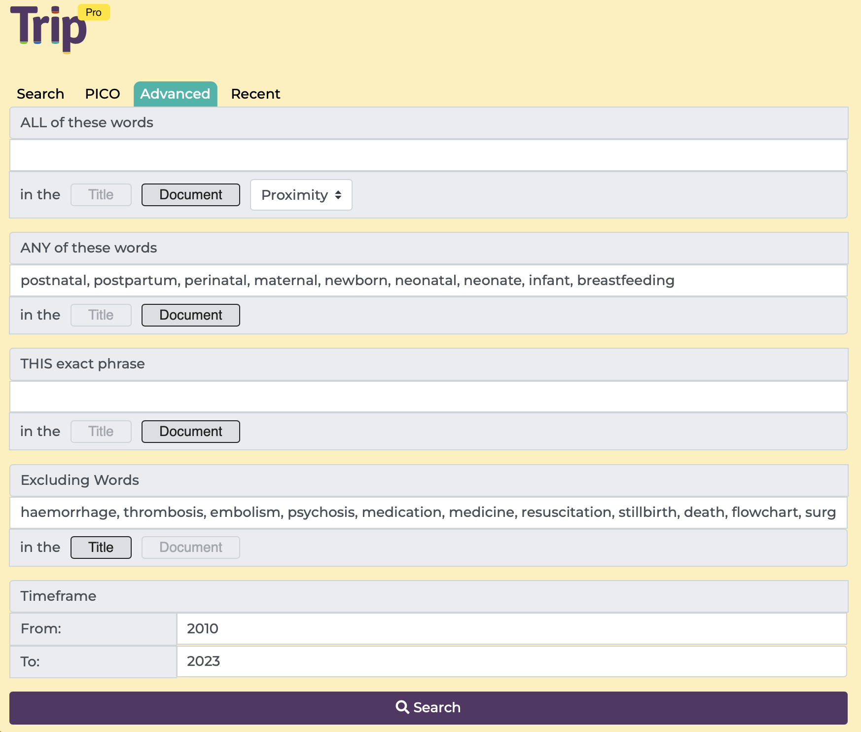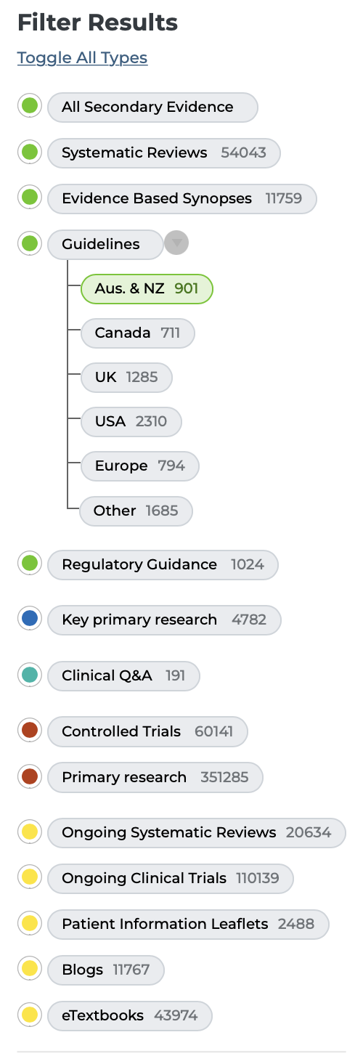

ANY of these words (in document):

postnatal, postpartum, perinatal, maternal, newborn, neonatal, neonate, infant, breastfeeding

EXCLUDING words (in title):

haemorrhage, thrombosis, embolism, psychosis, medication, medicine, resuscitation, stillbirth, death, flowchart, surgical, surgery

Timeframe: 2010 - 2023

Filters: Guidelines in Australia and New Zealand

