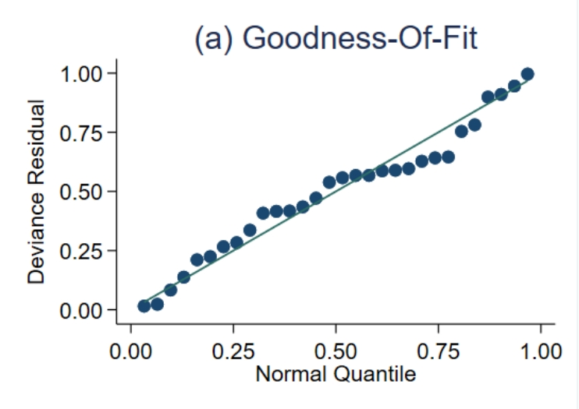  Quantile plot of residual based goodness-of fit  Supplement Figure 2. Model fitting | 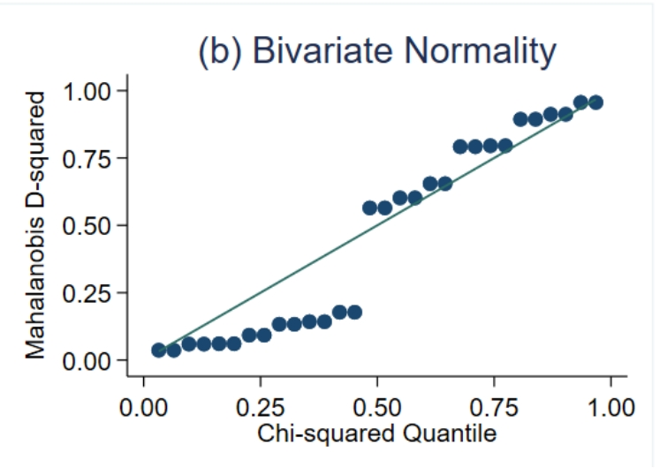  Chi-squared probability plot of squared Mahalanobis distances

