Supplemental data

Cardiotocography interpretation during labor by obstetric professionals: a large-scale online survey

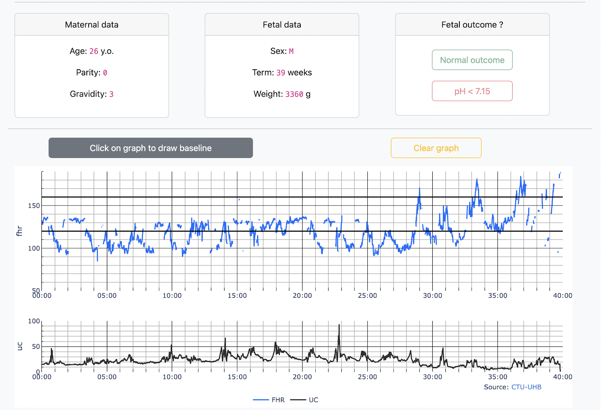
Figure S 1 Annotation tool - Example of case labelling

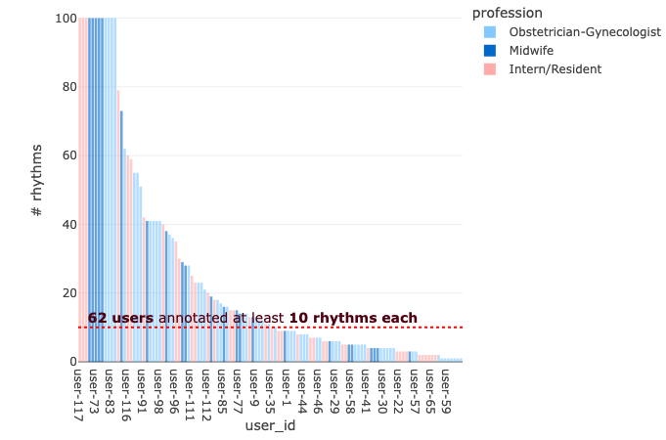
Figure S 2 Number of cases labelled per participant (sorted by number of labeled cases)
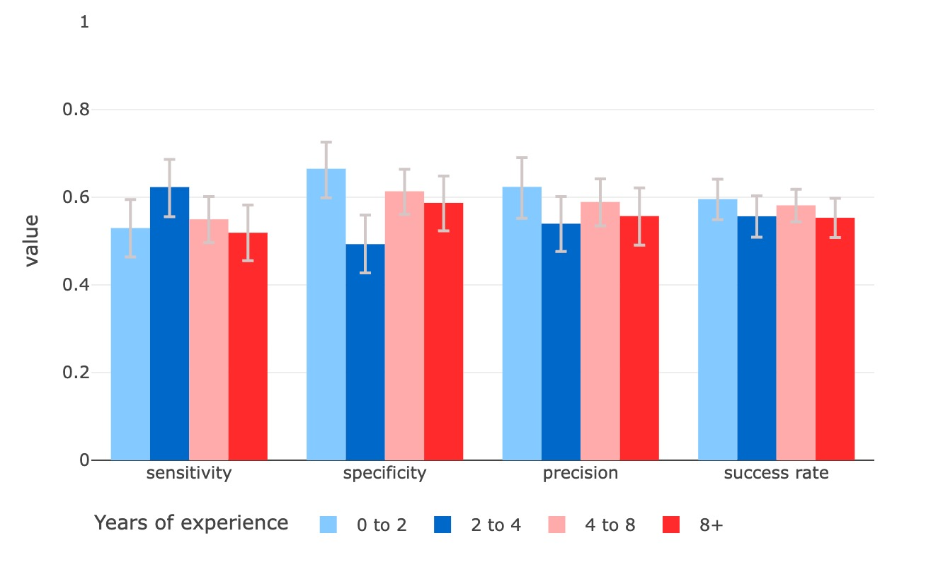
Figure S 3 Success rate as a function of the number of years of experience

