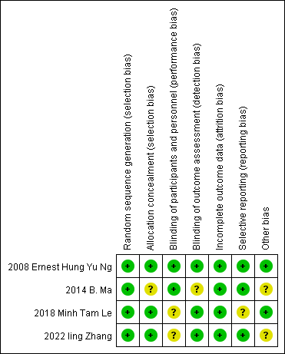
a

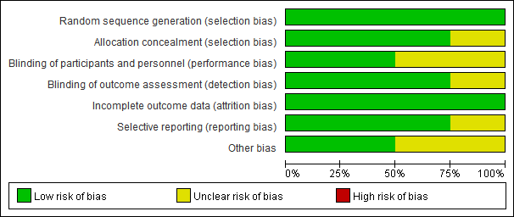

b
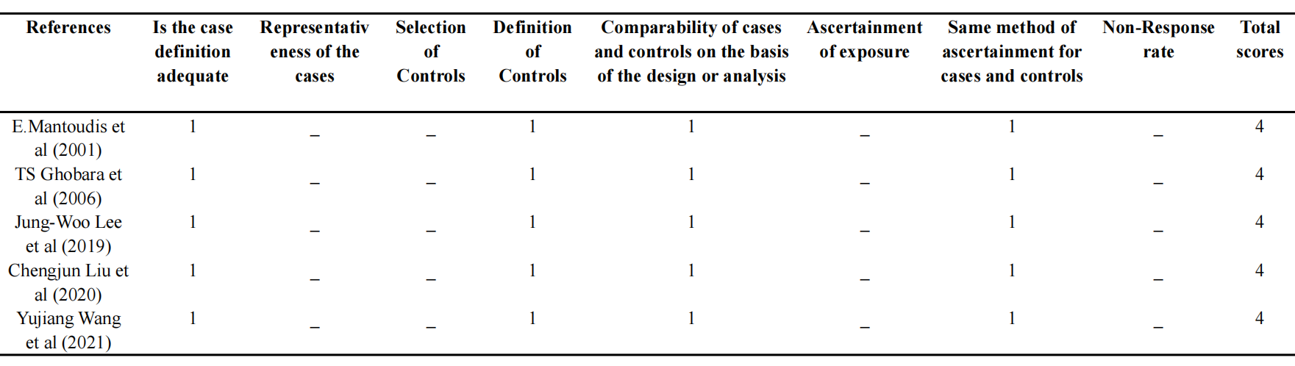
Supplementary Fig. S1: Quality assessment
In this meta-analysis, Cochrane risk-of-bias assessment to evaluate 4 RCT and Newcastle Ottawa Scale (NOS) risk assessment in 5 non-RCT.
(a) Cochrane risk-of-bias assessment; (b) NOS risk assessment.

a
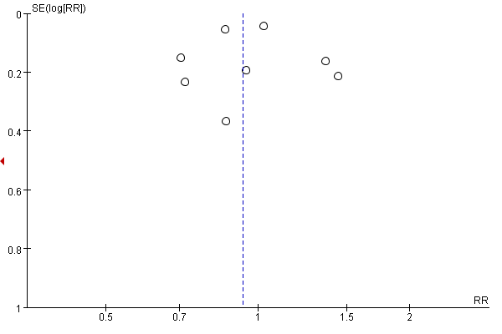
b
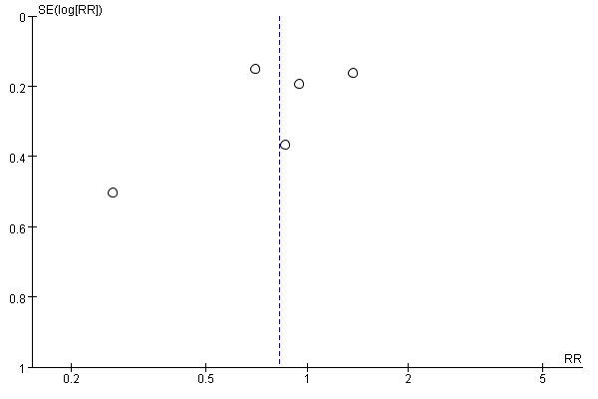
c
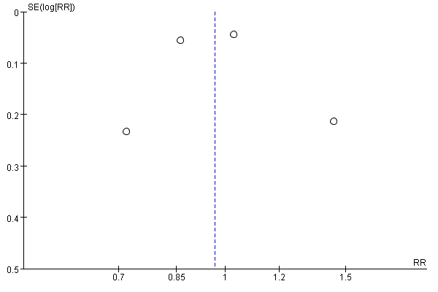

d
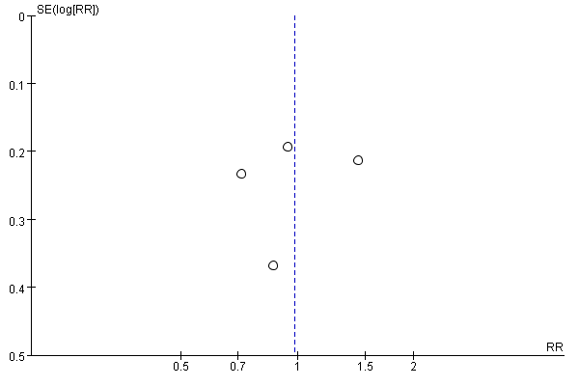
e
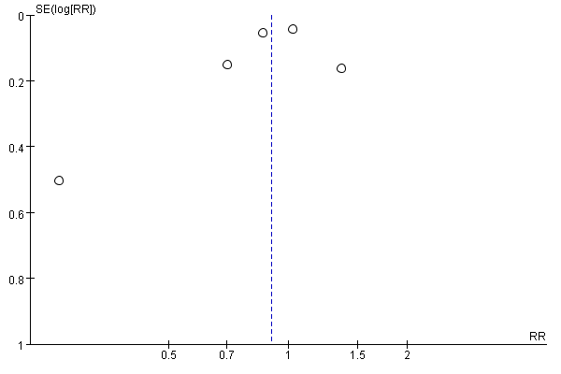
f
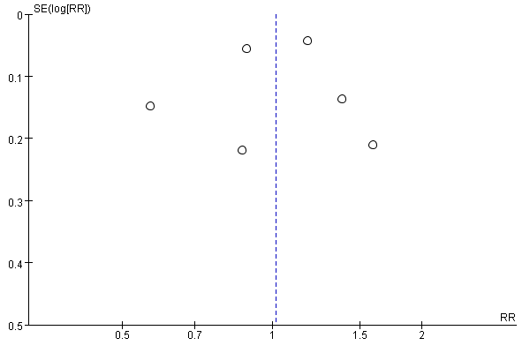

g
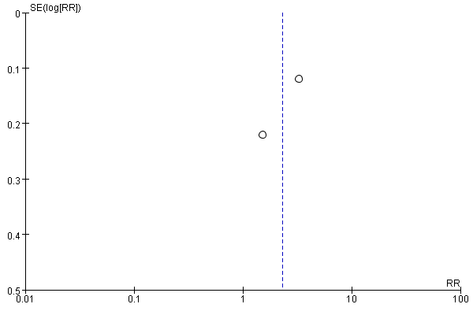
h
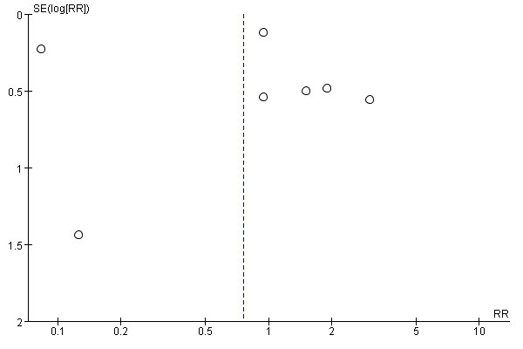
i
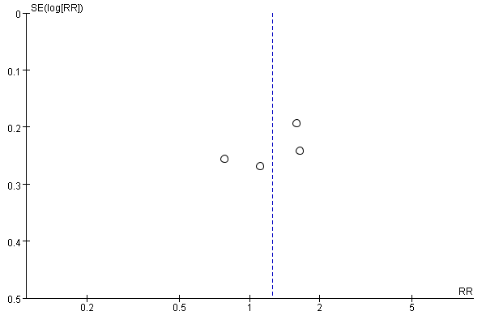

j
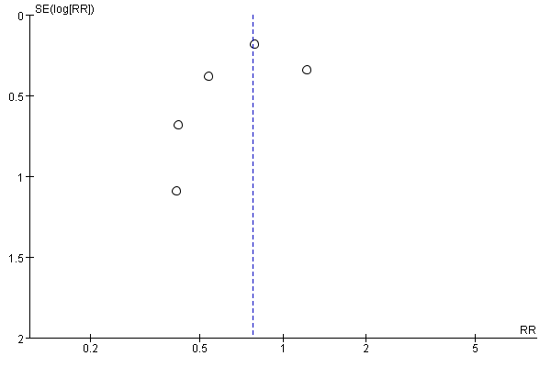
k
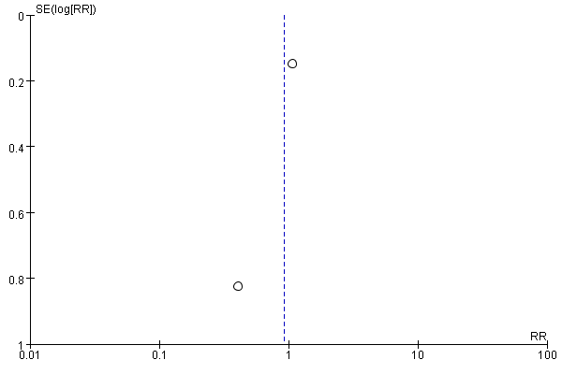
l
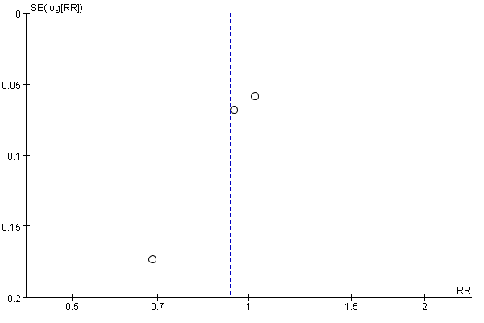

Supplementary Fig. S2: In heterogeneity analysis, miscarriage and premature birth showed low heterogeneity; clinical pregnancy, clinical pregnancy (fresh embryo), clinical pregnancy (frozen embryo), clinical pregnancy (RCT studies), ongoing pregnancy and live birth showed medium heterogeneity; clinical pregnancy (n0n-RCT studies), implantation rate, singleton and multiple pregnancy showed high heterogeneity.
(a) clinical pregnancy, I² = 71%; (b) clinical pregnancy (fresh embryo), I² = 74%; (c) clinical pregnancy (frozen embryo), I² = 74%; (d) clinical pregnancy (RCT studies), I² = 42%; (e) clinical pregnancy (non-RCT studies), I² = 83%; (f) implantation rate, I² = 89%; (g) singleton pregnancy, I² = 89%; (h) multiple pregnancies, I² = 94%; (i) ongoing pregnancy, I² = 54%; (j) miscarriage, I² = 0%; (k) premature birth, I² = 26%; (l)live birth, I² = 63%.

