Supplementary file (S1-S12)

S1: PROSPERO registration

We registered three study in PROSPERO separately but for publication of results we decided to combine the results of these studies together in one article. The titles and PROSPERO ID of each study is reported here.

- Comparison of the effectiveness of nifedipine and transdermal nitroglycerin in treatment of preterm labor: a systematic review and meta-analysis PROSPERO ID: CRD42021230008
- The comparison of efficacy of nifedipine and ritodrine on preterm labor: systematic review and meta-analysis PROSPERO ID: CRD42021290766
- The comparison of efficacy of nifedipine and magnesium sulfate on preterm labor: systematic review and meta-analysis PROSPERO ID: CRD42021290768

S2: Example search strategy
PubMed
Search: ((((((((birth, preterm[MeSH Terms] ) OR (births, preterm[MeSH Terms])) OR (labor, preterm[MeSH Terms])) OR (preterm birth[MeSH Terms])) OR (preterm births[MeSH Terms])) OR (preterm labor[MeSH Terms])) OR ((preterm delivery[Title/Abstract]) OR (preterm[Title/Abstract]))) AND (((nifedipine[Title/Abstract]) OR (nifedipine[MeSH Terms])) OR (((uterine contraction[MeSH Terms]) OR (uterine contractions[MeSH Terms])) OR (tocolysis[MeSH Terms])))) AND (((((Magnesium Sulfate[MeSH Terms]) OR (Magnesium Sulfate[Title/Abstract])) OR ((ritodrine[MeSH Terms]) OR (ritodrine[Title/Abstract]))) OR ((nitroglycerin[MeSH Terms]) OR (nitroglycerin[Title/Abstract]))) OR (((uterine contraction[MeSH Terms]) OR (uterine contractions[MeSH Terms])) OR (tocolysis[MeSH Terms])))

S3: PICOS criteria for inclusion of studies.

PICOS criteria | Definitions
Participants | All Pregnant women with preterm labor
Intervention | Nitroglycerin OR Ritodrine OR Magnesium Sulfate
Comparator | Control drug (Nifedipine)
Outcomes | Prolongation of pregnancy
Study design | RCTs (parallel, and prospective)

S4: Risk of bias assessment (ROB1).
Studies | Random sequence generation | Allocation concealment | Selective reporting | Other sources of bias | Blinding (participants and personnel) | Blinding (outcome assessment) | Incomplete outcome data | General risk of bias
Akhtar, 2020 | L | U | H | U | U | U | L | Unclear
Badshah, 2019 | L | L | L | U | U | U | L | LOW
Balasubramani, 2017 | L | H | U | U | U | U | L | Unclear
Dhawle, 2013 | L | L | H | L | U | U | L | LOW
Iftikhar, 2017 | L | L | H | L | U | U | L | LOW
Jamil, 2020 | L | L | H | L | U | U | L | LOW
Kashanian, 2014 | L | L | H | L | H | L | L | LOW
Kaur, 2021 | L | L | L | L | H | L | L | HIGH
Khan, 2019 | L | L | H | L | U | U | L | LOW
Sharma, 2019 | L | L | L | L | L | L | L | LOW
Zulfiqar, 2016 | H | H | L | L | U | U | L | HIGH
Padmini, 2015 | L | L | L | L | U | U | L | LOW
Vinodhini, 2019 | L | L | H | L | U | U | L | LOW
Yasmin, 2016 | L | U | H | L | U | U | L | Unclear
Goyal, 2023 | L | H | H | U | U | U | L | HIGH
Kalburgi, 2023 | L | H | H | U | U | U | L | HIGH
Al-Qattan, 2000 | L | L | L | L | U | U | L | LOW
Bankatlal, 2011 | L | L | L | L | U | U | L | LOW
Ceyhan, 2007 | H | H | H | L | H | H | L | HIGH
Garcıa-Velasco, 1998 | L | L | L | L | U | U | L | LOW
Gurjar, 2017 | H | H | H | L | U | U | L | HIGH
Kupfermi, 1993 | L | L | H | L | U | U | L | LOW
Maitra, 2007 | L | L | L | L | H | H | L | HIGH
Papatsoni, 1997 | L | L | L | L | U | U | L | LOW
Bracero, 1991 | L | L | L | L | U | U | L | LOW
Cararach, 2005 | L | L | L | L | H | H | L | HIGH
DikshaAmbedkar, 2022 | L | L | H | L | U | U | L | LOW
Glock, 1993 | L | L | L | L | U | U | L | LOW
Kara, 2009 | L | L | H | L | U | U | L | LOW
Khan, 2021 | L | U | H | L | U | U | L | Unclear
Klauser, 2013 | L | L | L | L | H | H | L | HIGH
Klauser, 2015 | L | L | L | L | H | H | L | HIGH
Nikbakht, 2014 | L | L | L | L | U | U | L | LOW
Niroomanesh, 2001 | U | U | H | L | U | U | L | Unclear
Faraji, 2013 | L | U | H | L | U | U | L | Unclear
Subhashini, 2013 | L | L | L | L | U | U | L | LOW
Vinodhini, 2019 | L | L | L | L | U | U | L | LOW
Alavi, 2015 | L | L | H | L | L | H | L | LOW
Bhat, 2023 | L | H | H | L | U | U | L | HIGH
Saleem, 2023 | L | H | H | L | U | U | L | HIGH

S5: The funnel plot related to studies that compared the efficacy of nifedipine with other tocolytic drugs in prolongation of pregnancy within 48 hours

S6 The funnel plot related to studies that compared the efficacy of nifedipine with other tocolytic drugs in prolongation of pregnancy within 48 hours to 1 week

S7: The funnel plot related to studies that compared the efficacy of nifedipine with other tocolytic drugs in prolongation of pregnancy to more than 1 week

S8: The funnel plot related to studies that compared the efficacy of nifedipine with other tocolytic drugs in prolongation of pregnancy for 34 weeks and more

S9: Comparing the efficacy of nifedipine with other tocolytic drugs in prolongation of pregnancy within 48 hours in low risk of bias studies
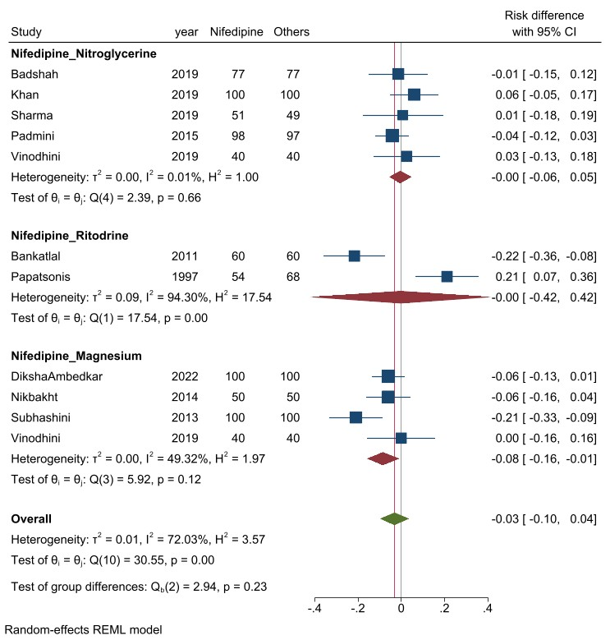

S10: Comparing the efficacy of nifedipine with other tocolytic drugs in prolongation of pregnancy within 48 hours to 1 week in low risk of bias studies
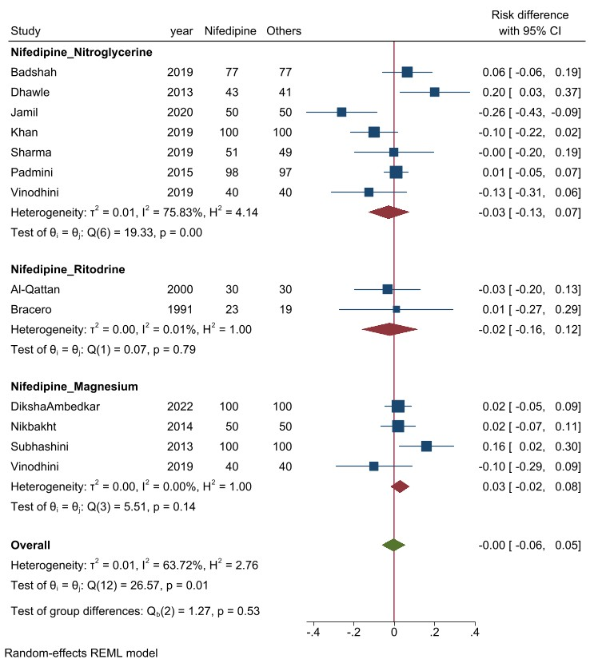

S11: Comparing the efficacy of nifedipine with other tocolytic drugs in prolongation of pregnancy for more than 1 week in low risk of bias studies
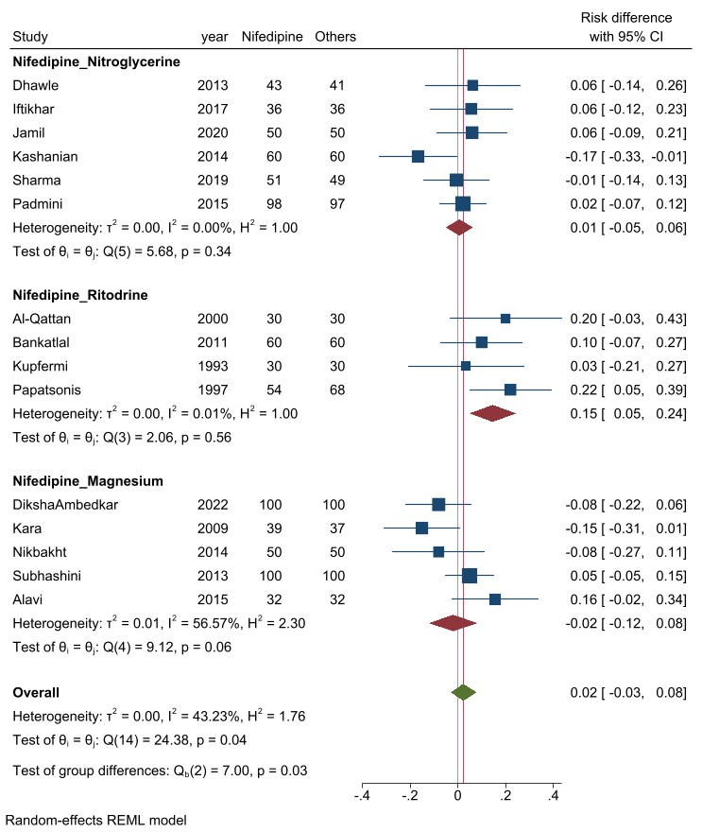

S12: Comparing the efficacy of nifedipine with other tocolytic drugs in prolongation of pregnancy for 34 weeks and more in low risk of bias studies
