Supplementary Material

Impact of invisible intimate partner violence on maternal healthcare utilization：
A cross-sectional study based on Pakistan Demographic Health Surveys

Figure and table legends

Supplementary Table 1. Classification of intimate relationship violence based on specific behaviors of violence by spouse

Supplementary Table 2. Prevalence of intimate relationship violence and maternal health use among women in two-year groups (2012-2013 and 2017-2018)
Note:
ANC = Antenatal Care.

Supplementary Table 3. Associations between maternal exposure to different forms of IPV, related control variables and use of maternal healthcare services in the past 12 months

Supplementary Table 4. Associations between maternal exposure to different forms of IPV, related control variables and use of maternal healthcare services in the past 3/5 years

*Supplementary Figure 1. Prevalence of emotional violence and physical violence (both severe and low scale) in Pakistan in year 2017-2018

*Supplementary Figure 2. Prevalence of emotional violence and physical violence (both severe and low scale) in Pakistan in year 2012-2013
Note:
FATA data were not included in the PDHS2012-2013 data, so prevalence rates were listed for only five administrative divisions

Supplementary Table 1. Classification of intimate relationship violence based on specific behaviors of violence by spouse
Types of intimate partner violence |  | Partner’s behaviors
Emotional violence |  | Spouse ever humiliated her.
 |  | Spouse ever threatened her with harm.
 |  | Spouse ever insulted her or made her feel bad.
Physical violence | Low scale physical violence (mild) | Spouse ever pushed, shook or threw something.
Physical violence | Low scale physical violence (mild) | Spouse ever slapped.
Physical violence | Low scale physical violence (mild) | Spouse ever punched with fist or something harmful.
Physical violence | Low scale physical violence (mild) | Spouse ever twisted her arm or pulled her hair.
Physical violence | Severe physical violence | Spouse ever kicked or dragged.
Physical violence | Severe physical violence | Spouse ever tried to strangle or burn.
Physical violence | Severe physical violence | Spouse ever threatened with knife/gun or other weapon.

Supplementary Table 2. Prevalence of intimate relationship violence and maternal health use among women in two-year groups (2012-2013 and 2017-2018)
 | PDHS2012-2013 | PDHS2017-2018
Prevalence of intimate partner violence during lifetime (%)
Emotional violence | 32.32 | 25.84
Physical violence
severe | 6.66 | 5.47
Mild | 20.36 | 17.45
Prevalence of intimate partner violence in the past 12 months (%)
Emotional violence | 28.36 | 20.62
Physical violence
severe | 3.74 | 3.41
Mild | 14.33 | 10.24
Maternal healthcare utilisation for women who gave birth in the past 3/5 years
N (%)
Inadequate ªANC visits | 1551 (85.55) | 1581 (87.20)
Non-institutional delivery | 846 (46.64) | 613 (33.66)
Absence of postnatal check-ups | 756 (73.18) | 1256 (69.09)
Maternal healthcare utilisation for women who gave birth in the past 12 months
N (%)
Inadequate ANC visits | 482 (97.57) | 472 (75.40)
Non-institutional delivery | 255 (44.97) | 164 (29.60)
Absence of postnatal check-ups | 224 (70.44) | 373 (67.45)
Note:
ªANC = Antenatal Care.

Supplementary Table 3. Associations between maternal exposure to different forms of IPV, related control variables and use of maternal healthcare services in the past 12 months
Variables | Had Less than 8 ªANC visits | Had No facility Delivery | Had no postnatal check-ups
 | aOR (95% CI) | aOR (95% CI) | aOR (95% CI)
Experienced Emotional violence in the past 12 months
No | [REF] | [REF] | [REF]
Yes | 2.16  (1.06 to 4.38) * | 2.24  (1.41 to 3.57) ** | 1.14  (0.70 to 1.87)
Experienced Physical violence in the past 12 months
No | [REF] | [REF] | [REF]
Mild | 1.65  (0.51 to 5.27) | 0.59  (0.33 to 1.08) | 1.52  (0.79 to 2.94)
Severe | 0.56  (0.15 to 2.07) | 0.53  (0.22 to 1.31) | 0.95  (0.34 to 2.67)
Age group
15-23 | [REF] | [REF] | [REF]
24-32 | 0.64  (0.34 to 1.20) | 1.12  (0.72 to 1.71) | 1.02  (0.58 to 1.75)
33-40 | 0.92  (0.38 to 2.25) | 0.98  (0.54 to 1.79) | 1.08  (0.55 to 2.13)
41-49 | 7.23  (0.77 to 67.58) | 1.29  (0.34 to 4.98) | 1.69  (0.23 to 12.68)
Education level of women
Higher | [REF] | [REF] | [REF]
Senior | 2.05  (1.01 to 4.18) * | 1.45  (0.51 to 4.16) | 1.14  (0.56 to 2.35)
Primary | 2.97  (1.20 to 7.35) * | 1.64  (0.54 to 4.97) | 2.18  (0.91 to 5.19)
No education | 5.97  (2.41 to 14.76) *** | 2.87  (0.99 to 8.26) | 2.04  (0.90 to 4.59)
Women current employment status
Yes | [REF] | [REF] | [REF]
No | 1.62  (0.73 to 3.59) | 0.75  (0.44 to 1.27) | 1.29  (0.73 to 2.26)
Education level of women’s partner
Higher | [REF] | [REF] | [REF]
Senior | 0.81  (0.39 to 1.68) | 1.43  (0.74 to 2.76) | 0.94  (0.47 to 1.88)
Primary | 1.12  (0.41 to 3.04) | 1.76  (0.81 to 3.81) | 1.01  (0.49 to 2.09)
No education | 1.23  (0.48 to 3.15) | 2.29  (1.16 to 4.53) * | 1.11  (0.50 to 2.48)
Wealth index
Richest | [REF] | [REF] | [REF]
Richer | 1.63  (0.72 to 3.72) | 1.66  (0.70 to 3.95) | 1.08  (0.50 to 2.34)
Middle | 2.82  (1.04 to 7.67) * | 2.61  (1.06 to 6.44) * | 0.94  (0.41 to 2.12)
Poorer | 3.36  (1.13 to 10.03) * | 3.65  (1.48 to 9.01) ** | 1.12  (0.45 to 2.80)
Poorest | 6.06  (1.55 to 23.76) ** | 3.51  (1.31 to 9.38) * | 0.80  (0.28 to 2.29)
Place of residence
Urban | [REF] | [REF] | [REF]
Rural | 1.13  (0.60 to 2.14) | 0.91  (0.55 to 1.53) | 1.66  (1.00 to 2.74) *
Decision Power in healthcare
Yes | [REF] | [REF] | [REF]
No | 1.10  (0.68 to 1.76) | 0.80  (0.53 to 1.20) | 1.80  (1.16 to 2.80) **
Year of survey
2012-2013 | [REF] | [REF] | [REF]
2017-2018 | 0.83  (0.49 to 1.39) | 0.35  (0.23 to 0.52) *** | 0.90  (0.59 to 1.40)
Weighted N | 1235 | 1235 | 1032
Note:
*p<0.05, **p<0.01，***p<0.001
ªANC = Antenatal Care.
The analyzed data are from two data sets PDHS2012-2013 and PDHS2017-2018.Physical violence are divided into low scale physical violence and severe physical violence as a rank variable.

Supplementary Table 4. Associations between maternal exposure to different forms of IPV, related control variables and use of maternal healthcare services in the past 3/5 years
Variables | Had Less than 8 ªANC visits | Had No facility Delivery | Had no Postnatal check-ups
 | aOR (95% CI) | aOR (95% CI) | aOR (95% CI)
Ever experienced Emotional violence during lifetime
No | [REF] | [REF] | [REF]
Yes | 1.48  (1.00 to 2.19) * | 1.16  (0.89 to 1.50) | 1.11  (0.82 to 1.51)
Ever experienced Physical violence during lifetime
No | [REF] | [REF] | [REF]
Mild | 1.15  (0.74 to 1.78) | 1.06  (0.80 to 1.39) | 1.73  (1.29 to 2.31) **
Severe | 0.87  (0.31 to 2.42) | 1.01  (0.68 to 1.50) | 1.25  (0.78 to 1.98)
Age group
15-23 | [REF] | [REF] | [REF]
24-32 | 0.75  (0.48 to 1.19) | 1.14  (0.82 to 1.58) | 1.02  (0.70 to 1.47)
33-40 | 0.96  (0.58 to 1.57) | 1.06  (0.75 to 1.50) | 1.09  (0.72 to 1.63)
41-49 | 0.71  (0.35 to 1,46) | 1.62  (1.04 to 2.52) * | 1.06  (0.57 to 1.97)
Education level of women
Higher | [REF] | [REF] | [REF]
Senior | 1.81  (1.20 to 2.783) ** | 2.10  (1.17 to 3.78) * | 1.08  (0.69 to 1.67)
Primary | 4.17  (2.38 to 7.29) *** | 3.35  (1.78 to 6.31) *** | 1.16  (0.68 to 1.98)
No education | 5.35  (3.21 to 8.92) *** | 3.73  (2.14 to 6.53) *** | 1.80  (0.68 to 2.25)
Women current employment status
Yes | [REF] | [REF] | [REF]
No | 1.10  (0.73 to 1.68) | 0.79  (0.59 to 1.04) | 1.17  (0.84 to 1.62)
Education level of women’s partner
Higher | [REF] | [REF] | [REF]
Senior | 0.79  (0.52 to 1.19) | 1.26  (0.88 to 1.79) | 1.21  (0.81 to 1.81)
Primary | 0.88  (0.50 to 1.56) | 1.81  (1.22 to 2.68) ** | 1.23  (0.75 to 2.02)
No education | 1.21  (0.70 to 2.09) | 1.90  (1.31 to 2.75) *** | 0.88  (0.56 to 1.37)
Wealth index
Richest | [REF] | [REF] | [REF]
Richer | 1.70  (1.09 to 2.65) * | 2.34  (1.42 to 3.85) *** | 1.27  (0.79 to 2.02)
Middle | 2.11  (1.22 to 3.66) ** | 2.98  (1.79 to 4.98) *** | 1.41  (0.85 to 2.37)
Poorer | 3.68  (1.83 to 7.37) *** | 5.02  (2.99 to 8.42) *** | 1.71  (0.99 to 2.95)
Poorest | 5.21  (2.23 to 12.14) *** | 5.40  (2.97 to 9.83) *** | 1.24  (0.68 to 2.25)
Place of residence
Urban | [REF] | [REF] | [REF]
Rural | 1.58  (1.05 to 2.40) * | 1.09  (0.81 to 1.45) | 1.59  (1.17 to 2.16) **
Decision Power in healthcare
Yes | [REF] | [REF] | [REF]
No | 1.12  (0.84 to 1.50) | 1.06  (0.85 to 1.33) | 1.22  (0.95 to 1.56)
Year of survey
2012-2013 | [REF] | [REF] | [REF]
2017-2018 | 1.05  (0.76 to 1.45) | 0.42  (0.33 to 0.54) *** | 0.98  (0.74 to 1.30)
Weighted N | 3768 | 3776 | 2909
Note:
*p<0.05, **p<0.01，***p<0.001
ªANC = Antenatal Care.
The analyzed data are from two data sets PDHS2012-2013 and PDHS2017-2018.Physical violence are divided into low scale physical violence and severe physical violence as a rank variable.

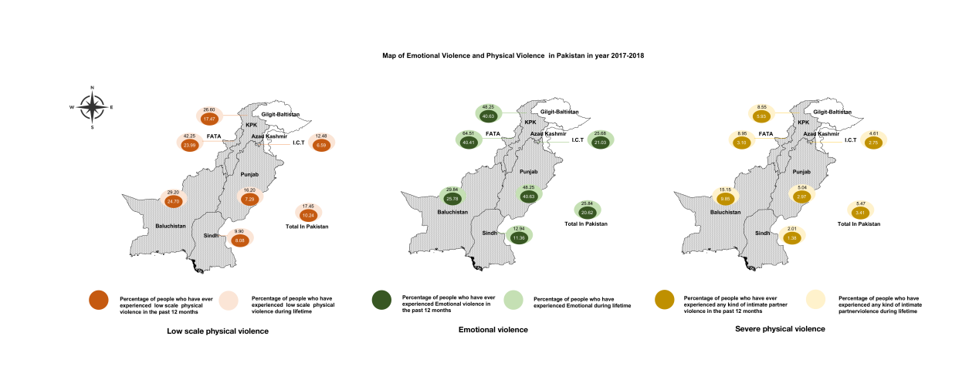
Supplementary Figure 1. Prevalence of emotional violence and physical violence (both severe and low scale) in Pakistan in year 2017-2018

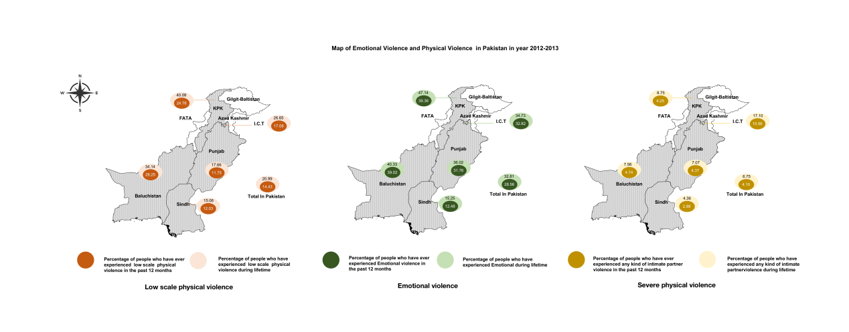
Supplementary Figure 2. Prevalence of emotional violence and physical violence (both severe and low scale) in Pakistan in year 2012-2013
Note:
FATA data were not included in the PDHS2012-2013 data, so prevalence rates were listed for only five administrative divisions

