Additional file 1. Overview of the study

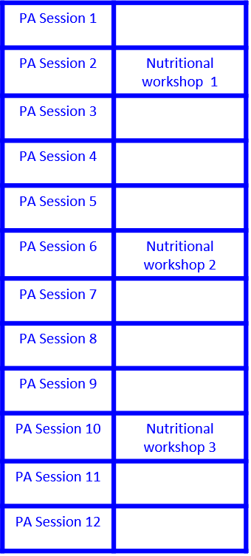
Proposed program during 12 weeks
12–22⁺⁶ weeks
Identification of eligible patients
Proposal for participation in the "Eat well, move well for baby's health" program
Usual pregnancy follow-up
One prenatal visit/month
Ultrasonography 22 SA and 32 w
Screening for gestational diabetes
and gravidic hypertension
Second evaluation
32–34 weeks
Questionnaires (PA, eating behaviors and affectivity)
Delivery and post-partum
Pregnancy, delivery, neonatal, and post-partum data
During the postnatal visit 6–8 weeks after delivery
Maternal and newborn weight
Breastfeeding duration
Questionnaires (PA, eating behaviors and affectivity)
20–24 weeks (before program):
- Socio-demographic data
- Clinical data
- Questionnaires (PA, eating behaviors and affectivity)
Yes
No
Inclusion
Consent to be included
PA: Physical activity

