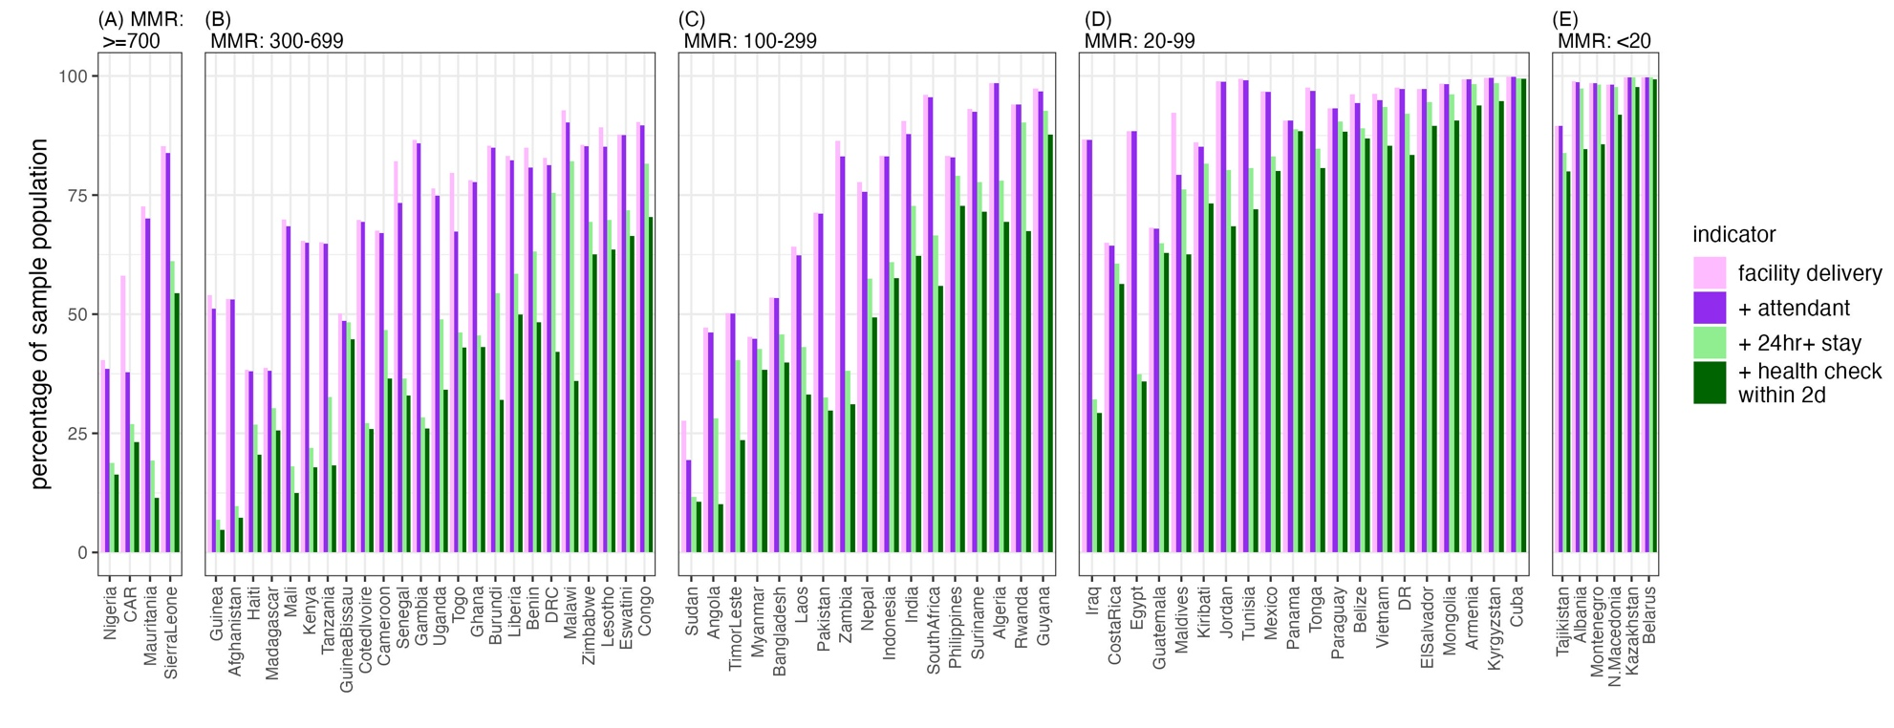
Supplementary Figure 1. Delivery care cascade using country data stratified by maternal mortality ratio transition phases: greater than or equal to 700 (A), 300 to 699 (B), 100 to 299 (C), 20 to 99 (D), less than 20 (E).

