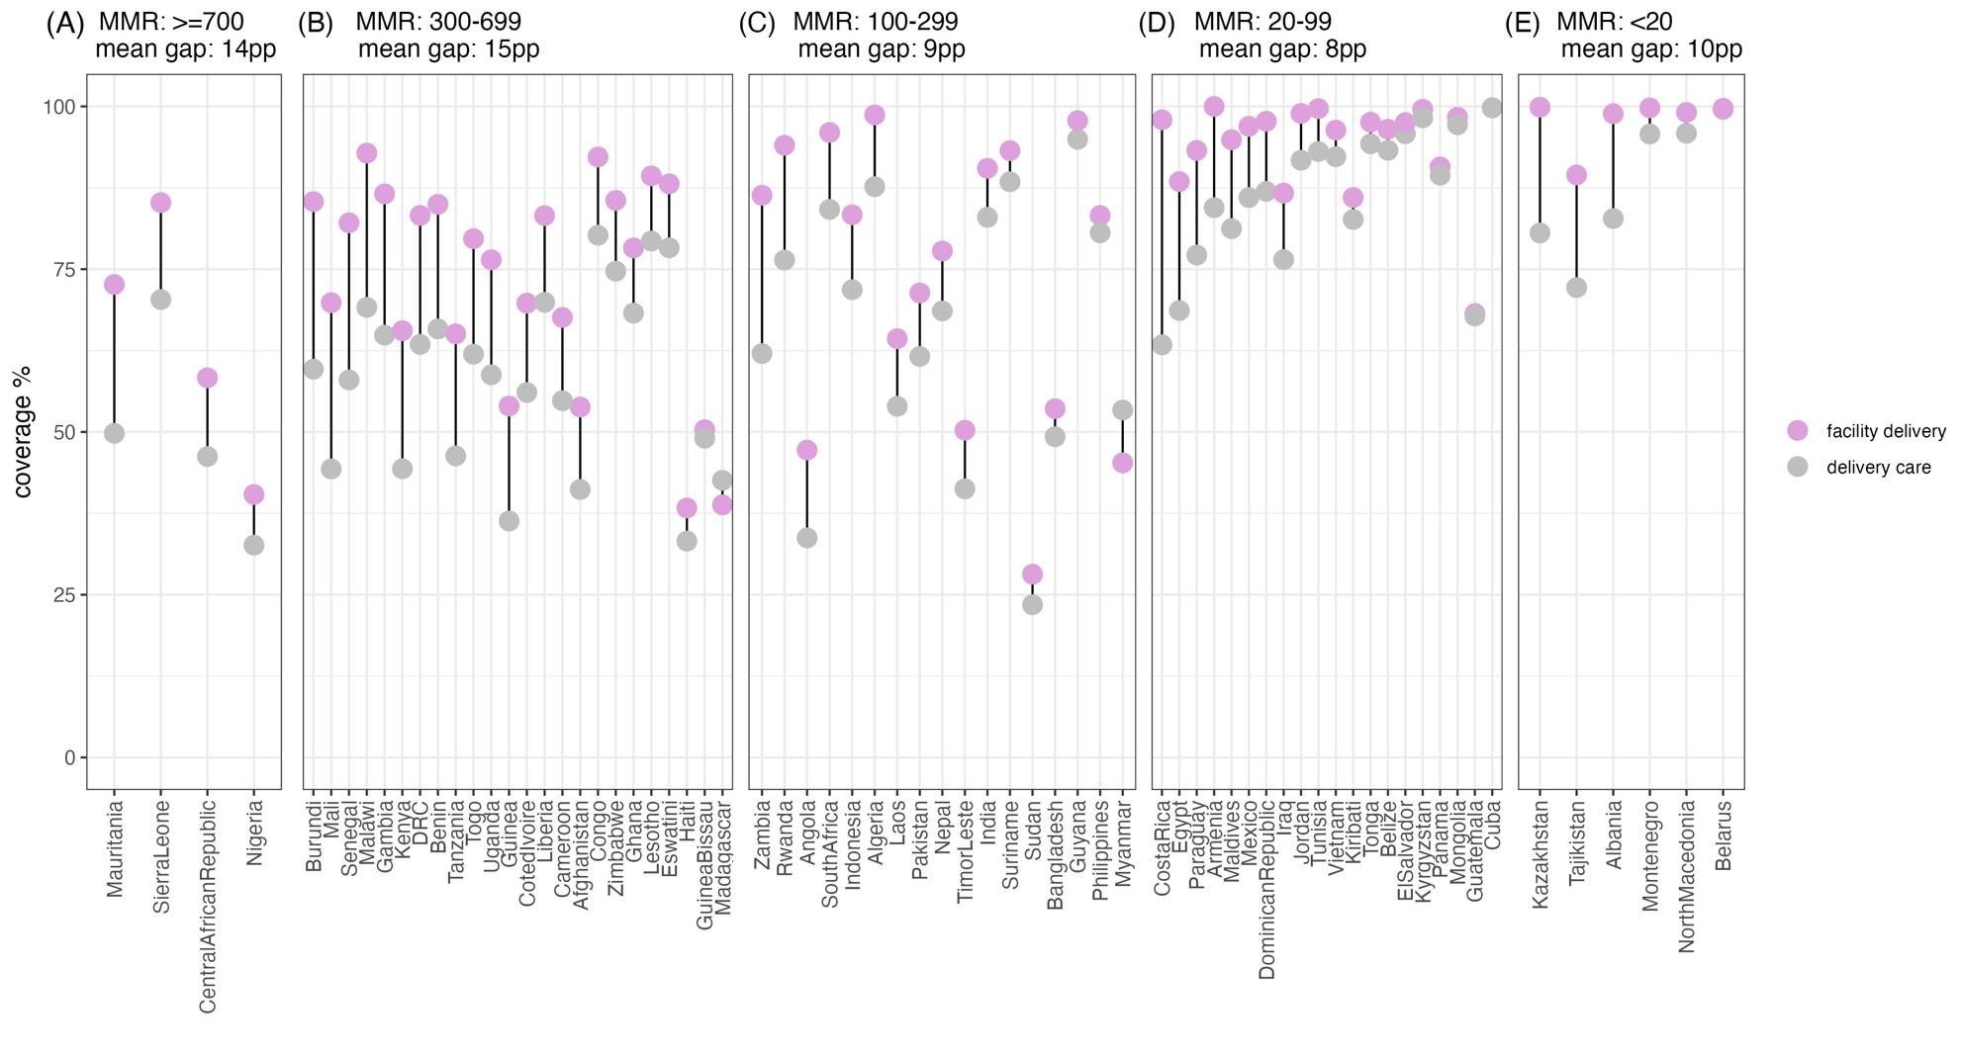

Supplementary Figure 2. Gap between facility delivery and delivery care coverage, by each study country, in each maternal mortality transition phase.

