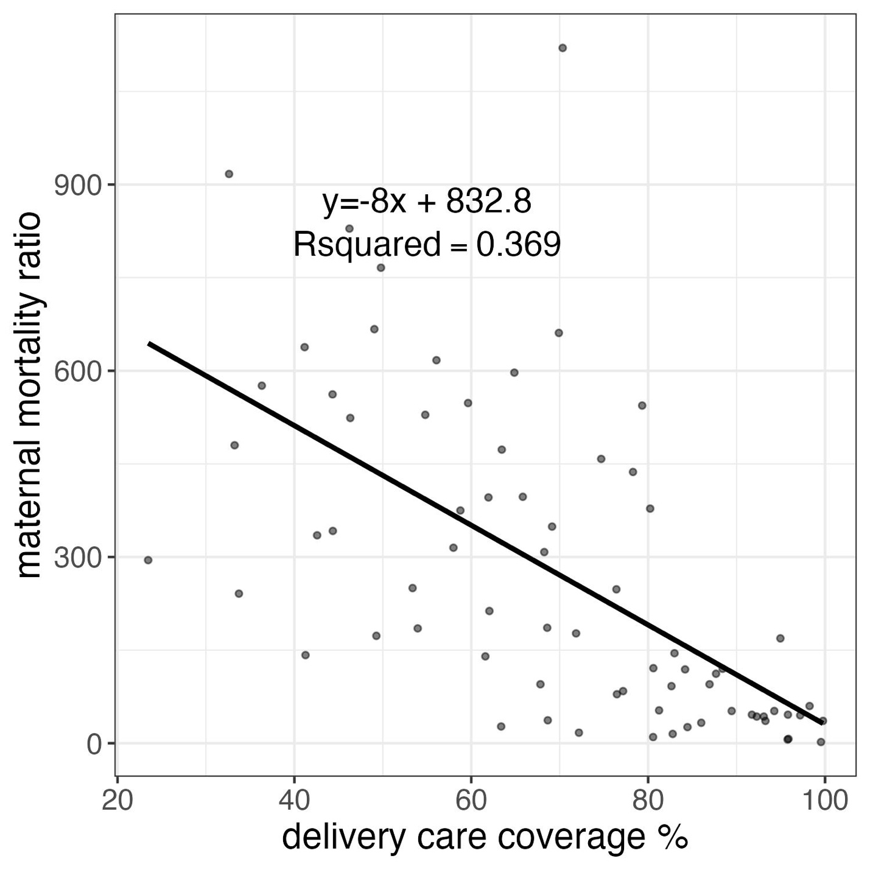

Supplementary Figure 3. Linear trend between the maternal mortality ratio and delivery care coverage among all countries in the study.

