Supplementary file

Supplementary table 1
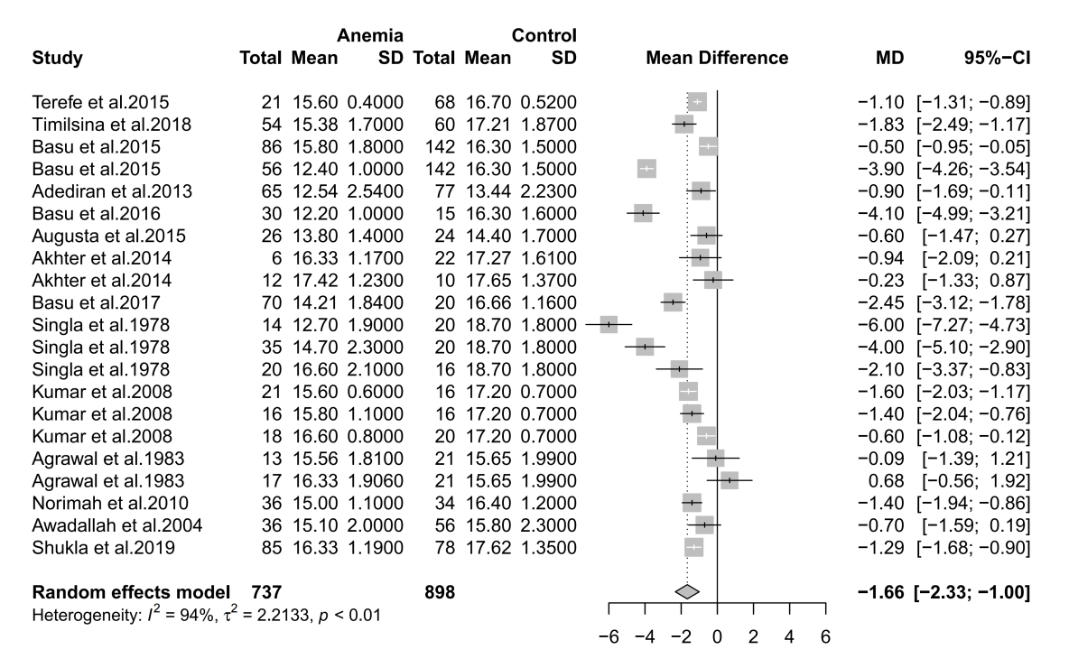
Supplementary table1 Forest plot of hazard ratios of affects of anemia during pregnancy on anemia incidence of newborns. (stratified analysis)

