Supplementary materials

sTable 1. Selection of GAMLSS models
sTable 2. EFW distributions of DCDA and MCDA twins by gestational weeks
sTable 3. Gestation-specific parameter values and EFW percentiles for DCDA twins
sTable 4. Gestation-specific parameter values and EFW percentiles for MCDA twins
sTable 5. Characteristics of DCDA and MCDA pregnancies in the validation set
sFigure 1. Frequency of EFW measurements by gestational weeks for DCDA and MCDA twins
sFigure 2. Flow chart for the participants in the validation set

sTable 1. Selection of GAMLSS models
Distribution | GAIC for MCDA twins | GAIC for DCDA twins
BCT | 23370.53 | 56177.34
BCTo | 23374.88 | 56179.41
BCCG | 23379.05 | 56246.75
BCCGo | 23383.60 | 56249.68
GAIC: Generalized Akaike Information Criterion

sTable 2. EFW distributions of DCDA and MCDA twins by gestational weeks
Gestational weeks | Dichorionic twins ª | Monochorionic twins ª | Difference in means (95% CI) ^{b} | P value
16 | 153.4 (24.5) | 145.9 (21.7) | -6.8 (-23.7 to 10.2) | 0.441
17 | 185.4 (21.3) | 191.0 (25.6) | 7.9 (-4.6 to 20.4) | 0.227
18 | 229.3 (44.8) | 217.0 (30.5) | -13.1 (-34.9 to 8.6) | 0.244
19 | 269.6 (48.4) | 266.8 (39.3) | -4.4 (-24.6 to 15.7) | 0.669
20 | 351.1 (49.8) | 323.6 (47.6) | -25.2 (-44.3 to -6.2) | 0.011
21 | 426.9 (48.3) | 410.8 (54.6) | -16.1 (-29.0 to -3.1) | 0.016
22 | 483.1 (52.1) | 470.4 (71.9) | -9.3 (-22.7 to 4.1) | 0.175
23 | 547.3 (70.6) | 546.2 (84.8) | 6.0 (-22.4 to 34.5) | 0.678
24 | 628.0 (110.0) | 649.1 (101.1) | 38.9 (-7.0 to 84.8) | 0.102
25 | 769.1 (104.2) | 744.6 (100.1) | -38.5 (-78.2 to 1.2) | 0.061
26 | 890.7 (109.9) | 842.5 (129.8) | -51.1 (-91.8 to -10.5) | 0.016
27 | 1043.8 (144.5) | 991.0 (145.2) | -80.1 (-135.5 to -24.8) | 0.006
28 | 1191.7 (139.1) | 1151.7 (144.3) | -28.2 (-64.8 to 8.5) | 0.134
29 | 1360.8 (148.2) | 1228.2 (174.4) | -136.6 (-185.6 to -87.5) | <0.001
30 | 1500.6 (176.5) | 1431.7 (203) | -72.2 (-113.6 to -30.7) | 0.001
31 | 1653.9 (194.2) | 1563.8 (210.6) | -81.7 (-133.3 to -30.1) | 0.002
32 | 1823.4 (216.1) | 1701.0 (240.7) | -117.5 (-181.7 to -53.3) | <0.001
33 | 1980.5 (248) | 1883.9 (297.6) | -96.6 (-171.9 to -21.3) | 0.013
34 | 2229.9 (269) | 2052.3 (322.7) | -166.5 (-247 to -86.1) | <0.001
35 | 2405.3 (274.5) | 2244.7 (314.9) | -187.8 (-275.3 to -100.2) | <0.001
36 | 2602.1 (299.0) | 2429.3 (352.1) | -161.3 (-249.7 to -72.9) | <0.001
37 | 2761.1 (333.9) | 2481.1 (428.9) | -238.8 (-487 to 9.5) | 0.067
ª Data was presented as mean (sd).
^{b} Adjusted for the covariates of maternal age, ethnicity, pre-pregnancy BMI, conception mode, presence of GDM, presence of gestational hypertension disorders, gestational age, and fetus sex.

sTable 3. Gestation-specific parameter values and EFW percentiles for DCDA twins
Gestational weeks | Location | Scale | Skewness | Kurtosis | Percentile
 |  |  |  |  | 3rd | 5th | 10th | 25th | 50th | 75th | 90th | 95th | 97th
16 | 149.72 | 0.12 | -0.84 | 9.63 | 119.75 | 123.41 | 129.00 | 138.46 | 149.72 | 162.79 | 177.52 | 188.61 | 197.17
17 | 184.49 | 0.13 | -0.19 | 9.74 | 140.75 | 146.29 | 154.65 | 168.50 | 184.49 | 202.31 | 221.43 | 235.15 | 245.37
18 | 224.03 | 0.14 | 0.40 | 9.85 | 161.60 | 169.93 | 182.26 | 202.09 | 224.03 | 247.35 | 271.10 | 287.40 | 299.15
19 | 276.90 | 0.14 | 0.81 | 9.96 | 195.66 | 207.12 | 223.72 | 249.51 | 276.90 | 304.81 | 332.11 | 350.23 | 363.01
20 | 351.18 | 0.12 | 0.91 | 10.07 | 260.70 | 273.67 | 292.32 | 321.03 | 351.18 | 381.57 | 410.96 | 430.30 | 443.87
21 | 425.76 | 0.10 | 0.79 | 10.18 | 334.44 | 347.36 | 366.06 | 395.05 | 425.76 | 456.94 | 487.31 | 507.38 | 521.49
22 | 481.83 | 0.10 | 0.70 | 10.30 | 384.07 | 397.79 | 417.70 | 448.75 | 481.83 | 515.60 | 548.61 | 570.51 | 585.93
23 | 547.80 | 0.11 | 0.95 | 10.41 | 422.33 | 440.34 | 466.25 | 506.08 | 547.80 | 589.68 | 629.94 | 656.28 | 674.66
24 | 644.45 | 0.12 | 1.36 | 10.53 | 471.29 | 497.50 | 534.32 | 589.12 | 644.46 | 698.13 | 748.16 | 780.12 | 802.11
25 | 764.09 | 0.12 | 1.53 | 10.65 | 548.88 | 582.30 | 628.69 | 696.65 | 764.11 | 828.53 | 887.75 | 925.20 | 950.79
26 | 897.09 | 0.12 | 1.42 | 10.77 | 658.76 | 694.97 | 745.75 | 821.17 | 897.10 | 970.44 | 1038.48 | 1081.75 | 1111.42
27 | 1041.73 | 0.11 | 1.11 | 10.89 | 791.56 | 827.94 | 879.98 | 959.40 | 1041.73 | 1123.33 | 1200.68 | 1250.65 | 1285.23
28 | 1194.28 | 0.11 | 0.65 | 11.01 | 939.19 | 974.41 | 1025.93 | 1107.05 | 1194.28 | 1283.78 | 1371.30 | 1429.19 | 1469.87
29 | 1344.51 | 0.10 | 0.11 | 11.13 | 1081.67 | 1116.21 | 1167.73 | 1251.28 | 1344.51 | 1443.87 | 1544.70 | 1613.42 | 1662.67
30 | 1488.91 | 0.10 | -0.28 | 11.26 | 1206.24 | 1242.12 | 1296.32 | 1386.06 | 1488.91 | 1601.75 | 1719.78 | 1802.27 | 1862.45
31 | 1639.82 | 0.11 | -0.30 | 11.38 | 1323.75 | 1363.66 | 1424.08 | 1524.41 | 1639.82 | 1766.85 | 1900.07 | 1993.36 | 2061.50
32 | 1809.68 | 0.11 | 0.03 | 11.51 | 1441.60 | 1489.20 | 1560.65 | 1677.67 | 1809.68 | 1951.72 | 2096.97 | 2196.45 | 2267.97
33 | 2000.62 | 0.11 | 0.48 | 11.64 | 1564.31 | 1622.95 | 1709.72 | 1848.59 | 2000.62 | 2158.92 | 2315.41 | 2419.60 | 2493.07
34 | 2205.75 | 0.11 | 0.83 | 11.77 | 1713.13 | 1781.75 | 1881.82 | 2038.61 | 2205.75 | 2375.12 | 2538.17 | 2644.45 | 2718.35
35 | 2407.23 | 0.11 | 1.03 | 11.90 | 1878.71 | 1953.89 | 2062.58 | 2230.72 | 2407.23 | 2583.37 | 2750.48 | 2858.14 | 2932.44
36 | 2597.08 | 0.11 | 0.98 | 12.04 | 2031.44 | 2111.37 | 2227.27 | 2407.28 | 2597.08 | 2787.16 | 2967.95 | 3084.62 | 3165.20
37 | 2777.52 | 0.11 | 0.76 | 12.17 | 2168.46 | 2252.41 | 2375.42 | 2569.39 | 2777.52 | 2989.39 | 3193.84 | 3327.20 | 3419.93

sTable 4. EFW reference values for MCDA twins
Gestational weeks | Location | Scale | Skewness | Kurtosis | Percentile
 |  |  |  |  | 3rd | 5th | 10th | 25th | 50th | 75th | 90th | 95th | 97th
16 | 146.22 | 0.15 | 0.83 | 91.52 | 106.09 | 111.08 | 118.78 | 131.70 | 146.22 | 161.00 | 174.59 | 182.89 | 188.36
17 | 185.05 | 0.15 | 0.88 | 79.47 | 134.25 | 140.63 | 150.43 | 166.80 | 185.05 | 203.52 | 220.44 | 230.76 | 237.55
18 | 219.63 | 0.14 | 0.94 | 69.01 | 159.31 | 166.97 | 178.68 | 198.11 | 219.63 | 241.29 | 261.06 | 273.09 | 281.01
19 | 265.84 | 0.14 | 0.99 | 59.92 | 192.77 | 202.15 | 216.43 | 239.96 | 265.84 | 291.74 | 315.32 | 329.64 | 339.06
20 | 328.95 | 0.14 | 1.05 | 52.03 | 238.42 | 250.18 | 267.99 | 297.13 | 328.95 | 360.63 | 389.37 | 406.82 | 418.28
21 | 402.82 | 0.14 | 1.10 | 45.18 | 291.78 | 306.39 | 328.38 | 364.10 | 402.82 | 441.17 | 475.87 | 496.92 | 510.76
22 | 475.53 | 0.14 | 1.16 | 39.23 | 344.16 | 361.66 | 387.87 | 430.10 | 475.53 | 520.29 | 560.70 | 585.21 | 601.33
23 | 554.29 | 0.14 | 1.21 | 34.06 | 400.74 | 421.47 | 452.33 | 501.65 | 554.29 | 605.89 | 652.39 | 680.60 | 699.18
24 | 645.48 | 0.14 | 1.27 | 29.58 | 466.02 | 490.62 | 526.96 | 584.54 | 645.48 | 704.92 | 758.42 | 790.90 | 812.33
25 | 748.08 | 0.14 | 1.32 | 25.68 | 539.17 | 568.25 | 610.91 | 677.85 | 748.08 | 816.24 | 877.54 | 914.83 | 939.47
26 | 864.27 | 0.13 | 1.38 | 22.30 | 621.57 | 655.94 | 705.93 | 783.57 | 864.27 | 942.22 | 1012.31 | 1055.04 | 1083.35
27 | 994.68 | 0.13 | 1.43 | 19.37 | 713.47 | 754.02 | 812.50 | 902.28 | 994.68 | 1083.52 | 1163.42 | 1212.30 | 1244.78
28 | 1132.10 | 0.13 | 1.49 | 16.82 | 809.42 | 856.88 | 924.66 | 1027.44 | 1132.11 | 1232.27 | 1322.47 | 1377.86 | 1414.83
29 | 1272.42 | 0.13 | 1.54 | 14.60 | 906.16 | 961.21 | 1038.97 | 1155.31 | 1272.44 | 1384.00 | 1484.68 | 1546.84 | 1588.52
30 | 1418.53 | 0.13 | 1.60 | 12.68 | 1005.44 | 1069.00 | 1157.72 | 1288.51 | 1418.57 | 1541.90 | 1653.53 | 1722.90 | 1769.69
31 | 1571.48 | 0.13 | 1.65 | 11.01 | 1107.54 | 1180.75 | 1281.64 | 1427.97 | 1571.56 | 1707.11 | 1830.31 | 1907.50 | 1959.91
32 | 1732.16 | 0.13 | 1.71 | 9.56 | 1212.59 | 1296.83 | 1411.33 | 1574.49 | 1732.30 | 1880.63 | 2016.20 | 2101.94 | 2160.65
33 | 1901.72 | 0.12 | 1.76 | 8.30 | 1320.80 | 1417.75 | 1547.59 | 1729.13 | 1901.97 | 2063.77 | 2212.68 | 2307.96 | 2373.82
34 | 2077.02 | 0.12 | 1.81 | 7.21 | 1429.38 | 1540.77 | 1687.73 | 1889.04 | 2077.47 | 2253.17 | 2416.31 | 2522.15 | 2596.14
35 | 2254.10 | 0.12 | 1.87 | 6.26 | 1535.02 | 1662.58 | 1828.37 | 2050.61 | 2254.85 | 2444.60 | 2622.75 | 2740.22 | 2823.43
36 | 2430.50 | 0.12 | 1.92 | 5.43 | 1635.67 | 1781.09 | 1967.43 | 2211.65 | 2431.73 | 2635.53 | 2829.49 | 2959.87 | 3053.66
37 | 2605.28 | 0.12 | 1.98 | 4.72 | 1730.50 | 1895.44 | 2104.10 | 2371.37 | 2607.22 | 2825.08 | 3035.87 | 3180.83 | 3286.96

sTable 5. Characteristics of DCDA and MCDA pregnancies in the validation set
Characteristics | DCDA twins |  |  |  |  | MCDA twins
Characteristics | Overall  (n=1,186) | No SGA  (n=1,016) | Suspected SGA  (n=85) | SGA  (n=85) | P value | Overall  (n=416) | No SGA  (n=319) | Suspected SGA  (n=79) | SGA  (n=18) | P value
Maternal age (year) | 33.59 ± 3.08 | 33.57 ± 3.02 | 33.92 ± 3.39 | 33.50 ± 3.47 | 0.583 | 31.64 ± 4.03 | 31.72 ± 4.00 | 31.66 ± 4.27 | 30.04 ± 3.31 | 0.227
Primipara | 1,050 (88.53) | 903 (88.88) | 72 (84.71) | 75 (88.24) | 0.508 | 286 (68.75) | 224 (70.22) | 51 (64.56) | 11 (61.11) | 0.483
IVF-ET | 938 (79.09) | 816 (80.31) | 61 (71.76) | 61 (71.76) | 0.04 | 72 (17.31) | 63 (19.75) | 8 (10.13) | 1 (5.56) | 0.054
Pre-gestational body mass index (kg/m²) |  |  |  |  | 0.134 |  |  |  |  | 0.164
Underweight, <18.5 kg/m² | 70 (5.90) | 54 (5.32) | 11 (12.94) | 5 (5.88) |  | 44 (10.58) | 34 (10.66) | 9 (11.39) | 1 (5.56)
Normal, 18.5-<24.0 kg/m² | 704 (59.36) | 605 (59.55) | 50 (58.82) | 49 (57.65) |  | 246 (59.13) | 193 (60.50) | 44 (55.70) | 9 (50.00)
Overweight, 24.0-<28 kg/m² | 204 (17.20) | 180 (17.72) | 10 (11.76) | 14 (16.47) |  | 74 (17.79) | 60 (18.81) | 11 (13.92) | 3 (16.67)
Obese, ≥28 kg/m² | 208 (17.54) | 177 (17.42) | 14 (16.47) | 17 (20.00) |  | 52 (12.50) | 32 (10.03) | 15 (18.99) | 5 (27.78)
Weight gain during pregnancy (kg) | 16.50 (13.00, 20.00) | 16.80 (13.50, 20.00) | 15.00 (12.00, 20.00) | 15.50 (12.00, 19.00) | 0.120 | 17.00 (13.75, 21.00) | 17.00 (14.00, 21.00) | 16.00 (12.00, 21.00) | 20.25 (16.50, 22.00) | 0.126
Gestational hypertension disorders | 184 (15.51) | 162 (15.94) | 8 (9.412) | 14 (16.47) | 0.27 | 70 (16.83) | 58 (18.18) | 10 (12.66) | 2 (11.11) | 0.505
Gestational diabetes mellitus | 316 (26.64) | 271 (26.67) | 21 (24.71) | 24 (28.24) | 0.872 | 100 (24.04) | 82 (25.71) | 14 (17.72) | 4 (22.22) | 0.332
Male fetus | 616 (51.94) | 525 (51.67) | 44 (51.76) | 47 (55.29) | 0.813 | 217 (52.16) | 178 (55.80) | 34 (43.04) | 5 (27.78) | 0.013
Gestational week | 37.00 (36.00, 37.00) | 37.00 (36.00, 37.00) | 37.00 (36.00, 37.00) | 37.00 (36.00, 37.00) | 0.016 | 36.00 (35.00, 37.00) | 36.00 (35.00, 37.00) | 36.00 (35.00, 37.00) | 35.00 (34.00, 37.00) | 0.012
Birth weight, g | 2,570.00 (2,320.00, 2,800.00) | 2,600.00 (2,360.00, 2,820.00) | 2,420.00 (2,270.00, 2,660.00) | 2,250.00 (2,080.00, 2,540.00) | <0.001 | 2,410.00 (2,200.00, 2,640.00) | 2,480.00 (2,280.00, 2,700.00) | 2,240.00 (2,080.00, 2,430.00) | 2,100.00 (1,790.00, 2,190.00) | <0.001
Data was presented as mean±sd or median (25th percentile to 75th percentile) for continuous variables and n (%) for categorical variables.

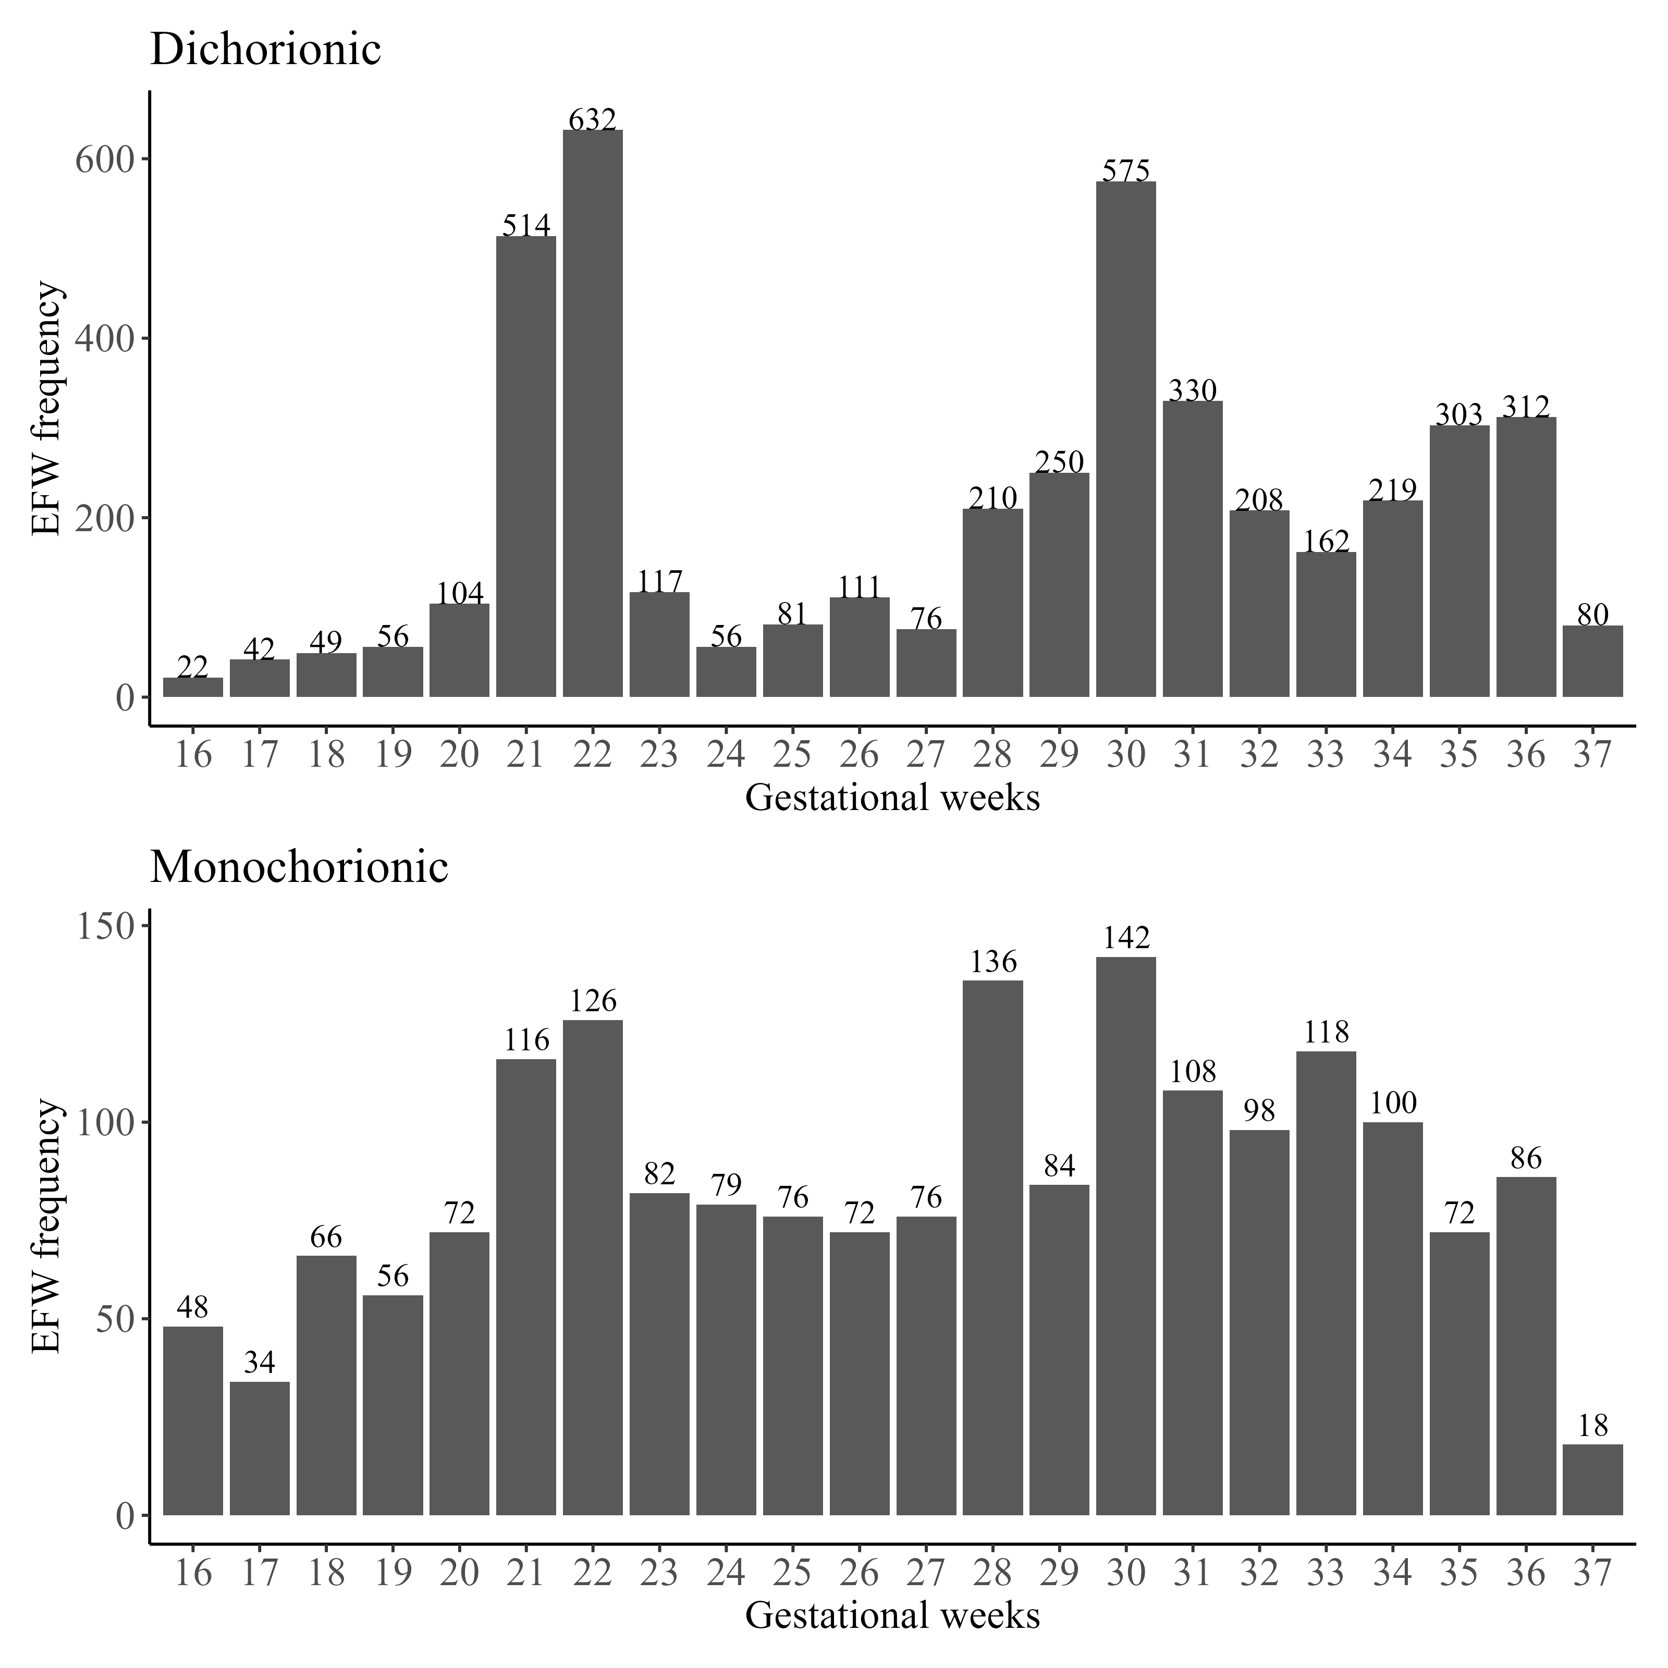
sFigure 1. Frequency of EFW measurements by gestational weeks for DCDA and MCDA twins
Notes: Gestational weeks were rounded to the nearest complete week.

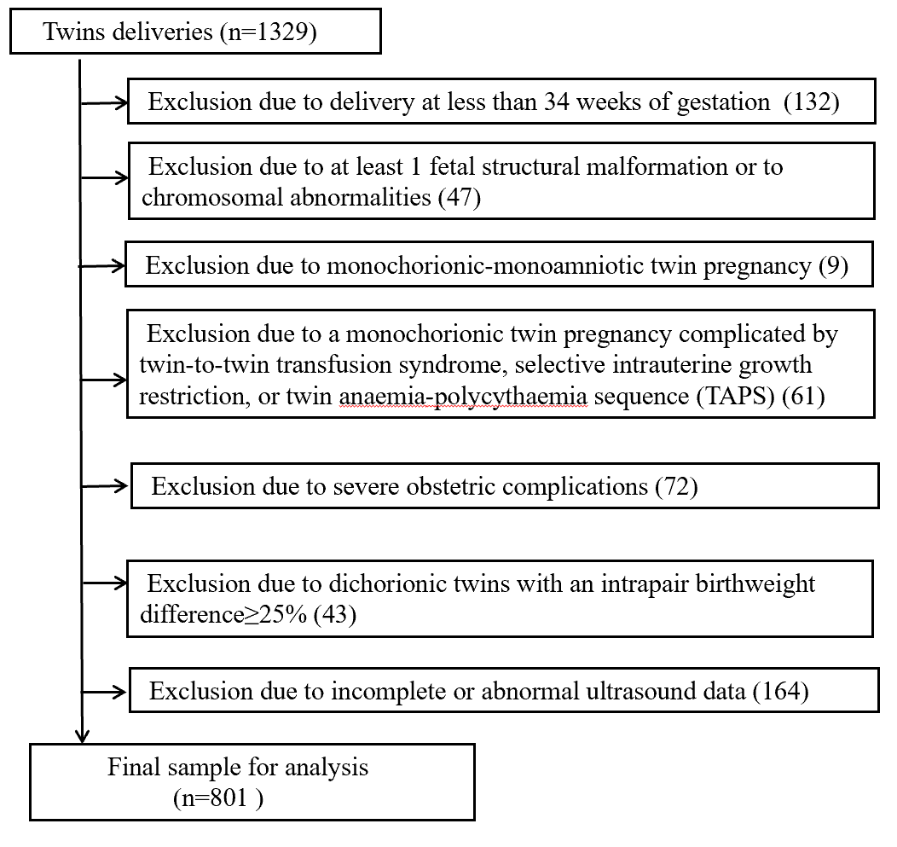

sFigure 2. Flow chart for the participants in the validation set

