Supplementary figures

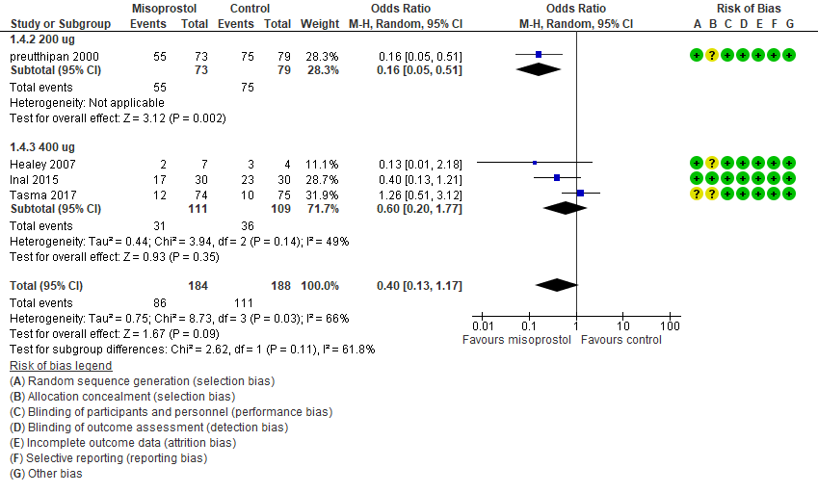
Figure S1 Misoprostol vs placebo Failure to dilate cervix or need further dilatation

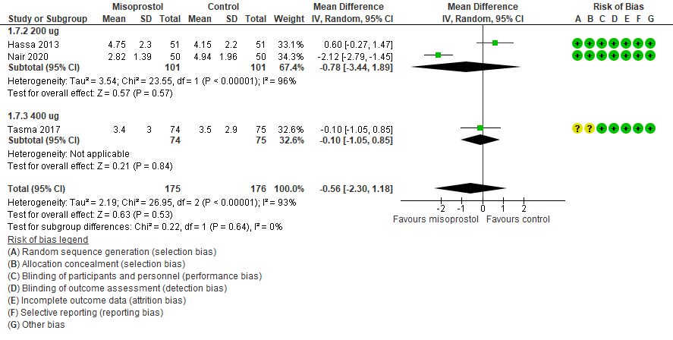
Figure S2 Misoprostol vs placebo preoperative pain score
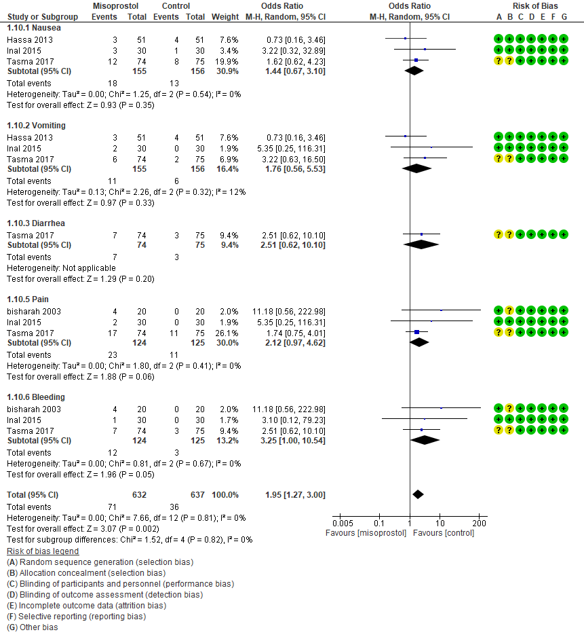
Figure S3 Misoprostol vs placebo Specific side effects

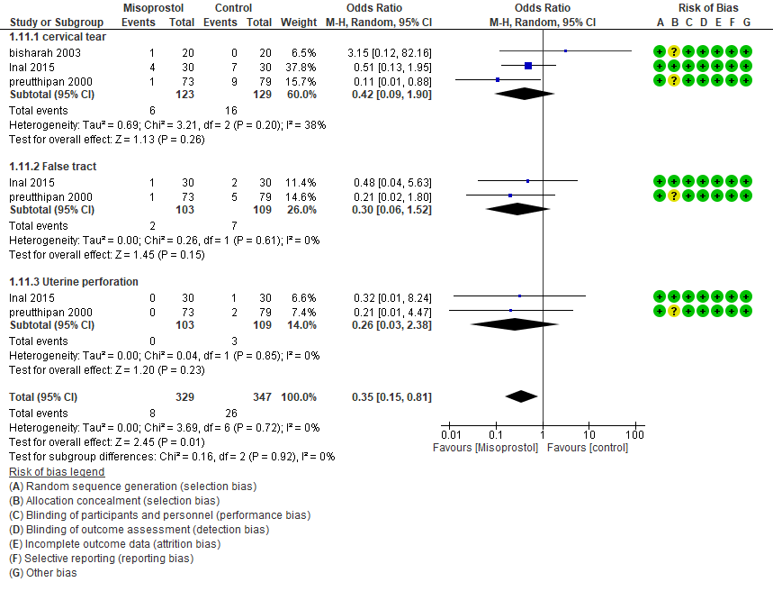

Figure S4 Misoprostol vs placebo Specific complications

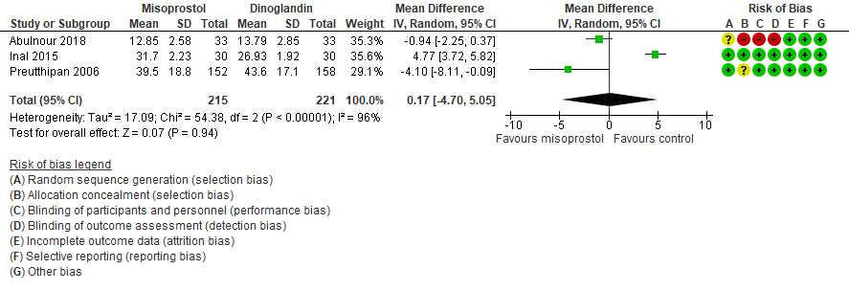
Figure S5 Misoprostol vs Dinoglandin Time of cervical dilatation
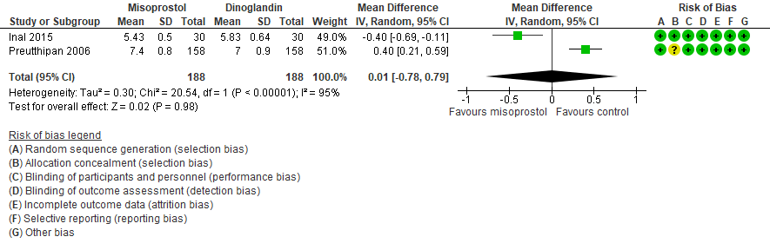
Figure S6 Misoprostol vs Dinoglandin preoperative cervical width
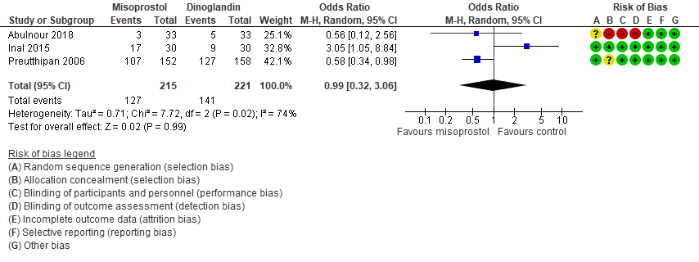
Figure S7 Misoprostol vs Dinoglandin Failure to dilate cervix or need further dilatation

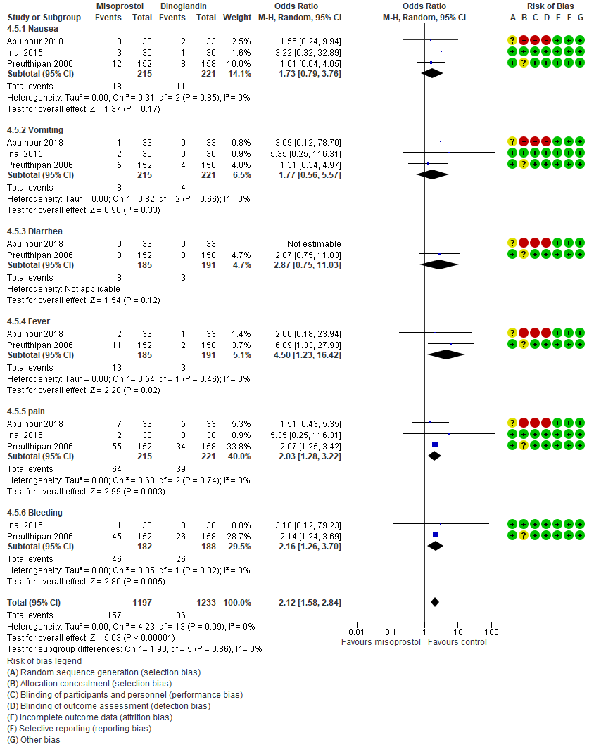
Figure S8 Misoprostol vs Dinoglandin Specific side effects

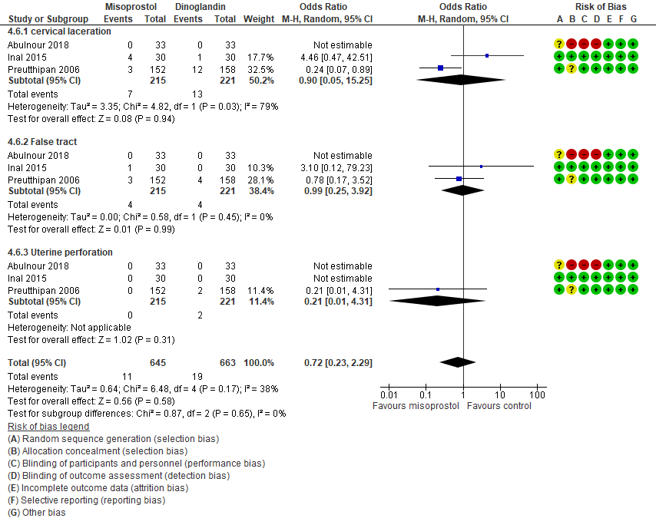
Figure S9 Misoprostol vs Dinoglandin Specific complications

