Supplementary Material

Figure 1. Conceptual model for the relationship between depression and adverse perinatal outcomes
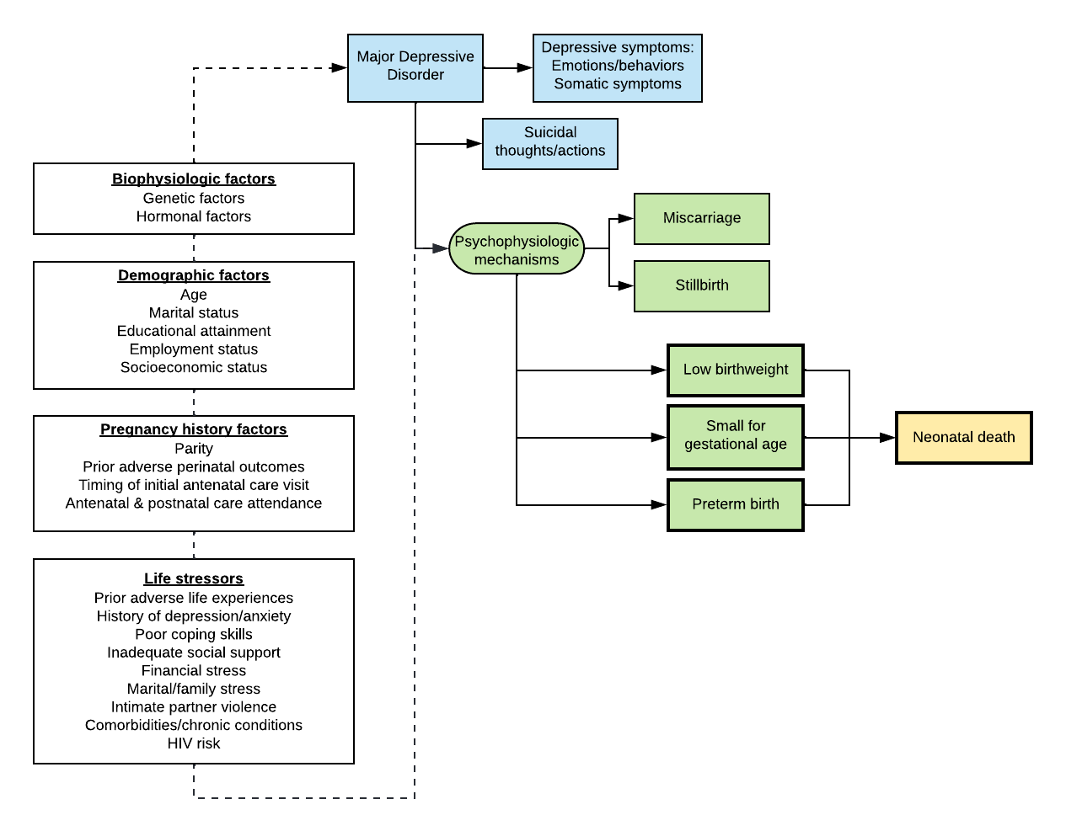

Table 1. Number of CESD-10 items missing among singleton births with pregnancy outcome data among women who did not acquire HIV by 9 months postpartum (n=4185)

Number of CESD-10 items missing | N (%)
0 | 3661 (87.48%)
1 | 259 (6.19%)
2 | 152 (3.63%)
3 | 67 (1.60%)
4 | 14 (0.33%)
5 | 7 (0.17%)
6 | 2 (0.05%)
7 | 1 (0.02%)
8 | 1 (0.02%)
9 | 0 (0.00%)
10 | 21 (0.50%)

Table 2. Number of MOS-SSS items missing among singleton births with pregnancy outcome data among women who did not acquire HIV by 9 months postpartum (n=4185)

Number of MOS-SSS items missing | N (%)
0 | 4077 (97.42%)
1 | 80 (1.91%)
2 | 7 (0.17%)
3 | 3 (0.07%)
4 | 18 (0.43%)

Table 3. Baseline characteristics of PrIMA study participants among those with complete CESD-10 information versus partial (n=4153)
 | Overall  (N=4153) | Complete CESD-10 (N=3659) | Incomplete CESD-10  (N=492)
Demographic characteristics | n (%) or  Median (IQR) | n (%) or Median (IQR) | n (%) or Median (IQR)
Age (years) | 24 (21, 28) (n=4151) | 24 (21, 29) (n=3659) | 24 (21, 28) (n=492) | 0.23
Adolescents and young women (<24 years) | 2370 (57.1%) | 2081 (56.8%) | 289 (58.7%) | 0.43
Missing | 2 (<1%) | 2 (0.1%) | 0 (0.0%)
Gestational age (enrollment, weeks) | 24 (20, 30) (n=4153) | 24 (20, 30) (n=3661) | 26 (18.285714, 30) (n=492) | 0.28
Married or living with a partner | 3491 (84.1%) | 3083 (84.2%) | 408 (82.9%) | 0.27
Missing | 34 (0.8%) | 33 (0.9%) | 1 (0.2%)
Completed education (years) | 10 (8, 12) (n=4072) | 10 (8, 12) (n=3589) | 10 (8, 12) (n=483) | 0.34
Regularly employed | 612 (14.7%) | 517 (14.1%) | 95 (19.3%) | 0.002
Missing | 52 (1.3%) | 44 (1.2%) | 8 (1.6%)
Household crowding (≥2 people/room) | 1995 (48.0%) | 1771 (48.4%) | 224 (45.5%) | 0.20
Missing | 27 (0.7%) | 26 (0.7%) | 1 (0.2%)
Pregnancy history & factors
Multiparous | 3082 (74.2%) | 2735 (74.7%) | 348 (70.7%) | 0.062
Missing | 5 (0.1%) | 4 (0.1%) | 1 (0.2%)
Prior pregnancy loss | 539 (13.0%) | 468 (12.8%) | 71 (14.4%) | 0.30
Missing | 14 (0.3%) | 12 (0.3%) | 2 (0.4%)
Prior preterm birth | 42 (1.0%) | 35 (1.0%) | 7 (1.4%) | 0.33
Trimester of initial antenatal care (ANC) visit
First | 615 (14.8%) | 523 (14.3%) | 92 (18.7%) | <0.001
Second | 2098 (50.5%) | 1894 (51.7%) | 204 (41.5%)
Third | 1440 (34.7%) | 1244 (34.0%) | 196 (39.8%)
Infant sex (female) | 1841 (44.3%) | 1632 (44.6%) | 209 (42.5%) | 0.62
Missing | 535 (12.9%) | 463 (12.6%) | 72 (14.6%)
HIV risk factors
Self-perceived high HIV risk | 369 (8.9%) | 320 (8.7%) | 49 (10.0%) | 0.35
Missing | 7 (0.2%) | 4 (0.1%) | 3 (0.6%)
Lifetime sexual partners | 2 (2, 3) (n=4148) | 2 (2, 3) (n=3656) | 2 (2, 3) (n=492) | 0.59
Partner HIV-positive* | 176 (4.2%) | 149 (4.1%) | 27 (5.5%) | 0.15
Missing | 52 (1.3%) | 49 (1.3%) | 3 (0.6%)
Sexually transmitted infection (enrollment) | 104 (2.5%) | 96 (2.6%) | 8 (1.6%) | 0.19
Missing | 7 (0.2%) | 5 (0.1%) | 2 (0.4%)
Psychosocial characteristics
Low social support (MOS-SSS score <72) | 1504 (36.2%) | 1372 (37.5%) | 132 (26.8%) | <0.001
Missing | 90 (2.2%) | 69 (1.9%) | 21 (4.3%)
Intimate partner violence ^{c} (HITS score ≥10) | 323 (7.8%) | 289 (7.9%) | 34 (6.9%) | 0.44
Missing | 5 (0.1%) | 5 (0.1%) | 0 (0.0%)

