Supplementary tables:
Full Search strategy.
PubMed/Medline
#1 | (Ketamine OR S-Ketamine OR esketamine OR "2-(2-Chlorophenyl)-2-(methylamino)cyclohexanone" OR CI-581 OR "CI 581" OR CI581 OR Ketalar OR Ketaset OR Ketanest OR Calipsol OR Kalipsol OR Calypsol OR narkamon OR keta OR ketmin OR ketava OR ketalin OR ketina OR brevinaze OR keta‐hameln OR Ketamines OR Spravato OR Ketalar OR Eskesia OR Ketanest-S OR Keta-S OR "Ketamine"[Mesh])
#2 | (postpartum OR Post-Partum OR "Post Partum" OR Puerperium OR puerperal OR postnatal OR Post-Natal OR "Post Natal" OR "fourth trimester" OR childbirth OR delivery OR "Postpartum Period"[Mesh])
#3 | (Depressive OR Depression OR Depressions OR Dysphoria OR "mood disorder" OR "Adjustment Disorder" OR "Affective Disorder" OR "Affective Symptoms" OR depressed OR "Depression"[Mesh])
#4 | (EPDS OR "edinburgh postnatal depression scale")
#5 | #1 AND ((#2 AND #3) OR #4)
Cochrane CENTRAL
#1 | (Ketamine OR S-Ketamine OR esketamine OR "2-(2-Chlorophenyl)-2-(methylamino)cyclohexanone" OR CI-581 OR "CI 581" OR CI581 OR Ketalar OR Ketaset OR Ketanest OR Calipsol OR Kalipsol OR Calypsol OR narkamon OR keta OR ketmin OR ketava OR ketalin OR ketina OR brevinaze OR keta‐hameln OR Ketamines OR Spravato OR Ketalar OR Eskesia OR Ketanest-S OR Keta-S).
#2 | (postpartum OR Post-Partum OR "Post Partum" OR Puerperium OR puerperal OR postnatal OR Post-Natal OR "Post Natal" OR "fourth trimester" OR childbirth OR delivery)
#3 | (Depressive OR Depression OR Depressions OR Dysphoria OR "mood disorder" OR "Adjustment Disorder" OR "Affective Disorder" OR "Affective Symptoms" OR depressed)
#4 | (EPDS OR "edinburgh postnatal depression scale")
#5 | #1 AND ((#2 AND #3) OR #4)
Web of Science
#1 | (Ketamine OR S-Ketamine OR esketamine OR "2-(2-Chlorophenyl)-2-(methylamino)cyclohexanone" OR CI-581 OR "CI 581" OR CI581 OR Ketalar OR Ketaset OR Ketanest OR Calipsol OR Kalipsol OR Calypsol OR narkamon OR keta OR ketmin OR ketava OR ketalin OR ketina OR brevinaze OR keta‐hameln OR Ketamines OR Spravato OR Ketalar OR Eskesia OR Ketanest-S OR Keta-S) (Topic)
#2 | (postpartum OR Post-Partum OR "Post Partum" OR Puerperium OR puerperal OR postnatal OR Post-Natal OR "Post Natal" OR "fourth trimester" OR childbirth OR delivery) (Topic)  (Topic)
#3 | (Depressive OR Depression OR Depressions OR Dysphoria OR "mood disorder" OR "Adjustment Disorder" OR "Affective Disorder" OR "Affective Symptoms" OR depressed) (Topic)
#4 | (EPDS OR "edinburgh postnatal depression scale") (Topic)
#5 | #1 AND ((#2 AND #3) OR #4)
Scopus
TITLE-ABS-KEY (Ketamine OR S-Ketamine OR esketamine OR "2-(2-Chlorophenyl)-2-(methylamino)cyclohexanone" OR CI-581 OR "CI 581" OR CI581 OR Ketalar OR Ketaset OR Ketanest OR Calipsol OR Kalipsol OR Calypsol OR narkamon OR keta OR ketmin OR ketava OR ketalin OR ketina OR brevinaze OR keta‐hameln OR Ketamines OR Spravato OR Ketalar OR Eskesia OR Ketanest-S OR Keta-S)
AND
(((postpartum OR Post-Partum OR "Post Partum" OR Puerperium OR puerperal OR postnatal OR Post-Natal OR "Post Natal" OR "fourth trimester" OR childbirth OR delivery) AND (Depressive OR Depression OR Depressions OR Dysphoria OR "mood disorder" OR "Adjustment Disorder" OR "Affective Disorder" OR "Affective Symptoms" OR depressed)) OR (EPDS OR "edinburgh postnatal depression scale"))

Table 1. Detailed search strategy for each database

Study | Year | Selection |  |  |  | Comparability |  | Outcome |  |  | Quality
Study | Year | Representativeness of the exposed | Non-  exposed | Ascertainment of exposure | Begin without outcome present |  |  | Outcome assessment | Follow-up length | Adequacy  of outcome | Quality
Liu H | 2023 | * | * | * | * | * | * |  | * | * | Good
Lou | 2023 | * | * | * | * | ** | * |  | * | * | Good
Wang Y | 2022 | * | * | * | * | * | * |  | * | * | Good
Table 2. Newcastle-Ottawa Scale (NOS) quality assessment summary for included studies

Study ID | Group | Short-term depression score | Long-term depression score | Day 1 postopartum pain | Day 2 postopartum pain | Event of nausea and vomiting | N
Shen 2023 | IV Ketamine 0.25 mg/kg | 2.25 (0-17) | 1.36 (0-18) | 1 (0-3) | 0 (0-2) |  | 100
Shen 2023 | Control | 2.4 (0-14) | 1.4 (0-13) | 1 (0-4) | 0 (0-4) |  | 102
Wang S 2022 | IV ketamine 0.5 mg/kg | 9 [6-13] | 10 [7-12] | 4 [3-7] |  | 7 (21.2) | 33
Wang S 2022 | Control | 8 [6-10] | 9 [7-11] | 4 [3-4] |  | 5 (15.2) | 33
Wang W 2022 | IV ketamine 0.4 mg/kg |  |  |  |  | 3 (7.7) | 39
Wang W 2022 | IV Ketamine 0.2 mg/kg |  |  |  |  | 4 (10.0) | 40
Wang W 2022 | IV Ketamine 0.1 mg/kg |  |  |  |  | 4 (10.5) | 38
Wang W 2022 | Control |  |  |  |  | 11 (28.2) | 39
Xu 2017 | IV ketamine 0.25 mg/ kg |  |  |  | 4 (0-7) |  | 162
Xu 2017 | Control |  |  |  | 4 (0-8) |  | 163
Wang W 2023 | IV Ketamine 0.2 mg/kg |  |  |  |  | 3 (5.2) | 58
Wang W 2023 | Control |  |  |  |  | 4 (7.0) | 57
Xu 2024 | Esketamine 0.2 mg/kg |  |  |  |  | 12 (7.5) | 159
Xu 2024 | Control |  |  |  |  | 13 (8.1) | 160
Wang W 2024 | Esketamine 0.2 mg/kg |  |  |  |  | 2 (3.4) | 59
Wang W 2024 | Control |  |  |  |  | 3 (5.2) | 58
Li 2024 | Esketamine 1.5 mg/kg |  |  |  |  | 34 (2.4) | 124
Li 2024 | Control |  |  |  |  | 31 (25.4) | 122
Ling 2023 | Esketamine 0.2 mg/kg |  |  |  |  | 2 (3.4) | 58
Ling 2023 | Control |  |  |  |  | 1 (1.7) | 59
Guo 2023 | Esketamine 1 mg/kg |  |  |  |  | 5 (5.9) | 85
Guo 2023 | Control |  |  |  |  | 13 (15.2) | 85
Wang Y 2022 | Esketamine 0.35 mg/kg |  |  |  |  | 27 (25) | 108
Wang Y 2022 | Control |  |  |  |  | 26 (19.7) | 132
Liu QR 2023 | IV ketamine 0.25 mg/kg |  | 5 [2-8] | 2 [1-2] | 1 [0-1] |  | 163
Liu QR 2023 | Control |  | 5.5 [3-8] | 2 [1-2] | 1 [1-1] |  | 163
Yang 2023 | Esketamine 2 mg kg | 4 [1-7] | 3 [1-7] | 2 [1-3] | 1 [1-2] |  | 99
Yang 2023 | Esketamine 1 mg kg | 5 [2-7] | 5 [2-8] | 2 [1-2] | 1 [1-2] |  | 99
Yang 2023 | Control | 7 [4-10] | 6 [3-10] | 2 [2-3] | 2 [2-2] |  | 97
Table 3. Summary of data that were not suitable for meta-analysism. Median (range), fregeancy (perecentage) or median [interquartile range]

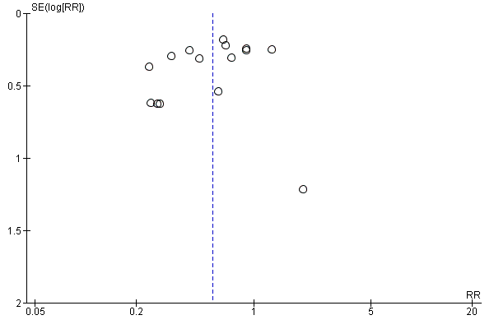
Supplementary figures

Figure 1A: funnel plot for long-term occurrence of PPD

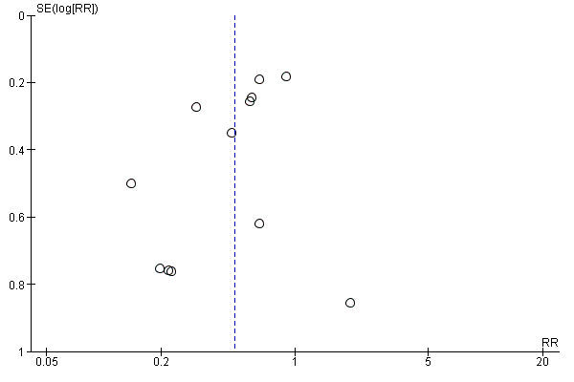
Figure 1B: funnel plot for long-term occurrence of PPD
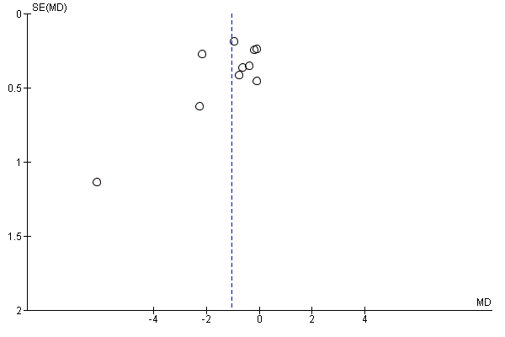
Figure 1C: funnel plot for long-term EPDS scores
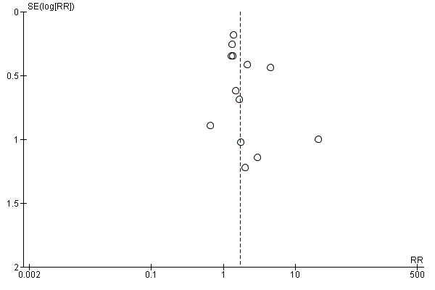
Figure 1D: funnel plot for Dizziness outcome

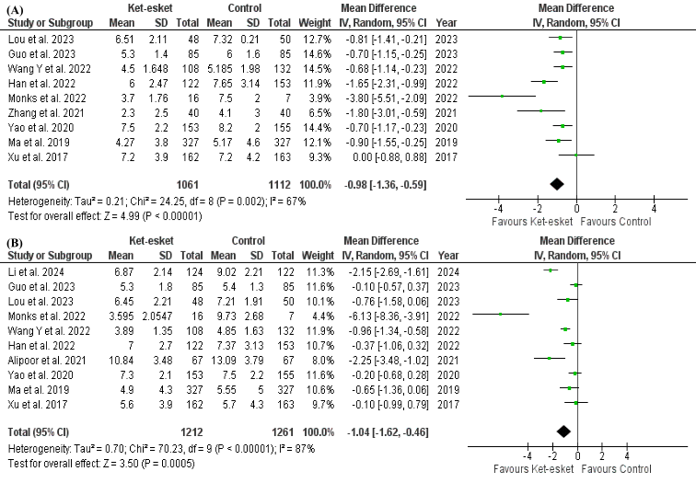
Figure 2 Forest plot A) of short-term EPDS scores, B) of long-term EPDS scores

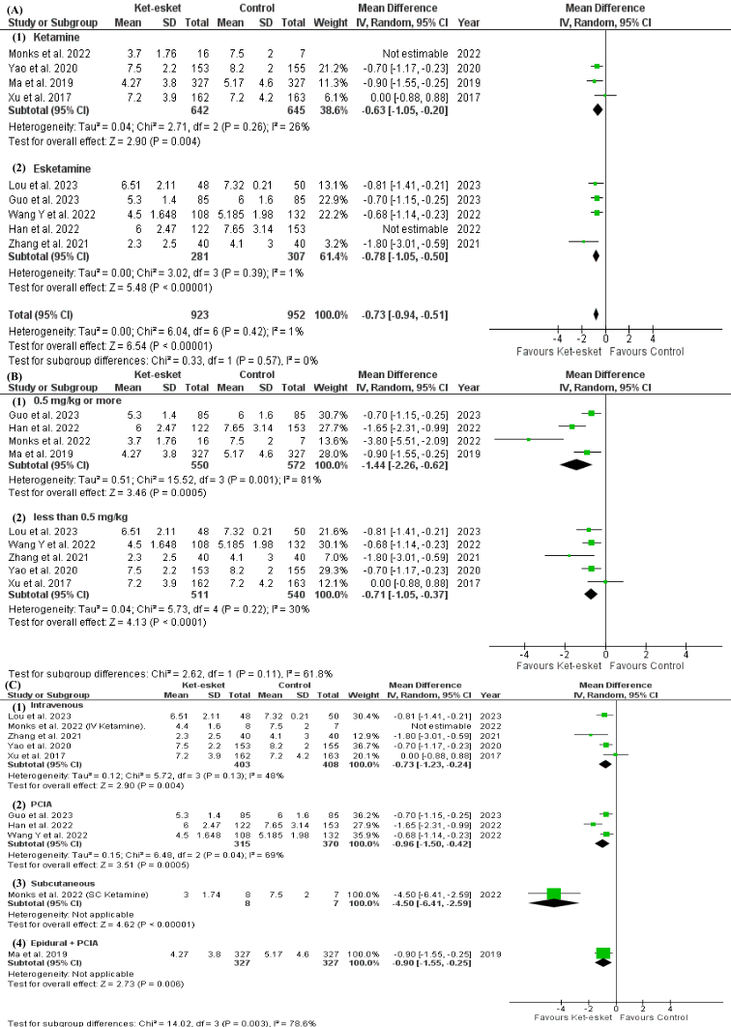
Figure 3 Forest plot A) Forest plot of subgroup analysis according to nature of drug for short-term EPDS, B) subgroup analysis according to dose of drug for short-term EPDS scores, C) of subgroup analysis according to route of drug administration for short-term EPDS scores
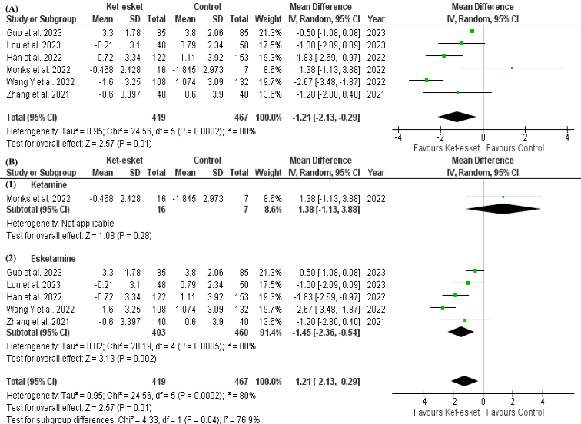
Figure 4 Forest plot A) of change in short-term EPDS scores from baseline, B) of subgroup analysis according to nature of drug for change in short-term EPDS scores from baseline

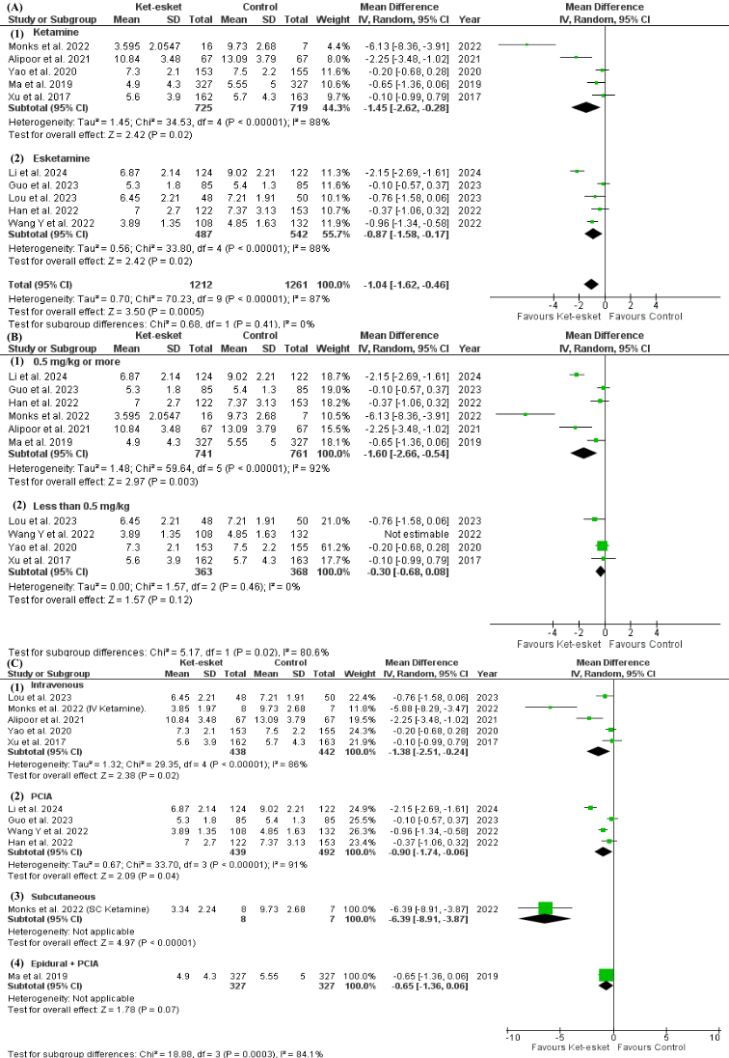
Figure 5 Forest plot A) Forest plot of subgroup analysis according to nature of drug for long-term EPDS, B) subgroup analysis according to dose of drug for long-term EPDS scores, C) of subgroup analysis according to route of drug administration for long-term EPDS scores

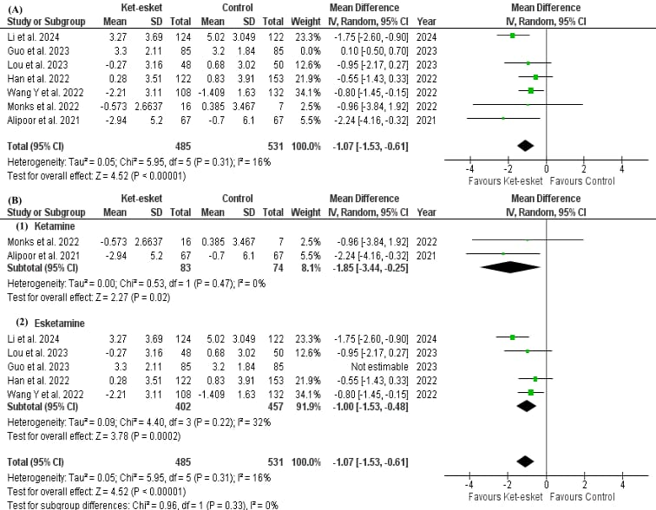
Figure 6 Forest plot A) of change in long-term EPDS scores from baseline, B) of subgroup analysis according to nature of drug for change in short-term EPDS scores from baseline

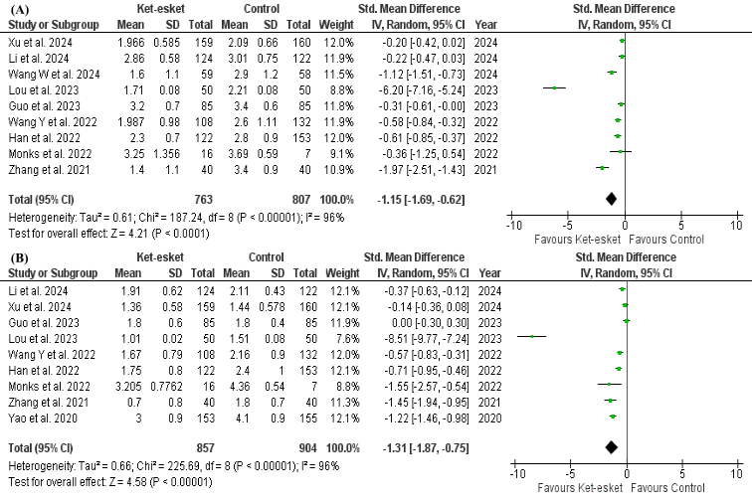
Figure 7 Forest plot A) of Day 1 pain score, B) of Day 2-3 pain score

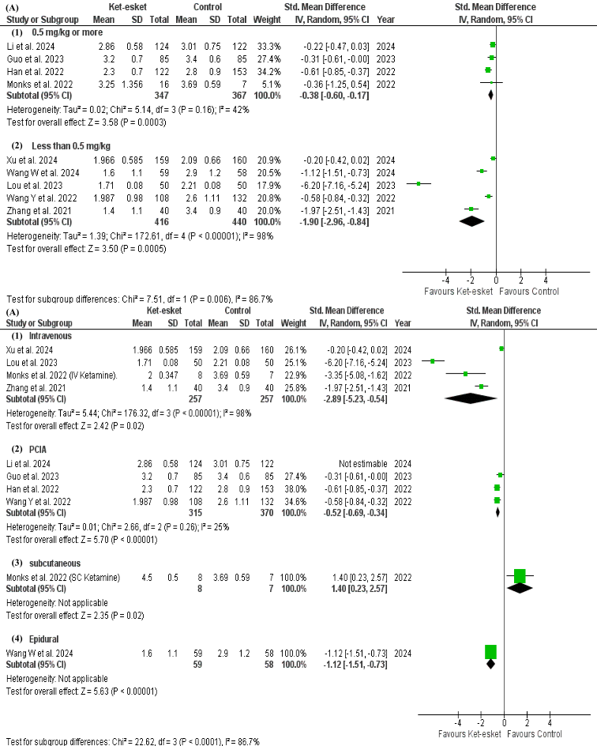
Figure 8 Forest plot A) of subgroup analysis according to dose of drug for Day 1 pain score, B) of subgroup analysis according to route of drug administration for Day 1 pain score

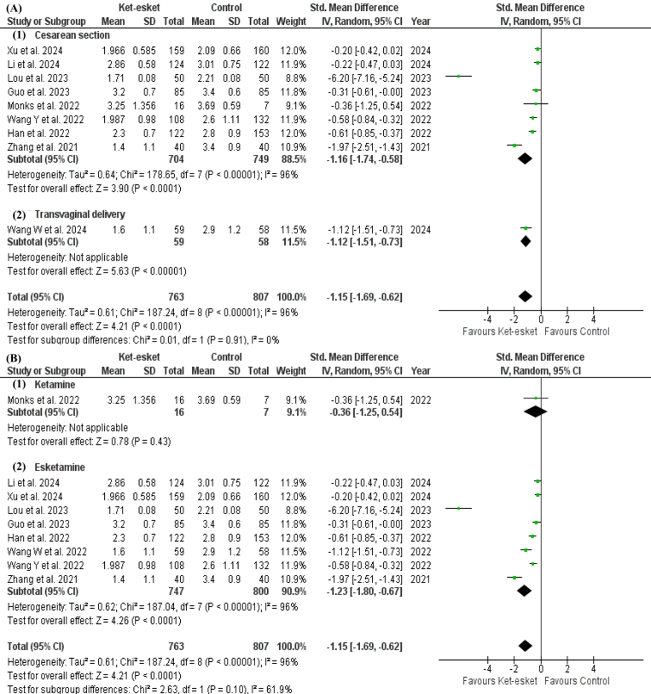
Figure 8 Forest plot A) of subgroup analysis according to mode of delivery for Day 1 pain score, B) of subgroup analysis according to nature of drug for Day 1 pain score

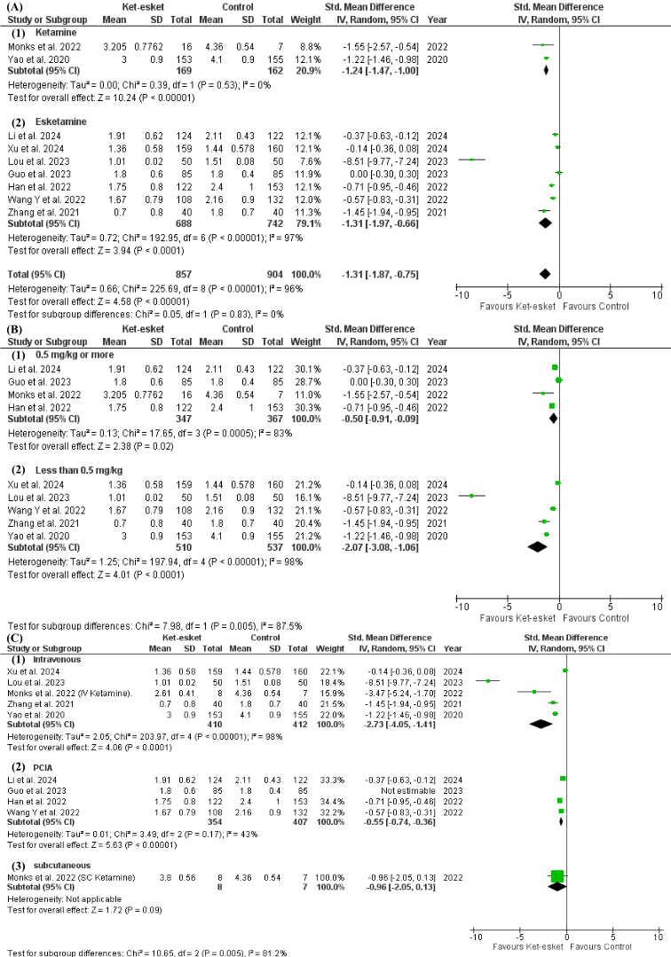
Figure 9 Forest plot A) of subgroup analysis according to nature of drug for Day 2-3 pain score, B) of subgroup analysis according to dose of drug for Day 2-3 pain score, C) of subgroup analysis according to route of drug administration for Day 2-3 pain score

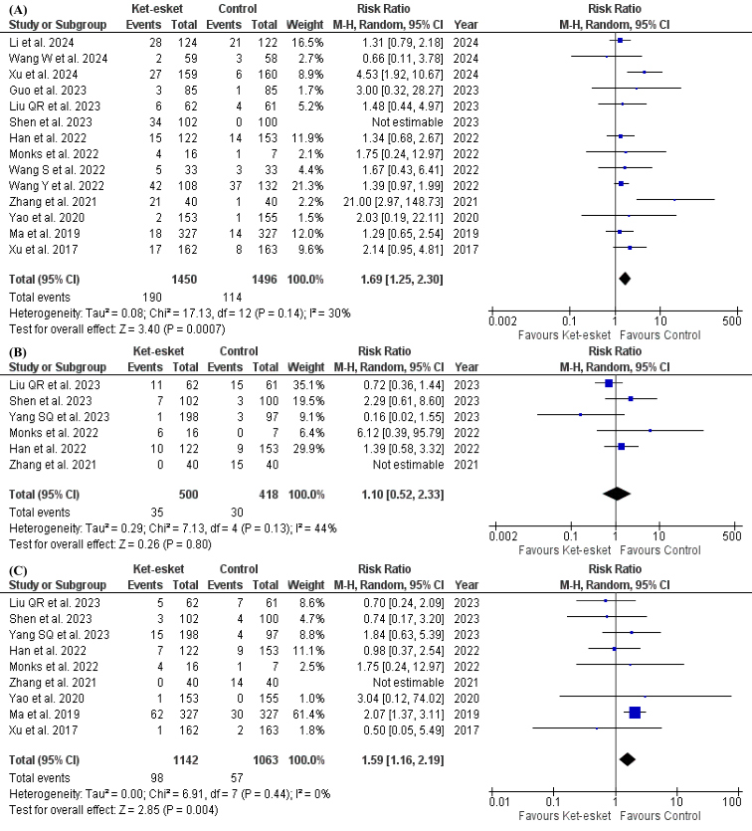
Figure 10 Forest plot A) of dizziness occurrence, B) of nausea occurrence, C) of vomiting occurrence

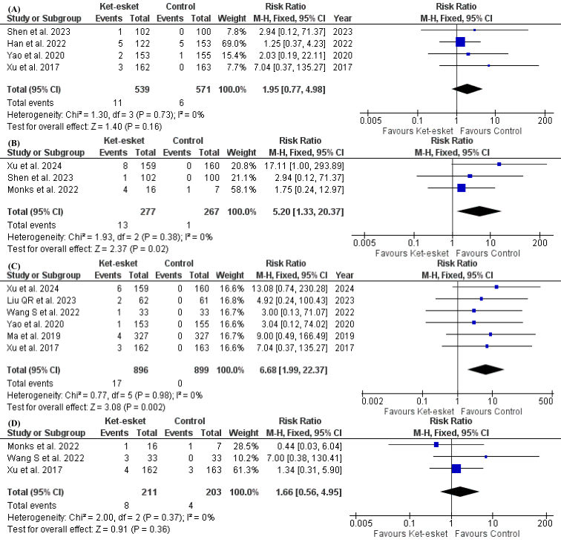
Figure 11 Forest plot A) of headache occurrence, B) of blurring of vision occurrence, C) of hallucination occurrence, D) of diplopia occurrence

