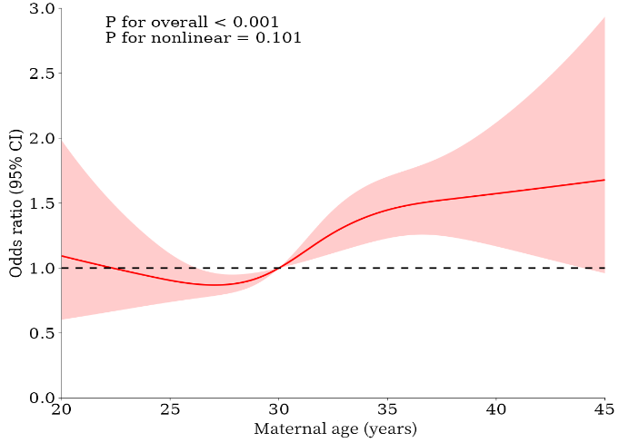
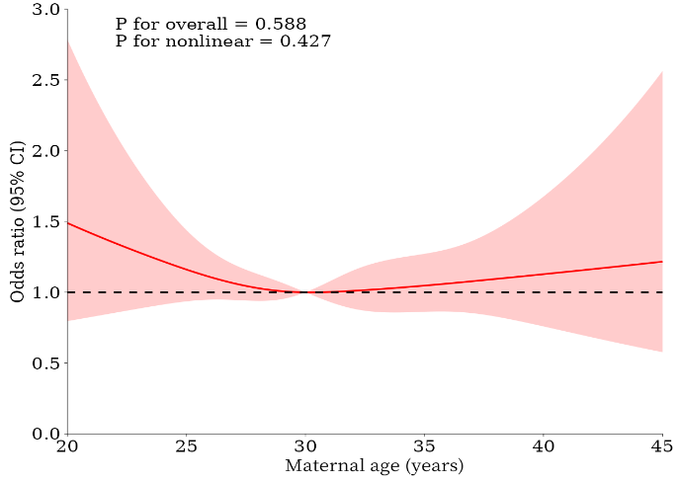
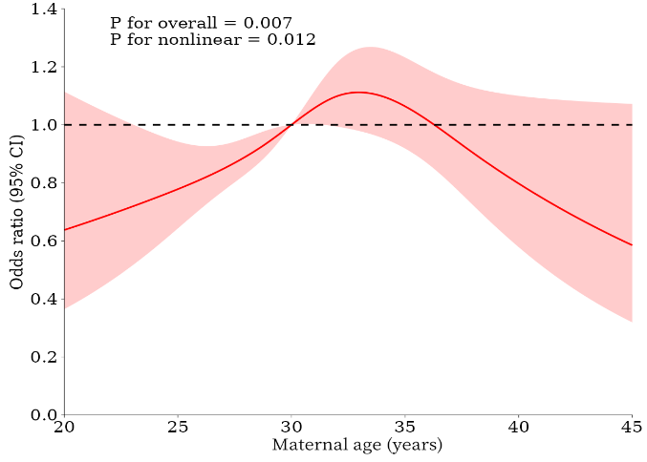
A B C
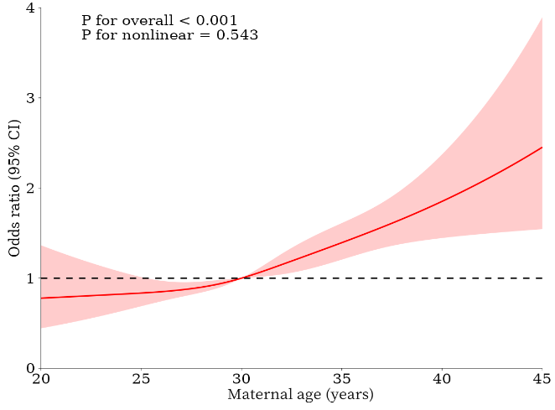
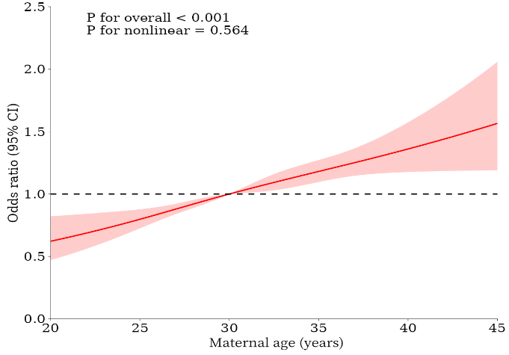

D E
Supplement 1 The nonlinear relationships between maternal age with adverse pregnancy outcome by restricted cubic spline approach. (A) Low birth weight;(B) Macrosomia; (C) SGA; (D) LGA; (E) Perterm birth. Model was established without any adjustments.

