Co-design and clinician evaluation of resources to address weight stigma in antenatal care
Briony Hill ^{1*}, Haimanot Hailu ¹, Bec Jenkinson ², Siarn Rakic ¹, Taniya S. Nagpal ³, Jacqueline A Boyle ⁴, Penelope Sheehan ^{5,6}, Sarah Darlison ⁵, and Helen Skouteris ^{1,7}

¹ Health and Social Care Unit, School of Public Health and Preventive Medicine, Monash
University, Melbourne, Australia
² Australian Women and Girls’ Health Research Centre, School of Public Health, The
University of Queensland, Brisbane, Australia
³ Faculty of Kinesiology, Sport, and Recreation, University of Alberta, Edmonton, Canada
⁴ Health Systems and Equity, Eastern Health Clinical School, Monash University, Melbourne, Australia
⁵ Director of Obstetrics, Eastern Health, Eastern Health, Melbourne, Australia
⁶Department of Obstetrics and Gynaecology, Monash University, Melbourne, Australia
⁷ Warwick Business School, Coventry, UK

*Corresponding author: Dr Briony Hill, Health and Social Care Unit, School of Public Health and Preventive Medicine, Monash University, 553 St Kilda Road, Melbourne VIC 3004, Australia
Email: briony.hill@monash.edu

Supplementary files
Resources co-designed to reduce weight stigma in maternity care


Figure S1a: Photo of pregnant woman for the digital monitor screen in the clinic waiting room


Figure S1b: Photo of pregnant woman for the digital monitor screen in the clinic waiting room


Figure S1c: Photo of pregnant woman for the digital monitor screen in the clinic waiting room


Figure S1d: Photo of pregnant woman for the digital monitor screen in the clinic waiting room


Figure S1e: Photo of pregnant woman for the digital monitor screen in the clinic waiting room


Figure S1f: Photo of pregnant woman for the digital monitor screen in the clinic waiting room


Figure S2a: Signpost 1 for the antenatal clinic to prompt clinicians to consider weight stigma in their clinical interactions


Figure S2b: Example of signpost 1 placed on a computer screen in the antenatal clinic


Figure S2c: Signpost 2 for the antenatal clinic to prompt clinicians to consider weight stigma in their clinical interactions

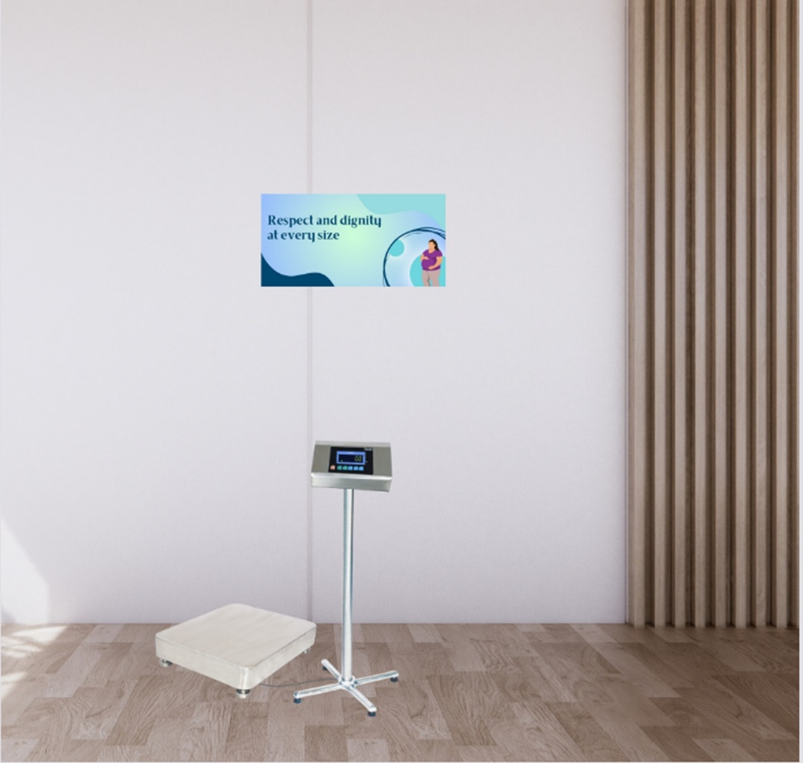
Figure S2d: Example signpost 2 displayed near the weighing scale in the antenatal clinic

Table S1. Links to podcast and consumer video
 | Source link
Doi link | https://doi.org/10.17605/OSF.IO/9U52P
URL link | https://osf.io/9u52p/?view_only=080743973d274964be0df3e429bf8ceb
NB: both links take you to the same site to access both the podcast and video

Table S2. Phase 5: Qualitative interview guide
Phase 5 Qualitative Interview Guide
- What is your opinion about the relevance and feasibility of these weight stigma resources in reducing weight stigma in ANC practice?
- What areas do you think these resources do well at?
- What areas of these resources do you think need improvement? (In terms of acceptability, enhancing awareness etc.)
- What are your thoughts on the importance the resources in enhancing the motivation of HCPs to reduce weight stigma in their clinical practice?
- Do you have anything you would like to add?

