Supporting information
Figure S1. Sensitivity analysis of the effect of SSC on uterine atony: Excluding one study at a time 28
Figure S2. Meta-analysis of the effect of SSC on blood loss ≥ 500 ml excluding trials with zero total events in both intervention groups 29
Figure S3. Funnel plot of mean blood loss after birth of the placenta 30
Figure S4. Sensitivity analysis of the effect of SSC on blood loss during the third stage of labour: Excluding one study at a time. 31
Figure S5. Meta-analysis of the effect of SSC on mean blood loss during the third stage of labour: (a) effect by mode of delivery; (b) by country income level. 32
Figure S6. Meta-analysis of the effect of SSC on mean blood loss after birth up to 2 hours: (a) Overall effect; (b) by country income level 33
Figure S7. Meta-analysis of the effect of SSC on mean blood loss after birth up to 24 hours: (a) Overall effect; (b) according to mode of delivery 34
Table S1. PRISMA checklist 35
Table S2. Results of search strategies from various data sources 38
Table S3. Studies Excluded During Full-Text Examination with Reasons 40
Table S4. Characteristics and outcome data of the two studies not eligible for inclusion in the meta-analysis. 42
Table S5. The study design characteristics were extracted according to the guidelines of the Non-Randomized Studies Methods Group 43
Table S6. Exclusion and inclusion criteria for included studies 47
Table S7. Assessment of the risk of bias of randomized controlled trials. 48
Table S8. Risk of bias assessment for quasi-experimental studies 51

- Sensitivity analysis of the effect of SSC on uterine atony: Excluding one study at a time
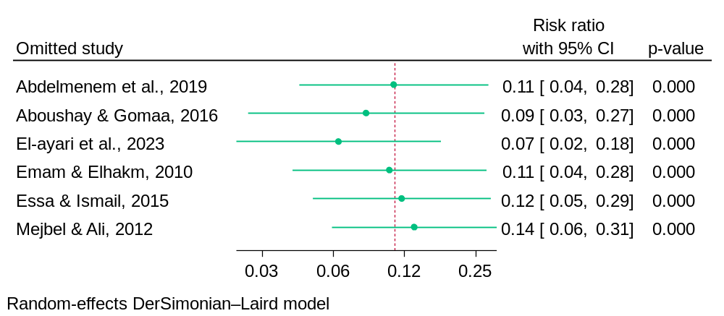
- Meta-analysis of the effect of SSC on blood loss ≥ 500 mL excluding trials with zero total events in both intervention groups
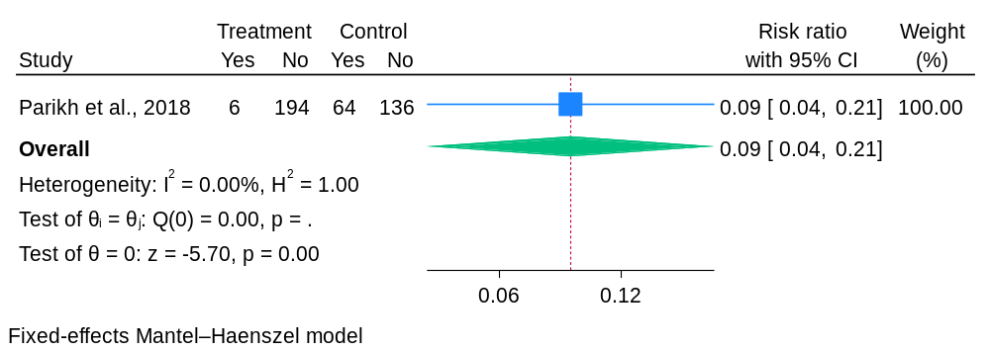

- Funnel plot of mean blood loss during the third stage of labour
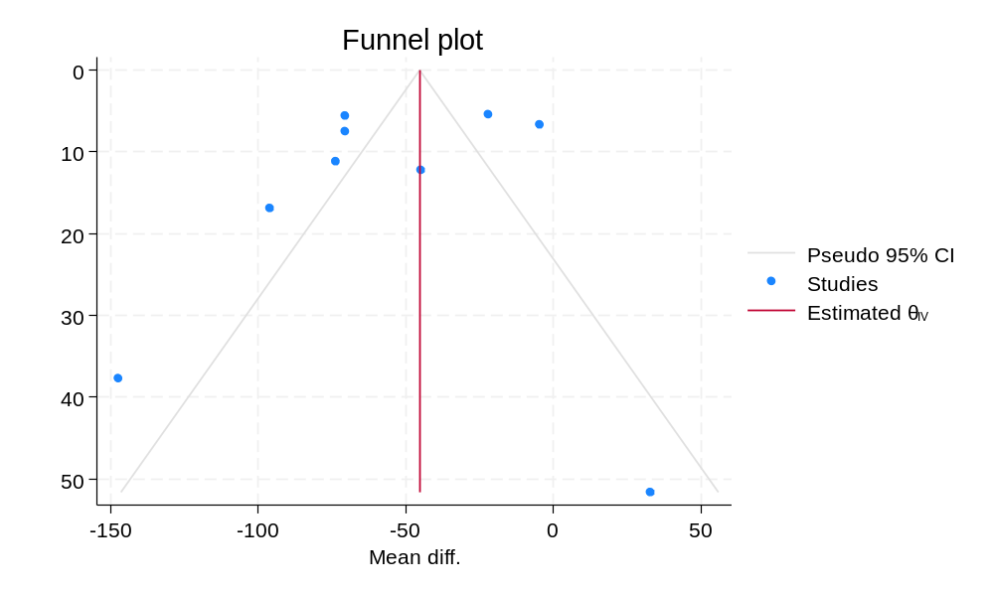

- Sensitivity analysis of the effect of SSC on blood loss during the third stage of labour: Excluding one study at a time.
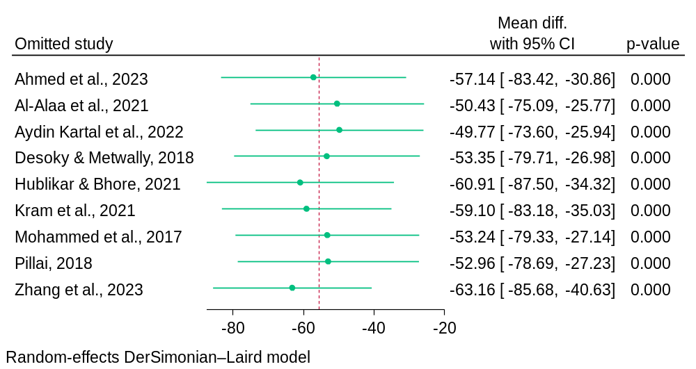

- Meta-analysis of the effect of SSC on mean blood loss during the third stage of labour: (a) effect by mode of delivery; (b) by country income level.
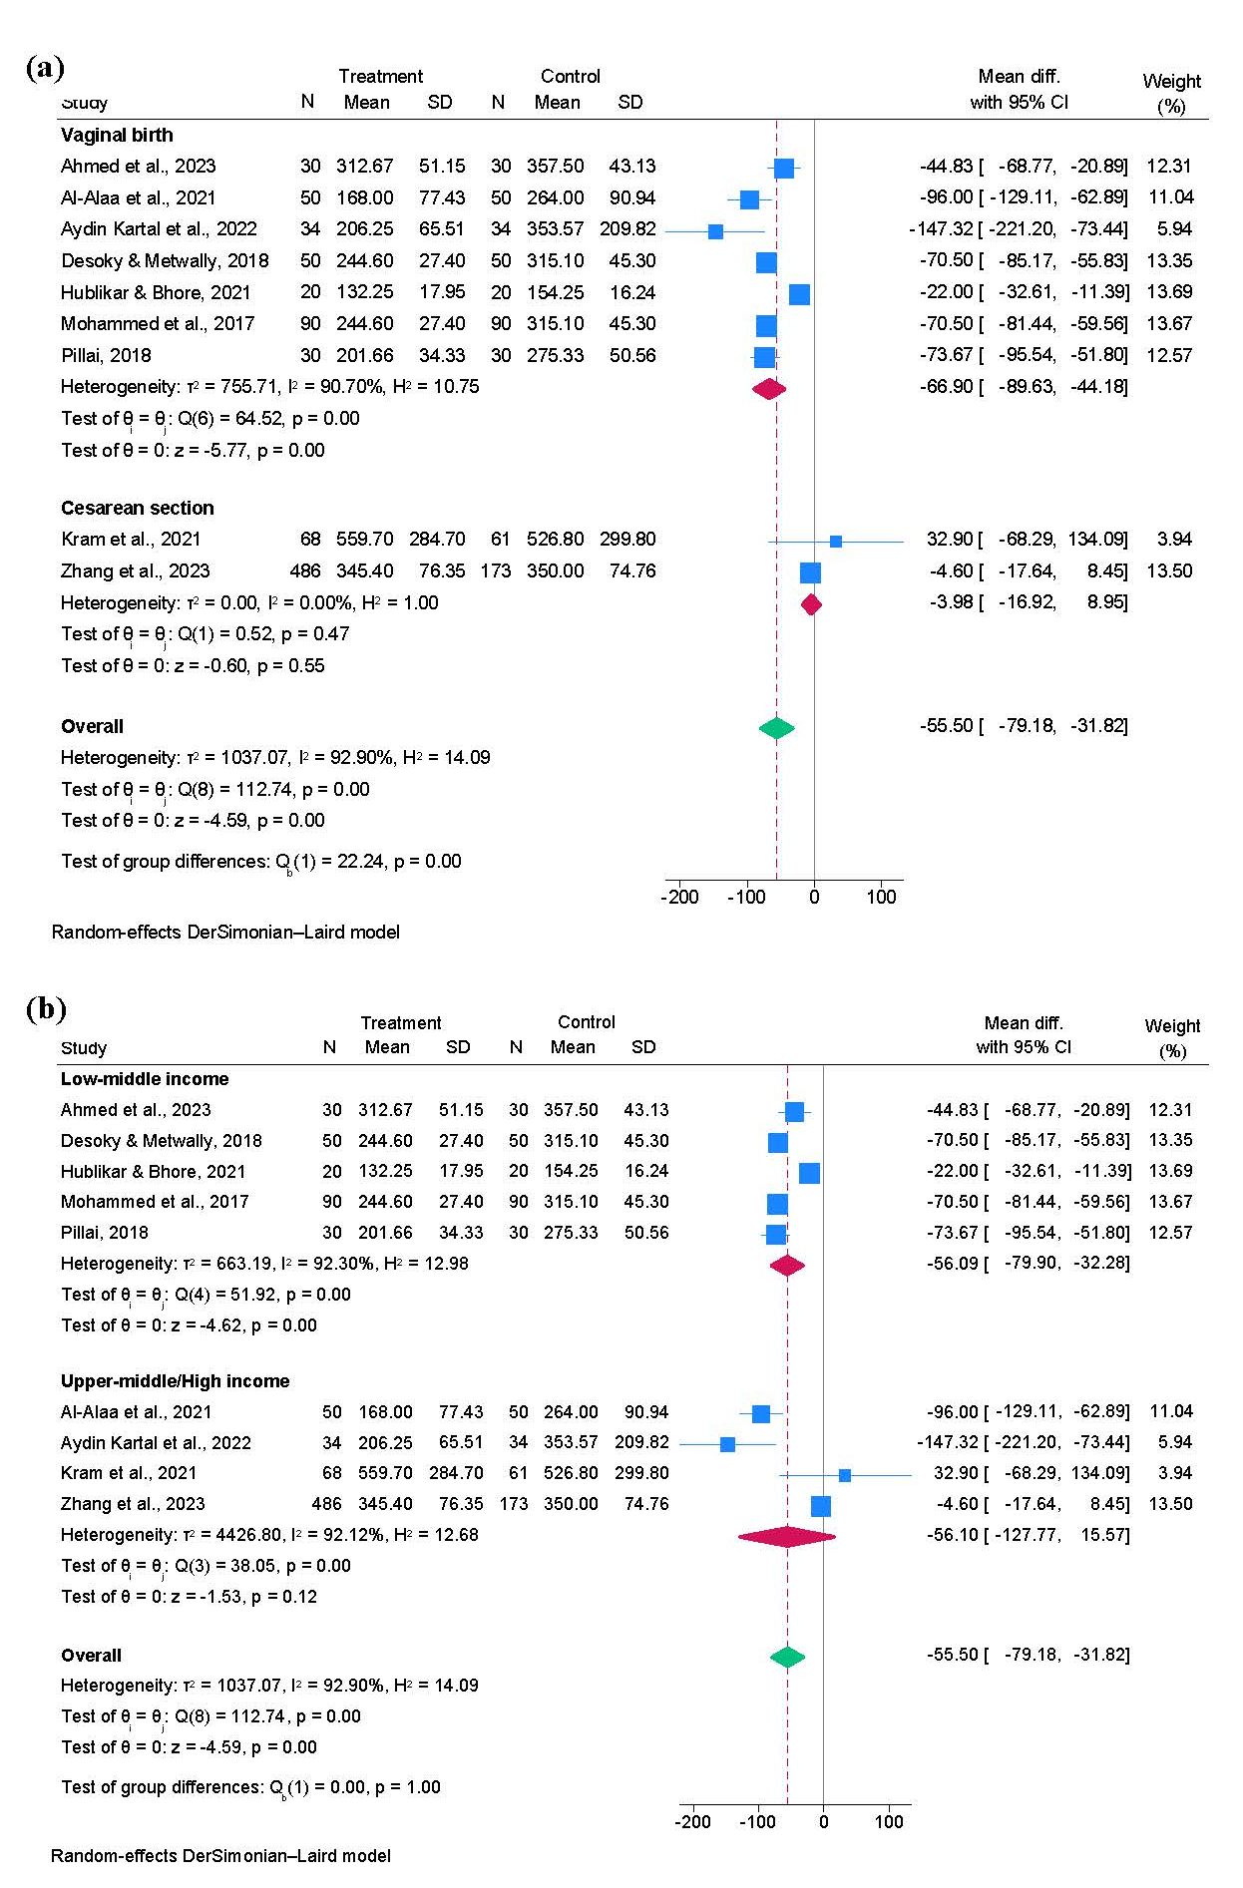
- Meta-analysis of the effect of SSC on mean blood loss after birth up to 2 hours: (a) Overall effect; (b) by country income level
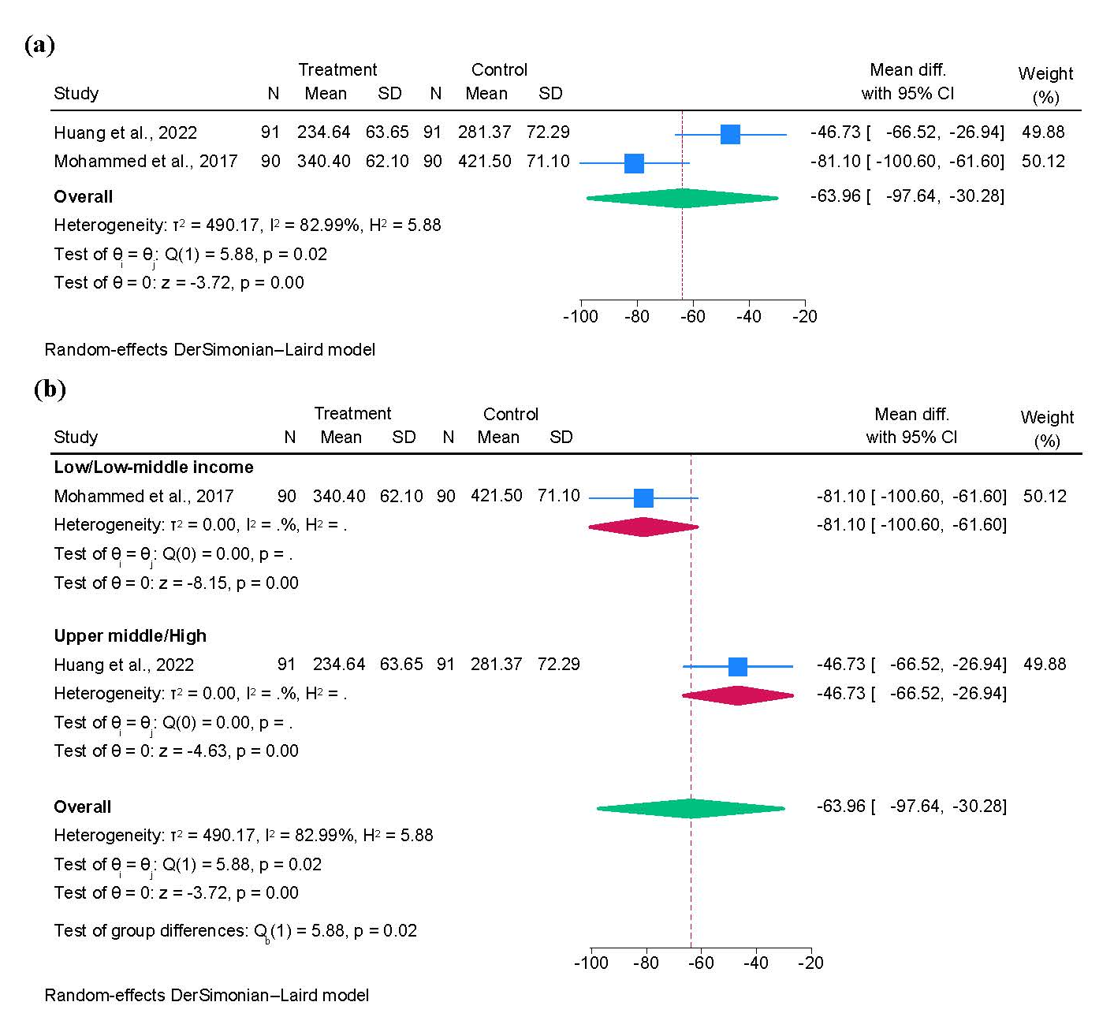

- Meta-analysis of the effect of SSC on mean blood loss after birth up to 24 hours: (a) Overall effect; (b) according to mode of delivery
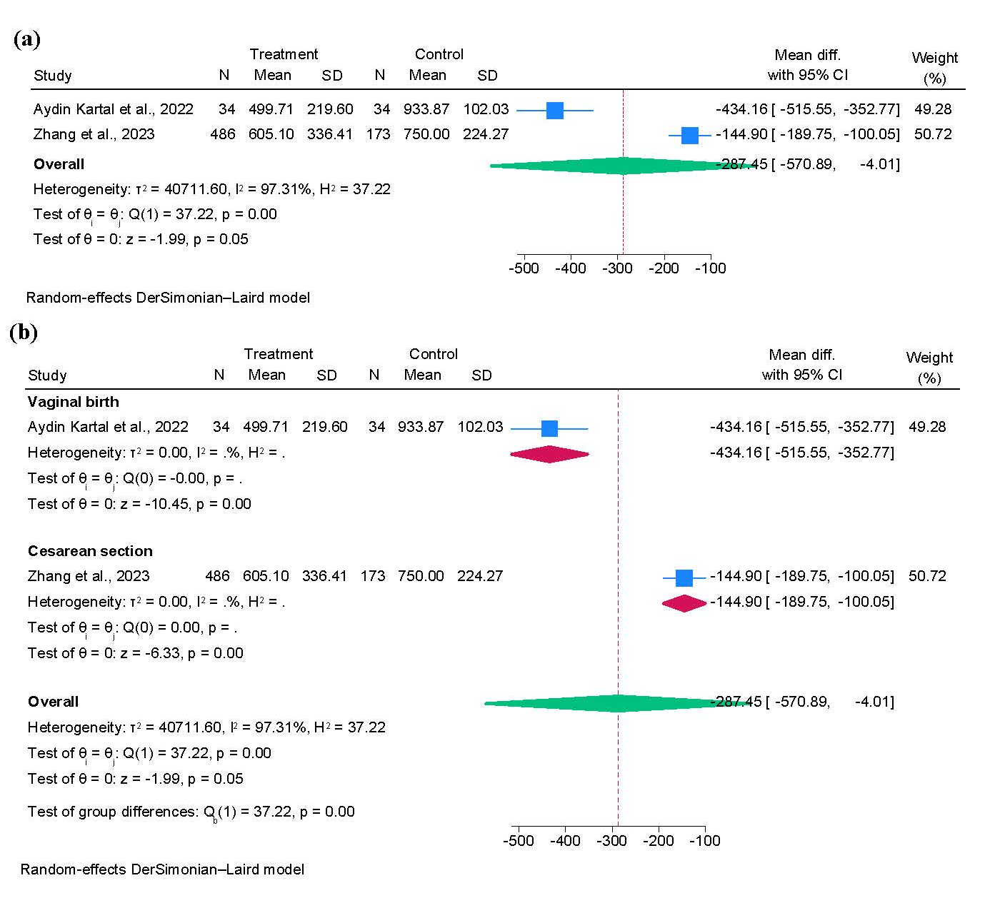

- PRISMA checklist
Section and Topic | Item # | Checklist item | Location where item is reported
TITLE
Title | 1 | Identify the report as a systematic review. | 1 page
ABSTRACT
Abstract | 2 | See the PRISMA 2020 for Abstracts checklist. | 1 page
INTRODUCTION
Rationale | 3 | Describe the rationale for the review in the context of existing knowledge. | 3-4 pages
Objectives | 4 | Provide an explicit statement of the objective(s) or question(s) the review addresses. | 4 pages
METHODS
Eligibility criteria | 5 | Specify the inclusion and exclusion criteria for the review and how studies were grouped for the syntheses. | 5 page
Information sources | 6 | Specify all databases, registers, websites, organisations, reference lists and other sources searched or consulted to identify studies. Specify the date when each source was last searched or consulted. | 5 page
Search strategy | 7 | Present the full search strategies for all databases, registers and websites, including any filters and limits used. | Supplementary Table 2
Selection process | 8 | Specify the methods used to decide whether a study met the inclusion criteria of the review, including how many reviewers screened each record and each report retrieved, whether they worked independently, and if applicable, details of automation tools used in the process. | 6 pages
Data collection process | 9 | Specify the methods used to collect data from reports, including how many reviewers collected data from each report, whether they worked independently, any processes for obtaining or confirming data from study investigators, and if applicable, details of automation tools used in the process. | 6 pages
Data items | 10a | List and define all outcomes for which data were sought. Specify whether all results that were compatible with each outcome domain in each study were sought (e.g. for all measures, time points, analyses), and if not, the methods used to decide which results to collect. | 6 page
Data items | 10b | List and define all other variables for which data were sought (e.g. participant and intervention characteristics, funding sources). Describe any assumptions made about any missing or unclear information. | 6 page
Study risk of bias assessment | 11 | Specify the methods used to assess risk of bias in the included studies, including details of the tool(s) used, how many reviewers assessed each study and whether they worked independently, and if applicable, details of automation tools used in the process. | 6 page
Effect measures | 12 | Specify for each outcome the effect measure(s) (e.g. risk ratio, mean difference) used in the synthesis or presentation of results. | 6-7 page
Synthesis methods | 13a | Describe the processes used to decide which studies were eligible for each synthesis (e.g. tabulating the study intervention characteristics and comparing against the planned groups for each synthesis (item #5)). | 6-7 page
Synthesis methods | 13b | Describe any methods required to prepare the data for presentation or synthesis, such as handling of missing summary statistics, or data conversions. | 6-7 page
Synthesis methods | 13c | Describe any methods used to tabulate or visually display results of individual studies and syntheses. | 6-7 page
Synthesis methods | 13d | Describe any methods used to synthesize results and provide a rationale for the choice(s). If meta-analysis was performed, describe the model(s), method(s) to identify the presence and extent of statistical heterogeneity, and software package(s) used. | 6-7 page
Synthesis methods | 13e | Describe any methods used to explore possible causes of heterogeneity among study results (e.g. subgroup analysis, meta-regression). | 6-7 page
Synthesis methods | 13f | Describe any sensitivity analyses conducted to assess robustness of the synthesized results. | 6-7 page
Reporting bias assessment | 14 | Describe any methods used to assess risk of bias due to missing results in a synthesis (arising from reporting biases). | 7 pages
Certainty assessment | 15 | Describe any methods used to assess certainty (or confidence) in the body of evidence for an outcome. | Not available
RESULTS
Study selection | 16a | Describe the results of the search and selection process, from the number of records identified in the search to the number of studies included in the review, ideally using a flow diagram. | 7 page;  figure 1
Study selection | 16b | Cite studies that might appear to meet the inclusion criteria, but which were excluded, and explain why they were excluded. | 7 page; Supplementary Table 3
Study characteristics | 17 | Cite each included study and present its characteristics. | 8 pages; Table 1, Supplementary Table 5 y 6
Risk of bias in studies | 18 | Present assessments of risk of bias for each included study. | 9-10 pages  Supplementary Table 7 and 8
Results of individual studies | 19 | For all outcomes, present, for each study: (a) summary statistics for each group (where appropriate) and (b) an effect estimate and its precision (e.g. confidence/credible interval), ideally using structured tables or plots. | Table 2
Results of syntheses | 20a | For each synthesis, briefly summarise the characteristics and risk of bias among contributing studies. | 10-12 pages  Table 2 and 3
Results of syntheses | 20b | Present results of all statistical syntheses conducted. If meta-analysis was done, present for each the summary estimate and its precision (e.g. confidence/credible interval) and measures of statistical heterogeneity. If comparing groups, describe the direction of the effect. | 10-12 pages  Table 2 and 3
Results of syntheses | 20c | Present results of all investigations of possible causes of heterogeneity among study results. | 10-12 pages  Table 2 and 3
Results of syntheses | 20d | Present results of all sensitivity analyses conducted to assess the robustness of the synthesized results. | 10-12 pages  Table 2 and 3
Reporting biases | 21 | Present assessments of risk of bias due to missing results (arising from reporting biases) for each synthesis assessed. | Supplementary Figure 9
Certainty of evidence | 22 | Present assessments of certainty (or confidence) in the body of evidence for each outcome assessed. | Not available
DISCUSSION
Discussion | 23a | Provide a general interpretation of the results in the context of other evidence. | 13-15 pages
Discussion | 23b | Discuss any limitations of the evidence included in the review. | 13-15 pages
Discussion | 23c | Discuss any limitations of the review processes used. | 13-15 page
Discussion | 23d | Discuss implications of the results for practice, policy, and future research. | 13-15 page
OTHER INFORMATION
Registration and protocol | 24a | Provide registration information for the review, including register name and registration number, or state that the review was not registered. | PROSPERO ID - CRD 42024543192
Registration and protocol | 24b | Indicate where the review protocol can be accessed, or state that a protocol was not prepared. | Not prepared
Registration and protocol | 24c | Describe and explain any amendments to information provided at registration or in the protocol. | Not available
Support | 25 | Describe sources of financial or non-financial support for the review, and the role of the funders or sponsors in the review. | Title page
Competing interests | 26 | Declare any competing interests of review authors. | Title page
Availability of data, code and other materials | 27 | Report which of the following are publicly available and where they can be found: template data collection forms; data extracted from included studies; data used for all analyses; analytic code; any other materials used in the review. | Yes

- Results of search strategies from various data sources
Databases, search strategies and number of identified records for published articles
Pubmed search history
Search | Query | 09/05/2024
#3 | Search: (#1) AND (#2) | 138
#2 | Search: “postpartum hemorrhage”[MeSH Terms] OR “postpartum haemorrhage”[All Fields] OR “blood loss”[All Fields] OR “uterine contraction”[MeSH Terms] OR “uterine contraction”[All Fields] OR “labor stage, third”[MeSH Terms] OR “third labor stage”[All Fields] OR “third stage labor”[All Fields] OR “third stage of labor” [All Fields] OR “third stage of labour”[All Fields] OR “placenta”[MeSH Terms] OR “placenta*”[All Fields] | 236,116
#1 | Search: “kangaroo mother care method”[MeSH Terms] OR “kangaroo mother care”[All Fields] OR “kangaroo care”[All Fields] OR “skin to skin”[All Fields] OR “Skin Contact”[All Fields] OR “breast crawl*”[All Fields] | 4,708
Scopus search history
ID | Search history | 09/05/2024
#3 | #1 AND #2 | 193
#2 | TITLE-ABS-KEY (“postpartum hemorrhage” OR “blood loss” OR “uterine contraction” OR “labor stages, third” OR “third labor stage” OR “third stage labor” OR “third stage of labor” OR “third stage of labour” OR placenta* ) | 306,647
#1 | TITLE-ABS-KEY (“kangaroo mother care method” OR “kangaroo mother care” OR “kangaroo care” OR “skin to skin” OR “skin contact” OR “breast crawl*” ) | 7,239
CINAHL (EBESCOhost) search history
ID# | Search Terms | 09/05/2024
S3 | S1 AND S2 | 71
S2 | AB (“postpartum hemorrhage” OR “blood loss” OR “uterine contraction” OR “third labor stage” OR “third stage labor” OR “third stage of labor” OR “third stage of labour” OR placenta) OR (MH “Postpartum Hemorrhage”) OR (MH “Uterine Contraction”) OR (MH “Placenta”) | 33,62
S1 | AB (“kangaroo mother care” OR “kangaroo care” OR “skin to skin” OR “skin contact” OR “breast crawl*”) OR (MH “Kangaroo Care”) | 2,648
Web of Science search history.
ID | Search Terms | 09/05/2024
#3 | #1 AND #2 | 182
#2 | TS=(“postpartum hemorrhage” OR “blood loss” OR “uterine contraction” OR “labor stages, third” OR “third stage labor” OR “third labor stage” OR “third stage of labor” OR “third stage of labour” OR placenta*) | 574,946
#1 | TS=(“kangaroo mother care” OR “kangaroo care” OR “skin to skin” OR “skin contact” OR “breast crawl*”) | 8,939
Cochrane Central Register of Controlled Trials (CENTRAL)
ID | Search Terms | 09/05/2024
#3 | #1 AND #2 | 44
#2 | [mh “postpartum hemorrhage”] OR “postpartum hemorrhage” OR “blood los” OR [mh “uterine contraction”] OR [mh “Labor Stages, Third”] OR “third stage labor” OR “third labor stage” OR “third stage of labor” OR “third stage of labour” OR placenta* in Trials | 8,056
#1 | [mh “Kangaroo-Mother Care Method”] OR “kangaroo mother care” OR “kangaroo care” OR “skin to skin” OR “skin contact” OR “breast crawl” in Trials | 1,285
Google Scholar
Search | Search Terms | 09/05/2024
Search 4 | allintitle: postpartum OR hemorrhage OR “blood loss” OR “uterine contraction” OR third OR stage OR stages OR labor OR labour OR placenta OR placental “breast crawl” | 15
Search 3 | allintitle: postpartum OR hemorrhage OR “blood loss” OR “uterine contraction” OR third OR stage OR stages OR labor OR labour OR placenta OR placental “skin contact” | 90
Search 2 | allintitle: postpartum OR hemorrhage OR “blood loss” OR “uterine contraction” OR third OR stage OR stages OR labor OR labour OR placenta OR placental “skin to skin” | 101
Search 1 | allintitle: postpartum OR hemorrhage OR “blood loss” OR “uterine contraction” OR third OR stage OR stages OR labor OR labour OR placenta OR placental “kangaroo* care” | 33
 | Total results of the 4 searches | 142
Results of the search strategies for registers databases.
ClinicalTrials.gov (www.clinicaltrials.gov)
Focus Your Search | Search Terms | 09/05/2024
Condition or disease | “postpartum hemorrhage” OR “blood loss” OR “uterine contraction” OR “labor stages, third” OR “third stage labor” OR “third labor stage” OR “third stage of labor” OR “third stage of labour” OR placenta | 6,785
Intervention/  treatment | “kangaroo mother care” OR “kangaroo care” OR “skin to skin” OR “skin contact” OR “breast crawl*” | 8,68
 | Search Results | 139
International Clinical Trials Registry Platform (ICTRP) (http://apps.who.int/trialsearch.aspx )
Focus Your Search | Search Terms | 09/05/2024
Condition or disease | “postpartum hemorrhage” OR “blood loss” OR “uterine contraction” OR “labor stages, third” OR “third stage labor” OR “third labor stage” OR “third stage of labor” OR “third stage of labour” OR placenta | 1,187
Intervention/  treatment | “kangaroo mother care” OR “kangaroo care” OR “skin to skin” OR “skin contact” OR “breast crawl*” | 300
 | Search Results | 2

- Studies Excluded During Full-Text Examination with Reasons
Reasons for exclusion of studies identified via databases and registers
No outcome of postpartum haemorrhage or blood loss
- Al-Morbaty, H. Y., Ashmauey, A. A., & Al-Ghamdi, A. A. (2017). The effect of mother and newborn early skin-to-skin contact on the duration of separation and expulsion of the placenta. J Nurs Health Stud, 2(2), 1–8. https://doi.org/10.21767/2574-2825.100016
- Gouda, A. M. I., & Ebrahem, G. G. S. (2019). Efficacy of Early Skin-to-Skin Contact on Thermal Regulation and Breastfeeding of the Newborns and on 3rd Stage of Labor and Postpartum Maternal Condition. Novelty Journals, 6(2), 775–786. www.noveltyjournals.com
- Gündüz, Ü., & Öztürk, S. (2023). The Effect of Skin-to-Skin Contact on Placental Separation Time and Initiation of Breastfeeding. Breastfeeding Medicine, 18(7), 522–527. https://doi.org/10.1089/bfm.2023.0083
- Khadivzadeh, T., Karimi, F. Z., & Tara, F. (2018). Effects of early mother-neonate skin-to-skin contact on the duration of the third stage of labor: A randomized clinical trial. Iranian Journal of Obstetrics, Gynecology and Infertility, 21(2), 23–29. https://doi.org/10.22038/ijogi.2018.10704
- Makwana, H., Sanadia, B. N., & Shah, H. (2019). A Study to Assess the Effectiveness of the Early Skin to Skin Contact and Initiation of Breastfeeding in Terms of Duration of Third Stage of Labor among Mothers Admitted in Selected Community Health Centers of Gujarat State. International Journal of Nursing Education and Research, 7(4), 487–492. https://doi.org/10.5958/2454-2660.2019.00109.1
- Marín Gabriel, M., Llana Martín, I., López Escobar, A., Fernández Villalba, E., Romero Blanco, I., & Touza Pol, P. (2010). Randomized controlled trial of early skin‐to‐skin contact: effects on the mother and the newborn. Acta Paediatrica, 99(11), 1630–1634. https://doi.org/10.1111/j.1651-2227.2009.01597.x
- Parmar, N., Sonali, P., Urja, P., Richa, C., Radhika, P., & Mittal, P. (2021). Assess the Effectiveness of Breast Crawl Technique on Selected Maternal and Neonatal Outcomes among Mothers Admitted in Labour Ward at Selected Hospitals of Kheda-Anand District. Article in Indian Journal of Forensic Medicine and Toxicology, 15(4). https://doi.org/10.37506/ijfmt.v15i4.16992
- Pérez-Jiménez, J. M., Luque-Oliveros, M., Gonzalez-Perez, D., Rivera-Sequeiros, A., Rodriguez-Blanco, C., Miguel Perez-Jimenez, J., Luque-Oliveros, M., Gonzalez-Perez, D., Rivera-Sequeiros, A., & Rodriguez-Blanco, C. (2023). Does immediate skin-to-skin contact at caesarean sections promote uterine contraction and recovery of the maternal blood haemoglobin levels? A randomized clinical trial. Nursing Open, 10(2), 649–657. https://doi.org/10.1002/nop2.1331
- Püsküllüoğlu, B., Göker, A., & Kosova, F. (2022). The Effect Of Skin To Skin Contact On The Expulsion Time Of The Placenta And Delivery Hormones. Journal of Dokuz Eylul University Medical Faculty, 36(2), 237–242. https://doi.org/doi: 10.18614/deutip1230581
- Ravneet, K., Bhupinder, K., Kaur, R., & Kaur, B. (2019). Effectiveness of breast crawl technique on duration of third stage of labor and initiation of breastfeeding among parturient mothers. Baba Farid University Nursing Journal, 17(2), 31–34. https://www.indianjournals.com/ijor.aspx?target=ijor:bfunj&volume=17&issue=2&article=005
- Safari, K., Saeed, A. A., Hasan, S. S., & Moghaddam-Banaem, L. (2018). The effect of mother and newborn early skin-to-skin contact on initiation of breastfeeding, newborn temperature and duration of third stage of labor. International Breastfeeding Journal, 13(1), 32. https://doi.org/10.1186/s13006-018-0174-9
- Sharma, A. (2016). Efficacy of early skin-to-skin contact on the rate of exclusive breastfeeding in term neonates: A randomized controlled trial. African Health Sciences, 16(3), 790. https://doi.org/10.4314/ahs.v16i3.20
- Tosun Güleroğlu, F., Mucuk, S., & Özgürlük, İ. (2020). The effect of mother-infant skin-to-skin contact on the involution process and maternal postpartum fatigue during the early postpartum period. Women & Health, 60(6), 707–718. https://doi.org/10.1080/03630242.2019.1707747
- Turan, Z., & Erenel, A. Ş. (2019). Effect of skin-to-skin contact on the placental separation time, mother’s oxytocin and pain levels: randomized controlled trial. Turkish Journal of Biochemistry, 44(5), 706–713. https://doi.org/10.1515/tjb-2018-0145
- Zheng, Y., Xia, Y., Ye, W., & Zheng, C. (2022). The Effect of Skin-to-Skin Contact on Postoperative Depression and Physical Recovery of Parturients after Cesarean Section in Obstetrics and Gynecology Department. Computational and Mathematical Methods in Medicine, 2022, 9927805. https://doi.org/10.1155/2022/9927805

Control group received SSC during the third stage of labour
- Ling, X., Zhang, Y., Xuan, L. P., Ma, J., Jiang, W., Song, Y., & Zhang, Q. Q. (2022). Study on the Effect of Early Comprehensive Intervention of Skin Contact Combined with Breastfeeding on Improving Blood Glucose in Early Birth of Newborns with Gestational Diabetes Mellitus. BioMed Research International, 2022, 1–8. https://doi.org/10.1155/2022/2305239
- Rana, P., & Swain, D. (2023). Efficacy of the Standard Breast Crawl Technique on Maternal and Newborn Outcomes After Term Vaginal Birth: A Randomized Controlled Trial. Journal of Midwifery and Women’s Health. https://doi.org/10.1111/JMWH.13487
- Xu, J., Zhang, M., Li, Y., & Gu, S. (2024). Implementation of early essential neonatal care for newborns delivered by cesarean section in Jiaxing: a single-center prospective randomized controlled trial. International Breastfeeding Journal, 19(1), 31. https://doi.org/10.1186/s13006-024-00635-y
Study design
- Almutairi, W. M., Ludington, S. M., Quinn Griffin, M. T., Burant, C. J., Al-Zahrani, A. E., Alshareef, F. H., & Badr, H. A. (2020). The Role of Skin-to-Skin Contact and Breastfeeding on Atonic Postpartum Hemorrhage. Nursing Reports, 11(1), 1–11. https://doi.org/10.3390/nursrep11010001
- Almutairi, W M. (2017). The role of skin-to-skin contact and breastfeeding on postpartum hemorrhage. Case Western Reserve University, Frances Payne Bolton School of Nursing, Cleveland, ABD.
- Cuerva, M. J., Carbonell, M., Boria, F., Gil, M. M., De La Calle, M., & Bartha, J. L. (2023). Influence on operative time of immediate skin‐to‐skin care in low‐risk primary cesarean births for breech presentation: Retrospective cohort study. Birth, 50(3), 571–577. https://doi.org/10.1111/birt.12683
- Nair, L. S., Salunkhe, J. A., & Kakade, S. V. (2022). Effect of breast crawl on placental separation among the primi parturient mothers. Journal of Positive School Psychology, 5985–5993.
- Posthuma, S., Korteweg, F. J., van der Ploeg, J. M., de Boer, H. D., Buiter, H. D., & van der Ham, D. P. (2017). Risks and benefits of the skin-to-skin cesarean section – a retrospective cohort study. The Journal of Maternal-Fetal & Neonatal Medicine, 30(2), 159–163. https://doi.org/10.3109/14767058.2016.1163683
- Saxton, A., Fahy, K., Rolfe, M., Skinner, V., & Hastie, C. (2015). Does skin-to-skin contact and breast feeding at birth affect the rate of primary postpartum haemorrhage: Results of a cohort study. Midwifery, 31(11), 1110–1117. https://doi.org/10.1016/j.midw.2015.07.008
Reasons for exclusion of new studies identified via other methods
No outcome of postpartum haemorrhage or blood loss
- Joshi, S. (2012). The effect of birth kangaroo care on maternal and neonatal outcome: a randomized, controlled trial. Sinhgad e Journal of Nursing, II(II), 13–17.
No SSC in intervention group
- Al Sabati, S. Y., & Mousa, O. (2019). Effect of Early Initiation of Breastfeeding on the Uterine Consistency and the Amount of Vaginal Blood Loss during Early Postpartum Period. Nursing & Primary Care, 3(3). https://doi.org/10.33425/2639-9474.1108
- Anto, A., & Dash, M. (2018). Early Initiation of Breastfeeding on Outcome of Third Stage of Labor among the Intra-Natal Mothers at Rggw &Ch, Puducherry. Journal of Acta Scientific Pediatrics. https://scholar.google.es/scholar?cluster=7065552000131244643&hl=es&as_sdt=2005&sciodt=0,5
- Dordević, G., Jovanović, B., & Dordević, M. (2008). An early contact with the baby--benefit for the mother. Medicinski Pregled, 61(11–12), 576–579. https://doi.org/10.2298/mpns0812576d
- Sumithra, S., Radha, C., & Mangai, S. (2019). Effectiveness of Early Suckling on Third Stage Labour among Parturient Women at Government Ranees Hospital, Pudukkottai. Nursing Journal of India, 110(1), 14–18. https://search.ebscohost.com/login.aspx?direct=true&db=ccm&AN=135611823&site=ehost-live

- Characteristics and outcome data of the two studies not eligible for inclusion in the meta-analysis.
 |  |  | Population characteristics |  |  |  | Intervention characteristics |  |  | Outcomes
Author, year | Country | Study  design | Simple size (n) | Type of population | BM | Inclusion/exclusion Criteria | Intervention group | Control group | Outcomes (Measurement) |  | Results of studies on the effect of SSC on maternal variables
Armbrust R, 2016 | Germany | RCT | 205 | SG and multiples, > 37 wks, regardless of parity | C | Women with heavy bleeding (placenta previa or increta), with a history of peripartum bleeding or haemorrhagic disorders, known severe maternal morbidity, breech presentation. Newborns with fetal anomalies, mechanical difficulty in lifting the head. | Immediate SSC after examining the baby for at least 60 minutes. | Routine care | Mean blood loss (mL) after birth of the placenta (NR) |  | No significant differences in blood loss (median of 520 mL for both groups)
Punnoose R, 2020 | India | Q-E | 70 | > 18 years, SG at 37 y 40 wks, regardless of parity. | V | Women with placenta previa, psychiatric disorders, severe pregnancy-induced hypertension, gestational diabetes mellitus. Newborns with meconium-stained amniotic fluid | Immediate SSC for 30 minutes | Routine care | Mean blood loss (mL) after birth of the placenta (indirect estimation using gravimetric technique) |  | Skin-to-skin contact reduces the amount of blood loss during the TSL (U=265.5)  Control Group (n=25) had a mean rank of 45.55 and a rank sum of 1,590.50  SSC Group (n=35) had a mean rank of 25.56 and a rank sum of 894.50
Abbreviations: birth mode; C, caesarean; mL, millilitres; NR, no report; Q-E, Quasi-experimental; RCT, randomized controlled trial; SG, singleton pregnancies; SSC, skin to skin contact; TSL, Third Stage of Labour; V, vaginal; wks, weeks of gestation
Citation: Armbrust R, Hinkson L, Von Weizsäcker K, Henrich W. The Charité caesarean birth: a family orientated approach of caesarean section. J Matern Neonatal Med [Internet]. 2016 Jan;29(1):163–8; Punnoose R, Kumar S, Jessy PS. Effectiveness of skin to skin contact between mother and baby at birth on maternal and neonatal outcomes among parturient. Indian J Obstet Gynecol Res [Internet]. 2020 [cited 2024 Apr 8];7(2):196–200.

- The study design characteristics were extracted according to the guidelines of the Non-Randomized Studies Methods Group
Autor, year | 1. Was the intervention/comparator: (answer ‘‘yes’’ to more than 1 item, if applicable) | 2. Were outcome data available: (answer ‘‘yes’’ to only 1 item) | 3. Was the intervention effect estimated by: (answer ‘‘yes’’ to only one item) | 4. Did the researchers aim to control for confounding (design or analysis) (answer ‘‘yes’’ to only one item) | 5. Were groups of individuals or clusters formed by (answer ‘yes’ to more than one item, if applicable): | 6. Were the following features of the study carried out after the study was designed (answer ‘‘yes’’ to more than one item, if applicable) | 7. Were the following variables measured prior to the intervention (answer ‘yes’ to more than one item, if applicable):
Abdelmenem et al., 2019 | Allocated to (provided for/administered to/chosen by) individuals | After intervention/comparator only (same individuals) | Difference between groups ^{c} (of individuals receiving either intervention or comparator) | Using methods that control in principle for any confounding | Quasi-randomization | Characterization of individuals before intervention; actions/choices leading to an individual becoming a member of a group ^{d}; and assessment of outcomes | Not all potential confounders.
Aboushay & Gomaa, 2016 | Allocated to (provided for/administered to/chosen by) individuals | After intervention/comparator only (same individuals) | Difference between groups ^{c} (of individuals receiving either intervention or comparator) | Using methods that control only for confounding by observed covariates | Some other action of researchers and time differences | Characterization of individuals before intervention; actions/choices leading to an individual becoming a member of a group ^{d}; and assessment of outcomes | Not all potential confounders.
Ahmed et al., 2023 | Allocated to (provided for/administered to/chosen by) individuals | After intervention/comparator only (same individuals) | Difference between groups ^{c} (of individuals receiving either intervention or comparator) | Using methods that control only for confounding by observed covariates | Some other action of researchers | Characterization of individuals before intervention; actions/choices leading to an individual becoming a member of a group ^{d}; and assessment of outcomes | Not all potential confounders.
Al-Alaa et al., 2021 | Allocated to (provided for/administered to/chosen by) individuals | After intervention/comparator only (same individuals) | Difference between groups ^{c} (of individuals receiving either intervention or comparator) | Using methods that control in principle for any confounding | Randomization | Characterization of individuals before intervention; actions/choices leading to an individual becoming a member of a group ^{d}; and assessment of outcomes | Not all potential confounders.
Aydin Kartal et al., 2022) | Allocated to (provided for/administered to/chosen by) individuals | After intervention/comparator only (same individuals) | Difference between groups ^{c} (of individuals receiving either intervention or comparator) | Using methods that control in principle for any confounding | Randomization | Characterization of individuals before intervention; actions/choices leading to an individual becoming a member of a group ^{d}; and assessment of outcomes | Not all potential confounders.
Desoky & Metwally, 2018 | Allocated to (provided for/administered to/chosen by) individuals | After intervention/comparator only (same individuals) | Difference between groups ^{c} (of individuals receiving either intervention or comparator) | Using methods that control only for confounding by observed covariates | Some other action of researchers and time differences | Characterization of individuals before intervention; actions/choices leading to an individual becoming a member of a group ^{d}; and assessment of outcomes | Not all potential confounders.
El-ayari et al., 2023 | Allocated to (provided for/administered to/chosen by) individuals | After intervention/comparator only (same individuals) | Difference between groups ^{c} (of individuals receiving either intervention or comparator) | Using methods that control only for confounding by observed covariates | Some other action of researchers | Characterization of individuals before intervention; actions/choices leading to an individual becoming a member of a group ^{d}; and assessment of outcomes | Not all potential confounders.
Emam & Elhakm, 2010 | Allocated to (provided for/administered to/chosen by) individuals | After intervention/comparator only (same individuals) | Difference between groups ^{c} (of individuals receiving either intervention or comparator) | Using methods that control only for confounding by observed covariates | Some other action of researchers and participants’ preferences | Characterization of individuals before intervention; actions/choices leading to an individual becoming a member of a group ^{d}; and assessment of outcomes | Not all potential confounders.
Essa & Ismail, 2015 | Allocated to (provided for/administered to/chosen by) individuals | After intervention/comparator only (same individuals) | Difference between groups ^{c} (of individuals receiving either intervention or comparator) | Using methods that control only for confounding by observed covariates | Some other action of researchers and time differences | Characterization of individuals before intervention; actions/choices leading to an individual becoming a member of a group ^{d}; and assessment of outcomes | Not all potential confounders.
Huang et al., 2022 | Allocated to (provided for/administered to/chosen by) individuals | After intervention/comparator only (same individuals) | Difference between groups ^{c} (of individuals receiving either intervention or comparator) | Using methods that control only for confounding by observed covariates | Some other action of researchers and participants’ preferences | Characterization of individuals before intervention; actions/choices leading to an individual becoming a member of a group ^{d}; and assessment of outcomes | Not all potential confounders.
Hublikar & Bhore, 2021 | Allocated to (provided for/administered to/chosen by) individuals | After intervention/comparator only (same individuals) | Difference between groups ^{c} (of individuals receiving either intervention or comparator) | Using methods that control only for confounding by observed covariates | No data provided, possibly through some other action of researchers. | Characterization of individuals before intervention; actions/choices leading to an individual becoming a member of a group ^{d}; and assessment of outcomes | Not all potential confounders.
Kram et al., 2021 | Allocated to (provided for/administered to/chosen by) individuals? | After intervention/comparator only (same individuals)? | Difference between groups c (of individuals receiving either intervention or comparator)? | Using methods that control in principle for any confounding? | Randomization | Characterization of individuals before intervention; actions/choices leading to an individual becoming a member of a group ^{d}; and assessment of outcomes | Not all potential confounders.
Mejbel & Ali, 2012 | Allocated to (provided for/administered to/chosen by) individuals | After intervention/comparator only (same individuals) | Difference between groups ^{c} (of individuals receiving either intervention or comparator) | Using methods that control only for confounding by observed covariates | No data provided, possibly through some other action of researchers. | Characterization of individuals before intervention; actions/choices leading to an individual becoming a member of a group ^{d}; and assessment of outcomes | Not all potential confounders.
Mohammed et al., 2017 | Allocated to (provided for/administered to/chosen by) individuals | After intervention/comparator only (same individuals) | Difference between groups ^{c} (of individuals receiving either intervention or comparator) | Using methods that control only for confounding by observed covariates | Some other action of researchers and time differences | Characterization of individuals before intervention; actions/choices leading to an individual becoming a member of a group ^{d}; and assessment of outcomes | Not all potential confounders.
Parikh et al., 2018 | Allocated to (provided for/administered to/chosen by) individuals | After intervention/comparator only (same individuals) | Difference between groups ^{c} (of individuals receiving either intervention or comparator) | Using methods that control in principle for any confounding | Randomization | Characterization of individuals before intervention; actions/choices leading to an individual becoming a member of a group ^{d}; and assessment of outcomes | Not all potential confounders.
Pillai, 2018 | Allocated to (provided for/administered to/chosen by) individuals | After intervention/comparator only (same individuals) | Difference between groups ^{c} (of individuals receiving either intervention or comparator) | Using methods that control in principle for any confounding | Quasi-randomization | Characterization of individuals before intervention; actions/choices leading to an individual becoming a member of a group ^{d}; and assessment of outcomes | Not all potential confounders.
Zafran et al., 2022 | Allocated to (provided for/administered to/chosen by) individuals | After intervention/comparator only (same individuals) | Difference between groups ^{c} (of individuals receiving either intervention or comparator) | Using methods that control in principle for any confounding | Randomization | Characterization of individuals before intervention; actions/choices leading to an individual becoming a member of a group ^{d}; and assessment of outcomes | Not all potential confounders.
Zhang et al., 2023 | Allocated to (provided for/administered to/chosen by) individuals | After intervention/comparator only (same individuals) | Difference between groups ^{c} (of individuals receiving either intervention or comparator) | Using methods that control in principle for any confounding | Randomization | Characterization of individuals before intervention; actions/choices leading to an individual becoming a member of a group ^{d}; and assessment of outcomes | Not all potential confounders.
  - Was the intervention/comparator: (answer ‘‘yes’’ to more than 1 item, if applicable)
- Allocated to (provided for/administered to/chosen by) individuals?
- Allocated to (provided for/administered to/chosen by) clusters of individuals? ª
- Clustered in the way it was provided (by practitioner or organizational unit)? ^{b}
  - Were outcome data available: (answer ‘‘yes’’ to only 1 item)
- After intervention/comparator only (same individuals)?
- After intervention/comparator only (not all same individuals)?
- Before (once) AND after intervention/comparator (same individuals)?
- Before (once) AND after intervention/comparator (not all same individuals)?
- Multiple times before AND multiple times after intervention/comparator (same individuals)?
- Multiple times before AND multiple times after intervention/comparator (not all same individuals)?
  - Was the intervention effect estimated by: (answer ‘‘yes’’ to only one item)
- Change over time (same individuals at different time points)?
- Change over time (not all same individuals at different time points)?
- Difference between groups ^{c} (of individuals or clusters receiving either intervention or comparator)?
  - Did the researchers aim to control for confounding (design or analysis) (answer ‘‘yes’’ to only one item)
- Using methods that control in principle for any confounding?
- Using methods that control in principle for time-invariant unobserved confounding?
- Using methods that control only for confounding by observed covariates?
  - Were groups of individuals or clusters formed by (answer ‘‘yes’’ to more than one item, if applicable) ^{e}
- Randomization?
- Quasi-randomization?
- Explicit rule for allocation based on a threshold for a variable measured on a continuous or ordinal scale or boundary (in conjunction with identifying the variable dimension, below)?
- Some other action of researchers?
- Time differences?
- Location differences?
- Health care decision makers/practitioners?
- Participants’ preferences?
- Policy maker
- On the basis of outcome? ^{d}
- Some other process? (specify)
  - Were the following features of the study carried out after the study was designed (answer ‘‘yes’’ to more than one item, if applicable)
- Characterization of individuals/clusters before intervention?
- Actions/choices leading to an individual/cluster becoming a member of a group? ^{d}
- Assessment of outcomes?
  - Were the following variables measured before intervention: (answer ‘‘yes’’ to more than one item, if applicable)
- Potential confounders?
- Outcome variable(s)?
ª This row describes ‘‘explicit’’ clustering. In randomized controlled trials, participants can be allocated individually or by virtue of ‘‘belonging’’ to a cluster such as a primary care practice or a village.
^{b} This row describes ‘‘implicit’’ clustering. In randomized controlled trials, participants can be allocated individually but with the intervention being delivered in clusters (e.g., group cognitive therapy); similarly, in a cluster-randomized trial (by general practice), the provision of an intervention could also be clustered by therapist, with several therapists providing ‘‘group’’ therapy.
^{c} A study should be classified as ‘‘yes’’ for this feature, even if it involves comparing the extent of change over time between groups.
^{d} For (nested) case control studies, group refers to the case/control status of an individual.
^{e} The distinction between these options is to do with the exogeneity of the allocation, hence designs further to the right in the table are more to have involve allocation by some non-exogenous agent.

- Exclusion and inclusion criteria for included studies
Author, year | Inclusion/exclusion
Abdelmenem et al., 2019 | Mothers with medical or obstetric complications, who do not wish to breastfeed, or with abnormally shaped or sized nipples or breasts
Aboushay & Gomaa, 2016 | Labour with complications (dysfunctional labour, dystocia) or general anaesthesia. Newborns showing signs of fetal distress during labour.
Ahmed et al., 2023 | Pregnancy with medical complications, history of intra- or postpartum haemorrhage, or nipple abnormalities. Newborns with congenital anomalies that may affect breastfeeding.
Al-Alaa et al., 2021 | Women with grand multiparity, placenta previa, placental abruption, history of postpartum haemorrhage, or caesarean section. Newborns requiring admission to the Neonatal Intensive Care Unit.
Aydin Kartal et al., 2022 | Women who are illiterate, with labour induction, analgesia administration, haemoglobin < 10 g/dl, chronic, mental or psychological illness, or any risk condition in the mother or child during or after birth. Newborns with congenital anomalies, Apgar score < 8, birth weight < 2500 g or > 4000 g, oral feeding obstruction, or breastfeeding problems related to the mother or child
Desoky & Metwally, 2018 | Women with medical or obstetric complications, severely retracted or inverted nipples.
El-ayari et al., 2023 | Women with mental disorders, pregnancy complications, complicated labour, or no desire to breastfeed. Newborns with complications or Apgar < 7.
Emam & Elhakm, 2010 | Women with no intention to breastfeed who have received pharmacological analgesia. Newborns with medical problems and Apgar < 7
Essa & Ismail, 2015 | Women with pregnancy complications, no desire to breastfeed, use of pharmacological substances for pain relief, or fetus in non-cephalic presentation.
Huang et al., 2022 | Severe pregnancy complications and/or underlying illness, medical contraindications to breastfeeding. Newborn with abnormal birth weight (< 2500 g or > 4000 g), deformities, transferred to the neonatal intensive care unit immediately after birth.
Hublikar & Bhore, 2021 | Newborn with Apgar score < 7.
Kram et al., 2021 | Women with comorbidities (such as uncontrolled diabetes), anticipated heavy intraoperative bleeding (haemorrhagic disorders, placenta previa, suspected placental abruption), chorioamnionitis, prolonged rupture of membranes, and BMI ≥ 45 kg/m². Newborns with known fetal anomalies and estimated fetal weight < 2000 g.
Mejbel & Ali, 2012 | Women with any illness presenting with cyanosis, irregular heartbeats, fatigue, chest pain, respiratory difficulty, or difficulty breathing when placing the newborn on the chest. Newborns with any illness, Apgar < 7, cyanosis, respiratory difficulty, wheezing, uncleared airways, irregular heartbeats, or distress syndrome.
Mohammed et al., 2017 | Mothers with obstetric or medical complications, non-cephalic presentation. Newborns who were not healthy.
Parikh et al., 2018 | Women with medical complications (such as heart disease), non-cephalic presentation, use of pain-relief medications, or inverted nipples. Newborns with weight < 2.5 kg, major congenital anomalies, presence of meconium, birth trauma, or respiratory difficulty at birth.
Pillai, 2018 | No details were provided about the exclusion criteria.
Zafran et al., 2022 | Women with unplanned caesarean section, general anaesthesia, uncontrolled diabetes mellitus, severe preeclampsia, human immunodeficiency virus carriers, major fetal malformations, estimated fetal weight < 5th percentile. Newborns requiring immediate medical attention after birth.
Zhang et al., 2023 | Women with unplanned caesarean section, general anaesthesia, uncontrolled diabetes mellitus, severe preeclampsia, human immunodeficiency virus carriers, major fetal malformations, estimated fetal weight < 5th percentile. Newborns requiring immediate medical attention after birth.

- Assessment of the risk of bias of randomized controlled trials.
Autor, year | Domain 1. Randomization process. General note | Domain 2. Deviations from intended interventions. General Notes | Domain 3. Missing outcome data. General notes | Domain 4. Measurement of the outcome. General note | Domain 5. Selection of the reported result. General note
Al-Alaa et al., 2021  Mean blood loss (mL) | LOW  They were randomly assigned using the simple lottery method. However, it does not specify whether the envelopes were sealed, opaque, or sequentially numbered. Nonetheless, there are no indications of imbalance in the randomization processes. | LOW  The women and caregivers were aware of the assigned intervention. There were no cessations or changes in the intervention. There was a lack of adherence: 62% began SSC immediately and 66% maintained contact for 60 minutes, but this reflects what might occur in clinical practice. A modified intention-to-treat analysis was performed, analysing participants according to the intervention received. | LOW  Data is available for all randomly assigned participants. | HIGH  The measurement methods are the same for both groups. The investigator is not blinded. While the quantification of blood loss does not involve subjective judgment, visual estimation does, which could be influenced by knowledge of the intervention. | SOME CONCERNS  A predefined analysis plan was not established before the availability of unblinded data. The outcome measures and analyses are detailed in the methods section. It is unlikely that the outcome was selected from among various possible measurements and outcome analyses.
Aydin Kartal et al., 2022  Mean blood loss (mL) | LOW  Sixty-four identical envelopes were sealed (with notes inside indicating intervention and control in a 1:1 ratio). The mothers were assigned to the groups they chose at random. The envelopes were closed, and it is stated that the second investigator did not know which group was included in each envelope. There are no indications of imbalance in the randomization processes. | LOW  The women and caregivers were aware of the assigned intervention due to the nature of the intervention. There are no indications of cessation of the intervention in either group or changes in the intervention. There were 45 post-randomization exclusions of participants, but the analysis is considered appropriate as the eligibility criteria were confirmed after the newborn's birth. | LOW  The study reported 39.8% (45 missing) data loss. Sensitivity analyses were not performed. Exclusions were due to non-compliance with inclusion criteria. Data losses are documented and are not related to the outcome. | LOW  The measurement methods were consistent between the intervention groups, using blood collection bags, an appropriate and sensitive method validated for the effects of the intervention. Although it was stated that the evaluators were blinded, this is unlikely given the nature of the intervention. The reported results on blood loss quantification are objective and do not involve subjective judgment, suggesting that knowledge of the intervention likely did not influence the observer-reported results. | LOW  The analyses were conducted according to a predefined plan. It is unlikely that the outcome being evaluated was selected based on multiple eligible measurements and analyses.
Kram et al., 2021  Mean blood loss (mL) | LOW  Patients who agreed to participate were randomly assigned in a 1:1 ratio to the experimental or control group using a computer-generated simple randomization sequence by a study team member. The randomization was concealed in sealed envelopes. There are no indications of imbalances in the randomization processes. | SOME CONCERNS  The women and caregivers were aware of the assigned intervention due to its nature. There are no indications of changes in the intervention. Five mothers in the control group later withdrew their consent. The percentage was not high enough to impact the results. | LOW  The study reported a 13.42% data loss. Sensitivity analyses were not performed. Data losses are documented and are not related to the outcome. | HIGH  The methodology details that "the estimated amount of blood loss" would be analysed; however, it is unclear if this statement refers to a visual estimation of blood loss. The measurement methods are the same for both groups. The investigator is not blinded. While the quantification of blood loss does not involve subjective judgment, visual estimation does, which could be influenced by knowledge of the intervention. | LOW  The analyses were conducted according to a predefined plan. It is unlikely that the evaluated outcome was selected based on multiple eligible measurements and analyses.
Parikh et al., 2018  Blood loss ≥ 500mL | LOW  Eligible women in the second stage of labour were randomly assigned to either the study or control group through sealed pre-mixed envelopes with assignment cards. The envelopes were closed, but it is not specified if they were opaque or sequentially numbered. There are no indications of imbalances in the randomization processes | LOW  The women and caregivers were aware of the assigned intervention due to its nature. However, there are no indications of cessation of the intervention in either group or changes in the intervention. An appropriate analysis was used to estimate the effect of the assignment to the intervention. Participants are analysed according to the intervention they received. | LOW  Data is available for all randomly assigned participants | HIGH  The measurement methods used the same techniques and time points for both intervention groups, and the measurement method was not inadequate. The study does not describe who the data collector was or whether they were blinded. The reported results for uterine atony through visual estimation, placing cloths under the buttocks, involve some judgment. The evaluators' beliefs in the beneficial effects of the intervention may influence the reported results. | SOME CONCERNS  A predefined analysis plan was not established before the availability of unblinded data. The outcome measures and analyses are detailed in the methods section. It is unlikely that the outcome was selected from among various possible measurements and outcome analyses.
Zafran et al., 2022  Severe PPH | LOW  Computer-generated random sequences were used to assign eligible women in a 1:1 ratio to the study or control group. The women were assigned to randomization code numbers in chronological order. The envelopes containing the assignments were sealed in a study box, and no imbalances were observed in the randomization processes. | SOME CONCERNS  The women and caregivers were aware of the assigned intervention due to its nature. Deviations from the planned intervention may have occurred, as evidenced by the withdrawal of consent from 11 women (2 in the study group and 9 in the control group). Participants who did not receive the assigned intervention were excluded from the analysis. However, the percentage of participants excluded from the analysis was likely not high enough to significantly affect the results. | LOW  A 10.7% data loss was recorded. The number of events was 5 in the experimental group and 7 in the control group, and the number of participants with missing data exceeded the number of events. Sensitivity analyses were not performed. All data losses are documented and are not related to their actual value. | HIGH  The measurement methods were uniform between both intervention groups. The surgeon assessed the blood loss, although it is not specified whether they were blinded. However, given the type of intervention, it is unlikely that they were blinded. The reported results for PPH through visual estimation require judgment, and the evaluators' beliefs in the beneficial effects of the intervention could influence the reported results. | LOW  The trial protocol provides clear evidence that the reported outcome domain corresponds to the previously established measures and analyses.
Zhang et al., 2023  Mean blood loss (mL) | LOW  Participants were randomly divided into four groups with a 1:1:1:1 ratio using SAS software version 9.2. Each participant was assigned a participation number according to the randomization code, determined by the recruitment sequences. Patients, obstetricians, nurses, and midwives were informed of the assignment results in the operating room without blinding, and no imbalances were observed in the randomization processes. | SOME CONCERNS  The women and caregivers were aware of the assigned intervention due to its nature. SSC was not successfully implemented in 22 women due to discomfort associated with SSC, which could arise because of routine care. These women were excluded from the analysis. | HIGH  The availability of data was 91.5%, and sensitivity analyses were not performed. Of the 61 losses, 7 were exclusions for not meeting inclusion criteria, while 22 participants were withdrawn due to discomfort with SSC, suggesting that the lack of outcome is not dependent on its actual value. However, 32 participants were withdrawn for medical reasons, 20 of which were due to bleeding during the operation, which could be related to the study outcome. It is not possible to determine if the lack of data differs between groups, as this information was not provided. | LOW  The measurement methods were consistent between both intervention groups and were not considered inadequate. It is not specified who collected the data or whether they were blinded, but this is unlikely given the type of intervention. Blood loss was measured by suctioning the collected fluids and using gravimetric techniques, which do not require judgment and are unlikely to influence the results reported by the evaluator. | LOW  The trial protocol provides clear evidence that the reported outcome domain corresponds to the previously defined measures and analyses.
PPH, postpartum haemorrhage; SSC, skin to skin contact

- Risk of bias assessment for quasi-experimental studies
Autor, year/  outcomes | Dominio 1. Bias due to  confounding | Dominio 2. Bias in  selection of participants  into the study | Dominio 3. Bias in  classification of  interventions | Dominio 4. Bias due to  deviations from  intended interventions | Dominio 5. Bias  due to missing  data | Dominio 6. Bias in  measurement of  outcomes | Dominio7. Bias in  selection of the  reported result
Abdelmenem et al., 2019  Uterine atony | SERIOUS  Participants were not randomly assigned to the intervention and control groups, so confounding factors cannot be controlled. However, several confounding factors were addressed in the study design by restricting the inclusion to women with vaginal birth, primigravidae, singleton pregnancies, and no medical or obstetric complications (although these are not specified). No adjustments were made for variables post-intervention. | LOW  Participants were selected based on characteristics observed before the start of the intervention. All eligible patients were included in the study and were followed from the beginning of the intervention. The follow-up for each participant began simultaneously with the start of the intervention. | LOW  The interventions are well-defined, and the assignment is made at the start of the intervention. | LOW  The women and caregivers were aware of the assigned intervention due to its nature. However, there were no indications of cessation or changes in the intervention in either group. Differences in care provided between the groups after the intervention occur during routine clinical care and are aimed at addressing the consequences of the intervention. In the CG, 28% received some uterotonic intake compared to 2% in the EG. | LOW  There were no missing data. | SERIOUS.  The measurement methods used in both intervention groups were consistent, both in methods and time points. Healthcare professionals were responsible for evaluating uterine atony, although it is not specified whether they were blinded, which is unlikely due to the nature of the intervention. While the evaluation of uterine atony through visual estimation may involve subjective judgment that could influence the results, there are no indications that this occurred. | MODERATE  A predefined analysis plan was not established before the availability of unblinded data. The outcome measures and analyses are detailed in the methods section. It is unlikely that the outcome was chosen from among various possible measurements and analyses. Subgroup analyses were not performed.
Aboushay & Gomaa, 2016  Uterine atony | SERIOUS  Participants were not randomly assigned to the intervention and control groups, so confounding factors cannot be controlled. Confounding factors were managed by restricting eligibility to women without cesarean sections or multiple births and controlling for parity as a baseline measure. However, there is unmeasured confounding bias in parity, as it is not controlled for in the analysis. More women in the control group were multiparous (34% vs. 58%). | LOW  Participants were chosen based on their characteristics prior to the start of the intervention, and all eligible patients were included in the study. The follow-up began simultaneously with the intervention for  each individual. | LOW  The interventions are well-defined, and the assignment is made at the start of the intervention. | LOW  The women and caregivers were aware of the assigned intervention due to its nature. However, there were no indications of cessation or changes in the intervention in either group. The differences in care provided between the groups after the intervention are due to routine clinical care aimed at addressing the consequences of the intervention. In the CG, 80% of the women received Methergine, compared to 48% in the EG, with no statistically significant differences (p > 0.005). | LOW  There were no missing data. | SERIOUS.  The measurement methods used the same methods and time points for both intervention groups, and the measurement method was not inadequate. The reported results for uterine atony through visual estimation involve some subjective judgment, which could influence the reported results, but there is no reason to believe this occurred. | MODERATE  A predefined analysis plan was not established before the availability of unblinded data. The outcome measures and analyses are detailed in the methods section. It is unlikely that the outcome was selected from among various possible measurements and analyses. Subgroup analyses were not performed.
Ahmed et al., 2023)  Mean blood loss (mL) | SERIOUS  To mitigate confounding factors, eligibility was restricted to primiparous women with no history of PPH and with vaginal birth. These restrictions help control some confounding factors, but not all, as the lack of randomization still allows other uncontrolled factors to influence the results. No adjustments were made for variables post-intervention. | LOW  Participants were selected based on characteristics observed before the start of the intervention. All eligible patients were included in the study and were followed from the beginning of the intervention. The follow-up for each participant began simultaneously with the start of the intervention. | LOW  The interventions are well-defined, and the assignment is made at the start of the intervention. | LOW  The women and caregivers were aware of the assigned intervention due to its nature. However, there are no indications of cessation or changes in the intervention in either group. | LOW  There were no missing data. | LOW  The measurement methods were consistent between the intervention groups. Blood loss was assessed using calibrated drapes (BRASSS‐V Drape). The outcome evaluators were not blinded due to the nature of the intervention. The reported results on blood loss quantification are objective and do not involve judgment. | MODERATE  There was no analysis plan prior to the availability of unblinded data. The measures and analyses are detailed in the methods section, and it is unlikely that the results were selected from among several possible options.
Desoky & Metwally, 2018)  Mean blood loss (mL) | SERIOUS  Participants were not randomly assigned to the intervention and control groups, so confounding factors cannot be controlled. Confounding factors were managed by restricting eligibility to women with singleton, vaginal birth, who were primigravidae, and without obstetric problems (although not specified). No adjustments were made for variables post-intervention. | LOW  Participants were selected based on characteristics observed before the start of the intervention. All eligible patients were included in the study and were followed from the beginning of the intervention. The follow-up for each participant began simultaneously with the start of the intervention. | LOW  The interventions are well-defined, and the assignment is made at the start of the intervention. | LOW  The women and caregivers were aware of the assigned intervention due to its nature. However, there are no indications of cessation or changes in the intervention in either group. | LOW  There were no missing data. | NO INFORMATION  The measurement methods were consistent in both intervention groups in terms of techniques and timing. However, the data collectors, women with medical training, were not blinded due to the nature of the intervention. While the reported results of blood loss quantification do not involve subjective judgment, visual estimation does. However, no information was provided on how the blood loss assessment was performed. | MODERATE  An analysis plan was not established before accessing the unblinded data. The outcome measures and analyses are detailed in the methods section, and it is unlikely that the outcome was selected from among various possible measurement and analysis options.
El-ayari et al., 2023  Uterine atony | SERIOUS  Confounding factors were controlled by restricting eligibility to women with singleton, vaginal, primiparous, and no obstetric problems (although not specified). No adjustments were made for variables post-intervention.. | LOW  Participants were chosen based on their characteristics prior to the start of the intervention, and all eligible patients were included in the study, with follow-up beginning simultaneously with the intervention for each individual. | LOW  The interventions are well-defined, and the assignment is made at the start of the intervention. | LOW  The women and caregivers were aware of the assigned intervention due to its nature. However, there are no indications of cessation or changes in the intervention in either group. | LOW  There were no missing data. | SERIOUS.  The measurement methods used the same methods and time points for both intervention groups, and the measurement method was not inadequate. The reported results for uterine atony through visual estimation involve some subjective judgment, which could influence the reported results, but there is no reason to believe this occurred. | MODERATE  There was no analysis plan prior to the availability of unblinded data. The measures and analyses are detailed in the methods section, and it is unlikely that the results were selected from among several possible options.
Emam & Elhakm, 2010  Uterine atony | SERIOUS  Confounding factors were controlled by restricting eligibility to women with singleton, primigravid pregnancies and anticipated normal vaginal birth (although not specified). No adjustments were made for variables post-intervention | LOW  Participants were selected based on characteristics observed before the start of the intervention. All eligible patients were included in the study and were followed from the beginning of the intervention. The follow-up for each participant began simultaneously with the start of the intervention. | LOW  The interventions are well-defined, and the assignment is made at the start of the intervention. | LOW  The women and caregivers were aware of the assigned intervention. There were no cessations or changes in the intervention in either group. Differences in subsequent care were due to routine clinical care to address the consequences of the intervention. In the CG, 84% received some uterotonic compared to 6% in the EG. | LOW  There were no missing data. | SERIOUS  The measurement methods were consistent in both groups. Healthcare professionals evaluated uterine atony, likely without blinding due to the nature of the intervention. Although visual estimation can be subjective, there are no indications that this affected the results | MODERATE  There was no analysis plan prior to the availability of unblinded data. The measures and analyses are detailed in the methods section, and it is unlikely that the results were selected from among several possible options.
Essa & Ismail, 2015  Uterine atony | SERIOUS  Intervention assignment occurred in the first stage of labour, allowing for confounding factors before birth. Confounding factors were controlled by restricting eligibility to women with singleton, vaginal, primiparous birth, and no obstetric problems (although not specified). No adjustments were made for variables post-intervention. | LOW  Participants were chosen based on their characteristics prior to the start of the intervention, and all eligible patients were included in the study, with follow-up beginning simultaneously with the intervention for each individual. | LOW  The interventions are well-defined, and the assignment is made at the start of the intervention. | LOW  The women and caregivers were aware of the assigned intervention. There were no cessations or changes in the intervention in either group. Differences in subsequent care were due to routine clinical care to address the consequences of the intervention. In the CG, 78% received some uterotonic compared to 2% in the EG. | LOW  There were no missing data. | SERIOUS  The measurement methods used the same techniques and time points for both intervention groups, and the measurement method was not inadequate. The reported results for uterine atony through visual estimation involve some subjective judgment, which could influence the reported results, but there is no reason to believe this occurred. | MODERATE  There was no analysis plan prior to the availability of unblinded data. The measures and analyses are detailed in the methods section, and it is unlikely that the results were selected from among several possible options
Huang et al., 2022  Mean blood loss (mL) | SERIOUS  Confounding factors were controlled by restricting eligibility to women with singleton, vaginal birth, no severe pregnancy complications or illness (though not specified), and newborns > 4 kg. Parity was considered as a potential confounding factor (p=0.628). There were no significant differences in the average weight of the mothers (p=0.102). No adjustments were made for variables post-intervention. | LOW  Participants were selected based on characteristics observed before the start of the intervention. All eligible patients were included in the study and were followed from the beginning of the intervention. The follow-up for each participant began simultaneously with the start of the intervention. | LOW  The interventions are well-defined, and the assignment is made at the start of the intervention. | LOW  The women and caregivers were aware of the assigned intervention due to its nature. However, there are no indications of cessation or changes in the intervention in either group. | MODERATE  There was a 10% data loss due to severe postpartum haemorrhage. These losses could depend on their true value. However, the proportions were similar in both groups. | NO INFORMATION.  The measurement methods were consistent in both groups in terms of techniques and timing. The data collectors, who were women with medical training, were not blinded due to the nature of the intervention. While the quantification of blood loss does not involve subjective judgment, visual estimation does. No information was provided on how this evaluation was performed. | LOW  The analyses were conducted according to a predefined plan. It is unlikely that the evaluated outcome was selected based on multiple eligible measurements and analyses.
Hublikar & Bhore, 2021  Mean blood loss (mL)  PPH of ≥ 500mL | SERIOUS  The participants were not randomly assigned to the intervention and control groups, which limits the control of confounding factors. Although the eligibility criteria are not specified, the sample included women with singleton and vaginal births. Parity (more women in the EG were multigravidas compared to the CG, 50% vs. 40%) and newborn weight (there were no newborns weighing > 4kg) were considered as possible measured confounding factors. No adjustments were made for variables post-intervention. | LOW  Participants were selected based on characteristics observed before the start of the intervention. All eligible patients were included in the study and were followed from the beginning of the intervention. The follow-up for each participant began simultaneously with the start of the intervention. | LOW  The interventions are well-defined, and the assignment is made at the start of the intervention. | LOW  The women and caregivers were aware of the assigned intervention due to its nature. However, there are no indications of cessation or changes in the intervention in either group. | LOW  There were no missing data. | LOW  The measurement methods were consistent between the intervention groups. Blood loss was measured using the Kelly pad and a measuring bottle. The outcome evaluators were not blinded due to the nature of the intervention. The reported results on blood loss quantification are objective and do not involve judgment, suggesting that the knowledge of the intervention likely did not influence the results reported by the observer. | MODERATE  A predefined analysis plan was not established before the availability of unblinded data. The outcome measures and analyses are detailed in the methods section. It is unlikely that the outcome was selected from among various possible measurements and analyses.
Mejbel & Ali, 2012  Uterine atony | SERIOUS  Some confounding factors were controlled by restricting eligibility to women with singleton, vaginal births who were healthy (although not specified). Considering parity as a potential confounding factor showed that there was a balance between the groups in terms of women with more than 4 births, with p=0.819. Additionally, there were no significant differences in newborn weight between the groups, with p=0.247. Both groups had the same episiotomy rates | LOW  Participants were selected based on characteristics observed before the start of the intervention. All eligible patients were included in the study and were followed from the beginning of the intervention. The follow-up for each participant began simultaneously with the start of the intervention. | LOW  The interventions are well-defined, and the assignment is made at the start of the intervention. | LOW  The women and caregivers were aware of the assigned intervention due to its nature. However, there are no indications of cessation or changes in the intervention in either group. | LOW  There were no missing data. | SERIOUS  The measurement methods used the same techniques and time points for both intervention groups, and the measurement method was not inadequate. The reported results for uterine atony through visual estimation involve some subjective judgment, which could influence the reported results, but there is no reason to believe this occurred. | MODERATE  A predefined analysis plan was not established before the availability of unblinded data. The outcome measures and analyses are detailed in the methods section. It is unlikely that the outcome was selected from among various possible measurements and analyses.
Mohammed et al., 2017  Mean blood loss (mL) | SERIOUS  Participants were not randomly assigned to the intervention and control groups, so confounding factors cannot be controlled. However, confounding factors were managed by restricting inclusion to women with singleton, vaginal births, and no obstetric or medical complications (though not specified). Multigravidity was considered as a potential confounding factor (p=0.614). No adjustments were made for variables post-intervention. | LOW  Participants were selected based on characteristics observed before the start of the intervention. All eligible patients were included in the study and were followed from the beginning of the intervention. The follow-up for each participant began simultaneously with the start of the intervention. | LOW  The interventions are well-defined, and the assignment is made at the start of the intervention. | LOW  The women and caregivers were aware of the assigned intervention due to its nature. However, there are no indications of cessation or changes in the intervention in either group. | LOW  There were no missing data. | LOW  The measurement methods were consistent across the intervention groups. Blood loss was measured through direct estimation using a calibrated container and the gravimetric technique. The outcome evaluators were not blinded due to the nature of the intervention. The reported results regarding the quantification of blood loss are objective and do not involve judgment, suggesting that the knowledge of the intervention likely did not influence the results reported by the observer. | MODERATE  A predefined analysis plan was not established before the availability of unblinded data. The outcome measures and analyses are detailed in the methods section. It is unlikely that the outcome was selected from among various possible measurements and analyses. Subgroup analyses were not performed.
Pillai, 2018  Mean blood loss (mL)  PPH of ≥ 500mL | CRITICAL  Participants were not randomly assigned to the intervention and control groups, which limits the control of confounding factors. Eligibility criteria are not specified, but the sample comprises women with singleton and vaginal births. No adjustments were made for variables post-intervention. | LOW  Participants were selected based on characteristics observed before the start of the intervention. All eligible patients were included in the study and were followed from the beginning of the intervention. The follow-up for each participant began simultaneously with the start of the intervention. | LOW  The interventions are well-defined, and the assignment is made at the start of the intervention. | LOW  The women and caregivers were aware of the assigned intervention due to its nature. However, there are no indications of cessation or changes in the intervention in either group. | LOW  There were no missing data. | LOW  The measurement methods were consistent across the intervention groups. Blood loss was measured using the gravimetric technique. The outcome evaluators were not blinded due to the nature of the intervention. The reported results regarding the quantification of blood loss are objective and do not involve judgment, suggesting that the knowledge of the intervention likely did not influence the results reported by the observer. | MODERATE  There was no analysis plan prior to the availability of unblinded data. The measures and analyses are detailed in the methods section, and it is unlikely that the results were selected from among several possible options.
CG, control group; EG, experimental group; PPH, postpartum haemorrhage.

