- UA

Outcome 1: Fetal distress (FD) during labor

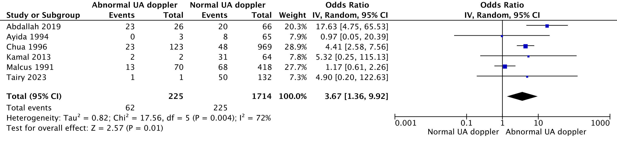
HKSJ conversion: Total: OR 3,67 (1,14-11,78) – p=0,035186

Sensitivity analysis – Exclusion of Tairy 2023 and Chua 1996:

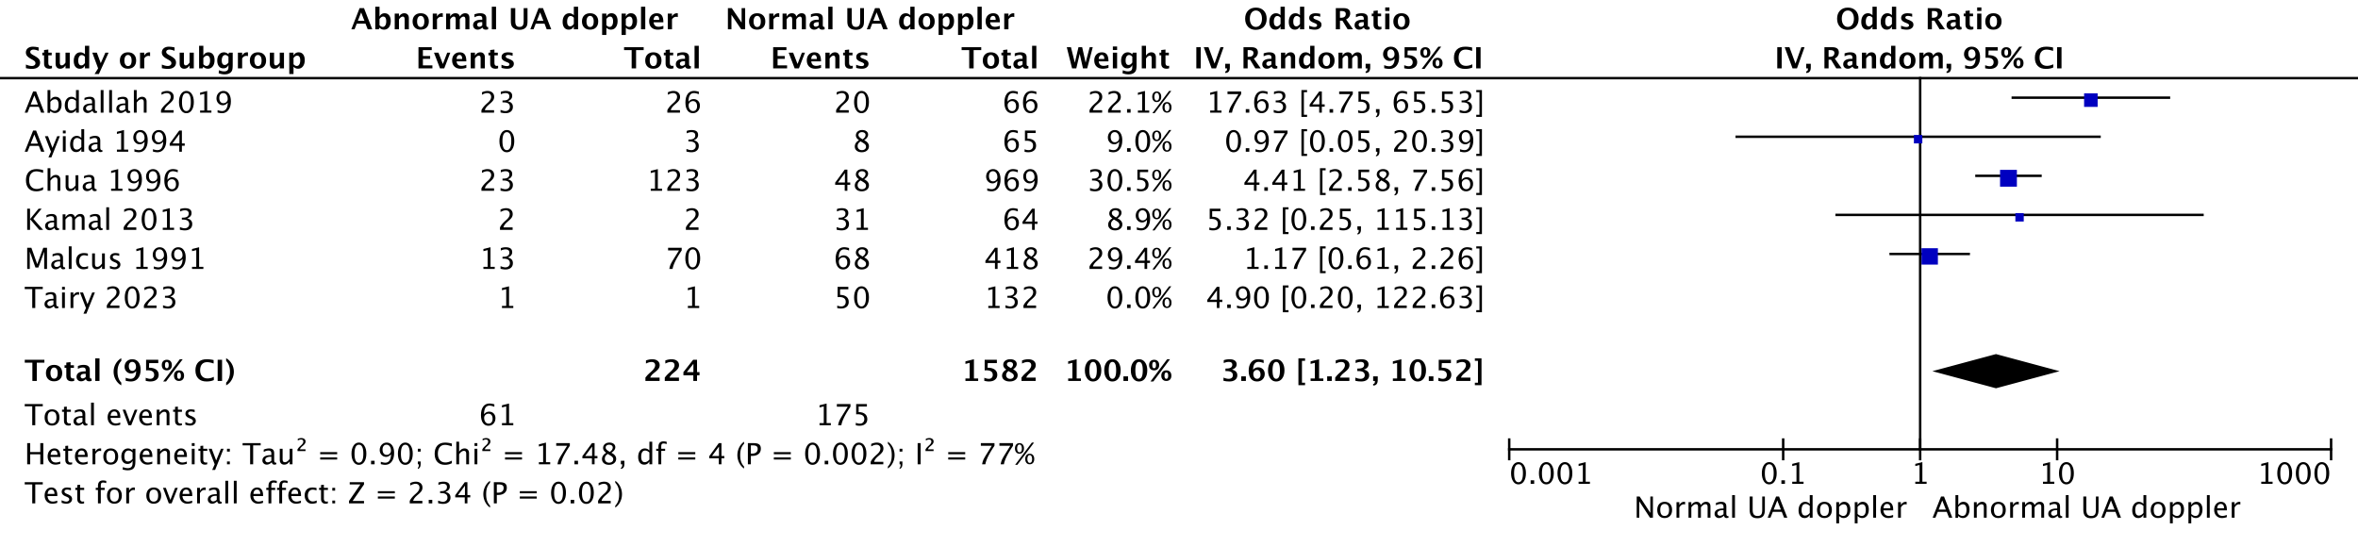
HKSJ conversion: Total: OR 3,60 (1,07-12,09) – p=0,041916

Outcome 2: Meconium-stained amniotic fluid (MSAF)

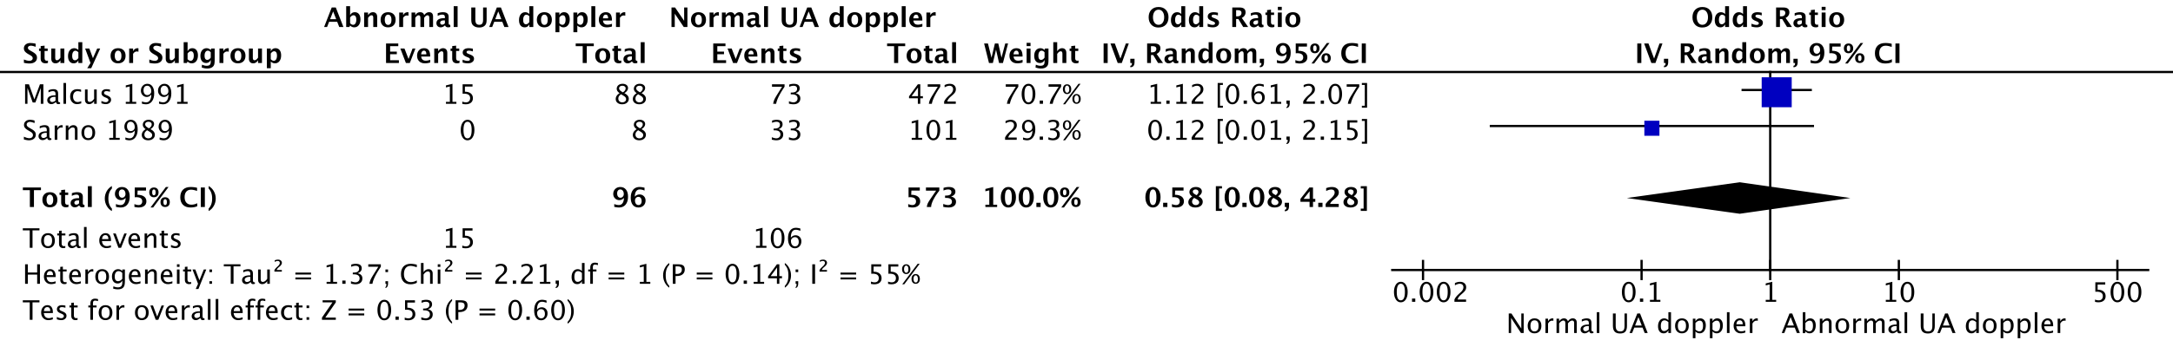
HKSJ conversion: OR 0,58 (0-236192,4) – p=0,686846

Outcome 3: Operative delivery for fetal distress (ODFD)

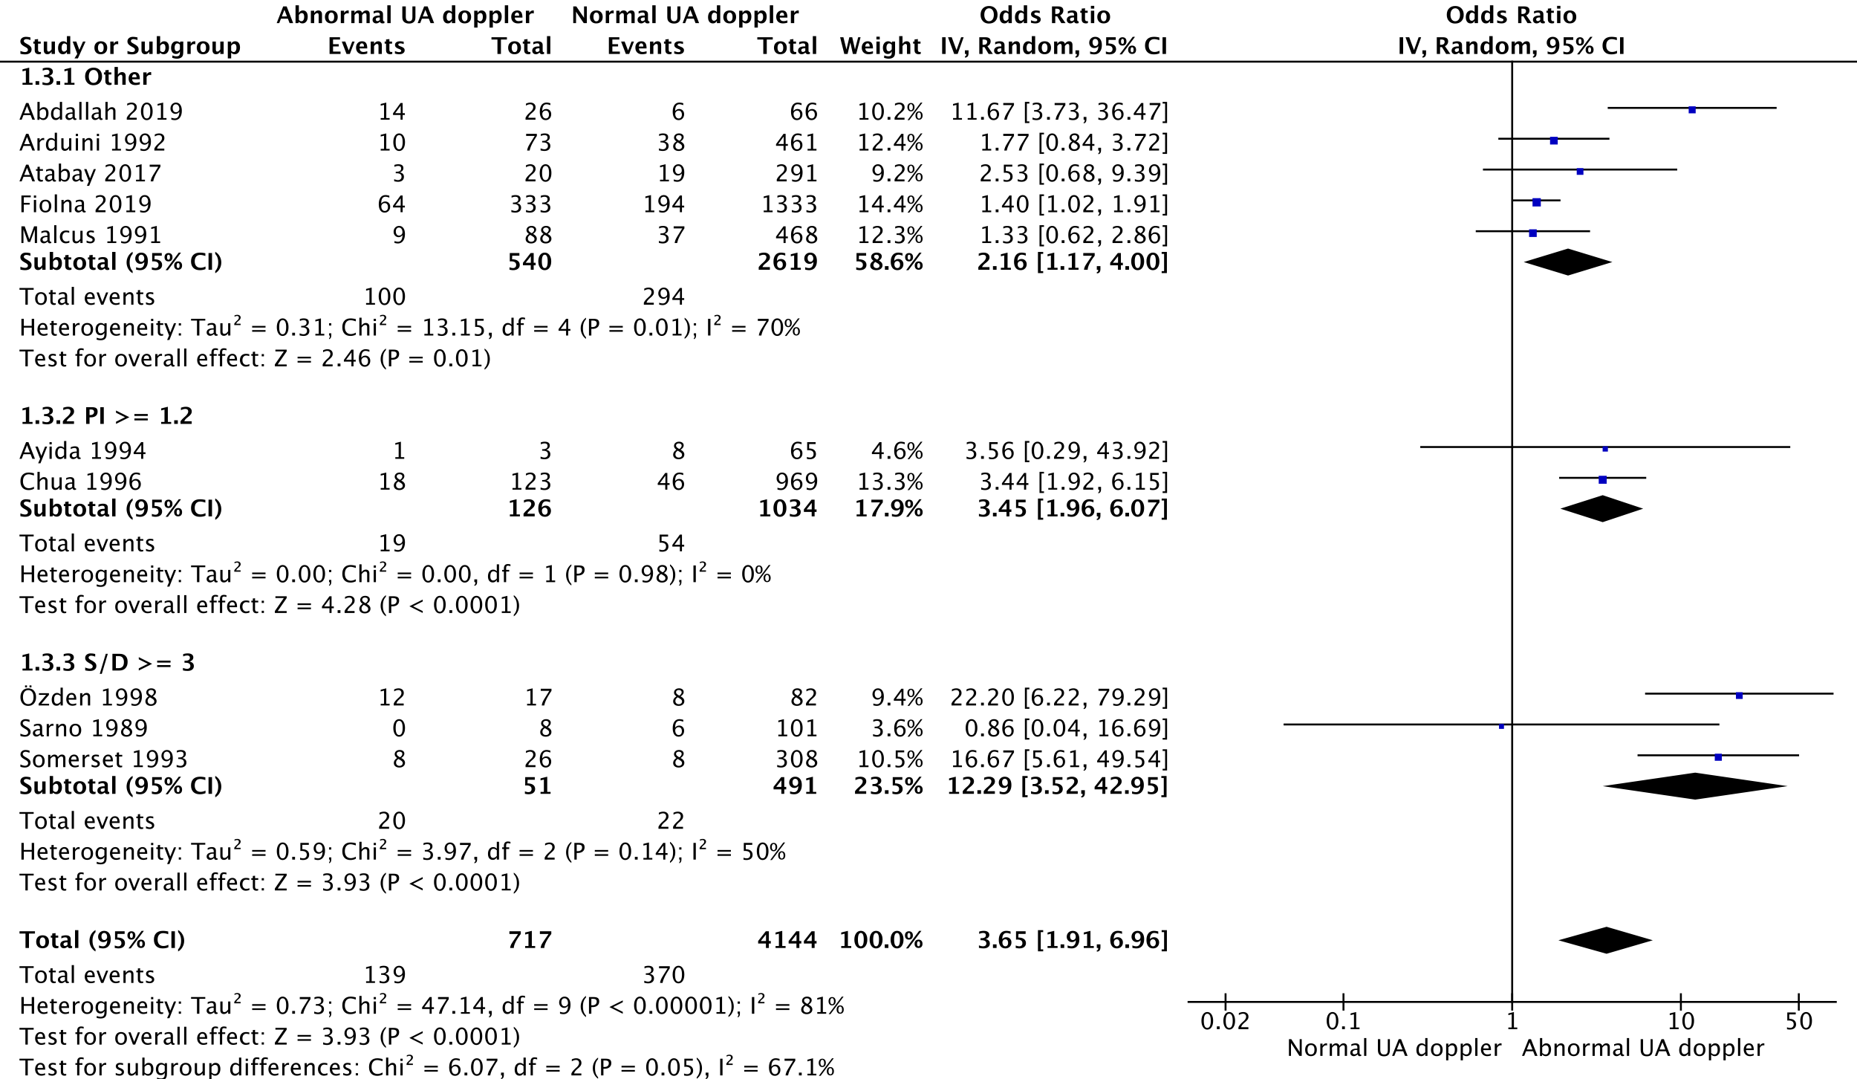

HKSJ conversion:
- Subgroup “other”: OR 2,16 (0,77-6,03) – p= 0,10555
- Subgroup PI >= 1,2: OR 3,45 (3,13-3,80) – p= 0,003923
- Subgroup S/D >=3: OR 12,29 (0,45-338,57) – p= 0,082813
- Total: OR 3,65 (1,66-8,04) – p= 0,004871

Funnel plot:
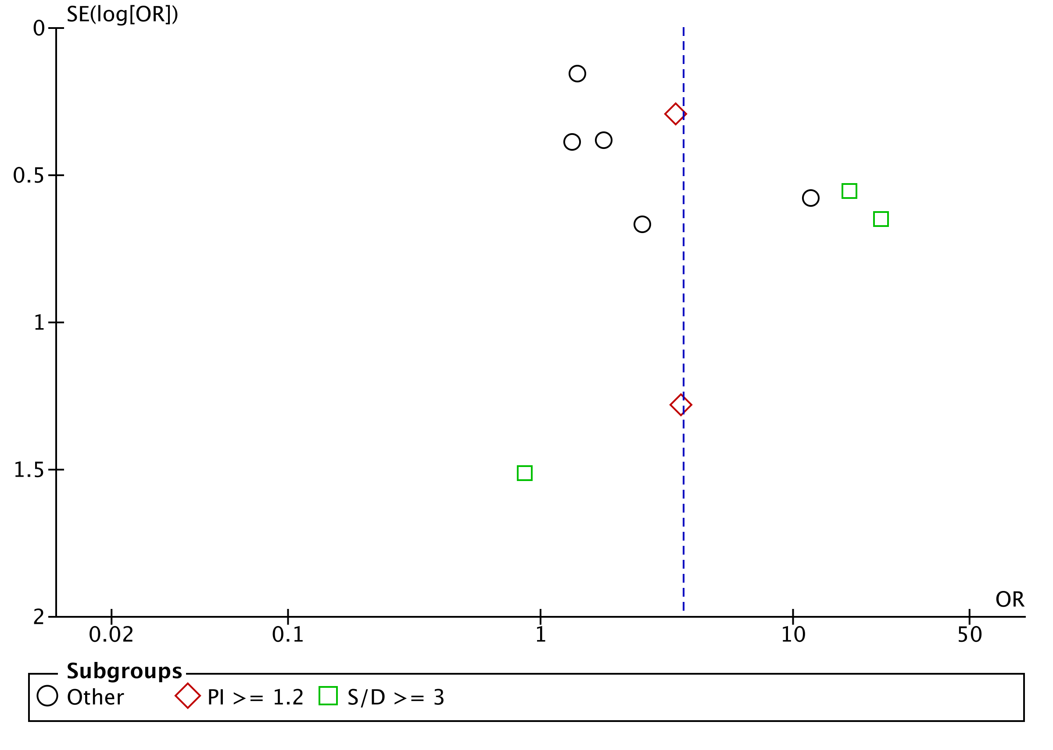

Sensitivity analysis – Exclusion of Chua 1996:

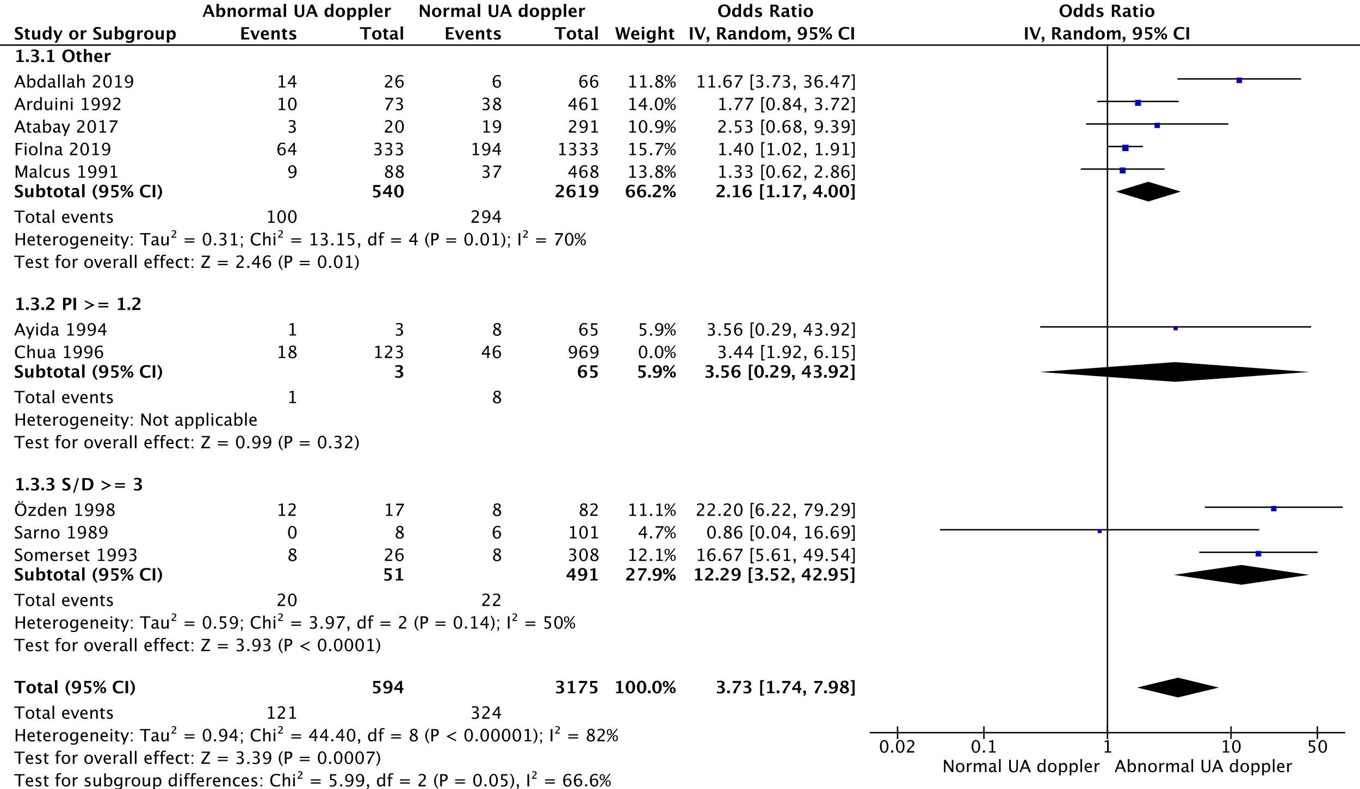

HKSJ conversion: OR 3,73 (1,49-9,35) – p= 0,010815

Outcome 4: spontaneous vaginal delivery (SVD) (vs. operative delivery, OD)

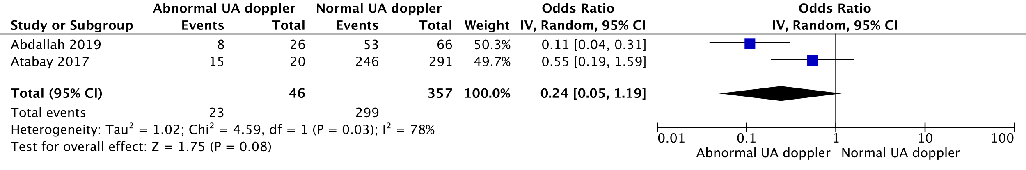
HKSJ conversion: OR 0,24 (0-6638,87) – p= 0,32694

Outcome 5: Assisted ventilation

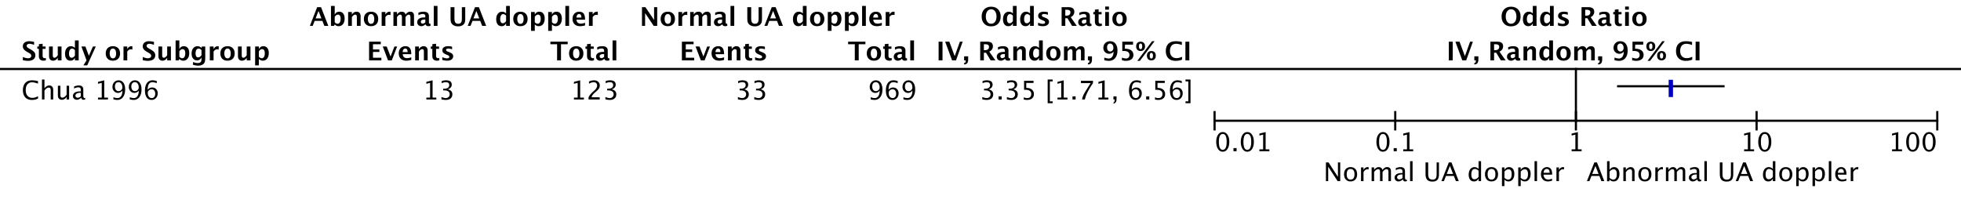
Outcome 6: Neonatal resuscitation

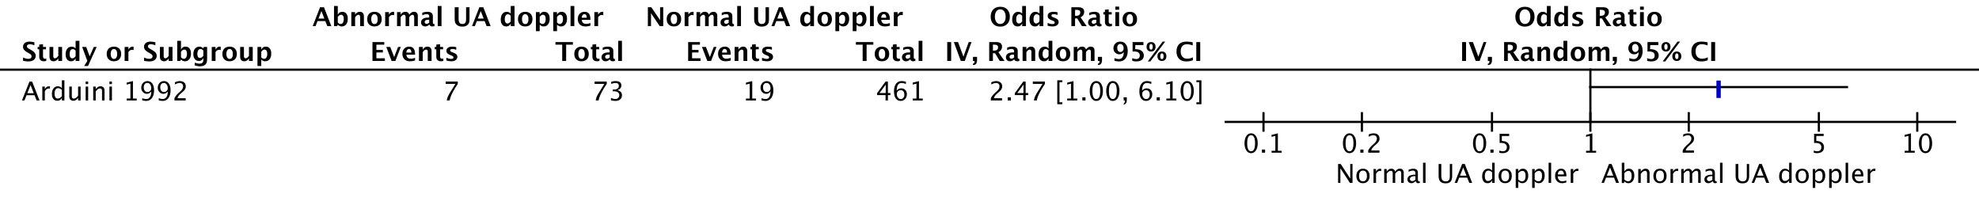

Outcome 7: Apgar (=)<7/5 at 1 min

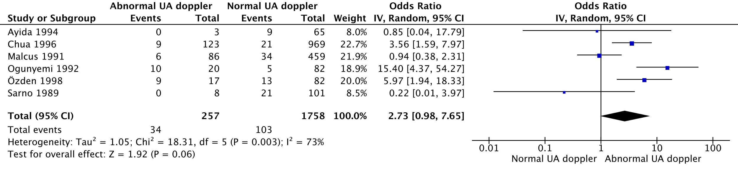
HKSJ conversion: OR 2,73 (0,64-11,69) – p=0,136112

Sensitivity analysis – Exclusion of Chua 1996:

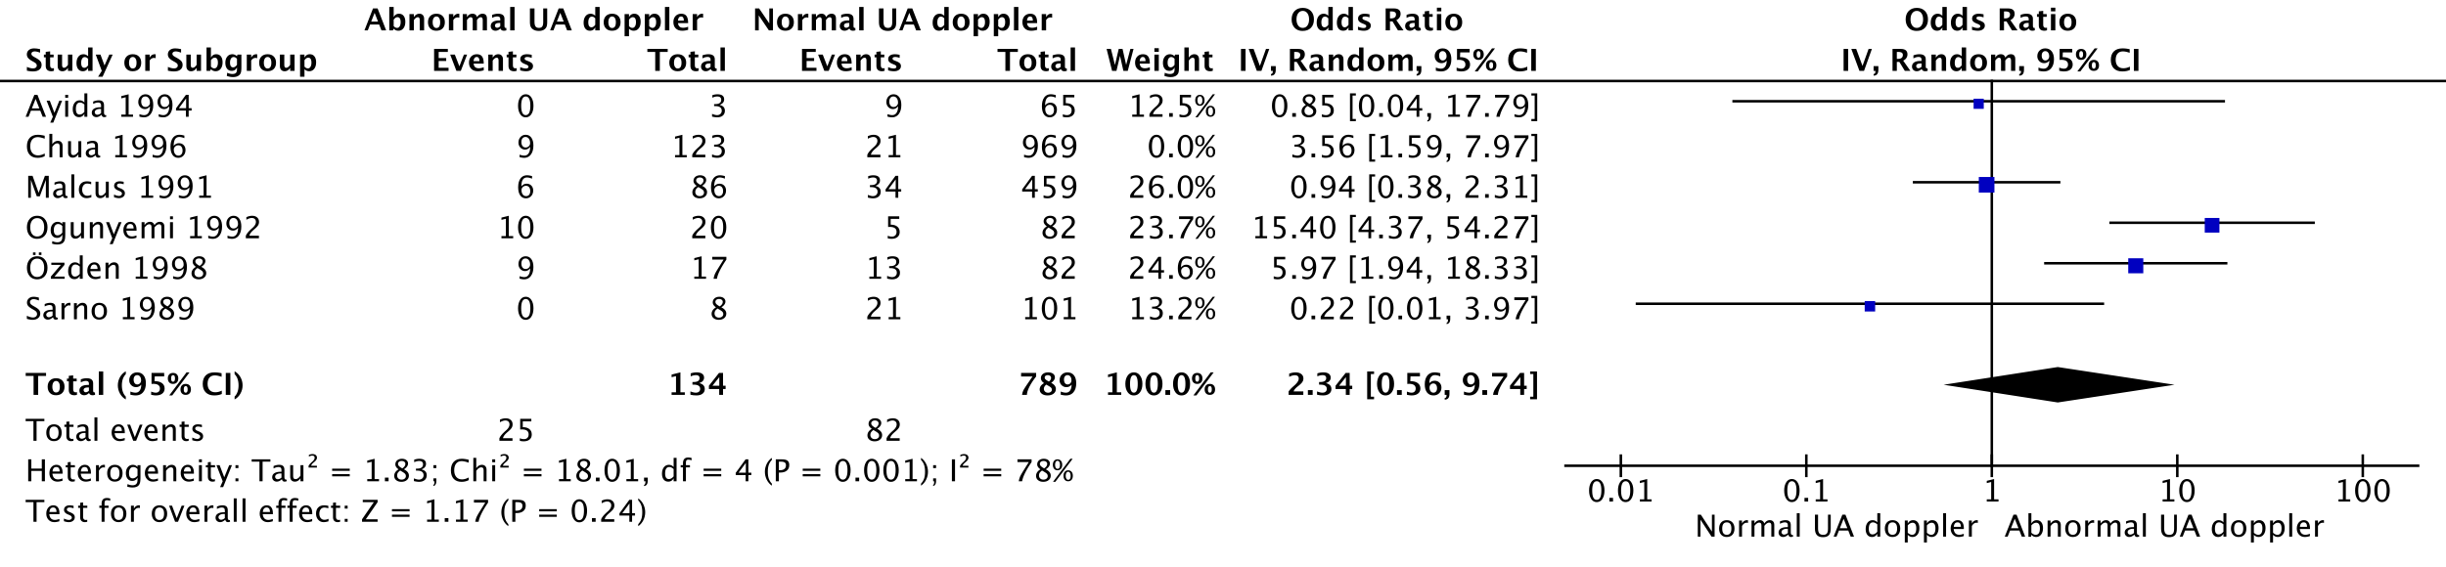
HKSJ conversion – Total: OR 2,34 (0,44-12,57) – p=0,250415

Outcome 8: Apgar score (=)<7 at 5 min

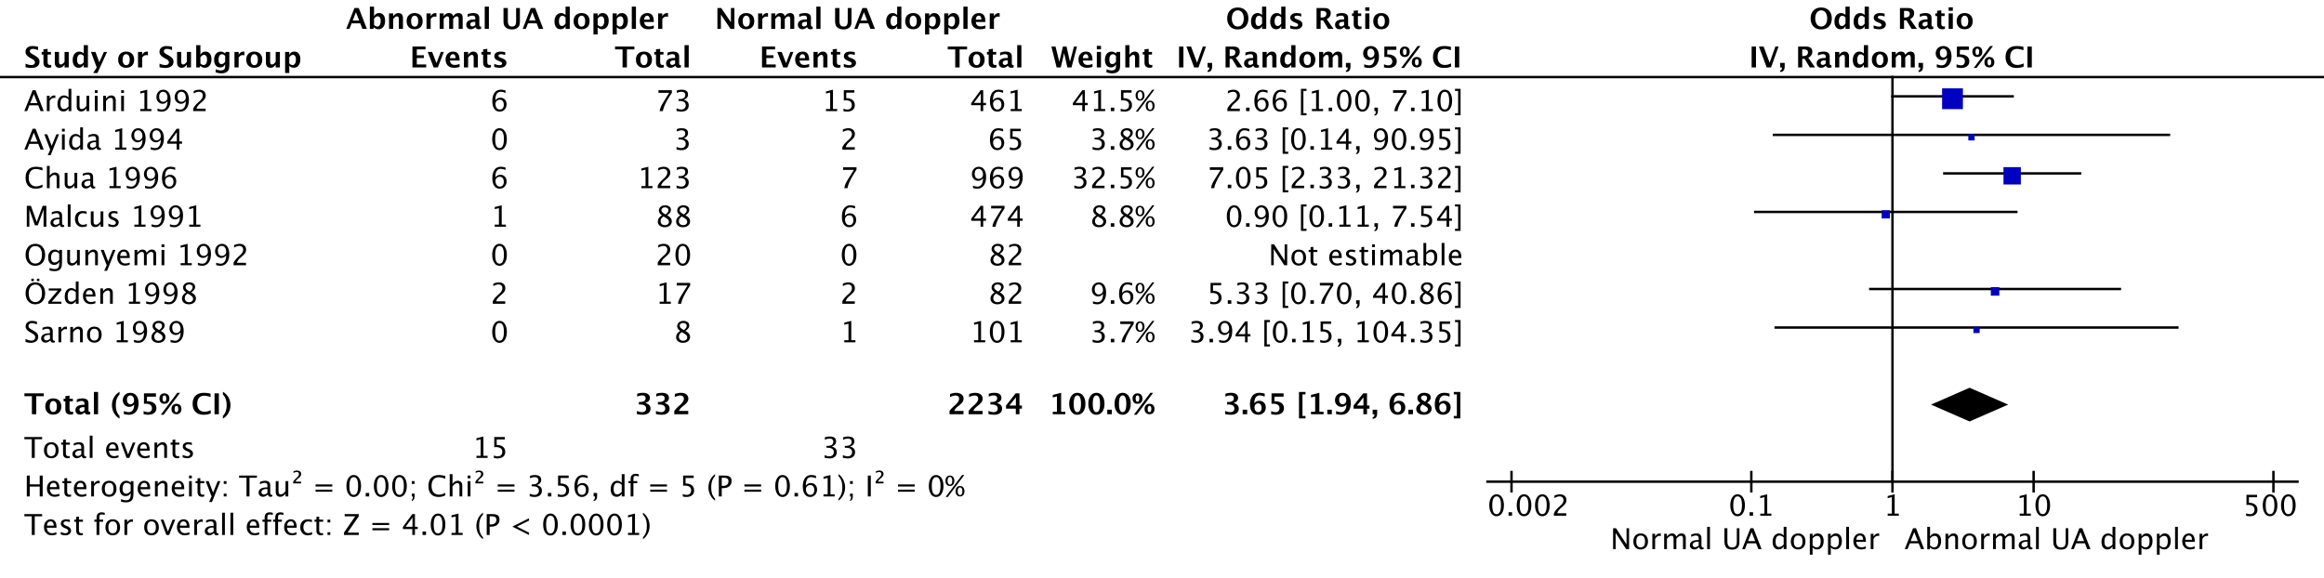
HKSJ conversion: OR 3,65 (1,82-7,34) – p= 0,00504

Sensitivity analysis – Exclusion of Chua 1996:

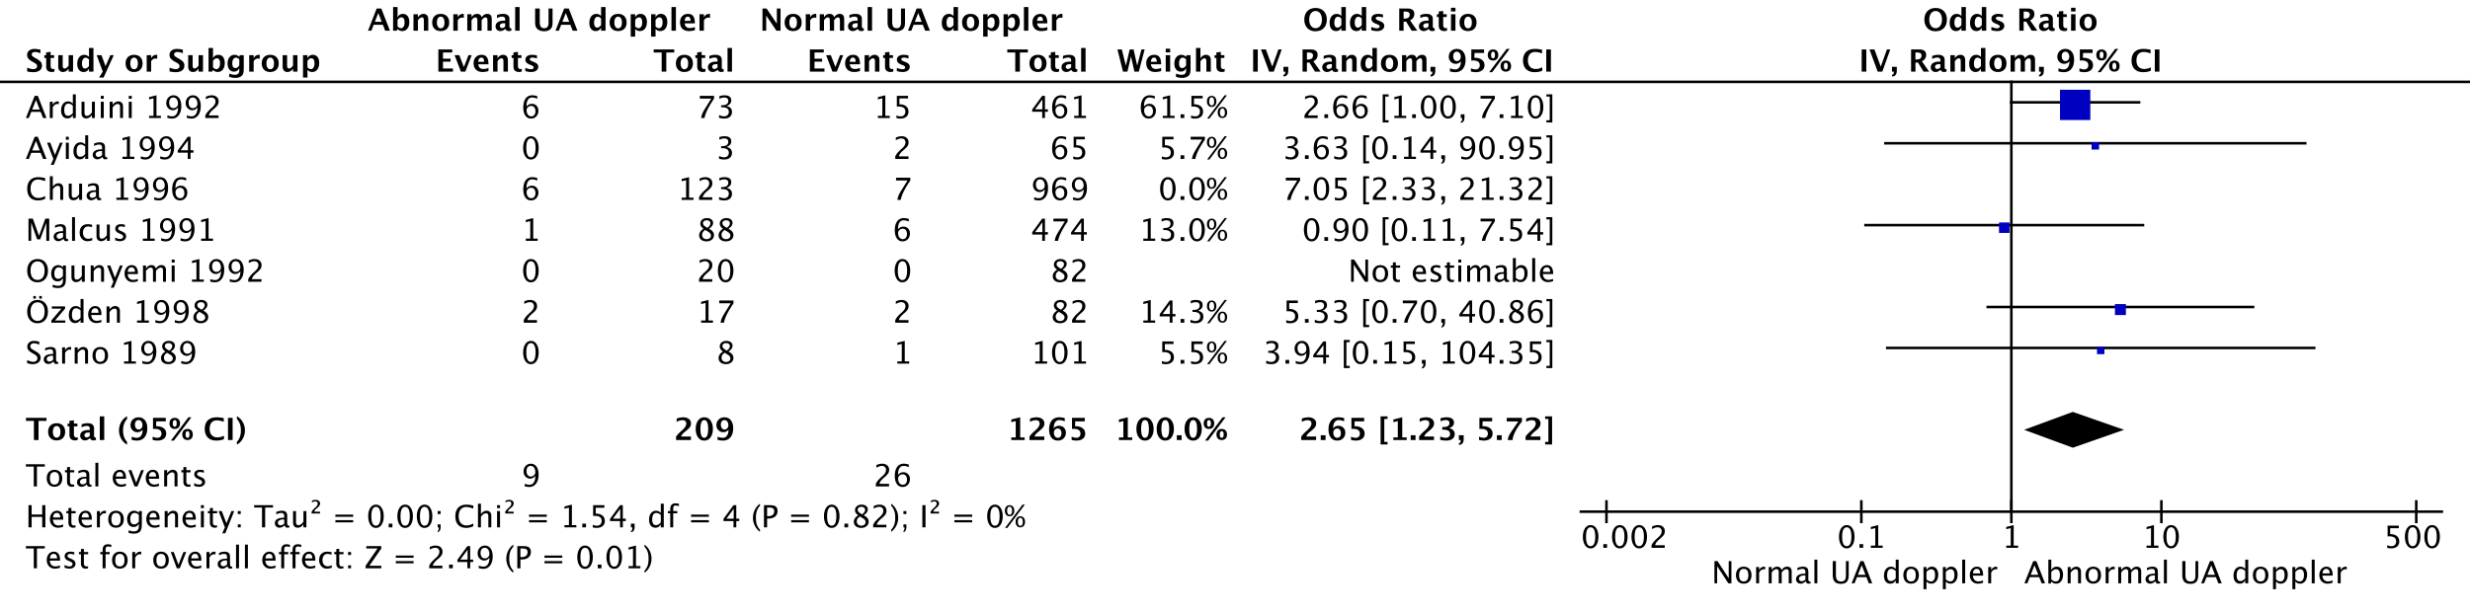
HKSJ conversion: OR 2,65 (1,52-4,63) – p= 0,006469

Outcome 9: Low UA pH

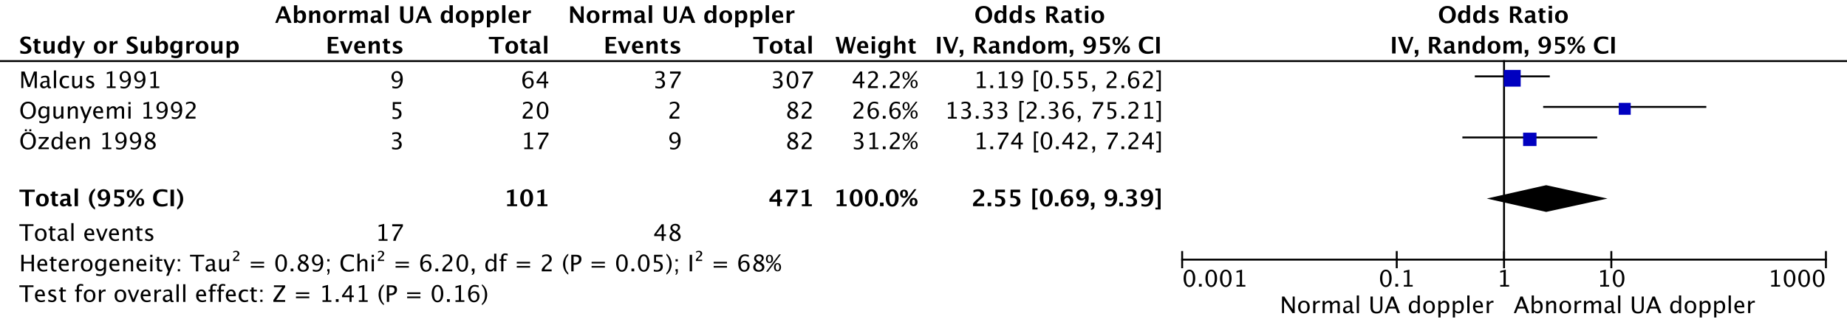
HKSJ conversion: OR 2,55 (0,12-54,94) – p= 0,31992

Outcome 10: NICU admission

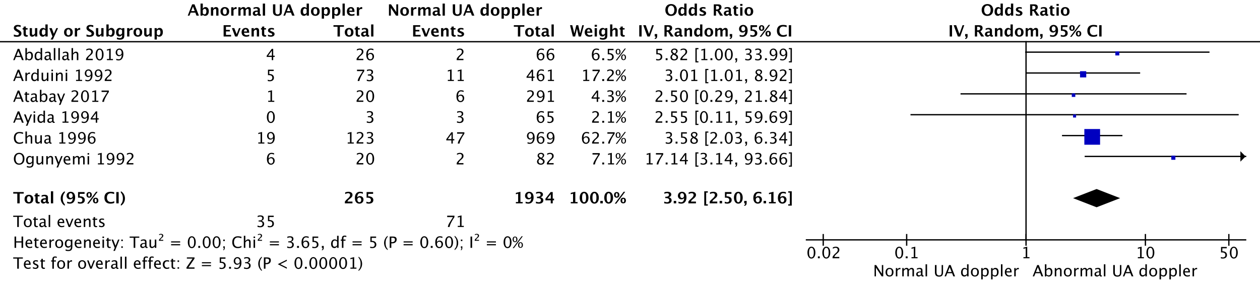
HKSJ conversion: Total OR 3,92 (2,36-6,51) – p=0,000964

Sensitivity analysis – Exclusion of Chua 1996:

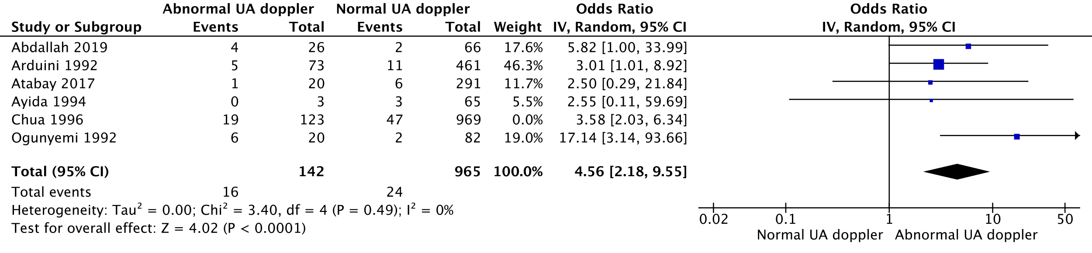
HKSJ conversion: Total OR 4,56 (2,05-10,14) – p=0,004562

Outcome 11: Neonatal birthweight (g)

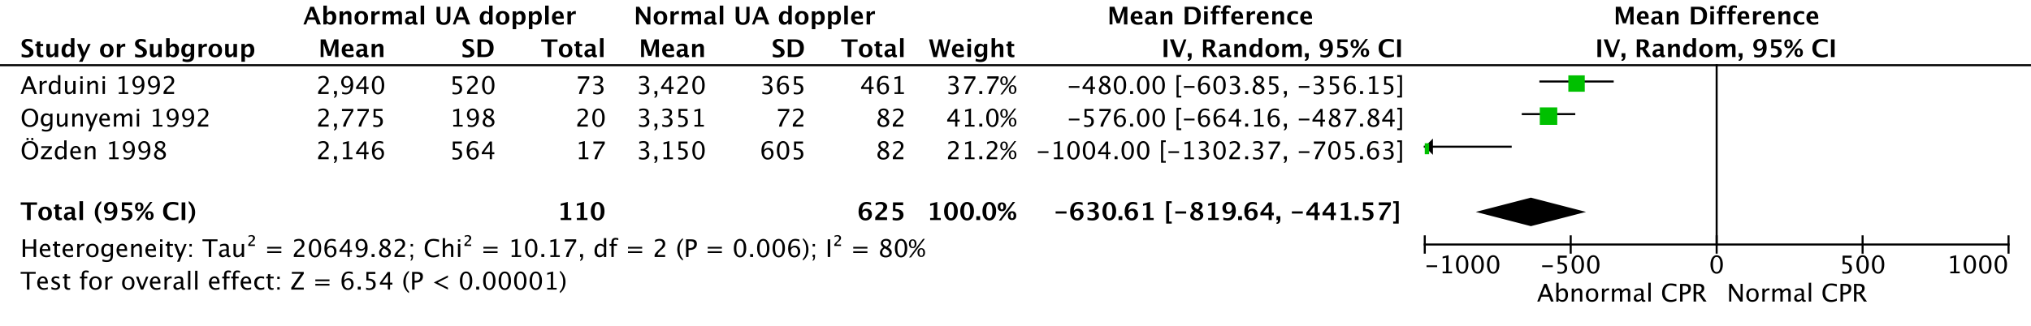
HKSJ conversion: MD -630,61 (-1234,29; -26,93) – p=0,046105

Outcome 12: SGA infant

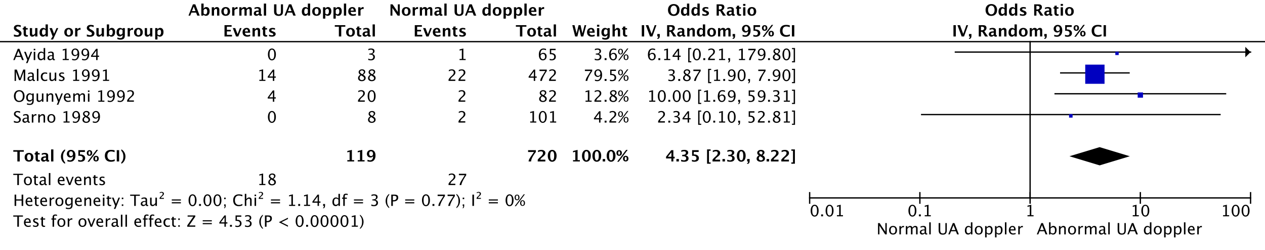
HKSJ conversion: OR 4,35 (2,30-8,22) – p= 0,005194

Outcome 13: Serious neonatal morbidity

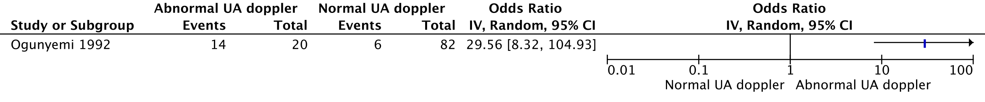
Outcome 14: Perinatal mortality

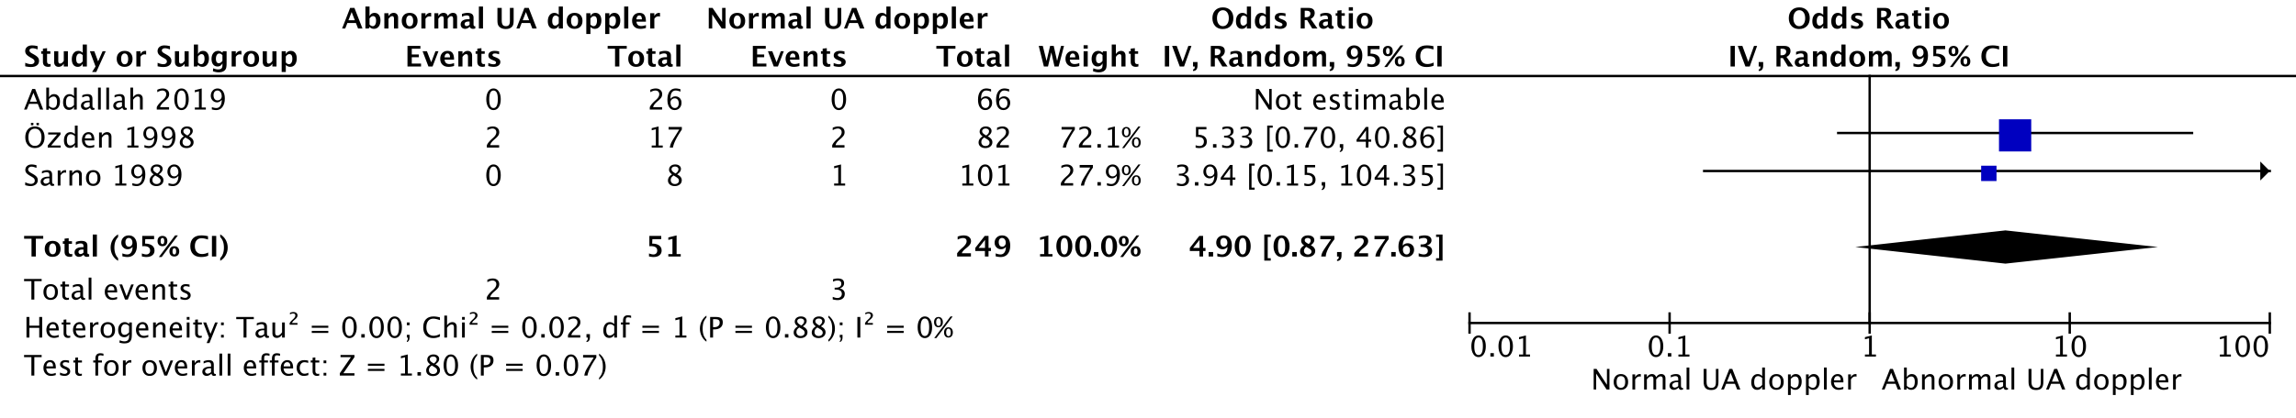
HKSJ conversion: OR 4,9 (0,88-27,42) – p=0,054158

Outcome 15: Composite adverse outcome

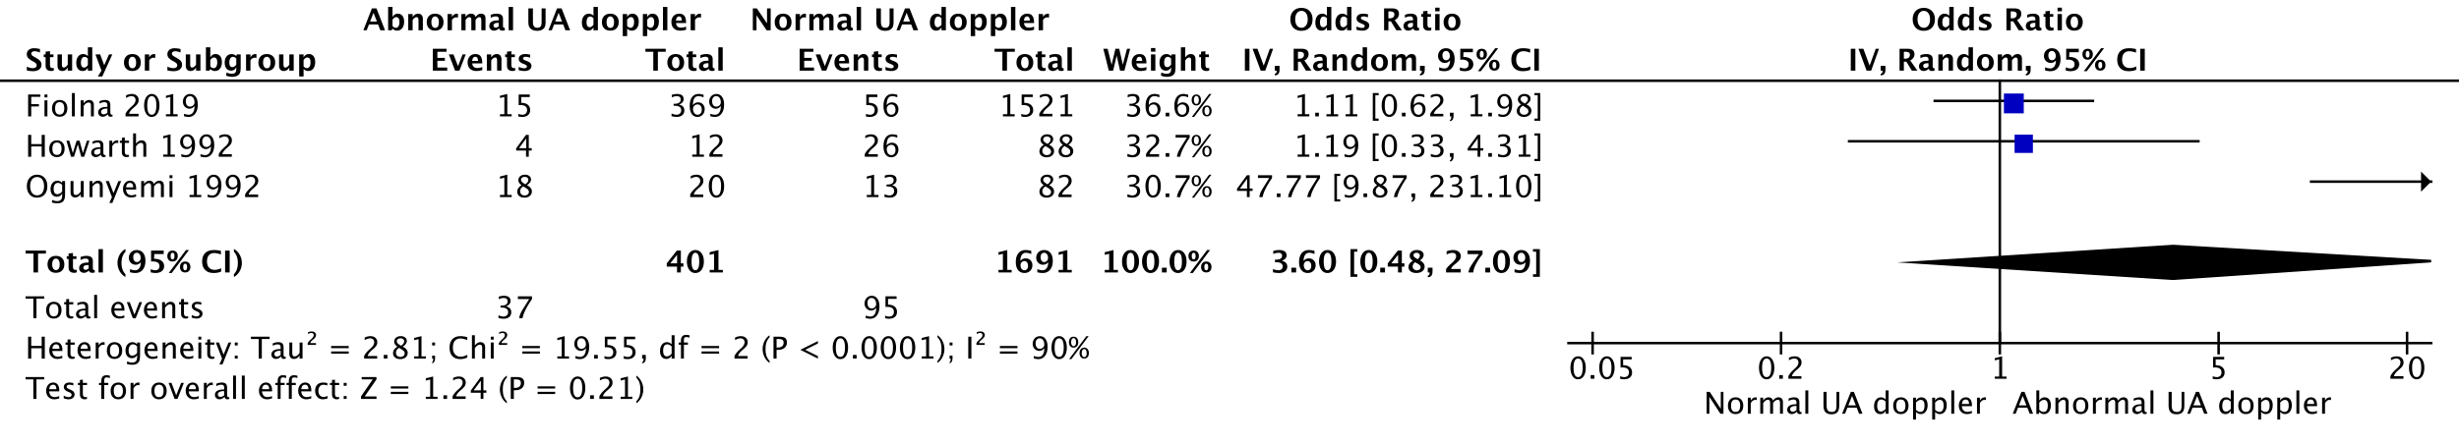
HKSJ conversion: OR 3,6 (0,02-675,15) – p=0,402784

- MCA

Outcome 1: Fetal distress (FD) during labor

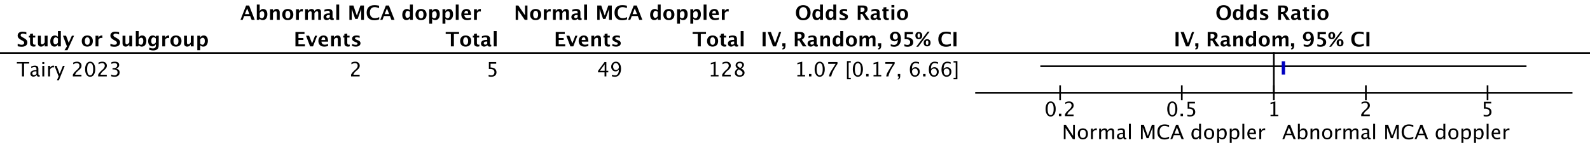
Study at critical risk of bias – no sensitivity analysis.

Outcome 2: Meconium-stained amniotic fluid (MSAF)

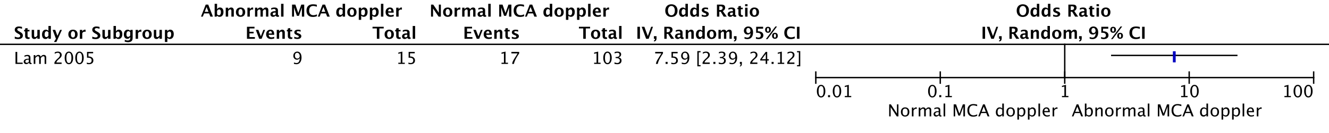

Outcome 3: Operative delivery for fetal distress (ODFD)

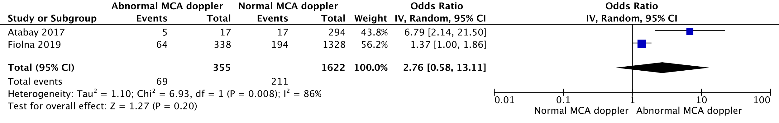
HKSJ conversion: OR 2,76 (0-66554,93) – p=0,422595

Outcome 4: spontaneous vaginal delivery (SVD) (vs. operative delivery, OD)

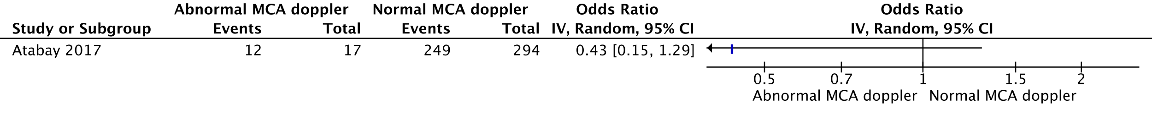
Outcome 5: NICU admission

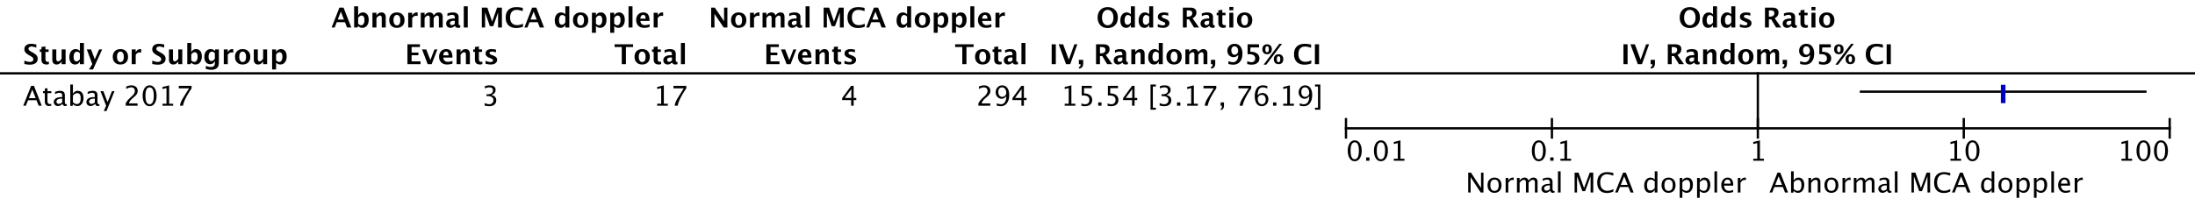
Outcome 6: Composite adverse outcome

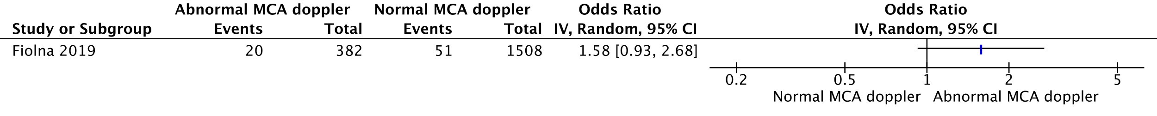
- CPR

Outcome 1: Fetal distress (FD) during labor

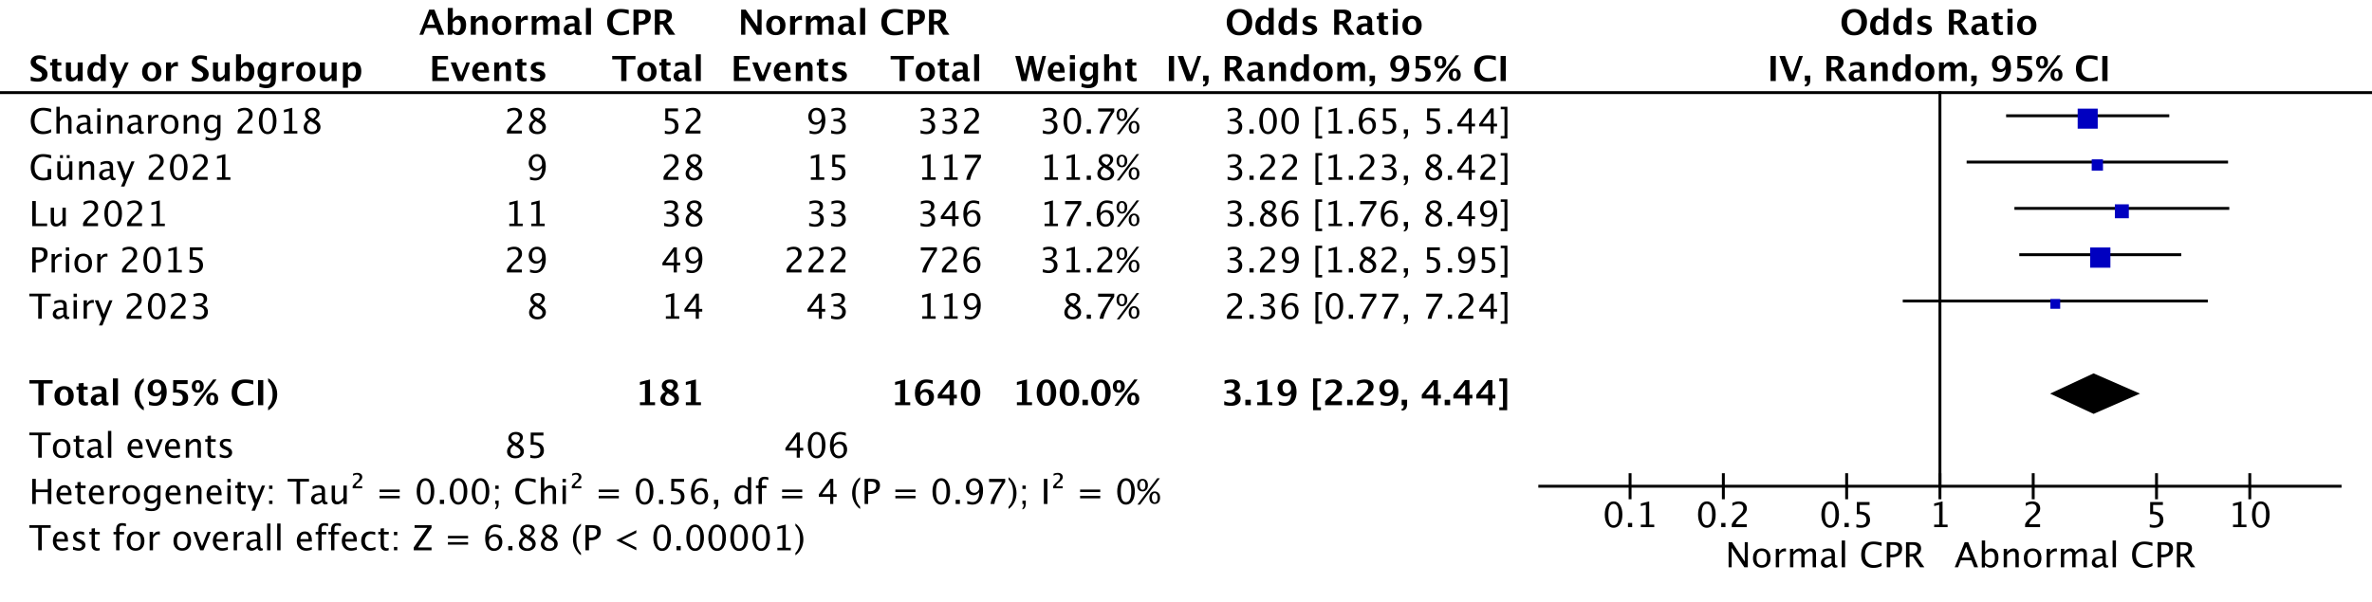
HKSJ conversion: OR 3,19 (2,68-3,80) – p= 5,05E-05

Sensitivity analysis – exclusion of Tairy 2023

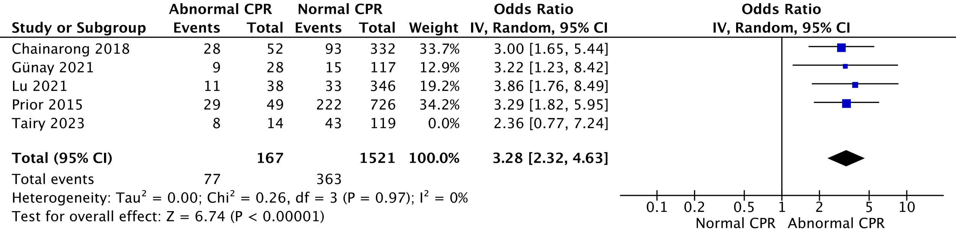
HKSJ conversion: OR 3,28 (2,90-3,71) – p= 1,14E-05

Outcome 2: Meconium-stained amniotic fluid (MSAF)

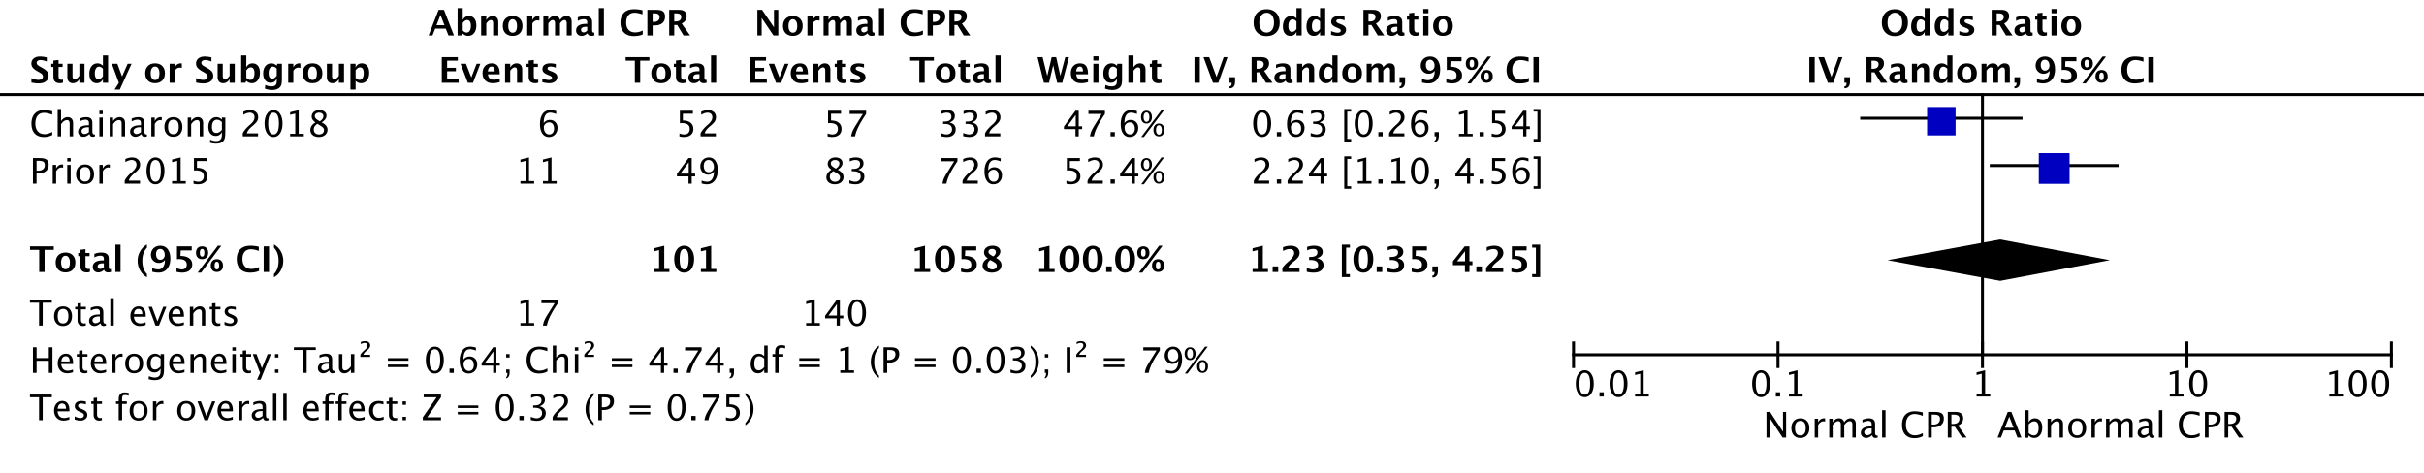
HKSJ conversion: OR 1,23 (0-3854,12) – p=0,798942

Outcome 3: Operative delivery for fetal distress (ODFD)

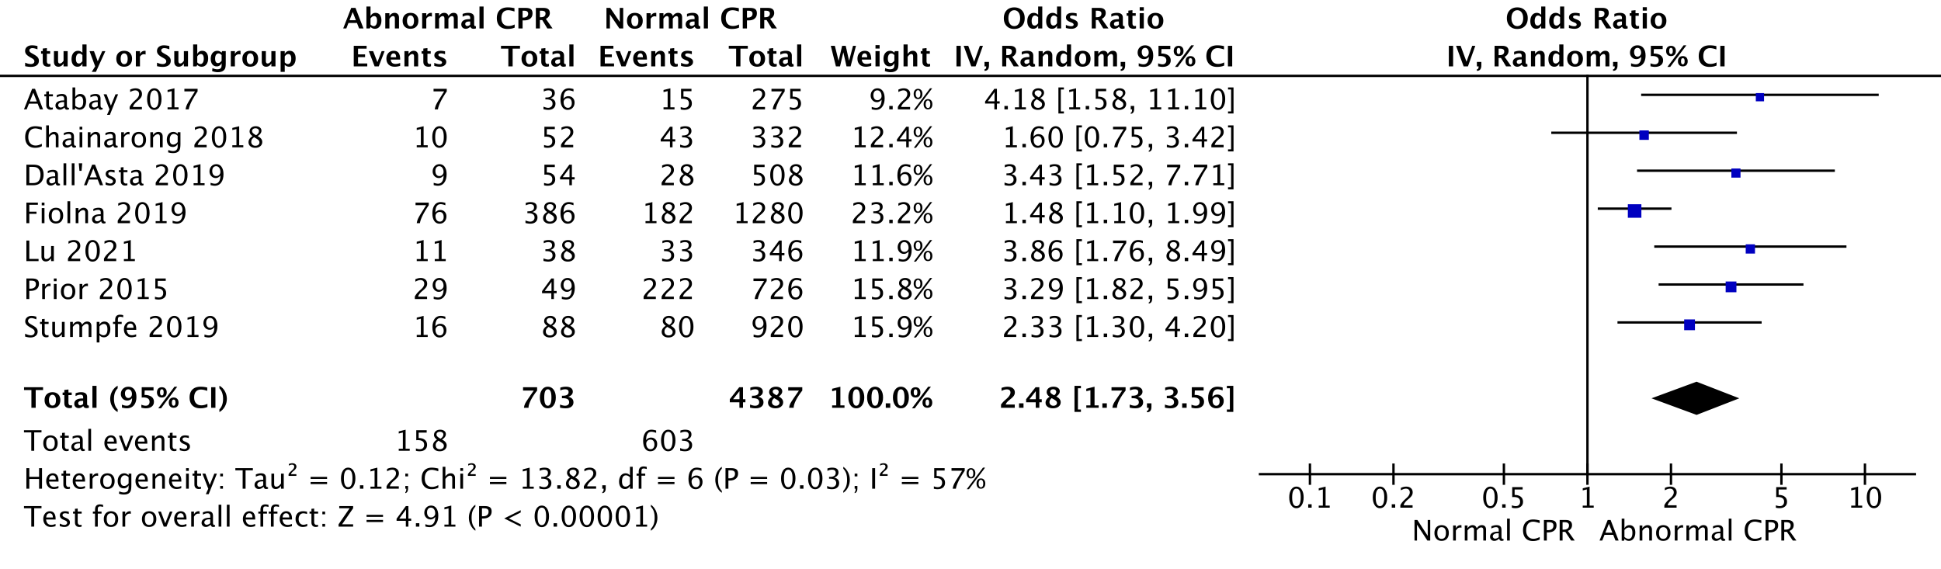
HKSJ conversion: OR 2,48 (1,66 - 3,70) – p= 0,001417

Outcome 4: Spontaneous vaginal delivery (SVD) (vs. operative delivery, OD)

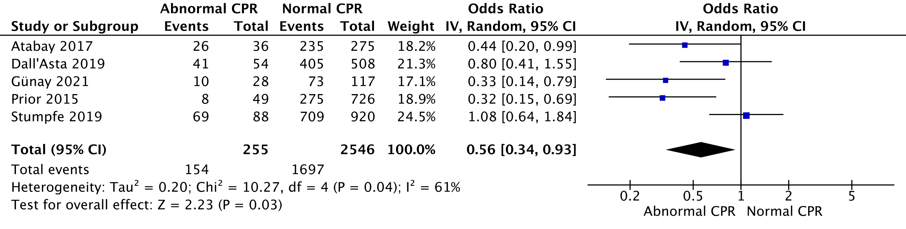
HKSJ conversion: OR 0,56 (0,28-1,12) – p=0,081358

Outcome 7: Apgar <7 at 1 min

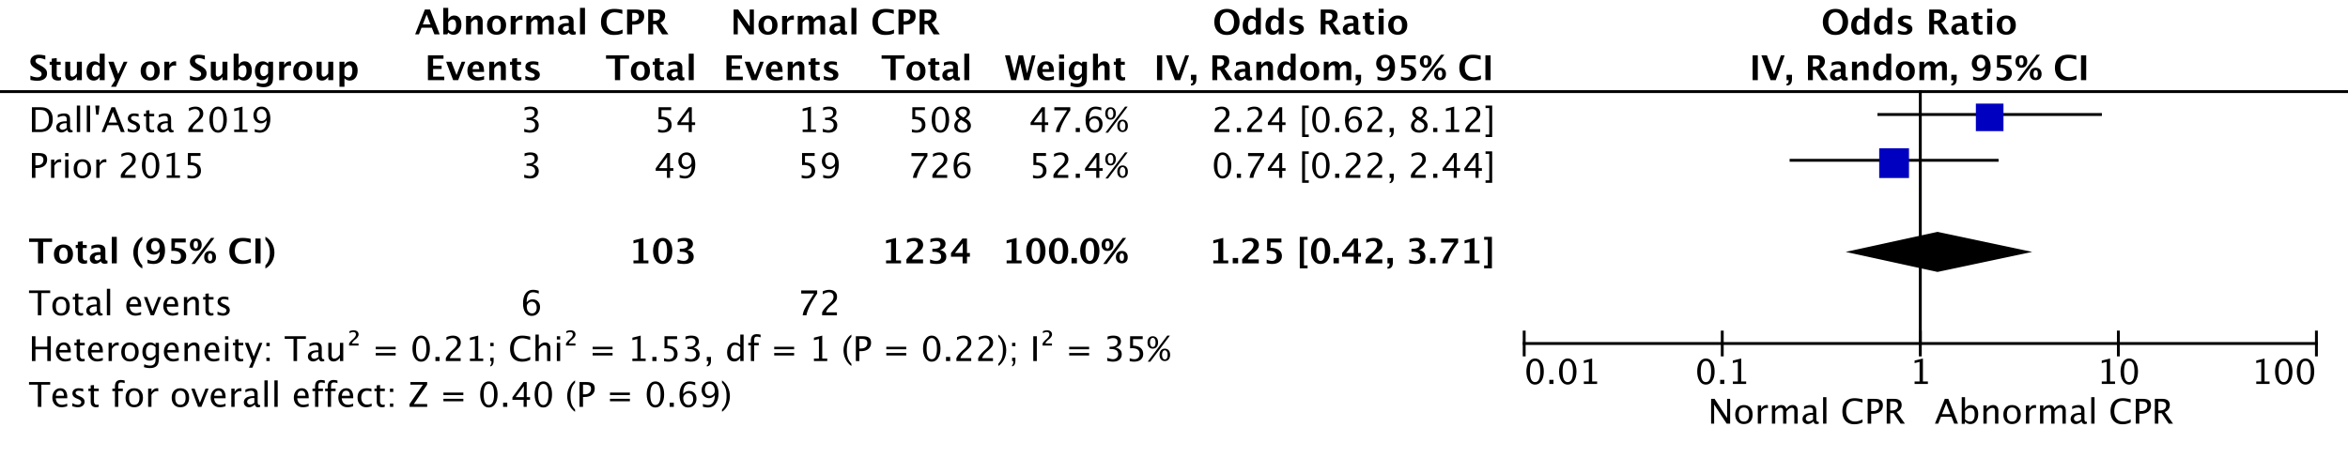
HKSJ conversion: OR 1,25 (0-1410,51) – p=0,7559

Outcome 8: Apgar <7 at 5 min

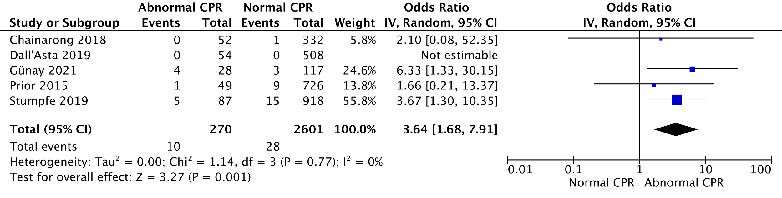
HKSJ conversion: OR 3,64 (2,03-6,54) – p=0,003599

Outcome 9: Low UA pH

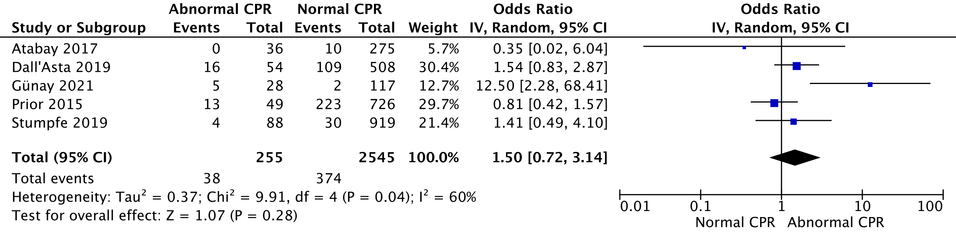
HKSJ conversion: OR 1,5 (0,43-5,22) – p=0,417529

Outcome 10: NICU admission

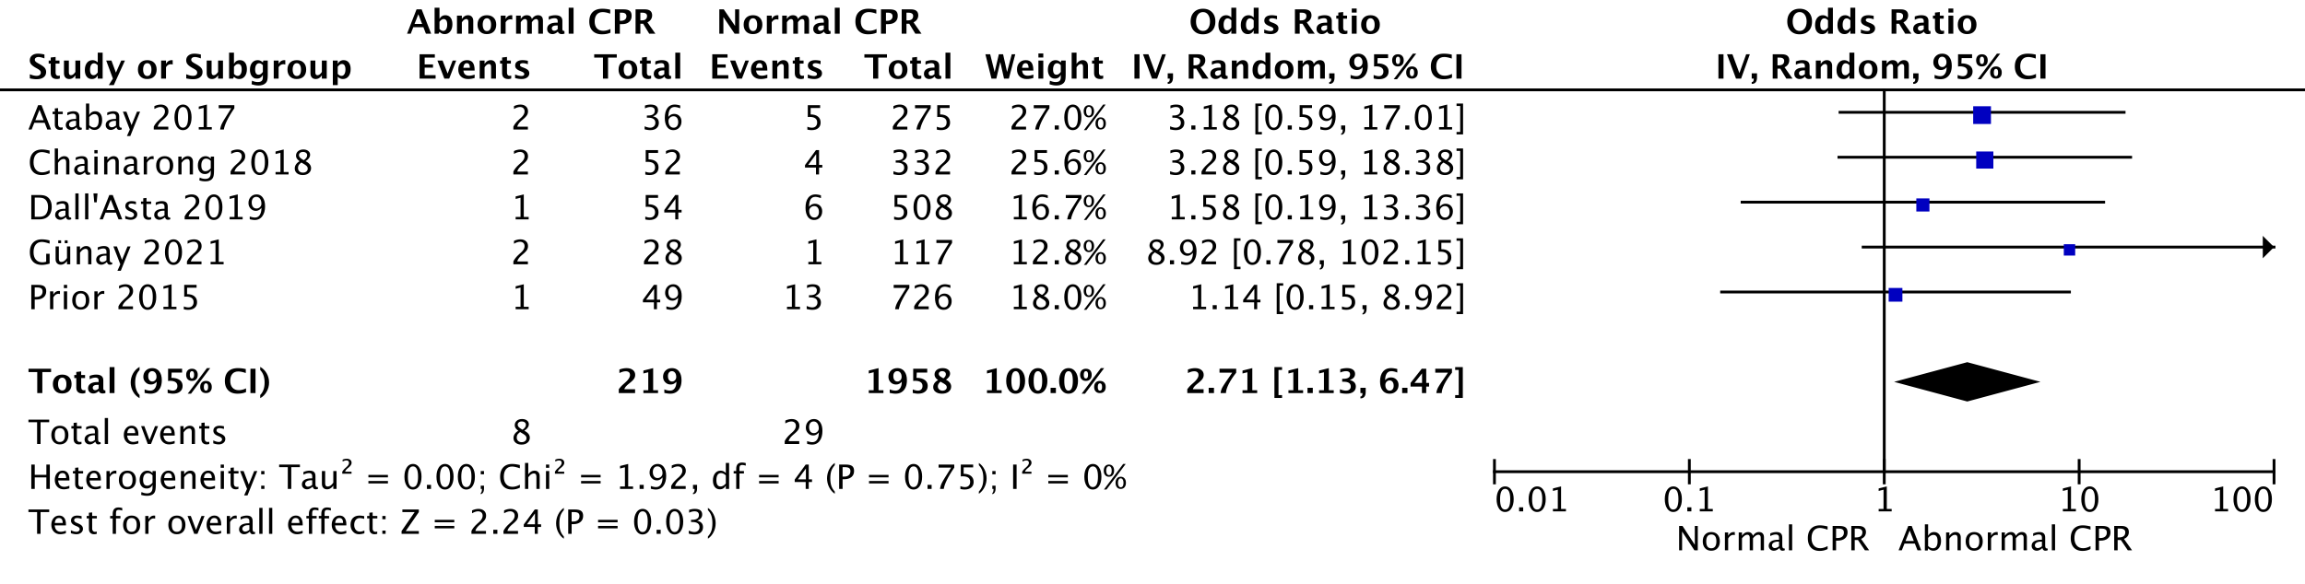
HKSJ conversion: OR 2,71 (1,15-6,38) – p=0,03198

Outcome 11: Neonatal birthweight (g)

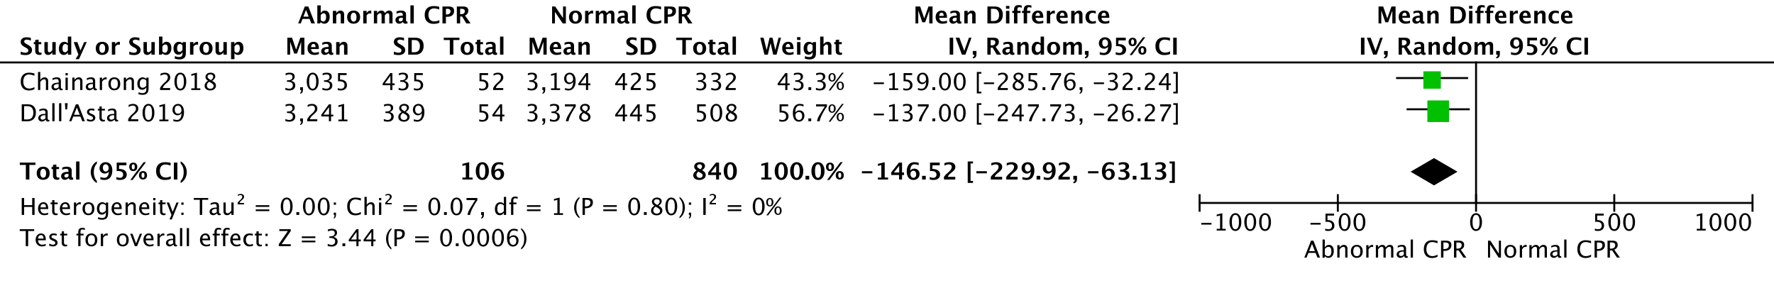
HKSJ conversion: MD -146,52 (-285,03; -8,01) – p=0,047276

Outcome 12: SGA infant

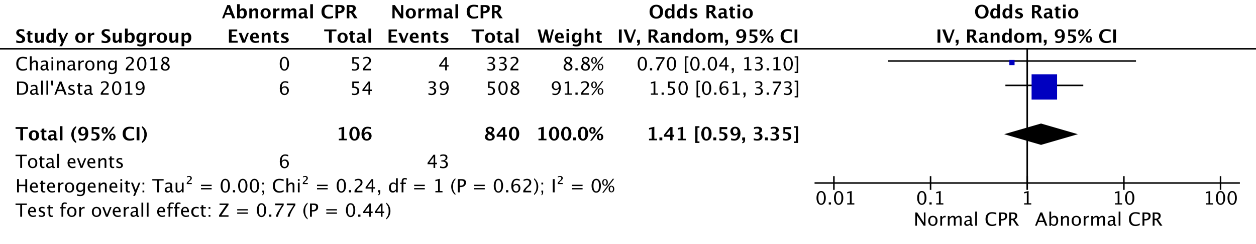
HKSJ conversion: OR 1,41 (0,09-21,93) – p=0,357251

Outcome 13: Serious neonatal morbidity

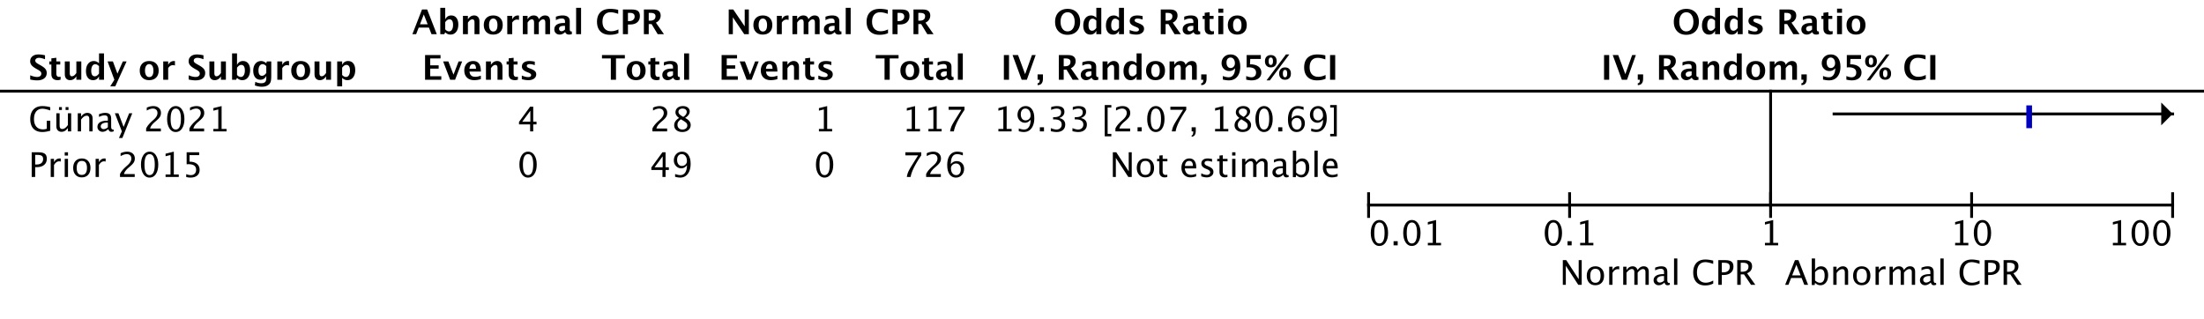
Outcome 14: Perinatal mortality

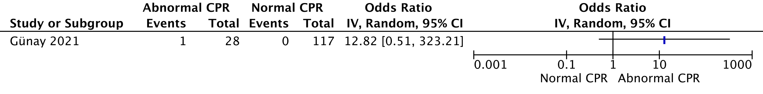
Outcome 15: Composite adverse outcome

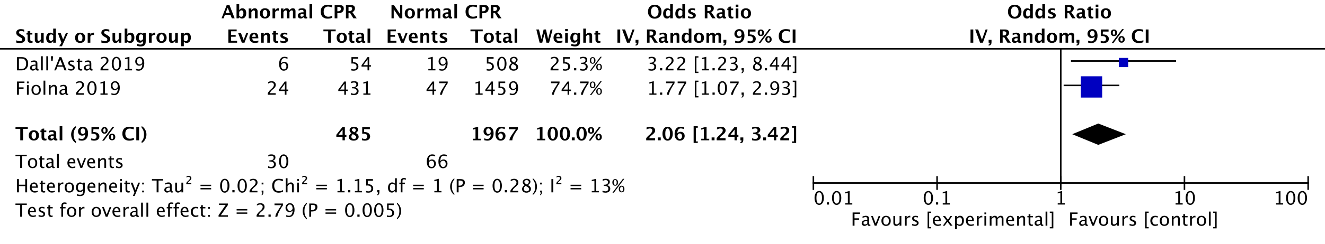
HKSJ conversion: OR 2,06 (0,08-56,16) – p=0,219964

- UV-pulsations

Outcome 1: Fetal distress (FD) during labor

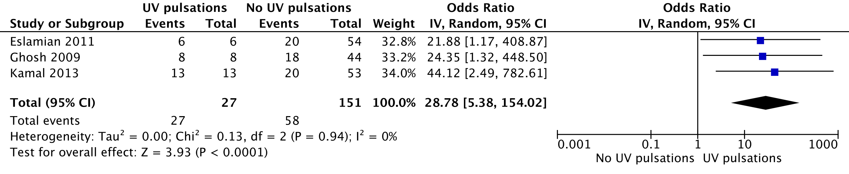
HKSJ conversion: OR 28,78 (11,21-73,87) – p= 0,004225

Sensitivity analysis – Exclusion of Eslamian 2011:

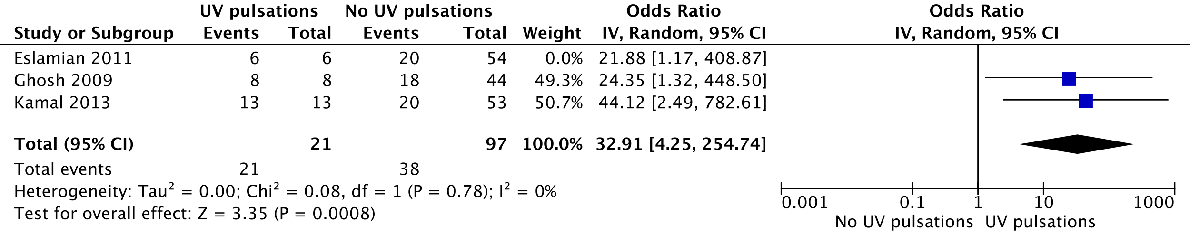
HKSJ conversion: OR 32,91 (13,33-81,28) – p= 0,003598

Outcome 2: Meconium-stained amniotic fluid (MSAF)

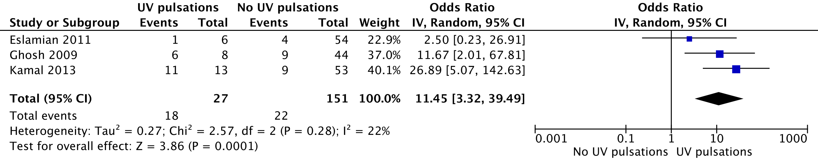
HKSJ conversion: OR 11,45 (0,73-180,83) – p=0,062761

Sensitivity analysis – Exclusion of Eslamian 2011:

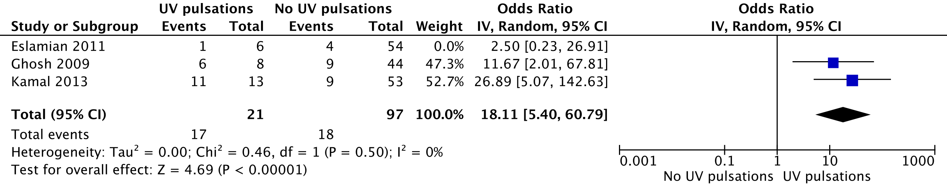
HKSJ conversion: OR 18,11 (5,1-64,36) – p=0,010193

Outcome 3: Operative delivery for fetal distress (ODFD)

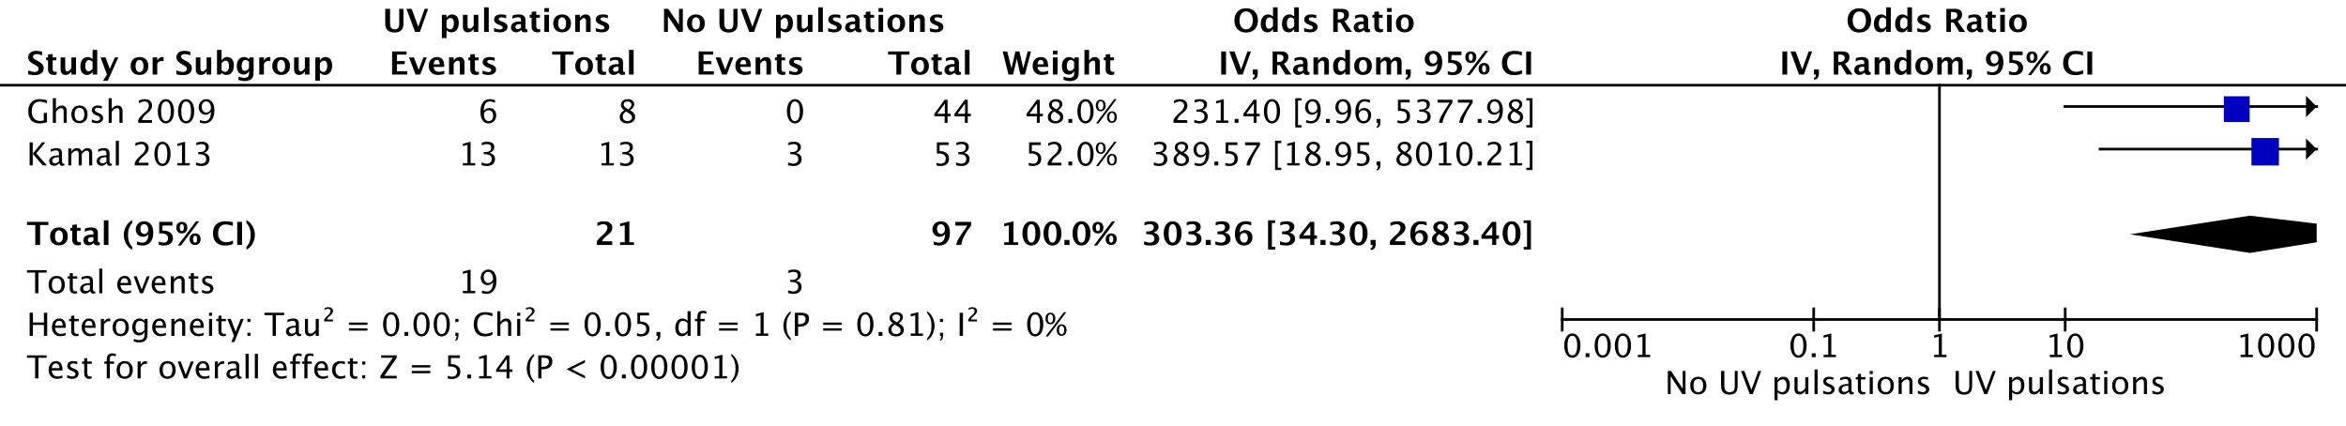
HKSJ conversion: OR 303,36 (11,11-8279,82) – p=0,02897

Outcome 4: spontaneous vaginal delivery (SVD) (vs. operative delivery, OD)

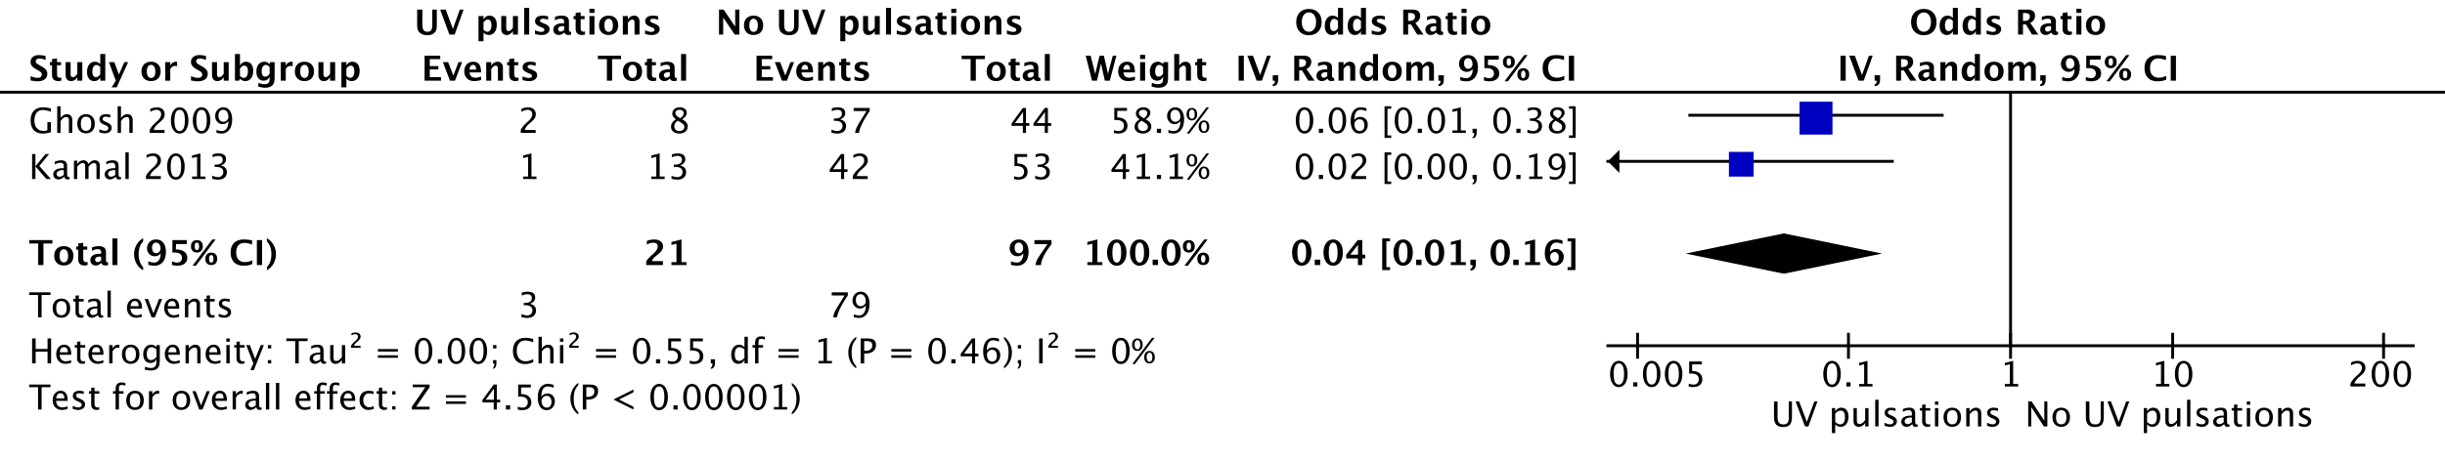
HKSJ conversion: OR 0,04 (0-39,42) – p=0,106294

Outcome 5: Apgar <7 at 5 min

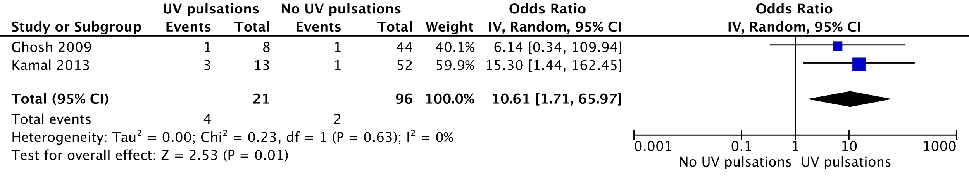
HKSJ conversion: OR 10,61 (0,04-3126,03) – p=0,119204

Outcome 6: Low UA pH

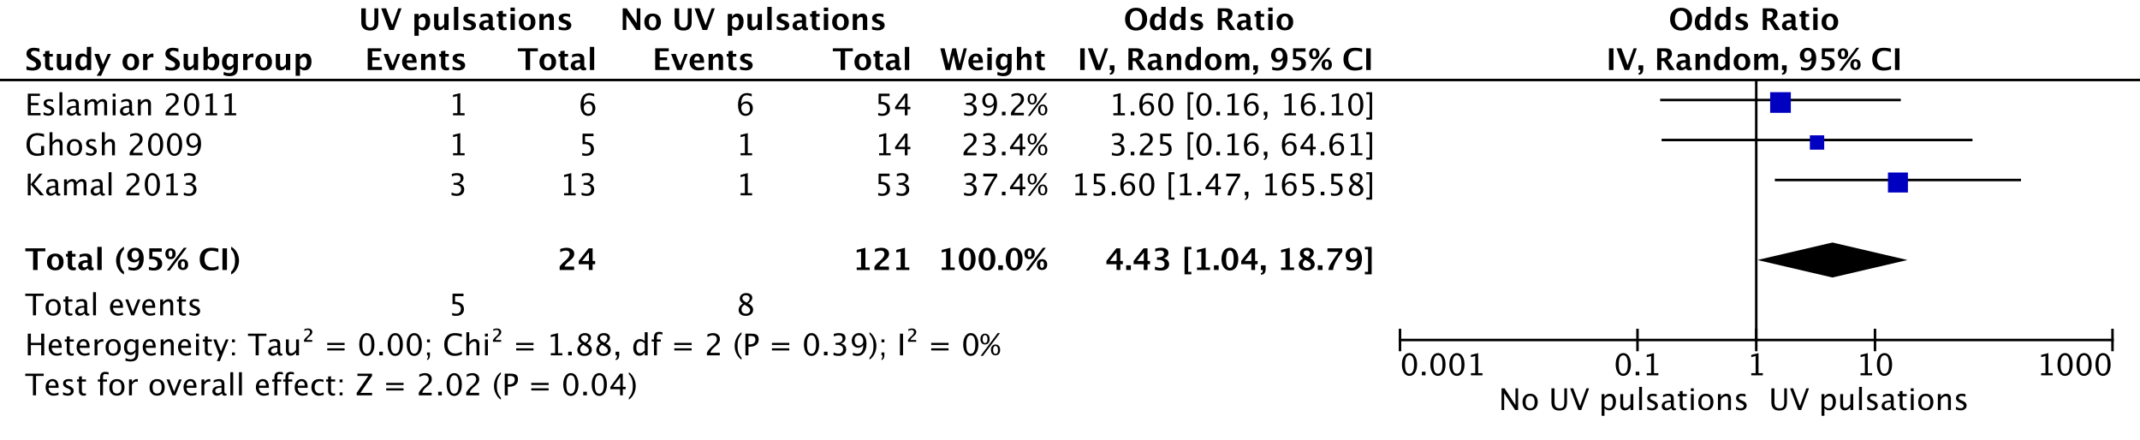
HKSJ conversion: OR 4,43 (0,2-95,94) – p=0,172733

Sensitivity analysis – Exclusion of Eslamian 2011:

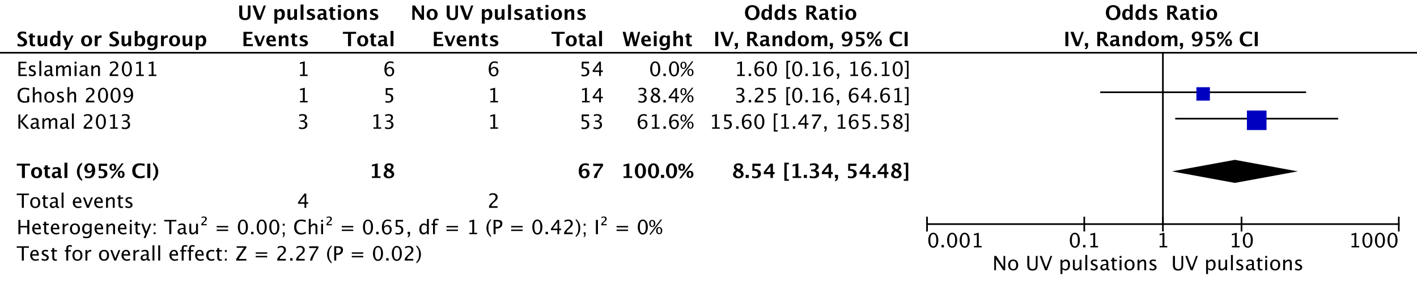
HKSJ conversion: OR 8,54 (0,84-87) – p=0,057831

Outcome 7: NICU admission

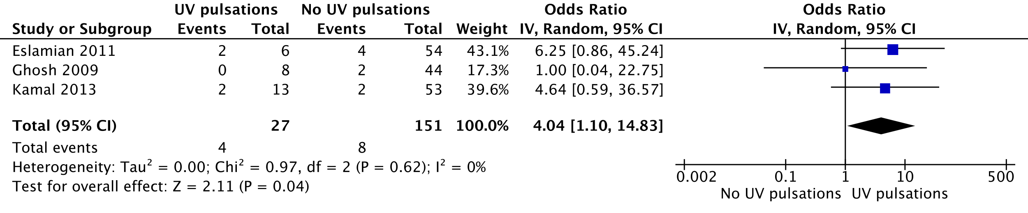
HKSJ conversion: OR 4,04 (0,55-29,49) – p=0,094266

Sensitivity analysis – Exclusion of Eslamian 2011:

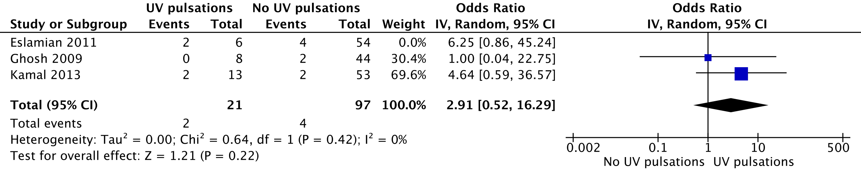
HKSJ conversion: OR 2,91 (0,34-24,93) – p=0,165736

Outcome 8: SGA infant

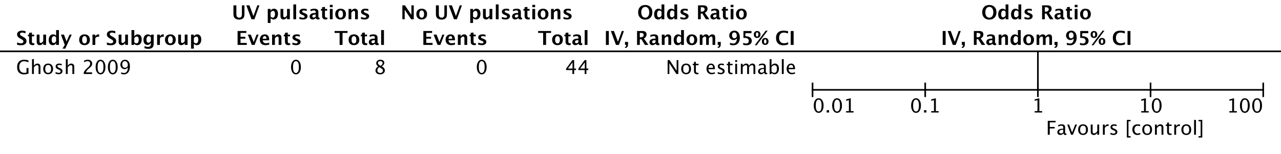

- UV-flow

Outcome 1: Fetal distress (FD) during labor

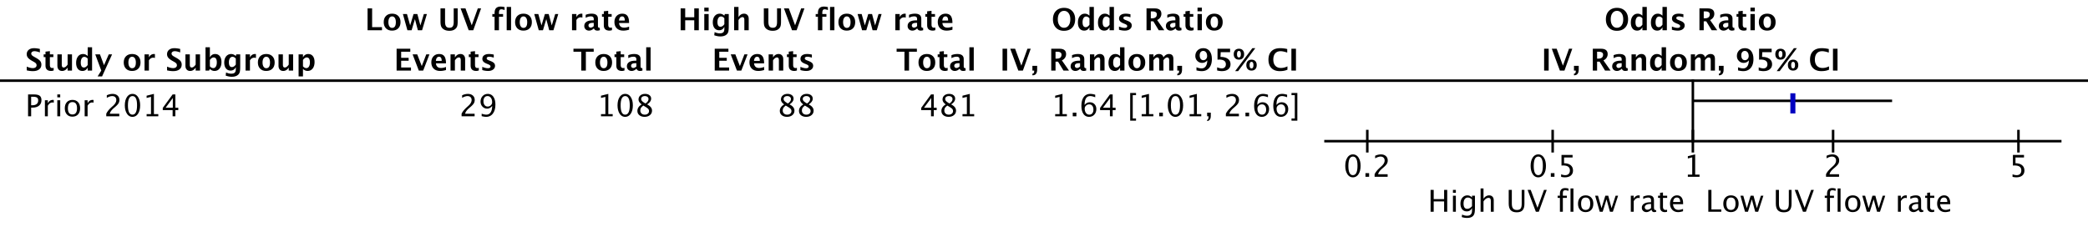
Outcome 2: Meconium-stained amniotic fluid (MSAF)

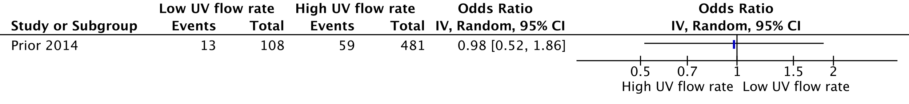
Outcome 3: Operative delivery for fetal distress (ODFD)

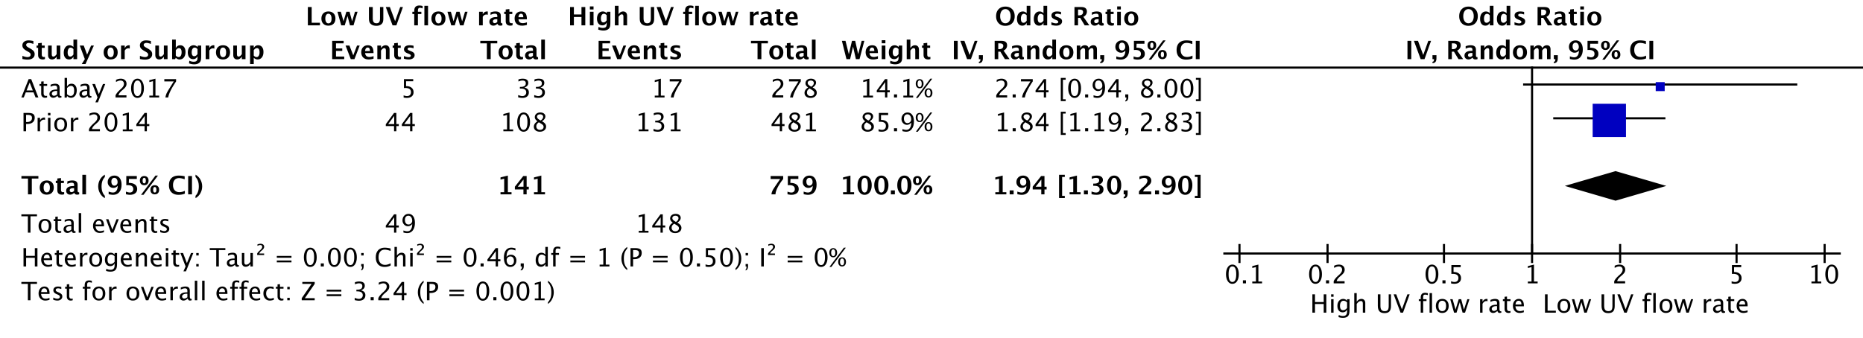
HKSJ conversion: OR 1,94 (0,33-11,29) – p=0,131272

Outcome 4: Spontaneous vaginal delivery (SVD) (vs. operative delivery, OD)

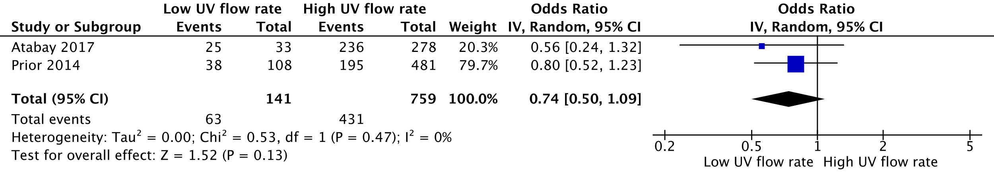
HKSJ conversion: OR 0,74 (0,12-4,59) – p=0,283254
Outcome 5: Apgar <7 at 5 min

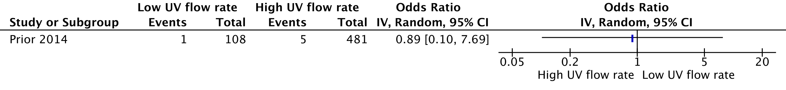
Outcome 6: Low UA pH

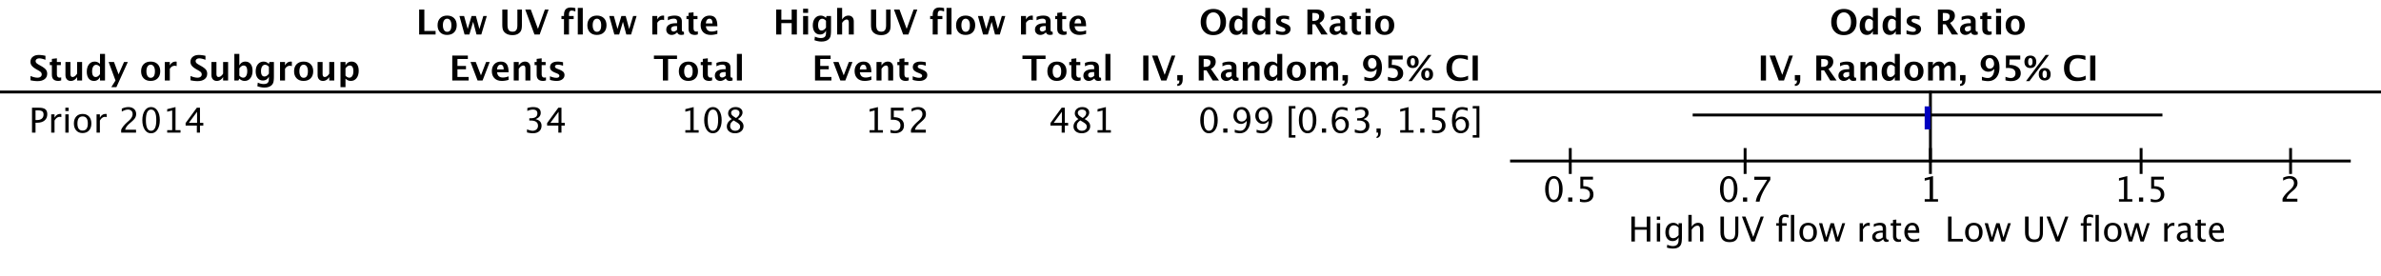
Outcome 7: NICU admission

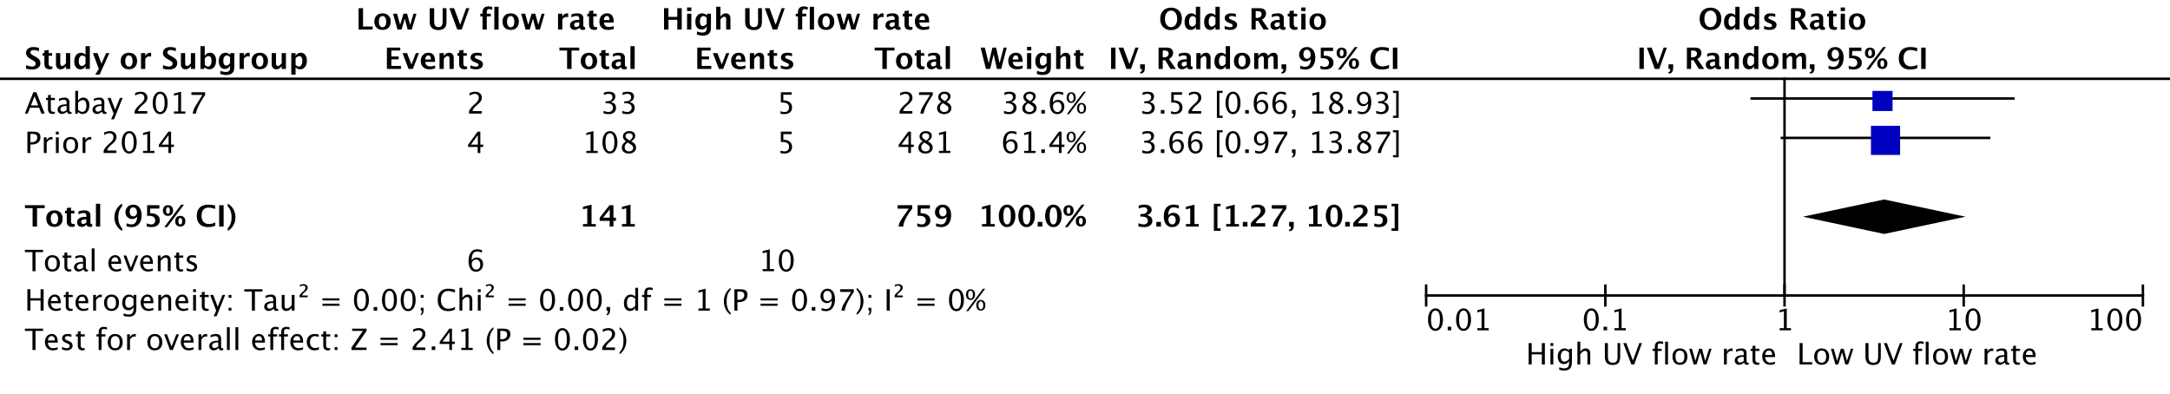
HKSJ conversion: OR 3,61 (2,83-4,6) – p=0,009438

Outcome 8: Serious neonatal morbidity

